BERT vs FinBERT — Comparison Report
Financial Sentiment Classification using FinBERT — optional experiment comparing domain-adapted FinBERT against generic BERT-base on the same fine-tuning task.

1. Objective
To test whether domain-specific pretraining (FinBERT) provides a measurable benefit over generic BERT-base on financial sentiment classification, both models were fine-tuned under an identical setup — same data splits, same hyperparameters, same training procedure — so that any difference in results is attributable to the pretrained checkpoint rather than experimental inconsistencies.

2. Experimental Setup
- Dataset: Financial PhraseBank (sentences_50agree), same cleaned and stratified 80/10/10 train/val/test split used throughout the project (3868 / 484 / 484 sentences).
- Checkpoints compared: ProsusAI/finbert (FinBERT) vs. bert-base-uncased (generic BERT), both uncased WordPiece tokenizers.
- Hyperparameters (identical for both): learning rate 2e-5, batch size 16, up to 4 epochs with early stopping (patience=2, monitored on validation macro F1), max_length=128, 10% linear warmup, weight decay 0.01, seed=42.
- Both runs performed on the same Google Colab T4 GPU session.

3. Results

3.1 Overall metrics (test set)
Model | Accuracy | Macro F1
Baseline (TF-IDF + Logistic Regression) | 78.3% | 75.4%
BERT-base (fine-tuned) | 87.0% | 85.5%
FinBERT (fine-tuned) | 89.3% | 88.0%

3.2 Per-class recall — BERT vs FinBERT
Class | BERT recall | FinBERT recall | Gap
Negative | 85.2% | 88.5% | +3.3 pts
Neutral | 90.6% | 92.3% | +1.7 pts
Positive | 80.1% | 83.1% | +3.0 pts

FinBERT outperforms BERT-base on every class, not only on average — indicating the domain-pretraining benefit is consistent rather than driven by a single class.

3.3 Confusion matrices (test set)
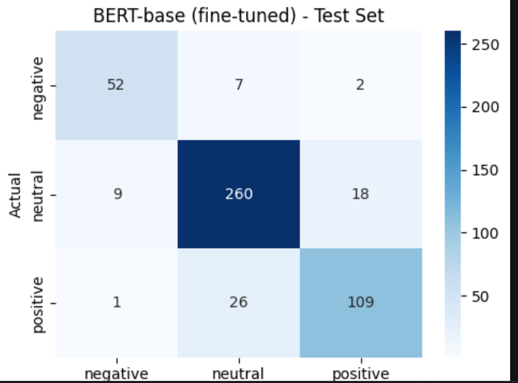 | 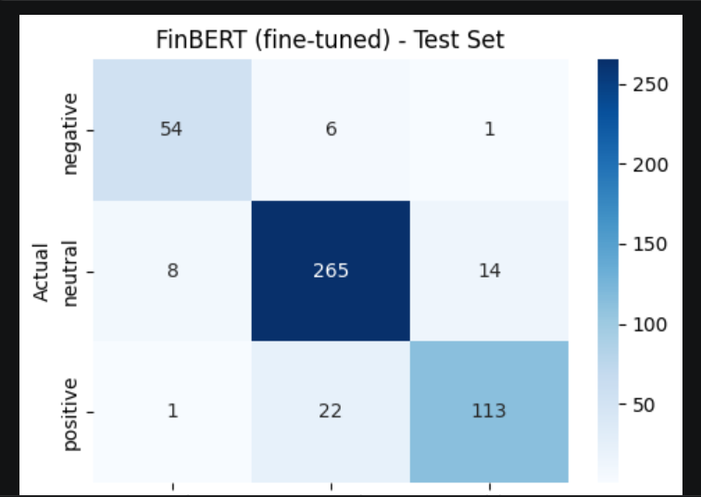

4. Interpretation
- FinBERT wins by +2.3 points accuracy and +2.5 points macro F1 over generic BERT-base — a modest but consistent improvement.
- Both Transformer models substantially outperform the TF-IDF + Logistic Regression baseline (75.4% macro F1), confirming the value of contextual, pretrained representations over bag-of-words features for this task.
- The result is consistent with published literature (e.g. "Is Domain Adaptation Worth Your Investment? Comparing BERT and FinBERT on Financial Tasks", Workshop on Economics and NLP, 2021), which found continued domain-specific pretraining helpful, though not dramatically so, for financial NLP tasks.

5. Caveat
FinBERT was originally fine-tuned by its creators on Financial PhraseBank itself, before this project re-fine-tuned it on a fresh, cleaned split of the same dataset. Generic BERT-base had no such prior exposure. Part of FinBERT's advantage here may therefore reflect this structural head start rather than domain-specific pretraining alone — a nuance worth stating explicitly rather than claiming a fully clean causal comparison.

6. Conclusion
Domain-adaptive pretraining provides a real, measurable, and consistent — if modest — benefit for financial sentiment classification in this setup. Both fine-tuned Transformer models substantially outperform a traditional lexical baseline, reinforcing the case for using pretrained Transformers over classical NLP approaches for this task.

