SUMMER INTERNSHIP REPORT
on
Design and Development of “ReNest”:
A Full Stack Student Marketplace Web Application
Submitted in the Partial Fulfilment of the Requirement for the Award of
Bachelor of Technology
in
Computer Science & Engineering
(Artificial Intelligence & Machine Learning)

Submitted By

Utkarsh Yadav

Roll No. - 2403611530068

Under the Guidance of
Mr. Bhavesh Mathur
Faculty Guide
Department of Computer Science & Engineering (AI&ML)
RRIMT, Lucknow, UP, India


RR INSTITUTE OF MODERN TECHNOLOGY, LUCKNOW, UP, INDIA
(Recognized by AICTE, Govt. of India & Affiliated to Dr. A.P.J. Abdul Kalam Technical University, Lucknow, UP)
AKTU College Code -361
Academic Session 2025-26

CERTIFICATE
This is to certify that the Summer Internship Report entitled "Design and Development of ReNest: A Full Stack Student Marketplace Web Application" submitted by Mr. Utkarsh Yadav (Roll No. 2403611530068), a student of Bachelor of Technology in Computer Science & Engineering (Artificial Intelligence & Machine Learning) at R.R. Institute of Modern Technology, Lucknow, affiliated to Dr. A.P.J. Abdul Kalam Technical University (AKTU), Lucknow, is a bonafide record of the work carried out by him during the 40-day Summer Internship under my guidance and supervision.
The work presented in this report is original and has been completed as a part of the academic requirements for the award of the degree of Bachelor of Technology. To the best of my knowledge and belief, this report has not been submitted, either wholly or partially, to any other university or institution for the award of any degree, diploma, or other academic qualification.
During the internship, the student demonstrated dedication, sincerity, and a strong willingness to learn modern web development technologies. The project involved the design and implementation of a full-stack web application using technologies such as Node.js, Express.js, MongoDB, HTML, CSS, JavaScript, JWT Authentication, and RESTful APIs. The student successfully applied theoretical concepts to solve practical problems and completed the assigned work in a systematic and professional manner.
I wish him success in all his future academic and professional endeavors.

Date: ___________________
Place: Lucknow

Faculty Guide | Head of Department
Mr. Bhavesh Mathur | Mr. Chandan Kr. Gupta
Department of Computer Science & Engineering (AI & ML) | Department of Computer Science & Engineering (AI & ML)
R.R. Institute of Modern Technology | R.R. Institute of Modern Technology
Signature | Signature & Seal

DECLARATION
I, Utkarsh Yadav, Roll No. 2403611530068, a student of Bachelor of Technology in Computer Science & Engineering (Artificial Intelligence & Machine Learning) at R.R. Institute of Modern Technology, Lucknow, hereby declare that the Summer Internship Report entitled "Design and Development of ReNest: A Full Stack Student Marketplace Web Application" is an original record of the work carried out by me during my 40-day Summer Internship under the guidance of Mr. Bhavesh Mathur, Faculty Guide, Department of Computer Science & Engineering (Artificial Intelligence & Machine Learning.
I further declare that this project has been developed solely for the purpose of partial fulfilment of the requirements for the award of the Bachelor of Technology degree under Dr. A.P.J. Abdul Kalam Technical University (AKTU), Lucknow.
I certify that the work presented in this report is original and has not been submitted, either wholly or partially, to any other university, institution, or organization for the award of any degree, diploma, certificate, or any other academic qualification.
The information, observations, analyses, and conclusions presented in this report are based on my own learning, practical implementation, and internship experience. Wherever the work or ideas of others have been referred to, appropriate acknowledgment has been provided in the references section.
I take full responsibility for the authenticity and accuracy of the contents of this report.

Place: Lucknow
Date: ___________________

Signature of the Student
(Utkarsh Yadav)
Roll No. 2403611530068

ACKNOWLEDGEMENT
The successful completion of this Summer Internship and the development of the ReNest – A Full Stack Student Marketplace Web Application would not have been possible without the guidance, encouragement, and support of several individuals and organizations.
First and foremost, I express my sincere gratitude to Mr. Bhavesh Mathur, Faculty Guide, Department of Computer Science & Engineering (Artificial Intelligence & Machine Learning), R.R. Institute of Modern Technology, Lucknow, for his valuable guidance, continuous motivation, constructive suggestions, and constant support throughout the internship period. His technical insights and encouragement helped me successfully complete this project.
I would also like to express my heartfelt thanks to the Department of Computer Science & Engineering and the management of R.R. Institute of Modern Technology, Lucknow, for providing me with the opportunity to undergo this Summer Internship as a part of my academic curriculum. The knowledge, resources, and learning environment provided by the institution played a significant role in enhancing my technical and professional skills.
I am thankful to the training organization and all the trainers for sharing their valuable knowledge of Full Stack Web Development and for providing practical exposure to modern software development technologies. The training sessions helped me strengthen my understanding of frontend development, backend development, database management, RESTful APIs, version control, testing methodologies, and professional software development practices.
I would also like to thank my classmates and friends for their cooperation, constructive discussions, and encouragement during the internship. Their support helped me overcome several technical challenges encountered during the development of the project.
Finally, I express my deepest gratitude to my parents and family members for their unconditional love, continuous encouragement, patience, and unwavering belief in me throughout my academic journey. Their constant support has been the greatest source of motivation behind the successful completion of this internship and the preparation of this report.
I sincerely acknowledge everyone who, directly or indirectly, contributed to the successful completion of this internship and this project.

Utkarsh Yadav
Roll No. 2403611530068
B.Tech, Computer Science & Engineering (Artificial Intelligence & Machine Learning)
R.R. Institute of Modern Technology, Lucknow

ABSTRACT
The rapid growth of digital technology has transformed the way people buy and sell products, making online marketplaces an integral part of everyday life. However, most existing e-commerce platforms are designed for the general public and often lack features that address the specific needs of college students. Students frequently possess textbooks, electronic gadgets, stationery, furniture, and other reusable items that become unnecessary after a semester or an academic year. Finding trustworthy buyers or sellers within the college community can be difficult, resulting in unused resources and unnecessary expenditure. To address this problem, ReNest was conceptualized and developed as a dedicated student marketplace that promotes the reuse of products within a secure campus environment.
ReNest is a Full Stack Web Application designed to enable college students to buy, sell, and manage second-hand products conveniently through a user-friendly web interface. The application provides a centralized platform where authenticated users can register, log in securely, create product listings, browse available products, view detailed product information, manage their own listings, and contact sellers for further communication. By restricting the platform to the student community, the system aims to improve trust, encourage sustainable reuse of resources, and reduce unnecessary spending.
The project has been developed using modern web technologies including HTML5, CSS3, and JavaScript for the frontend, while Node.js and Express.js are used to implement the backend services. MongoDB, along with Mongoose, is employed for data storage and database management. Secure user authentication is implemented using JSON Web Tokens (JWT), while bcrypt is used to encrypt user passwords before storing them in the database. Additional development tools such as Postman, Git, and GitHub were utilized for API testing, version control, and collaborative development practices.
The system follows a modular architecture consisting of authentication, product management, user management, database management, and REST API modules. This architecture improves maintainability, scalability, and ease of future enhancements. Proper
The development of ReNest provided valuable practical exposure to the complete Software Development Life Cycle (SDLC), including requirement analysis, system design, implementation, testing, debugging, and documentation. Throughout the internship, significant knowledge was gained in backend development, RESTful API design, database modeling, authentication mechanisms, project organization, and version control workflows. The project also strengthened problem-solving abilities and enhanced understanding of how modern full-stack applications are designed and deployed in real-world environments.
Overall, ReNest demonstrates the practical application of full-stack web development technologies in solving a real-world problem faced by college students. The project successfully achieves its objective of providing a secure, user-friendly, and scalable platform for buying and selling second-hand products within a campus community while establishing a strong foundation for future enhancements such as real-time messaging, online payments, product reviews, notifications, and mobile responsiveness.

TABLE OF CONTENTS

S. No. | Particulars | Page No.
1. | Certificate | i
2. | Declaration | ii
3. | Acknowledgement | iii
4. | Abstract | iv
5. | Table of Contents | v
6. | Chapter 1 – Introduction | 1
7. | Chapter 2 – Organization / Internship Profile | 5
8. | Chapter 3 – Internship Objectives | 8
9. | Chapter 4 – Technologies Used | 12
10. | Chapter 5 – Project Description | 17
11. | Chapter 6 – Existing System | 21
12. | Chapter 7 – Proposed System | 23
13. | Chapter 8 – Requirement Analysis | 26
14. | Chapter 9 – System Design | 30
15. | Chapter 10 – Implementation | 43
16. | Chapter 11 – Testing | 51
17. | Chapter 12 – Internship Evaluation Sheet | 55
18. | Chapter 13 – Daily Work Report | 57
19. | Chapter 14 – Challenges Faced | 59
20. | Chapter 15 – Skills Gained | 61
21. | Chapter 16 – Conclusion | 63
22. | References | 64
23. | Appendix | 66

CHAPTER 1

INTRODUCTION
1.1 Introduction
The advancement of information technology has transformed the way people buy, sell, and exchange goods. Online marketplaces have become one of the most popular digital platforms because they provide convenience, accessibility, and faster communication between buyers and sellers.
College students often need books, electronic gadgets, furniture, stationery, and other academic essentials. After completing a semester, many of these items remain unused, while other students require them. However, there is no dedicated platform within most colleges that allows students to exchange these products safely and efficiently.
ReNest is a Full Stack Student Marketplace Web Application developed to solve this problem. It provides a secure platform where students can register, browse products, list items for sale, manage their listings, and contact sellers within their campus community.
The application is developed using HTML, CSS, JavaScript, Node.js, Express.js, MongoDB, Mongoose, JWT Authentication, and REST APIs. It follows a modular architecture that ensures scalability, maintainability, and secure user authentication.
Key Highlights of ReNest
- Student-focused online marketplace
- Secure user authentication using JWT
- Product listing and management
- Browse available products
- User profile management
- RESTful API architecture
- MongoDB database integration
- Responsive and user-friendly interface
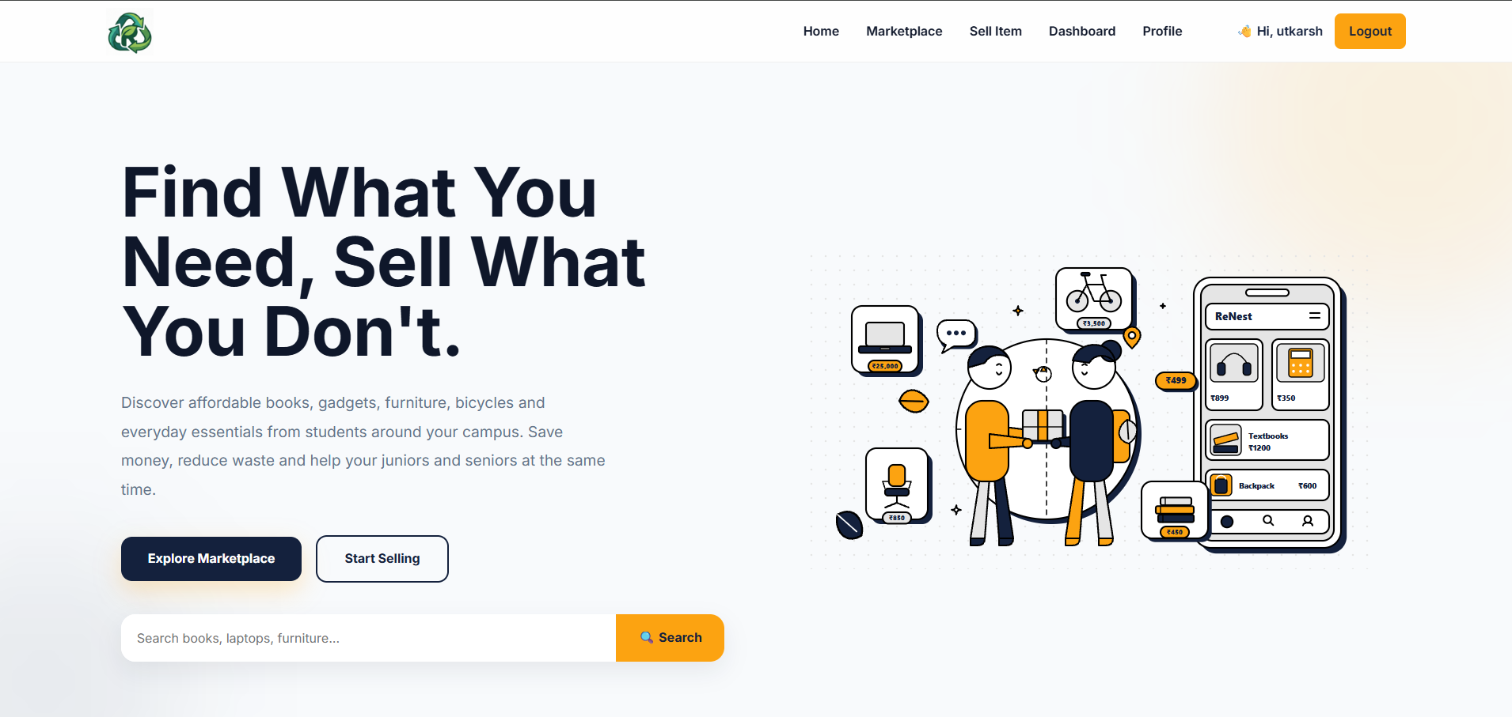
1.2 Background of the Project
The increasing use of digital platforms has changed the way people buy and sell products. Online marketplaces such as Amazon, Flipkart, and OLX have simplified product transactions for the general public. However, these platforms are not specifically designed for college students and often lack a trusted campus-based environment.
Students frequently own books, calculators, laptops, bicycles, furniture, and other items that become unnecessary after a semester. At the same time, new students often need these products but struggle to find affordable options within their college.
ReNest was developed to bridge this gap by providing a dedicated marketplace exclusively for students. The platform promotes the reuse of products, reduces unnecessary expenses, and creates a trusted environment for buying and selling within the college community.

1.3 Need of the Project
The development of ReNest is motivated by the following needs:
- To provide a dedicated marketplace for college students.
- To simplify buying and selling of second-hand products.
- To reduce dependency on social media groups and informal communication.
- To promote the reuse of educational resources and reduce waste.
- To provide secure authentication for users.
- To maintain organized product information.
- To improve accessibility through a web-based platform.
- To create a trusted campus community for transactions.

1.4 Objectives of the Project
The main objectives of the project are:
- To develop a secure student marketplace.
- To implement user authentication using JWT.
- To allow students to register and manage their accounts.
- To enable users to add, edit, and delete product listings.
- To provide product browsing and detailed product information.
- To implement RESTful APIs for communication between frontend and backend.
- To securely store user and product information using MongoDB.
- To gain practical experience in Full Stack Web Development.
- To understand real-world software development practices.

1.5 Scope of the Project
The scope of ReNest includes the following functionalities:
Current Scope
- User Registration and Login
- Secure Authentication
- User Profile Management
- Product Listing
- Product Editing
- Product Deletion
- Marketplace Browsing
- Product Details Page
- Product Categories
- MongoDB Database Integration
- REST API Implementation
- Input Validation
- Error Handling
Future Scope
- Real-time Chat System
- Online Payment Gateway
- Wishlist Feature
- Product Search and Filters
- Ratings and Reviews
- College Email Verification
- Admin Dashboard
- Push Notifications
- Mobile Responsive Application
- Mobile App Development

1.6 Mission
The mission of ReNest is to develop a secure, reliable, and user-friendly marketplace exclusively for college students that encourages the reuse of products and promotes sustainable resource sharing within educational institutions.
The project also aims to provide practical exposure to modern Full Stack Web Development technologies while implementing industry-standard software development practices.

Chapter 1 Summary
This chapter introduced the ReNest project by discussing its background, the need for a dedicated student marketplace, project objectives, scope, and mission. It also highlighted how the project addresses real-world challenges faced by students while providing an opportunity to apply modern web development technologies in a practical environment.

CHAPTER 2
ORGANIZATION / INTERNSHIP PROFILE

2.1 Organization Overview
The Summer Internship was undertaken as a part of the Bachelor of Technology curriculum at R.R. Institute of Modern Technology (RRIMT), Lucknow, affiliated with Dr. A.P.J. Abdul Kalam Technical University (AKTU), Lucknow.
The internship program was designed to provide practical exposure to modern software development technologies and bridge the gap between academic learning and industry practices. During the training, students were introduced to Full Stack Web Development concepts, project development methodologies, and software engineering principles through hands-on sessions and practical assignments.
Note: Replace this section with the training organization's details once confirmed.

2.2 Internship Details
Particular | Details
Internship Title | Summer Internship on Full Stack Web Development
Project Title | ReNest – A Full Stack Student Marketplace Web Application
Duration | 40 Days
Student Name | Utkarsh Yadav
Roll Number | 2403611530068
Branch | Computer Science & Engineering (AI & ML)
College | R.R. Institute of Modern Technology, Lucknow
University | Dr. A.P.J. Abdul Kalam Technical University (AKTU)
Faculty Guide | Mr. Bhavesh Mathur

2.3 Training Objectives
The primary objectives of the internship were:
- To understand the fundamentals of Full Stack Web Development.
- To gain practical experience in frontend and backend technologies.
- To learn database design and management using MongoDB.
- To understand RESTful API development.
- To implement secure authentication mechanisms.
- To improve debugging and testing skills.
- To understand Git and GitHub workflow.
- To develop a real-world web application.

2.4 Training Methodology
The internship followed a practical learning approach that combined theoretical concepts with hands-on implementation.
The methodology included:
- Classroom-based technical sessions.
- Hands-on coding exercises.
- Mini practical assignments.
- Project-based learning.
- Regular debugging sessions.
- API testing using Postman.
- Version control using Git and GitHub.
- Continuous project evaluation and documentation.

2.5 Technologies Covered During Training
Category | Technologies / Tools
Frontend | HTML5, CSS3, JavaScript
Backend | Node.js, Express.js
Database | MongoDB, Mongoose
Authentication | JWT, bcrypt
API Testing | Postman
Version Control | Git, GitHub
Development Tool | Visual Studio Code
Browser | Google Chrome

2.6 Learning Approach
During the internship, emphasis was placed on learning by implementation rather than theory alone. Each technology was introduced through practical demonstrations followed by coding exercises. The acquired knowledge was applied in developing the ReNest project, enabling a better understanding of real-world software development practices.

Chapter Summary
This chapter provided an overview of the internship, including the organization, objectives, training methodology, technologies covered, and the overall learning approach adopted during the 40-day internship program.

CHAPTER 3
INTERNSHIP OBJECTIVES

3.1 Internship Details
Particular | Details
Internship Title | Summer Internship on Full Stack Web Development
Project Title | ReNest – A Full Stack Student Marketplace Web Application
Duration | 40 Days
Student Name | Utkarsh Yadav
Roll Number | 2403611530068
Branch | Computer Science & Engineering (Artificial Intelligence & Machine Learning)
College | R.R. Institute of Modern Technology, Lucknow
University | Dr. A.P.J. Abdul Kalam Technical University (AKTU)
Faculty Guide | Mr. Bhavesh Mathur
Development Tools | Visual Studio Code, Git, GitHub, Postman
Database | MongoDB
Backend | Node.js, Express.js
Frontend | HTML5, CSS3, JavaScript

3.2 Project Overview
ReNest is a Full Stack Student Marketplace Web Application developed to provide a secure platform where college students can buy and sell second-hand products within their campus community.
The application enables authenticated users to:
- Register and log in securely.
- Browse available products.
- Add new product listings.
- View product details.
- Edit or remove their own listings.
- Manage their user profile.
- Contact product sellers.
The system is designed using a modular architecture, making it scalable, secure, and easy to maintain.

3.3 Objectives of the Internship
The internship was conducted with the following objectives:
- To understand the complete Software Development Life Cycle (SDLC).
- To gain practical knowledge of Full Stack Web Development.
- To develop a real-world web application.
- To learn backend development using Node.js and Express.js.
- To understand MongoDB database design.
- To implement secure authentication using JWT.
- To design RESTful APIs.
- To improve debugging and testing skills.
- To understand project documentation.
- To apply classroom concepts to practical software development.

3.4 Learning Objectives
During the internship, emphasis was placed on acquiring the following technical skills:
Technical Learning
- HTML5 and Semantic Web Design
- CSS3 Styling and Responsive Design
- JavaScript Programming
- Node.js Development
- Express.js Framework
- MongoDB Database
- Mongoose ODM
- REST API Development
- JWT Authentication
- Password Hashing using bcrypt
- Git & GitHub Version Control
- API Testing using Postman

3.5 Learning Outcomes
At the successful completion of the internship, the following outcomes were achieved.
Technical Skills
- Full Stack Web Development
- Frontend Development
- Backend Development
- Database Design
- REST API Development
- User Authentication
- Secure Password Management
- CRUD Operations
- Debugging
- Software Testing
- Git Version Control
- Professional Documentation

Professional Skills
- Problem Solving
- Logical Thinking
- Time Management
- Team Collaboration
- Technical Communication
- Project Planning
- Documentation Skills
- Software Development Practices

3.6 Key Features Developed During the Internship
Module | Features Implemented
Authentication | Registration, Login, JWT Authentication, Password Encryption
Product Management | Add Product, Edit Product, Delete Product, View Product
Marketplace | Browse Products, Categories, Product Details
User Module | User Profile, My Listings
Database | MongoDB Collections, CRUD Operations
Backend | REST APIs, Middleware, Validation, Error Handling

3.7 Internship Outcome
The internship provided practical exposure to modern software development by integrating frontend technologies, backend services, and database management into a single project.
The development of ReNest enhanced my understanding of application architecture, secure authentication, RESTful API development, and project organization. It also strengthened my ability to analyze problems, design scalable solutions, and implement them using industry-standard technologies.

Chapter Summary
This chapter presented the internship details, project overview, objectives, learning outcomes, and the major features implemented during the development of ReNest. It also highlighted the technical and professional skills acquired throughout the internship.

CHAPTER 4
TECHNOLOGIES USED

4.1 Introduction
The development of ReNest involved the use of modern web development technologies to build a secure, scalable, and user-friendly student marketplace. Each technology was selected based on its functionality, performance, and suitability for full-stack application development.

4.2 Technology Stack
Category | Technology | Purpose
Frontend | HTML5 | Structure of web pages
Frontend | CSS3 | Styling and responsive design
Frontend | JavaScript | Client-side functionality and interactivity
Backend | Node.js | Server-side JavaScript runtime
Backend | Express.js | Web application framework
Database | MongoDB | NoSQL database for storing user and product data
ODM | Mongoose | Database modeling and schema management
Authentication | JWT | Secure user authentication
Security | bcrypt | Password hashing and encryption
Configuration | dotenv | Environment variable management
API Testing | Postman | Testing REST APIs
Version Control | Git | Source code management
Repository | GitHub | Project hosting and version control
Development Tool | Visual Studio Code | Code editor
Browser | Google Chrome | Testing and debugging

4.3 Software Development Life Cycle (SDLC)
The development of ReNest followed the Software Development Life Cycle (SDLC), ensuring systematic planning, development, testing, and maintenance.
Phases of SDLC
- Requirement Analysis
- Planning
- System Design
- Development
- Testing
- Deployment
- Maintenance

SDLC Workflow
Requirement Analysis
│
▼
Planning
│
▼
System Design
│
▼
Development
│
▼
Testing
│
▼
Deployment
│
▼
Maintenance

4.4 Technologies Description
HTML5
HTML5 was used to create the structure of all web pages including the Home page, Login page, Marketplace, Dashboard, Profile, and Product pages.

CSS3
CSS3 was used to design the user interface, implement responsive layouts, apply animations, and improve the overall appearance of the application.

JavaScript
JavaScript provides dynamic functionality such as form validation, API requests, DOM manipulation, event handling, and interaction with backend services.

Node.js
Node.js was used to execute JavaScript on the server and handle incoming client requests efficiently.

Express.js
Express.js simplified backend development by providing routing, middleware support, request handling, and REST API implementation.

MongoDB
MongoDB stores user accounts, product listings, authentication data, and other application information in a flexible NoSQL database.

Mongoose
Mongoose was used to define schemas, create models, and perform CRUD operations between the application and MongoDB.

JWT Authentication
JSON Web Tokens (JWT) provide secure authentication by generating tokens after successful login and verifying users before allowing access to protected routes.

bcrypt
bcrypt secures user passwords by converting them into hashed values before storing them in the database.

Postman
Postman was used to test REST APIs by sending HTTP requests and validating API responses during development.

Git & GitHub
Git was used to track project changes locally, while GitHub served as the remote repository for source code management and version control.

4.5 Advantages of the Technologies Used
- Open-source technologies with strong community support.
- Fast and efficient backend using Node.js.
- Flexible NoSQL database with MongoDB.
- Secure authentication using JWT.
- Password protection through bcrypt hashing.
- Easy API development with Express.js.
- Efficient version control using Git and GitHub.
- Simple API testing using Postman.
- Modular architecture for future scalability.

4.6 Limitations
- JWT tokens require proper management for security.
- MongoDB requires careful schema planning to maintain consistency.
- Node.js is single-threaded, making CPU-intensive tasks less efficient.
- Internet connectivity is required to access the deployed application.
- Additional features such as real-time chat and payment integration are not implemented in the current version.

4.7 Future Scope
The project can be enhanced with the following features:
- Image upload using cloud storage.
- Real-time messaging between buyers and sellers.
- Wishlist functionality.
- Advanced product search and filters.
- College email verification.
- Product ratings and reviews.
- Admin dashboard.
- Push notifications.
- Online payment gateway integration.
- Responsive mobile application.

Chapter Summary
This chapter presented the technologies, development tools, and software development methodology used during the implementation of ReNest. It also discussed the advantages, limitations, and future enhancement possibilities of the project.

CHAPTER 5
PROJECT DESCRIPTION

5.1 Project Introduction
ReNest is a Full Stack Student Marketplace Web Application developed to provide a secure platform where students can buy and sell second-hand products within their college community.
The application allows authenticated users to register, log in, browse products, add new product listings, manage their own products, and view detailed information about available items. By limiting the marketplace to students, the platform aims to build trust and encourage the reuse of useful products.

5.2 Problem Statement
Students often own items such as textbooks, electronic gadgets, calculators, furniture, bicycles, and stationery that are no longer required after a semester. Although these products are still useful, there is no dedicated platform within colleges where students can exchange them safely.
As a result, students usually depend on:
- WhatsApp groups
- Social media posts
- Personal contacts
- College notice boards
These methods are unorganized, difficult to manage, and often unreliable.

5.3 Proposed Solution
ReNest provides a centralized web platform where students can securely buy and sell second-hand products.
The system allows users to:
- Register and log in securely.
- Browse available products.
- Publish products for sale.
- Edit or remove their own listings.
- View product details.
- Contact sellers.
- Manage their profile.
This improves accessibility, transparency, and convenience while reducing unnecessary waste of usable products.

5.4 Project Goals
The major goals of ReNest are:
- Develop a secure student marketplace.
- Simplify buying and selling within the campus.
- Promote the reuse of educational resources.
- Implement secure authentication using JWT.
- Provide an easy-to-use interface.
- Maintain organized product records.
- Develop scalable REST APIs.
- Gain practical experience in Full Stack Development.

5.5 Major Modules
Module | Description
Authentication Module | Handles user registration, login, JWT authentication, and logout.
Product Module | Manages product creation, editing, deletion, and viewing.
User Module | Handles user profile and product management.
Database Module | Stores user and product information using MongoDB.
API Module | Provides REST APIs for frontend and backend communication.

5.6 Working of ReNest
The overall workflow of the application is as follows:
- User registers on the platform.
- User logs in using registered credentials.
- JWT token is generated after successful authentication.
- User can browse available products.
- Authenticated users can add new products.
- Users can edit or delete their own listings.
- Buyers can view product details and contact the seller.
- Product information is stored and retrieved from MongoDB through REST APIs.

5.7 System Architecture
The ReNest application follows a layered architecture consisting of four major layers.
Users
│
▼
Frontend (HTML, CSS, JavaScript)
│
REST API Requests
│
▼
Backend (Node.js + Express.js)
│
Authentication & Business Logic
│
▼
MongoDB Database (Mongoose)

5.8 Key Features
Authentication
- User Registration
- User Login
- JWT Authentication
- Password Encryption
- Protected Routes
Marketplace
- Browse Products
- Product Details
- Product Categories
- Product Description
- Product Price
User Features
- Add Product
- Edit Product
- Delete Product
- Manage Own Listings
- User Profile
Backend Features
- REST APIs
- MongoDB Integration
- Authentication Middleware
- Input Validation
- Error Handling

5.9 Benefits of the Project
- Dedicated marketplace for students.
- Secure user authentication.
- Easy product management.
- Organized database.
- Scalable architecture.
- User-friendly interface.
- Reduced dependency on informal selling methods.
- Promotes sustainable reuse of products.

Chapter Summary
This chapter described the ReNest project, its problem statement, proposed solution, objectives, working methodology, architecture, major modules, and key features. The project provides a secure and efficient marketplace that simplifies the buying and selling process within a college environment.

CHAPTER 6
EXISTING SYSTEM

6.1 Introduction
Before the development of ReNest, students generally relied on informal methods to buy and sell second-hand products. These methods lacked proper organization, security, and reliability, making the process inconvenient for both buyers and sellers.

6.2 Existing System
The commonly used methods for exchanging products among students include:
- WhatsApp Groups
- Telegram Groups
- Facebook Marketplace
- OLX
- Personal Contacts
- College Notice Boards
Although these platforms facilitate buying and selling, they are not specifically designed for college students and do not provide a trusted campus-based marketplace.

6.3 Limitations of the Existing System
The existing system suffers from several limitations:
- No dedicated marketplace for students.
- Difficult to verify genuine buyers and sellers.
- Product information is scattered across multiple platforms.
- No centralized product management.
- Lack of secure user authentication.
- Higher chances of fraudulent listings.
- No proper categorization of products.
- Difficult to manage old or sold listings.
- Communication depends on external applications.

6.4 Problems Identified
The major problems observed are:
Problem | Description
Lack of Trust | Users cannot easily verify whether the seller belongs to the same college.
Poor Organization | Products are shared randomly through messages or posts.
Difficult Search | Finding required products takes considerable time.
No User Management | No dedicated user profiles or product history.
No Listing Control | Sellers cannot efficiently manage their posted products.
Limited Security | Most platforms do not provide campus-specific authentication.

6.5 Drawbacks of the Existing System
- Time-consuming product search.
- Unorganized buying and selling process.
- Dependence on multiple communication platforms.
- Limited control over product listings.
- Higher possibility of fake or outdated advertisements.
- No dedicated platform for campus transactions.

CHAPTER 7
PROPOSED SYSTEM

7.1 Introduction
The proposed system, ReNest, is a Full Stack Student Marketplace Web Application developed to provide a secure and organized platform for buying and selling second-hand products within a college campus.
Unlike traditional methods such as social media groups or general online marketplaces, ReNest is specifically designed for students, providing a centralized platform with secure authentication, product management, and an easy-to-use interface.

7.2 Proposed System
ReNest provides the following functionalities:
- Secure user registration and login.
- JWT-based user authentication.
- Browse available products.
- Add new product listings.
- View detailed product information.
- Edit or delete own products.
- User profile management.
- MongoDB-based data storage.
- RESTful API communication.

7.3 Advantages of the Proposed System
The proposed system offers several advantages over traditional methods:
- Dedicated platform for college students.
- Secure authentication using JWT.
- Organized product management.
- Easy navigation and user-friendly interface.
- Faster product discovery.
- Reliable database management.
- Centralized marketplace.
- Scalable architecture for future enhancements.

7.4 Existing System vs Proposed System
Feature | Existing System | ReNest (Proposed System)
Platform | WhatsApp, Facebook, OLX | Dedicated Student Marketplace
User Authentication | Not Available | JWT Authentication
User Profile | Limited | Available
Product Management | Manual | Complete CRUD Operations
Product Categories | Limited | Organized Categories
Database | Not Available | MongoDB
Security | Low | High
Search & Browsing | Difficult | Easy
Product Updates | Manual | Instant
Scalability | Limited | High

7.5 Benefits of ReNest
The implementation of ReNest provides the following benefits:
For Students
- Easy buying and selling process.
- Trusted campus-based marketplace.
- Affordable access to second-hand products.
- Better product visibility.
- Reduced dependency on social media.
For Sellers
- Easy product management.
- Edit and delete listings anytime.
- Better reach within the college community.
- Organized product information.
For the Institution
- Encourages sustainable reuse of resources.
- Promotes digital learning initiatives.
- Supports a safer and more organized exchange platform.

7.6 Future Enhancements
The current version of ReNest provides the core marketplace functionalities. The following features can be added in future versions:
- Real-time chat between buyers and sellers.
- Wishlist management.
- Product search with advanced filters.
- Image upload using cloud storage.
- Ratings and reviews.
- College email verification.
- Online payment gateway.
- Push notifications.
- Admin dashboard.
- Mobile application support.

7.7 Outcome of the Proposed System
The proposed system successfully addresses the limitations of existing buying and selling methods by providing a centralized, secure, and user-friendly marketplace exclusively for students. It simplifies product management, improves accessibility, and creates a trusted environment for campus transactions.

Chapter Summary
This chapter presented the proposed solution, ReNest, and explained how it improves upon existing methods of buying and selling second-hand products. It also highlighted the key advantages, comparison with the existing system, benefits, and future enhancements.

CHAPTER 8
REQUIREMENT ANALYSIS

8.1 Introduction
Requirement analysis is the process of identifying the functional and non-functional requirements of a software system before its development. It helps in understanding the system objectives, user expectations, hardware and software needs, and overall project feasibility.
For the development of ReNest, the requirements were analyzed to ensure that the application provides a secure, efficient, and user-friendly marketplace for students.

8.2 Hardware Requirements
Component | Minimum Requirement
Processor | Intel Core i3 or above
RAM | 4 GB
Storage | 10 GB Free Disk Space
Display | 1366 × 768 Resolution
Keyboard | Standard Keyboard
Mouse | Standard Mouse
Internet | Required

8.3 Software Requirements
Software | Purpose
Windows 11 | Operating System
Visual Studio Code | Code Editor
Node.js | Backend Runtime
Express.js | Backend Framework
MongoDB | Database
Postman | API Testing
Git | Version Control
GitHub | Source Code Repository
Google Chrome | Application Testing

8.4 Functional Requirements
The functional requirements define the features provided by the system.
User Module
- User Registration
- User Login
- User Logout
- User Profile Management
Product Module
- Add Product
- View Product
- Edit Product
- Delete Product
- Browse Marketplace
Authentication Module
- JWT Authentication
- Password Hashing
- Protected Routes
Database Module
- Store User Data
- Store Product Data
- CRUD Operations
API Module
- Authentication APIs
- Product APIs
- User APIs
- Middleware Integration

8.5 Non-Functional Requirements
Requirement | Description
Performance | Fast response time for user requests
Security | JWT Authentication and encrypted passwords
Reliability | Stable API responses and secure data handling
Availability | Accessible through a web browser
Maintainability | Modular code structure for easy updates
Scalability | Can support future feature expansion
Usability | Simple and intuitive user interface

8.6 User Requirements
The application should allow users to:
- Create an account.
- Log in securely.
- Browse available products.
- View product details.
- Add new product listings.
- Edit or delete their own products.
- Manage their profile.
- Contact sellers.

8.7 System Requirements
The system should:
- Authenticate users securely.
- Validate user inputs.
- Store data in MongoDB.
- Handle API requests efficiently.
- Prevent unauthorized access.
- Provide proper error handling.
- Maintain data consistency.
- Support future enhancements.

8.8 Constraints
The current implementation has the following constraints:
- Internet connection is required.
- Product image upload is limited in the current version.
- No integrated payment gateway.
- Communication between buyer and seller is handled outside the application.
- The platform is intended for student use within a campus environment.

CHAPTER 9
SYSTEM DESIGN

9.1 Introduction
System design is the process of defining the architecture, components, modules, database structure, and interactions of a software system. It provides a blueprint for implementation and ensures that the application is scalable, maintainable, and easy to understand.
For ReNest, a layered architecture was adopted to separate the presentation layer, business logic, and database operations.

9.2 System Architecture
The ReNest application follows a three-tier architecture, where each layer has a specific responsibility.
Layers of the System
1. Presentation Layer
This layer represents the user interface of the application. It is developed using:
- HTML5
- CSS3
- JavaScript
Users interact with the application through web pages such as Login, Marketplace, Product Details, Dashboard, and Profile.

2. Application Layer
The application layer contains the business logic of the system.
It is developed using:
- Node.js
- Express.js
This layer is responsible for:
- Processing client requests
- User authentication
- Product management
- API handling
- Input validation
- Middleware execution
- Error handling

3. Database Layer
The database layer stores all application data.
It uses:
- MongoDB
- Mongoose
This layer manages:
- User information
- Product listings
- Authentication data
- Database queries

Figure 9.1 System Architecture
+----------------------+
| User |
+----------+-----------+
|
|
HTTP Request/Response
|
▼
+----------------------------------------+
| Frontend (Presentation Layer) |
|----------------------------------------|
| HTML | CSS | JavaScript |
+----------------+-----------------------+
|
| REST API
▼
+----------------------------------------+
| Backend (Application Layer) |
|----------------------------------------|
| Node.js |
| Express.js |
| JWT Authentication |
| Middleware |
| Controllers |
+----------------+-----------------------+
|
|
▼
+----------------------------------------+
| Database Layer |
|----------------------------------------|
| MongoDB |
| Mongoose |
+----------------------------------------+

Explanation of the Architecture
The user accesses the application through a web browser and interacts with the frontend developed using HTML, CSS, and JavaScript. Whenever the user performs an action, such as logging in or adding a product, the frontend sends an HTTP request to the backend server.
The backend, developed using Node.js and Express.js, processes the request, performs authentication and validation, and communicates with the MongoDB database using Mongoose. After processing the request, the backend sends an appropriate response back to the frontend, which is then displayed to the user.
This layered architecture ensures better modularity, easier maintenance, and improved scalability.

Advantages of the Architecture
- Separation of concerns.
- Modular development.
- Easy debugging and maintenance.
- Better security through middleware.
- Scalable backend architecture.
- Efficient database management.
- Simplified API communication.
9.3 System Workflow
The workflow of ReNest illustrates how a user interacts with the application from authentication to product management. The process ensures that only authenticated users can access protected features while maintaining secure communication between the frontend, backend, and database.
Workflow Steps
- User opens the ReNest application.
- User registers or logs into the system.
- The server validates the user's credentials.
- Upon successful authentication, a JWT token is generated.
- The authenticated user can browse available products.
- The user can add, edit, or delete their own product listings.
- Product data is stored and retrieved from the MongoDB database.
- The requested information is displayed to the user.
- The user logs out, ending the session.

Figure 9.2 Workflow of ReNest
Start
│
▼
Open ReNest Website
│
▼
Register / Login Account
│
▼
User Credentials Valid?
┌─────┴─────┐
│ │
No Yes
│ │
Display Error Generate JWT
│ │
└─────┬─────┘
│
▼
Browse Marketplace
│
▼
View Product Information
│
▼
Add / Edit / Delete Product
│
▼
Update MongoDB Database
│
▼
Display Updated Data
│
▼
Logout
│
▼
End
Figure 9.2: Workflow of ReNest

Workflow Explanation
The application begins when a user visits the ReNest website. If the user does not have an account, they must complete the registration process. Existing users can log in using their registered credentials.
After successful authentication, the backend generates a JWT token that is used to authorize future requests. Authenticated users can browse products, view product details, and manage their own listings. All product-related operations are processed by the backend and stored in the MongoDB database. Finally, the user can log out, ending the authenticated session.

9.4 Data Flow Diagram (DFD)
A Data Flow Diagram (DFD) represents how information moves between users, the application, and the database.

Level 0 DFD (Context Diagram)
+----------------+
| Student |
+--------+-------+
|
Login / Product Requests
|
▼
+------------------+
| ReNest |
| Application |
+--------+---------+
|
Product & User Information
|
▼
+------------------+
| MongoDB |
+------------------+
Figure 9.3: Level 0 Data Flow Diagram

Explanation
The student interacts with the ReNest application by sending requests such as registration, login, product browsing, and product management. The application processes these requests and stores or retrieves the required information from the MongoDB database before returning the response to the user.

Level 1 DFD
Student
│
▼
+--------------------------+
| Authentication Module |
+------------+-------------+
│
▼
User Collection
│
▼
+--------------------------+
| Product Management |
+------------+-------------+
│
▼
Product Collection
│
▼
+--------------------------+
| API Response |
+------------+-------------+
│
▼
Student
Figure 9.4: Level 1 Data Flow Diagram

Explanation
The Level 1 DFD illustrates the internal functioning of the application. User authentication is performed first, after which authenticated users can access product management functionalities. Product information is stored in the Product Collection, while user details remain in the User Collection. The backend processes requests and returns appropriate responses to the frontend.

Advantages of the DFD
- Clearly represents data movement.
- Simplifies system understanding.
- Helps identify data sources and destinations.
- Improves communication during system design.
- Useful for future maintenance and enhancements.

9.5 Flowchart
The flowchart illustrates the logical flow of the ReNest application from user authentication to product management.
Figure 9.5 Flowchart of ReNest
START
│
▼
Open ReNest Website
│
▼
Register / Login
│
▼
Credentials Verified?
┌────────┴────────┐
│ │
No Yes
│ │
Show Error Message Dashboard
│ │
└────────┬────────┘
│
▼
Browse Products
│
▼
View Product Details
│
▼
Add / Edit / Delete Product
│
▼
Save Data in Database
│
▼
Logout
│
▼
END
Figure 9.5: Flowchart of ReNest
Explanation
The flowchart begins with the user accessing the website. After successful authentication, the user is redirected to the dashboard, where marketplace operations such as browsing products and managing listings can be performed. All changes are stored in the database before the user logs out.

9.6 Use Case Diagram
A Use Case Diagram represents the interaction between the user and the ReNest application.
Primary Actor
Student (User)
Use Cases
- Register
- Login
- Browse Marketplace
- View Product Details
- Add Product
- Edit Product
- Delete Product
- Manage Profile
- Logout

Figure 9.6 Use Case Diagram
+----------------+
| Student |
+-------+--------+
|
---------------------------------------------
| | | | | | |
Register Login Browse View Add Edit Delete Profile Logout
Figure 9.6: Use Case Diagram
Explanation
The Student is the primary actor of the system. After logging in, the student can browse products, view product details, manage personal listings, update profile information, and securely log out of the application.

9.7 Class Diagram
The Class Diagram provides a conceptual representation of the major entities used in the application.
Figure 9.7 Class Diagram
+----------------------+
| User |
+----------------------+
| _id |
| name |
| email |
| password |
| phone |
+----------------------+

│
│ owns
▼

+----------------------+
| Product |
+----------------------+
| _id |
| title |
| category |
| description |
| price |
| image |
| ownerId |
+----------------------+
Figure 9.7: Class Diagram
Explanation
The User class stores authentication and profile information, while the Product class stores all marketplace listings. A single user can own multiple products, establishing a one-to-many relationship.

9.8 Activity Diagram
The Activity Diagram illustrates the sequence of activities performed during user interaction.
Figure 9.8 Activity Diagram
Start
│
▼
Open Website
│
▼
Login/Register
│
▼
Authentication
│
▼
Dashboard
│
▼
Browse Products
│
▼
Manage Products
│
▼
Logout
│
▼
End
Figure 9.8: Activity Diagram
Explanation
The activity begins when a user accesses the website. After authentication, the user can browse the marketplace, perform product management operations, and finally log out, ending the session.

9.9 Sequence Diagram
The Sequence Diagram shows the communication between different components of the system.
Figure 9.9 Sequence Diagram
User
│
│ Login Request
▼
Frontend
│
│ API Request
▼
Backend
│
│ Verify User
▼
MongoDB
│
│ User Data
▲
Backend
│
│ JWT Token
▲
Frontend
│
│ Dashboard
▲
User
Figure 9.9: Sequence Diagram
Explanation
The user submits login credentials through the frontend. The backend verifies these credentials using MongoDB. If authentication is successful, a JWT token is generated and returned to the frontend, allowing the user to access protected features.

9.10 Entity Relationship (ER) Diagram
The ER Diagram represents the relationship between the main database entities.
Figure 9.10 ER Diagram
+-----------+ 1 M +------------+
| User |-----------------------| Product |
+-----------+ +------------+
| userId | | productId |
| name | | title |
| email | | category |
| password | | price |
| phone | | ownerId FK |
+-----------+ +------------+
Figure 9.10: Entity Relationship Diagram
Explanation
Each User can create multiple Product listings. The ownerId field in the Product collection acts as a foreign reference to the User collection, establishing a one-to-many relationship.

Chapter Summary
This chapter presented the complete system design of ReNest, including the architecture, workflow, flowchart, DFD, Use Case Diagram, Class Diagram, Activity Diagram, Sequence Diagram, and Entity Relationship Diagram. These diagrams collectively describe the structure, functionality, and interactions within the application, providing a clear blueprint for implementation.

CHAPTER 10
IMPLEMENTATION

10.1 Introduction
Implementation is the phase in which the system design is converted into a working software application. During this phase, the frontend interface, backend services, database connectivity, authentication mechanisms, and REST APIs were developed and integrated to build the complete ReNest application.
The project follows a modular approach, where different functionalities are divided into separate components, making the application easier to understand, maintain, and enhance.

10.2 Project Structure
The ReNest project is organized into different folders based on their functionality. This modular structure improves code readability and simplifies future maintenance.
Project Structure
ReNest/
│
├── client/
│ ├── assets/
│ ├── css/
│ ├── images/
│ ├── js/
│ └── pages/
│
├── server/
│ ├── config/
│ ├── controllers/
│ ├── middleware/
│ ├── models/
│ ├── routes/
│ ├── utils/
│ └── server.js
│
├── .env
├── package.json
└── README.md
Figure 10.1: Project Folder Structure
(Modify the folder names if your final project structure differs.)

10.3 Folder Description
Folder/File | Purpose
client | Contains all frontend files
assets | Stores images, icons, and static resources
css | Stylesheets for different pages
js | JavaScript files for frontend functionality
pages | HTML pages of the application
server | Contains backend source code
config | Database configuration
controllers | Business logic of APIs
middleware | Authentication and validation middleware
models | MongoDB schemas and models
routes | REST API endpoints
utils | Helper functions
.env | Stores environment variables
package.json | Project dependencies and scripts

10.4 Frontend Implementation
The frontend of ReNest was developed using HTML5, CSS3, and JavaScript. It provides an interactive user interface through which users can access all features of the application.
Major Frontend Pages
Page | Purpose
Home Page | Landing page of the application
Login Page | User authentication
Registration Page | New user registration
Marketplace | Display available products
Product Details | Shows complete information about a product
Sell Product | Add a new product
Dashboard | Manage user activities
Profile | Display and update user information

10.5 Backend Implementation
The backend was developed using Node.js and Express.js. It manages application logic, authentication, database communication, and REST API handling.
The backend performs the following operations:
- User authentication.
- Product management.
- Request validation.
- Database operations.
- Error handling.
- Protected route management.

10.6 Database Implementation
MongoDB was used as the primary database for storing application data.
The database stores:
- User Information
- Product Information
- Authentication Data
Mongoose was used to define schemas and perform CRUD operations between the application and the MongoDB database.

10.7 Development Workflow
The implementation followed the following workflow:
- Requirement Analysis
- Frontend Design
- Backend Development
- Database Integration
- API Development
- Authentication Implementation
- Testing
- Bug Fixing
- Documentation
10.8 User Authentication
User authentication is one of the core functionalities of ReNest. It ensures that only registered users can access protected features such as adding products, editing listings, and managing personal information.
The authentication process consists of the following steps:
- The user registers by providing the required information.
- The password is encrypted using bcrypt before being stored.
- During login, the entered password is compared with the encrypted password.
- If the credentials are valid, the server generates a JSON Web Token (JWT).
- The generated token is returned to the client.
- The token is attached to protected requests for user verification.

10.9 Authentication Flow
User Login
│
▼
Validate Credentials
│
▼
Compare Password (bcrypt)
│
▼
Generate JWT Token
│
▼
Return Token
│
▼
Access Protected Routes
Figure 10.2: Authentication Flow

10.10 REST API Design
The backend communicates with the frontend using RESTful APIs. Each API performs a specific operation and returns responses in JSON format.
Authentication APIs
Method | Endpoint | Purpose
POST | /register | Register a new user
POST | /login | Authenticate user
GET | /profile | Fetch user profile

Product APIs
Method | Endpoint | Purpose
GET | /products | Retrieve all products
GET | /products/:id | View product details
POST | /products | Add a new product
PUT | /products/:id | Update product
DELETE | /products/:id | Delete product
Note: Replace the endpoints with your actual API routes if they differ.

10.11 Database Design
The application stores its data in MongoDB using two primary collections.
User Collection
Field | Description
Name | User's full name
Email | User email address
Password | Encrypted password
Phone | Contact number

Product Collection
Field | Description
Title | Product title
Category | Product category
Description | Product description
Price | Selling price
Image | Product image
Owner ID | Reference to the user

10.12 Middleware
Middleware acts as an intermediary between the client request and the server response.
The middleware used in ReNest performs the following functions:
- JWT verification.
- Request authentication.
- Input validation.
- Error handling.
- Route protection.
Using middleware improves security and prevents unauthorized users from accessing restricted resources.

10.13 Controllers
Controllers contain the business logic of the application. They process incoming requests, interact with the database, and send appropriate responses to the client.
The major controller responsibilities include:
- User registration.
- User login.
- Product management.
- Profile management.
- Response generation.
Separating controllers from routes improves project organization and maintainability.

10.14 Routes
Routes define the API endpoints of the application and determine how client requests are handled.
The routes are categorized into:
- Authentication Routes
- Product Routes
- User Routes
Each route forwards the request to its respective controller for processing.

10.15 Models
Models define the structure of the MongoDB collections using Mongoose schemas.
The project primarily consists of:
- User Model
- Product Model
These models ensure consistent storage and validation of data within the database.

10.16 Error Handling
The application includes error handling mechanisms to improve stability and user experience.
Examples include:
- Invalid login credentials.
- Missing required fields.
- Unauthorized access.
- Invalid product details.
- Database connection errors.
- Internal server errors.
Proper error messages help users understand and resolve issues efficiently.

10.17 Security Features
To enhance application security, the following measures have been implemented:
- Password hashing using bcrypt.
- JWT-based authentication.
- Protected API routes.
- Input validation.
- Environment variable management using dotenv.
- Secure database communication.

10.18 Implementation Summary
The implementation of ReNest combines frontend technologies, backend services, and database management into a single integrated system. The modular architecture, secure authentication, RESTful APIs, and MongoDB database ensure that the application is maintainable, scalable, and suitable for future enhancements.

Chapter Summary
This chapter explained the implementation details of ReNest, including project organization, authentication, REST APIs, database design, middleware, controllers, models, routes, and security features. The modular implementation simplifies development while ensuring secure and efficient communication between different components of the application.

CHAPTER 11
TESTING

11.1 Introduction
Testing is an essential phase of software development that ensures the application functions correctly and meets the specified requirements. During the development of ReNest, different testing techniques were performed to verify the functionality, security, and reliability of the application.
The objective of testing was to identify errors, validate user inputs, verify API responses, and ensure smooth interaction between the frontend, backend, and database.

11.2 Objectives of Testing
The main objectives of testing were:
- To verify that all modules work correctly.
- To detect and fix software bugs.
- To validate user inputs.
- To ensure secure authentication.
- To verify API functionality.
- To improve application reliability.
- To ensure proper database operations.

11.3 Types of Testing Performed
Testing Type | Purpose
Unit Testing | Testing individual functions and modules
Integration Testing | Verifying communication between frontend, backend, and database
Functional Testing | Checking whether application features work correctly
API Testing | Testing REST APIs using Postman
Validation Testing | Verifying user input and error handling

11.4 Test Cases
Test Case | Input | Expected Result | Status
User Registration | Valid user details | Account created successfully | Pass
User Registration | Existing email | Error message displayed | Pass
User Login | Correct credentials | Login successful | Pass
User Login | Invalid credentials | Login failed | Pass
Add Product | Valid product details | Product added successfully | Pass
Edit Product | Updated information | Product updated | Pass
Delete Product | Existing product | Product removed | Pass
Browse Products | Request all products | Product list displayed | Pass
Protected Route | Invalid JWT Token | Access denied | Pass
User Profile | Valid user | Profile displayed | Pass

11.5 API Testing
The REST APIs were tested using Postman.
The following APIs were verified:
- User Registration API
- User Login API
- Product Listing API
- Product Details API
- Update Product API
- Delete Product API
- User Profile API
[Insert Screenshot: Postman API Testing]

11.6 Input Validation
The application validates user input before processing requests.
The following validations were implemented:
- Required fields cannot be empty.
- Email format validation.
- Password validation.
- Product title validation.
- Product price validation.
- Unauthorized access prevention using JWT.
- Invalid request handling.

11.7 Expected Results
The expected behavior of the application includes:
- Successful user authentication.
- Proper product management.
- Accurate database operations.
- Secure API communication.
- Correct error handling.
- Stable application performance.

11.8 Actual Results
After testing, the following observations were made:
- All authentication features worked successfully.
- Product CRUD operations were executed correctly.
- MongoDB stored and retrieved data accurately.
- Protected routes were accessible only to authenticated users.
- API responses were generated correctly.
- Error messages were displayed appropriately for invalid requests.

11.9 Advantages of Testing
- Improved software quality.
- Reduced application errors.
- Increased system reliability.
- Better user experience.
- Enhanced application security.
- Easier debugging and maintenance.

Chapter Summary
This chapter discussed the testing process carried out during the development of ReNest. Various testing techniques, including unit testing, integration testing, functional testing, and API testing, were performed to verify the correctness, security, and reliability of the application. The results confirmed that the implemented features functioned as expected and met the project requirements.

CHAPTER 12
INTERNSHIP EVALUATION SHEET

12.1 Student Details
Particular | Details
Student Name | Utkarsh Yadav
Roll Number | 2403611530068
Course | Bachelor of Technology
Branch | Computer Science & Engineering (Artificial Intelligence & Machine Learning)
College | R.R. Institute of Modern Technology, Lucknow
University | Dr. A.P.J. Abdul Kalam Technical University (AKTU)
Internship Duration | 40 Days
Project Title | ReNest – A Full Stack Student Marketplace Web Application
Faculty Guide | Mr. Bhavesh Mathur

12.2 Performance Evaluation
Evaluation Criteria | Maximum Marks | Marks Obtained
Attendance & Punctuality | 10
Technical Knowledge | 10
Programming Skills | 15
Project Planning | 10
Project Implementation | 15
Documentation | 10
Problem Solving Ability | 10
Communication Skills | 10
Presentation | 10
Overall Performance | 10
Total | 100

12.3 Faculty Remarks
Remarks:

12.4 Recommendation
☐ Excellent
☐ Very Good
☐ Good
☐ Satisfactory
☐ Needs Improvement

12.5 Signatures
Faculty Guide | Head of Department
Signature: ____________ | Signature: ____________
Mr. Bhavesh Mathur | HOD, CSE (AI&ML) Department
Date: ____________ | Date: ____________

Chapter Summary
This chapter provides the internship evaluation sheet used to assess the student's overall performance during the internship. The evaluation is based on technical knowledge, project implementation, documentation, communication skills, and overall professional development.

CHAPTER 13
DAILY WORK REPORT

13.1 Introduction
The Summer Internship was conducted over a period of 40 days, during which theoretical concepts and practical implementation were carried out simultaneously. The initial phase focused on learning Full Stack Web Development technologies, while the later phase involved designing, developing, testing, and documenting the ReNest project.

13.2 40-Day Internship Work Report
Day | Work Performed
Day 1 | Internship orientation and introduction to Full Stack Web Development.
Day 2 | Learned HTML structure, semantic elements, and webpage creation.
Day 3 | Practiced HTML concepts and built basic web pages.
Day 4 | Studied HTML forms, tables, lists, and multimedia elements.
Day 5 | Learned CSS fundamentals and page styling techniques.
Day 6 | Implemented responsive layouts using Flexbox and Grid.
Day 7 | Explored JavaScript basics, variables, operators, and functions.
Day 8 | Learned DOM manipulation and event handling.
Day 9 | Studied asynchronous JavaScript concepts and API handling.
Day 10 | Introduction to Node.js and backend development.
Day 11 | Learned Express.js routing and middleware concepts.
Day 12 | Studied MongoDB and basic CRUD operations.
Day 13 | Implemented MongoDB connection using Mongoose.
Day 14 | Learned Git, GitHub, and version control workflow.
Day 15 | Requirement analysis and planning of the ReNest project.
Day 16 | Designed the project architecture and folder structure.
Day 17 | Created frontend pages for the application.
Day 18 | Designed the user interface using CSS.
Day 19 | Implemented user registration functionality.
Day 20 | Developed secure user login using JWT authentication.
Day 21 | Integrated bcrypt for password encryption.
Day 22 | Created MongoDB models for users and products.
Day 23 | Developed REST APIs for authentication.
Day 24 | Implemented product listing functionality.
Day 25 | Developed product details page and data retrieval APIs.
Day 26 | Implemented edit and delete product features.
Day 27 | Developed user profile management module.
Day 28 | Integrated frontend with backend APIs.
Day 29 | Tested API endpoints using Postman.
Day 30 | Implemented middleware for route protection.
Day 31 | Added input validation and improved error handling.
Day 32 | Performed debugging and resolved application issues.
Day 33 | Improved UI design and user experience.
Day 34 | Optimized backend API performance.
Day 35 | Conducted integration testing of all modules.
Day 36 | Fixed identified bugs and improved application stability.
Day 37 | Verified authentication and database operations.
Day 38 | Prepared project documentation and diagrams.
Day 39 | Performed final testing and project review.
Day 40 | Completed internship report and final project submission.

13.3 Overall Outcome
During the internship, practical exposure was gained in modern web development technologies and software engineering practices. The development of ReNest helped strengthen knowledge of frontend development, backend development, database management, RESTful APIs, authentication, testing, debugging, and project documentation.

CHAPTER 14
CHALLENGES FACED

14.1 Introduction
During the development of ReNest, several technical and implementation challenges were encountered. These challenges provided valuable learning opportunities and helped improve problem-solving and debugging skills. Each issue was analyzed systematically and resolved using appropriate development practices.

14.2 Challenges and Solutions
Challenge | Solution
Understanding the Express.js framework and routing | Studied Express documentation and implemented routes through practical examples.
Establishing a connection with MongoDB | Configured MongoDB properly using Mongoose and verified the database connection.
Implementing JWT Authentication | Learned the JWT authentication flow and protected routes using authentication middleware.
Password Security | Used bcrypt to hash passwords before storing them in the database.
Designing the Database Schema | Planned separate collections for users and products to maintain proper relationships.
API Development | Designed RESTful APIs and tested them using Postman before frontend integration.
Frontend and Backend Integration | Connected frontend pages with backend APIs using JavaScript and verified API responses.
Input Validation | Added validation checks for user registration, login, and product details to prevent invalid data.
Error Handling | Implemented proper error messages and handled exceptions to improve user experience.
Project Organization | Divided the project into modules such as routes, models, controllers, and middleware for better maintainability.

14.3 Technical Challenges
Some of the major technical challenges included:
- Understanding REST API communication.
- Managing JWT-based authentication.
- Working with MongoDB collections.
- Organizing backend files efficiently.
- Debugging asynchronous JavaScript code.
- Testing APIs before frontend integration.

14.4 Lessons Learned
These challenges helped in:
- Improving debugging skills.
- Understanding backend architecture.
- Learning secure authentication techniques.
- Gaining practical experience in API development.
- Developing confidence in building full-stack applications.

Chapter Summary
This chapter discussed the major challenges encountered during the development of ReNest and the solutions adopted to overcome them. The experience gained from resolving these issues contributed significantly to improving technical knowledge and practical software development skills.

CHAPTER 15

SKILLS GAINED

15.1 Introduction
The internship provided practical exposure to modern software development technologies and strengthened both technical and professional competencies. The knowledge gained during the training was applied throughout the development of the ReNest project.

15.2 Technical Skills
The following technical skills were developed during the internship:
- HTML5
- CSS3
- JavaScript
- Node.js
- Express.js
- MongoDB
- Mongoose
- REST API Development
- JWT Authentication
- Password Hashing using bcrypt
- Git and GitHub
- API Testing using Postman
- Database Design
- Debugging and Troubleshooting
- Software Documentation

15.3 Professional Skills
The internship also helped improve the following professional skills:
- Problem Solving
- Logical Thinking
- Time Management
- Team Collaboration
- Communication Skills
- Technical Documentation
- Analytical Thinking
- Software Development Planning
- Project Management

15.4 Internship Outcome
By the end of the internship, I was able to understand the complete workflow of a Full Stack Web Application, including frontend development, backend development, database management, authentication, testing, and documentation. The internship also enhanced my confidence in developing real-world software projects using modern technologies.

Chapter Summary
This chapter highlighted the technical and professional skills acquired during the internship. These skills will be valuable for future academic projects, internships, and professional software development roles.

CHAPTER 16
CONCLUSION

16.1 Conclusion
The Summer Internship provided an excellent opportunity to gain practical experience in Full Stack Web Development and understand the complete software development process. Throughout the internship, modern technologies such as HTML, CSS, JavaScript, Node.js, Express.js, MongoDB, JWT Authentication, and RESTful APIs were learned and applied in the development of the ReNest project.
The project successfully achieved its objective of providing a secure and user-friendly marketplace for college students to buy and sell second-hand products within their campus community. The modular architecture, secure authentication mechanism, organized database design, and RESTful API implementation make the application reliable, scalable, and suitable for future enhancements.
In addition to technical knowledge, the internship improved problem-solving abilities, debugging skills, project planning, teamwork, and technical documentation. It also provided valuable insight into real-world software development practices and strengthened my confidence in developing full-stack web applications.
Overall, the internship was a valuable learning experience that helped bridge the gap between academic knowledge and practical implementation while contributing significantly to my professional and technical growth.

REFERENCES
Books
- Ethan Brown, Web Development with Node and Express, O'Reilly Media.
- Brad Dayley, Brendan Dayley, Caleb Dayley, Node.js, MongoDB and Angular Web Development, Addison-Wesley.
- Shannon Bradshaw, Eoin Brazil, Kristina Chodorow, MongoDB: The Definitive Guide, O'Reilly Media.
- Jon Duckett, HTML and CSS: Design and Build Websites, John Wiley & Sons.
- Jon Duckett, JavaScript and jQuery: Interactive Front-End Web Development, John Wiley & Sons.
- Ian Sommerville, Software Engineering, 10th Edition, Pearson Education.

Official Documentation
- HTML Living Standard – https://html.spec.whatwg.org/
- MDN Web Docs (HTML, CSS & JavaScript) – https://developer.mozilla.org/
- Node.js Documentation – https://nodejs.org/docs/latest/api/
- Express.js Documentation – https://expressjs.com/
- MongoDB Documentation – https://www.mongodb.com/docs/
- Mongoose Documentation – https://mongoosejs.com/docs/
- JSON Web Token (JWT) Documentation – https://jwt.io/
- bcrypt Documentation – https://github.com/kelektiv/node.bcrypt.js
- Dotenv Documentation – https://github.com/motdotla/dotenv
- Postman Learning Center – https://learning.postman.com/

Development Tools
- Visual Studio Code
- Node.js
- MongoDB Community Server / MongoDB Atlas
- Git
- GitHub
- Postman
- Google Chrome

Online Resources
- W3Schools – https://www.w3schools.com/
- GeeksforGeeks – https://www.geeksforgeeks.org/
- Stack Overflow – https://stackoverflow.com/

APPENDIX
The appendix contains supporting material related to the development and testing of the ReNest project. These materials provide additional evidence of the implementation process and are included for reference.

Appendix A: Project Screenshots
A.1 Home Page
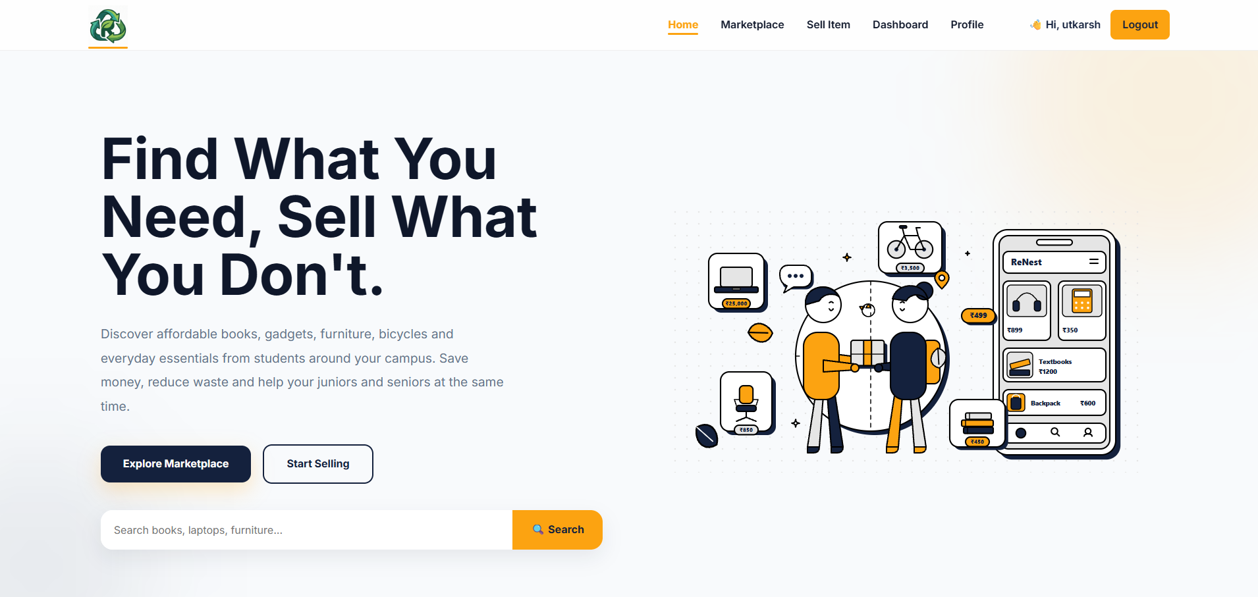
A.2 User Registration
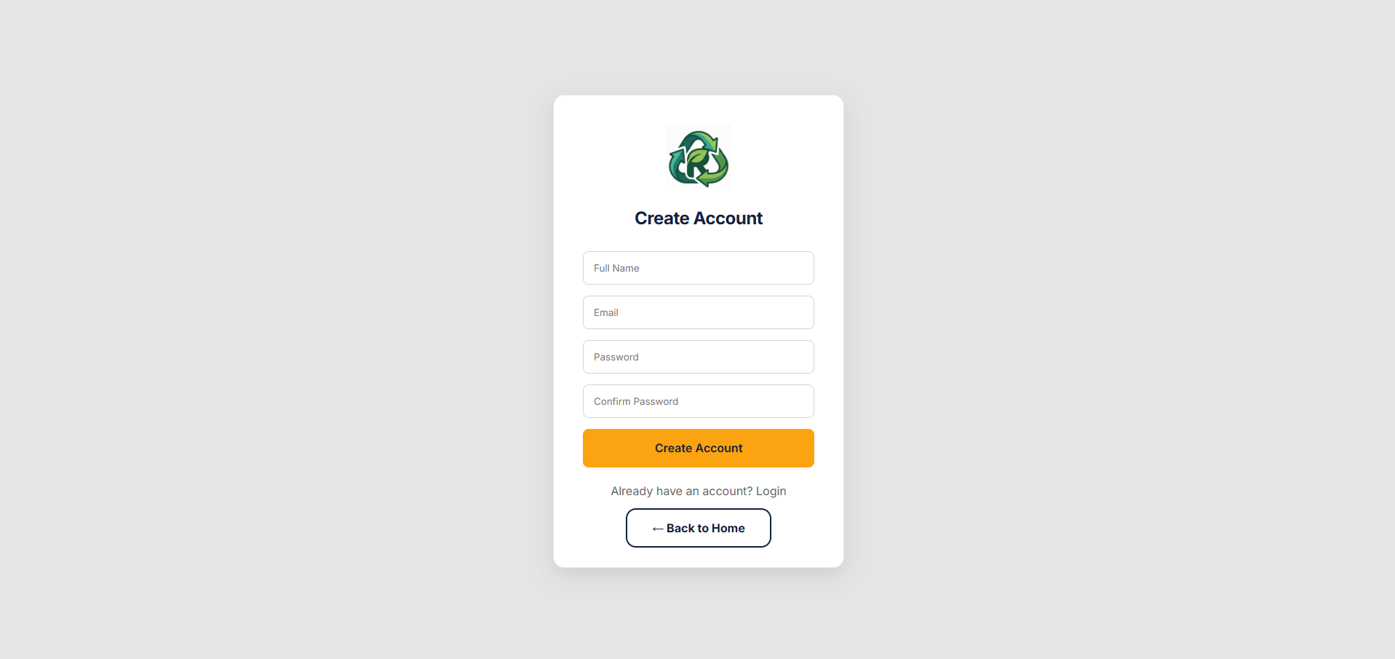

A.3 User Login
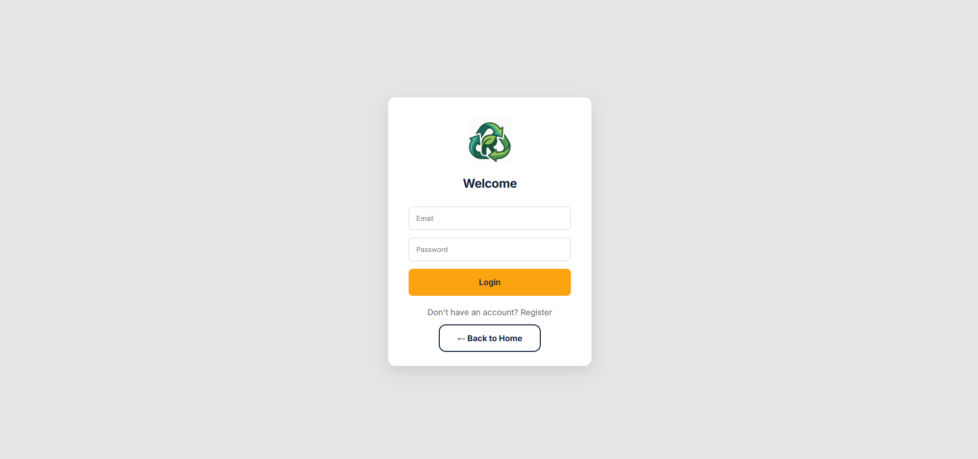
A.4 Dashboard
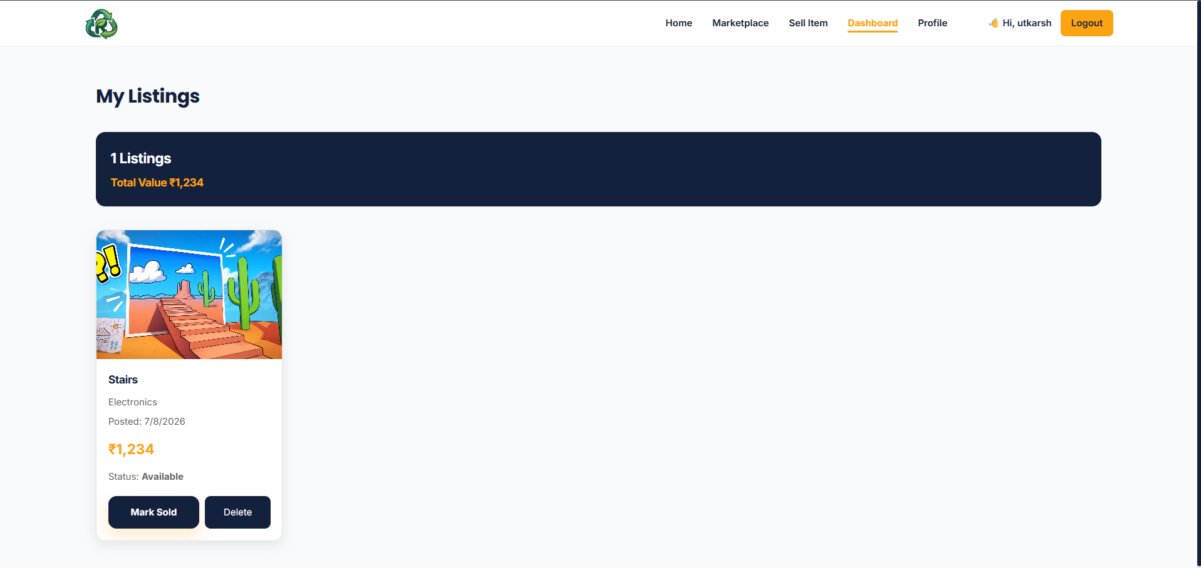

A.5 Marketplace
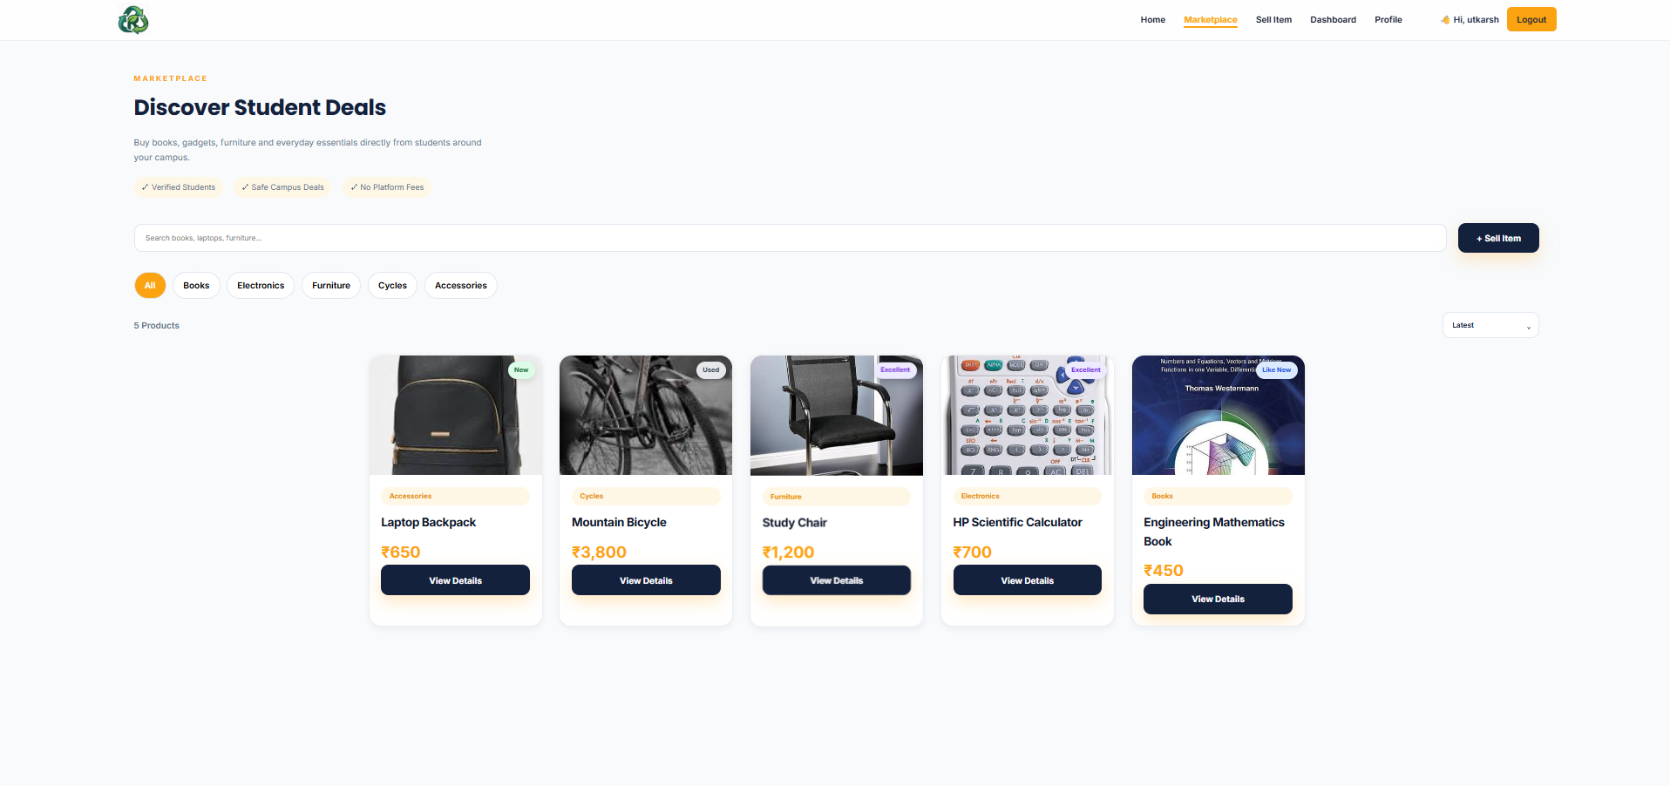
A.6 Product Details
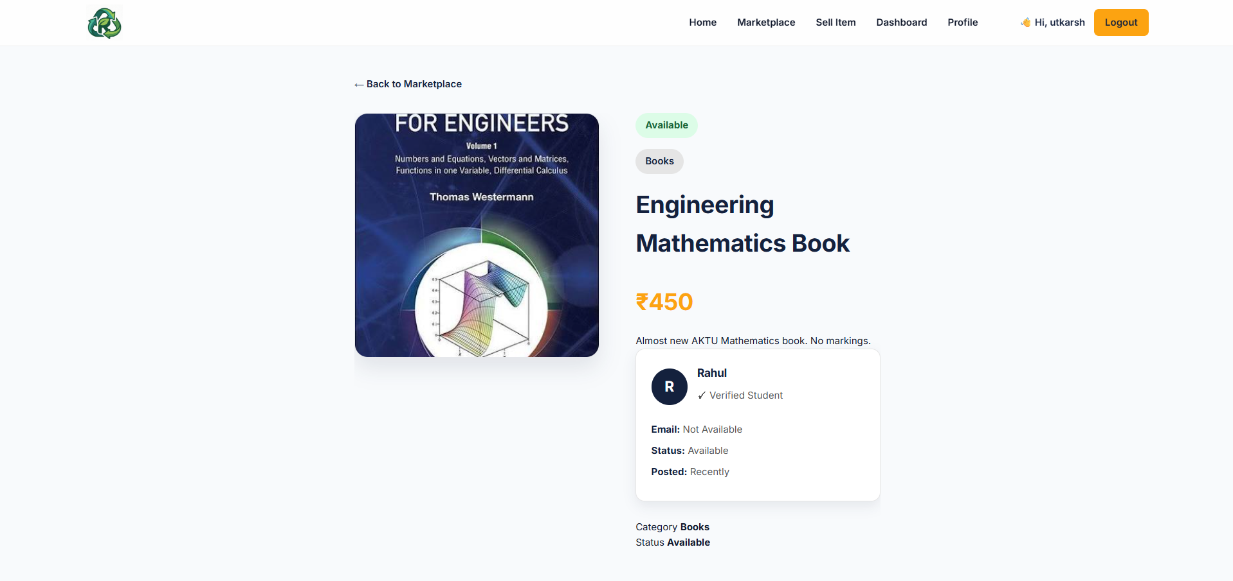

A.7 Sell Product
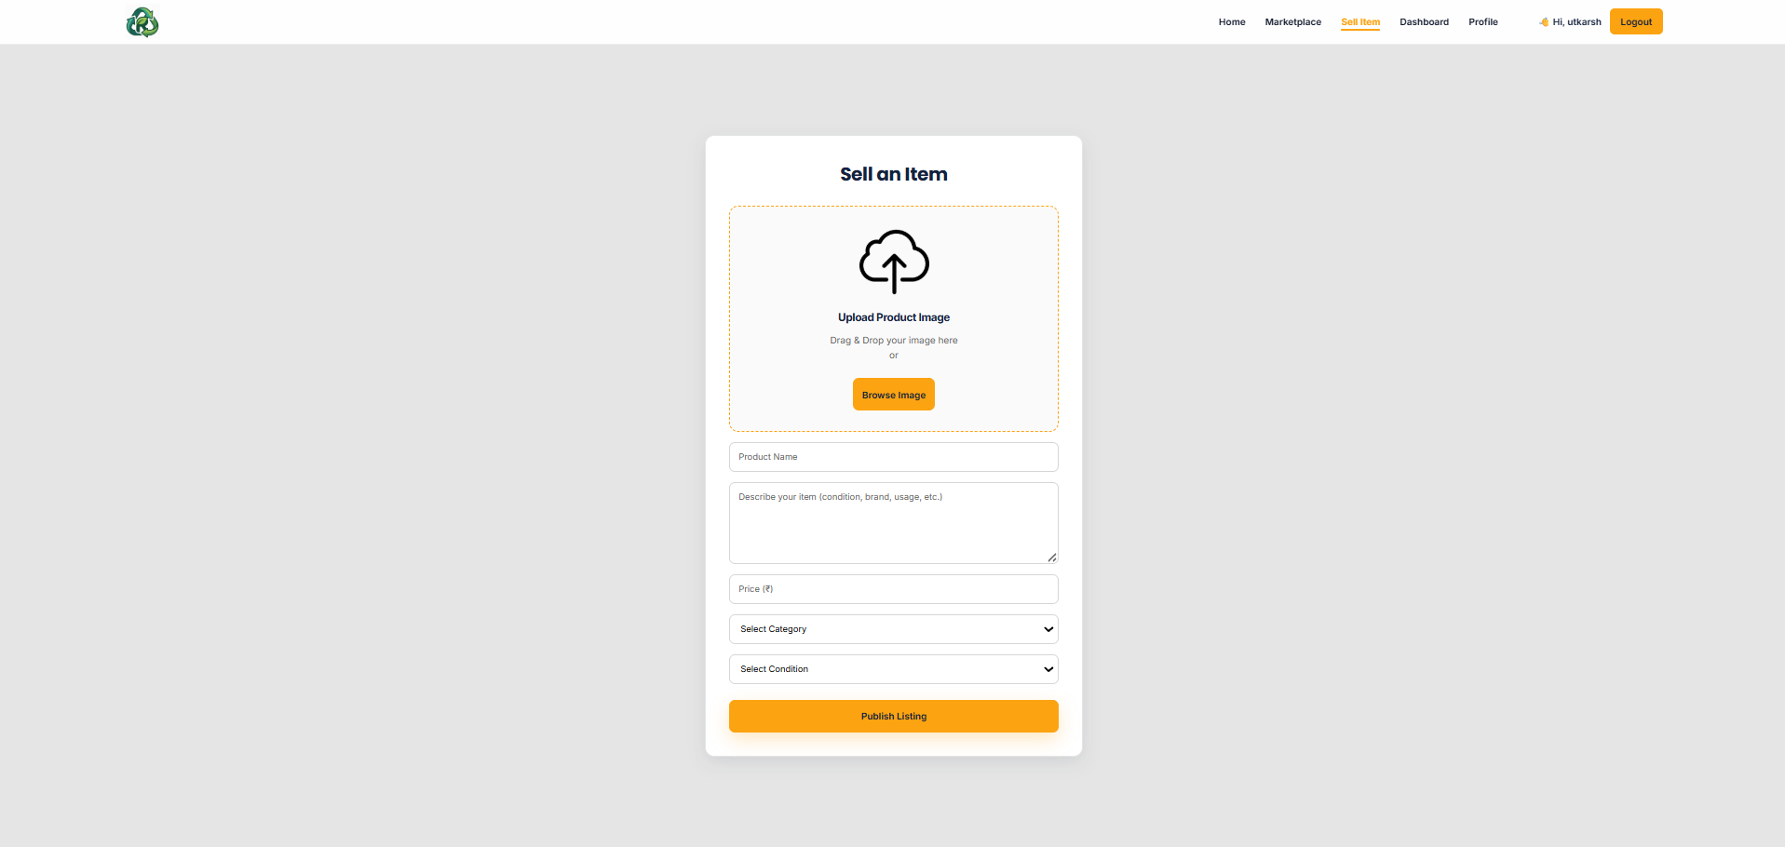
A.8 User Profile
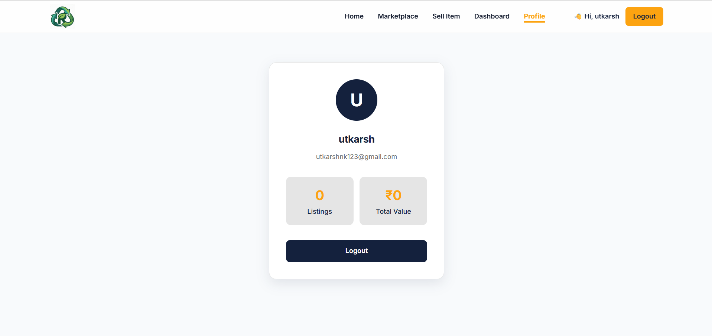

Appendix B: Project Structure
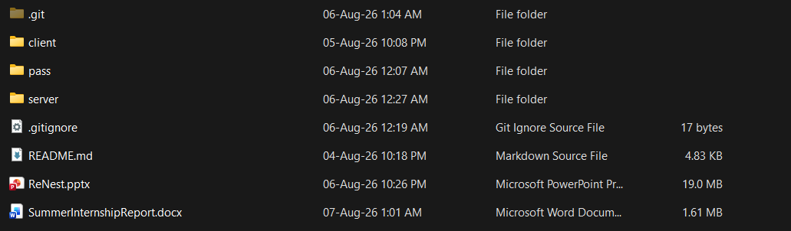
Appendix C: GitHub Repository
Repository Name: ReNest
Repository URL:
https://github.com/Utkarsh0k/ReNest
Appendix F: Software Used
Software | Version
Windows 11 | 24H2
Visual Studio Code | Latest
Node.js | LTS
Express.js | 5.x
MongoDB | Latest
Git | Latest
Postman | Latest
Google Chrome | Latest

