**Parkinson's Disease Diagnosis from Patients**

**Facial Emotions Analysis**

*Corresponding Author:*  Poluru Reddy Jahanve

Poluru Reddy Jahanve   
Department of Computer Science and Engineering  
Amrita Vishwa Vidyapeetham

Bangalore, India

[BL.EN.U4CSE21159@bl.students.amrita](mailto:BL.EN.U4CSE21159@bl.students.amrita)

.edu

Siwani Karna   
Department of Computer Science and Engineering  
Amrita Vishwa VidyapeethamBangalore, India

[BL.EN.U4CSE21191@bl.students.amrita](mailto:BL.EN.U4CSE21191@bl.students.amrita).

eduUtkarsh Tiwari   
Department of Computer Science and Engineering  
Amrita Vishwa Vidyapeetham

Bangalore, India

[BL.EN.U4CSE21212@bl.students.amrita](mailto:BL.EN.U4CSE21212@bl.students.amrita)

.edu

*Abstract*— *This report provides an extensive exploration of machine learning and data analysis techniques applied to a specific dataset. The analysis covers a broad spectrum of areas, including data preprocessing, visualization, classification utilizing the k-nearest neighbors (kNN) algorithm, and model evaluation. It includes an evaluation of class separability within the dataset and investigates the viability of class centroids as a metric for assessing separability. Furthermore, it delves into the behavior of the kNN classifier across varying 'k' values, illuminating potential scenarios of overfitting and underfitting. The report offers valuable insights into the kNN classifier's performance, incorporating accuracy metrics, and conducts a thorough examination of model suitability. In summary, this study presents a comprehensive and enlightening journey through the realm of machine learning processes and their implications when applied to real-world datasets*

Keywords—Machine Learning, Data Analysis, K-Nearest Neighbor(KNN), class separability, Model Evaluation

# Introduction

An early diagnosis is crucial for providing the best possible patient care for Parkinson's disease (PD), a prevalent and degenerative neurological condition that affects millions of people worldwide. We consider the potential of facial emotion analysis, a non-invasive technology that can detect subtle changes in facial expressions linked to Parkinson's disease, in our search for more precise detection techniques. A precise and timely diagnosis is more crucial than ever given the alarmingly high annual rate of Parkinson's disease diagnoses, which ranges from 2 to 3 percent. In this study, a trustworthy model for identifying Parkinson's disease is developed using cutting-edge machine-learning techniques. We want to significantly increase our understanding of Parkinson's disease, progress diagnostics, and ultimately improve the condition of patients by deeply researching the mechanisms behind this.

# Literature Survey

2.0 Towards Identification of Hypomimia in Parkinson's

Disease Based on Face Recognition Methods. [*M. Rajnoha* et al., 2018] [2]

This study examines how well traditional classifiers and face recognition techniques can identify PD hypomimia from static facial pictures. Even if video recording processing methods are more effective, PD hypomimia can still be diagnosed via automatic static face analysis. The authors recommend that future research concentrate on examining larger datasets to generalize the results and show the viability of diagnosing PD hypomimia using static facial pictures.

2.1 Novel and improved stage estimation in Parkinson's disease using clinical scales and machine learning. [*R. Prashanth* et al., 2022] [3]

This study investigates the ability of standard classifiers and face recognition methods to recognise PD hypomimia in static facial photographs. Even though methods for processing video recordings are more efficient, automatic static face analysis can still be useful in the diagnosis of PD hypomimia. Future research should focus on analysing larger datasets, according to the authors, in order to generalise the results and demonstrate the practicality of identifying PD hypomimia using static face photos.

2.2 Facial Expression Guided Diagnosis of Parkinson's Disease Via High-Quality Data Augmentation.[W. Huang et al,. 2022] [4]

The MDS-UPDRS, the Hoehn and Yahr scale, and machine learning methods like ordinal logistic regression (OLR) and support vector machine (SVM) classifiers are used to create a new Parkinson's disease (PD) staging system that is based on these features. SVM, AdaBoost-based ensemble, Random forests, and probabilistic generative models all performed well; the AdaBoost-based ensemble had the highest accuracy, coming in at 97.46%. It is advised to continue researching the estimation of feature importance between stages.

2.3 Application of logistic regression algorithm in the diagnosis of expression disorder in Parkinson's disease. [Y. Guan et al., 2021] [5]

This study uses a logical regression machine learning approach to quantitatively assess the facial expressions of Parkinson's patients by utilizing computer vision, image processing, and pattern recognition technologies. The well-established quantitative evaluation approach and differential diagnosis model allow for a more accurate assessment of the severity of PD. The logistic regression classifier in the study had an astounding accuracy rate.

2.4 Tabular data augmentation for video-based detection of hypomimia in Parkinson’s disease. [Guilherme C. Oliveira et al, 2023] [6]

This study uses a machine learning model built on video recordings to provide a unique method for the computerised detection of hypomimia, a sign of Parkinson's disease (PD). The study uses synthetic data produced by a Conditional Generative Adversarial Network (CGAN) for training augmentation to get over the problem of sparse and unbalanced datasets. In a test set with a roughly 7% prevalence of PD, the model, enhanced with Test-Time Augmentation (TTA), obtained an amazing classification accuracy of 83%. Although it is not yet appropriate for official diagnosis, this method shows promise for population screening and supporting physicians because it successfully identifies persons with PD. In order to address the issues of limited data availability in the medical field, the paper also emphasises the significance of proper dataset processing and production approaches.

2.5 Context-Sensitive Prediction of Facial Expressivity using Multimodal Hierarchical Bayesian Neural Networks

[Ajjen Joshi et al, 2018][7]

This study highlights the challenge of assessing facial expressivity in Parkinson's disease (PD) patients in order to monitor the progression of symptoms. It might be difficult to accurately assess patients' emotional states since PD typically results in "facial masking," or decreased facial movement. By leveraging characteristics from video and audio data to estimate facial expressivity scores, the research offers a machine learning approach to address this problem. The authors examine how factors in the interview situation, like patient emotion and gender, can influence prediction accuracy. A hierarchical Bayesian neural network architecture is used to configure the model to account for different context-sensitive groups. The results demonstrate the method's potential to enhance medical professionals' and researchers' evaluations of PD patients' facial expressivity, providing relevant data.

2.6 Improving Parkinson Detection using Dynamic Features from Evoked Expressions in Video. [Luis F. Gomez et al, 2021] [8]

The work provides a multimodal PD detection method that makes advantage of the static and dynamic characteristics of evoked facial motions. Notably, the study examines the potential for a special collection of 17 dynamic features for the identification of Parkinson's disease and introduces a brand-new set of 17 dynamic features to describe facial expression. This study also investigates the utility of various evoked facial emotions and their link to specific facial muscle movements (Action Units) in PD detection. The results underline the significance of facial gesture analysis in this context by showing that integrating static features from pre-trained deep architectures yield up to 77.36% of accuracy for PD detection and that the combination with dynamic features improves PD detection by up to 13.46% (from 75.00% to 88.46%).

2.7 Analysis of facial expressions in Parkinson's disease through video-based automatic methods. [*Andrea Bandini*

et al., 2017] [9]

The research suggests a video-based automated system for analyzing facial expressions in Parkinson's disease (PD) patients. It focuses on facial bradykinesia, which is a key motor indication of PD and involves a reduction or loss of facial movements and emotive facial expressions. In both posed and imitated facial expressions, control subjects displayed greater distances than PD patients, indicating larger facial movements in control subjects. The application of contactless video-based systems for analyzing facial expressions in rehabilitation, notably in speech therapy, can be explored in more detail.

2.8 Impaired recognition of facial expressions of anger in Parkinson's disease patients acutely withdrawn from dopamine replacement therapy. [Andrew D. Lawrence et al,. 2007] [10]

This study looks on the identification of angry facial expressions in Parkinson's disease (PD) patients who temporarily stopped receiving dopamine replacement therapy (DRT).

Patients with Parkinson's disease (PD) who were temporarily weaned off of dopamine replacement therapy (DRT) displayed decreased detection of angry facial expressions, but their recognition of other emotion expressions and processing of facial identity was unaffected.

Future research could investigate if people with Parkinson's disease have any selective impairments in their ability to recognise facial expressions of emotions other than fear and contempt.

2.9 Artificial intelligence for assisting diagnostics and assessment of Parkinson’s disease—A review. [Minja Belić et al,. 2019] [11]

The selection criteria for the publications presented in this paper were based on the use of machine learning algorithms for diagnosis and assessment of Parkinson's disease (PD) using data describing body motions, including movements of the upper and lower extremities and whole-body movements. The paper is a review of various AI techniques for Parkinson's Disease prediction. Deep learning algorithms were searched with more traditional machine learning techniques. To uncover desirable patterns in the acquired data, the majority of the research that were included used supervised learning together with traditional machine learning techniques. greater coordination of data gathering procedures, sharing, and data set fusion through greater collaboration between medical institutions, physicians, and researchers.

# Data Description

The "face_mimic_df" dataset used in this study covers a wide range of facial features, such as Action Units (AUs), age, and gender, making it relevant to studies on emotion recognition and affective computing. It is a useful tool for creating machine-learning models that categorize emotions. Handling missing data, encoding categorical characteristics with Label Encoder, and normalizing numerical properties are all preprocessing stages. This dataset supports testing machine learning methods and is consistent with prior studies. The detail in its description highlights how important it is to research affective computing and emotion recognition.

# Methodology

In this research paper, the authors employed the K-Nearest Neighbors (KNN) machine learning algorithm to develop a predictive model for Parkinson's disease (PD). The dataset contains various numerical attributes related to PD.

To gain insights into the data distribution, statistical measures such as the mean and variance were computed. For instance, consider the attribute "AU_12_t12," which had a mean of 0.27 and a standard deviation of 0.24.Fig. 1 shows spread of Attribut AU_12_t12 of class 1 which means diagonised case. In essence, the standard deviation quantifies the degree of spread or dispersion in a dataset. A lower standard deviation suggests that the data points are closely clustered around the mean, while a higher standard deviation indicates greater variability. This statistical tool aids in comprehending the data's variability.

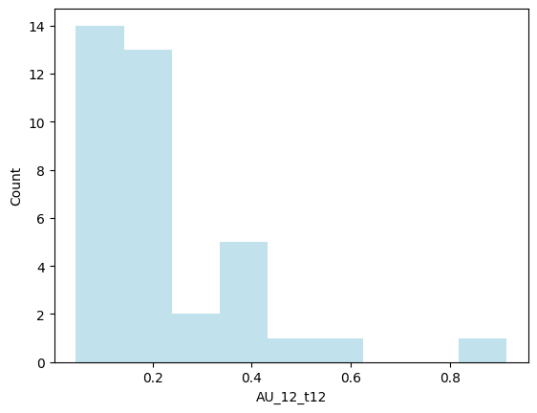

Fig. 1 Standard Deviation(spread) of feature AU_12_t12 of class 1 Diagnosed cases.

For model development, the scikit-learn (sklearn) library, a widely-used open-source machine learning toolkit in Python, was utilized. Sklearn offers a comprehensive suite of tools and algorithms for various machine learning tasks such as classification, regression, clustering, and dimensionality reduction. Its consistent and user-friendly API has made it a preferred choice among machine learning practitioners and researchers for model experimentation and development.

The dataset was split into two components: Labels and Training Features. The Training data was further divided into a training set and a testing set using the train_test_split function from sklearn, with an 80:20 ratio. Subsequently, the model was trained using the KNeighborsClassifier algorithm.

# Observation Analysis & Inferences

## Review of the dataset's Class Separability

By categorizing the 'AU_01_t12' attribute, specifically the "Inner Brow Raiser" property into two separate classes—"au_01_t12_class_0" and "au_01_t12_class_1"—based on whether Parkinson's disease was diagnosed or not, we were able to analyze the "AU_01_t12" attribute. We made a histogram plot with Matplotlib to show how these two classes are distributed.

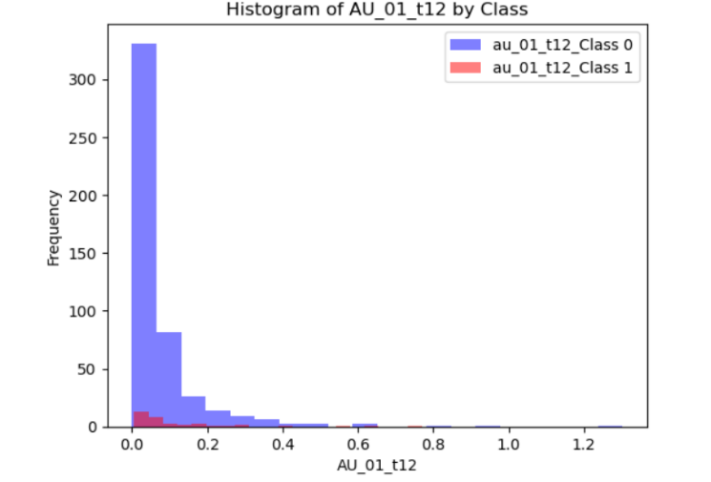

Fig 2: Illustration of two imbalanced classes.

The resulting histogram plot clearly illustrates that "au_01_t12_class_0" occurs much more frequently than "au_01_t12_class_1." This disparity in frequency between the two classes suggests that our dataset has a considerable class imbalance.

## Evaluation of Class Centroid Distances' Suitability

The separation of classes can be evaluated using the distance between class centroids, which represents the mean of the vectors inside each class. In the case of 'AU_01_t12,' the distance of 0.07092 between class centroids is significant due to the relatively narrow range of values from 1.5838e-05 to 1.3022. This shows that the classes are clearly divided.

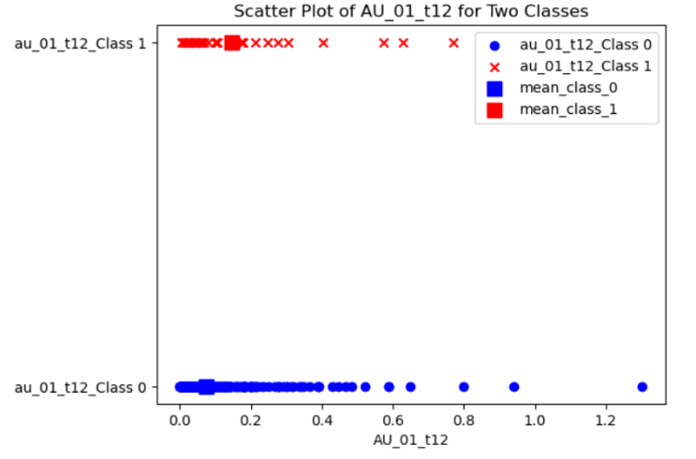

Fig 3: Illustration of class separability.

While ' au_01_t12_Class 0' and ' au_01_t12_Class 1' are visually distinguishable in Fig 2, there is overlap between each class and its corresponding centroid ('mean_class_0' and'mean_class_0'). Due to this overlap, centroids might not accurately represent the distribution of data points within each class.

In conclusion, class centroids offer a helpful perspective on class separability, particularly when the range of values is narrow. Nevertheless, considering data distribution, variance, and additional analyses is essential for a comprehensive evaluation of class separability.

## Behavior of kNN Classifier

The classifier's behavior changes depending on the k value. We must choose k so that the dominance of one class and the presence of outliers have no impact on the outcome. As we increase the amount of k, accuracy might somewhat improve, but after we achieve an optimal value, accuracy will decline if k grows wildly.

Over-fitting: This occurs when the model has received sufficient training, but because the value of k is small, it is unable to accurately predict the results on the test set. Test accuracy is superior to training accuracy.

Under-fitting: This occurs when k is high, the model was improperly trained, and it is unable to accurately predict the outcomes of the test set.

## Performance Evaluation of kNN Classifier

Based on the study of a number of metrics, such as accuracy, precision, recall, and F1-Score, the k-Nearest Neighbours (kNN) classifier does reasonably well in our investigation. With an accuracy of roughly 96%, it exhibits an exceptional ability to classify instances appropriately. The classifier also maintains a reasonable balance between true positives, false positives, and false negatives, as shown by the accurate, recall, and F1-Score values that are roughly balanced at 0.67. According to these results, the kNN classifier is effective at categorizing data instances in our dataset, making it a solid choice for classification jobs.

## Analysing the Fit of the Model

In scikit-learn, we used various evaluation metrics to assess the performance of a K-Nearest Neighbors (KNN) classifier. Here are some common evaluation metrics along with their formulas:

1. Accuracy:

- Formula: (Number of Correct Predictions) / (Total Number of Predictions)

- Code in scikit-learn: `accuracy_score(y_true, y_pred)`

2. Precision:

- Formula: (True Positives) / (True Positives + False Positives)

- Code in scikit-learn: `precision_score(y_true, y_pred)`

3. Recall (Sensitivity):

- Formula: (True Positives) / (True Positives + False Negatives)

- Code in scikit-learn: `recall_score(y_true, y_pred)`

4. F1-Score:

- Formula: 2 * (Precision * Recall) / (Precision + Recall)

- Code in scikit-learn: `f1_score(y_true, y_pred)`

5. Confusion Matrix:

- A table that presents a summary of the model's performance. It includes True Positives (TP), True Negatives (TN), False Positives (FP), and False Negatives (FN).

We conducted an evaluation of our model, achieving an impressive accuracy rate of 96%. However, it's worth noting that while our accuracy is high, the precision, recall, and F1-score stand at 50%. These metrics provide a more nuanced view of our model's performance, indicating room for improvement in correctly identifying positive cases.

Furthermore, we visualized our results using a Confusion Matrix, which is displayed in Figure 4.

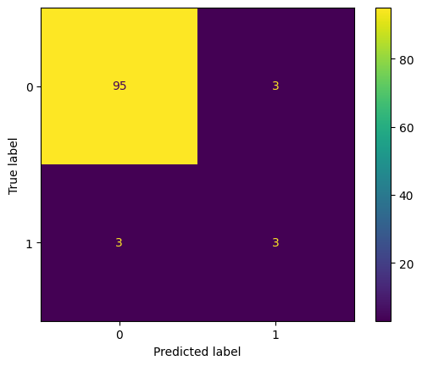

Figure. 4 Confusion matrix

The dataset exhibited a good fit with the model (Q5) which answers the question of our assignment that our model is regular fit, suggesting that it conformed well to the chosen algorithm. Nonetheless, there is an opportunity to enhance the model's performance, especially in terms of precision and recall.

## Identification of kNN Classifier Overfitting

A kNN (k-Nearest Neighbours) classifier experiences overfitting when the value of k is too low. The model may become extremely sensitive under certain conditions due to noise or outliers in the training data. It might therefore try to match the training data very closely, including all of its noise, and may as a result fail to generalise successfully to new data. Or, to put it another way, when k is little, the model is overly intricate and only captures random oscillations in the data, not the underlying patterns. To prevent overfitting in kNN, which enhances generalization performance, the decision boundaries should be lowered in smoothness, and noise sensitivity should be reduced.

# Results & Analysis

We carefully evaluated the properties of the dataset during our inquiry. To further understand class separability, we first examined intraclass dispersion and interclass distances. We created feature means and variances to better understand the data distribution by analyzing density patterns. We also examined Minkowski distances with various "r" factors. For example, splitting the dataset into training and test sets made it simpler to investigate the model's performance for k-nearest Neighbours (kNN) classification, where we trained a kNN classifier (k=3) and evaluated the accuracy on the test set. A complete picture of classification performance was supplied by a confusion matrix and metrics of prediction behavior like recall, precision, and F1-Score. These results serve as a platform for additional talks on data separability and models.

# Conclusion

As a result, our team's thorough study of the dataset provided critical information about class separability and the effectiveness of the k-nearest Neighbours (kNN) classifier. To comprehend the data distribution, we looked at intraclass spread, interclass distances, and density patterns. To comprehend the behavior of the distance metric, we also studied Minkowski distances with different "r" values.

We were able to assess the efficiency and accuracy of the kNN classifier with a focus on precision, recall, and F1-Score measures by dividing the dataset into training and test sets. Our results showed that the model was successful in striking a compromise between recall and precision to provide a regular fit. This research advances our project's knowledge of data separability and kNN classifier performance.

##### Acknowledgment

I would want to express my heartfelt appreciation to the university, Amrita Vishwa Vidyapeetham, Dr. Peeta Basa Pati, our lecturer, and Ms. Roshni for delivering the project and assignment as well as assisting us with the information we learned from the project. Their expertise in the field helped make this project report successful.

##### References

1. Y. Le-Cun, Ali, M.R., Myers, T., Wagner, E. et al, “Facial expressions can detect Parkinson’s disease: preliminary evidence from videos collected online”. Proceedings of the npj Digit, vol Med 4, pp. 529-129, Sep. 2021, DOI: 10.1038/s41746-021-00502-8
2. M. Rajnoha, J. Mekyska, R. Burget, I. Eliasova, M. Kostalova and I. Rektorova, "Towards Identification of Hypomimia in Parkinson's Disease Based on Face Recognition Methods," 2018 10th International Congress on Ultra Modern Telecommunications and Control Systems and Workshops (ICUMT), Moscow, Russia, 2018, pp. 1-4, doi: 10.1109/ICUMT.2018.8631249.
3. R. Prashanth, Sumantra Dutta Roy, “Novel and improved stage estimation in Parkinson's disease using clinical scales and machine learning”, Neurocomputing, Volume 305, 2018, Pages 78-103, ISSN 0925-2312, https://doi.org/10.1016/j.neucom.2018.04.049.
4. W. Huang, Y. Zhou, Y. -m. Cheung, P. Zhang, Y. Zha and M. Pang, "Facial Expression Guided Diagnosis of Parkinson's Disease Via High-Quality Data Augmentation," in IEEE Transactions on Multimedia, 2022, doi: 10.1109/TMM.2022.3216961.
5. Y. Guan, "Application of logistic regression algorithm in the diagnosis of expression disorder in Parkinson's disease," 2021 IEEE 2nd International Conference on Information Technology, Big Data and Artificial Intelligence (ICIBA), Chongqing, China, 2021, pp. 1117-1120, doi: 10.1109/ICIBA52610.2021.9688135.
6. Guilherme C. Oliveira, Quoc C. Ngo, Leandro A. Passos, João P. Papa, Danilo S. Jodas, Dinesh Kumar, “Tabular data augmentation for video-based detection of hypomimia in Parkinson’s disease”, Computer Methods and Programs in Biomedicine, Volume 240, 2023, 107713, ISSN 0169-2607, https://doi.org/10.1016/j.cmpb.2023.107713.
7. A. Joshi, S. Ghosh, S. Gunnery, L. Tickle-Degnen, S. Sclaroff and M. Betke, "Context-Sensitive Prediction of Facial Expressivity Using Multimodal Hierarchical Bayesian Neural Networks," 2018 13th IEEE International Conference on Automatic Face & Gesture Recognition (FG 2018), Xi'an, China, 2018, pp. 278-285, doi: 10.1109/FG.2018.00048.
8. L. F. Gomez, A. Morales, J. R. Orozco-Arroyave, R. Daza and J. Fierrez, "Improving Parkinson Detection using Dynamic Features from Evoked Expressions in Video," 2021 IEEE/CVF Conference on Computer Vision and Pattern Recognition Workshops (CVPRW), Nashville, TN, USA, 2021, pp. 1562-1570, doi: 10.1109/CVPRW53098.2021.00172.
9. Andrea Bandini, Silvia Orlandi, Hugo Jair Escalante, Fabio Giovannelli, Massimo Cincotta, Carlos A. Reyes-Garcia, Paola Vanni, Gaetano Zaccara, Claudia Manfredi, Analysis of facial expressions in parkinson's disease through video-based automatic methods, Journal of Neuroscience Methods, Volume 281, 2017, Pages 7-20, ISSN 0165-0270, [*doi: 10.1016/j.jneumeth.2017.02.006*](https://doi.org/10.1016/j.jneumeth.2017.02.006)*.*
10. Andrew D. Lawrence, Ines K. Goerendt, David J. Brooks, Impaired recognition of facial expressions of anger in Parkinson's disease patients acutely withdrawn from dopamine replacement therapy, Neuropsychologia, Volume 45, Issue 1, 2007, Pages 65-74, ISSN 0028-3932,  [doi: 10.1016/j.neuropsychologia.2006.04.016](https://doi.org/10.1016/j.neuropsychologia.2006.04.016).
11. Minja Belić, Vladislava Bobić, Milica Badža, Nikola Šolaja, Milica Đurić-Jovičić, Vladimir S. Kostić,Artificial intelligence for assisting diagnostics and assessment of Parkinson’s disease—A review, Clinical Neurology and Neurosurgery, Volume 184, 2019, 105442, ISSN 0303-8467, <https://doi.org/10.1016/j.clineuro.2019.105442>