QUEST LIFE
Level Up. Live Better.
Development Framework, Documentation & Build Timeline
Gamified AI Fitness & Nutrition Platform · Mobile + Web
Rebrand of the FitQuest concept — same core engine, new identity

Table of Contents

1. Concept & Positioning
Quest Life is the renamed, refined direction of the FitQuest concept: an RPG-styled fitness and nutrition app where every workout, meal, and streak feeds a character-progression system (XP, Levels, Stats, Quests, Guilds). The name change trades the “quest” gaming metaphor alone for a broader “your life is the game” framing, reflected in the tagline “Level Up. Live Better.”
This document turns the two reference mockups you generated into an actionable build framework: a full screen/feature inventory, the exact XP & levelling formulas to implement, the system architecture, a Python-first tech stack, a recommended build order, and a week-by-week timeline.

2. Feature & Screen Inventory
Extracted directly from the two reference designs so nothing gets lost between mockup and build.

2.1 Mobile App Screens
Screen | Key elements
Dashboard | Level + avatar, XP bar, 6 core stats (STR/END/SPD/DIS/REC/etc.), today's quest list with progress, bottom nav
Quests | Daily / Weekly / Boss tabs, per-quest XP reward, progress bars, claim button
Workout Plan | Weekly calendar strip, exercise list with sets × reps, per-exercise thumbnail, “Start Workout” CTA
AI Diet Plan | Daily macro rings (calories/protein/carbs/fat), meal-by-meal breakdown, “Regenerate Plan” CTA
Progress | XP-over-time chart, workouts/calories/active-minutes summary, weight/body-fat/muscle-mass deltas, streak counter
Edit Preferences | Goal, experience level, workout days/week, workout type, diet type, allergies, cuisine, budget, daily steps goal, sleep goal — single “Update Preferences” action
Level Up Modal | Full-screen celebration, new level, rewards unlocked (stat boosts, titles, cosmetics, gold)

2.2 Website (Web Dashboard) Screens
Screen | Key elements
Dashboard | Sidebar nav (Dashboard, Quests, Workout, Diet, Progress, Analytics, Community, Achievements, Settings), level/XP summary, stat cards, today's plan, progress chart, AI recommendations panel
Weekly Boss | Aggregate challenge card with progress bar and reward preview
Guild | Guild level, member count/list, guild XP bar, “Open Guild” action
Leaderboard | Friends / Global tabs, ranked list with XP totals
Achievements | Badge grid with unlock criteria

2.3 Cross-cutting Extras
- Food recognition — photo → estimated calories/macros
- Exercise form analysis — real-time posture feedback via MediaPipe
- Adaptive difficulty — AI adjusts intensity and XP multiplier from performance
- Injury-risk prediction — warns before overtraining
- Wearables sync — Google Fit / Apple Health
- Notifications — reminders, streak warnings, AI coach messages

3. XP & Progression System (Spec)

3.1 XP Sources
Action | XP Reward
Workout completed | +200 XP
Daily quest completed | +100 XP
Healthy meal logged | +50 XP
Steps goal achieved | +50 XP
Streak bonus (per day) | +10 – 50 XP, scales with streak length
Weekly boss completed | +300 – 500 XP
Community challenge | +100 – 300 XP

3.2 Level Curve
XP required for a level follows a power curve so early levels feel fast and later levels feel earned:
xp_required(level) = round(BASE_XP * level ** 1.2) # BASE_XP ≈ 175
Level | XP Required (approx.)
10 | 2,100
20 | 6,200
40 | 22,500

3.3 Intensity Multiplier
A user-adjustable intensity slider (Edit Preferences) scales all XP earned, trading difficulty for reward:
Intensity | Multiplier
Easy | 0.85×
Medium | 1.00×
Hard | 1.15×
Extreme | 1.30×
Final formula: xp_awarded = base_xp × streak_multiplier × intensity_multiplier × class_affinity. This is the same live-recalculation model demonstrated in the FitQuestCharacterSheet prototype — preferences change the multipliers used on the next logged action, never rewriting past history.

4. System Architecture
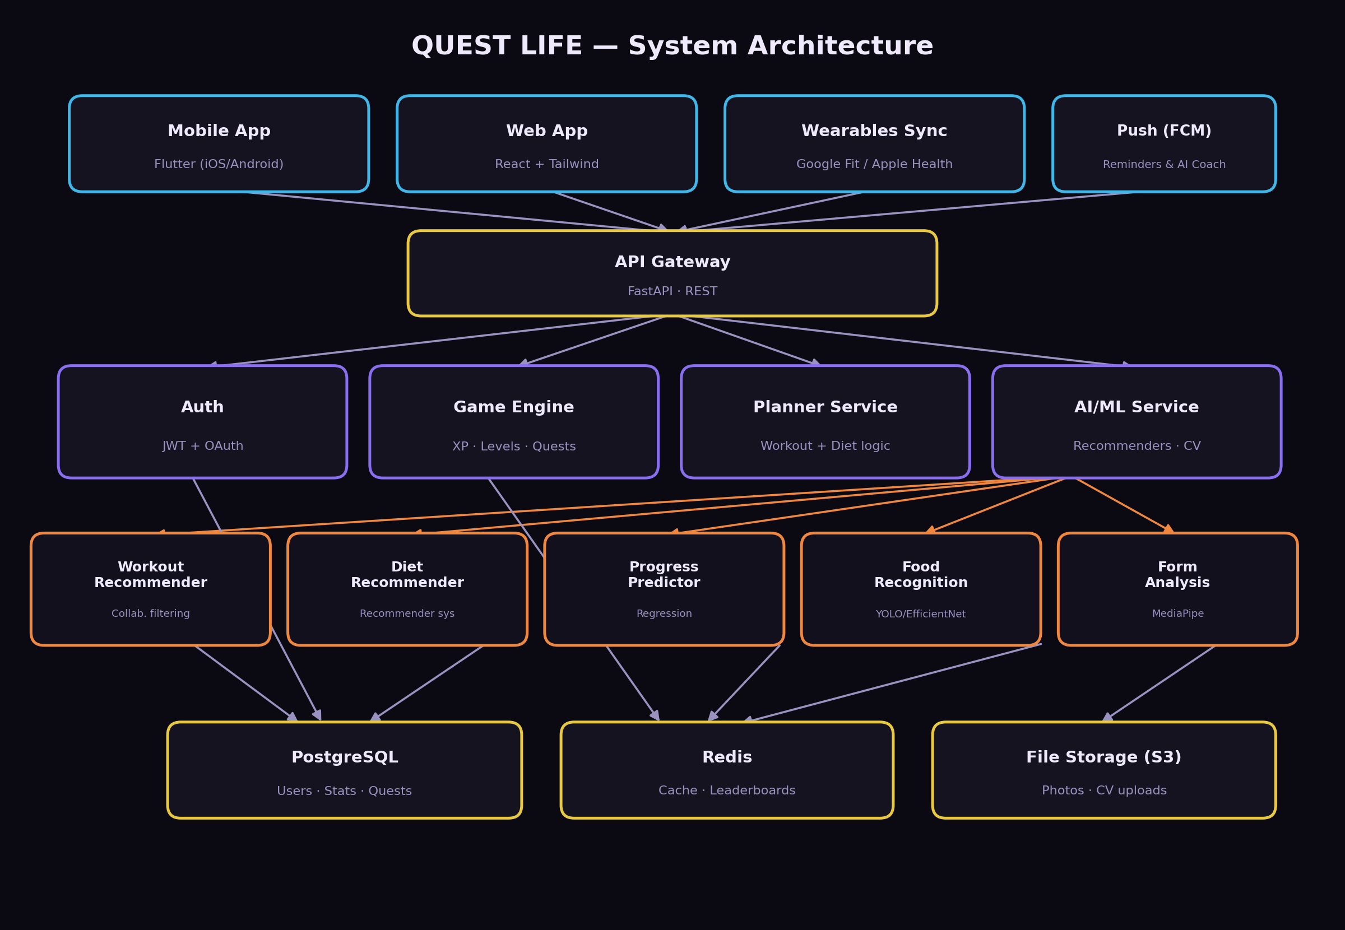
Figure 1 — Quest Life system architecture

5. Tech Stack (Python-first)
Layer | Technology
Frontend (mobile) | Flutter (Dart) — one codebase, iOS + Android
Frontend (web) | React + Tailwind CSS
Backend / API | Python — FastAPI
Database | PostgreSQL (primary) + Redis (cache, leaderboards)
AI / ML | Python — scikit-learn, PyTorch/TensorFlow, Pandas, NumPy, OpenCV
Authentication | JWT + OAuth (Google, Apple)
Background jobs | Celery (plan generation, CV/image jobs)
Push notifications | Firebase Cloud Messaging
Cloud / deployment | Docker, Nginx, AWS (EC2, S3, RDS) or Render
This mirrors the stack in both reference mockups — the only material choice you're making is confirming Python end-to-end for backend + AI/ML, which both designs already assume.

6. Development Framework — What to Build, in Order
Build bottom-up: data model and XP engine before any screen, rule-based planners before AI, and AI/CV last since they're valuable but not blocking for a demoable product.
- Data model & auth — Users, Stats, Quests, Activities, Preferences tables in PostgreSQL; JWT auth endpoints.
- XP / Level / Streak engine — pure Python module: award_xp(), level_for_xp(), apply_streak(), fully unit-tested. This is the heart of the app and has zero external dependencies.
- Rule-based workout planner — constraint selection (DP/backtracking) over an exercise database using days/week, equipment, experience, injuries. No AI needed yet.
- Rule-based diet planner — Mifflin-St Jeor BMR/TDEE calculation + meal filtering by cuisine/diet/budget from a curated meal database.
- Mobile UI — Dashboard, Quests, Workout Plan, Diet Plan, Progress, Edit Preferences, wired to the engine above.
- Website dashboard — React port of the same data, plus Achievements and Leaderboard views.
- Gamification layer — daily/weekly quests, weekly boss, badges, streak combo logic, live XP recalculation on preference edits.
- AI Coach (no external API) — template phrase bank keyed off state (streak broken, PR hit, plan changed, level up) as discussed.
- ML layer — weight-prediction regression and workout/diet recommenders (scikit-learn), trained on your own or synthetic usage data.
- Computer vision — form-check (MediaPipe) and food recognition (YOLO/EfficientNet) as stretch features.
- Social layer — guilds, friends leaderboard, community challenges.
- Polish & deploy — Docker Compose, CI (GitHub Actions + pytest), deploy to Render/AWS.
Steps 1–7 alone are a complete, demoable, gamified fitness app with zero AI dependency — everything from Section 9 onward in ML/CV is additive, not required for a working MVP.

7. Build Timeline
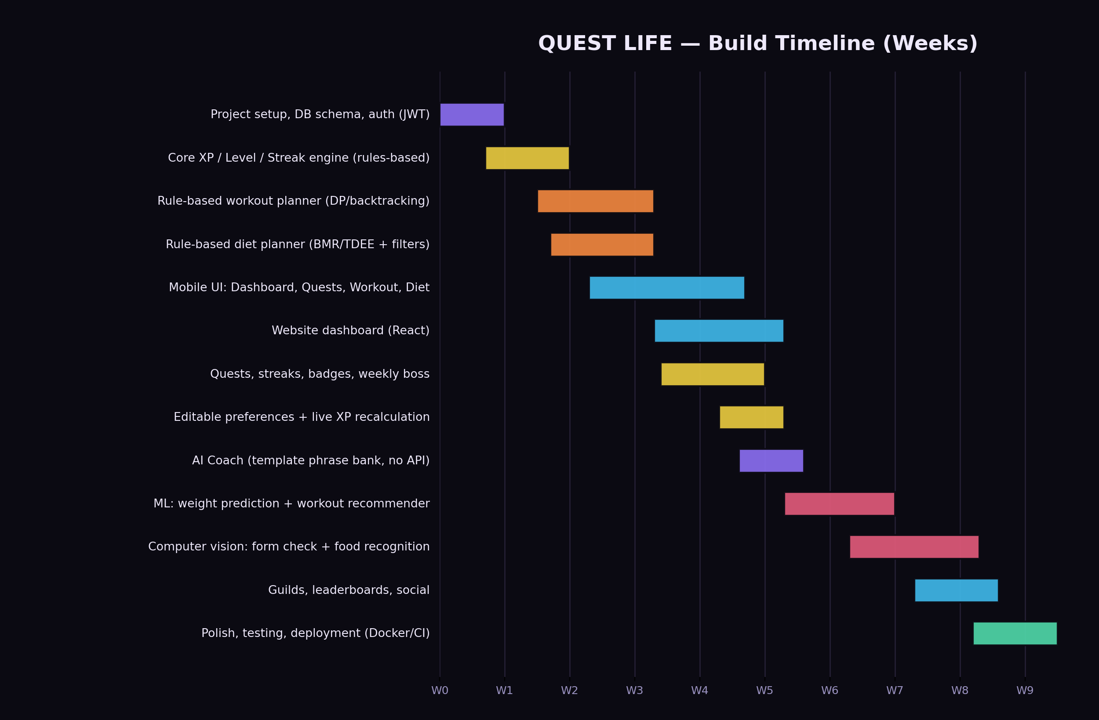
Figure 2 — Quest Life build timeline (weeks, overlapping tracks)

7.1 Week-by-week
- Weeks 1–2 — Project setup, DB schema, auth, XP/level/streak engine with unit tests.
- Weeks 2–3 — Rule-based workout + diet planners.
- Weeks 3–5 — Mobile UI: Dashboard, Quests, Workout, Diet screens.
- Weeks 4–5 — Website dashboard.
- Weeks 4–5 — Quests, streaks, badges, weekly boss.
- Week 5 — Editable preferences wired to live XP recalculation.
- Week 5–6 — Template-based AI Coach.
- Weeks 6–7 — ML: weight prediction + workout recommender.
- Weeks 7–9 — Computer vision: form check + food recognition.
- Weeks 8–9 — Guilds, leaderboards, social.
- Weeks 9–10 — Testing, polish, Docker + CI, deployment.
This assumes solo development at a steady pace; compress weeks 6–9 (ML/CV/social) if you're prioritizing a working core app for a deadline, since they're independent, additive tracks.

8. Suggested Backend Structure
questlife-backend/
app/
main.py # FastAPI app entrypoint
core/ # config, security, deps
models/ # SQLAlchemy models (User, Stats, Quest, Activity)
schemas/ # Pydantic request/response schemas
engine/
xp_engine.py # award_xp, level curve, streak logic
workout_planner.py # constraint-based plan generation
diet_planner.py # BMR/TDEE + meal filtering
coach.py # template phrase bank
ml/ # scikit-learn / PyTorch models, training scripts
routers/ # /auth /quests /workouts /diet /progress /guilds
tests/ # pytest
alembic/ # DB migrations
docker-compose.yml
requirements.txt

9. Immediate Next Steps
- Lock the data model — Users, Stats, Quests, Activities, Preferences — before writing any UI.
- Build and unit-test the XP engine in isolation; it's the one module everything else depends on.
- Ship the rule-based planners + Dashboard/Quests screens first — that alone is a demoable MVP.
- Treat AI Coach, ML recommenders, and CV as additive stretch tracks, not blockers.
— End of document —

