1. [Sample.json](https://drive.google.com/file/d/1hEBzD1mTOSZkaq4xziRfBSc9bkqO5qHc/view?usp=sharing)

Download the above json and import it to a component

Render the below screen

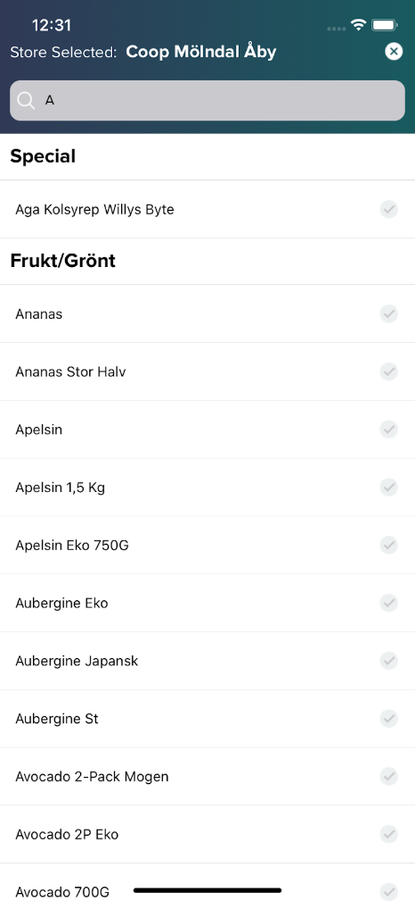

* Search bar above (Search functionality is optional)
* Use categoryName as section list header
* productName as name of the product
* Store Selected: Text is hardcoded
* On Cross User will go back
* Header Effect is optional

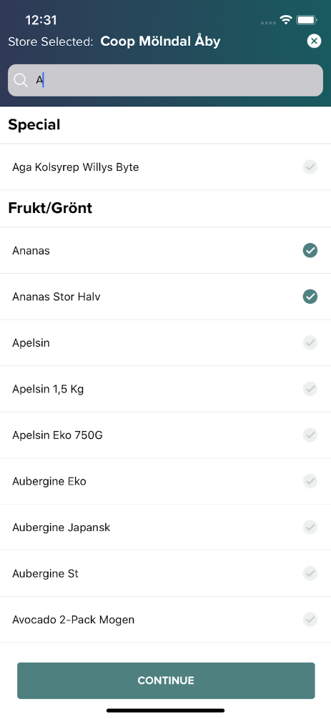

* User can select any item in the list
* Show selected and unselected checkbox
* Once a item is selected CONTINUE button is shown on the screen

Color Code : #4f8080

Hint:

 Header is using Linear Gradient Effect

 gradientStartColor: 'rgba(26,36,68,0.9)',

 gradientEndColor: 'rgba(0,73,78,0.9)',

import React, {Component, useState} from 'react';

import IconAntDesign from 'react-native-vector-icons/AntDesign';

import {

  StyleSheet,

  Text,

  TouchableOpacity,

  View,

  SafeAreaView,

  SectionList,

  ListItem,

  StatusBar,

} from 'react-native';

import {DATA} from './data1';

import Header from './Header'

Item = ({title, click}) => {

  const [visible, setvisible] = useState(false);

  return (

    <View style={styles.item}>

      <Text style={styles.title}>{title}</Text>

      <TouchableOpacity

        onPress={() => {

          setvisible(!visible);

          click();

        }}>

        {visible ? (

          <IconAntDesign name="checkcircle" size={18} color="green" />

        ) : (

          <IconAntDesign name="checkcircle" size={18} color="grey" />

        )}

      </TouchableOpacity>

    </View>

  );

};

class Fruits extends Component {

  constructor(props){

    super(props);

    this.state={btnVisible:false}

  }

  clickHandler=()=>{

    this.setState({btnVisible:!this.state.btnVisible})

  }

  render() {

    const {btnVisible}=this.state

    return (

      <View style={styles.container}>

        <SectionList

          sections={DATA}

          keyExtractor={(item, index) => item + index}

          renderItem={({item}) => {

            return <ListItem title={item} click={this.clickHandler} />;

          }}

          renderSectionHeader={({section: {title}}) => (

            <Text style={styles.header}>{title}</Text>

          )}

        />

     {btnVisible?<TouchableOpacity style={styles.btn}>

          <Text style={{color:'white'}}>Continue</Text>

        </TouchableOpacity>:null}

      </View>

    );

  }

}

const styles = StyleSheet.create({

  container: {

    flex: 1,

    marginHorizontal: 16,

    position:'relative'

  },

  item: {

    backgroundColor: 'white',

    padding: 20,

    marginVertical: 8,

    flexDirection: 'row',

    alignItems: 'center',

    justifyContent: 'space-between',

    borderTopWidth: 0.5,

  },

  header: {

    fontSize: 20,

    borderTopWidth: 0.5,

  },

  title: {

    fontSize: 16,

  },

  btn:{

    position:'absolute',

    width:'80%',

    height:40,

    backgroundColor:'#4f8080' ,

    justifyContent:'center',

    alignItems:'center',

    bottom:20,

    left:40

  },

});

export default Fruits;

Header File:

import React, {Component} from 'react';

import {

Text,

StyleSheet,

SafeAreaView,

View,

TextInput,

TouchableOpacity,

Alert,

} from 'react-native';

import IconAntDesign from 'react-native-vector-icons/AntDesign';

import LinearGradient from 'react-native-linear-gradient';

export default class Header extends Component {

close = () => {

Alert.alert('close app', 'Are you sure?', [

{

text: 'ok',

onPress: () => null,

},

{

text: 'Cancel',

onPress: () => null,

style: 'destructive',

},

]);

};

render() {

return (

<LinearGradient

colors={['rgba(26,36,68,0.9)', 'rgba(0,73,78,0.9)']}

style={styles.Container}>

<SafeAreaView>

<View style={styles.textContainer}>

<Text style={styles.store1}> Store Selected:</Text>

<Text style={styles.store2}>Coop Moindal Aby</Text>

<TouchableOpacity onPress={this.close}>

<IconAntDesign

style={styles.close}

name="closecircle"

color="#fff"

/>

</TouchableOpacity>

</View>

<TextInput style={styles.input} />

</SafeAreaView>

</LinearGradient>

);

}

}

const styles = StyleSheet.create({

Container: {

backgroundColor: 'green',

},

textContainer: {

flexDirection: 'row',

alignItems: 'center',

marginLeft: 10,

},

store1: {

color: 'white',

fontSize: 16,

},

store2: {

color: '#fff',

fontWeight: 'bold',

fontSize: 16,

},

close: {

marginLeft: '50%',

fontSize: 15,

},

input: {

backgroundColor: '#d3d3d3',

width: '90%',

height: 40,

marginLeft: '5%',

marginVertical: 10,

borderRadius: 10,

},

linearGradient: {

flex: 1,

},

});

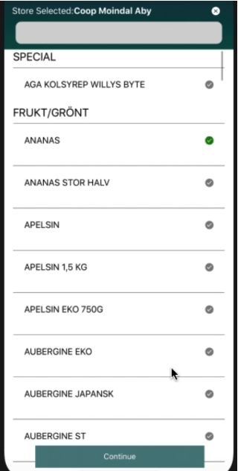

Create a custom Activity Indicator using Modal and custom gif

import React, {Component} from 'react';

import {Text,

StyleSheet,

Image, Button,

View, SafeAreaView,

TouchableOpacity, Modal,

TouchableOpacityBase} from 'react-native';

export default class Createmod extends Component {

  constructor(){

    super();

    this.state={

      show:false

    }

  }

  render() {

    return (

      <SafeAreaView>

        <View style={styles.container}>

          <Button style={styles.btn} title='Show Modal' onPress={()=>{this.setState({show:true})}}/>

          <Modal animationType='slide' transparent={true} visible={this.state.show} >

            <View style={{backgroundColor: 'grey', flex: 1}}>

              <View

                style={{

                  backgroundColor: 'white',

                  margin: 50,

                  padding: 40,

                  borderRadius: 20,

                  marginTop: 350,

                  marginHorizontal: 80,

                }}>

                <Text style={{fontSize: 25, marginHorizontal:20}}>Hello</Text>

                <Image

               style={{marginLeft:20}}

                source={require('./ghost.gif')}/>

                <Button title='Hide Modal' onPress={()=>{this.setState({show:false})}}/>

              </View>

            </View>

          </Modal>

        </View>

      </SafeAreaView>

    );

  }

}

const styles = StyleSheet.create({

    container: {

      justifyContent: 'center',

      alignItems: 'center',

    },

btn:{

},

});

