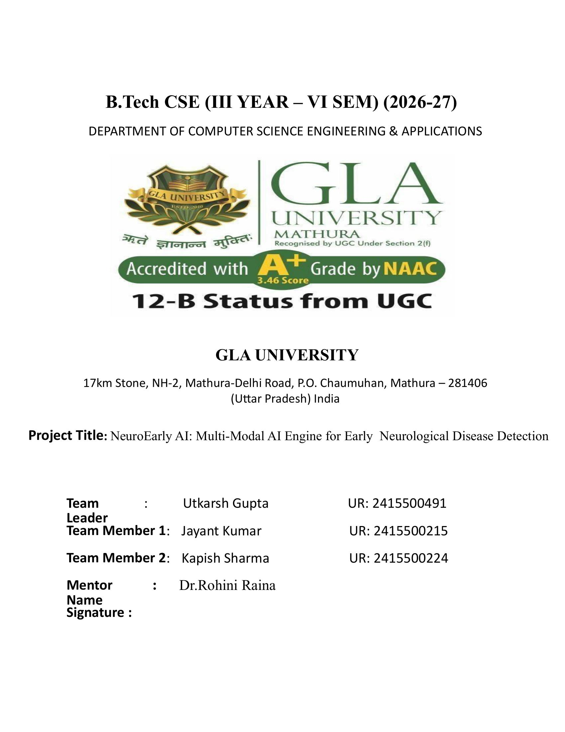

Table of Contents
1. Overview 3
2. Scope and Control 3
3. Stakeholders and RACI 4
4. Team and Roles 5
5. Week-wise Plan and Assignments 5
6. Users and UX 5
7. Market and Competitors 6
8. Objectives and Success Metrics 7
9. Key Features 7
10. Architecture 8
11. Data Design 8
12. Technical Workflow Diagrams 9
13. Research and Evaluation 9
14. Appendices 10

1. Overview

Problem Statement
Early neurological diseases are difficult to identify because subtle changes in speech, movement, cognition, and brain structure can go unnoticed during routine clinical assessments. Existing diagnostic methods can be costly, time-consuming, and dependent on specialist availability.

Goal
Build NeuroEarly AI, a multimodal AI engine that combines MRI/X-ray imaging, speech, gait, motor, and cognitive biomarkers to provide early neurological risk assessment and clinical decision support.

Non-goals
Autonomous diagnosis, replacing doctors, prescribing treatment, or making definitive clinical decisions without professional validation in v1.

Value Proposition
An accessible, explainable, non-invasive AI screening platform that combines multiple health signals to identify potential early warning signs and support timely clinical evaluation.

2. Scope and Control

2.1 In-scope
- Patient profile creation and neurological risk assessment
- MRI and X-ray image analysis for abnormalities
- Speech, gait, tremor, and cognitive biomarker analysis
- AI-based early neurological risk assessment
- Conversational AI-assisted health guidance
- Longitudinal health monitoring and risk trends
- Doctor-facing dashboard with patient insights and reports

2.2 Out-of-scope
- Autonomous medical diagnosis or treatment decisions
- Medication prescription or dosage recommendations
- Fully autonomous clinical decision-making
- Real-time emergency medical intervention
- Mobile application and wearable-device integration in v1

2.3 Assumptions
- Users provide reasonably good-quality medical images and assessment data
- AI models are trained using reliable and representative datasets
- Users understand that results are preliminary screening insights, not medical diagnoses
- Doctors validate AI-generated findings before clinical decisions

2.4 Constraints
- Limited availability of high-quality labeled neurological datasets
- Variations in MRI, X-ray, speech, and behavioral data quality
- Limited computational resources for large multimodal models
- Academic project timeline and prototype limitations
- Clinical validation and regulatory approval are outside the v1 scope

2.5 Dependencies
- Publicly available neurological and medical imaging datasets
- MRI and X-ray image-processing frameworks
- Speech, gait, motor, and cognitive analysis libraries
- AI/ML frameworks such as PyTorch and scikit-learn
- Cloud infrastructure for model training and inference
- Secure database and authentication services for patient data

2.6 Acceptance Criteria and Sign-off
- GIVEN a patient profile WHEN a screening assessment is completed THEN a personalized risk report is generated
- GIVEN an assessment session WHEN the fused risk score exceeds the clinical threshold THEN a clinician alert is triggered
- GIVEN a screening request WHEN the system processes multimodal inputs THEN the system generates results within acceptable latency
Sign-off table
Stakeholder | Role | Decision area | Signature/Approval | Date
Dr. Rohini Raina | Mentor | Scope, final acceptance |  | 08 Sep 2026
Utkarsh Gupta | Product Lead | Release readiness |  | 08 Sep 2026

3. Stakeholders and RACI
Activity | Responsible (R) | Accountable (A) | Consulted (C) | Informed (I)
Requirements | Jayant Kumar | Utkarsh Gupta | Mentor | Team
Design | Jayant Kumar & Kapish Sharma | Jayant Kumar & Kapish Sharma | Mentor | Team
Implementation | Utkarsh Gupta | Utkarsh Gupta | — | Team
Testing | Jayant Kumar | Utkarsh Gupta | Mentor | Team
Release | Jayant Kumar | Kapish Sharma | Mentor | Dept

4. Team and Roles
Member | Role | Responsibilities | Key skills | Availability | Contact
Jayant Kumar | ML & Frontend | Scope, backlog, reviews | Product, APIs | 6 hrs/wk | jayant.kumar_cs.aiml24@gla.ac.in
Utkarsh Gupta | Tech Lead & ML Engineer | Architecture, APIs, security | Node, Express, SQL, WebSockets | 6 hrs/wk | utkarsh.gupta_cs.aiml24@gla.ac.in
Utkarsh Gupta & Jayant Kumar | Frontend & Dashboard | React UI, state, accessibility | React, TypeScript | 6 hrs/wk | utkarsh.gupta_cs.aiml24@gla.ac.in
Kapish Sharma | QA, Docs & Clinical Evaluation | Test plan, E2E testing, documentation | Playwright, technical writing | 6 hrs/wk | kapish.sharma_cs.aiml23@gla.ac.in

5. Week-wise Plan and Assignments
Week | Dates | Milestone | Lead (Utkarsh) | Backend (Jayant) | Frontend (Utkarsh) | QA/Docs (Kapish)
1 | 24–30 Aug | Requirements freeze | Finalize scope | API contracts v0 | Wireframes | Test plan draft
2 | 1–4 Sep | Architecture & DB | Architecture review | Schema & migrations | UI kit | Test data
3 | 5–14 Sep | Backend scaffolding | Risk & unblock | Auth + Users API | Auth screens | Smoke tests
4 | 14–20 Sep | Frontend scaffolding | Sync checkpoint | Listings API | Routing, forms | Accessibility checks
5 | 24–30 Sep | Feature set A | Scope cut decisions | Create/Edit listing | Listing UI | E2E CRUD tests
6 | 1–8 Oct | Feature set B | KPI review | Search API | Search UI + Profile | Performance tests
7 | 9–20 Oct | Hardening | Risk burn-down | Bug fixes | Bug fixes | Regression suite
8 | 21–31 Oct | Release & deck | Final sign-off | Release notes | UI polish | User manual

6. Users and UX

6.1 Personas
- Patient/User: Wants a simple, accessible way to understand potential early neurological warning signs without complex medical terminology.
- Doctor/Neurologist: Needs reliable AI-assisted insights, biomarker analysis, imaging findings, and explainable results to support clinical evaluation.
- Caregiver: Wants to monitor changes in a patient's cognitive, motor, and neurological health over time.

6.2 Top User Journey
Patient → Login → Create Health Profile → Complete Digital Assessments → Upload MRI/X-ray → AI Analysis → View Risk Insights → Doctor Review → Longitudinal Monitoring

6.3 User Stories
- As a patient, I want a simple multimodal assessment so that I can identify potential early warning signs and seek professional evaluation in time.
- As a doctor, I want explainable AI findings so that I can understand the factors contributing to the patient's risk assessment.

6.4 Accessibility & Localization
- Simple, non-technical explanations of AI results
- Accessible web-based interface
- Clear visualizations, risk indicators, and heatmaps
- Designed for both patients and healthcare professionals

7. Market and Competitors

7.1 Competitor Table
Competitor | Product | Target users | Key features | Strengths | Weaknesses | Our differentiator
Altoida | AR-based digital biomarker platform (Digital NeuroMarker Platform) | Clinical trials, neurology clinics | AR/motor/cognitive tasks producing hundreds of digital biomarkers; FDA Breakthrough Device Designation for MCI-to-Alzheimer's prediction | Strong clinical validation, pharma partnerships | Tablet/AR-hardware dependent; primarily research/investigational use, not yet broadly commercial | Adds neuroimaging fusion and speech/ocular biomarkers on a standard smartphone, no AR hardware required
Neurotrack | Digital cognitive assessment + memory-health coaching platform | Primary care, health systems, employer wellness | Eye-tracking based cognitive assessment, clinically validated, FDA Class II device, behaviour-change coaching | 170,000+ assessments delivered, strong peer-reviewed publication record | Focused on cognitive/eye-tracking screening only; no imaging or multi-modal fusion | Combines speech, motor, ocular and imaging signals into one fused risk score with explainable heatmaps
Standard-of-care (PET imaging / CSF biomarkers) | Clinical diagnostic procedures | Specialist neurology centres | Gold-standard biomarker confirmation (amyloid PET, CSF tau/amyloid) | High diagnostic accuracy, clinically accepted | Invasive (lumbar puncture) or expensive (PET), limited to specialist centres, not scalable for screening | Low-cost, non-invasive, remote-capable screening layer that triages who actually needs PET/CSF testing

7.2 Positioning
NeuroEarly AI focuses on multimodal, personalized, explainable AI-based early neurological screening, combining medical imaging and non-invasive digital biomarkers to support timely clinical evaluation.
Measurable Delta:
- Assessment time: Target ≤5 minutes for digital screening vs. longer traditional clinical assessments.
- Multimodal analysis: 5+ signals — MRI/X-ray, speech, gait, motor, and cognitive data — analyzed within one platform.
- Explainability: AI-generated heatmaps and biomarker insights vs. opaque prediction outputs.
- Accessibility: Remote, non-invasive preliminary screening vs. dependence on specialist-led assessments.
- Monitoring: Longitudinal risk tracking vs. isolated assessment snapshots.

8. Objectives and Success Metrics
Objective | Description | KPI
O1: Onboarding | Complete user registration and profile setup within 60 seconds | Median onboarding time
O2: AI Performance | Generate screening results within 30 seconds | Inference time
O3: Accuracy | Achieve ≥85% F1-score on validation datasets | F1-score, sensitivity, specificity
O4: Multimodal Improvement | Multimodal model outperforms individual-modality models | Performance improvement
O5: Explainability | Provide explanations for ≥90% of predictions | Explainability coverage
O6: Accessibility | Maintain ≥90% successful completion of core screening flows | Completion rate

9. Key Features
Feature | Description | Priority | Dependencies | Acceptance criteria
Multi-Modal Biomarker Capture | Captures passive acoustic speech, fine motor/gait dynamics, and ocular saccade data via a smartphone or tablet | Must | Auth, Sensor SDKs | GIVEN a patient starts an assessment WHEN all three modalities are recorded THEN raw biomarker data is stored successfully
Neuroimaging Analysis | Processes uploaded MRI/CT scans to detect structural indicators such as early hippocampal volume change | Must | Imaging Model, Object Storage | GIVEN a scan is uploaded WHEN processing completes THEN a structural risk contribution and heatmap are generated within target latency
Fusion Risk Engine | Combines all modalities via a multi-modal transformer to produce a single, unified risk score | Must | Biomarker Capture, Imaging Analysis | GIVEN all available modalities WHEN the assessment is submitted THEN a fused risk score with confidence interval is returned
Explainable Score Mapping | Maps the fused risk score to recognised clinical scales (MMSE, MoCA, UPDRS) with visual saliency overlays | Should | Fusion Risk Engine | GIVEN a generated risk score WHEN a clinician opens the report THEN scale-mapped scores and a saliency overlay are displayed
Federated Learning & Privacy | Simulates privacy-preserving, cross-site model training without centralising raw patient data | Could | Federated learning framework | GIVEN multiple simulated sites WHEN a federated training round runs THEN the global model updates without any raw data leaving its site

10. Architecture

10.1 High-Level Architecture
The system follows a modular, privacy-conscious architecture designed to support multi-modal data capture, imaging analysis, and explainable risk scoring.
- Clients: Web/mobile Single Page Application for the patient assessment flow (speech, motor, ocular capture) and a separate clinician dashboard (React) for reviewing risk scores and imaging overlays.
- Authentication Service: Handles patient and clinician registration, login, and secure, role-based access.
- Assessment & Capture Service: Orchestrates the digital assessment session and stores raw sensor/audio data.
- Biomarker Processing Service: Extracts acoustic, motor, and ocular features from raw capture data.
- Imaging Analysis Service: Preprocesses and analyses uploaded MRI/CT scans for structural indicators.
- Fusion & Risk Engine: Multi-modal transformer that combines all biomarker streams into a unified, explainable risk score.
- Data Stores: Clinical database (patient records, profiles, risk scores) and object storage (raw audio, imaging scans, saliency reports).
- Integrations: Public neuroimaging/clinical datasets, federated learning framework, and clinical-scale mapping (MMSE/MoCA/UPDRS) service.

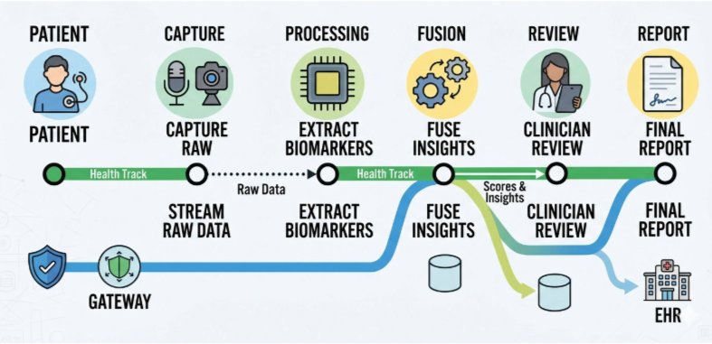

11. Data Design

11.1 Core Entities
- Patient
- Assessment Session
- Biomarker Record (acoustic / motor / ocular)
- Imaging Scan
- Risk Score
- Patient and health-derived data is treated as sensitive/PHI and stored with encryption and strict access control.

11.2 Data Dictionary
Entity | Field | Type | Null? | Allowed values | Source | Notes
Patient | id | UUID | No | — | System | PK
Patient | consentStatus | Enum | No | Given / Withdrawn | Patient | Required before capture
AssessmentSession | modalitiesCaptured | Array | No | speech / motor / ocular / imaging | System | —
ImagingScan | modality | Enum | No | MRI / CT | Clinic upload | Indexed
RiskScore | score | Decimal | No | 0–1 | Fusion engine | With confidence interval

11.3 Schemas and Migrations
- ER diagram included in appendix
- Database migrations version-controlled
- Rollback tested on staging environment

12. Technical Workflow Diagrams
The following diagrams are included to explain system behavior:
- State Transition Diagram (assessment session lifecycle)
- Sequence Diagram (patient capture → biomarker processing → fusion → clinician review)
- Use Case Diagram
- Data Flow Diagram (DFD)
- Entity Relationship Diagram (ERD)
- System Architecture Diagram

13. Research and Evaluation

13.1 Study of Existing Platforms
Platforms such as Altoida and Neurotrack demonstrate that digital biomarkers — AR-based motor/cognitive tasks and eye-tracking assessments respectively — can meaningfully support early cognitive-decline screening, and both have achieved clinical validation and regulatory recognition in their respective niches. However, each tends to focus on a single modality (AR/motor or ocular/cognitive) rather than fusing speech, motor, ocular, and neuroimaging signals together. Traditional gold-standard diagnostics (PET imaging, CSF biomarker testing) remain accurate but invasive, costly, and confined to specialist centres. This gap motivated NeuroEarly AI: a multi-modal, explainable screening layer that can run on a standard smartphone and help triage which patients warrant further specialist or invasive testing.

13.2 Evaluation Using Historical Data
NeuroEarly AI will be evaluated on historical, de-identified data from public longitudinal studies (e.g., ADNI, PPMI), comparing predicted risk scores against actual clinical outcomes to assess sensitivity, specificity, and calibration across disease stages (pre-clinical, MCI, diagnosed).

13.3 User Feedback
Simulated clinician and patient feedback will guide improvements to explainability, trustworthiness, and ease of use of the assessment flow and dashboard.

13.4 KPI Tracking
Key metrics tracked include risk-score response time (p95), model sensitivity/specificity/AUC, clinician engagement with explanations, and system uptime, with regular monitoring to ensure reliability and continuous improvement.

14. Appendices

14.1 Glossary
- AI: Systems simulating human intelligence.
- MCI: Mild Cognitive Impairment — an intermediate stage between normal ageing and dementia.
- MMSE / MoCA: Standardised clinical cognitive screening scales.
- UPDRS: Unified Parkinson's Disease Rating Scale.
- KPI: Metrics measuring performance.
- SLO: Target service performance.
- p95: 95th percentile response time.

14.2 References
- ADNI (Alzheimer's Disease Neuroimaging Initiative): https://adni.loni.usc.edu
- PPMI (Parkinson's Progression Markers Initiative): https://www.ppmi-info.org
- Altoida: https://altoida.com
- Neurotrack: https://neurotrack.com
- React: https://react.dev
- MDN Web Docs: https://developer.mozilla.org
- Scikit-learn: https://scikit-learn.org
- PyTorch: https://pytorch.org
- IEEE Xplore — Machine Learning in Neurodegenerative Disease Detection: https://ieeexplore.ieee.org
- Springer — AI-Based Digital Biomarkers for Neurological Disorders: https://link.springer.com

