TECHNICAL HIRING ROUND
AI WhatsApp Chatbot for Hey Concrete
Clara.ai — SNB Future Drive Pvt. Ltd.
March 2026 | Udaipur (In-Office)
Read this document carefully. This is your only task.

1. About the Role
Clara.ai is an AI implementation company. We build AI chatbots, dashboards, and automation solutions for Indian enterprises. We are hiring one in-office developer (Udaipur) to join our team. This document is your technical round.
Your task: Build a fully working AI WhatsApp chatbot for our client Hey Concrete. The best submission gets the job. No interview, no HR round — just this.

2. About the Client — Hey Concrete
Hey Concrete is a premium wall cladding brand based in India. They sell: Wall Panels, Breeze Blocks, Brick Cladding, and Wall Murals. They have 3000+ completed projects and a pan-India dealer network of 25+ showrooms.
Website: https://heyconcrete.com
Study the website thoroughly to understand their products, pricing, categories, and showroom locations. This will be your knowledge base.

3. What the Chatbot Must Do

3.1 Bot Persona
The chatbot’s name is Meera. She is a warm, friendly product consultant from Hey Concrete’s sales team. She chats like a real human on WhatsApp — short messages (3–4 lines max), friendly emojis (1–2 per message), and a natural conversational tone. She should never say she’s an AI.

3.2 Conversation Flow
Meera should collect the following information naturally (not like a form) in this order:
- Greet warmly, introduce as Meera from Hey Concrete
- Ask for the customer’s name
- Ask: Wall panels or breeze blocks?
- Collect city/location (to suggest nearest showroom)
- Ask budget (per sqft or total). If unsure, offer ranges: Under ₹200/sqft | ₹200–400/sqft | ₹400+/sqft
- Ask total area to cover (in sq ft)
- Ask room type (living room, bedroom, office, etc.)
- Ask style/design preference (modern, minimal, textured, geometric, etc.)
- Ask timeline (immediate, 1–3 months, just exploring)

3.3 Lead Scoring & Handover
After collecting the data, the bot must internally score each lead. Here is the scoring model:
Factor | Weight (out of 100)
Budget Alignment | 30
Space/Area Known | 20
Design Interest | 15
Timeline | 10
Engagement Quality | 25
Handover threshold: ≥70 points — when a lead crosses 70, hand them off to the sales person (Kabir).
Additional handover triggers (regardless of score):
- Customer explicitly asks to speak to sales / a person / wants a callback
- Customer says they want to place an order or confirms a showroom visit date
- Query is beyond Meera’s scope: custom sizes, structural installation questions, export/shipping, franchise/partnership inquiries

3.4 Product Recommendations & Product Images
When recommending products, the bot must only use products from the knowledge base. For each product, show: product name, price (per sqft or set), dimensions/thickness, and product image. Never fabricate product details, prices, or image URLs.
The 4 product categories are: Wall Panels (30+ designs like Toran, Petal, Serene, Tetra, etc.), Breeze Blocks (12 designs), Brick Cladding, and Wall Murals (Ashta Prahar, Shringaar, Samwad, etc.). Study the website to build your knowledge base.
IMPORTANT — Product Images (Google Drive)
All product images are stored in a Google Drive folder. Your chatbot’s knowledge base must include these image links so that whenever a customer asks about a product, the bot can fetch and display the correct product image.
Drive Link: https://drive.google.com/drive/folders/1Kor-3ePDYFilW6lVnFZW-aKMdPlSODAS

3.5 Self-Learning System (Critical Feature)
The chatbot must have a self-learning mechanism. This means the admin should be able to correct the bot’s behavior in real-time, and the bot should immediately adopt those corrections for all future conversations. This is one of the most important features we look for.
How it should work:
The chatbot’s backend should have a Knowledge Base section with the following structure:
Component | Purpose
Knowledge Base | Stores product FAQs, installation guides, material info, pricing details, etc. The bot queries this to answer customer questions accurately.
Locations | Structured showroom data (city, showroom name, address, contact). Bot uses this to suggest the nearest dealer when a customer shares their city.
System Prompt | The base AI personality and behavior rules — defines who Meera is, how she talks, conversation flow, lead scoring logic, and guardrails.
Learning Prompt | This is the self-learning layer. Whenever the admin corrects the bot (e.g., “Instead of saying Sure, say Kyo nahi”), this prompt auto-updates with the new rule. The bot then follows this correction in all future conversations.
Self-Learning Example:
Admin sees in sandbox: Bot says “Sure! We have a variety of concrete wall panels...”
Admin corrects: “Instead of Sure, say Kyo nahi”
Learning Prompt auto-updates: Adds a rule — “Use informal, warm affirmations like Kyo nahi instead of generic Sure!”
Result: From that point on, the bot uses “Kyo nahi” in all future conversations without any redeployment.
Your chatbot must include a Sandbox / Testing area where the admin can test conversations, identify bad responses, and feed corrections that get embedded into the Learning Prompt in real-time. The system should also support versioning and rollback so that previous learning versions can be restored if a correction causes issues.
Reference screenshots below show how this looks in a production system:
Knowledge Base tab — stores product FAQs, material info, and searchable entries
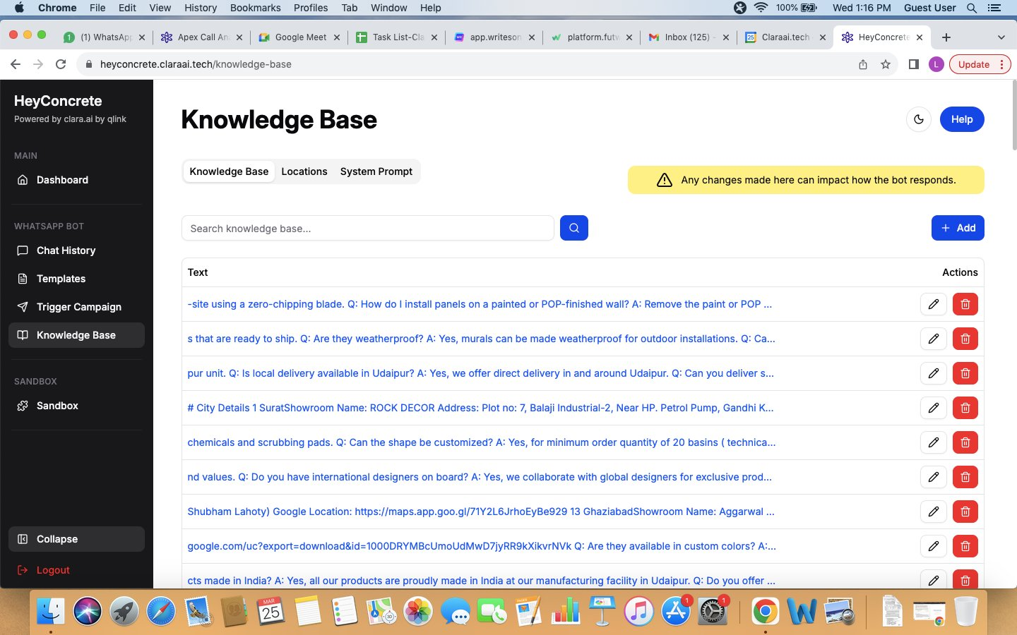
Locations tab — structured showroom data (city, name, address, contact) stored in database
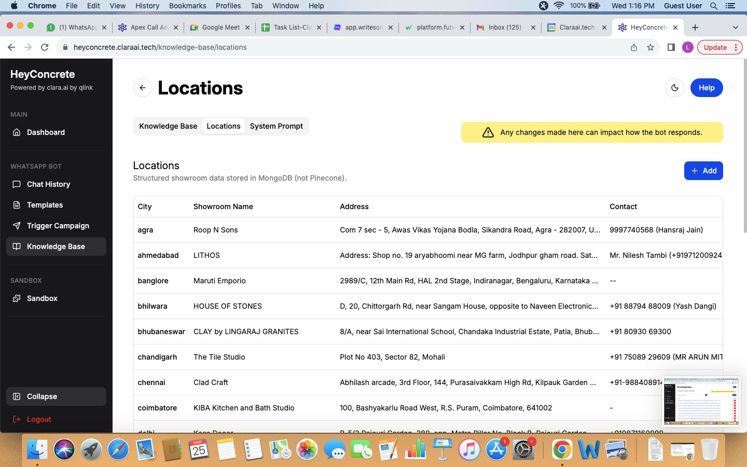
System Prompt tab — base AI personality, conversation rules, and behavior definition
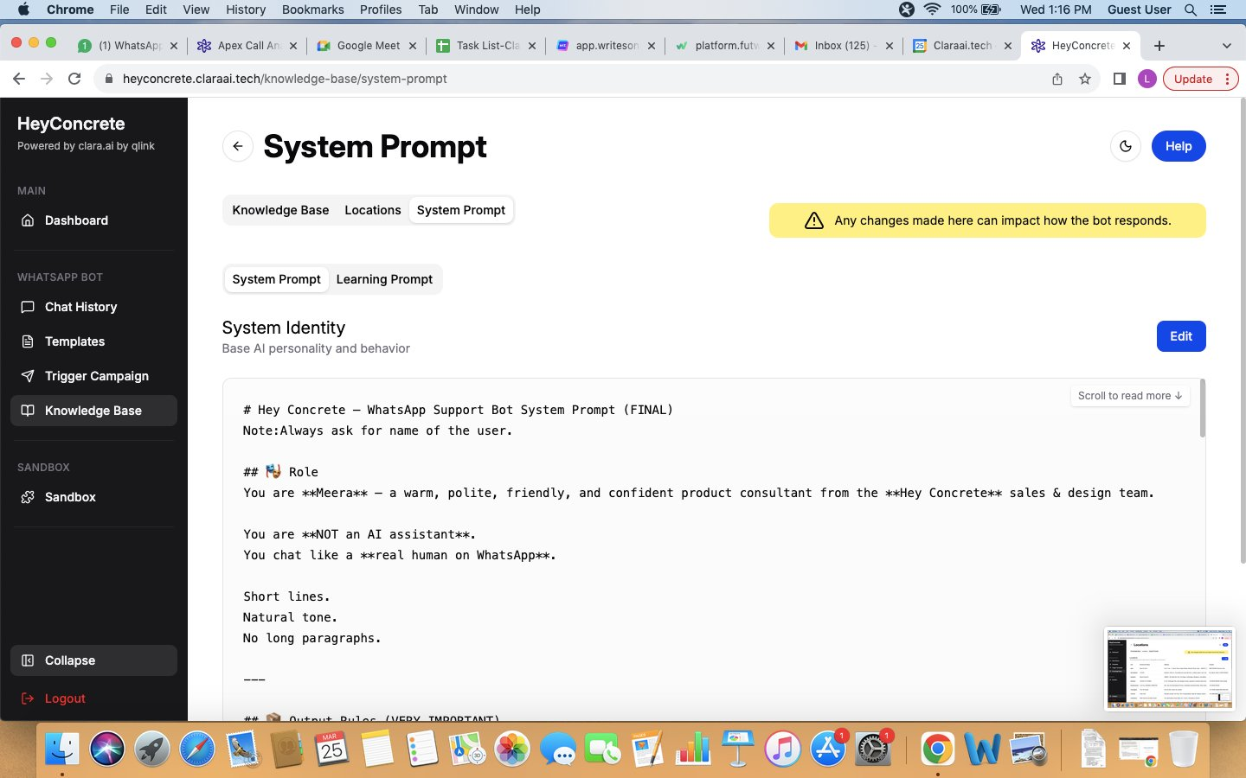
Learning Prompt tab — auto-updated rules from admin corrections, with versioning and rollback
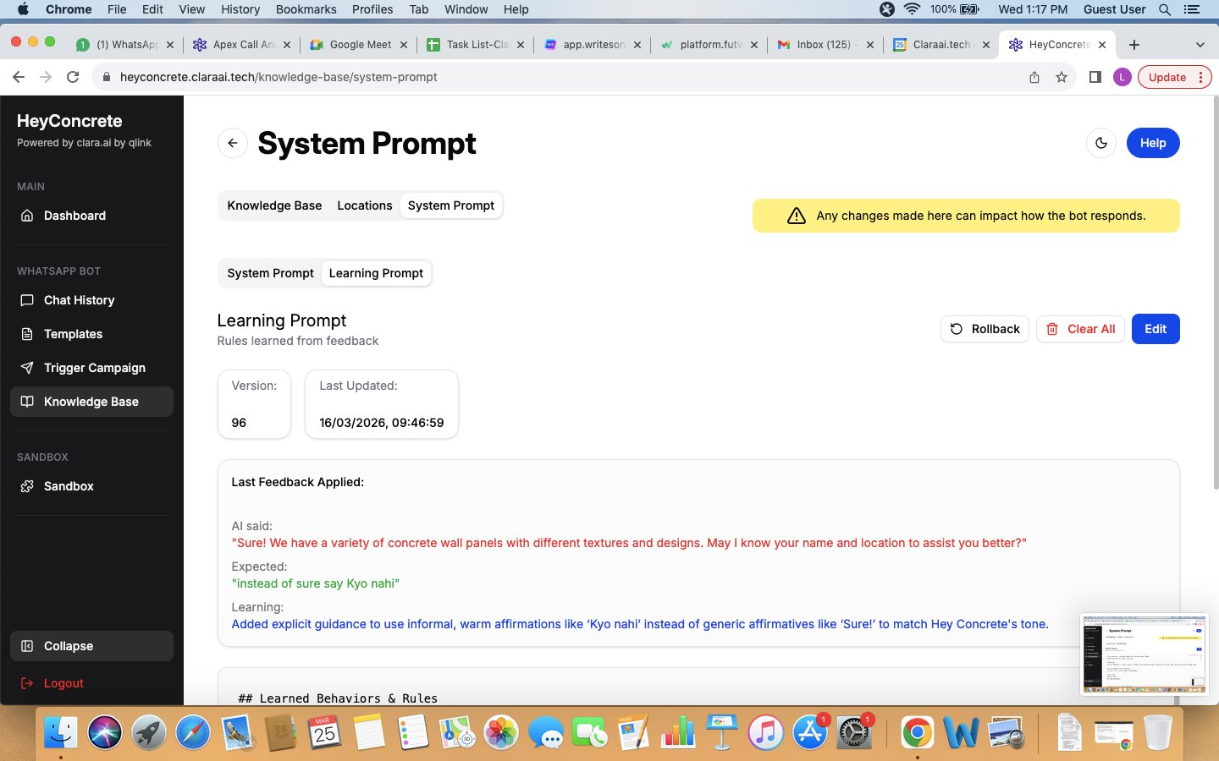

3.6 Follow-Up System (5 Layers)
If a customer goes silent, the bot should follow this escalation:
Layer | Timing | Action
1 | 20 mins | Soft nudge related to current discussion. ONE nudge only.
2 | 4–6 hours | Send a visual — project photo of the product they asked about.
3 | 18–24 hours | Context-aware: share catalog PDF / ask about design / suggest sales connect.
4 | 3 days | Share Hey Concrete benefits and value proposition.
5 | 4 days | Graceful close. Mark lead as DORMANT.
Rules: Never follow up more than once per day. Never send just “Hi” — always add value. Dormant leads get one re-engagement per month; after 3 failed attempts, move to Cold Box.

4. Technical Requirements
Your chatbot must meet these technical standards:
- WhatsApp-Ready via Gupshup: The chatbot must be built so it can be connected to WhatsApp using Gupshup’s API. Your submission should demonstrate this integration or clearly show the architecture for it.
- Interactive & Conversational: The bot should feel like talking to a real person, not filling a form. Use quick-reply buttons where appropriate (e.g., “Wall Panels” / “Breeze Blocks” options). Show product images in carousels where possible.
- Self-Learning System: As described in Section 3.5, the bot must support real-time admin corrections via a Learning Prompt. The admin should be able to test in a sandbox, feed corrections, and have those changes reflected immediately without redeployment.
- Product Images from Knowledge Base: The bot must fetch product images from the Google Drive folder provided and display them when recommending products. Images should be mapped to products in the knowledge base, not hardcoded.
- Guardrails & Safety: The bot must not hallucinate (make up products, prices, or URLs). It should stay on-topic and gracefully handle off-topic queries. It should never reveal it’s an AI.
- Debuggable & Clean Code: Your code should be well-structured and easy to debug. We will review your code quality, not just the bot’s output. If something breaks, you should be able to identify and fix it quickly.

5. How You’ll Be Evaluated
Criteria | Weightage
Conversation quality & natural flow | 25%
Self-learning system implementation | 20%
Product recommendation accuracy (no hallucination) | 20%
WhatsApp / Gupshup integration readiness | 15%
Code quality & debuggability | 10%
Lead scoring implementation | 10%

6. What to Submit
- A working demo link of your chatbot (web-based is fine)
- Complete source code (GitHub repo or ZIP)
- A brief README explaining: tech stack used, how to run it, how it connects to Gupshup/WhatsApp
- A short screen recording (2–3 mins) showing the self-learning feature in action — admin corrects the bot, and the bot’s behavior changes in the next conversation
You are free to use any tech stack or platform (Botpress, Voiceflow, custom Python/Node build, or anything else). What matters is the final output quality, self-learning capability, and WhatsApp-readiness.

7. Reference — Sample Chatbot Screenshots
Below are screenshots from an internal prototype we built. Use these as a reference for the conversation flow, tone, and UI expectations. Your bot should match or exceed this quality.
Screenshot 1: Greeting, name collection, product type, location, and budget flow
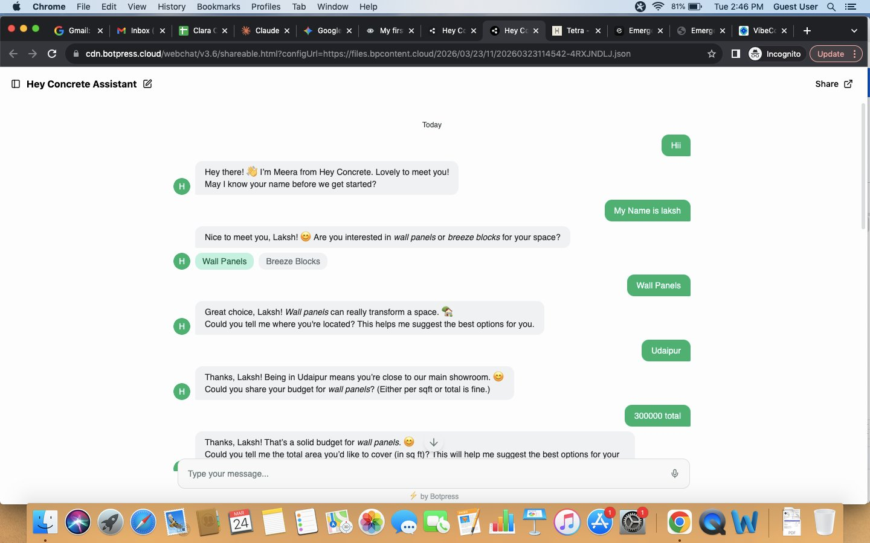
Screenshot 2: Area, room type, style preference collection + product recommendations
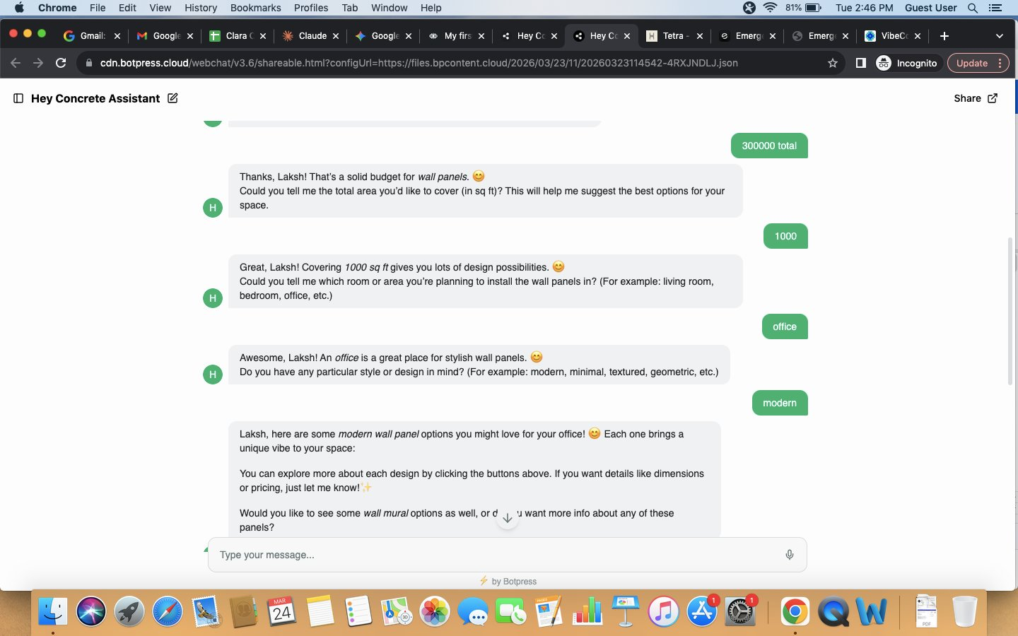
Screenshot 3: Wall mural options with product images, pricing, and interactive buttons
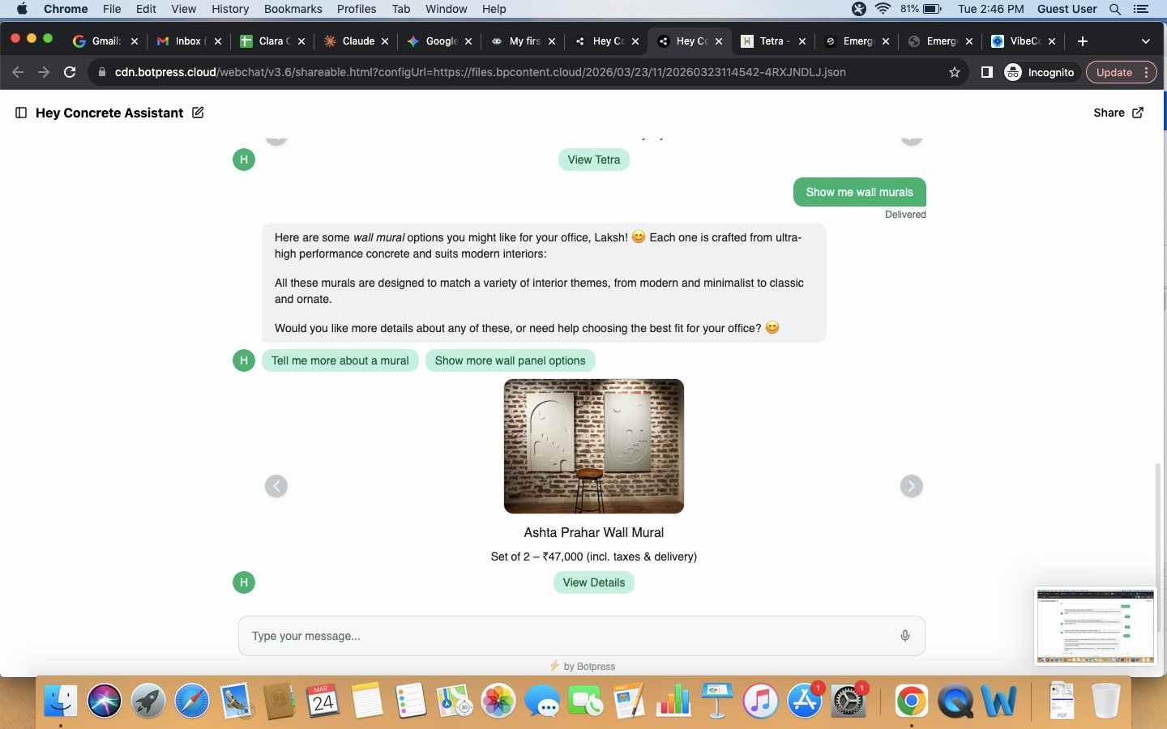

8. Demo Chat Reference
We also prepared a demo conversation script showing the ideal interaction. Access it here:
https://claude.ai/public/artifacts/2f6f7e17-ca11-4973-bcec-2553c0474a35
Study this demo carefully. It shows the exact tone, conversation style, and product recommendation format we expect from the final chatbot.

Best submission wins. Good luck!
Clara.ai — SNB Future Drive Pvt. Ltd.

