

**Batch No. : 136A**

* + **Sharau Ade (TL)**
  + **Atul Pawar(SM)**
  + **Avantika Padamwar**
  + **Dipali Warge**
  + **Komal Raut**
  + **Utkarsh Bokan**

Index Page :

|  |  |  |  |  |  |
| --- | --- | --- | --- | --- | --- |
| Sr. No. | | **Title** | | **Page No.** |  |
| Chapter 1 | | **Introduction** | |  |
| 1.1 | | **Operating Environment – Hardware**  **and Software** | |  |
| 1.2 | | **Detail Description of Technology Used** | |  |
| Chapter 2 | | **Proposed System** | |  |
| 2.1 | | **Proposed System** | |  |
| 2.2 | | **Objectives of System** | |  |
| 2.3 | | **User Requirements** | |  |
| Chapter 3 | | **Analysis And Design** | |  |
| 3. |  | **a PMriocrjoeficnatnAcerBcahnikt:e** | **cture Diagram** |  | 2 |
|  | |  | |  |
| 3.2 | | **Data Flow Diagram** | |  |
| 3.3 | | **Entity Relationship Diagram** | |  |
| 3.4 | | **Use Case Diagram** | |  |
| 3.4 | | **Activity Diagram** | |  |
| 3.5 | | **Sequence Diagram** | |  |
| 3.6 | | **Collaboration Diagram** | |  |
| 3.7 | | **Table Specifications** | |  |

# Chapter 1. Introduction

### What is Home Loan Management System ?

Loan management systems help automate the entire Home loan lifecycle.

Depending on requirements, these programs can assist in part or whole. The software can help with processing customer information, create new loans, and more. They can also provide lenders with accurate statements and reports. Moreover, they can manage interest rates and provide the tools for [collection automati](https://www.leadsquared.com/debt-collection-process-automation-saas/)on.

#### Concept And Features of System:

1. It is a tool for empowerment of the poorest.
2. Delivery is normally through self Help Group (SHGs).
3. It is essential for promoting self-employment, generally used for:
4. **aComp Java Microfinance Bank:**

Direct income generation

**lete**

3

* 1. Rearrangement of assets and liabilities for the household to participate in future opportunities and
  2. Consumption smoothing.

1. It is not just a financing system, but a tool for social change, especially for women.
   1. Provide for seasonality
   2. Allow repayment flexibility
   3. x a ceiling in loan sizes.

**Complete Java Microfinance Bank:**

* 1. **Methodology Used For Web Site Development:** Agile Methodology

4

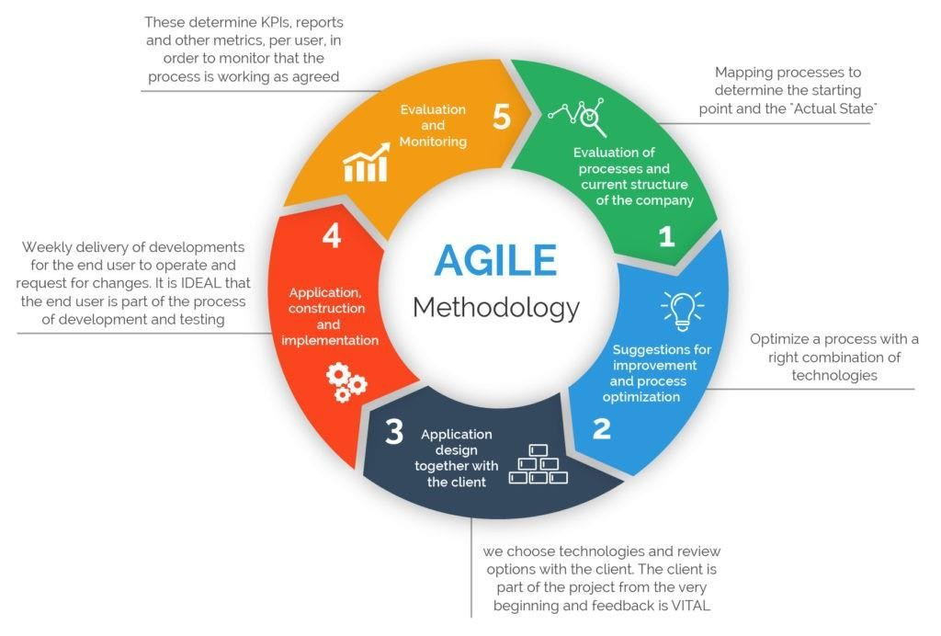

### Modules:

* Relationship Executive

**Complete Java Microfinance Bank:**

5

* Operational Executive
* Credit Manager

#### Relationship Executive:

Relationship executives identify and pursue business relationships with corporate and business unit executives. They create new business opportunities through customer relationships, while also providing value to customers through professional services agreements and solution sales. Relationship executives also establish strategic relationships with internal departments, including sales, marketing and business development teams. They use their internal and external relationships to develop sales strategies and service offerings that enable new opportunities for business and revenue growth.

#### Operational Executive:

* The Operations Executive is responsible for the part of the workplace team that directly manages the operations and maintenance of facilities. The Operations Executive can report to various parts of the company such as the Facilities Executive, Chief Financial Officer or Chief Operations Officer, but usually has direct access to senior management.

#### Enquiry module:

Collect All enquiries from customer verify them And forward to OE for cibil generation .

#### Sanction Module:

Check customer details Verify all the documents provide proper EMI options and provide sanction letter of loan to customer

### ABSTRACT

The project entitled “**Home Loan Management System**” is to be developed for maintaining the Home loan activities like, customer preferences, customer enquiry, interest rates, customer EMI, Customer follow ups details, customer employee details. The system is efficient in generating reports which will help in the maintaining records of the customer.

This project which has become a mainstream instrument for providing access to formal financial services for helpless people. This project is developed to maintain all the details of the users and to develop online portal.

* 1. **OPERATING ENVIRONMENT – HARDWARE AND SOFTWARE**

### Hardware Requirements for Server :

**Processor** : Pentium IV 1.8 GHz

**Memory size** : 2 GB RAM

**Storage** : 40 GB Hard Disk

**Display** : EGA/VGA Color Monitor, 600 x 800 Pixels Resolution, High Color

**Internet Connection** : Required

**Key Board** : Any with minimum required keys

**Mouse** : Any

* + - **Software Requirements : Operating System** : Windows 7 and above **Front-End Tool** : ANGULAR 8.0, HTML

J2EE (Java, Spring 3.0, Hibernate 3.0)

**Web Server** : Apache Tomcat 6.0.

**Back-End Tool** : MySQL 5.0

### Hardware Requirements for Client :

Pentium III 800 MHz

**PrCoomcepslestoerJava Microfinance B**:**ank:**

9

**Memory size** : 2 MB RAM

**Storage** : 40 GB Hard Disk

**Display** : EGA/VGA Color Monitor, 600 x 800 Pixels Resolution, High Color

**Key Board** : Any with minimum required keys

**Internet Connection** : Required

### DETAIL DESCRIPTION OF TECHNOLOGY USED

#### JAVA:

JAVA 8 is a major feature release of JAVA programming language development. Its initial version was released on 18 March 2014. With the Java 8 release, Java provided supports for functional programming, new JavaScript engine, new APIs for date time manipulation, new streaming API, etc.

#### FEATUES OF JAVA:

* **Lambda expression** − Adds functional processing capability to Java.
* **Method references** − Referencing functions by their names instead of invoking them directly. Using functions as parameter.
* **ComplDeteefJaauvaltMmicerothfinoadnc**−**e** I**B**n**a**t**n**e**k**r**:**face to have default method implementation.

10

* **New tools** − New compiler tools and utilities are added like ‘jdeps’ to figure out dependencies.
* **Stream API** − New stream API to facilitate pipeline processing.
* **Date Time API** − Improved date time API.
* **Optional** − Emphasis on best practices to handle null values properly.

#### APACHE TOMCAT SERVER:

Apache Tomcat is an open-source implementation of the Java Servlet, Java Server Pages, Java Expression Language and Web Socket technologies. Tomcat provides a "pure Java" HTTP web server environment in which Java code can run.

**Apache Tomcat** is **used** to deploy your Java Servlets and JSPs. So in your Java project you can build your WAR (short for Web Archive) file, and just drop it in the deploy directory in **Tomcat**. So basically **Apache** is an HTTP **Server**, serving HTTP. **Tomcat** is a Servlet and JSP **Server** serving Java technologies.

#### HIBERNATE:

**Hibernate** is a Java framework that simplifies the development of Java application

to interact with the database. It is an open source, lightweight, ORM (Object

**Complete Java Microfinance Bank:**

11

Relational Mapping) tool. Hibernate implements the specifications of JPA (Java

Persistence API) for data persistence.

#### Following are the advantages of hibernate framework:

1. Open Source and Lightweight

Hibernate framework is open source under the LGPL license and lightweight.

1. Fast Performance

The performance of hibernate framework is fast because cache is internally used in hibernate framework. There are two types of cache in hibernate framework first level cache and second level cache. First level cache is enabled by default.

1. Database Independent Query

HQL (Hibernate Query Language) is the object-oriented version of SQL. It generates the database independent queries. So you don't need to write database specific queries. Before Hibernate, if database is changed for the project, we need to change the SQL query as well that leads to the maintenance problem.

1. Automatic Table Creation

Hibernate framework provides the facility to create the tables of the database automatically. So there is no need to create tables in the database manually.

1. Simplifies Complex Join

**Complete Java Microfinance Bank:**

Fetching data from multiple tables is easy in hibernate framework.

12

1. Provides Query Statistics and Database Status

Hibernate supports Query cache and provide statistics about query and database status.

#### MySQL:

**MySQL** is a relational database management system based on SQL – Structured Query Language. The application is **used** for a wide range of purposes, including

data warehousing, e-commerce, and logging applications. The most common use for **MySQL** however, is for the purpose of a web database.

**MySQL** is not a **programming language**. Instead, it is a relational database management system (RDBMS). It is used to store data, not to write programs. The SQL **programming language** can be used to program a **MySQL** database.

#### MAVEN:

**Maven** is an automation and management tool developed by Apache Software Foundation. ... In Yiddish language the meaning of **Maven** is "accumulator of knowledge". It is written in Java Language and used to build and manage projects written in C#, Ruby, Scala, and other languages.

**Maven** is a powerful project management tool that is based on POM (project

**Complete Java Microfinance Bank:**

13

object model). It is used for projects build, dependency and documentation. It

simplifies the build process like ANT In short terms we can tell maven is a tool

that can be used for building and managing any Java-based project

#### SPRING BOOT:

**Spring Boot** is an open source Java-based framework used to create a micro Service. It is developed by Pivotal Team and is used to build stand-alone and production ready spring applications.

**Spring Boot** is basically an extension of the spring framework which eliminated the boilerplate configurations required for setting up a spring application.

**Spring Boot** is a lightweight framework that takes most of the work out of configuring Spring-based applications. In this tutorial, you'll learn how to use Spring Boot's starters, opinions, and executable JAR file structure to quickly create Spring-based applications that “just run”.

**Spring Boot Rest API** Example. ... Writing **Restful** services in **Spring Boot** is no- different than Spring MVC. If you are a **REST** Client [**Rest** Consumer], **Spring**

**Complete Java Microfinance Bank:**

**Boot** provides Rest Template Builder that can be used to customize the Rest

14

Template before calling the **REST** endpoints.

#### ANGULAR:

Angular is an application design framework and development platform for creating efficient and sophisticated single-page apps.These Angular docs help you learn and use the Angular framework and development platform, from your first application to optimizing complex single-page apps for enterprises.

#### FEATURES AND BENEFITS:

**CROSS PLATFORM**

1. **Progressive Web Apps**

Use modern web platform capabilities to deliver app-like experiences. High performance, offline, and zero-step installation.

#### Native

**Complete Java Microfinance Bank:**

15

Build native mobile apps with strategies from Cordova, Ionic, or Native Script.

#### Desktop

Create desktop-installed apps across Mac, Windows, and Linux using the same Angular methods you've learned for the web plus the ability to access native OS APIs.

#### PRODUCTIVITY

1. **Templates**

Quickly create UI views with simple and powerful template syntax.

#### Angular CLI

Command line tools: start building fast, add components and tests, then instantly deploy.

#### IDE’s

Get intelligent code completion, instant errors, and other feedback in popular editors and IDEs.

#### SPEED AND PERFORMANCE

**1.CoCmopdleeteGJeanvaerMaitciroonfinance Bank:**

16

Angular turns your templates into code that's highly optimized for today's JavaScript virtual machines, giving you all the benefits of hand-written code with the productivity of a framework.

#### Code Splitting

Angular apps load quickly with the new Component Router, which delivers automatic code-splitting so users only load code required to render the view they request.

# Chapter 2. Proposed System

### Proposed System

The customer can directly apply for a loan by selecting a bank and loan type from the list available. Here once the customer fills basic enquiry form, it reaches the bank server so he gets a login id password. The application is received by loan agency who will have three departments- PickUp, Verifiaction and Legal. The server administrator now can check it and select whether to go forward or reject the candidate. This system can be controlled by the administrator. First he will look at the application received and allot the application for a particular employee of pickup department. If he needs to go forward the banker may select to send customer to next stage. Now the customer gets stage 1 approval and needs to upload his scanned documents to the site through his login. The employee will go and make a physical verification of the documents at the customers and receives the documents necessary for the loan. Once the documents are submitted they are cross verified at the server and reply is sent to server. The system server also gets the person location and his image secretly by tracking the computer through which he submits documents to the bank server needed for bank verification. Then he logs into this system and forwards the application to the verification department which will verify the whereabouts of the person, his organization, his salary particulars etc. The bank may now cross verify customer details and also request extra documents by sending online alerts to the customer email. and then forwards the application with a status verified. Then application reaches the legal department. The legal department people will verify the builder details and when satisfied sends their report to the administrator.

**Complete Java Microfinance Bank:**

17

The customer just needs to upload needed documents online and can also track loan status. The administrator or final approving authority views both types of reports, Viz, the reports from verification department and the report legal department. This will help him to take a decision regarding whether to forward it to the bank or not. The same is communicated to the customer.

He gets a Message verification as once his loan has been approved from confirming the process. The customer can at any time view the status of his application and can send any messages to the administrator and can get clarifications from him. Thus the bank loan management system s/w helps to simplify the loan system along with making the work easy.

### Purpose of proposed system

* + - * Interest rates and the loan details are also available at the click of a mouse.

**Compl•ete Java**C**M**us**ic**t**r**o**o**m**fin**e**a**r**nc**c**e**a**B**n**a**a**nk**p**:**ply for a loan and after approved it they can track their details from online.

18

* + - * This system provides detail about the customers, their loan details, EMI details and its rate details.
      * Using with this system admin can find customer easily and it’s a paperless system so workload is reduced.
      * The decision process becomes faster and more consistent.
      * After registration and login customer can use the system easily and also customer can view any query about loan details as well as EMI details in their profile. So this system saves time.
      * Provides good communication for the customer.
      * In this system there are used EMI (Equated Monthly instalment) calculators.
      * Provides a facility to generate the reports very.

**2.1.2 Advantages of the proposed System**

19

* Entire activities of the show room are recorded through the system.

**Complete Java Microfinance Bank:**

* Customer Data is maintained.
* Reports generated will be more useful for management to take the quick business decisions.
* Customer database is maintained which will be helpful for intimating the service completion details and new offers
* Customer follow-ups are maintained which will be an added advantage of this system.
* It helps with your CIBIL Score as CIBIL or Credit Scores are a summary of customer history in loan credits and repayments over a period of time.

**Complete Java Microfinance Bank:**

20

### Objectives of System

During the past several decades personnel function has been transformed from a relatively obscure record keeping staff to central and top level management function. There are many factors that have influenced this transformation like technological advances, professionalism, and general recognition of human beings as most important resources.

A computer based management system is designed to handle all the primary information required to calculate monthly statements of Customer Record which include monthly statement of any month. Separate database is maintained to handle all the details required for the correct statement calculation and generation.

This project intends to introduce more user friendliness in the various activities such as record updating, maintenance, and searching. The searching of record has been made quite simple as all the details of the Customer can be obtained by simply keying in the identification of that Customer. Similarly, record maintenance and updating can also be accomplished by using the identification of Employee with all the details being automatically generated. These details are also being promptly automatically updated in the master file thus keeping the record absolutely up-to-date.

The entire information has maintained in the database or Files and

whoever wants to retrieve can’t retrieve, only authorization user can retrieve the necessary information which can be easily be accessible from the file. The main objective of the entire activity is to automate the process of day to day activities

of pay.

**Complete Java Microfinance Bank:**

21

### Major Functionalities:

The system is very simple in design and to implement. The system requires very less system resources and the system will work in almost all configurations. It has got

#### Following features :-

1. Ensure data accuracy’s.
2. Proper control of the higher officials.
3. Minimize manual data entry.
4. Minimum time needed for the various processing.
5. Greater efficiency.
6. Better service.
7. User friendliness and interactive.
8. Minimum time required.

### User Requirements

The system after careful analysis has been identified to be presented with the following modules:

* Relationship Executive
* Operational Executive
* Account Head
* Branch Manager
* Credit Manager
* Loan Disbursement
* Master Module
* Ledger Generate
* Telecaller.

#### Relationship Executive:

Relationship executives identify and pursue business relationships with corporate and business unit executives. They create new business opportunities through customer relationships, while also providing value to customers through professional services agreements and solution sales.

Re**Co**la**m**t**p**io**le**n**te**sh**Ja**ip**va**e**M**xe**ic**c**r**u**of**t**i**i**n**v**a**e**n**s**ce**a**B**ls**a**o**nk**e**:** stablish strategic relationships with internal departments, including sales, marketing and business development teams. They use their internal and external relationships to develop sales strategies and service offerings that enable new opportunities for business and revenue growth.

23

#### Operational Executive:

The Operations Executive is responsible for the part of the workplace team that directly manages the operations and maintenance of facilities. The

Operations Executive can report to various parts of the company such as the Facilities Executive, Chief Financial Officer or Chief Operations Officer, but usually has direct access to senior management.

On the basis of the submission of the required details & documents, the financial institution will analyze the application. From existing residential address to CIBIL score, complete information is thoroughly checked. Once the bank has validated all the details, loan amount is sanctioned.

**Complete Java Microfinance Bank:**

24

### Methodology Used For Web Application Development:

Agile Methodology

**Complete Java Microfinance Bank:**



25

# Chapter 3. Analysis And Design

**Complete Java Microfinance Bank:**

## Project Architecture :

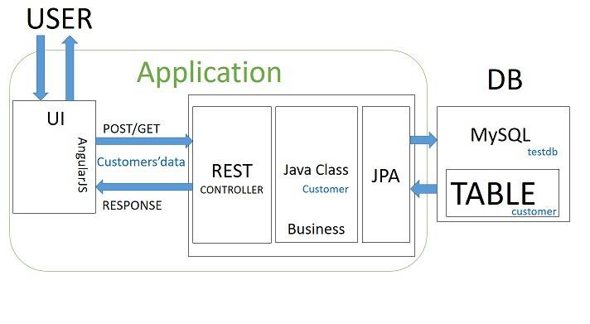

26

### Data Flow Diagram :

**Complete Java Microfinance Bank:** 27

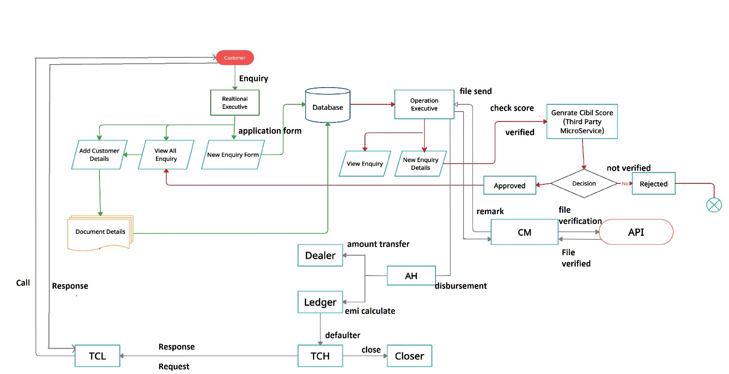

* 1. **Entity Relationship Diagram :**

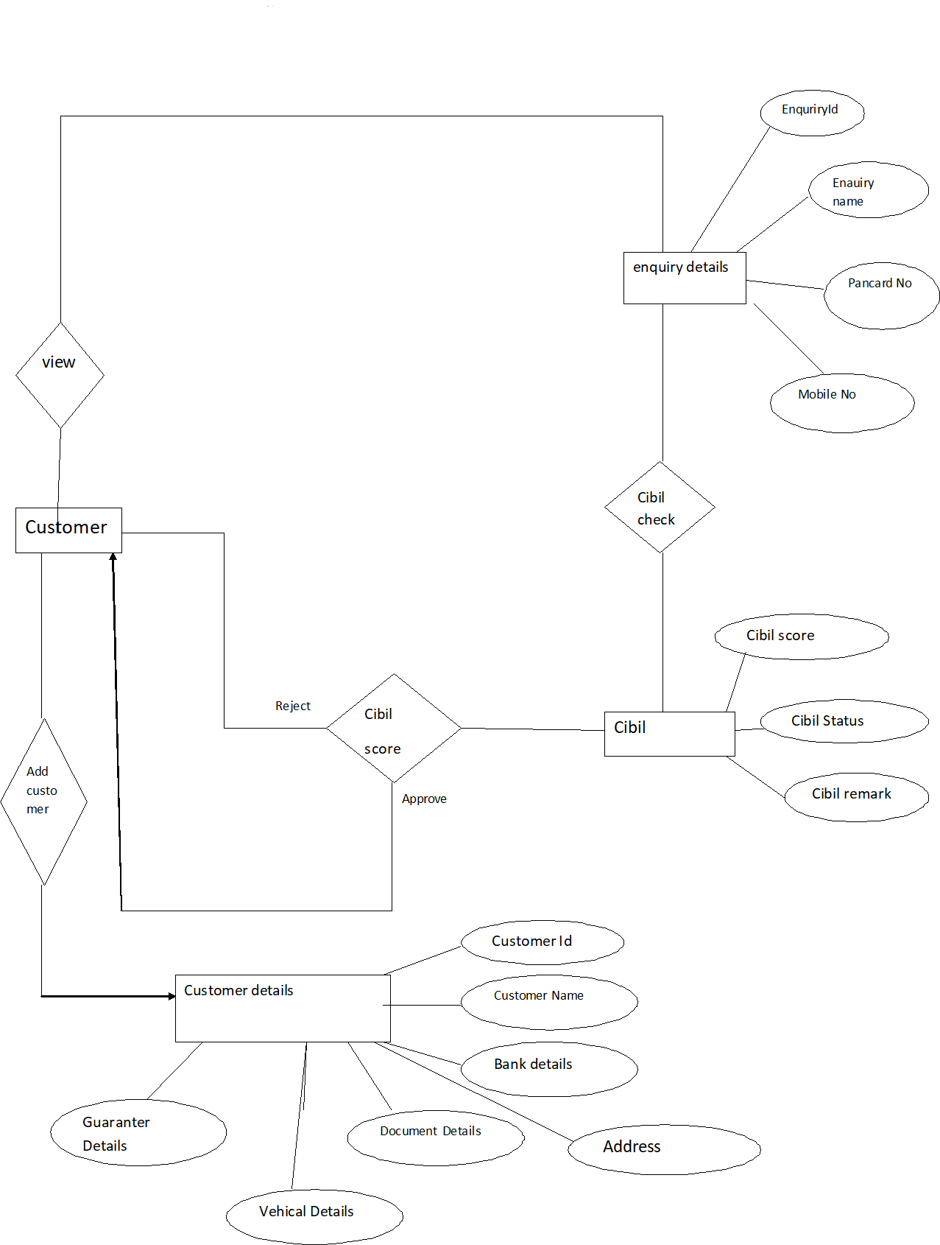

28

## USE CASE DIAGRAM

#### RE :

**Complete Java Microfinance Bank:**

29

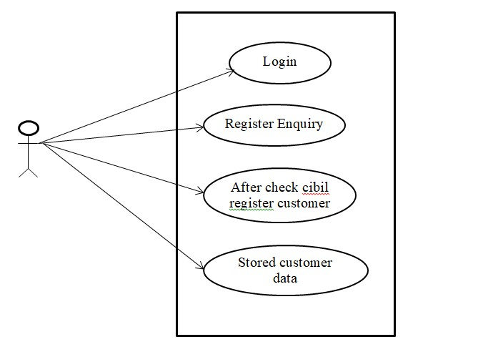

**OE :**

**Complete Java Microfinance Bank:**

30

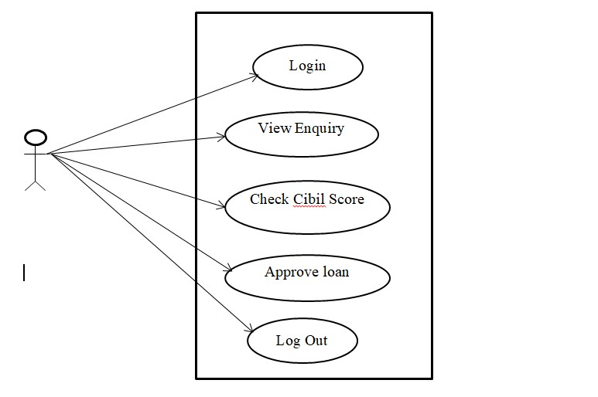

* 1. **Activity Diagram :**

**Admin side :**



Log in



No

Yes



Manage all User

Manage Loan Type

**Complete Java Microfinance Bank:**

Details

Manage EMI

Calculation

Manage EMI

Payment

Manage Report

31

Log out

## Collaboration Diagram :

#### Admin Side :

**Complete Java Microfinance Bank:**

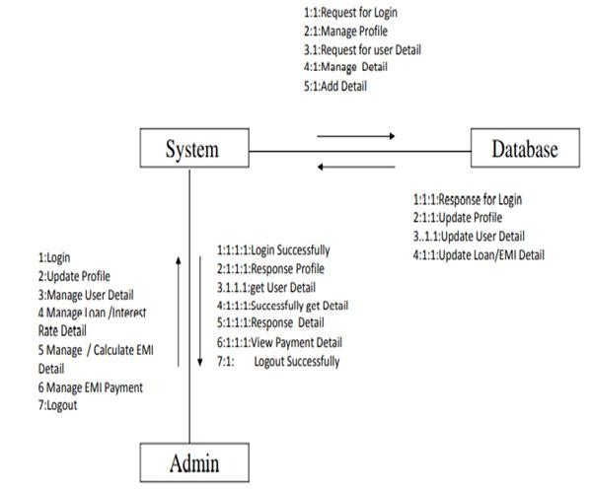

32

* 1. **Table Specification :**

**Table Name : Enquiry_Details Primary Key :** enq_id

**Description :**These table manage the Enquiry(Customer’s) Details Information

|  |  |  |  |  |  |  |
| --- | --- | --- | --- | --- | --- | --- |
| Sr.No | Pojo Class | Table | Fields | Relationship | Data Type | Sub table |
| 1 | EnquiryDetails | EnquiryDetails | eID |  | int |  |
| name |  | String |  |
| DOB |  | String |  |
| gender |  | String |  |
| email |  | String |  |
| mobileNo |  | String |  |
| pancardNo |  | String |  |

#### Table Name : Cibil Score Primary Key : CibilId

**Complete Java Microfinance Bank:**

33

**Description :**These table manage the Cibil’s(Customer’s) Details Information.

|  |  |  |  |  |  |  |
| --- | --- | --- | --- | --- | --- | --- |
| Sr.No | Pojo Class | Table | Fields | Relationship | Data Type | Sub table |
| 6 | Cibil | Cibil | cibilId |  | int |  |
| cibilScore |  | int |  |
| cibilScoreDateTime |  | String |  |
| status |  | String |  |
| remark |  | String |  |
|  |  |  |  |
|  |  |  |  |

#### Table Name : Customer Registration Details Primary Key : CustomerId

**Description :**These table manage the Customer’s Details Information.

|  |  |  |  |  |  |
| --- | --- | --- | --- | --- | --- |
| Sr.No | Pojo Class | Table | Relationship | Data Type | Sub table |
| 2 | CustomerReg | CRegDetails |  | int |  |
|  | String |  |
|  | String |  |
|  | int |  |
|  | String |  |
|  | String |  |
|  | String |  |
|  | String |  |
|  | Double |  |
| onetoone | AllPersonalDocs | AllPersonalDocs |
| onetoMany | DependentInfo(family) | DependentInfo |
| onetoone | CustomerAddress | CustomerAddress |
| onetoone | Profession | Profession |
| onetoOne | Cibil | Cibil |
| oneToOne | LoanDetails | LoanDetails |
| onetoMany | PreviousLoan | PreviousLoan |
| onetoone | AccountDetails | AccountDetails |
| onetoone | PropertyInfo | PropertyInfo |
| onetomany | GuarantorDetails | GuarantorDetails |
|  |  |  |

#### Table Name : Property Details Primary Key : propertyId

**Description :**These table manage the Address Details Information.

|  |  |  |  |  |
| --- | --- | --- | --- | --- |
| Sr.NO | PropertyAddress Table | pojo class | Fields | Data Type |
| 1 | PropertyAddress | PropertyAddress | aId | int |
| areaname | String |
| cityname | String |
| district | String |
| state | String |
| pincode | double |
| streetName | String |
|  |  |
|  |  |

#### Table Name : Gaurantor Details Primary Key : GaurantorId

**Description :**These table manage the Gaurantor’s Details Information.

**omplete Java Microfinance Bank:** 35

|  |  |  |  |  |  |  |
| --- | --- | --- | --- | --- | --- | --- |
| Sr.No | Pojo Class | Table | Fields | Relationship | Data Type | Sub table |
| 11 | GuarantorDetails | GuarantorDetails | gid |  | int |  |
| gName |  | String |  |
| gDateofBirth |  | String |  |
| gRelationshipwithCustomer |  | String |  |
| gMobNo |  | String |  |
| gAdharCardNo |  | String |  |
| gJobDetails |  | String |  |
| gloaclAddress |  | String |  |
| gPermanentAddress |  | String |  |

**Table Name : Previous Loan Details Primary Key :** previousloanId

**Description :**These table manage the Previous loan Details Information.

|  |  |  |  |  |  |  |
| --- | --- | --- | --- | --- | --- | --- |
| Sr.No | Pojo Class | Table | Fields | Relationship | Data Type | Sub table |
| 8 | PreviousLoan | PreviousLoan | ploanId |  | int |  |
| ploanAmount |  | Double |  |
| pTenure |  | int |  |
| paidAmount |  | Double |  |
| remainingAmount |  | Double |  |
| deafulterCount |  | int |  |
| pbankDetails | onetoOne | PreviousLoanBank | PreviousLoanBank |
| status |  | String |  |
| remark |  | String |  |
|  |  |  |  |

**Complete Java Microfinance Bank:** 36

**Complete Java Microfinance Bank:**

37