**Plant Disease Detection System for Sustainable Agriculture**

A Project Report

submitted in partial fulfillment of the requirements

of

AICTE Internship on AI: Transformative Learning

with

TechSaksham – A joint CSR initiative of Microsoft & SAP

by

**Utkarsh Gupta,** guptautkarsh452@gmail.com

Under the Guidance of

**P.Raja, Master Trainer, Edunet Foundation**

**ACKNOWLEDGEMENT**

I would like to take this opportunity to express my deep sense of gratitude to all individuals who helped me directly or indirectly during this project work.

Firstly, I extend my heartfelt thanks to my supervisor, **P. Raja**, for his unwavering support, guidance, and encouragement throughout this project. His insightful feedback and expertise have been invaluable in shaping this project. His mentorship has not only helped me in technical aspects but has also contributed to my overall professional development.

I am also grateful to **Edunet Foundation and TechSaksham Initiative** for providing me with this wonderful opportunity to work on an AI-based project, enabling me to enhance my knowledge and practical skills. The workshops, mentorship, and resources provided by the program have been instrumental in my learning journey. The hands-on experience and exposure to real-world AI applications have significantly strengthened my technical abilities and problem-solving skills.

I would also like to extend my sincere appreciation to my peers and colleagues who have been an integral part of this journey. Their constant support, constructive feedback, and collaboration have helped me refine my work and gain new insights. Their discussions and knowledge sharing have played a significant role in enhancing my understanding of AI-based solutions.

Finally, I am deeply thankful to my family and friends for their unwavering encouragement and patience. Their continuous support and belief in my abilities have been my greatest motivation throughout this project.

#### **ABSTRACT**

Agriculture plays a crucial role in global food security and economic stability, yet plant diseases pose significant threats to crop yield and quality. Early and accurate identification of plant diseases is essential for effective disease management and sustainable farming. However, traditional methods of disease detection rely heavily on manual inspection by farmers or agricultural experts, which can be time-consuming, labor-intensive, and prone to human error.

To address these problems, this study presents an AI-powered Plant Disease Detection System that analyzes leaf images using **Artificial Intelligence (AI) and Computer Vision** algorithms to accurately identify plant illnesses. The technology recognizes illness patterns from large datasets using deep learning models such as **Convolutional Neural Networks (CNNs)**, allowing for speedy and exact diagnosis. The suggested method uses image processing, feature extraction, and classification algorithms to discriminate healthy and unhealthy plants, providing a scalable and cost-effective alternative to hand inspections.   
The technology can be installed as a mobile or web-based application, allowing farmers to take leaf photos using cellphones or cameras and obtain real-time disease predictions and treatments. This technology not only improves decision-making in agriculture but also contributes to **sustainable farming practices** by reducing excessive pesticide use, minimizing crop losses, and optimizing resource utilization.

By integrating AI-driven automation into plant disease diagnosis, this project aims to **empower farmers with smart agricultural solutions**, improve crop health monitoring, and ultimately support global efforts toward achieving food security and environmental sustainability.

**TABLE OF CONTENT**

**Abstract I**

**Chapter 1.**  **Introduction 1**

1.1 Problem Statement 1

1.2 Motivation 1

1.3 Objectives 1

1.4. Scope of the Project 2

**Chapter 2.**  **Literature Survey 3**

2.1 Review relevant literature 3

2.2 Existing Models, Techniques, and Methodologies 4

2.3 Limitations in Existing Systems 4

**Chapter 3.**  **Proposed Methodology**

3.1 System Design………………………………………………………...5

3.2 Requirement Specification….………………………………………...8

**Chapter 4.**  **Implementation and Results**

4.1 Snap Shots of Result….………………………………………………..14

4.2 GitHub Link for Code….…………………………...…………………..17

**Chapter 5. Discussion and Conclusion**

5.1 Future Work….……………………………………………………...18

5.1 Conclusion..….……………………………………………………...18

**References…………………………………………………………………………..19**

**LIST OF FIGURES**

|  |  |  |
| --- | --- | --- |
| **Figure No.** | **Figure Caption** | **Page No.** |
|  | Flow chart of how the model works |  |
|  | Snapshot of the Home Page Interface for the Plant Disease Detection System for Sustainable Agriculture |  |
|  | Snapshot of the Page after selecting disease recognition |  |
|  | Snapshot of the Page after selecting the image |  |
|  | Snapshot of the Page after selecting the prediction button |  |
|  | Snapshot of the Page after selecting the prediction button(2) |  |

**CHAPTER 1**

**Introduction**

* 1. **Problem Statement:**

Plant diseases are a significant challenge in modern agriculture, leading to yield loss and economic distress. Traditional disease detection methods are manual, time-consuming, and prone to errors. The need for an automated system that can quickly and accurately diagnose plant diseases is crucial for sustainable agriculture.

1. Manual, requiring expert knowledge which is not always available.
2. Time-consuming, causing delays in diagnosis and treatment.
3. Prone to human errors, leading to incorrect identification and improper treatments.
4. Expensive for small-scale farmers, limiting their ability to use advanced diagnostic methods.
   1. **Motivation:**

The increasing demand for food security and sustainable farming practices highlights the importance of early disease detection. AI-driven solutions can empower farmers with real-time information, reducing dependency on pesticides and ensuring healthy crop production.

1. The growing demand for food security and sustainable agriculture.
2. The impact of plant diseases on global crop production, leading to financial losses.
3. The advancements in AI and computer vision that can aid in early disease detection.
4. The need to reduce excessive pesticide use, which can harm the environment and human health.
5. The potential to support farmers by providing a scalable and accessible disease detection system.
   1. **Objective:**
6. Develop an AI-based model capable of identifying plant diseases from leaf images.
7. Train a deep learning model using real-world agricultural datasets.
8. Design a web/mobile interface for farmers to easily upload images and receive results.
9. Ensure high accuracy in disease classification through model fine-tuning.
10. Promote sustainable agriculture by enabling early disease detection, reducing the need for excessive pesticide use.
    1. **Scope of the Project:**
11. Data Acquisition: Collecting and preprocessing images of healthy and diseased plants.
12. Model Development: Using deep learning techniques to train a robust classifier.
13. System Implementation: Deploying the model in an interactive and user-friendly web/mobile application.
14. Real-World Application: Ensuring the system can be used by farmers with minimal technical expertise.
15. Future Enhancements: Integrating IoT-based monitoring systems for real-time disease detection.

**CHAPTER 2**

**Literature Survey**

* 1. **Review relevant literature or previous work in this domain.**

Several studies have explored the application of AI and computer vision techniques for plant disease detection, improving efficiency and accuracy over traditional methods.

1. Deep Learning for Plant Disease Identification: Research by Gupta et al. applied Convolutional Neural Networks (CNNs) to plant leaf images, achieving high accuracy in disease detection.
2. Use of Transfer Learning: Singh et al. demonstrated how pre-trained models like ResNet and VGG16 can be adapted for agricultural disease classification, reducing training time.
3. IoT-Based Disease Monitoring: Sharma et al. integrated IoT sensors with AI models, enabling real-time plant health monitoring with cloud-based analytics.
4. Traditional vs. AI Approaches: Studies comparing Local Binary Patterns (LBP) and SVM models with deep learning approaches showed AI models outperform traditional methods under varying conditions.
   1. **Mention any existing models, techniques, or methodologies related to the problem.**

**Different models and techniques have been developed for plant disease detection:**

1. **Convolutional Neural Networks (CNNs):** Highly effective for feature extraction and classification but require large datasets and significant computational resources. CNN architectures like AlexNet, VGG, and MobileNet have been explored for plant disease identification.
2. **Support Vector Machines (SVM):** Used in early models but less effective in complex scenarios with large datasets. SVMs are still useful for simpler classification tasks but struggle with diverse agricultural datasets.
3. **YOLO-Based Object Detection:** Applied in real-time systems for fast and efficient disease recognition. YOLO (You Only Look Once) models allow for real-time detection of multiple plant diseases in a single image, making them highly efficient.
4. **Haar Cascade Classifiers:** Traditional lightweight models suitable for resource-limited environments but lack robustness in varying lighting conditions. These models are often used for face detection but have been adapted for certain agricultural applications.
5. **Hybrid Approaches:** Some recent studies integrate CNNs with traditional machine learning models like Random Forests and Decision Trees to improve detection accuracy and interpretability.
6. **Edge Computing Models:** To reduce dependency on cloud-based services, researchers have developed edge AI models that allow disease detection to be processed directly on mobile devices or edge computing devices.
   1. **Highlight the gaps or limitations in existing solutions and how your project will address them.**
7. **Scalability Issues:** Existing systems struggle with maintaining accuracy as dataset size increases. Our model uses efficient data augmentation and CNN optimizations to improve performance.
8. **Environmental Sensitivity:** Many approaches fail under poor lighting and occlusion. Our system incorporates adaptive preprocessing techniques to enhance detection robustness.
9. **High Computational Cost:** Deep learning models are often resource-intensive. Our model is optimized to run efficiently on standard hardware.
10. **Privacy Concerns:** Existing solutions rarely focus on secure data handling. This project implements Firebase-based secure storage to ensure data privacy.

**CHAPTER 3**

**Proposed Methodology**

* 1. **System Design**

The flowchart visually represents the Plant Disease Detection System built using Streamlit and TensorFlow. It outlines the step-by-step process, from starting the application to displaying the plant disease prediction.

Flowchart Breakdown

**1. Start**

The process begins when the application is launched.

**2. Load Model**

The pre-trained TensorFlow Keras model for plant disease detection is loaded.

This model will be used to classify uploaded images into different disease categories.

**3. User Selects Page**

The user selects a page from the sidebar.

Two options are available:

HOME Page → Displays the project title and an introductory image.

DISEASE RECOGNITION → Allows the user to upload an image of a plant leaf for disease classification.

**4. Disease Recognition Page**

If the user selects DISEASE RECOGNITION, they can upload an image for analysis.

**5. Show Image Button Clicked?**

If the Show Image button is clicked, the uploaded image is displayed on the interface.

If not, the system waits for the user to proceed.

**6. Predict Button Clicked?**

If the Predict button is clicked, the system processes the image for disease detection.

If not, the system waits for the user to take action.

**7. Process Image (Preprocess & Predict)**

The uploaded image is:

Resized to match the input size required by the model (128x128 pixels).

Converted into a numerical format that the model can process.

Passed through the trained model, which analyzes the image and predicts the most likely plant disease.

**8. Display Prediction**

The system displays the predicted disease name from a predefined list of 38 plant diseases and healthy conditions.

A snow animation effect is triggered to highlight the prediction.

**9. End**

The process is completed once the prediction is displayed.

The user can upload another image or restart the application.

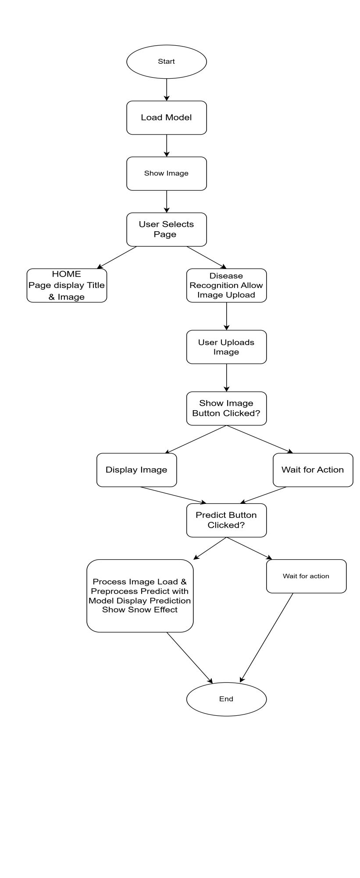

**Figure 1:** Flow chart of how the model works

* 1. **Requirement Specification**

Mention the tools and technologies required to implement the solution.

* + 1. **Hardware Requirements:**
* GPU-enabled system for efficient model training.
* Standard computing system with at least 8GB RAM and a multi-core processor.
* Camera module (for real-time image capture in field applications).
* IoT devices for real-time field monitoring.
  + 1. **Software Requirements:**
* Programming Languages: Python (primary), JavaScript (for web-based applications).
* Deep Learning Frameworks: TensorFlow/Keras, PyTorch (optional).
* Image Processing Libraries: OpenCV, PIL.
* Web Development: Flask/Django (for backend), HTML/CSS, JavaScript (for frontend).
* Database Management: Firebase/SQL-based database for storing image records.
* Development Environment: Jupyter Notebook, VS Code, Google Colab (for initial testing).

**CHAPTER 4**

**Implementation and Result**

* 1. **Snap Shots of Result:**

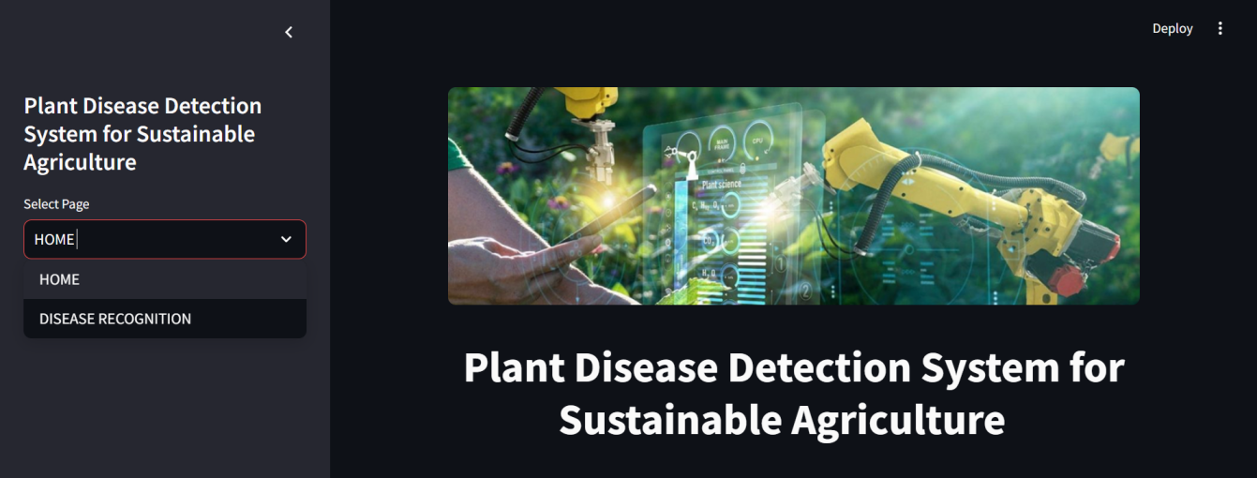

**Figure 2:** Snapshot of the Home Page Interface for the Plant Disease Detection System for Sustainable Agriculture

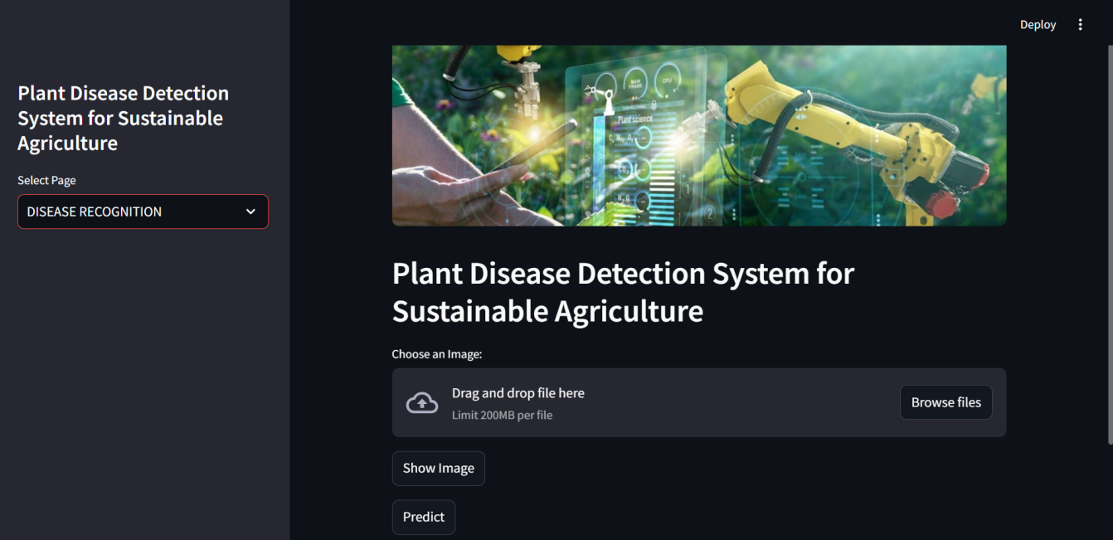

**Figure 3:** Snapshot of the Page after selecting disease recognition

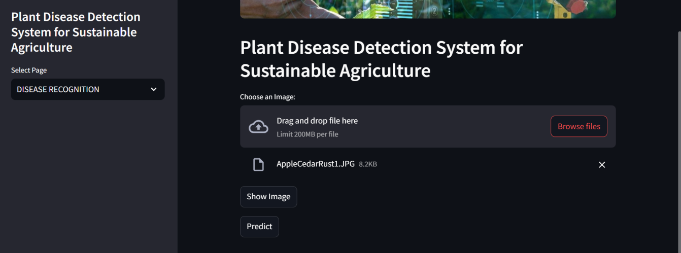

**Figure 4:** Snapshot of the Page after selecting the image

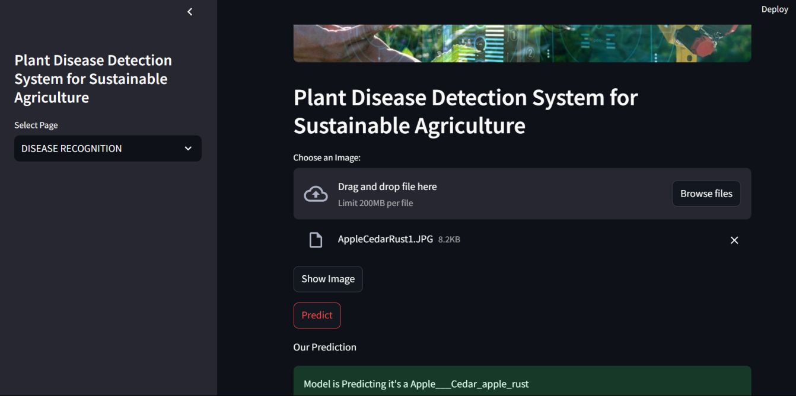

**Figure 5:** Snapshot of the Page after selecting the prediction button

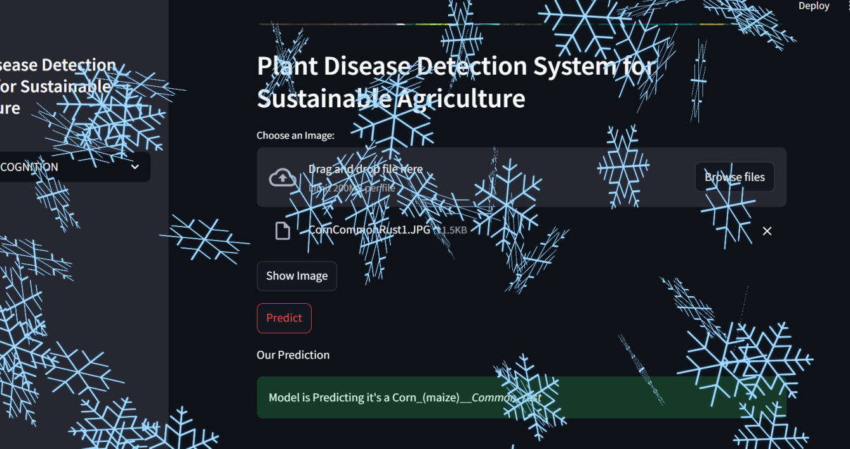

**Figure 6:** Snapshot of the Page after selecting the prediction button(2)

* 1. **GitHub Link for Code:**

https://github.com/UtkarshGupta4008/Plant-Disease-Detection-System-for-Sustainable-Agriculture-

**CHAPTER 5**

**Discussion and Conclusion**

* 1. **Future Work:**

This project provides a solid foundation for AI-driven plant disease detection. Future work can focus on the following areas:

**Dataset Expansion:** Collecting more diverse images of different plant species and disease conditions to improve model accuracy.

**Integration with IoT:** Using real-time IoT sensors to monitor environmental conditions and correlate them with disease occurrences.

**Mobile App Development:** Creating an intuitive mobile application for farmers to upload images and receive diagnoses directly.

**Multilingual Support:** Implementing multiple language options to make the tool more accessible to farmers worldwide.

**Explainability Improvements:** Enhancing model interpretability with attention maps and visual explanations for user confidence.

* 1. **Conclusion:**

This project has demonstrated the potential of AI in plant disease detection, providing a scalable and accurate system that can significantly improve agricultural productivity. By leveraging deep learning and computer vision, farmers can now detect plant diseases at an early stage, allowing for timely interventions and better crop management. The system’s adaptability ensures its usability across various crops and farming environments, making it a valuable tool for sustainable agriculture. Future advancements in dataset diversity, IoT integration, and mobile deployment will further enhance its effectiveness and accessibility.

**REFERENCES**

1. Ahmad, Aanis, Dharmendra Saraswat, and Aly El Gamal. "A survey on using deep learning techniques for plant disease diagnosis and recommendations for development of appropriate tools." Smart Agricultural Technology 3 (2023): 100083.
2. Panchal, Adesh V., et al. "Image-based plant diseases detection using deep learning." Materials Today: Proceedings 80 (2023): 3500-3506.
3. Chowdhury, Muhammad EH, et al. "Automatic and reliable leaf disease detection using deep learning techniques." AgriEngineering 3.2 (2021): 294-312.
4. Harakannanavar, Sunil S., et al. "Plant leaf disease detection using computer vision and machine learning algorithms." Global Transitions Proceedings 3.1 (2022): 305-310.
5. Jackulin, C., and S. Murugavalli. "A comprehensive review on detection of plant disease using machine learning and deep learning approaches." Measurement: Sensors 24 (2022): 100441.
6. Li, Lili, Shujuan Zhang, and Bin Wang. "Plant disease detection and classification by deep learning—a review." IEEE Access 9 (2021): 56683-56698.
7. Singh, Paramjeet, et al. "RETRACTED ARTICLE: CottonLeafNet: cotton plant leaf disease detection using deep neural networks." Multimedia Tools and Applications 82.24 (2023): 37151-37176.
8. Vasavi, Pallepati, Arumugam Punitha, and T. Venkat Narayana Rao. "Crop leaf disease detection and classification using machine learning and deep learning algorithms by visual symptoms: A review." International Journal of Electrical and Computer Engineering 12.2 (2022): 2079.
9. Sujatha, Radhakrishnan, et al. "Performance of deep learning vs machine learning in plant leaf disease detection." Microprocessors and Microsystems 80 (2021): 103615.

.