Hardware Used-

- Arduino Uno-
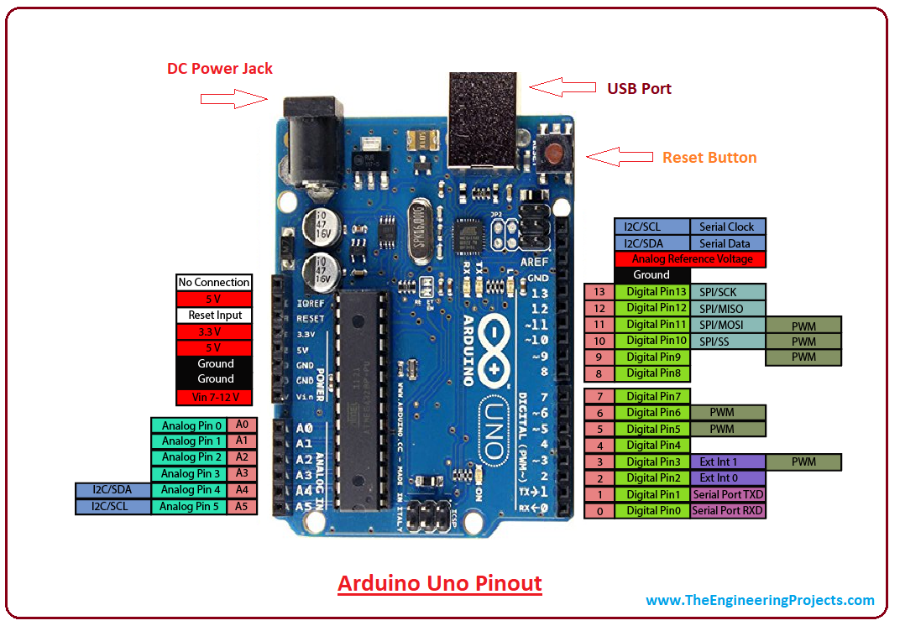

- Microcontroller: Microchip ATmega328P [7]
- Operating Voltage: 5 Volts
- Input Voltage: 7 to 20 Volts
- Digital I/O Pins: 14 (of which 6 can provide PWM output)
- Analog Input Pins: 6
- DC Current per I/O Pin: 20 mA
- DC Current for 3.3V Pin: 50 mA
- Flash Memory: 32 KB of which 0.5 KB used by bootloader
- SRAM: 2 KB
- EEPROM: 1 KB
Clock Speed: 16 MHz

- Node Mcu-

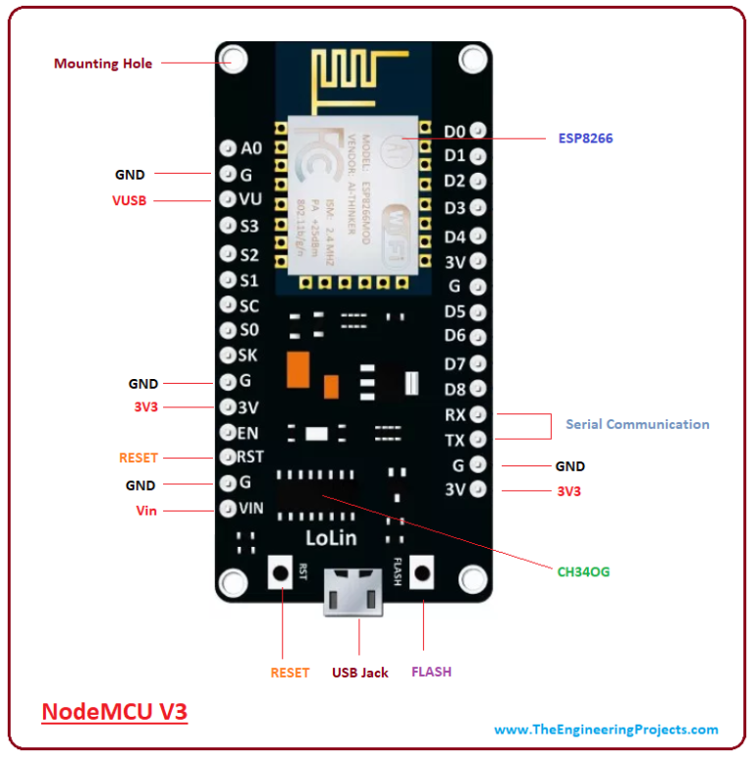

Features of the ESP32 include the following:[3]
- Processors:
  - CPU: Xtensa dual-core (or single-core) 32-bit LX6 microprocessor, operating at 160 or 240 MHz and performing at up to 600 DMIPS

- Memory: 520 KiB SRAM
- Wireless connectivity:
  - Wi-Fi: 802.11 b/g/n
  - Bluetooth: v4.2 BR/EDR and BLE
- Security:
  - IEEE 802.11 standard security features all supported, including WFA, WPA/WPA2 and WAPI
  - Secure boot
  - Flash encryption
  - 1024-bit OTP, up to 768-bit for customers
  - Cryptographic hardware acceleration: AES, SHA-2, RSA, elliptic curve cryptography (ECC), random number generator (RNG)
- Power management:
  - Internal low-dropout regulator
  - Individual power domain for RTC
  - 5μA deep sleep current
  - Wake up from GPIO interrupt, timer, ADC measurements, capacitive touch sensor interrupt

- RFID Module-

RC522 RFID Module
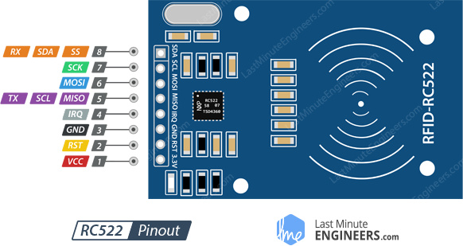

The RC522 is a 13.56MHz RFID module that is bas
ed on the MFRC522 controller from NXP semiconductors. The module can supports I2C, SPI and UART and normally is shipped with a RFID card and key fob. It is commonly used in attendance systems and other person/object identification applications.
RC522 Pin Configuration
Pin Number | Pin Name | Description
1 | Vcc | Used to Power the module, typically 3.3V is used
2 | RST | Reset pin – used to reset or power down the module
3 | Ground | Connected to Ground of system
4 | IRQ | Interrupt pin – used to wake up the module when a device comes into range
5 | MISO/SCL/Tx | MISO pin when used for SPI communication, acts as SCL for I2c and Tx for UART.
6 | MOSI | Master out slave in pin for SPI communication
7 | SCK | Serial Clock pin – used to provide clock source
8 | SS/SDA/Rx | Acts as Serial input (SS) for SPI communication, SDA for IIC and Rx during UART

- Micro SD Card Adapter-
Micro SD Card Adapter with Voltage Regulator and Translator-

Specifications
- Inputs: 6 SPI + Power and Ground
- Vcc Voltage: up to 5V (3.3V regulator is included)
- I/O Voltage: up to 5V (voltage translator included)
- Speed: High Speed SD
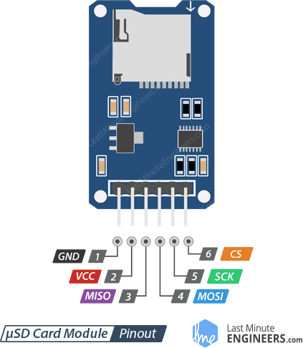

- VCC pin supplies power for the module and should be connected to 5V pin on the Arduino.
- GND should be connected to the ground of Arduino.
- MISO (Master In Slave Out) is SPI output from the Micro SD Card Module.
- MOSI (Master Out Slave In) is SPI input to the Micro SD Card Module.
- SCK (Serial Clock) pin accepts clock pulses which synchronize data transmission generated by Arduino.
- SS (Slave Select) pin is used by Arduino(Master) to enable and disable specific devices on SPI bus.

- RTC Module-
DS3231 Real Time Clock
The DS3231 is a low-cost, highly accurate Real Time Clock which can maintain hours, minutes and seconds, as well as, day, month and year information. Also, it has automatic compensation for leap-years and for months with fewer than 31 days.

The module uses the I2C Communication Protocol which makes the connection to the Arduino Board very easy.
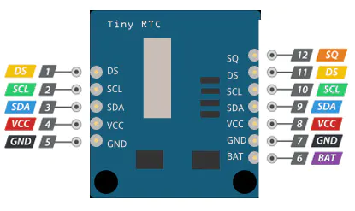

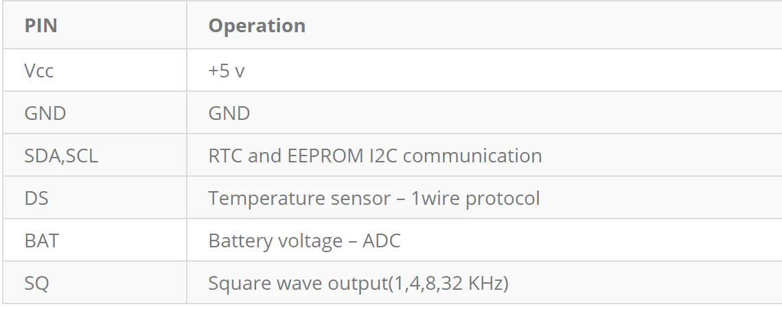

6. 16*2 LCD-

7.Emergency Switches-

Schematics-

