 | Shri Balasaheb Mane Shikshan Prasarak Mandal’s  ASHOKRAO MANE GROUP OF INSTITUTIONS  Vathar Tarf Vadgaon│Kolhapur│Maharashtra |   
 | An Autonomous Institute | Record No.: R&D/108
M.Tech Project / Research Synopsis

Master’s Research Project Phase - I
Synopsis Report
Name of College | Ashokrao Mane Group of Institutions
Name of Course | M.Tech. Computer Engineering
Name of Student (PRN No.) | MR. UTKARSH KHANDU KARALE (PRN No.-25PCS1018)
Roll No. | Roll No.-118
Date of Registration | August 2025
Name of Guide | ASST. PROF. V.A.PATIL
Type of Master’s Research Project | Non-Sponsored
Proposed Topic of Master’s Research Project | PhishScope: An Explainable Hybrid Intelligence Framework for Static and Dynamic Phishing Website Analysis

1. Introduction / Background
Phishing websites have evolved into sophisticated cyberattacks that employ dynamic web content, JavaScript execution, multi-stage redirections, cloaking techniques, and rapidly changing infrastructure to evade conventional detection mechanisms. While recent machine learning and deep learning approaches have significantly improved detection accuracy, most existing solutions rely primarily on static website features such as URLs, HTML structure, domain information, and SSL certificate metadata. This research introduces PhishScope, an explainable hybrid intelligence framework that combines multi-source static feature analysis with isolated browser-based dynamic execution to generate transparent, evidence-based risk assessments.

2. Relevance / Motivation
• Static-only analysis often fails to capture malicious runtime behaviors revealed during website execution.
• Many current machine learning detection systems operate as black-box models, providing limited interpretability.
• This lack of transparency restricts practical adoption in real-world cybersecurity environments.
• Modern phishing attacks employ dynamic content, JavaScript obfuscation, and multi-stage redirections that static scanners miss entirely.
• Developing an integrated framework that applies Explainable Artificial Intelligence (XAI) to both static and dynamic telemetry will improve detection reliability.
• An explainable phishing detection system will foster user trust and empower cybersecurity analysts with deployable investigation tools.
• A practical deployment via browser extension and desktop application can bridge the gap between academic research and real-world cybersecurity needs.

3. Literature Review
Sr. | Authors | Title | Venue / Year | Identified Limitation
1 | Author, A., et al. | PhishParrot: A User Profile-Optimizing Crawler Leveraging LLMs | IEEE TIFS, 2026 | LLM-based phishing crawler; no XAI; limited static feature integration.
2 | Chiba, D., et al. | PhishLumos: From a Single URL to Campaign-Level Mitigation | IEEE Access, 2026 | Campaign-level phishing analysis; no browser behavior analysis.
3 | Author, B., et al. | Adaptive Cloud–Edge Coordination for Real-Time Phishing URL Detection | IEEE Security & Privacy, 2026 | DistilBERT + MLP for URL detection; static URL-focused; no runtime behavior.
4 | Author, C., et al. | XGBoost-Based URL Phishing Detection with Cross-Dataset Validation | Computers & Security, 2026 | XGBoost phishing classifier; URL-only analysis without HTML or behavioral features.
5 | Author, D., et al. | DPMLF: URL Character and HTML Semantic Deep Features | JISA, 2026 | CNN-based deep learning for URL and HTML features; no runtime behavior analysis.
6 | Author, E., et al. | Generalized Explainable AI Framework for Phishing Detection | IJIS, 2026 | RF + CNN + SHAP for phishing; no browser execution or dynamic analysis.
7 | Singhal, D., Verma, A. | Whale Optimization and AutoML for Precise Phishing Detection | J. Mobile Multimedia, 2025 | AutoML-based phishing detection; no dynamic analysis or behavioral features.
8 | Author, F., et al. | Convolutional Graph Network-Based Feature Extraction for Phishing | IEEE TNNLS, 2025 | GraphSAGE + SVM for phishing; URL-centric approach without multi-source features.
9 | Kumar, A., et al. | Phishing URL Detection with Contextual Embeddings and Machine Learning | IEEE CNS, 2025 | Hybrid ML with contextual embeddings; limited feature scope; no dynamic analysis.
10 | Sharma, B., et al. | Impact of Feature Engineering in Phishing URL Detection | IEEE Access, 2025 | Feature engineering study for phishing; lacks Explainable AI (XAI) integration.
11 | Gupta, D., et al. | Explainable Machine Learning for Phishing Detection | IEEE Access, 2025 | XGBoost + SHAP for phishing; no HTML or dynamic behavioral features.
12 | Patel, G., et al. | Deep Learning-Based Phishing Website Detection | IEEE TrustCom, 2024 | CNN for HTML-based detection; ignores SSL, Domain, and network execution.

4. Literature Review Summary
The review of current literature highlights a strong dependency on static URL and HTML features for phishing detection. Most contemporary studies focus on maximizing classification accuracy using models like Random Forest, CNNs, or BERT, but heavily neglect dynamic runtime behaviors (such as JavaScript execution or redirect chains). Additionally, while a few recent papers integrate XAI (like SHAP), they typically do so over limited feature sets rather than a comprehensive, multi-source framework.

5. Problem Statement
Phishing websites have evolved into sophisticated cyberattacks that employ dynamic web content, multi-stage redirections, and rapidly changing infrastructure. Most existing solutions rely primarily on static features and operate as black-box models, providing limited interpretability. Therefore, there is a critical need for an explainable hybrid intelligence framework that combines multi-source static analysis with isolated browser-based dynamic execution and Explainable Artificial Intelligence (XAI) to generate transparent, evidence-based risk assessments for practical cybersecurity deployment.

6. Research Gap
• Limited Integration of Multi-Source Features: Current models rarely integrate URL, HTML, Domain, SSL, and network data into a single pipeline.
• Insufficient Dynamic Behavioral Analysis: Modern phishing exploits runtime behaviors (redirects, JS actions, network calls) that static scanners miss entirely.
• Lack of Explainable Decision-Making: High-performing deep learning models lack explicit transparency, reducing analyst trust in predictions.
• Absence of Integrated Frameworks: Focus is often placed solely on classification metrics rather than unified risk assessment systems combining static and dynamic evidence.
• Limited Practical Deployment: Validations are frequently offline, lacking user-oriented tools like browser extensions for real-time detection.
• Generalization Across Datasets: Cross-dataset evaluation is limited, leaving true real-world robustness unproven against diverse phishing campaigns.
• Accuracy–Interpretability–Efficiency Trade-off: Prior research neglects balancing computational load and explainability with raw classification accuracy.

7. Aim
To design and develop PhishScope, an explainable hybrid intelligence framework that integrates multi-source static feature analysis with isolated browser-based dynamic behavioral execution and Explainable Artificial Intelligence (XAI) techniques to generate transparent, evidence-based phishing risk assessments for practical cybersecurity deployment.

8. Objectives
1. To extract and integrate multi-source static website features, including URL, HTML, domain, and SSL certificate information.
2. To design and develop a hybrid intelligence framework combining static feature analysis with dynamic browser-based behavioral analysis.
3. To monitor runtime website behaviors (JavaScript, network requests, DOM changes) within an isolated browser environment.
4. To incorporate Explainable Artificial Intelligence (XAI) techniques (SHAP/LIME) for generating transparent predictions.
5. To evaluate the framework's effectiveness, reliability, and practical applicability using standard cybersecurity metrics.

9. Proposed Methodology

9.1 Data Collection
Malicious and benign website instances will be aggregated from repositories like PhishTank, OpenPhish, and curated benign URL lists. The dataset will include diverse phishing attack types to ensure model generalizability.

9.2 Multi-Source Static Feature Extraction
A multi-layer architecture will collect URL-based features (length, special characters, subdomain count), HTML structural features (form actions, iframe usage, script tags), Domain features (WHOIS data, registration age, DNS records), and SSL certificate metadata (issuer, validity, certificate chain).

9.3 Dynamic Behavioral Analysis
An isolated browser sandbox environment will be developed to safely execute websites and monitor runtime behaviors including JavaScript execution patterns, network request sequences, redirect chains, DOM modifications, and browser API interactions.

9.4 Feature Preprocessing
Collected static and dynamic features will be cleaned, normalized, and encoded. Feature scaling will be applied where required. The dataset will be split into 70% Training, 15% Validation, and 15% Test partitions.

9.5 Hybrid ML Classification
Hybrid machine learning models combining Random Forest and XGBoost will be trained on the processed multi-source feature sets. Performance will be evaluated using Accuracy, Precision, Recall, F1-Score, and ROC-AUC metrics.

9.6 Explainable AI (XAI) Module
SHAP (SHapley Additive exPlanations) will be used as the primary feature-attribution method, with LIME (Local Interpretable Model-agnostic Explanations) for comparative analysis. Both global and local explanations will be generated to identify key contributing features for phishing classification decisions.

9.7 Risk Scoring and Alerting
A composite risk scoring mechanism will integrate classification confidence, dynamic behavior indicators, and XAI feature attributions to produce evidence-based risk assessments with categorized threat levels.

9.8 Practical Deployment
The framework will be deployed through two user-oriented tools: a browser extension for real-time phishing alerts during web browsing, and a desktop investigation application for cybersecurity analysts to perform detailed website analysis.

9.9 Validation and Comparison
The proposed framework will be compared against existing phishing detection methods. Evaluation will include detection performance, explainability quality, runtime efficiency, and practical usability. Cross-dataset experiments will assess generalizability.

10. System Overiew
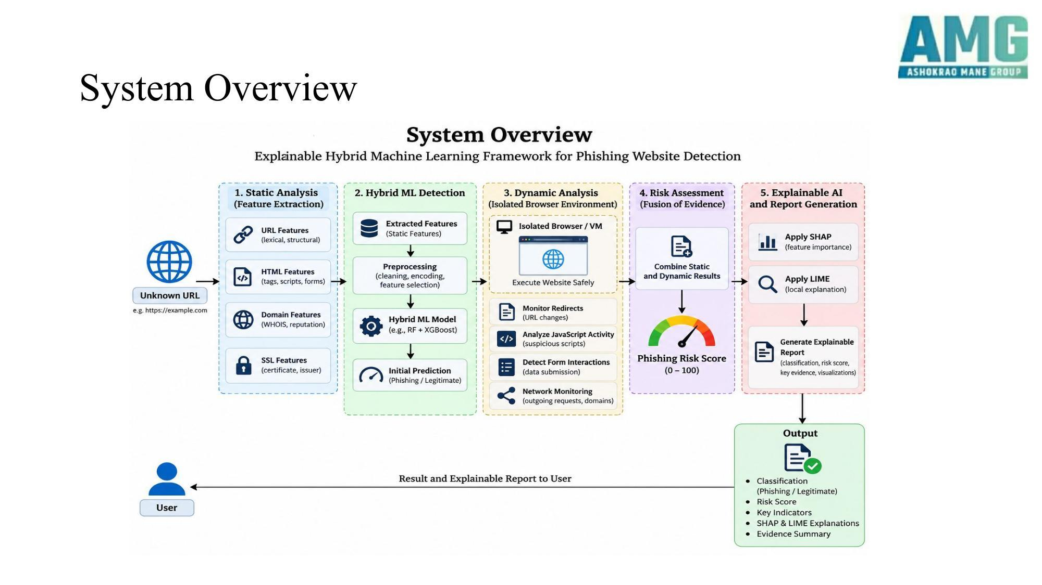

C) Action Plan
Sr.  No. | Activity/Month | Aug 26  Sept 26 | Oct 26  Nov 26 | Dec 26  Jan 27  Feb 27 | Mar 27  Apr 27 | May 27 | Jun 27
1 | Literature Review & Problem Definition
2 | Data Collection & Feature Extraction Development
3 | Dynamic Analysis Sandbox Development
4 | Hybrid ML Model Training & XAI Integration
5 | Evaluation, Validation & Browser Extension
6 | Thesis Writing & Research Paper Publication

D) Facilities Available and Requirement
• Computer laboratory / personal computer systems with internet connectivity.
• Python programming environment with Jupyter Notebook, VS Code or equivalent IDE.
• Python ML/AI libraries: Scikit-learn, XGBoost, Random Forest, SHAP, LIME, NumPy, Pandas, Matplotlib.
• Web analysis libraries: BeautifulSoup, Requests for HTML/URL feature extraction.
• Browser automation tools: Selenium / Playwright for dynamic website execution.
• Isolated execution environment: Docker containers or Virtual Machines (VM) for browser sandbox.
• Network monitoring tools: Wireshark / network traffic logging for behavioral analysis.
• Access to phishing URL databases: PhishTank, OpenPhish, and curated benign URL datasets.
• Cloud/online computing resources for computationally intensive model training and dynamic website execution.

E) Expected Cost of the Dissertation Work
Sr. No. | Particular | Approx. Cost (Rs.)
1 | Cloud Instances / Sandbox Infrastructure | 10,000
2 | Data Acquisition / API Keys | 15,000
3 | Software Licensing & Security Tools | 2,000
4 | Publication / Registration Fees | 5,000
 | Total (Approx.) | 32,000

F) Expected Date of Completion
30 June 2027

11. Expected Outcomes
1. A working PhishScope framework capable of providing evidence-based, highly accurate phishing risk assessments.
2. Multi-source feature extraction pipeline integrating URL, HTML, Domain, SSL, and dynamic behavioral indicators.
3. An isolated browser sandbox module for safe dynamic website execution and behavior monitoring.
4. Hybrid ML classification model with demonstrated high performance (Accuracy, Precision, Recall, F1-Score, ROC-AUC).
5. Transparent and interpretable predictions through SHAP and LIME explanations.
6. A browser extension prototype for real-time phishing alerting during web browsing.
7. A desktop investigation application for cybersecurity analysts.
8. A research paper suitable for submission to a reputed conference/journal, subject to the quality and originality of the final results.

12. Research Contribution
• Novel hybrid architecture integrating multi-source static telemetry with isolated browser-based dynamic behavioral analysis for comprehensive phishing detection.
• Integration of Explainable AI (SHAP/LIME) across both static and dynamic feature spaces, providing transparent and interpretable risk assessments.
• Evidence-based risk scoring mechanism combining classification confidence, dynamic behavior indicators, and feature attributions.
• Prediction-level explainability rather than relying only on aggregate model accuracy.
• Practical deployment through a browser extension and desktop investigation application suitable for direct industry integration.

13. Scope of Work
The scope is strictly bounded to the analysis and detection of phishing websites through static indicators and isolated dynamic execution. The study will include multi-source feature extraction (URL, HTML, Domain, SSL), browser-based dynamic behavior monitoring, hybrid ML classification, and XAI-based interpretation.
The initial scope will not include phishing emails, SMS phishing (smishing), voice phishing (vishing), enterprise-scale threat intelligence, or deep malware reverse-engineering. The primary contribution of the present M.Tech work will be the computational framework, experimental evaluation, and prototype deployment tools.

14. Work Plan

Activity | Proposed Duration
Literature Review & Data Source Identification | September–October 2026
Feature Extraction & System Architecture Design | October–November 2026
Dynamic Analysis Sandbox & ML Model Development | November-December 2026
XAI Integration, Testing & Performance Evaluation | December 2026-February 2027
Deployment (Browser Extension), Thesis & Research Paper | February 2027- June 2027

15. References
[1] Author, A., et al. (2026). PhishParrot: A user profile-optimizing crawler leveraging LLMs. IEEE Transactions on Information Forensics and Security.
[2] Chiba, D., et al. (2026). PhishLumos: From a single URL to campaign-level mitigation. IEEE Access.
[3] Author, B., et al. (2026). Adaptive cloud–edge coordination for real-time phishing URL detection. IEEE Security & Privacy.
[4] Author, C., et al. (2026). XGBoost-based URL phishing detection with cross-dataset validation. Computers & Security.
[5] Author, D., et al. (2026). DPMLF: URL character and HTML semantic deep features. Journal of Information Security and Applications.
[6] Author, E., et al. (2026). Generalized explainable AI framework for phishing detection. International Journal of Information Security.
[7] Singhal, D., & Verma, A. (2025). Whale optimization and AutoML for precise phishing detection. Journal of Mobile Multimedia.
[8] Author, F., et al. (2025). Convolutional graph network-based feature extraction for phishing. IEEE Transactions on Neural Networks and Learning Systems.
[9] Kumar, A., et al. (2025). Phishing URL detection with contextual embeddings and machine learning. IEEE Conference on Communications and Network Security.
[10] Sharma, B., et al. (2025). Impact of feature engineering in phishing detection. IEEE Access.
[11] Gupta, D., et al. (2025). Explainable ML for phishing detection. IEEE Access.
[12] Patel, G., et al. (2024). Deep learning-based phishing website detection. IEEE Conference on Trust, Security and Privacy in Computing and Communications.

PG Student | Guide | PG Coordinator
Head of Department |  | Director

