Mobile Application Development Lab Record [ICT 3268]

Ashwin Singh Kushwaha 230953208
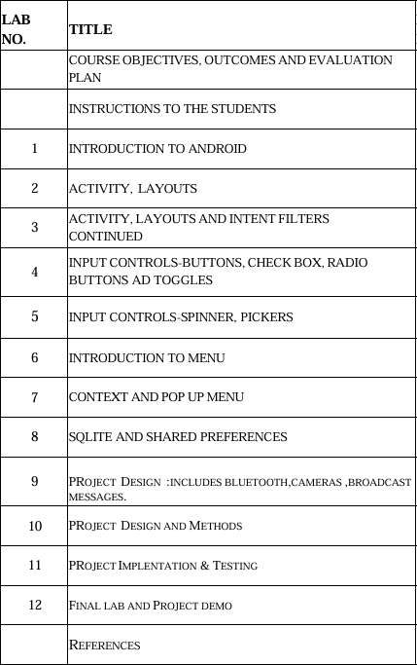
Roll No. 27 CCE-C1

Lab 1 Basics of Android Mobile Application Development Tool
Q1) Create an Android application to show the demo of displaying text with justifying elements, changing text colours, fonts etc.
Q2) Find the “hello word” text in the XML document and modify the text.

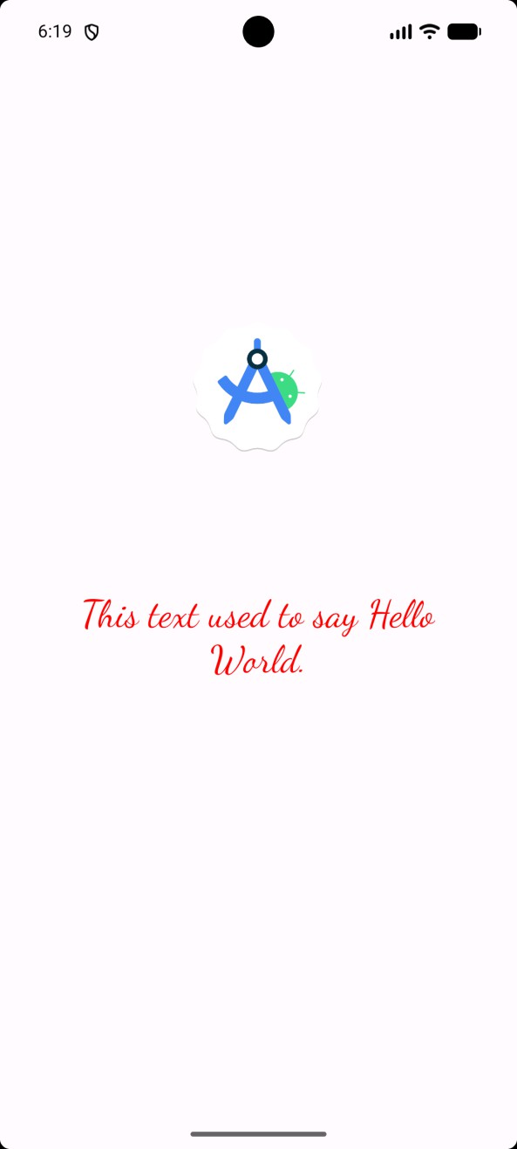

XML Code: -
<TextView android:id="@+id/textView" android:layout_width="317dp" android:layout_height="137dp" android:fontFamily="cursive"
android:text="This text used to say Hello World." android:textColor="@color/red" android:textSize="30dp" android:textAlignment="center" app:layout_constraintBottom_toBottomOf="parent" app:layout_constraintEnd_toEndOf="parent" app:layout_constraintHorizontal_bias="0.497" app:layout_constraintStart_toStartOf="parent" app:layout_constraintTop_toTopOf="parent" app:layout_constraintVertical_bias="0.59" />

<ImageView android:id="@+id/imageView" android:layout_width="112dp" android:layout_height="185dp" android:layout_marginTop="164dp"
app:layout_constraintEnd_toEndOf="parent" app:layout_constraintHorizontal_bias="0.498" app:layout_constraintStart_toStartOf="parent" app:layout_constraintTop_toTopOf="parent" app:srcCompat="@drawable/sample" />

Java Code: -
public class MainActivity extends AppCompatActivity {

@Override
protected void onCreate(Bundle savedInstanceState) { super.onCreate(savedInstanceState); EdgeToEdge.enable(this); setContentView(R.layout.activity_main);
ViewCompat.setOnApplyWindowInsetsListener(findViewById(R.id.main), (v, insets) -> {
Insets systemBars = insets.getInsets(WindowInsetsCompat.Type.systemBars());
v.setPadding(systemBars.left, systemBars.top, systemBars.right, systemBars.bottom);
return insets;
});
}
}

LAB 2 Introduction to Activity and Layouts in Android
Q1) Create an app that illustrates that the activity lifecycle method being triggered by various action. Understand when onCreate() , onStart(), onResume() events occur.

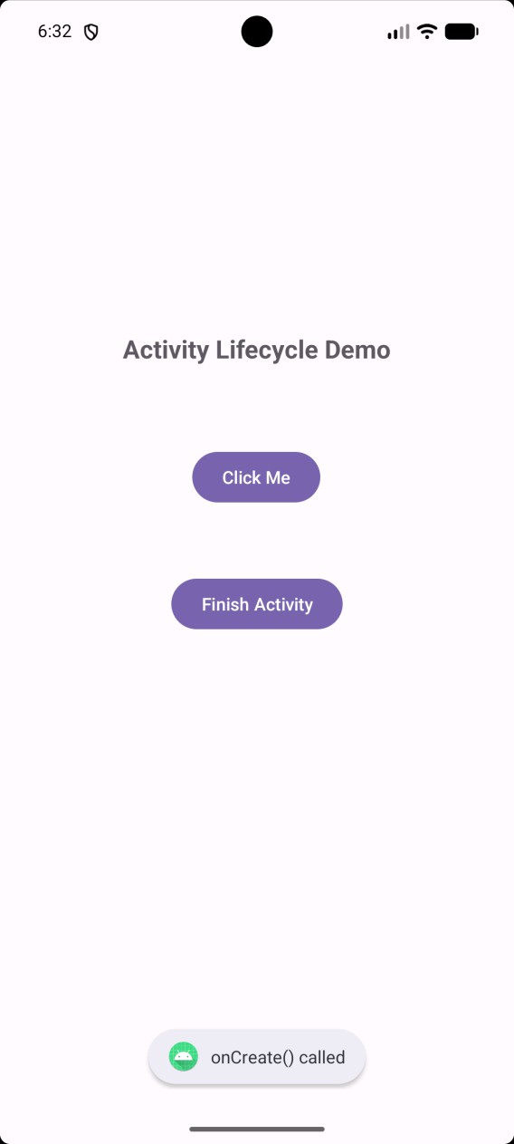
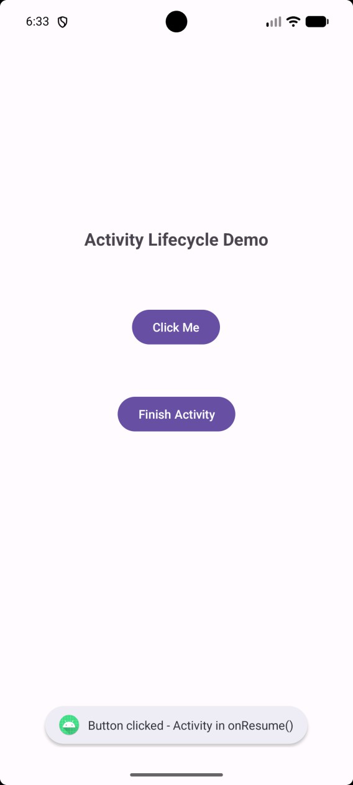

XML Code :-
<TextView android:id=”@+id/txtTitle”
android:layout_width=”wrap_content” android:layout_height=”wrap_content” android:text=”Activity Lifecycle Demo” android:textSize=”20sp” android:textStyle=”bold” app:layout_constraintBottom_toBottomOf=”parent” app:layout_constraintEnd_toEndOf=”parent” app:layout_constraintStart_toStartOf=”parent” app:layout_constraintTop_toTopOf=”parent” app:layout_constraintVertical_bias=”0.264” />

<Button android:id=”@+id/btnToast”
android:layout_width=”wrap_content” android:layout_height=”wrap_content” android:text=”Click Me” app:layout_constraintBottom_toBottomOf=”parent” app:layout_constraintEnd_toEndOf=”parent” app:layout_constraintHorizontal_bias=”0.498” app:layout_constraintStart_toStartOf=”parent” app:layout_constraintTop_toBottomOf=”@+id/txtTitle” app:layout_constraintVertical_bias=”0.118” />

Java Code :-
public class MainActivity extends AppCompatActivity { private static final String TAG = “LifecycleDemo”;
@Override
protected void onCreate(Bundle savedInstanceState) { super.onCreate(savedInstanceState); EdgeToEdge.enable(this); setContentView(R.layout.activity_main);

ViewCompat.setOnApplyWindowInsetsListener(findViewById(R.id.main), (v, insets) -> {
Insets systemBars = insets.getInsets(WindowInsetsCompat.Type.systemBars());
v.setPadding(systemBars.left, systemBars.top, systemBars.right, systemBars.bottom);
return insets;
});

Toast.makeText(this, “onCreate() called”, Toast.LENGTH_SHORT).show(); Log.d(TAG, “onCreate()”);

Button btnToast = findViewById(R.id.btnToast); Button btnFinish = findViewById(R.id.btnFinish);

btnToast.setOnClickListener(v ->

Toast.makeText(this, “Button clicked – Activity in onResume()”, Toast.LENGTH_SHORT).show()
);

btnFinish.setOnClickListener(v -> finish());
}

@Override
protected void onStart() { super.onStart();
Toast.makeText(this, “onStart() called”, Toast.LENGTH_SHORT).show(); Log.d(TAG, “onStart()”);
}

@Override
protected void onResume() { super.onResume();
Toast.makeText(this, “onResume() called”, Toast.LENGTH_SHORT).show(); Log.d(TAG, “onResume()”);
}

@Override
protected void onPause() { super.onPause(); Log.d(TAG, “onPause()”);
}

@Override
protected void onStop() {

super.onStop(); Log.d(TAG, “onStop()”);
}

@Override
protected void onDestroy() { super.onDestroy();
Toast.makeText(this, “onDestroy() called”, Toast.LENGTH_SHORT).show(); Log.d(TAG, “onDestroy()”);
}
}

Q2) Create a Calculator app that does the function of multiplication, addition, division, subtraction but displays the result in the format of:- Num1 operator num2 = result. Back button on the next activity should get back to the calculator activity again.
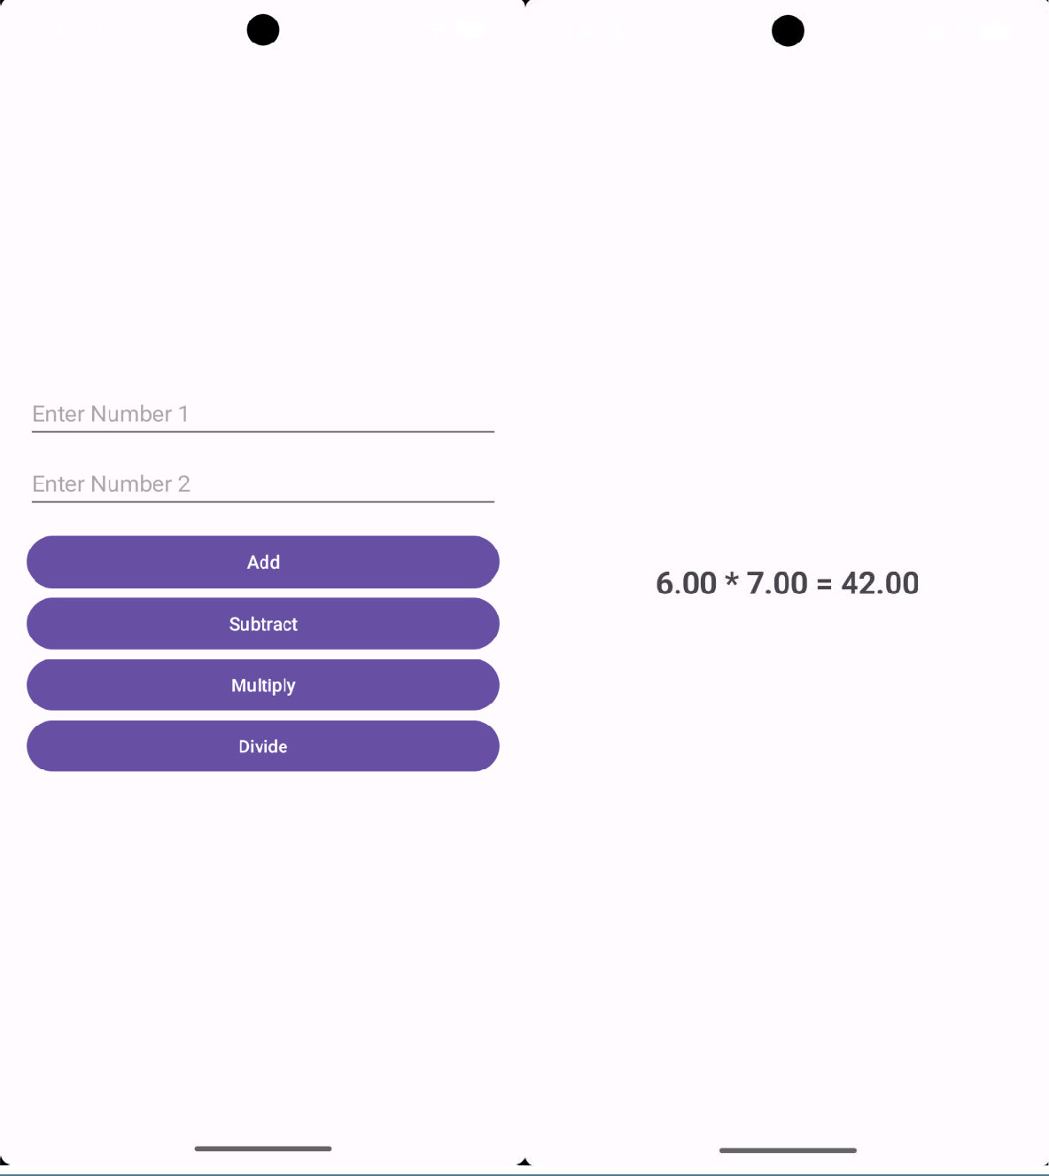

XML Code :-
- activity_main.xml
<EditText
android:id="@+id/etNum1”
android:layout_width=”match_parent” android:layout_height=”wrap_content” android:hint=”Enter Number 1” android:inputType=”numberDecimal” />
<Button
android:id=”@+id/btnAdd” android:text=”Add” android:layout_width=”match_parent” android:layout_height=”wrap_content” android:layout_marginTop=”15dp”/>

activity_result.xml
<TextView
android:id=”@+id/txtResult” android:textSize=”24sp” android:textStyle=”bold” android:text=”Result” android:layout_width=”wrap_content”

android:layout_height=”wrap_content”/>

Java Code :-
- Main Activity
protected void onCreate(Bundle savedInstanceState) { super.onCreate(savedInstanceState); setContentView(R.layout.activity_main);

etNum1 = findViewById(R.id.etNum1); etNum2 = findViewById(R.id.etNum2);

Button btnAdd = findViewById(R.id.btnAdd); Button btnSub = findViewById(R.id.btnSub); Button btnMul = findViewById(R.id.btnMul); Button btnDiv = findViewById(R.id.btnDiv);

// Setting listeners for each operation button btnAdd.setOnClickListener(v -> calculate(“+”)); btnSub.setOnClickListener(v -> calculate(“-“)); btnMul.setOnClickListener(v -> calculate(“*”)); btnDiv.setOnClickListener(v -> calculate(“/”));
}
private void calculate(String op) {
String s1 = etNum1.getText().toString(); String s2 = etNum2.getText().toString();

if (s1.isEmpty() || s2.isEmpty()) { Toast.makeText(this, “Enter both numbers”,
Toast.LENGTH_SHORT).show();

return;
}

try {
double n1 = Double.parseDouble(s1); double n2 = Double.parseDouble(s2); double res = 0;

switch (op) { case “+”:
res = n1 + n2; break;
case “-“:
res = n1 – n2; break;
case “*”:
res = n1 * n2; break;
case “/”:
if (n2 == 0) {
Toast.makeText(this, “Cannot divide by zero”, Toast.LENGTH_SHORT).show();
return;
}
res = n1 / n2; break;
}

Intent i = new Intent(this, ResultActivity.class);

i.putExtra(“n1”, n1);
i.putExtra(“n2”, n2);
i.putExtra(“op”, op);
i.putExtra(“res”, res); startActivity(i);
} catch (NumberFormatException e) {
Toast.makeText(this, “Invalid input”, Toast.LENGTH_SHORT).show();
}
}

ResultActivity
public class ResultActivity extends AppCompatActivity {

@Override
protected void onCreate(Bundle savedInstanceState) { super.onCreate(savedInstanceState); setContentView(R.layout.activity_result);

TextView txt = findViewById(R.id.txtResult);

// Retrieve the data passed from MainActivity double n1 = getIntent().getDoubleExtra(“n1”, 0); double n2 = getIntent().getDoubleExtra(“n2”, 0); String op = getIntent().getStringExtra(“op”);

double res = getIntent().getDoubleExtra(“res”, 0);

// Display the formatted result
String resultText = String.format(Locale.getDefault(), “%.2f %s %.2f =
%.2f”, n1, op, n2, res); txt.setText(resultText);
}
}

Q3) Create the following given scenario using linear and relative layout concept.

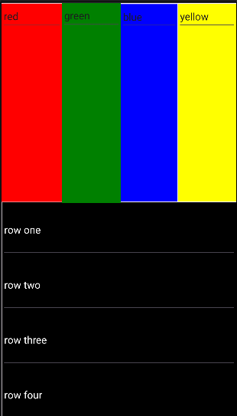
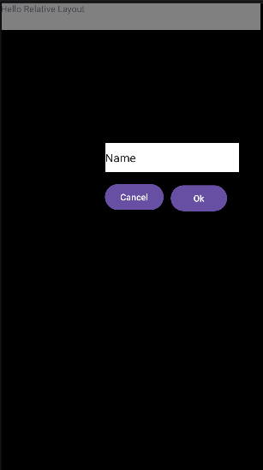

XML Code:-
- Linear Layout
<LinearLayout
android:id=”@+id/linearLayout2” android:layout_width=”410dp” android:layout_height=”96dp” android:orientation=”vertical” android:background=”@color/black” app:layout_constraintBottom_toBottomOf=”parent” app:layout_constraintEnd_toEndOf=”parent” app:layout_constraintStart_toStartOf=”parent” >

<EditText android:id=”@+id/editTextText5” android:layout_width=”match_parent” android:layout_height=”match_parent” android:ems=”10” android:textColor=”@color/white” android:inputType=”text” android:text=”row four” />

</LinearLayout>

Relative Layout

<RelativeLayout android:layout_width=”409dp” android:layout_height=”729dp”
app:layout_constraintBottom_toBottomOf=”parent” app:layout_constraintEnd_toEndOf=”parent” app:layout_constraintHorizontal_bias=”0.0” app:layout_constraintStart_toStartOf=”parent” app:layout_constraintTop_toTopOf=”parent” android:background=”@color/black” app:layout_constraintVertical_bias=”0.0”>

<Button
android:id=”@+id/button2” android:layout_width=”wrap_content” android:layout_height=”wrap_content” android:layout_alignParentBottom=”true” android:layout_marginEnd=”11dp” android:layout_marginBottom=”403dp” android:layout_toStartOf=”@+id/button” android:text=”Cancel” />

<EditText android:id=”@+id/editTextText” android:layout_width=”wrap_content”

android:background=”@color/white” android:layout_height=”wrap_content” android:layout_above=”@+id/button2” android:layout_alignParentTop=”true” android:layout_alignParentEnd=”true” android:layout_marginTop=”218dp” android:layout_marginEnd=”38dp” android:layout_marginBottom=”15dp” android:ems=”10” android:inputType=”text” android:text=”Name” />

<TextView android:id=”@+id/textView2” android:layout_width=”406dp” android:layout_height=”43dp”
android:layout_alignParentStart=”true” android:layout_alignParentTop=”true” android:layout_alignParentEnd=”true” android:layout_alignParentBottom=”true” android:layout_marginStart=”-2dp” android:layout_marginTop=”-2dp” android:layout_marginEnd=”5dp” android:layout_marginBottom=”688dp” android:background=”#808080” android:text=”Hello Relative Layout” />

</RelativeLayout>

Q4) Create an app such that when the user click on the given URL typed by the user, it visits the corresponding page.

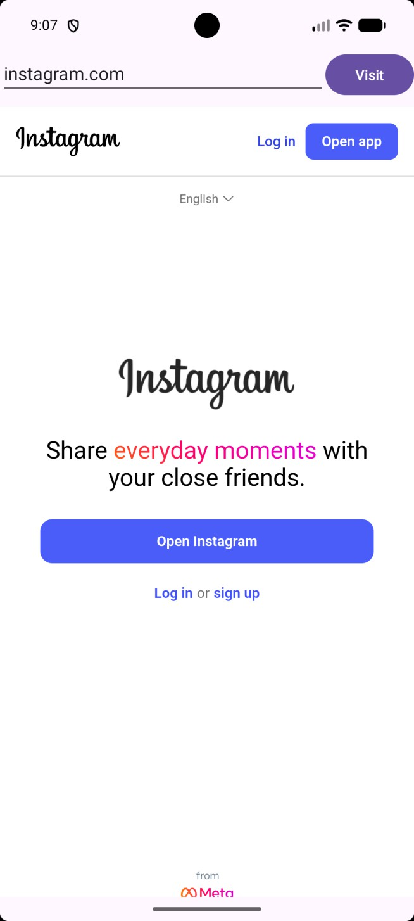

XML Code :-
<?xml version=”1.0” encoding=”utf-8”?>
<LinearLayout xmlns:android=”http://schemas.android.com/apk/res/android”
android:id=”@+id/main” android:layout_width=”match_parent” android:layout_height=”match_parent” android:orientation=”vertical” android:padding=”16dp”>

<LinearLayout android:layout_width=”match_parent” android:layout_height=”wrap_content” android:orientation=”horizontal”>

<EditText android:id=”@+id/editTextUrl” android:layout_width=”0dp” android:layout_height=”wrap_content” android:layout_weight=”1”
android:hint=”Enter URL (e.g. google.com)” android:inputType=”textUri” android:autofillHints=”url” />

<Button android:id=”@+id/buttonVisit”
android:layout_width=”wrap_content”

android:layout_height=”wrap_content” android:text=”Visit” />
</LinearLayout>

<WebView android:id=”@+id/22ebView” android:layout_width=”match_parent” android:layout_height=”0dp” android:layout_weight=”1” android:layout_marginTop=”8dp” />

</LinearLayout>

Java Code :-
protected void onCreate(Bundle savedInstanceState) { super.onCreate(savedInstanceState); EdgeToEdge.enable(this); setContentView(R.layout.activity_main);
ViewCompat.setOnApplyWindowInsetsListener(findViewById(R.id.main), (v, insets) -> {
Insets systemBars = insets.getInsets(WindowInsetsCompat.Type.systemBars());
- setPadding(systemBars.left, systemBars.top, systemBars.right, systemBars.bottom);
return insets;
});
EditText editTextUrl = findViewById(R.id.editTextUrl); Button buttonVisit = findViewById(R.id.buttonVisit); WebView 23ebView = findViewById(R.id.webView);

23ebView.setWebViewClient(new WebViewClient()); 23ebView.getSettings().setJavaScriptEnabled(true);

buttonVisit.setOnClickListener(v -> {
String url = editTextUrl.getText().toString(); if (!url.isEmpty()) {
if (!url.startsWith(“http://”) && !url.startsWith(“https://”)) {

url = “https://” + url;
}
24ebView.loadUrl(url);
}
});
}

LAB 3 Activity and Layout Continued
Q1) Using given scenario develop an application to perform following layout operations
- List view
- Grid view
- Tab layout
- Table layout
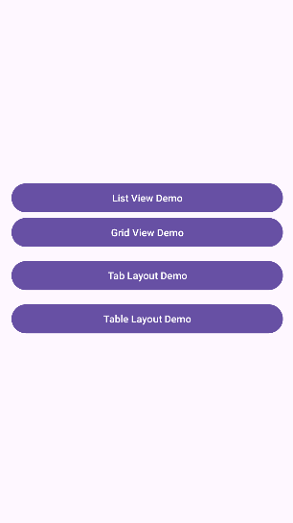
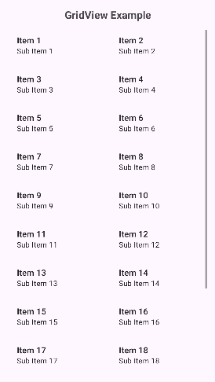
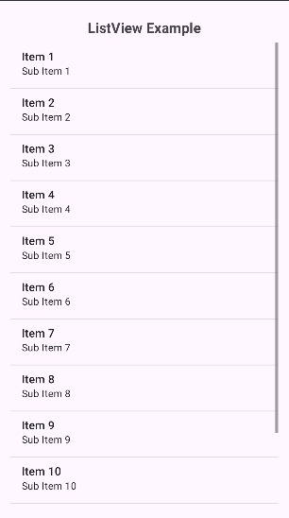
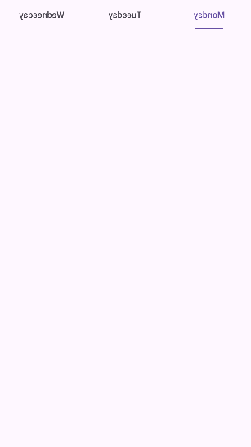
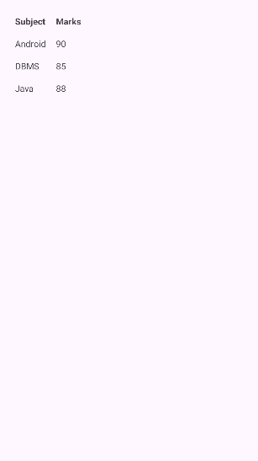

XML Code :-
  - activity_main.xml
<LinearLayout android:layout_width="match_parent" android:layout_height="match_parent" android:orientation="vertical" android:gravity="center" android:padding="16dp">

<Button android:id="@+id/btnListView" android:layout_width="match_parent"
android:layout_height="wrap_content" android:text="List View Demo" />
</LinearLayout>

activity_list_view.xml
<TextView
android:layout_width="match_parent" android:layout_height="wrap_content" android:text="ListView Example" android:textSize="20sp" android:textStyle="bold" android:gravity="center" android:padding="8dp"/>

<ListView android:id="@+id/listView"
android:layout_width="match_parent" android:layout_height="match_parent"/>

activity_grid_view.xml
<GridView
android:id="@+id/gridView" android:layout_width="match_parent" android:layout_height="match_parent" android:horizontalSpacing="10dp" android:numColumns="2" android:stretchMode="columnWidth" android:verticalSpacing="10dp" />

activity_tab_layoyt.xml
<androidx.constraintlayout.widget.ConstraintLayout xmlns:android="http://schemas.android.com/apk/res/android" xmlns:app="http://schemas.android.com/apk/res-auto" xmlns:tools="http://schemas.android.com/tools" android:id="@+id/main" android:layout_width="match_parent" android:layout_height="match_parent" tools:context=".TabLayoutActivity">

<com.google.android.material.tabs.TabLayout android:id="@+id/tabLayout" android:layout_width="0dp"

android:layout_height="wrap_content" app:layout_constraintTop_toTopOf="parent" app:layout_constraintStart_toStartOf="parent" app:layout_constraintEnd_toEndOf="parent">

<com.google.android.material.tabs.TabItem android:layout_width="wrap_content" android:layout_height="wrap_content" android:text="Monday" />

activity_table_layout.xml
<TableLayout
android:id="@+id/tableLayout" android:layout_width="wrap_content" android:layout_height="wrap_content" android:stretchColumns="1" app:layout_constraintTop_toTopOf="parent" app:layout_constraintStart_toStartOf="parent" app:layout_constraintEnd_toEndOf="parent" android:padding="16dp">

<!-- Header Row -->
<TableRow>
<TextView android:text="Subject" android:padding="8dp" android:textStyle="bold" />

<TextView

android:text="Marks" android:padding="8dp" android:textStyle="bold" />
</TableRow>

Java Code :-

- MainActivity
protected void onCreate(Bundle savedInstanceState) { super.onCreate(savedInstanceState); EdgeToEdge.enable(this); setContentView(R.layout.activity_main);

ViewCompat.setOnApplyWindowInsetsListener(findViewById(R.id.main), (v, insets) -> {
Insets systemBars = insets.getInsets(WindowInsetsCompat.Type.systemBars());
  - setPadding(systemBars.left, systemBars.top, systemBars.right, systemBars.bottom);
return insets;
});

Button btnListView = findViewById(R.id.btnListView);

btnListView.setOnClickListener(v -> {
Intent intent = new Intent(MainActivity.this, ListViewActivity.class); startActivity(intent);

});

Button btnGridView = findViewById(R.id.btnGridView); btnGridView.setOnClickListener(v -> {
Intent intent = new Intent(MainActivity.this, GridViewActivity.class); startActivity(intent);
});

Button btnTabLayout = findViewById(R.id.btnTabLayout); btnTabLayout.setOnClickListener(v -> {
Intent intent = new Intent(MainActivity.this, TabLayoutActivity.class);
startActivity(intent);
});
Button btnTableLayout = findViewById(R.id.btnTableLayout); btnTableLayout.setOnClickListener(v -> {
Intent intent = new Intent(MainActivity.this, TableLayoutActivity.class);
startActivity(intent);
});
}

ListViewActivity
public class ListViewActivity extends AppCompatActivity {

ListView listView; @Override
protected void onCreate(Bundle savedInstanceState) { super.onCreate(savedInstanceState);

setContentView(R.layout.activity_list_view); listView = findViewById(R.id.listView);
String[] items = { "Android", "Java",
"Kotlin",
"XML",
"SQLite", "Firebase"
};

ArrayAdapter<String> adapter = new ArrayAdapter<>(this,
android.R.layout.simple_list_item_1, items);

listView.setAdapter(adapter);
}
}

GridViewActivity
protected void onCreate(Bundle savedInstanceState) { super.onCreate(savedInstanceState); EdgeToEdge.enable(this); setContentView(R.layout.activity_grid_view); gridView = findViewById(R.id.gridView);

ViewCompat.setOnApplyWindowInsetsListener(findViewById(R.id.main), (v, insets) -> {
Insets systemBars = insets.getInsets(WindowInsetsCompat.Type.systemBars());
  - setPadding(systemBars.left, systemBars.top, systemBars.right, systemBars.bottom);
return insets;
});
String[] items = { "GridViewItem1", "GridViewItem2", "GridViewItem3", "GridViewItem4", "GridViewItem5", "GridViewItem6"
};

ArrayAdapter<String> adapter = new ArrayAdapter<>( this,
android.R.layout.simple_list_item_1, items
);

gridView.setAdapter(adapter);
}

TabLayoutActivity
TabLayout tabLayout;

ViewPager2 viewPager;

@Override
protected void onCreate(Bundle savedInstanceState) { super.onCreate(savedInstanceState); setContentView(R.layout.activity_tab_layout);

tabLayout = findViewById(R.id.tabLayout); viewPager = findViewById(R.id.viewPager);

TabPagerAdapter adapter = new TabPagerAdapter(this); viewPager.setAdapter(adapter);

new TabLayoutMediator(tabLayout, viewPager, (tab, position) -> {
switch (position) { case 0:
tab.setText("Monday"); break;
case 1:
tab.setText("Tuesday"); break;
case 2:
tab.setText("Wednesday"); break;
}
}).attach();
}

TableLayoutActivity
protected void onCreate(Bundle savedInstanceState) { super.onCreate(savedInstanceState); EdgeToEdge.enable(this); setContentView(R.layout.activity_table_layout);
ViewCompat.setOnApplyWindowInsetsListener(findViewById(R.id.main), (v, insets) -> {
Insets systemBars = insets.getInsets(WindowInsetsCompat.Type.systemBars());
  - setPadding(systemBars.left, systemBars.top, systemBars.right, systemBars.bottom);
return insets;
});

Q2) Write a program to list different sports, and when a sport is selected, display a message showing the selected sport.
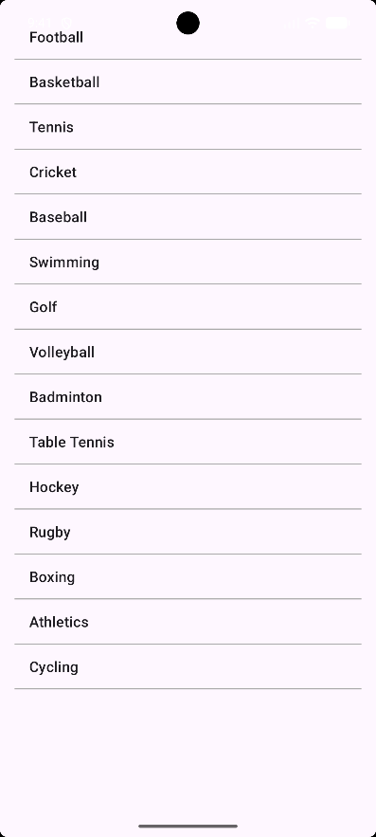

XML Code :-
<androidx.constraintlayout.widget.ConstraintLayout xmlns:android="http://schemas.android.com/apk/res/android" xmlns:app="http://schemas.android.com/apk/res-auto" xmlns:tools="http://schemas.android.com/tools" android:layout_width="match_parent" android:layout_height="match_parent" tools:context=".MainActivity">
<ListView android:id="@+id/listViewSports" android:layout_width="0dp" android:layout_height="0dp" android:layout_margin="16dp"
android:divider="@android:color/darker_gray" android:dividerHeight="1dp" app:layout_constraintBottom_toBottomOf="parent" app:layout_constraintEnd_toEndOf="parent" app:layout_constraintStart_toStartOf="parent" app:layout_constraintTop_toTopOf="parent" />

</androidx.constraintlayout.widget.ConstraintLayout>

Java Code :-
private ListView listViewSports; private String[] sportsArray = {
"Football", "Basketball", "Tennis", "Cricket", "Baseball", "Swimming", "Golf", "Volleyball", "Badminton", "Table Tennis", "Hockey", "Rugby", "Boxing", "Athletics", "Cycling"
};
protected void onCreate(Bundle savedInstanceState) { super.onCreate(savedInstanceState); setContentView(R.layout.activity_main); listViewSports = findViewById(R.id.listViewSports);
ArrayAdapter<String> adapter = new ArrayAdapter<>( this,
android.R.layout.simple_list_item_1, sportsArray
);

listViewSports.setAdapter(adapter); listViewSports.setOnItemClickListener(new
AdapterView.OnItemClickListener() { @Override

public void onItemClick(AdapterView<?> parent, View view, int position, long id) {
String selectedSport = sportsArray[position]; Toast.makeText(
MainActivity.this,
"You selected: " + selectedSport, Toast.LENGTH_SHORT
).show();
}
});
}

Q3) Design an news application and Implement the navigation between sections like Top Stories, Sports, and Entertainment using tab layout.

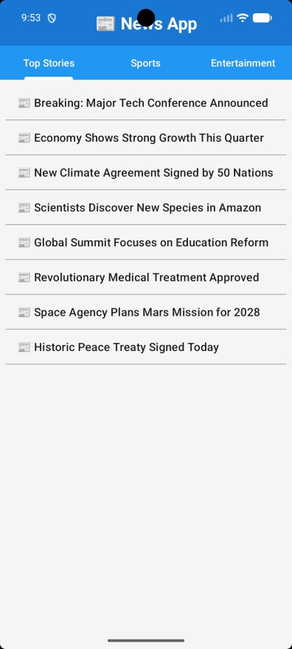
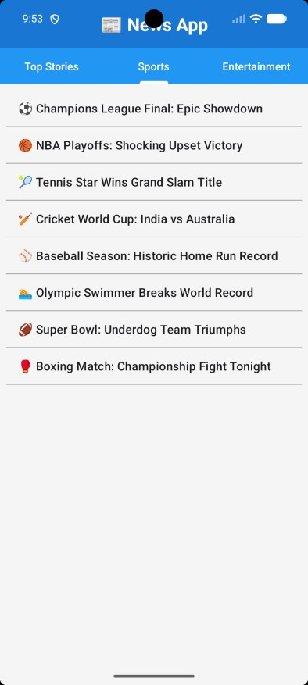
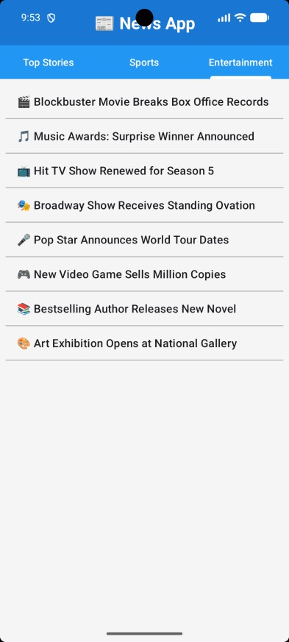

XML Code :-
<?xml version="1.0" encoding="utf-8"?>
<androidx.constraintlayout.widget.ConstraintLayout xmlns:android="http://schemas.android.com/apk/res/android" xmlns:app="http://schemas.android.com/apk/res-auto" xmlns:tools="http://schemas.android.com/tools" android:layout_width="match_parent" android:layout_height="match_parent" tools:context=".MainActivity">

<TextView android:id="@+id/textViewTitle" android:layout_width="0dp" android:layout_height="wrap_content" android:text="📰 News App" android:textSize="24sp" android:textStyle="bold"
android:textColor="@android:color/white" android:background="#1976D2" android:padding="16dp" android:gravity="center"

app:layout_constraintEnd_toEndOf="parent" app:layout_constraintStart_toStartOf="parent" app:layout_constraintTop_toTopOf="parent" />

<com.google.android.material.tabs.TabLayout android:id="@+id/tabLayout" android:layout_width="0dp" android:layout_height="wrap_content" android:background="#2196F3" app:tabTextColor="@android:color/white" app:tabSelectedTextColor="@android:color/white" app:tabIndicatorColor="@android:color/white" app:tabIndicatorHeight="4dp" app:layout_constraintEnd_toEndOf="parent" app:layout_constraintStart_toStartOf="parent"
app:layout_constraintTop_toBottomOf="@id/textViewTitle" />

<androidx.viewpager2.widget.ViewPager2 android:id="@+id/viewPager" android:layout_width="0dp" android:layout_height="0dp" app:layout_constraintBottom_toBottomOf="parent"

app:layout_constraintEnd_toEndOf="parent" app:layout_constraintStart_toStartOf="parent" app:layout_constraintTop_toBottomOf="@id/tabLayout" />

</androidx.constraintlayout.widget.ConstraintLayout>

<ListView
android:id="@+id/listViewSports" android:layout_width="0dp" android:layout_height="0dp" android:layout_margin="8dp" android:divider="@android:color/darker_gray" android:dividerHeight="1dp" app:layout_constraintBottom_toBottomOf="parent" app:layout_constraintEnd_toEndOf="parent" app:layout_constraintStart_toStartOf="parent" app:layout_constraintTop_toTopOf="parent" />

Java Code :-
- Main Activity
private TabLayout tabLayout; private ViewPager2 viewPager; private ViewPagerAdapter adapter; @Override
protected void onCreate(Bundle savedInstanceState) { super.onCreate(savedInstanceState); setContentView(R.layout.activity_main);
tabLayout = findViewById(R.id.tabLayout); viewPager = findViewById(R.id.viewPager); adapter = new ViewPagerAdapter(this); viewPager.setAdapter(adapter);
new TabLayoutMediator(tabLayout, viewPager, (tab, position) -> { switch (position) {
case 0:
tab.setText("Top Stories"); break;
case 1:
tab.setText("Sports"); break;
case 2:
tab.setText("Entertainment"); break;
}
}
).attach();

}

ViewPagerAdapter
public ViewPagerAdapter(@NonNull FragmentActivity fragmentActivity) { super(fragmentActivity);
}

@NonNull @Override
public Fragment createFragment(int position) { switch (position) {
case 0:
return new TopStoriesFragment(); case 1:
return new SportsFragment(); case 2:
return new EntertainmentFragment(); default:
return new TopStoriesFragment();
}
}

@Override
public int getItemCount() { return 3;
}

Fragment Part
private ListView listView; private String[] newsItems = {
"⚽ Champions League Final: Epic Showdown", "🏀 NBA Playoffs: Shocking Upset Victory", "🎾 Tennis Star Wins Grand Slam Title",
"🏏 Cricket World Cup: India vs Australia",
"⚾ Baseball Season: Historic Home Run Record", "🏊 Olympic Swimmer Breaks World Record", "🏈 Super Bowl: Underdog Team Triumphs",
"🥊 Boxing Match: Championship Fight Tonight"
};
@Nullable @Override
public View onCreateView(@NonNull LayoutInflater inflater, @Nullable ViewGroup container, @Nullable Bundle savedInstanceState) {
View view = inflater.inflate(R.layout.fragment_sports, container, false); listView = view.findViewById(R.id.listViewSports); ArrayAdapter<String> adapter = new ArrayAdapter<>(
getContext(), android.R.layout.simple_list_item_1,newsItems
);

listView.setAdapter(adapter);

listView.setOnItemClickListener(new AdapterView.OnItemClickListener() { @Override
public void onItemClick(AdapterView<?> parent, View view, int position, long id) {
Toast.makeText(getContext(), newsItems[position], Toast.LENGTH_SHORT).show();
}
});

return view;
}

LAB 4 Input Controls in Android
Q1) Develop a "Test App" that includes a layout with a Button and a ToggleButton. When each button is clicked, a custom Toast message should be displayed with different images as their content.

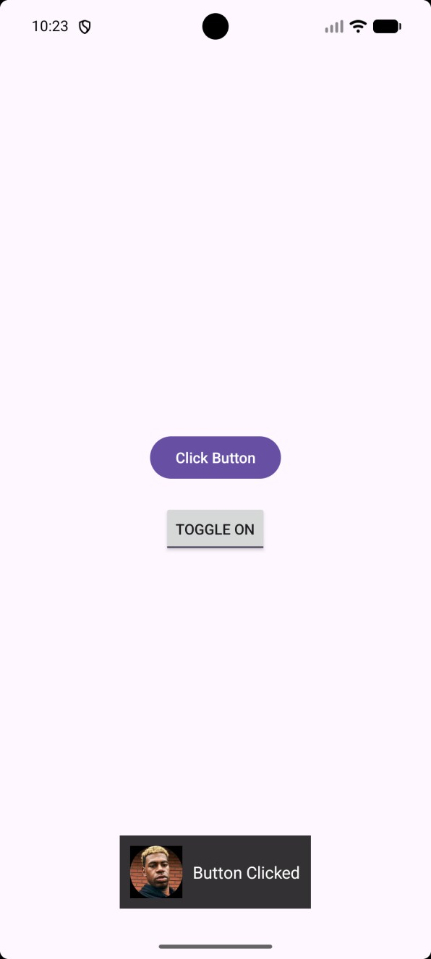
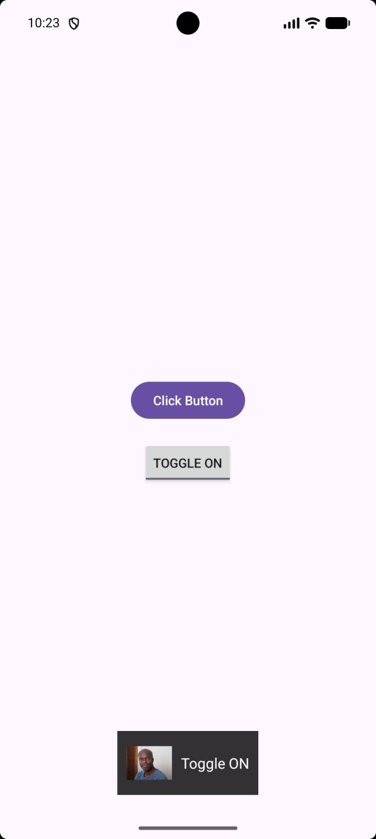
XML Code :-

- activity_main.xml
<?xml version="1.0" encoding="utf-8"?>
<LinearLayout xmlns:android="http://schemas.android.com/apk/res/android"
android:id="@+id/main" android:layout_width="match_parent" android:layout_height="match_parent" android:gravity="center" android:orientation="vertical" android:padding="20dp">

<Button android:id="@+id/btnClick"
android:layout_width="wrap_content" android:layout_height="wrap_content" android:text="Click Button" />

<ToggleButton android:id="@+id/toggleBtn" android:layout_width="wrap_content" android:layout_height="wrap_content" android:layout_marginTop="20dp" android:textOff="Toggle OFF" android:textOn="Toggle ON" />
</LinearLayout>

toast_custom.xml

<ImageView
android:id="@+id/toastImage" android:layout_width="50dp" android:layout_height="50dp" android:layout_marginEnd="10dp" android:scaleType="centerInside" />

<TextView android:id="@+id/toastText"
android:textColor="@android:color/white" android:textSize="16sp" android:layout_width="wrap_content" android:layout_height="wrap_content"/>

Java Code :-

protected void onCreate(Bundle savedInstanceState) { super.onCreate(savedInstanceState); EdgeToEdge.enable(this); setContentView(R.layout.activity_main);

btnClick = findViewById(R.id.btnClick); toggleButton = findViewById(R.id.toggleBtn);

btnClick.setOnClickListener(v -> showCustomToast( "Button Clicked",
R.drawable.floydmal
));

// Using setOnCheckedChangeListener is better for ToggleButtons toggleButton.setOnCheckedChangeListener((buttonView, isChecked) -> {
if (isChecked) {
showCustomToast("Toggle ON", R.drawable.baldksi);
} else {
showCustomToast("Toggle OFF", R.drawable.baldksi);
}
});
ViewCompat.setOnApplyWindowInsetsListener(findViewById(R.id.main), (v, insets) -> {
Insets systemBars = insets.getInsets(WindowInsetsCompat.Type.systemBars());
v.setPadding(systemBars.left, systemBars.top, systemBars.right, systemBars.bottom);
return insets;
});
}

private void showCustomToast(String message, int imageRes) { LayoutInflater inflater = getLayoutInflater();
View view = inflater.inflate(R.layout.toast_custom, null); ImageView image = view.findViewById(R.id.toastImage); TextView text = view.findViewById(R.id.toastText); image.setImageResource(imageRes); text.setText(message);

Toast toast = new Toast(getApplicationContext()); toast.setView(view); toast.setDuration(Toast.LENGTH_SHORT); toast.show();
}

Q2) Create an app that contains a view with multiple buttons, each labelled with different Android versions. When a button is clicked, a Toast message should appear, displaying the corresponding Android version's name along with its associated icon.

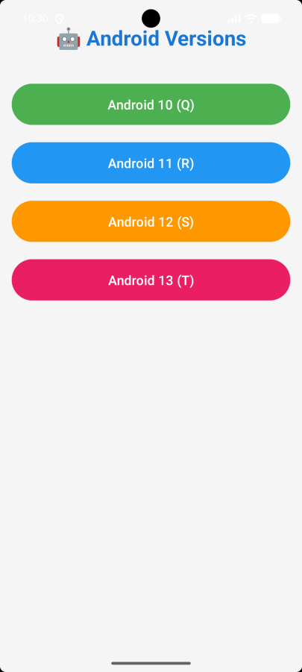
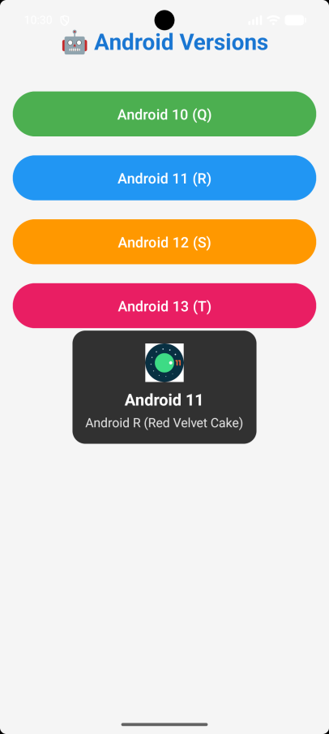
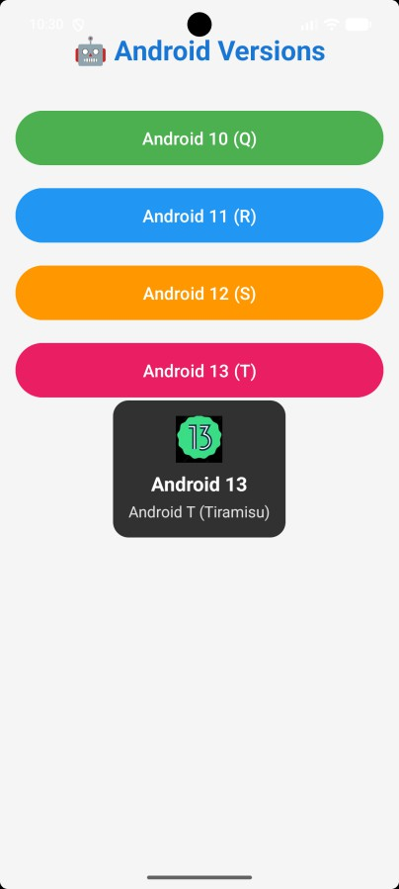

XML Code :-
- activity_main.xml
<androidx.constraintlayout.widget.ConstraintLayout xmlns:android="http://schemas.android.com/apk/res/android" xmlns:app="http://schemas.android.com/apk/res-auto" xmlns:tools="http://schemas.android.com/tools" android:layout_width="match_parent" android:layout_height="match_parent" android:background="#F5F5F5"
android:padding="16dp" tools:context=".MainActivity">

<!-- Title -->
<TextView android:id="@+id/textViewTitle" android:layout_width="0dp" android:layout_height="wrap_content" android:text="🤖 Android Versions" android:textSize="28sp" android:textStyle="bold"

android:textColor="#1976D2" android:gravity="center" android:padding="16dp" app:layout_constraintEnd_toEndOf="parent" app:layout_constraintStart_toStartOf="parent" app:layout_constraintTop_toTopOf="parent" />

<!-- Android 10 Button -->
<Button android:id="@+id/buttonAndroid10" android:layout_width="0dp" android:layout_height="wrap_content" android:text="Android 10 (Q)" android:textSize="18sp" android:padding="16dp" android:layout_marginTop="24dp" android:backgroundTint="#4CAF50"
app:layout_constraintEnd_toEndOf="parent" app:layout_constraintStart_toStartOf="parent" app:layout_constraintTop_toBottomOf="@id/textViewTitle" />

custom_toast.xml
<LinearLayout xmlns:android="http://schemas.android.com/apk/res/android" android:layout_width="wrap_content" android:layout_height="wrap_content" android:orientation="vertical"
android:padding="16dp" android:background="@drawable/toast_background" android:gravity="center">

<!-- Icon -->
<ImageView android:id="@+id/toastIcon" android:layout_width="48dp" android:layout_height="48dp"
android:src="@android:drawable/star_big_on" android:layout_marginBottom="8dp" />

<!-- Version Text -->
<TextView android:id="@+id/toastVersion" android:layout_width="wrap_content" android:layout_height="wrap_content" android:text="Android 10" android:textSize="20sp" android:textStyle="bold" android:textColor="#FFFFFF"

android:layout_marginBottom="4dp" />

Java Code :-
private void showCustomToast(String version, String name, int iconResId) {
// Create a custom Toast
Toast toast = new Toast(getApplicationContext()); toast.setDuration(Toast.LENGTH_LONG); toast.setGravity(Gravity.CENTER, 0, 0);
// Inflate custom layout
LayoutInflater inflater = getLayoutInflater();
View layout = inflater.inflate(R.layout.custom_toast, null);
// Get views from custom layout
ImageView imageIcon = layout.findViewById(R.id.toastIcon); TextView textVersion = layout.findViewById(R.id.toastVersion); TextView textName = layout.findViewById(R.id.toastName);
// Set the icon and text imageIcon.setImageResource(iconResId); textVersion.setText(version); textName.setText(name);
// Set the custom layout to the toast toast.setView(layout);

// Show the toast toast.show();
}

buttonAndroid10.setOnClickListener(new View.OnClickListener() { @Override
public void onClick(View v) {
showCustomToast("Android 10", "Android Q (Queen Cake)", R.drawable.android_10);
}
});

Q3) Develop a view with a ToggleButton labeled "Current Mode" that has two states: "Wi-Fi" and "Mobile Data." Based on the state of the toggle button, an image corresponding to the selected mode should appear, and a Toast message should display the current mode. Additionally, when the user clicks the "Change Mode" button, the app should switch to the corresponding mode and update the image accordingly.
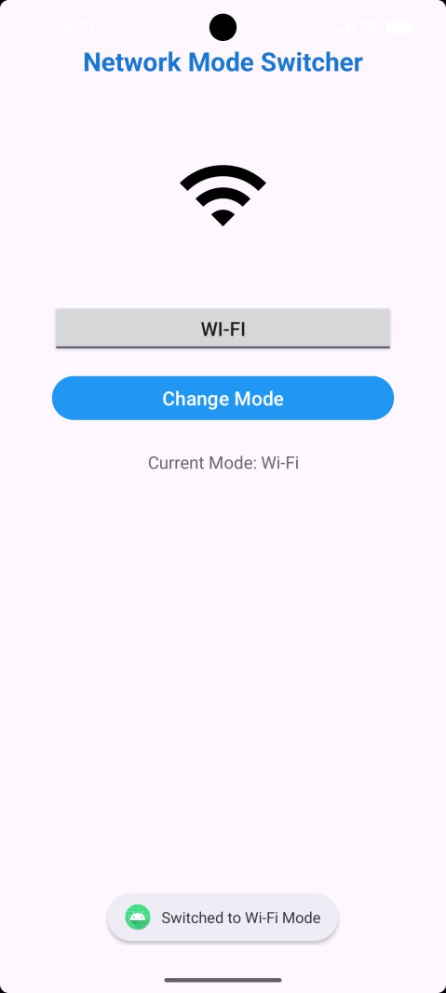
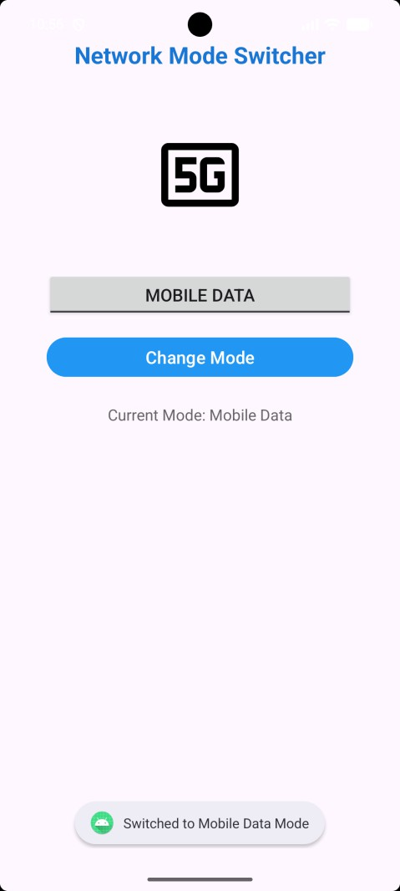

XML Code :-
<androidx.constraintlayout.widget.ConstraintLayout xmlns:android="http://schemas.android.com/apk/res/android"
xmlns:app="http://schemas.android.com/apk/res-auto" xmlns:tools="http://schemas.android.com/tools" android:id="@+id/main" android:layout_width="match_parent" android:layout_height="match_parent" android:padding="16dp" tools:context=".MainActivity">

<!-- Title -->
<TextView android:id="@+id/textViewTitle" android:layout_width="0dp" android:layout_height="wrap_content" android:text="Network Mode Switcher" android:textAlignment="center" android:textSize="24sp" android:textStyle="bold"

android:textColor="#1976D2" android:layout_marginTop="24dp" app:layout_constraintEnd_toEndOf="parent" app:layout_constraintStart_toStartOf="parent" app:layout_constraintTop_toTopOf="parent" />

<!-- ONLY ONE ImageView needed! -->
<ImageView android:id="@+id/imageViewMode" android:layout_width="150dp" android:layout_height="150dp" android:scaleType="fitCenter" android:src="@drawable/ic_wifi_foreground" android:layout_marginTop="32dp" app:layout_constraintEnd_toEndOf="parent" app:layout_constraintStart_toStartOf="parent"
app:layout_constraintTop_toBottomOf="@id/textViewTitle" />

<!-- Toggle Button -->
<ToggleButton android:id="@+id/toggleButtonMode" android:layout_width="0dp"

android:layout_height="wrap_content" android:checked="true" android:text="Current Mode" android:textOff="Mobile Data" android:textOn="Wi-Fi" android:textSize="18sp" android:layout_marginTop="24dp" android:layout_marginStart="32dp" android:layout_marginEnd="32dp" app:layout_constraintEnd_toEndOf="parent" app:layout_constraintStart_toStartOf="parent"
app:layout_constraintTop_toBottomOf="@id/imageViewMode" />

<!-- Change Mode Button -->
<Button android:id="@+id/buttonChangeMode" android:layout_width="0dp" android:layout_height="wrap_content" android:text="Change Mode" android:textSize="18sp" android:backgroundTint="#2196F3" android:layout_marginTop="16dp"

android:layout_marginStart="32dp" android:layout_marginEnd="32dp" app:layout_constraintEnd_toEndOf="parent" app:layout_constraintStart_toStartOf="parent" app:layout_constraintTop_toBottomOf="@id/toggleButtonMode" />

Java Code :-
private ToggleButton toggleButtonMode; private ImageView imageViewMode;
private Button buttonChangeMode; private TextView textViewStatus;
@Override
protected void onCreate(Bundle savedInstanceState) { super.onCreate(savedInstanceState); setContentView(R.layout.activity_main);

// STEP 2: Initialize - Find all views from the layout toggleButtonMode = findViewById(R.id.toggleButtonMode); imageViewMode = findViewById(R.id.imageViewMode); buttonChangeMode = findViewById(R.id.buttonChangeMode); textViewStatus = findViewById(R.id.textViewStatus);

// STEP 3: Set up ToggleButton listener
// This listens for when the user clicks the toggle toggleButtonMode.setOnCheckedChangeListener(new

CompoundButton.OnCheckedChangeListener() { @Override
public void onCheckedChanged(CompoundButton buttonView, boolean isChecked) {
// isChecked = true means Wi-Fi (ON state)
// isChecked = false means Mobile Data (OFF state) updateMode(isChecked);
}
});
buttonChangeMode.setOnClickListener(new View.OnClickListener() { @Override
public void onClick(View v) {
// Flip the toggle state
// If it's currently ON (true), make it OFF (false)
// If it's currently OFF (false), make it ON (true) toggleButtonMode.setChecked(!toggleButtonMode.isChecked());

// Note: We don't need to call updateMode() here because
// changing the toggle will automatically trigger the listener above
}
});
updateMode(toggleButtonMode.isChecked());
}
private void updateMode(boolean isWifiMode) { if (isWifiMode) {
imageViewMode.setImageResource(R.drawable.ic_wifi_foreground); textViewStatus.setText("Current Mode: Wi-Fi");
Toast.makeText(this, "Switched to Wi-Fi Mode",

Toast.LENGTH_SHORT).show();
} else {

imageViewMode.setImageResource(R.drawable.ic_mobile_data_foreground); textViewStatus.setText("Current Mode: Mobile Data"); Toast.makeText(this, "Switched to Mobile Data Mode",
Toast.LENGTH_SHORT).show();
}
}

Q4) Create a “Food Ordering App” which lists food items with check boxes. Once the user checks /unchecks the item and click on the submit button display the items ordered along with cost of each item and total cost in a new activity. Once the user clicks on the submit button he/she should not be allowed to change the order i.e. he should not be allowed to change the state of the items checked.
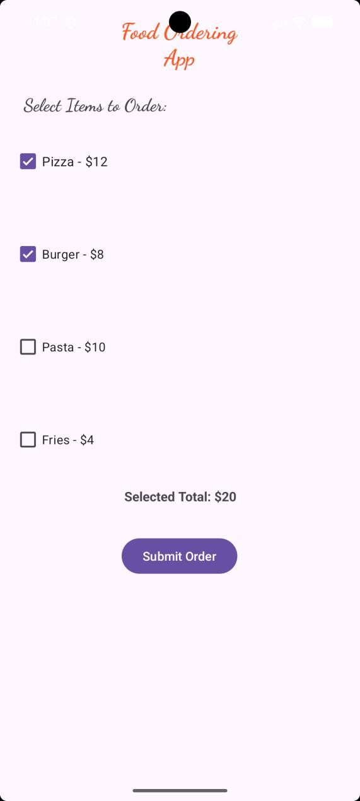
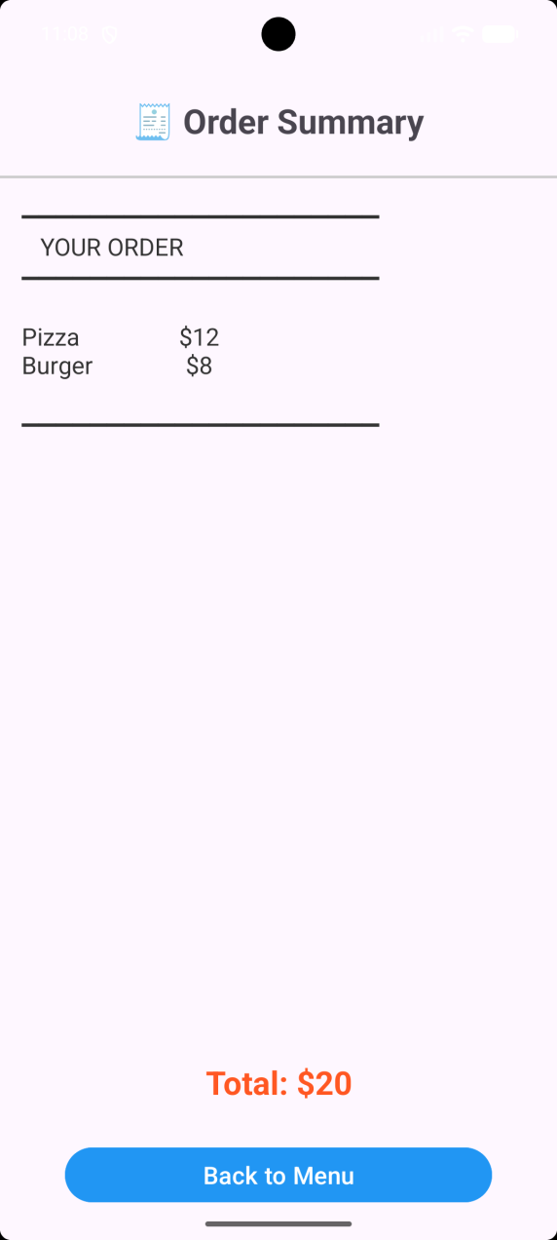

XML Code :-
- activity_main.xml
<TextView
android:id="@+id/textViewTitle" android:layout_width="155dp" android:layout_height="64dp" android:layout_marginTop="16dp" android:text="Food Ordering App" android:textAlignment="center" android:fontFamily="cursive" android:textColor="@color/orange" android:textSize="25dp" android:textStyle="bold" app:layout_constraintEnd_toEndOf="parent" app:layout_constraintHorizontal_bias="0.498" app:layout_constraintStart_toStartOf="parent" app:layout_constraintTop_toTopOf="parent" />

<CheckBox android:id="@+id/checkBoxPizza" android:layout_width="157dp" android:layout_height="42dp" android:layout_marginStart="16dp" android:layout_marginTop="8dp"

android:text="Pizza - $12" android:textSize="15dp" app:layout_constraintStart_toStartOf="parent"
app:layout_constraintTop_toBottomOf="@+id/textViewInstruction" />
<Button
android:id="@+id/buttonSubmit" android:layout_width="wrap_content" android:layout_height="wrap_content" android:layout_marginTop="88dp" android:text="Submit Order" app:layout_constraintEnd_toEndOf="parent" app:layout_constraintHorizontal_bias="0.498" app:layout_constraintStart_toStartOf="parent"
app:layout_constraintTop_toBottomOf="@+id/checkBoxFries" />

activity_order_summary.xml
<TextView
android:id="@+id/textViewOrderTitle" android:layout_width="wrap_content" android:layout_height="wrap_content" android:layout_marginTop="72dp" android:text="□ Order Summary" android:textSize="25sp" android:textStyle="bold"

android:textAlignment="center" app:layout_constraintEnd_toEndOf="parent" app:layout_constraintHorizontal_bias="0.498" app:layout_constraintStart_toStartOf="parent" app:layout_constraintTop_toTopOf="parent" />

<View
android:id="@+id/viewDivider" android:layout_width="0dp" android:layout_height="2dp" android:layout_marginTop="24dp" android:background="#CCCCCC" app:layout_constraintEnd_toEndOf="parent" app:layout_constraintHorizontal_bias="0.0" app:layout_constraintStart_toStartOf="parent"
app:layout_constraintTop_toBottomOf="@+id/textViewOrderTitle" />
<ScrollView android:id="@+id/scrollViewItems" android:layout_width="0dp" android:layout_height="0dp" android:layout_marginBottom="200dp"
app:layout_constraintBottom_toBottomOf="parent" app:layout_constraintEnd_toEndOf="parent" app:layout_constraintHorizontal_bias="0.0" app:layout_constraintStart_toStartOf="parent" app:layout_constraintTop_toBottomOf="@+id/viewDivider" app:layout_constraintVertical_bias="0.0">
<TextView android:id="@+id/textViewOrderedItems"

android:layout_width="match_parent" android:layout_height="wrap_content" android:text="Your order will appear here" android:textSize="18sp" android:padding="16dp" android:textColor="#333333" />
</ScrollView>

Java Code :-
- MainActivity
protected void onCreate(Bundle savedInstanceState) { super.onCreate(savedInstanceState); setContentView(R.layout.activity_main); checkBoxPizza = findViewById(R.id.checkBoxPizza); checkBoxBurger = findViewById(R.id.checkBoxBurger); checkBoxPasta = findViewById(R.id.checkBoxPasta); checkBoxFries = findViewById(R.id.checkBoxFries); buttonSubmit = findViewById(R.id.buttonSubmit); textViewTotal = findViewById(R.id.textViewTotal);

CheckBox[] allCheckBoxes = {
checkBoxPizza, checkBoxBurger, checkBoxPasta, checkBoxFries
};

CompoundButton.OnCheckedChangeListener updateTotalListener = new CompoundButton.OnCheckedChangeListener() {
@Override

public void onCheckedChanged(@NonNull CompoundButton buttonView, boolean isChecked) {
updateRunningTotal();
}
};

for (CheckBox checkBox : allCheckBoxes) { checkBox.setOnCheckedChangeListener(updateTotalListener);
}

buttonSubmit.setOnClickListener(new View.OnClickListener() { @Override
public void onClick(View v) {
// Check if any item is selected if (!isAnyItemSelected()) {
Toast.makeText(MainActivity.this, "Please select at least one item!", Toast.LENGTH_SHORT).show();
return;
}
// CRITICAL: Disable all checkboxes so user can't change order disableAllCheckboxes();

orderSubmitted = true; buttonSubmit.setText("Order Submitted ✓");
buttonSubmit.setEnabled(false); // Disable submit button too

ArrayList<String> selectedItems = new ArrayList<>(); ArrayList<Integer> selectedPrices = new ArrayList<>();

if (checkBoxPizza.isChecked()) { selectedItems.add(foodNames[0]); selectedPrices.add(foodPrices[0]);
}
if (checkBoxBurger.isChecked()) { selectedItems.add(foodNames[1]); selectedPrices.add(foodPrices[1]);
}
if (checkBoxPasta.isChecked()) { selectedItems.add(foodNames[2]); selectedPrices.add(foodPrices[2]);
}

if (checkBoxFries.isChecked()) { selectedItems.add(foodNames[3]); selectedPrices.add(foodPrices[3]);
}

Intent intent = new Intent(MainActivity.this, OrderSummaryActivity.class);
// Pass data to next activity intent.putStringArrayListExtra("items", selectedItems); intent.putIntegerArrayListExtra("prices", selectedPrices);

// Start the OrderSummaryActivity startActivity(intent);
}
});

}
private boolean isAnyItemSelected() { return checkBoxPizza.isChecked() ||
checkBoxBurger.isChecked() || checkBoxPasta.isChecked() || checkBoxFries.isChecked();
}
private void updateRunningTotal() {
// Don't update if order already submitted if (orderSubmitted) {
return;
}

int total = 0;

if (checkBoxPizza.isChecked()) total += foodPrices[0]; if (checkBoxBurger.isChecked()) total += foodPrices[1]; if (checkBoxPasta.isChecked()) total += foodPrices[2]; if (checkBoxFries.isChecked()) total += foodPrices[3];

textViewTotal.setText("Selected Total: $" + total);
}

OrderSummaryActivity
protected void onCreate(Bundle savedInstanceState) { super.onCreate(savedInstanceState); setContentView(R.layout.activity_order_summary);

// STEP 1: Initialize views

textViewOrderedItems = findViewById(R.id.textViewOrderedItems); textViewOrderTotal = findViewById(R.id.textViewOrderTotal); buttonBack = findViewById(R.id.buttonBack);

// STEP 2: Get data from MainActivity Intent intent = getIntent();
ArrayList<String> items = intent.getStringArrayListExtra("items"); ArrayList<Integer> prices = intent.getIntegerArrayListExtra("prices");

// STEP 3: Build the order summary
StringBuilder orderSummary = new StringBuilder(); orderSummary.append("━━━━━━━━━━━━━━━━━━━━━\n"); orderSummary.append(" YOUR ORDER\n"); orderSummary.append("━━━━━━━━━━━━━━━━━━━━━\n\n");

int total = 0;

// Add each item to the summary if (items != null && prices != null) {
for (int i = 0; i < items.size(); i++) { String itemName = items.get(i); int itemPrice = prices.get(i);

orderSummary.append(String.format("%-20s $%d\n", itemName, itemPrice));
total += itemPrice;
}
}

orderSummary.append("\n━━━━━━━━━━━━━━━━━━━━━\n");

// STEP 4: Display the order textViewOrderedItems.setText(orderSummary.toString()); textViewOrderTotal.setText("Total: $" + total);

// STEP 5: Set up Back button buttonBack.setOnClickListener(new View.OnClickListener() {
@Override
public void onClick(View v) {
// Go back to MainActivity
finish(); // This closes OrderSummaryActivity and returns to previous screen
}
});
}

