

Mobile Application Development

LAB
Lab Record 1 - 4 Name : Lakshya Jain Reg. : 230953334
Batch : CCE – C2

LAB NO: 1

BASICS OF ANDROID MOBILE APPLICATION DEVELOPMENT TOOL

Lab exercises:
Develop an Android application for the following program
- Create an Android application to show the demo of displaying text with justifying elements, changing text colors, fonts etc.
- Find the “hello word” text in the XML document and modify the text.

Program note : I have consolidated these two questions into a single application

XML Layout: Activity Main (activity_main.xml)
<?xml version="1.0" encoding="utf-8"?>
<LinearLayout
xmlns:android="http://schemas.android.com/apk/res/android" android:layout_width="match_parent" android:layout_height="match_parent" android:orientation="vertical"
android:gravity="center" android:padding="20dp" android:background="#FFFFFF">

<TextView
android:id="@+id/demoText" android:layout_width="match_parent" android:layout_height="wrap_content"
android:text="This is a demo of Text Styling in Android.\n\nWe can change colors, fonts, size, and even justify the text properly."
android:textSize="20sp" android:textColor="#FF5722" android:textStyle="bold" android:justificationMode="inter_word" android:padding="15dp" android:fontFamily="sans-serif"/>

<!-- Button to go to Second Screen -->
<Button
android:id="@+id/nextBtn" android:layout_width="wrap_content" android:layout_height="wrap_content" android:text="Go to Modify Hello World" android:layout_marginTop="30dp"/>
</LinearLayout>

XML Layout: Activity Main (activity_second.xml)
<?xml version="1.0" encoding="utf-8"?>
<LinearLayout
xmlns:android="http://schemas.android.com/apk/res/android" android:layout_width="match_parent" android:layout_height="match_parent" android:orientation="vertical"
android:gravity="center" android:padding="20dp">

<TextView
android:id="@+id/helloText" android:layout_width="wrap_content" android:layout_height="wrap_content" android:text="Hello World" android:textSize="26sp" android:textColor="#0000FF" android:textStyle="italic" android:padding="20dp"/>

<Button
android:id="@+id/changeBtn" android:layout_width="wrap_content" android:layout_height="wrap_content" android:text="Modify Hello World Text"/>
</LinearLayout>

Java Source: Main Activity (MainActivity.java)
package com.example.lab1;

import android.content.Intent; import android.os.Bundle; import android.widget.Button;

import androidx.appcompat.app.AppCompatActivity; public class MainActivity extends AppCompatActivity {
Button nextBtn;

@Override
protected void onCreate(Bundle savedInstanceState) { super.onCreate(savedInstanceState); setContentView(R.layout.activity_main);

nextBtn = findViewById(R.id.nextBtn);

// Move to Second Screen nextBtn.setOnClickListener(v -> {
Intent intent = new Intent(MainActivity.this, SecondActivity.class);
startActivity(intent);
});
}
}

Java Source: Main Activity (SecondActivity.java)
package com.example.lab1;

import android.graphics.Color; import android.os.Bundle; import android.widget.Button; import android.widget.TextView;

import androidx.appcompat.app.AppCompatActivity;
public class SecondActivity extends AppCompatActivity { TextView helloText;
Button changeBtn;

@Override
protected void onCreate(Bundle savedInstanceState) { super.onCreate(savedInstanceState); setContentView(R.layout.activity_second);

helloText = findViewById(R.id.helloText); changeBtn = findViewById(R.id.changeBtn);

// Modify Hello World Text on Button Click changeBtn.setOnClickListener(v -> {
helloText.setText("Text Modified Successfully!"); helloText.setTextColor(Color.GREEN); helloText.setTextSize(28);
});
}
}

Manifests: (AndroidManifest.xml)

<?xml version="1.0" encoding="utf-8"?>
<manifest xmlns:android="http://schemas.android.com/apk/res/android" xmlns:tools="http://schemas.android.com/tools">

<application
android:allowBackup="true" android:dataExtractionRules="@xml/data_extraction_rules" android:fullBackupContent="@xml/backup_rules" android:icon="@mipmap/ic_launcher" android:label="@string/app_name" android:roundIcon="@mipmap/ic_launcher_round" android:supportsRtl="true" android:theme="@style/Theme.Lab1">
<activity android:name=".SecondActivity"></activity>
<activity
android:name=".MainActivity" android:exported="true">
<intent-filter>
<action android:name="android.intent.action.MAIN" />

<category android:name="android.intent.category.LAUNCHER"
/>
</intent-filter>
</activity>
</application>

</manifest>

Output:
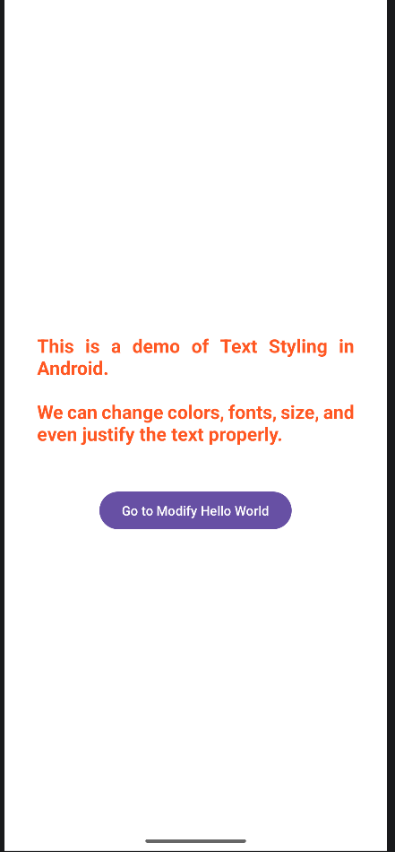
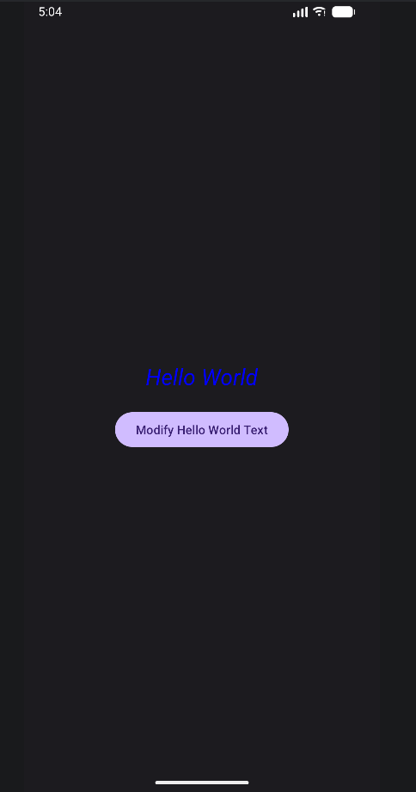

LAB NO: 2

INTRODUCTION TO ACTIVITY AND LAYOUTS IN ANDROID

Lab exercises
1.Create an app that illustrates that the activity lifecycle method being triggered by various action. Understand when
onCreate(),onStart(),onResume event occur.

XML Layout: Activity Main (activity_main.xml)
<?xml version="1.0" encoding="utf-8"?>
<LinearLayout
xmlns:android="http://schemas.android.com/apk/res/android" android:layout_width="match_parent" android:layout_height="match_parent" android:orientation="vertical"
android:padding="20dp" android:gravity="center">

<TextView
android:id="@+id/lifecycleText" android:layout_width="match_parent" android:layout_height="wrap_content" android:text="Activity Lifecycle Events Will Appear Here" android:textSize="18sp"
android:textStyle="bold" android:padding="15dp" android:background="#E0E0E0"/>

</LinearLayout>

Java Source: Main Activity (MainActivity.java)

package com.example.lab2;

import android.os.Bundle; import android.util.Log;
import android.widget.TextView;

import androidx.appcompat.app.AppCompatActivity; public class MainActivity extends AppCompatActivity {

TextView lifecycleText; String message = "";

@Override
protected void onCreate(Bundle savedInstanceState) { super.onCreate(savedInstanceState); setContentView(R.layout.activity_main);

lifecycleText = findViewById(R.id.lifecycleText);

message += "onCreate() Called\n"; lifecycleText.setText(message);

Log.d("LifecycleEvent", "onCreate() Triggered");
}

@Override
protected void onStart() { super.onStart();

message += "onStart() Called\n"; lifecycleText.setText(message);

Log.d("LifecycleEvent", "onStart() Triggered");
}

@Override
protected void onResume() { super.onResume();

message += "onResume() Called\n"; lifecycleText.setText(message);

Log.d("LifecycleEvent", "onResume() Triggered");
}

@Override
protected void onPause() { super.onPause();

Log.d("LifecycleEvent", "onPause() Triggered");
}

@Override
protected void onStop() { super.onStop();

Log.d("LifecycleEvent", "onStop() Triggered");
}

@Override
protected void onDestroy() { super.onDestroy();

Log.d("LifecycleEvent", "onDestroy() Triggered");
}
}

Output:
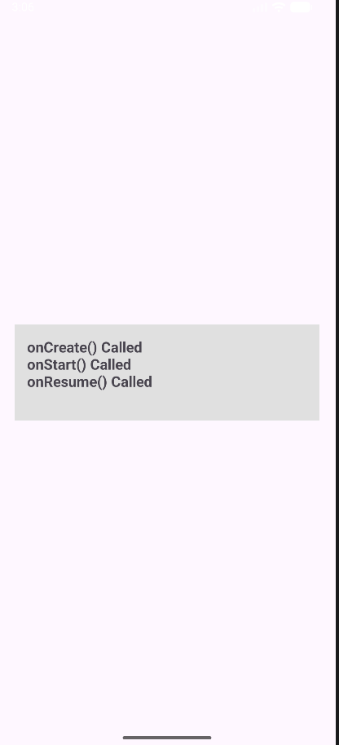

Q2 Create a Calculator app that does the function of multiplication,
addition, division, subtraction but displays the result in the format of:-Num1 operator num2 = result. Back button on the next activity should get back to the calculator activity again.

XML Layout : Activity Main (activity_main.xml)

<?xml version="1.0" encoding="utf-8"?>
<LinearLayout
xmlns:android="http://schemas.android.com/apk/res/android" android:layout_width="match_parent" android:layout_height="match_parent" android:orientation="vertical" android:background="#F5F5F5"
android:padding="25dp">

<!-- Title -->
<TextView
android:layout_width="wrap_content" android:layout_height="wrap_content" android:text="Calculator App" android:textSize="28sp" android:textStyle="bold" android:textColor="#222" android:layout_gravity="center" android:paddingBottom="20dp"/>

<!-- Input 1 -->
<EditText
android:id="@+id/num1" android:layout_width="match_parent" android:layout_height="wrap_content" android:hint="Enter Number 1" android:inputType="numberDecimal" android:padding="15dp" android:background="@android:drawable/edit_text" android:textSize="18sp"/>

<!-- Input 2 -->
<EditText
android:id="@+id/num2" android:layout_width="match_parent" android:layout_height="wrap_content" android:hint="Enter Number 2" android:inputType="numberDecimal" android:layout_marginTop="15dp" android:padding="15dp" android:background="@android:drawable/edit_text" android:textSize="18sp"/>

<!-- Buttons Layout -->
<GridLayout
android:layout_width="match_parent" android:layout_height="wrap_content" android:layout_marginTop="25dp" android:columnCount="2" android:rowCount="2" android:alignmentMode="alignMargins" android:useDefaultMargins="true">

<Button
android:id="@+id/btnAdd" android:text="+ Add" android:textSize="18sp" android:layout_width="0dp" android:layout_height="60dp" android:layout_columnWeight="1"/>

<Button
android:id="@+id/btnSub" android:text="- Subtract" android:textSize="18sp" android:layout_width="0dp"

android:layout_height="60dp" android:layout_columnWeight="1"/>

<Button
android:id="@+id/btnMul" android:text="× Multiply" android:textSize="18sp" android:layout_width="0dp" android:layout_height="60dp" android:layout_columnWeight="1"/>

<Button
android:id="@+id/btnDiv" android:text="÷ Divide" android:textSize="18sp" android:layout_width="0dp" android:layout_height="60dp" android:layout_columnWeight="1"/>
</GridLayout>

</LinearLayout>

XML Layout : Activity Main (activity_result.xml)

<?xml version="1.0" encoding="utf-8"?>
<LinearLayout
xmlns:android="http://schemas.android.com/apk/res/android" android:layout_width="match_parent" android:layout_height="match_parent" android:gravity="center"
android:orientation="vertical" android:padding="30dp" android:background="#FFFFFF">

<TextView
android:layout_width="wrap_content" android:layout_height="wrap_content" android:text="Result" android:textSize="30sp" android:textStyle="bold" android:textColor="#222" android:paddingBottom="25dp"/>

<!-- Expression Output -->
<TextView
android:id="@+id/resultText" android:layout_width="match_parent" android:layout_height="wrap_content"

android:text="10 + 5 = 15" android:textSize="22sp" android:textStyle="bold" android:textColor="#4CAF50" android:gravity="center" android:padding="20dp" android:background="#F0F0F0"/>

</LinearLayout>

Java Source: Main Activity (MainActivity.java)
package com.example.lab2;

import android.content.Intent; import android.os.Bundle; import android.widget.Button; import android.widget.EditText; import android.widget.Toast;

import androidx.appcompat.app.AppCompatActivity; public class MainActivity2 extends AppCompatActivity {
EditText num1, num2;
Button btnAdd, btnSub, btnMul, btnDiv;

@Override
protected void onCreate(Bundle savedInstanceState) { super.onCreate(savedInstanceState); setContentView(R.layout.activity_main2);

// Linking UI
num1 = findViewById(R.id.num1); num2 = findViewById(R.id.num2);

btnAdd = findViewById(R.id.btnAdd); btnSub = findViewById(R.id.btnSub); btnMul = findViewById(R.id.btnMul);

btnDiv = findViewById(R.id.btnDiv);

// Button Clicks
btnAdd.setOnClickListener(v -> calculate("+")); btnSub.setOnClickListener(v -> calculate("-")); btnMul.setOnClickListener(v -> calculate("*")); btnDiv.setOnClickListener(v -> calculate("/"));
}

private void calculate(String operator) {

if (num1.getText().toString().isEmpty() || num2.getText().toString().isEmpty()) {
Toast.makeText(this, "Please enter both numbers!", Toast.LENGTH_SHORT).show();
return;
}

double n1 = Double.parseDouble(num1.getText().toString()); double n2 = Double.parseDouble(num2.getText().toString());

double result = 0;

switch (operator) { case "+":
result = n1 + n2; break;

case "-":
result = n1 - n2; break;

case "*":
result = n1 * n2; break;

case "/":
if (n2 == 0) {
Toast.makeText(this, "Cannot divide by zero!", Toast.LENGTH_SHORT).show();

return;
}
result = n1 / n2; break;
}
String expression = n1 + " " + operator + " " + n2 + " = " +
result;

Intent intent = new Intent(MainActivity2.this, ResultActivity.class);
intent.putExtra("finalResult", expression); startActivity(intent);
}
}

Java Source: Main Activity (ResultActivity.java)
package com.example.lab2;

import android.os.Bundle; import android.widget.TextView;

import androidx.appcompat.app.AppCompatActivity;

public class ResultActivity extends AppCompatActivity { TextView resultText;
@Override
protected void onCreate(Bundle savedInstanceState) { super.onCreate(savedInstanceState); setContentView(R.layout.activity_result);

resultText = findViewById(R.id.resultText);

// Get expression from intent
String finalResult = getIntent().getStringExtra("finalResult");

resultText.setText(finalResult);
}
}

Output :
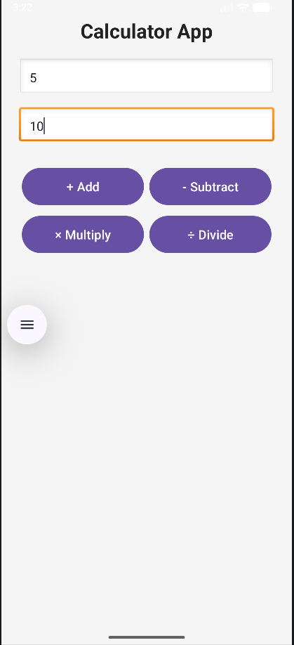
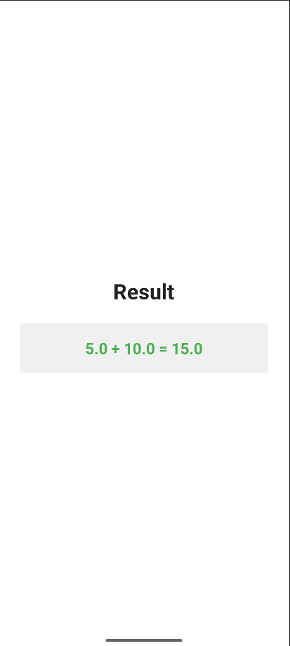

- Create the following given scenario using linear and relative layout concept.

XML Layout : Activity Main (activity_linear.xml)

<?xml version="1.0" encoding="utf-8"?>

<!-- Main Vertical Layout -->
<LinearLayout xmlns:android="http://schemas.android.com/apk/res/android" android:layout_width="match_parent" android:layout_height="match_parent"

android:orientation="vertical" android:background="#000000">

<!-- Top Horizontal Color Blocks -->
<LinearLayout
android:layout_width="match_parent" android:layout_height="200dp" android:orientation="horizontal">

<!-- RED -->
<TextView
android:layout_width="0dp" android:layout_height="match_parent" android:layout_weight="1" android:background="#FF0000" android:text="red" android:textColor="#FFFFFF" android:gravity="top|center" android:padding="5dp"/>

<!-- GREEN -->
<TextView
android:layout_width="0dp" android:layout_height="match_parent" android:layout_weight="1" android:background="#00FF00" android:text="green" android:textColor="#FFFFFF" android:gravity="top|center" android:padding="5dp"/>

<!-- BLUE -->
<TextView
android:layout_width="0dp" android:layout_height="match_parent" android:layout_weight="1" android:background="#0000FF" android:text="blue" android:textColor="#FFFFFF" android:gravity="top|center" android:padding="5dp"/>

<!-- YELLOW -->
<TextView
android:layout_width="0dp" android:layout_height="match_parent" android:layout_weight="1" android:background="#CCCC00" android:text="yellow" android:textColor="#FFFFFF" android:gravity="top|center" android:padding="5dp"/>
</LinearLayout>

<!-- Rows Below -->
<TextView
android:layout_width="wrap_content"

android:layout_height="wrap_content" android:text="row one" android:textSize="28sp" android:textColor="#AAAAAA" android:padding="10dp"/>

<TextView
android:layout_width="wrap_content" android:layout_height="wrap_content" android:text="row two" android:textSize="28sp" android:textColor="#AAAAAA" android:padding="10dp"/>

<TextView
android:layout_width="wrap_content" android:layout_height="wrap_content" android:text="row three" android:textSize="28sp" android:textColor="#AAAAAA" android:padding="10dp"/>

<TextView
android:layout_width="wrap_content" android:layout_height="wrap_content" android:text="row four" android:textSize="28sp" android:textColor="#AAAAAA" android:padding="10dp"/>

</LinearLayout>

XML Layout : Activity Main (activity_relative.xml)

<?xml version="1.0" encoding="utf-8"?>

<RelativeLayout xmlns:android="http://schemas.android.com/apk/res/android" android:layout_width="match_parent" android:layout_height="match_parent"
android:background="#111111" android:padding="15dp">

<!-- Label -->
<TextView
android:id="@+id/typeText" android:layout_width="wrap_content" android:layout_height="wrap_content" android:text="Type here:" android:textColor="#FFFFFF" android:textSize="18sp"/>

<!-- Input Box -->

<EditText
android:id="@+id/editBox" android:layout_width="match_parent" android:layout_height="wrap_content" android:layout_below="@id/typeText" android:layout_marginTop="8dp" android:background="#FFFFFF" android:padding="10dp"/>

<!-- OK Button -->
<Button
android:id="@+id/okBtn" android:layout_width="wrap_content" android:layout_height="wrap_content" android:text="OK" android:layout_below="@id/editBox" android:layout_alignParentRight="true" android:layout_marginTop="10dp"/>

<!-- Cancel Button -->
<Button
android:id="@+id/cancelBtn" android:layout_width="wrap_content" android:layout_height="wrap_content" android:text="Cancel" android:layout_below="@id/editBox" android:layout_toLeftOf="@id/okBtn" android:layout_marginTop="10dp" android:layout_marginRight="10dp"/>

</RelativeLayout>

Output =>
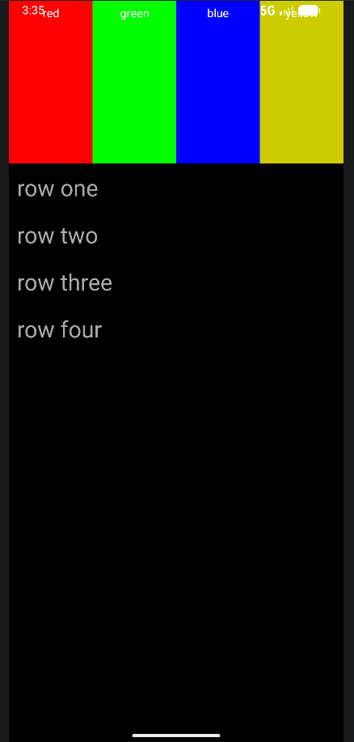
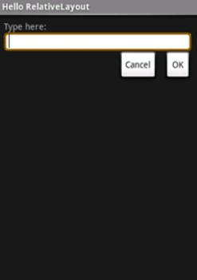

- Create an app such that when the user click on the given URL typed by the user, it visits the corresponding page.

XML Layout : Activity Main (activity_main.xml)

<?xml version="1.0" encoding="utf-8"?>

<LinearLayout xmlns:android="http://schemas.android.com/apk/res/android" android:layout_width="match_parent" android:layout_height="match_parent"
android:orientation="vertical" android:padding="25dp" android:gravity="center"

android:background="#F5F5F5">

<!-- Title -->
<TextView
android:layout_width="wrap_content" android:layout_height="wrap_content" android:text="URL Visitor App" android:textSize="26sp" android:textStyle="bold" android:textColor="#222" android:paddingBottom="20dp"/>

<!-- URL Input -->
<EditText
android:id="@+id/urlInput" android:layout_width="match_parent" android:layout_height="wrap_content" android:hint="Enter URL (example: google.com)" android:inputType="textUri" android:padding="15dp" android:textSize="18sp"
android:background="@android:drawable/edit_text"/>

<!-- Visit Button -->
<Button
android:id="@+id/visitBtn" android:layout_width="match_parent" android:layout_height="wrap_content" android:text="Visit Website" android:textSize="18sp" android:layout_marginTop="20dp" android:padding="15dp"/>

</LinearLayout>

Java Source: Main Activity (MainActivity.java)

package com.example.lab2;

import android.content.Intent; import android.net.Uri;
import android.os.Bundle; import android.widget.Button; import android.widget.EditText; import android.widget.Toast;

import androidx.appcompat.app.AppCompatActivity;

public class MainActivity4 extends AppCompatActivity {

EditText urlInput; Button visitBtn;

@Override
protected void onCreate(Bundle savedInstanceState) { super.onCreate(savedInstanceState); setContentView(R.layout.activity_main4);

urlInput = findViewById(R.id.urlInput); visitBtn = findViewById(R.id.visitBtn);

visitBtn.setOnClickListener(v -> {
String url = urlInput.getText().toString().trim(); if (url.isEmpty()) {
Toast.makeText(MainActivity4.this,
"Please enter a URL!", Toast.LENGTH_SHORT).show();
return;
}

// If user types without https:// add it
if (!url.startsWith("http://") && !url.startsWith("https://"))
{
url = "https://" + url;
}

// Open URL in Browser
Intent intent = new Intent(Intent.ACTION_VIEW); intent.setData(Uri.parse(url));

startActivity(intent);
});
}
}

Output =>

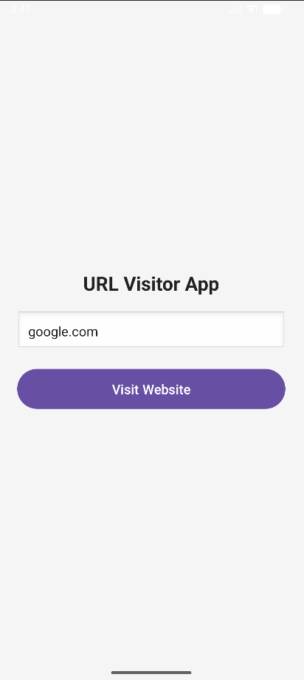

LAB NO: 3

ACTIVITY AND LAYOUT CONTINUED

Lab Exercise:
- Using given scenario develop an application to perform following layout operations
  - List view

  - Grid view

  - Tab layout

  - Table layout

- Write a program to list different sports, and when a sport is selected, display a message showing the selected sport.
- Design an news application and Implement the navigation between sections like Top Stories, Sports, and Entertainment using tab layout.

Program : Please note, all the questions have been consolidated into one code

XML Layout : Activity main(activity_main.xml)

<?xml version="1.0" encoding="utf-8"?>
<LinearLayout xmlns:android="http://schemas.android.com/apk/res/android" android:layout_width="match_parent" android:layout_height="match_parent"
android:orientation="vertical" android:gravity="center" android:padding="20dp"

android:background="#121212">

<TextView
android:layout_width="wrap_content" android:layout_height="wrap_content" android:text="VIEWS" android:textColor="#FFFFFF" android:textSize="24sp" android:textStyle="bold" android:layout_marginBottom="30dp"/>

<Button
android:id="@+id/btnListView" android:layout_width="match_parent" android:layout_height="wrap_content" android:text="1. Sports List (ListView)" android:layout_marginBottom="10dp"/>

<Button
android:id="@+id/btnGridView" android:layout_width="match_parent" android:layout_height="wrap_content" android:text="2. Photo Gallery (GridView)" android:layout_marginBottom="10dp"/>
<Button
android:id="@+id/btnTabLayout" android:layout_width="match_parent" android:layout_height="wrap_content" android:text="3. News App (Tab Layout)" android:layout_marginBottom="10dp"/>
<Button
android:id="@+id/btnTableLayout" android:layout_width="match_parent" android:layout_height="wrap_content" android:text="4. Menu Options (Table Layout)"/>

</LinearLayout>

Java Source : Main Activity (MainActivity.java)

package com.example.lab3;

import android.content.Intent; import android.os.Bundle;
import androidx.appcompat.app.AppCompatActivity; import android.widget.Button;

public class MainActivity extends AppCompatActivity {

@Override
protected void onCreate(Bundle savedInstanceState) { super.onCreate(savedInstanceState); setContentView(R.layout.activity_main);

Button btnListView = findViewById(R.id.btnListView); Button btnGridView = findViewById(R.id.btnGridView); Button btnTabLayout = findViewById(R.id.btnTabLayout); Button btnTableLayout = findViewById(R.id.btnTableLayout);

btnListView.setOnClickListener(v -> startActivity(new Intent(MainActivity.this, SportsActivity.class)));
btnGridView.setOnClickListener(v -> startActivity(new Intent(MainActivity.this, GalleryActivity.class)));
btnTabLayout.setOnClickListener(v -> startActivity(new Intent(MainActivity.this, NewsActivity.class)));
btnTableLayout.setOnClickListener(v -> startActivity(new Intent(MainActivity.this, MenuActivity.class)));
}
}

XML Layout : Activity List View (activity_list_view.xml)

<?xml version="1.0" encoding="utf-8"?>

<LinearLayout xmlns:android="http://schemas.android.com/apk/res/android" android:layout_width="match_parent" android:layout_height="match_parent" android:orientation="vertical">

<ListView
android:id="@+id/simpleListView" android:layout_width="match_parent" android:layout_height="wrap_content" android:divider="#000" android:dividerHeight="1dp" />
</LinearLayout>

Java Source : List View Activity (ListViewActivity.java)

package com.example.lab3;

import android.os.Bundle;
import android.widget.ArrayAdapter; import android.widget.ListView;
import androidx.appcompat.app.AppCompatActivity;

public class ListViewActivity extends AppCompatActivity {
String[] countries = {"American Samoa", "El Salvador", "Saint Helena", "Saint Kitts and Nevis", "Saint Lucia"};

@Override
protected void onCreate(Bundle savedInstanceState) { super.onCreate(savedInstanceState); setContentView(R.layout.activity_list_view);

ListView listView = findViewById(R.id.simpleListView); ArrayAdapter<String> adapter = new ArrayAdapter<>(this,
android.R.layout.simple_list_item_1, countries); listView.setAdapter(adapter);
}
}

XML Layout : Activity Gallery (activity_gallery.xml)

<GridView xmlns:android="http://schemas.android.com/apk/res/android" android:id="@+id/gridView"
android:layout_width="match_parent" android:layout_height="match_parent" android:numColumns="3" android:columnWidth="90dp" android:stretchMode="columnWidth" android:gravity="center" android:background="#ff5c00" android:padding="10dp" />

Java Source : Gallery Activity (GalleryActivity.java)

package com.example.lab3;

import android.content.Context; import android.os.Bundle; import android.view.View; import android.view.ViewGroup;
import android.widget.BaseAdapter; import android.widget.GridView; import android.widget.ImageView;
import androidx.appcompat.app.AppCompatActivity;
public class GalleryActivity extends AppCompatActivity { int[] images = {
android.R.drawable.ic_menu_camera, android.R.drawable.ic_menu_gallery, android.R.drawable.ic_menu_call, android.R.drawable.ic_menu_manage, android.R.drawable.ic_menu_share, android.R.drawable.ic_menu_send
};

@Override
protected void onCreate(Bundle savedInstanceState) { super.onCreate(savedInstanceState); setContentView(R.layout.activity_gallery);

GridView gridView = findViewById(R.id.gridView); gridView.setAdapter(new ImageAdapter(this));
}

public class ImageAdapter extends BaseAdapter { private Context mContext;

public ImageAdapter(Context c) { mContext = c;
}

@Override
public int getCount() { return images.length;
}

@Override
public Object getItem(int position) { return null;
}

@Override
public long getItemId(int position) { return 0;
}

@Override
public View getView(int position, View convertView, ViewGroup parent) {
ImageView imageView;
if (convertView == null) {
imageView = new ImageView(mContext);

300));
imageView.setLayoutParams(new GridView.LayoutParams(300,

imageView.setScaleType(ImageView.ScaleType.CENTER_CROP); imageView.setPadding(8, 8, 8, 8);
} else {
imageView = (ImageView) convertView;

}

imageView.setImageResource(images[position]); return imageView;
}
}
}

XML Layout : Activity Menu (activity_menu.xml)

<TableLayout xmlns:android="http://schemas.android.com/apk/res/android" android:layout_width="match_parent" android:layout_height="match_parent"
android:background="#121212" android:padding="10dp"
android:stretchColumns="1"> <TextView android:text="File Menu" android:textColor="#FF9800" android:padding="10dp"/>

<TableRow android:padding="5dp">
<TextView android:text="Open..." android:textColor="#FFF" />
<TextView android:text="Ctrl-O" android:textColor="#AAA" android:gravity="end" />
</TableRow>

<View android:layout_height="1dp" android:background="#444" />

<TableRow android:padding="5dp">
<TextView android:text="Save As..." android:textColor="#FFF" />
<TextView android:text="Ctrl-Shift-S" android:textColor="#AAA" android:gravity="end" />
</TableRow>

<TableRow android:padding="5dp">
<TextView android:text="Export..." android:textColor="#FFF" />

<TextView android:text="Ctrl-E" android:textColor="#AAA" android:gravity="end" />
</TableRow>
</TableLayout>

Java Source : Main Activity (MenuActivity.java)

package com.example.lab3; import android.os.Bundle;
import androidx.appcompat.app.AppCompatActivity; public class MenuActivity extends AppCompatActivity {
@Override
protected void onCreate(Bundle savedInstanceState) { super.onCreate(savedInstanceState);

setContentView(R.layout.activity_menu);

}

XML Layout : Activity News (activity_news.xml)

<?xml version="1.0" encoding="utf-8"?>
<LinearLayout xmlns:android="http://schemas.android.com/apk/res/android" xmlns:app="http://schemas.android.com/apk/res-auto" android:layout_width="match_parent" android:layout_height="match_parent"
android:orientation="vertical" android:paddingTop="24dp">

<com.google.android.material.tabs.TabLayout android:id="@+id/tabLayout" android:layout_width="match_parent" android:layout_height="wrap_content" android:background="#212121" app:tabTextColor="#FFFFFF" app:tabSelectedTextColor="#FF9800"

app:tabIndicatorColor="#FF9800"/>

<androidx.viewpager2.widget.ViewPager2 android:id="@+id/viewPager" android:layout_width="match_parent" android:layout_height="0dp" android:layout_weight="1" />
</LinearLayout>

Java Source : News Activity (NewsActivity.java)
package com.example.lab3; import android.os.Bundle;
import androidx.annotation.NonNull;
import androidx.appcompat.app.AppCompatActivity; import androidx.fragment.app.Fragment;
import androidx.viewpager2.adapter.FragmentStateAdapter; import androidx.viewpager2.widget.ViewPager2;
import com.google.android.material.tabs.TabLayout;
import com.google.android.material.tabs.TabLayoutMediator;

public class NewsActivity extends AppCompatActivity { @Override
protected void onCreate(Bundle savedInstanceState) { super.onCreate(savedInstanceState); setContentView(R.layout.activity_news);

TabLayout tabLayout = findViewById(R.id.tabLayout); ViewPager2 viewPager = findViewById(R.id.viewPager);

viewPager.setAdapter(new FragmentStateAdapter(this) { @NonNull
@Override
public Fragment createFragment(int position) { return NewsFragment.newInstance(position);
}

@Override
public int getItemCount() { return 3;
}
});

new TabLayoutMediator(tabLayout, viewPager, (tab, position) -> { String[] titles = {"Top Stories", "Sports", "Entertainment"}; tab.setText(titles[position]);
}).attach();

}
}

Java Source : News Fragment (NewsFragment.java)
package com.example.lab3; import android.os.Bundle;
import android.view.LayoutInflater; import android.view.View;
import android.view.ViewGroup; import android.widget.TextView; import androidx.annotation.NonNull; import androidx.annotation.Nullable;
import androidx.fragment.app.Fragment; public class NewsFragment extends Fragment {
public static NewsFragment newInstance(int position) { NewsFragment fragment = new NewsFragment(); Bundle args = new Bundle();
args.putInt("pos", position); fragment.setArguments(args); return fragment;
}

@Nullable @Override
public View onCreateView(@NonNull LayoutInflater inflater, @Nullable ViewGroup container, @Nullable Bundle savedInstanceState) {
TextView textView = new TextView(getContext()); int pos = getArguments().getInt("pos");
String[] content = {"Welcome to Top Stories", "Latest Sports News", "Entertainment Updates"};
textView.setText(content[pos]); textView.setGravity(android.view.Gravity.CENTER); textView.setTextSize(24);
return textView;
}
}

XML Layout : Activity Sports (activity_sports.xml)

<?xml version="1.0" encoding="utf-8"?>

<LinearLayout xmlns:android="http://schemas.android.com/apk/res/android" android:layout_width="match_parent" android:layout_height="match_parent"
android:orientation="vertical" android:background="#121212" android:padding="16dp" android:gravity="center_horizontal">

<TextView
android:layout_width="wrap_content" android:layout_height="wrap_content" android:text="Select a Sport" android:textColor="#FFB74D" android:textSize="22sp" android:textStyle="bold" android:layout_marginBottom="20dp" />

<ListView
android:id="@+id/sportsListView" android:layout_width="match_parent" android:layout_height="0dp" android:layout_weight="1" android:divider="#444444" android:dividerHeight="1dp"
android:background="@color/cardview_light_background" android:padding="8dp" />

</LinearLayout>

Java Source : Sports Activity (SportsActivity.java)

package com.example.lab3;

import android.os.Bundle; import android.view.View;
import android.widget.AdapterView; import android.widget.ArrayAdapter; import android.widget.ListView; import android.widget.Toast;
import androidx.appcompat.app.AppCompatActivity;

public class SportsActivity extends AppCompatActivity {
String[] sports = {"Football", "Cricket", "Basketball", "Tennis", "Hockey", "Badminton", "Swimming", "Athletics"};

@Override
protected void onCreate(Bundle savedInstanceState) { super.onCreate(savedInstanceState); setContentView(R.layout.activity_sports);
ListView listView = findViewById(R.id.sportsListView); ArrayAdapter<String> adapter = new ArrayAdapter<>(this,
android.R.layout.simple_list_item_1, sports);
listView.setAdapter(adapter); listView.setOnItemClickListener(new
AdapterView.OnItemClickListener() {
@Override
public void onItemClick(AdapterView<?> parent, View view, int position, long id) {
String selectedSport = sports[position];

Toast.makeText(SportsActivity.this,
"You selected: " + selectedSport, Toast.LENGTH_SHORT).show();
}
});
}
}

Manifest : Android Manifest (AndroidManifest.xml)
<?xml version="1.0" encoding="utf-8"?>
<manifest xmlns:android="http://schemas.android.com/apk/res/android" xmlns:tools="http://schemas.android.com/tools">

<application
android:allowBackup="true" android:dataExtractionRules="@xml/data_extraction_rules" android:fullBackupContent="@xml/backup_rules" android:icon="@mipmap/ic_launcher" android:label="@string/app_name" android:roundIcon="@mipmap/ic_launcher_round" android:supportsRtl="true" android:theme="@style/Theme.Lab3">
<activity
android:name=".MainActivity" android:exported="true">
<intent-filter>
<action android:name="android.intent.action.MAIN" />

<category android:name="android.intent.category.LAUNCHER" />

</intent-filter>
</activity>

<activity android:name=".SportsActivity" />
<activity android:name=".GalleryActivity" />
<activity android:name=".NewsActivity" />
<activity android:name=".MenuActivity" />
</application>

</manifest>

Images :
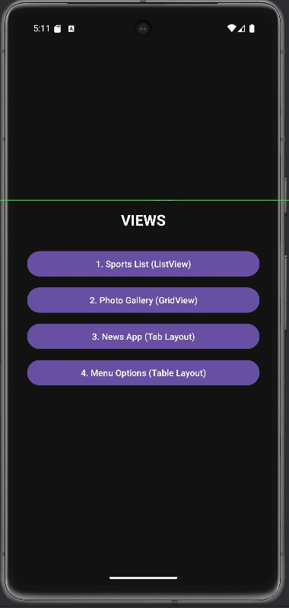
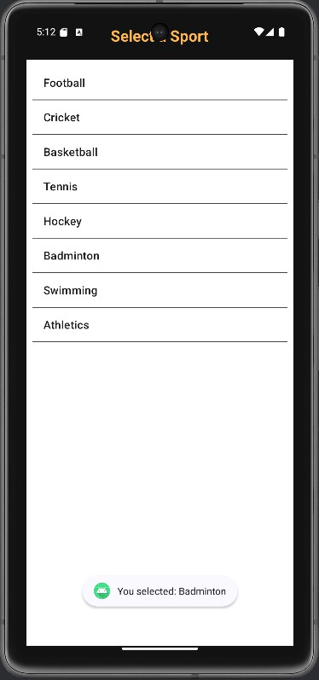
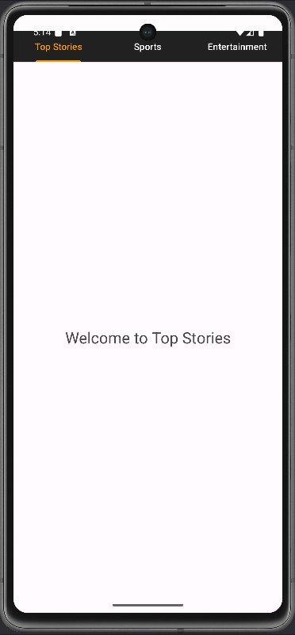

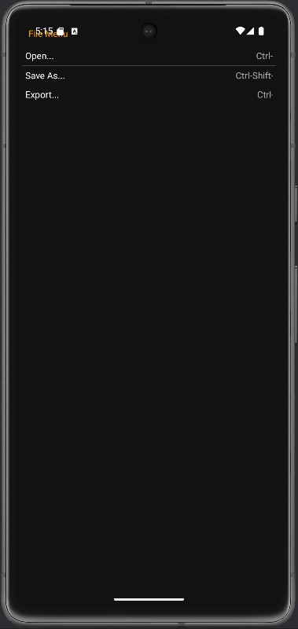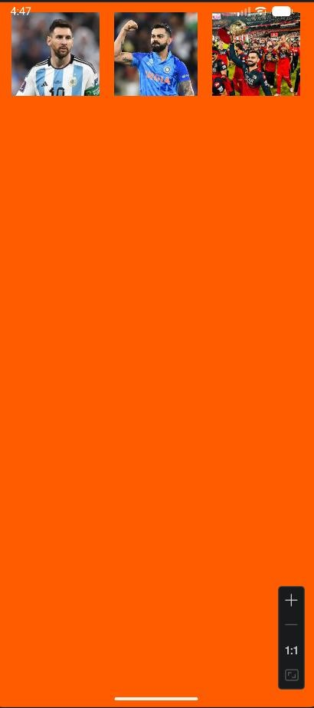

LAB NO: 4

INPUT CONTROLS IN ANDROID

Lab exercises:
- Develop a "Test App" that includes a layout with a Button and a ToggleButton. When each button is clicked, a custom Toast message should be displayed with different images as their content.
- Create an app that contains a view with multiple buttons, each labeled with different Android versions. When a button is clicked, a Toast message should appear, displaying the corresponding Android version's name along with its associated icon.
- Develop a view with a ToggleButton labeled "Current Mode" that has two states: "Wi-Fi" and "Mobile Data." Based on the state of the toggle button, an image corresponding to the selected mode should appear, and a Toast message should display the current mode. Additionally, when the user clicks the "Change

Mode" button, the app should switch to the corresponding mode and update the image accordingly.

- Create a “Food Ordering App” which lists food items with check boxes. Once the user checks /unchecks the item and click on the submit button display the items ordered along with cost of each item and total cost in a new activity. Once the user clicks on the submit button he/she should not be allowed to change the order i.e. he should not be allowed to change the state of the items checked.

Please note : All programs have been consolidated to on App

XML Layout : Activity main (activity_main.xml)

<?xml version="1.0" encoding="utf-8"?>
<LinearLayout xmlns:android="http://schemas.android.com/apk/res/android"
android:layout_width="match_parent" android:layout_height="match_parent" android:orientation="vertical" android:padding="24dp" android:gravity="center_horizontal" android:background="#FAFAFA">

<TextView
android:layout_width="wrap_content" android:layout_height="wrap_content" android:text="Lab 4 Experiments" android:textSize="22sp" android:textStyle="bold" android:textColor="#212121" android:layout_marginBottom="24dp" />

<Button
android:id="@+id/btnTestApp" android:layout_width="match_parent" android:layout_height="wrap_content" android:text="Test App (Button + Toggle)" android:layout_marginBottom="12dp" android:elevation="4dp" />

<Button
android:id="@+id/btnAndroidVersions" android:layout_width="match_parent" android:layout_height="wrap_content" android:text="Android Versions" android:layout_marginBottom="12dp" android:elevation="4dp" />

<Button
android:id="@+id/btnModeSwitch" android:layout_width="match_parent" android:layout_height="wrap_content" android:text="Wi-Fi / Mobile Mode" android:layout_marginBottom="12dp" android:elevation="4dp" />

<Button
android:id="@+id/btnFoodOrder" android:layout_width="match_parent" android:layout_height="wrap_content" android:text="Food Ordering App" android:elevation="4dp" />

</LinearLayout>

XML Layout : Activity test app(activity_test_app.xml)

<LinearLayout xmlns:android="http://schemas.android.com/apk/res/android" android:layout_width="match_parent" android:layout_height="match_parent"
android:gravity="center" android:orientation="vertical">

<Button
android:id="@+id/btnClick" android:text="Click Me" android:layout_width="wrap_content" android:layout_height="wrap_content"/>

<ToggleButton
android:id="@+id/toggleBtn" android:textOn="ON" android:textOff="OFF"

android:layout_width="wrap_content" android:layout_height="wrap_content"/>
</LinearLayout>

XML Layout : Custom Toast (custom_toast.xml)

<?xml version="1.0" encoding="utf-8"?>
<LinearLayout xmlns:android="http://schemas.android.com/apk/res/android" android:layout_width="wrap_content" android:layout_height="wrap_content"
android:orientation="vertical" android:padding="12dp" android:background="#444444" android:gravity="center">

<ImageView
android:id="@+id/toast_image" android:layout_width="48dp" android:layout_height="48dp" android:layout_marginBottom="8dp" />

<TextView
android:id="@+id/toast_text" android:layout_width="wrap_content" android:layout_height="wrap_content" android:textColor="#FFFFFF" android:textSize="16sp" android:gravity="center"/>
</LinearLayout>

XML Layout : Activity mode switch (activity_mode_switch.xml)

<?xml version="1.0" encoding="utf-8"?>
<LinearLayout xmlns:android="http://schemas.android.com/apk/res/android" android:layout_width="match_parent" android:layout_height="match_parent"

android:gravity="center" android:orientation="vertical" android:padding="20dp">

<ToggleButton
android:id="@+id/toggleMode" android:layout_width="wrap_content" android:layout_height="wrap_content" android:textOn="Wi-Fi" android:textOff="Mobile Data" />

<Button
android:id="@+id/btnChange" android:layout_width="wrap_content" android:layout_height="wrap_content" android:text="Change Mode" android:layout_marginTop="16dp" />

</LinearLayout>

XML Layout : Activity food order (activity_food_order.xml)

<?xml version="1.0" encoding="utf-8"?>
<LinearLayout xmlns:android="http://schemas.android.com/apk/res/android" android:layout_width="match_parent" android:layout_height="match_parent"
android:orientation="vertical" android:padding="20dp">

<CheckBox
android:id="@+id/cbPizza" android:layout_width="wrap_content" android:layout_height="wrap_content" android:text="Pizza - ₹100" />

<CheckBox
android:id="@+id/cbBurger" android:layout_width="wrap_content" android:layout_height="wrap_content" android:text="Burger - ₹60" />

<Button
android:id="@+id/btnSubmit" android:layout_width="match_parent" android:layout_height="wrap_content" android:text="Submit Order" android:layout_marginTop="16dp" />

</LinearLayout>

XML Layout : Activity Android Version (activity_android_versions.xml)

<LinearLayout xmlns:android="http://schemas.android.com/apk/res/android" android:layout_width="match_parent" android:layout_height="match_parent"
android:orientation="vertical" android:padding="20dp">

<Button android:text="Android Oreo" android:id="@+id/btnOreo" android:layout_width="match_parent" android:layout_height="wrap_content"/>

<Button android:text="Android Pie" android:id="@+id/btnPie" android:layout_width="match_parent" android:layout_height="wrap_content"/>
</LinearLayout>

Java Source : Main Activity (MainActivity.java)

package com.example.lab4_part2;

import android.content.Intent; import android.os.Bundle;

import androidx.activity.EdgeToEdge;
import androidx.appcompat.app.AppCompatActivity; import androidx.core.graphics.Insets;
import androidx.core.view.ViewCompat;
import androidx.core.view.WindowInsetsCompat;
public class MainActivity extends AppCompatActivity { @Override
protected void onCreate(Bundle savedInstanceState) { super.onCreate(savedInstanceState); setContentView(R.layout.activity_main);

findViewById(R.id.btnTestApp)
.setOnClickListener(v -> startActivity(
new Intent(this, TestAppActivity.class)));

findViewById(R.id.btnAndroidVersions)
.setOnClickListener(v -> startActivity(
new Intent(this, AndroidVersionActivity.class)));

findViewById(R.id.btnModeSwitch)
.setOnClickListener(v -> startActivity(
new Intent(this, ModeSwitchActivity.class)));

findViewById(R.id.btnFoodOrder)
.setOnClickListener(v -> startActivity(
new Intent(this, FoodOrderActivity.class)));

}
}

Java Source : Test App Activity (TestAppActivity.java)

package com.example.lab4_part2; import android.os.Bundle;
import android.view.LayoutInflater; import android.view.View;
import android.widget.Button; import android.widget.ImageView; import android.widget.TextView; import android.widget.Toast;
import android.widget.ToggleButton;

import androidx.appcompat.app.AppCompatActivity;
public class TestAppActivity extends AppCompatActivity { @Override
protected void onCreate(Bundle savedInstanceState) { super.onCreate(savedInstanceState); setContentView(R.layout.activity_test_app);

Button btn = findViewById(R.id.btnClick); ToggleButton toggle = findViewById(R.id.toggleBtn);

btn.setOnClickListener(v -> showCustomToast( "Button Clicked", R.drawable.ic_launcher_background
));

toggle.setOnCheckedChangeListener((b, isChecked) -> showCustomToast( isChecked ? "Toggle ON" : "Toggle OFF", R.drawable.ic_launcher_foreground
));
}

private void showCustomToast(String message, int imageRes) { LayoutInflater inflater = getLayoutInflater();
View view = inflater.inflate(R.layout.custom_toast, null);

ImageView image = view.findViewById(R.id.toast_image); TextView text = view.findViewById(R.id.toast_text);

image.setImageResource(imageRes); text.setText(message);

Toast toast = new Toast(this); toast.setDuration(Toast.LENGTH_SHORT); toast.setView(view);
toast.show();
}
}

Java Source : Mode Switch Activity (ModeSwitchActivity.java)

package com.example.lab4_part2;

import android.os.Bundle; import android.widget.Button; import android.widget.Toast;
import android.widget.ToggleButton;

import androidx.activity.EdgeToEdge;
import androidx.appcompat.app.AppCompatActivity; import androidx.core.graphics.Insets;
import androidx.core.view.ViewCompat;
import androidx.core.view.WindowInsetsCompat;
public class ModeSwitchActivity extends AppCompatActivity { @Override
protected void onCreate(Bundle savedInstanceState) { super.onCreate(savedInstanceState); setContentView(R.layout.activity_mode_switch);

ToggleButton toggle = findViewById(R.id.toggleMode); Button btn = findViewById(R.id.btnChange);

Mode",

}
}
btn.setOnClickListener(v -> Toast.makeText(this,
toggle.isChecked() ? "Wi-Fi Mode" : "Mobile Data Toast.LENGTH_SHORT).show());

Java Source : Food Order Activity (FoodOrderActivity.java)

package com.example.lab4_part2;

import android.os.Bundle; import android.widget.Button; import android.widget.CheckBox; import android.widget.Toast;

import androidx.activity.EdgeToEdge;
import androidx.appcompat.app.AppCompatActivity; import androidx.core.graphics.Insets;
import androidx.core.view.ViewCompat;
import androidx.core.view.WindowInsetsCompat;
public class FoodOrderActivity extends AppCompatActivity { @Override
protected void onCreate(Bundle savedInstanceState) {
super.onCreate(savedInstanceState); setContentView(R.layout.activity_food_order);

CheckBox pizza = findViewById(R.id.cbPizza); CheckBox burger = findViewById(R.id.cbBurger); Button submit = findViewById(R.id.btnSubmit);

submit.setOnClickListener(v -> { int total = 0;
String order = "";

if (pizza.isChecked()) { total += 100;
order += "Pizza ₹100\n"; pizza.setEnabled(false);
}
if (burger.isChecked()) { total += 60;
order += "Burger ₹60\n"; burger.setEnabled(false);
}

Toast.makeText(this,
order + "Total: ₹" + total, Toast.LENGTH_LONG).show();

submit.setEnabled(false);
});
}
}

Java Source : Android Version Activity (AndroidVersionActivity.java)

package com.example.lab4_part2;

import android.os.Bundle; import android.widget.Toast;

import androidx.activity.EdgeToEdge;
import androidx.appcompat.app.AppCompatActivity; import androidx.core.graphics.Insets;
import androidx.core.view.ViewCompat;
import androidx.core.view.WindowInsetsCompat;

public class AndroidVersionActivity extends AppCompatActivity {

@Override
protected void onCreate(Bundle savedInstanceState) { super.onCreate(savedInstanceState); setContentView(R.layout.activity_android_versions);

findViewById(R.id.btnOreo)
.setOnClickListener(v ->
Toast.makeText(this,"Android Oreo",Toast.LENGTH_SHORT).show());

findViewById(R.id.btnPie)
.setOnClickListener(v ->
Toast.makeText(this,"Android Pie",Toast.LENGTH_SHORT).show());
}

}

Output =>
