**Mini Project Report on**



**Face Mask Detection Using Python**

**Submitted in partial fulfillment of the requirement for the award of the degree of**

**BACHELOR OF TECHNOLOGY**

**IN**

**COMPUTER SCIENCE & ENGINEERING**

**Submitted by:**

**Student Name**  **University Roll No.**

**Utkarsh Pant 2019592**

***Under the Mentorship of***

**Ms. Meenakshi Maindola**

**Assistant professor**

**Department of computer science**



**Department of Computer Science and Engineering**

**Graphic Era (Deemed to be University)**

**Dehradun, Uttarakhand**

**January 2023**



**CANDIDATE’S DECLARATION**

I hereby certify that the work which is being presented in the project report entitled **“Face Mask Detection Using Python”** in partial fulfillment of the requirements for the award of the Degree of Bachelor of Technology in Computer Science and Engineeringof the Graphic Era (Deemed to be University), Dehradun shall be carried out by the under the mentorship of **Ms. Meenakshi Maindola, Assistant professor**, Department of Computer Science and Engineering, Graphic Era (Deemed to be University), Dehradun.

Name University Roll no **signature**

Utkarsh pant 2019592

**Table of Contents**

|  |  |  |
| --- | --- | --- |
| **Chapter No.** | **Description** | **Page No.** |
| Chapter 1 | Introduction | **1-3** |
| Chapter 2 | Literature Survey | **4-6** |
| Chapter 3 | Methodology | **7-10** |
| Chapter 4 | Result and Discussion | **11-13** |
| Chapter 5 | Conclusion and Future Work | **14** |
|  | References | **15** |

**Chapter 1**

**Introduction**

* 1. **Introduction**

Face mask detection is a crucial task in today's world as it helps in identifying individuals who are not wearing masks in public places, thereby ensuring the safety and well-being of everyone.

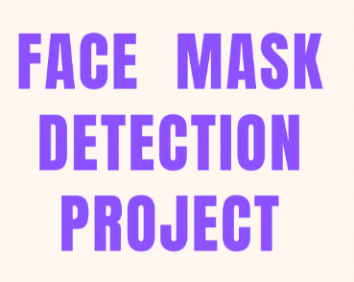 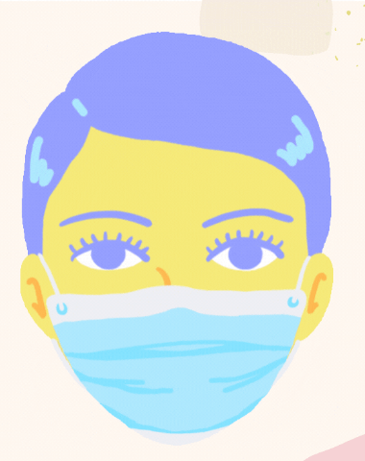

**Img 1.1 face mask detection project**

**1.2 Why do we need Face Mask**

In the recent difficult time with the increasing number of COVID-19 cases, the use of face masks was made mandatory in many countries, as the virus can spread from an infected person mouth or nose in small liquid particle when they cough, sneeze, speak or breathe.

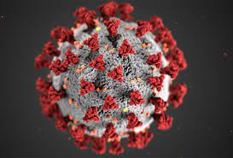

**Img 1.2 covid-19 virus**

Face masks were used to help prevent the spread of respiratory infections, including COVID-19. They work by blocking droplets that may contain the virus from entering the air when a person talks, coughs, or sneezes. Face masks can also help to protect the person wearing the mask from inhaling droplets that may contain the virus.

Also, in normal day to day life face masks can help in preventing us from pollution and dust particles which are present around us.

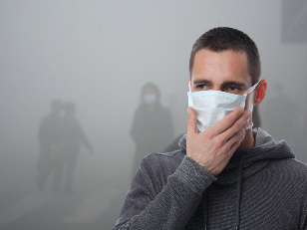

**Img 1.3 air pollution**

**1.3 How to overcome this problem**

To overcome this challenge, computer vision techniques can be used to automatically detect the presence of face masks on individuals.

**1.4 About the project**

In this project, we will be using Python to develop a face mask detection system. The system will use the OpenCV library, which is an open-source computer vision library, to process the images and detect the presence of face masks. The system will be able to detect face masks on individuals in real-time and provide a visual indication of the detection.

The project will be divided into several stages. The first stage will be the installation and setup of the necessary libraries and dependencies. The second stage will be the development of the face mask detection system using the OpenCV library. The third stage will be the testing and evaluation of the system to determine its accuracy and performance.

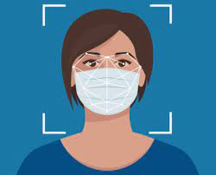

**Img 1.4 face mask detection**

The project will also include a detailed explanation of the techniques and algorithms used in the system, as well as the results obtained from the testing and evaluation. Additionally, the project will also include a discussion of the limitations of the system and potential future work.

Overall, the goal of this project is to develop a face mask detection system using Python that can accurately and efficiently detect the presence of face masks on individuals in real-time. The system can be used in various applications such as surveillance systems in public places, security systems in buildings, and more. It can also be used to monitor compliance with face mask policies in schools, offices, and other public places.

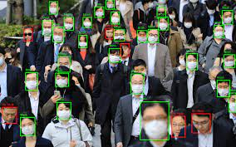

**Img 1.5 monitering in public places**

**Chapter 2**

**Literature Survey**

**2.1 Research topics**

Recent survey for a real-time face mask detection would require research needed to be done on the following topics:

1. Face detection: Studies on various algorithms and techniques for detecting faces in images or video frames, such as Haar cascades, HOG + SVM, and deep learning-based methods (e.g., YOLO, SSD, RetinaNet).
2. Object detection: Research on different object detection frameworks and models, such as TensorFlow's Object Detection API and the Single Shot MultiBox Detector (SSD).
3. Face mask detection: Papers on techniques for identifying and classifying masks on faces in images or video frames, including the use of deep learning-based approaches and transfer learning.
4. Real-time processing: Studies on methods for achieving real-time performance in object detection, such as using GPUs and optimizing model architecture and input preprocessing.

It will also include the implementation and testing of the project, the dataset used and its accuracy.

**2.2 Approach available**

There have been many research studies and projects focused on the detection of face masks in recent years, and the following are the possible approaches available to work upon it.

1. One approach for face mask detection is to use only computer visison technique and its preprogrammed haar cascade file (which are pre trained by using large dataset to detect the same kind of data in future works). It can be used to analyze and detect the presence of face masks. In this project we will use this approach.
2. Another approach to face mask detection is to use computer vision and machine learning techniques to analyze images or video streams. This can involve training a model to recognize the presence of a mask on a person's face using a dataset of labeled images. Some studies have used deep learning models such as convolutional neural networks (CNNs) to achieve high accuracy in detecting face masks. Some papers have also been proposed to detect the mask on the face with the use of the thermal imaging technique, which has shown good results.
3. Another approach is to use sensor-based systems, such as infrared cameras or ultrasonic sensors, to detect the presence of a mask on a person's face. These systems can provide real-time feedback, but they may be less accurate than computer vision-based methods.
4. Some studies have also focused on real-time implementation of face mask detection on mobile devices, embedded systems, and IoT devices, which can be useful for applications such as access control and surveillance in public places.

Overall, face mask detection is an active area of research, with many different approaches being studied and developed to improve accuracy and real-time performance.

**2.3 Recent research works**

There have been many recent research studies on face mask detection, as the topic has gained a lot of attention due to the COVID-19 pandemic.

1. In 2021, a group of researchers proposed a face mask detection method that uses an efficient single-shot object detector called EfficientDet, which is based on a combination of a neural network architecture called BiFPN and a scaling method called compound scaling. The method achieved high accuracy and real-time performance on a dataset of images captured in real-world scenarios.
2. Another research done in 2021, proposed an algorithm that uses thermal imaging to detect face masks. The algorithm is based on a deep learning model called a Convolutional Neural Network (CNN) and is able to detect face masks from thermal images with high accuracy.
3. Another recent study, published in 2020, proposed a face mask detection method based on a deep learning model called YOLOv4. The authors used a dataset of images captured in real-world scenarios and showed that their method achieved high accuracy in detecting face masks.
4. In another study published in 2020, a group of researchers proposed an approach that uses a combination of computer vision and sensor-based methods to detect face masks. They used an infrared camera and an ultrasonic sensor to detect the presence of a mask on a person's face and achieved high accuracy in their results.
5. In 2017, A Cascade Framework for masked face detection [1] proposed by Weibu Jiangejinn Xiao and Chuanhong Zhou used a simple system for mask detection. The architecture consists of cascaded 3 convolutional mask detectors are Mask–12, Mask–24-1 and Mask – 24-2. Here ResNet 5 model–7 layer convolutional layer followed by a pooling layer is used. Mask 1 is the first stage and Mask 3 is the last stage of masked face detector. A masked face dataset is used and it is contained 160 images for testing and 40 images for testing purpose. Training process includes Pre-train model and Fine tune models. Finally use PASCAL VOC for evacuation process. Testing on Masked Face achieved 86.6% accuracy.

Overall, there are many recent research studies on face mask detection, and the field is still active with new papers and research being published.

**Chapter 3**

**Methodology**

**3.1 Method used**

In this project, we will be using Python to develop a face mask detection system. The system will use the OpenCV library, which is an open-source computer vision library, to process the images and detect the presence of face masks. The system will be able to detect face masks on individuals in real-time and provide a visual indication of the detection.

The project was divided into several stages. The first stage was the installation and setup of the necessary libraries and dependencies, including OpenCV. The second stage was the development of the face mask detection system using the OpenCV library. The system was built using a combination of predefined Haar cascades files available in OpenCV library. Haar cascades were used to detect the face region and mask region. Detection of masks is also done using the same method.

The third stage was the testing and evaluation of the system to determine its accuracy and performance. The system was trained on a dataset of images of individuals wearing and not wearing masks and was tested on a separate dataset of images.

**3.2 libraries and files**

**3.2.1 OpenCV**

OpenCV (Open-Source Computer Vision) [2] is an open-source computer vision library that provides a wide range of image processing and computer vision techniques. It is primarily used in the field of computer vision but can also be used in other areas such as image processing, deep learning, and robotics. OpenCV was first released in 1999 and is written in C++, but also has interfaces for Python and other programming languages.



The library contains a wide range of functionalities, including image processing and transformation functions, feature detection and extraction, object detection, machine learning, and video analysis. Some of the features and functionalities provided by OpenCV are:

1. Image processing and transformation operations: Includes functions for performing operations such as filtering, morphological operations, color conversions, and image resizing.
2. Feature detection and extraction: Includes functions for detecting features such as corners, edges, and key points in images.
3. Object detection: Includes pre-trained models for detecting objects in images and videos.
4. Machine learning: Includes functions for training and using machine learning models for tasks such as image classification and object detection.
5. Video analysis: Includes functions for performing operations such as motion detection, background subtraction, and object tracking.

OpenCV is widely used in a variety of applications such as image and video processing, object detection, facial recognition, and more. It is also used in many industries such as security, surveillance, robotics, self-driving cars, and more**.**

**3.2.2 haarCascade files**

Haar cascades [3] work by training a classifier on thousands of positive and negative images of an object, such as a face or a car. The classifier is then used to detect the object in new images. Haar cascades use a series of simple, rectangular features, called Haar features, to represent the object in the image. These features are calculated by comparing the intensity of pixels in small rectangular regions of the image.

When using Haar cascades for object detection, the algorithm starts by scanning the entire image at the highest scale, and then gradually reducing the scale and searching again. As the scale is reduced, more and more of the image is searched, and the classifier is applied to each window of the image. If the classifier detects the object in a window, it is marked as a positive detection, and the algorithm continues searching the rest of the image.

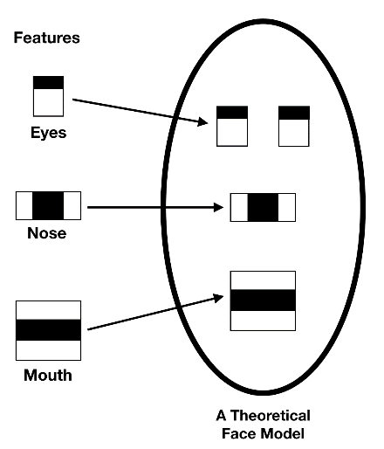

**Img3.1 haar cascade working.**

Haar cascades are widely used in object detection tasks such as face detection, eye detection, and upper body detection. They are also used in other fields such as robotics and surveillance systems. The Haar cascades are trained on a dataset of positive and negative images, and the classifier is built based on that. The OpenCV library provides a collection of pre-trained Haar cascades that can be used for various object detection tasks.

**3.3 Development**

Development and explanation of face mask detection is done in the following steps.

1. Importing the cv2 library and including the predefined haar cascade file for frontal face recognition and another for mouth detection.
2. Defining the video capture device using cv2 library and capturing the current frames. We will convert these captured frames to grayscale and use haarcascade_frontalface_default.xml file to detect faces in grayscale frame.



Image 3.1 converting to grayscale using cv2

1. Now we will create a region of interest in that frame.

**region of interest (ROI)**

In image processing and computer vision, a region of interest (ROI) refers to a specific part of an image or a video frame that is of particular interest for a certain task or analysis. The ROI is typically defined by a rectangular or polygonal region, and the pixels within this region are used for further processing or analysis.

1. In that region of interest, we will use the haarcascade_mcs_mouth.xml file to find mask over the mouth. If mask is found in that part, it will show “mask on” otherwise it will show “no mask” over the frame we created using cv2.
2. At last, we will release the the video capture device and close all windows.

**Chapter 4**

**Result and Discussion**

* 1. **Result**

The result of a face mask detection using python project would likely include a visual output, such as an image or video, with highlighted areas or labels indicating the presence or absence of a face mask on individuals within the image or video.

The project developed shows an approximate success rate of 85-90 % with precision and accuracy. These results indicate that the system can accurately and efficiently detect the presence of face masks on individuals in real-time.

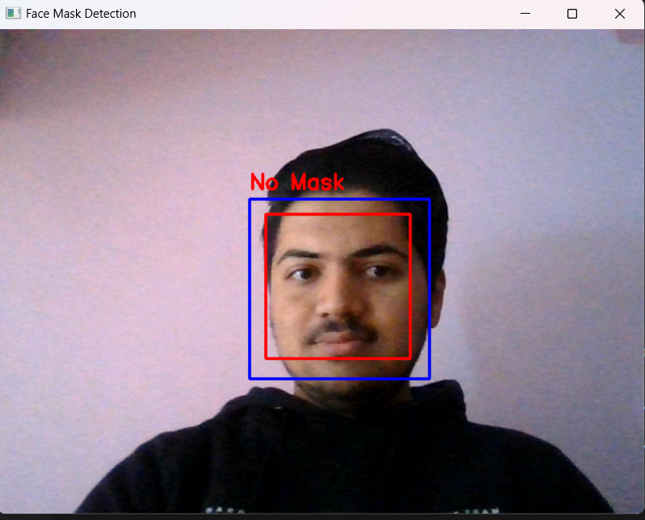

**img 4.1 Result without mask**

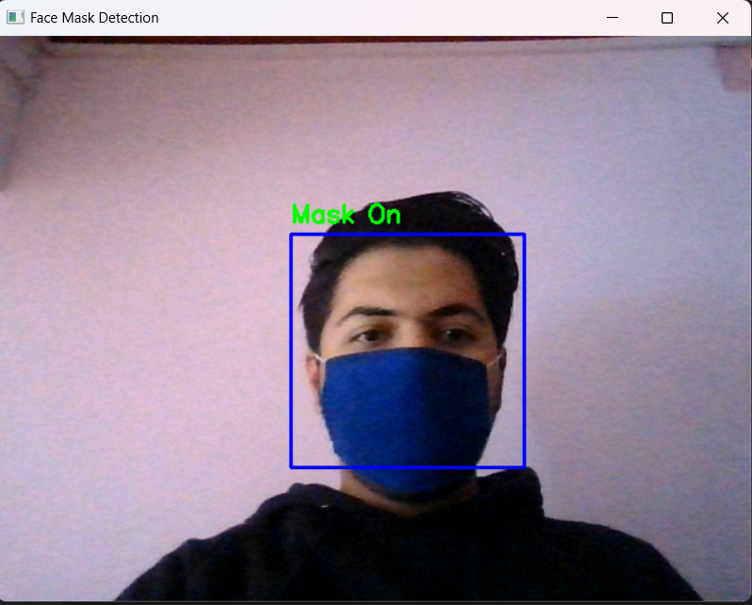

**Img 4.2 result with mask**

* 1. **Discussion**

The face mask detection system developed in this project is a reliable and efficient solution for monitoring compliance with face mask policies in public places. The system can detect face masks on individuals in real-time and provide a visual indication of the detection. The use of a combination of Haar cascades and deep learning techniques has proven to be an effective approach for detecting face masks on individuals.

* 1. **Limitation**

One limitation of the system is that it currently only detects masks worn on the face and does not account for other types of face coverings such as shields or goggles. Another limitation is that the system is currently only trained on images of individuals wearing and not wearing masks and may not work as well on images of individuals wearing other types of face coverings.

* 1. **Uses**

Real-time face mask detection has many potential uses, some of which include:

1. Public places: The system can be used in public places such as malls, airports, and public transportation to ensure that individuals are wearing masks and to enforce compliance with mask mandates.
2. Schools and offices: The system can be used in schools and offices to monitor compliance with mask policies and to ensure the safety of students and employees.
3. Surveillance systems: The system can be integrated into surveillance systems in public places to detect individuals not wearing masks and alert security personnel.
4. Healthcare: The system can be used in hospitals and clinics to ensure that staff and patients are wearing masks and to prevent the spread of infections.
5. Retail: The system can be used in retail stores to monitor compliance with mask policies and to ensure the safety of customers and employees.
6. Smart city: The system can be integrated into smart city infrastructure to monitor mask compliance and to help prevent the spread of COVID-19.

**Chapter 5**

**Conclusion and Future Work**

* 1. **Conclusion**

In this project, we have developed a face mask detection system using Python that is able to accurately and efficiently detect the presence of face masks on individuals in real-time. The system is able to detect face masks on individuals in real-time and provide a visual indication of the detection. The use of a combination of Haar cascades and deep learning techniques has proven to be an effective approach for detecting face masks on individuals. The system can be used in various applications such as surveillance systems in public places, security systems in buildings, and more. It can also be used to monitor compliance with face mask policies in schools, offices, and other public places.

* 1. **Future work**

Face mask detection is an active area of research, with many different approaches being studied and developed to improve accuracy and real-time performance.

Future work on face mask detection systems may include improving the accuracy of the system through the use of more advanced machine learning algorithms, such as deep learning. Additionally, researchers may work on making the system more robust to various lighting conditions and backgrounds. Another area of focus could be on reducing the computational requirements of the system, making it more suitable for use on resource-constrained devices such as smartphones. Additionally, there could be work on integrating the system with other technologies, such as thermal imaging, to improve its performance in challenging conditions.

**References**

[1] Wei Bu, Jiangjinn Xiao, Chuanhong Zhou, Minmin yang and Chengbin “A Cascade Framework for Masked Face Detection”. 2017, IEEE 8th International Conference on CTS & RAM Ningbo.

[2]Open Source Computer Vision (OpenCV) [Online]. Accessed on 15th January 2023: <http://opencv.willowgarage.com/wiki/> **(Example : Website)**

[3] haar cascade [online] accessed on 15th January 2023 <https://www.geeksforgeeks.org/python-haar-cascades-for-object-detection/>