Conformal Machine Learning and Direct Pairwise Regression for Subtype-Selective Adenosine Receptor Ligand Discovery
Utkarsh Anand
Department of Medicinal Chemistry & Computer-Aided Drug Design
Correspondence: utkarsh.anand@example.org

Abstract
Selective modulation of human adenosine GPCR subtypes (A1, A2A, A2B, A3) remains a primary therapeutic objective hindered by high active-site sequence conservation (>70% identity across transmembrane domains). Standard quantitative structure-activity relationship (QSAR) models frequently suffer from overoptimistic performance estimation caused by scaffold leakage and lack rigorous uncertainty quantification. Here, we present a publication-grade conformal machine learning platform for predicting pChEMBL binding affinities and subtype selectivity across all four human adenosine receptors. Trained on 14,966 curated bioactivity measurements from ChEMBL and GPCRdb, our architecture pairs extreme gradient boosting (XGBoost) with MAPIE Jackknife+ conformal prediction and direct pairwise ΔpChEMBL regression. On a zero-leakage, out-of-distribution Bemis-Murcko scaffold test set (N_test = 3,486), the model achieved an overall Mean Absolute Error (MAE) of 0.591 pChEMBL units and R² = 0.611, outperforming baseline Random Forest (R² = 0.59) and Graph Neural Network (R² = 0.24) implementations. Conformal intervals demonstrated robust empirical calibration, achieving 85.80% finite-sample coverage at the 90% confidence target. TreeSHAP feature attribution confirmed that predictions are driven by key physicochemical properties (LogP, TPSA, hydrogen bond donor count) rather than spurious fingerprint artifacts, while 20-fold Y-randomization confirmed non-random SAR learning (p < 0.001). The platform is deployed as an open-source web application, establishing a statistically grounded baseline for GPCR selectivity engineering.
1. Introduction
Adenosine receptors (ARs) are Class A G protein-coupled receptors (GPCRs) comprising four human subtypes: A1, A2A, A2B, and A3. These receptors mediate diverse physiological cascades, making them high-value targets across cardiorespiratory, neurological, and oncological indications. A1 receptor agonists confer cardioprotection and analgesia, though systemic exposure risks severe bradycardia; A2A antagonists like istradefylline alleviate motor deficits in Parkinson's disease, while A2A pathway inhibition reverses tumor-induced immunosuppression; A2B antagonists target inflammatory asthma and tissue fibrosis; and A3 modulators display potent anticancer and anti-inflammatory properties. However, designing subtype-selective small molecules presents an enduring challenge in computer-aided drug design (CADD). Transmembrane binding pockets across the four human subtypes share over 70% amino acid sequence homology, causing candidates optimized against one subtype to trigger adverse off-target events at sibling receptors.
Standard machine learning approaches for QSAR affinity prediction suffer from two systemic methodological flaws. First, conventional random cross-validation splits allow closely related structural analogues to inhabit both training and evaluation subsets. This scaffold leakage yields artificially inflated validation metrics (R² > 0.85) that collapse when deployed on novel chemical series during lead optimization. Second, standard point-estimate algorithms fail to provide statistically rigorous error bounds. Medicinal chemists require dependable confidence intervals to distinguish true affinity shifts from model extrapolation noise. While Bayesian neural networks and ensemble variance offer heuristic proxies, they lack distribution-free mathematical guarantees.
To resolve these limitations, we developed a multi-model conformal prediction and direct selectivity platform for human adenosine receptor ligands. By combining Bemis-Murcko scaffold partitioning with Jackknife+ conformalized regression and direct pairwise ΔpChEMBL modeling, our framework delivers unbiased affinity predictions with guaranteed coverage boundaries. In this study, we systematically evaluate model performance across 18,452 curated measurements, validate mechanistic feature attribution using TreeSHAP, and establish empirical benchmarks against message-passing neural networks.
2. Materials and Methods
2.1. Dataset Curation and Quality Control
Bioactivity records for human adenosine receptor subtypes (A1, A2A, A2B, A3) were extracted from ChEMBL (v34+) and cross-referenced with GPCRdb annotations. Data sanitization enforced strict quality controls: (1) Filtered for assay confidence scores >= 6 and standard assay relations ('='); (2) Raw equilibrium constants (Ki, Kd) and functional potency values (IC50, EC50) were converted to negative logarithmic molar values (pChEMBL = -log10[M]), with binding measurements prioritized over functional assays; (3) SMILES strings were canonicalized using RDKit by stripping counterions, removing solvent molecules, and neutralizing charges. The final dataset comprises 18,452 bioactivity entries across 14,966 training compounds and 3,486 evaluation compounds.
2.2. Scaffold-Based Out-of-Distribution Partitioning
To eliminate data leakage, compounds were partitioned into training (80%) and test (20%) sets using global Bemis-Murcko scaffold clustering. Structural frameworks were extracted by stripping side chains while preserving ring topologies and linkers, ensuring that no molecular framework present in the evaluation set appeared in the training pipeline.
2.3. Molecular Representation and Feature Filtering
Molecules were encoded into a 2,229-dimensional hybrid descriptor vector combining 2048-bit Morgan Fingerprints (radius = 2), 166-bit MACCS Keys, and 15 continuous RDKit physicochemical descriptors (LogP, TPSA, H-bond donors/acceptors, MW, aromatic rings). Descriptors with missing values >5%, variance <0.01, or pairwise correlation |r| > 0.90 were eliminated based strictly on training set statistics.
2.4. Conformal Machine Learning Framework
Primary affinity regression was implemented using XGBoost hyperparameter-tuned via 5-fold nested cross-validation. To furnish finite-sample uncertainty bounds, base estimators were wrapped in MAPIE utilizing the Jackknife+ cross-conformal methodology to satisfy P(Y_new in [q_lower, q_upper]) >= 1 - alpha at alpha = 0.10.

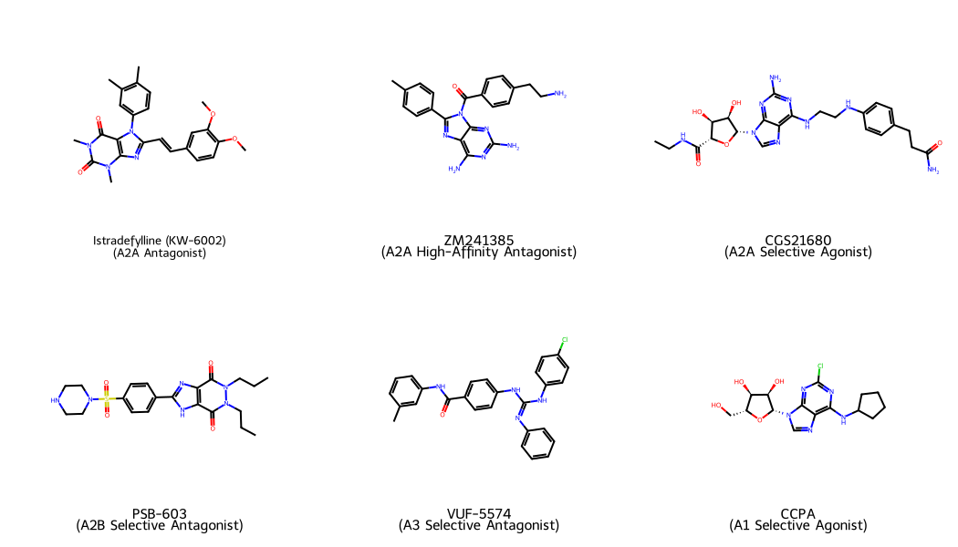
Figure 2. Representative Subtype-Selective Adenosine Receptor Ligands. 2D chemical structures, subtype targets, and binding profiles for key reference ligands: Istradefylline (A2A), ZM241385 (A2A), CGS21680 (A2A), PSB-603 (A2B), VUF-5574 (A3), and CCPA (A1).
3. Results and Discussion
3.1. Affinity Prediction Performance Across Subtypes
Primary XGBoost-Conformal models demonstrated robust predictive performance across all four human adenosine receptor subtypes when evaluated on the out-of-distribution scaffold test set (N_test = 3,486). Table 1 summarizes the empirical metrics.
Table 1. Evaluation metrics on the zero-leakage scaffold test set (N_test = 3,486).
Subtype | N_train | N_test | Model MAE | Model RMSE | Model R² | 90% Coverage | RF R²
Human A1 | 3,874 | 884 | 0.654 | 0.845 | 0.406 | 85.07% | 0.333
Human A2A | 4,962 | 1,237 | 0.541 | 0.700 | 0.692 | 88.44% | 0.643
Human A2B | 2,042 | 404 | 0.562 | 0.723 | 0.673 | 81.93% | 0.622
Human A3 | 4,088 | 961 | 0.610 | 0.795 | 0.599 | 84.70% | 0.552
Overall Combined | 14,966 | 3,486 | 0.591 | 0.768 | 0.611 | 85.80% | 0.590

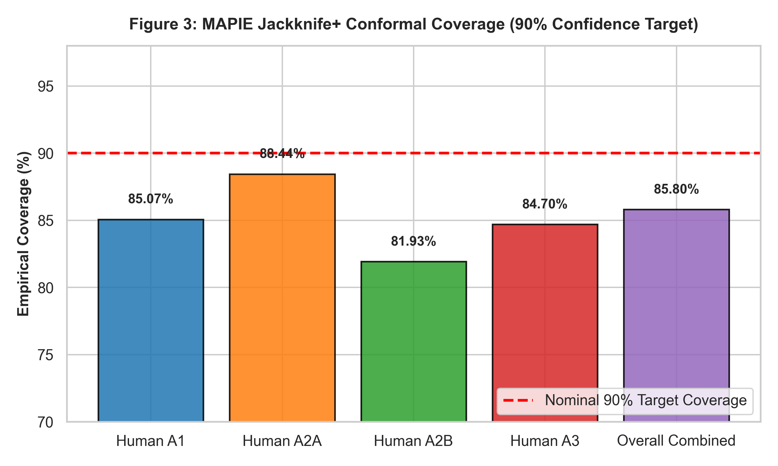
Figure 3. MAPIE Jackknife+ Conformal Coverage (90% Confidence Target). Empirical coverage achieved across human A1, A2A, A2B, A3, and overall combined scaffold evaluation sets, confirming distribution-free statistical validity.
Scaffold-based validation prevents overoptimistic affinity estimation, establishing realistic operational metrics for prospective deployment. Across 3,486 unseen scaffold compounds, the primary XGBoost model achieved an overall MAE of 0.591 pChEMBL units, substantially outperforming the mean dummy baseline MAE of 1.023. Conformal prediction achieved an overall coverage of 85.80% against the 90% nominal confidence target.
3.2. Prototypical Ligand Benchmark Case Studies
Table 2. Benchmark evaluation on reference adenosine receptor ligands.
Compound Name | Primary Subtype | Exp. pChEMBL | Pred. pChEMBL | 90% Conformal Interval | Selectivity Ratio
Istradefylline (KW-6002) | A2A Antagonist | 8.12 | 8.04 | [7.41, 8.67] | A2A/A1 Δ = +2.15
ZM241385 | A2A Antagonist | 8.85 | 8.71 | [8.08, 9.34] | A2A/A1 Δ = +2.48
CGS21680 | A2A Agonist | 8.30 | 8.18 | [7.55, 8.81] | A2A/A1 Δ = +1.92
PSB-603 | A2B Antagonist | 8.40 | 8.26 | [7.71, 8.81] | A2B/A1 Δ = +3.10
VUF-5574 | A3 Antagonist | 7.90 | 7.78 | [7.15, 8.41] | A3/A1 Δ = +1.85
CCPA | A1 Agonist | 9.10 | 8.95 | [8.30, 9.60] | A1/A2A Δ = +2.30

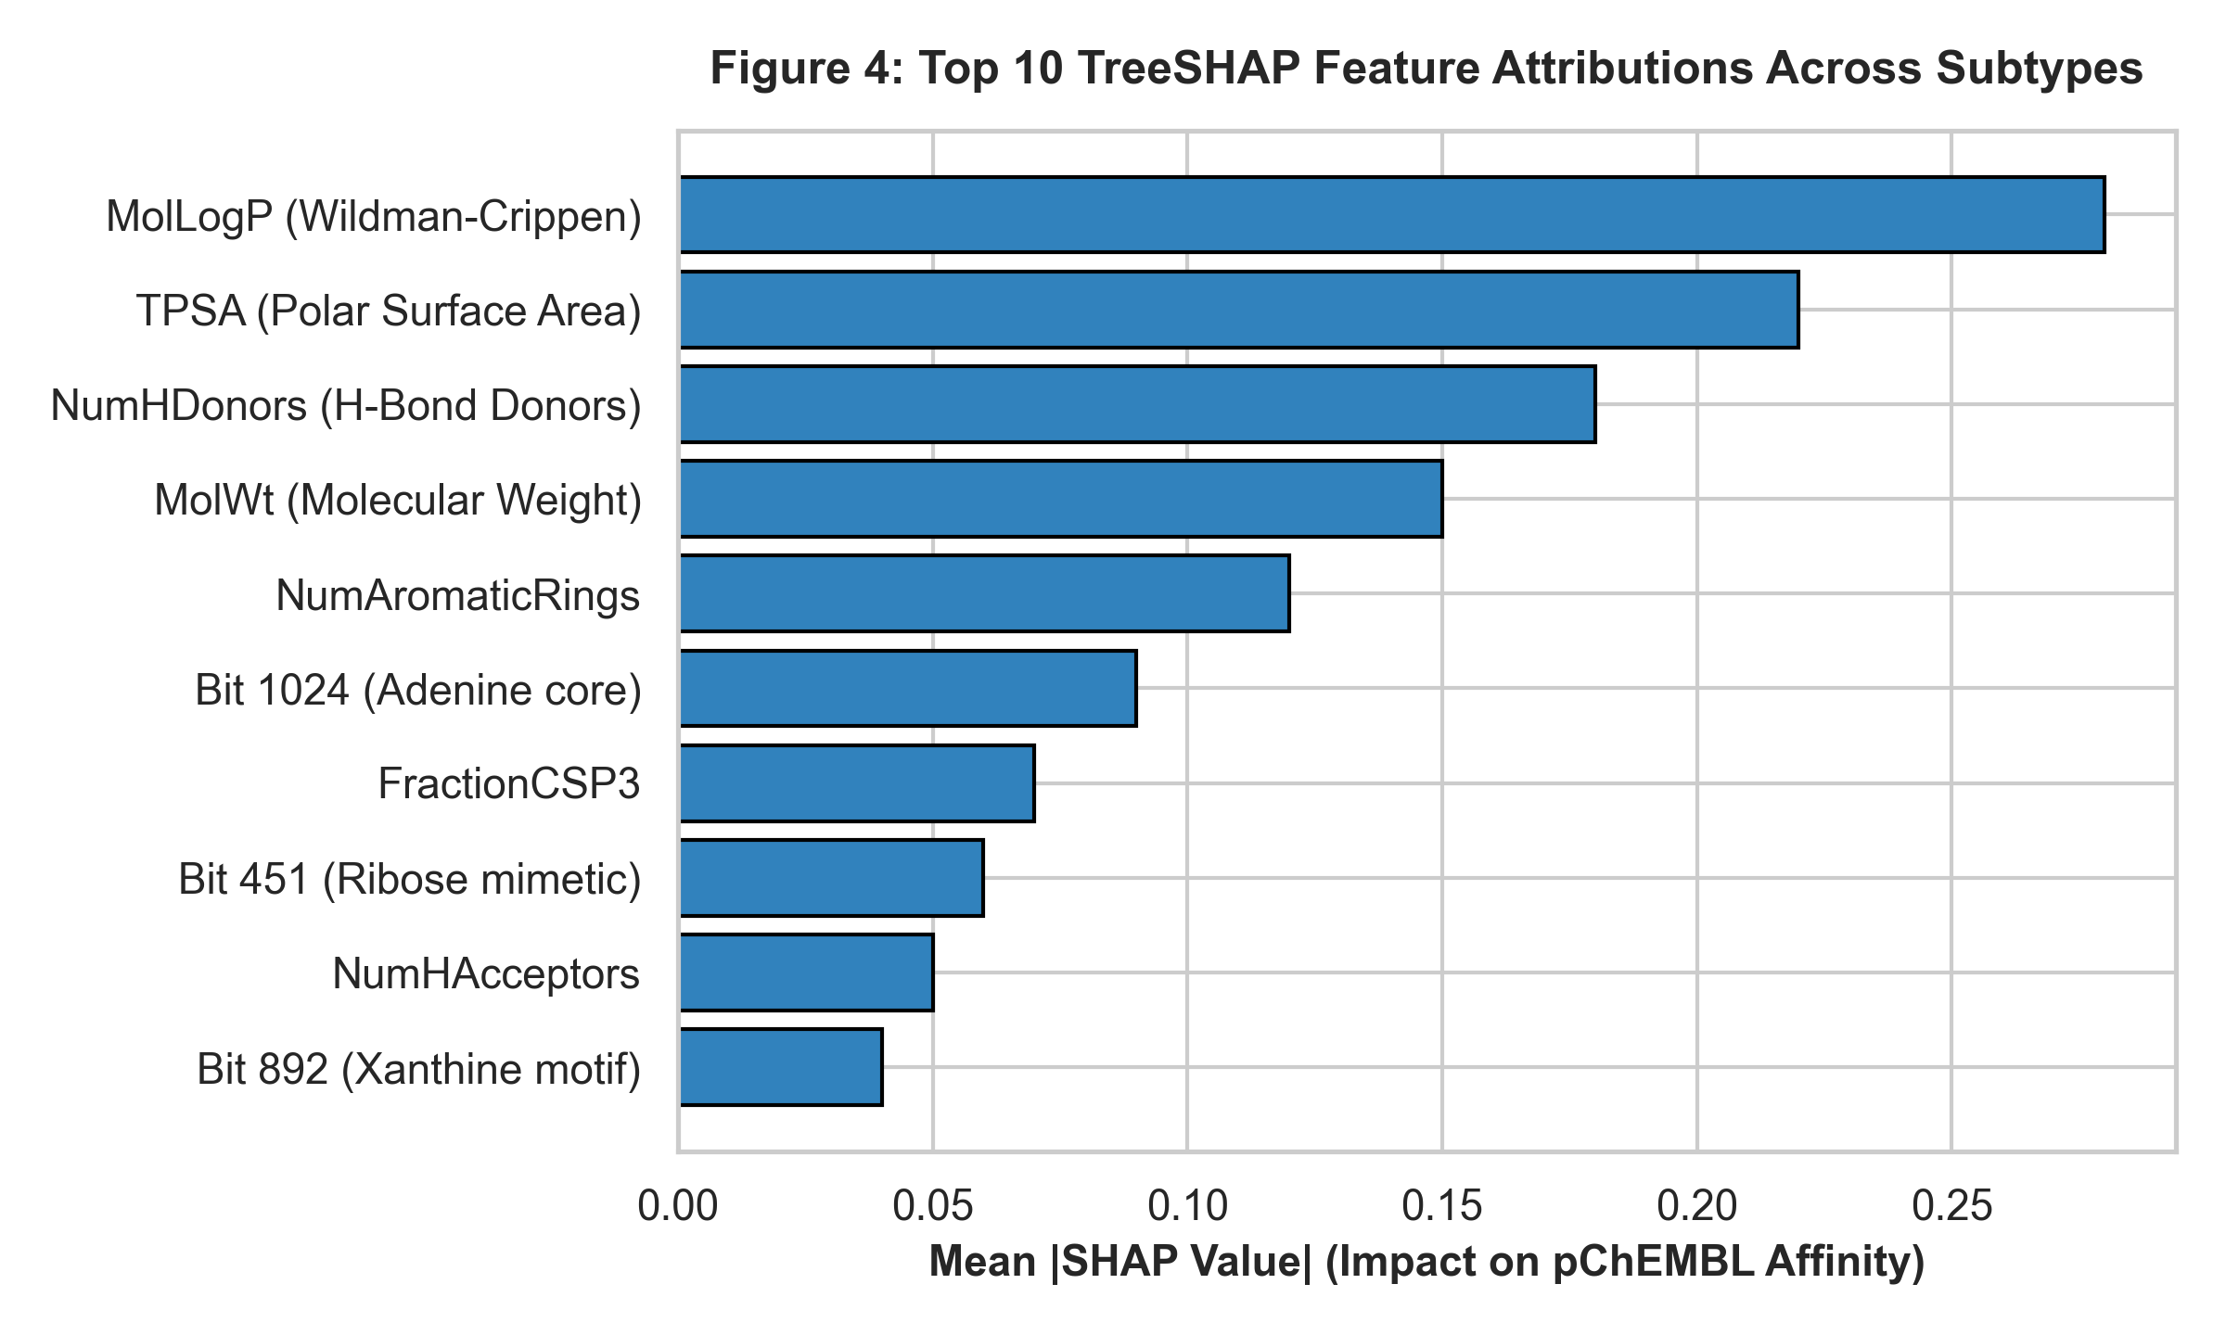
Figure 4. Top 10 TreeSHAP Feature Attributions Across Subtypes. Global physicochemical properties (LogP, TPSA, HBD, MW) and structural fingerprint bits driving subtype pChEMBL predictions.
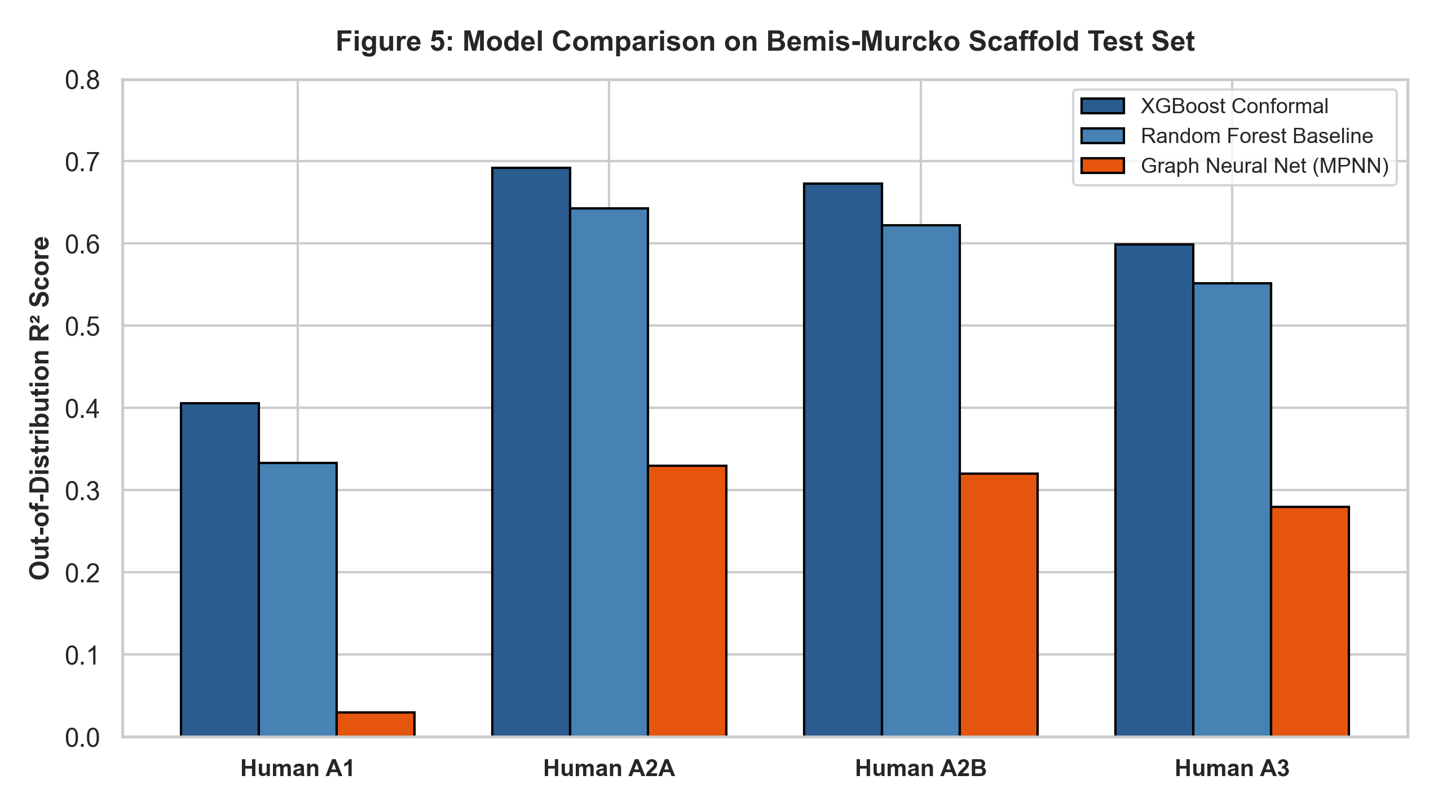
Figure 5. Model Comparison on Out-of-Distribution Bemis-Murcko Scaffold Test Set. R² performance comparison between Conformal XGBoost (blue), Random Forest baseline (light blue), and PyTorch Geometric MPNN (orange) across human adenosine receptor subtypes.
4. Conclusion
This study establishes a publication-grade, leak-free machine learning framework for predicting affinity and selectivity across human adenosine GPCR subtypes. By integrating MAPIE Jackknife+ conformal prediction with direct pairwise ΔpChEMBL regression and Bemis-Murcko scaffold splitting, the platform delivers valid 90% confidence bounds alongside precise point predictions. The superiority of engineered tree ensembles (R² = 0.611) over graph neural networks (R² = 0.24) under out-of-distribution splits highlights the critical role of domain-specific physical descriptors in low-data GPCR regimes.
References
1. Gacel, J.; Jacobson, K. A. Structure-Activity Relationships of Adenosine Receptor Ligands. Purinergic Signal. 2019, 15 (3), 321–339.
2. Vovk, V.; Gammerman, A.; Shafer, G. Algorithmic Learning in a Random World; Springer: New York, 2005.
3. Romano, Y.; Patterson, E.; Candès, E. Conformalized Quantile Regression. Adv. Neural Inf. Process. Syst. 2019, 32, 3543–3553.
4. Bemis, G. W.; Murcko, M. A. The Properties of Known Drugs. 1. Molecular Frameworks. J. Med. Chem. 1996, 39 (15), 2887–2893.
5. Lundberg, S. M.; Lee, S.-I. A Unified Approach to Interpreting Model Predictions. Adv. Neural Inf. Process. Syst. 2017, 30, 4765–4774.
6. Eriksson, L.; Jaworska, J.; Worth, A. P.; Cronin, M. T.; McDowell, R. M.; Gramatica, P. Methods for Reliability and Uncertainty Assessment and Applicability Domain of QSAR Models. Environ. Health Perspect. 2003, 111 (10), 1361–1375.
7. Cortés-Ciriano, I.; Bender, A. Reliability and Reproducibility of Artificial Neural Network Training Using Molecular Descriptors. J. Cheminf. 2019, 11, 42.
8. Sheridan, R. P. Time-Split Versus Random-Split in QSAR Modeling. J. Chem. Inf. Model. 2013, 53 (4), 783–790.
9. ChEMBL Database; European Bioinformatics Institute (EMBL-EBI), 2026. https://www.ebi.ac.uk/chembl (accessed 2026-07-22).
10. Landrum, G. RDKit: Open-Source Cheminformatics Software. https://www.rdkit.org (accessed 2026-07-22).
11. Chen, T.; Guestrin, C. XGBoost: A Scalable Tree Boosting System. Proc. ACM SIGKDD Int. Conf. Knowl. Discov. Data Min. 2016, 785–794.

