**Women Safety Analytics: Real-Time Threat Detection for Enhanced Safety**

**Submitted for**

**Statistical Machine Learning CSET211**

Submitted by:

**UTKARSH PUSHPANKAR (E23CSEU1990)**

**AAROHI SURI (E23CSEU2008)**

Submitted to

**DR. SUDHANSHU GUPTA**

**July-Dec 2024**

**SCHOOL OF COMPUTER SCIENCE AND ENGINEERING**

**INDEX**

|  |  |  |  |  |
| --- | --- | --- | --- | --- |
| Sr.No | Content | | Page No | |
| 1. | Abstract | | 3 | |
| 2. | Introduction | | 3 | |
| 3. | | Related Work | | 3-4 |
| 4. | | Methodology | | 4 |
| 5. | | Hardware/ Software Required | | 4 |
| 6. | | Experimental Results | | 5-10 |
| 7. | | Conclusions | | 10 |
| 8. | | Future Scope | | 10 |
| 9. | | Github Repository Link | | 11 |

1. **Abstract:** The growing concerns over women's safety in urban areas necessitate innovative solutions for real-time monitoring and threat detection. This project, 'Women Safety Analytics,' leverages advanced machine learning techniques to create a robust surveillance system that identifies potential threats to women in public spaces. By integrating YOLOv8 for person detection and ResNet50 with transfer learning for gender classification, the system detects lone women at night, women surrounded by men, and SOS gestures. Real-time alerts and hotspot analysis further enhance its utility, enabling law enforcement to intervene proactively and ensuring a safer environment for women.
2. **Introduction:** With increasing urbanization, the safety of women in public spaces has become a critical issue. Traditional methods of ensuring security, such as manual surveillance, are often insufficient to address modern challenges. This project aims to bridge this gap by developing a Women Safety Analytics system that employs real-time monitoring and advanced analytics to identify and address potential threats. By leveraging deep learning techniques, the system provides insights into gender distribution, detects anomalies, and generates alerts, fostering a safer urban environment.
3. **Related Work (If Any):** Existing research on surveillance systems highlights the potential of machine learning models like YOLO and ResNet in object detection and classification tasks. While systems for general crowd monitoring and anomaly detection exist, few focus specifically on women’s safety. This project builds upon these technologies, customizing them for gender classification, threat detection, and alert generation tailored to women’s safety scenarios.

**Link to existing research paper:** [**(PDF) Women Safety Analytics Protecting Women From Safety Threats**](https://www.researchgate.net/publication/384076254_Women_Safety_Analytics_Protecting_Women_From_Safety_Threats)

1. **Methodology:** The methodology comprises the following steps:  
   1. Person Detection: YOLOv8, fine-tuned on a custom dataset, detects individuals in surveillance footage.  
   2. Gender Classification: ResNet50, enhanced through transfer learning, classifies the gender of detected individuals, focusing on real-world surveillance scenarios.  
   3. Threat Detection: Real-time algorithms analyze situations such as a lone woman at night or a woman surrounded by men. SOS gestures are identified using gesture recognition techniques.  
   4. Alert System: Threats trigger immediate notifications and are logged for hotspot analysis.
2. **Hardware/Software Required:** Hardware:  
   - High-performance GPU (e.g., NVIDIA RTX series) for training and real-time detection.  
   - Surveillance cameras for data collection and live monitoring.  
     
   Software:  
   - Python for model implementation.  
   - TensorFlow/Keras and PyTorch for deep learning.  
   - Google Colab and it’s T4 GPU for training.  
   - OpenCV for real-time video processing.  
   - Cloud services for alert notifications and hotspot mapping.
3. **Experimental Results:**

**The graph for Gender Classification Model’s Accuracy:**

**The graph for Gender Classification Model’s Loss:**

**Predictions Using the Fine-Tuned Gender Classification Model trained Using Transfer Learning on Resnet50 Model:**

**Green Represents Correct Prediction while Red Represents Incorrect Prediction**

**Predictions when the Person Detection Model is connected to the Gender Classification Model using a pipeline:**

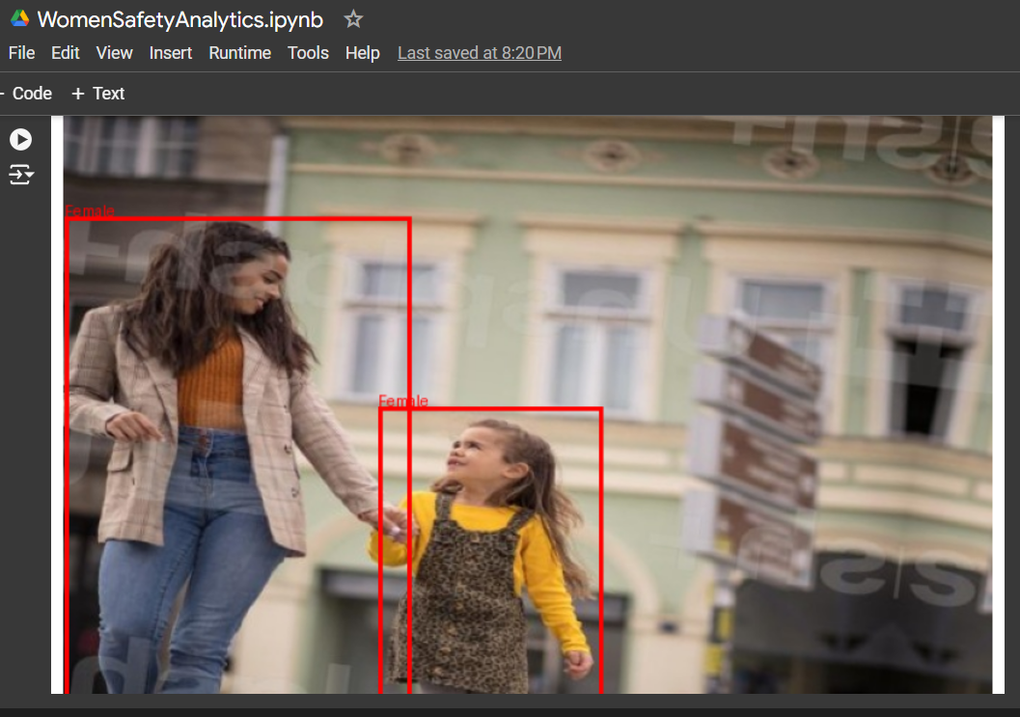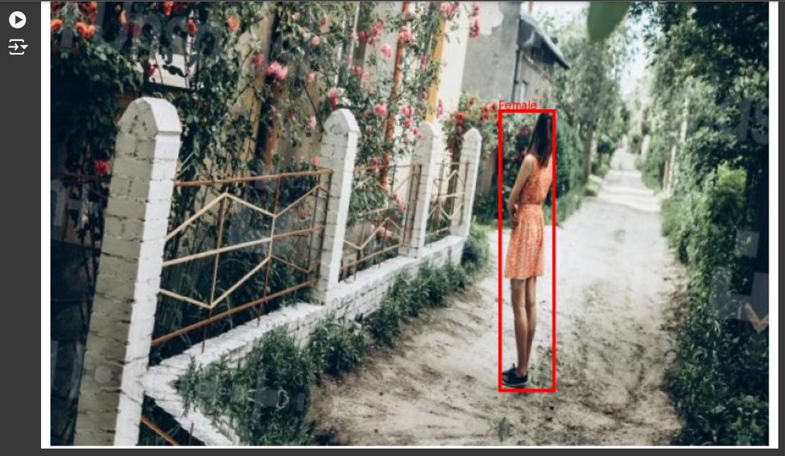

**Test Results for Gender Classification Model (Stats):**

1. **Conclusions:** The Women Safety Analytics system demonstrates the feasibility of leveraging deep learning for real-time threat detection. By integrating person detection, gender classification, and anomaly detection, the project provides an effective solution for enhancing women’s safety. Real-time alerts and hotspot analysis empower law enforcement to take proactive measures, making public spaces safer.
2. **Future Scope:** 1. Improvement Areas: Enhance SOS gesture recognition and refine models for better night-time detection.  
   2. Additional Features: Incorporate GPS tracking for precise location identification and sentiment analysis to evaluate crowd behavior.  
   3. Deployment: Expand integration with smart city surveillance systems for wider adoption.

**9.GitHub Link of Your Complete Project:**

**https://github.com/UtkarshPushpankar/Women-Safety-Analytics-Using-Machine-Learning**