**DBMS PROJECT REPORT**

**TEAM** :-

UTKARSH SETH - PES1UG21CS687

VIBHA MARPALLE - PES1UG21CS708

**WATER POLLUTION MANAGEMENT DATABASE**

* **Description** : The Water Pollution Management Database Project aims to create a comprehensive and efficient system for monitoring, managing, and mitigating water pollution. This project stores state wise information about water bodies like pollution levels, pollutants and remedies which can be updated by government users and has a feature to raise requests regarding a body by citizen users.
* **List of Software used** : MySQL, Javascript, HTML, CSS, ReactJS, NodeJS, ExpressJS.
* **ER Diagram**

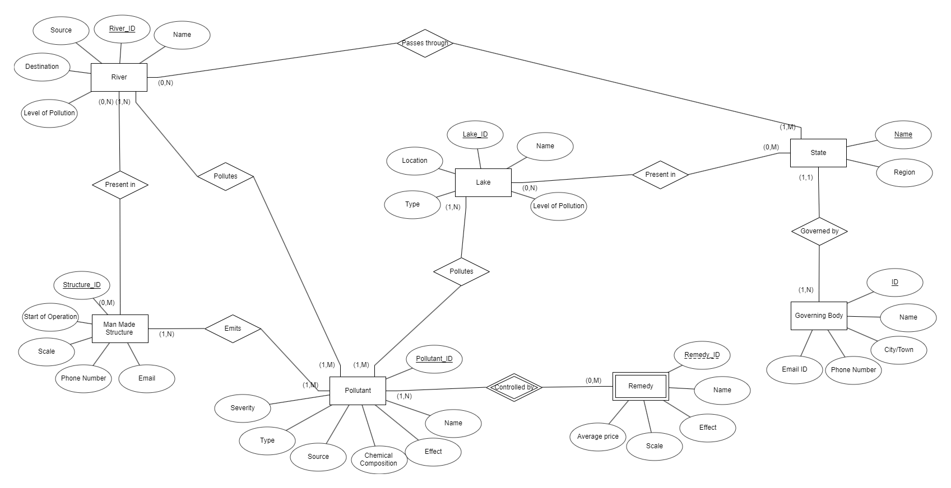

* **Relational Schema**

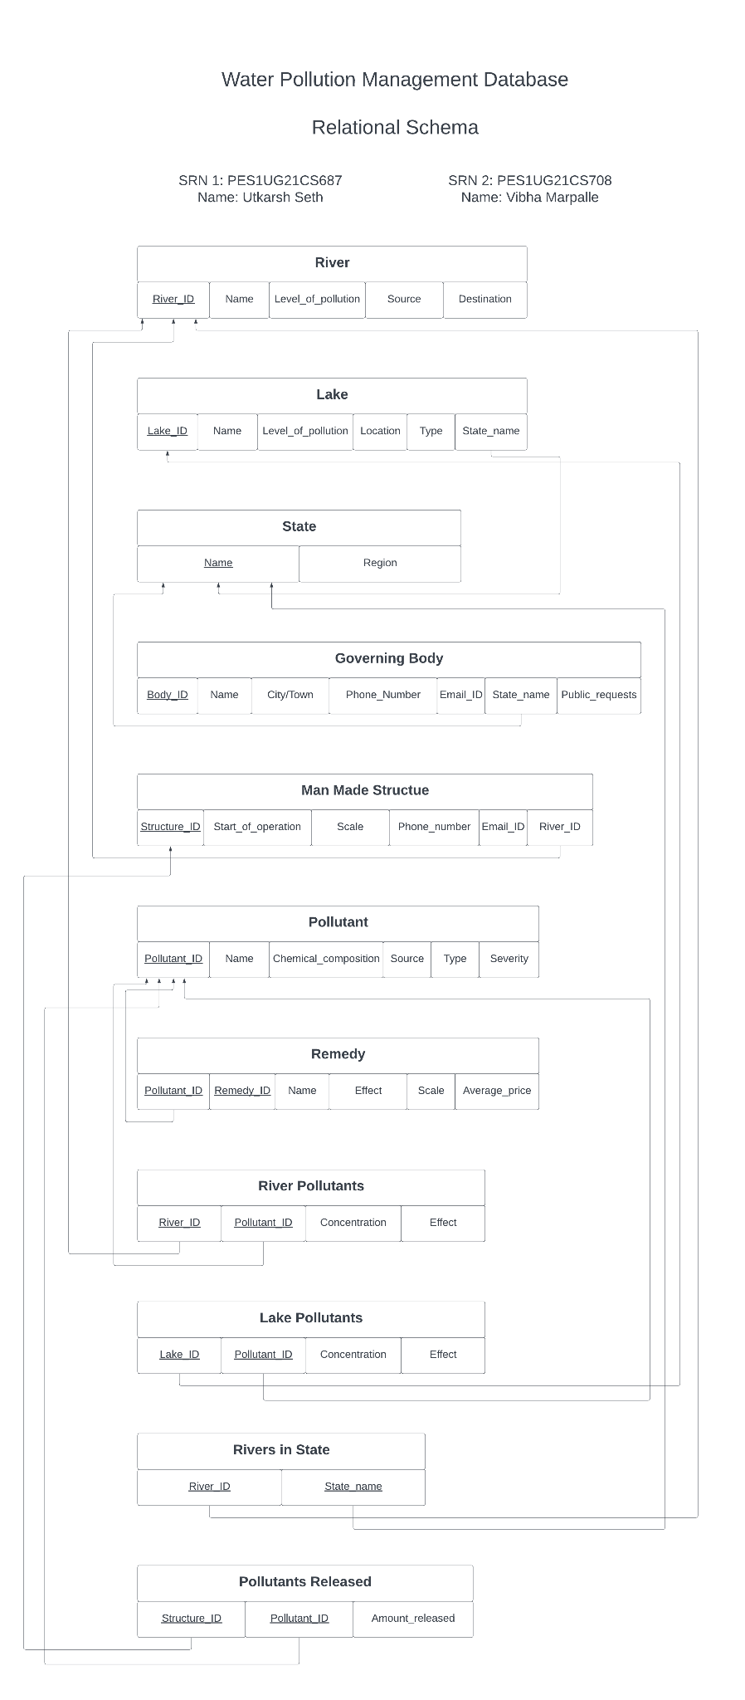

* **DDL SQL commands**

CREATE DATABASE miniProject;

USE miniProject;

CREATE TABLE rivers (

`river_id` VARCHAR(10) PRIMARY KEY,

`name` VARCHAR(30) NOT NULL,

`level_of_pollution` ENUM("1", "2", "3", "4", "5"),

`source` VARCHAR(30),

`destination` VARCHAR(30)

);

CREATE TABLE states (

`name` VARCHAR(30) PRIMARY KEY,

`region` VARCHAR(30) NOT NULL

);

CREATE TABLE lakes (

`lake_id` VARCHAR(10) PRIMARY KEY,

`name` VARCHAR(30) NOT NULL,

`level_of_pollution` ENUM("1", "2", "3", "4", "5"),

`location` VARCHAR(50),

`type` ENUM("Natural", "Man-made"),

`state_name` VARCHAR(30)

);

ALTER TABLE lakes ADD FOREIGN KEY (`state_name`) REFERENCES states(`name`) ON DELETE CASCADE ON UPDATE CASCADE;

CREATE TABLE pollutants (

`pollutant_id` VARCHAR(10) PRIMARY KEY,

`name` VARCHAR(30) NOT NULL,

`chemical_composition` VARCHAR(30),

`source` VARCHAR(30),

`type` VARCHAR(30),

`severity` ENUM("High", "Medium", "Low")

);

CREATE TABLE man_made_structures (

`structure_id` VARCHAR(10) PRIMARY KEY,

`start_of_operation` DATE NOT NULL,

`scale` ENUM("Small", "Medium", "Large") NOT NULL,

`phone_number` VARCHAR(15) NOT NULL,

`email` VARCHAR(50) NOT NULL,

`river_id` VARCHAR(10) NOT NULL,

CONSTRAINT FOREIGN KEY (`river_id`) REFERENCES rivers(`river_id`) ON DELETE CASCADE ON UPDATE CASCADE

);

CREATE TABLE river_pollutants (

`river_id` VARCHAR(10),

`pollutant_id` VARCHAR(10),

`concentration` VARCHAR(20) NOT NULL,

`effect` VARCHAR(100) NOT NULL,

CONSTRAINT PRIMARY KEY (`river_id`, `pollutant_id`),

CONSTRAINT FOREIGN KEY (`river_id`) REFERENCES rivers(`river_id`) ON DELETE CASCADE ON UPDATE CASCADE,

CONSTRAINT FOREIGN KEY (`pollutant_id`) REFERENCES pollutants(`pollutant_id`) ON DELETE CASCADE ON UPDATE CASCADE

);

CREATE TABLE lake_pollutants (

`lake_id` VARCHAR(10),

`pollutant_id` VARCHAR(10),

`concentration` VARCHAR(20) NOT NULL,

`effect` VARCHAR(100) NOT NULL,

CONSTRAINT PRIMARY KEY (`lake_id`, `pollutant_id`),

CONSTRAINT FOREIGN KEY (`lake_id`) REFERENCES lakes(`lake_id`) ON DELETE CASCADE ON UPDATE CASCADE,

CONSTRAINT FOREIGN KEY (`pollutant_id`) REFERENCES pollutants(`pollutant_id`) ON DELETE CASCADE ON UPDATE CASCADE

);

CREATE TABLE rivers_in_state (

`river_id` VARCHAR(10),

`state_name` VARCHAR(30),

CONSTRAINT PRIMARY KEY (`river_id`, `state_name`),

CONSTRAINT FOREIGN KEY (`river_id`) REFERENCES rivers(`river_id`) ON DELETE CASCADE ON UPDATE CASCADE,

CONSTRAINT FOREIGN KEY (`state_name`) REFERENCES states(`name`) ON DELETE CASCADE ON UPDATE CASCADE

);

CREATE TABLE pollutants_released (

`structure_id` VARCHAR(10),

`pollutant_id` VARCHAR(10),

`amount_released` VARCHAR(30) NOT NULL,

CONSTRAINT PRIMARY KEY (`structure_id`, `pollutant_id`),

CONSTRAINT FOREIGN KEY (`structure_id`) REFERENCES man_made_structures(`structure_id`) ON DELETE CASCADE ON UPDATE CASCADE,

CONSTRAINT FOREIGN KEY (`pollutant_id`) REFERENCES pollutants(`pollutant_id`) ON DELETE CASCADE ON UPDATE CASCADE

);

CREATE TABLE government_bodies (

`body_id` VARCHAR(10),

`name` VARCHAR(45) NOT NULL,

`city/town` VARCHAR(45) NOT NULL,

`phone` VARCHAR(15) NOT NULL,

`email` VARCHAR(45) NULL,

`state_name` VARCHAR(30) NOT NULL,

PRIMARY KEY (`body_id`)

);

ALTER TABLE government_bodies ADD CONSTRAINT FOREIGN KEY (`state_name`) REFERENCES states(`name`) ON DELETE CASCADE ON UPDATE CASCADE;

CREATE TABLE remedies (

`pollutant_id` VARCHAR(10),

`remedy_id` VARCHAR(10) NOT NULL,

`name` VARCHAR(45) NOT NULL,

`effect` VARCHAR(100) NOT NULL,

`scale` VARCHAR(45) NULL,

`avg_price` FLOAT NOT NULL,

PRIMARY KEY (pollutant_id, remedy_id),

CONSTRAINT FOREIGN KEY (`pollutant_id`) REFERENCES pollutants(`pollutant_id`) ON DELETE CASCADE ON UPDATE CASCADE

);

CREATE TABLE users (

`email` VARCHAR(50) PRIMARY KEY,

`first_name` VARCHAR(30) NOT NULL,

`last_name` VARCHAR(30) NOT NULL,

`password` VARCHAR(50) NOT NULL

);

CREATE TABLE admins (

`id` INT PRIMARY KEY,

`first_name` VARCHAR(30) NOT NULL,

`last_name` VARCHAR(30) NOT NULL,

`password` VARCHAR(30) NOT NULL

);

CREATE TABLE government_users (

`government_id` INT PRIMARY KEY,

`first_name` VARCHAR(30) NOT NULL,

`last_name` VARCHAR(30) NOT NULL,

`email` VARCHAR(50) NOT NULL,

`password` VARCHAR(50) NOT NULL

);

CREATE TABLE requests (

`request_id` VARCHAR(15) PRIMARY KEY,

`user_email` VARCHAR(50),

`lake_id` VARCHAR(10),

`river_id` VARCHAR(10),

`city` VARCHAR(45) NOT NULL,

`state_name` VARCHAR(30),

`content` VARCHAR(300) NOT NULL,

CONSTRAINT FOREIGN KEY (`user_email`) REFERENCES users(`email`) ON DELETE CASCADE ON UPDATE CASCADE,

CONSTRAINT FOREIGN KEY (`lake_id`) REFERENCES lakes(`lake_id`) ON DELETE CASCADE ON UPDATE CASCADE,

CONSTRAINT FOREIGN KEY (`state_name`) REFERENCES states(`name`) ON DELETE CASCADE ON UPDATE CASCADE

);

* **CRUD Operations Screenshots**

1) Read

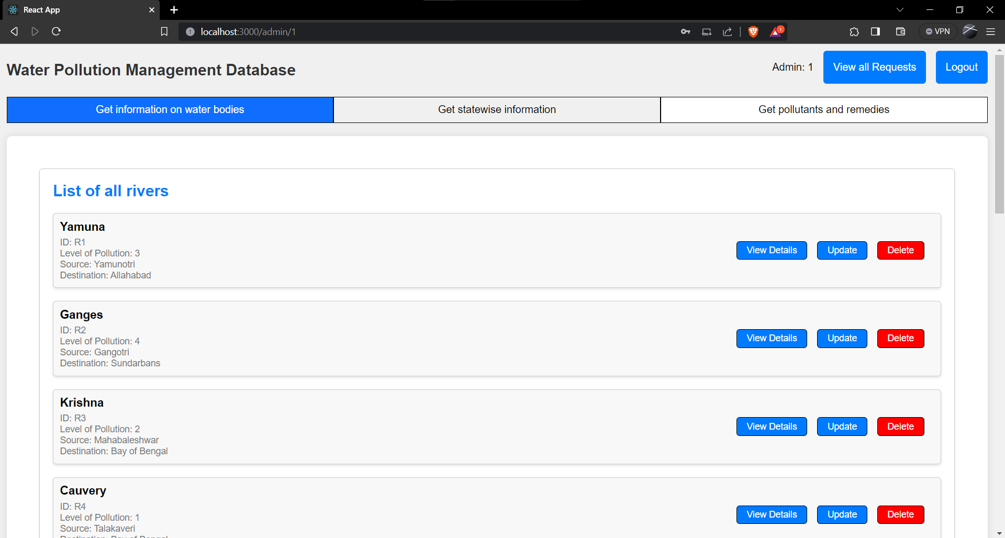

2) Update

Before:

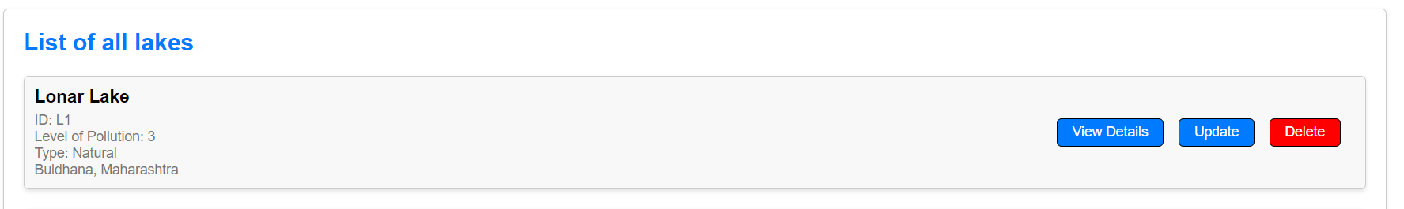

Updating the city:

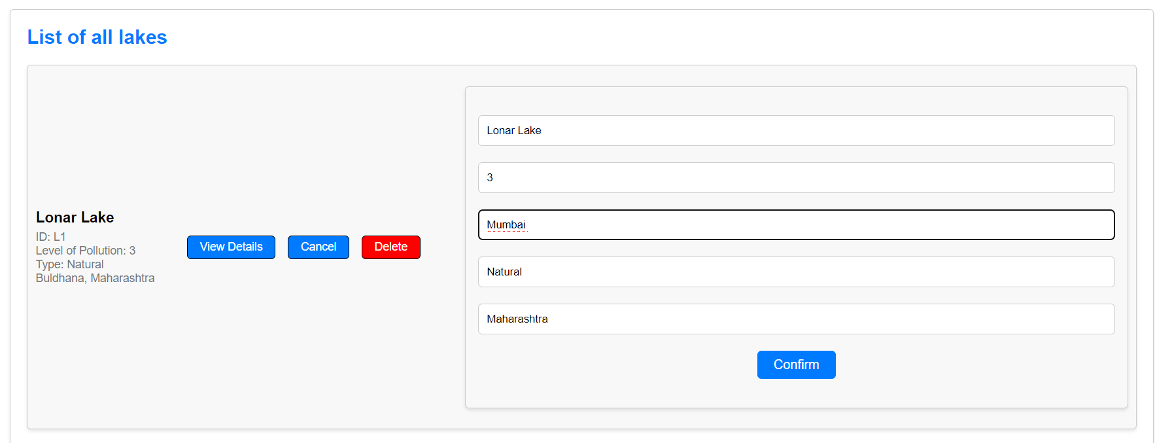

After:

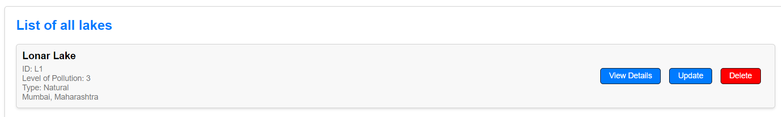

3) Delete

Before:

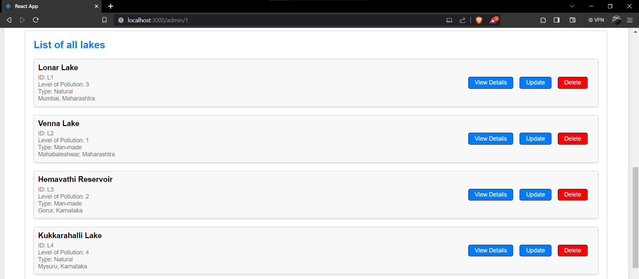

After deleting Venna Lake:

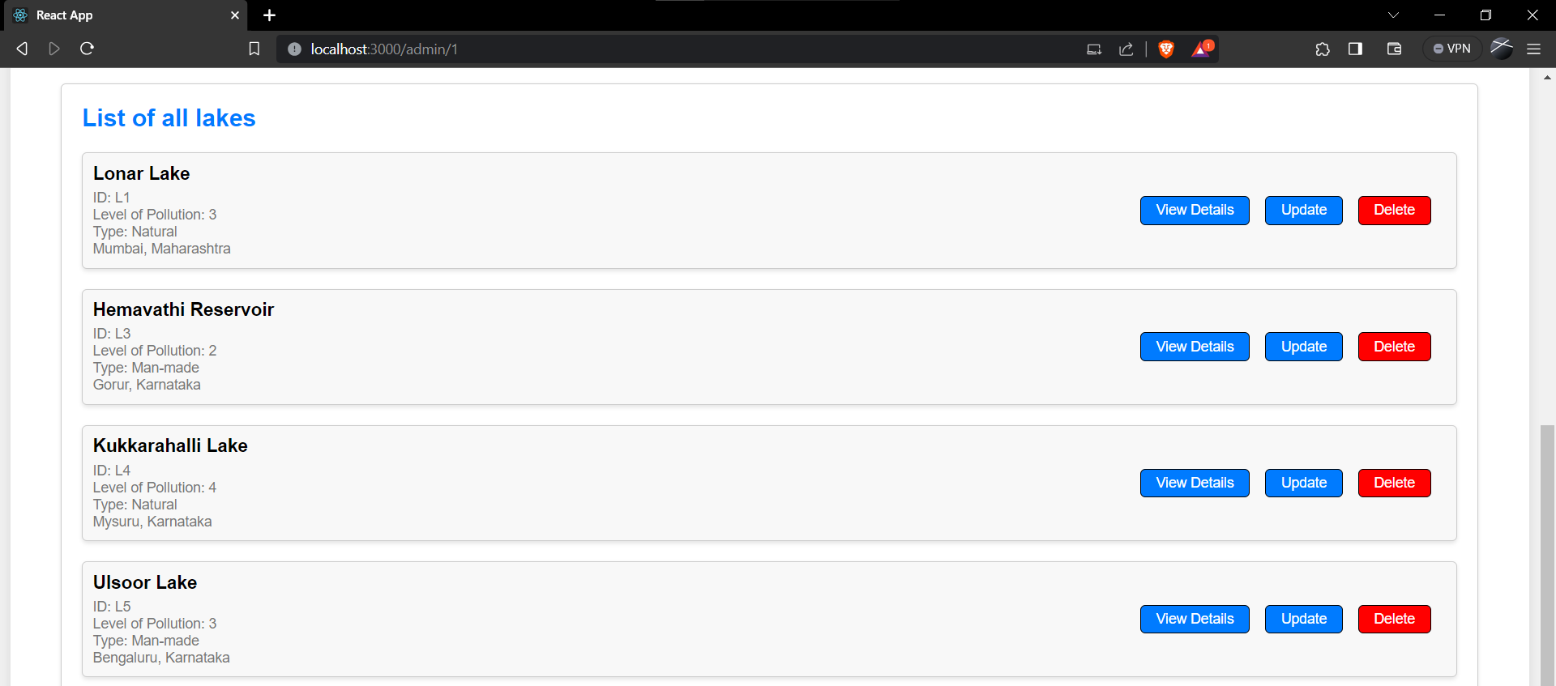

* **List of Functionalities with frontend screenshot**

1) Signup/Login for government bodies

a) Signup

Before:

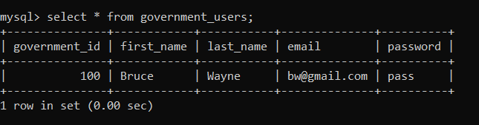

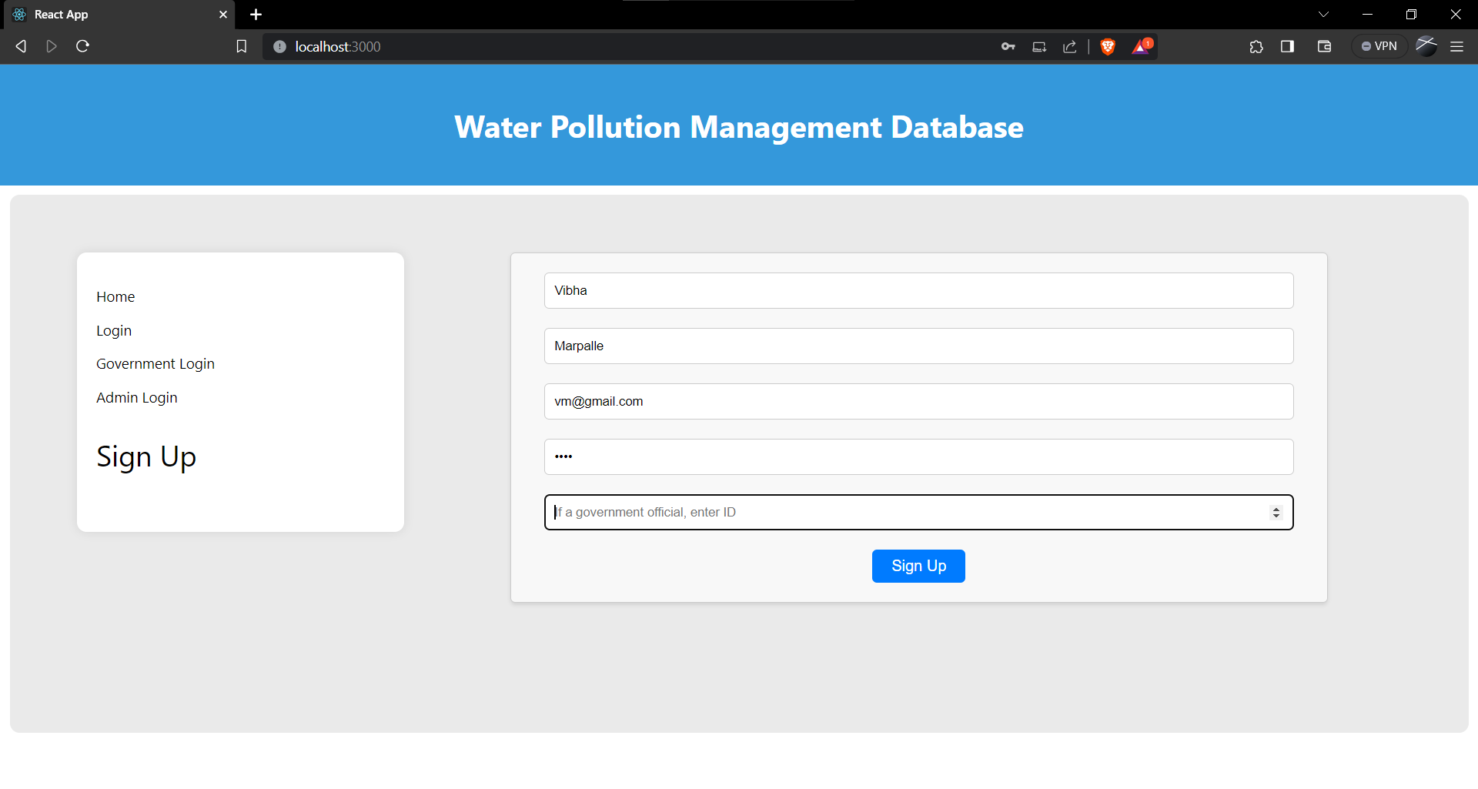

After:

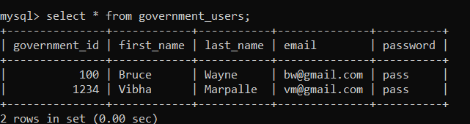

Login:

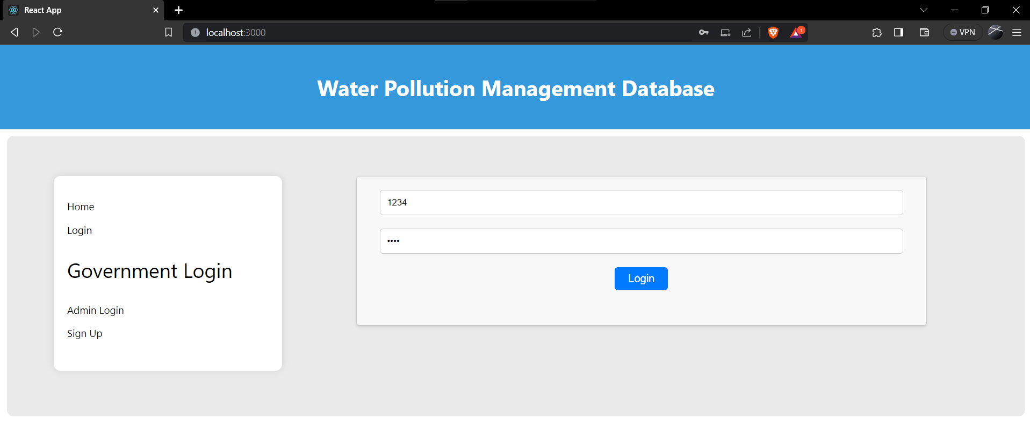

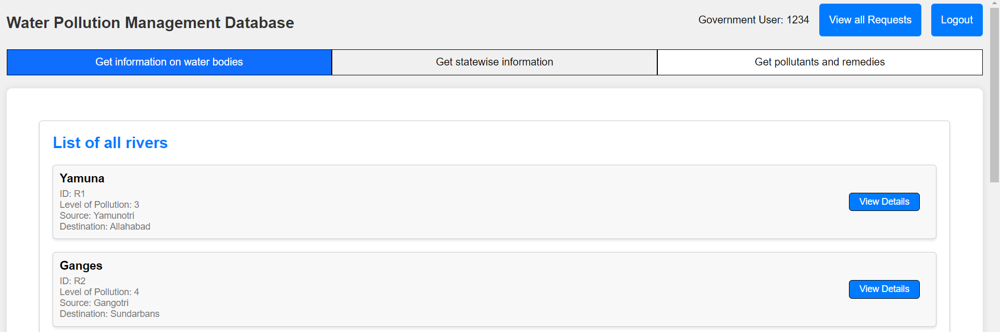

2) Viewing the pollution status for a water body

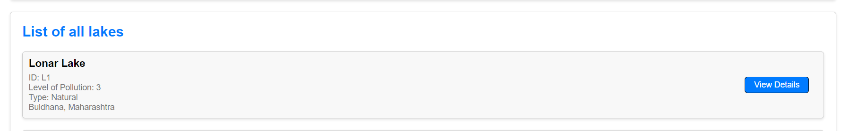

After clicking on ‘View Details’:

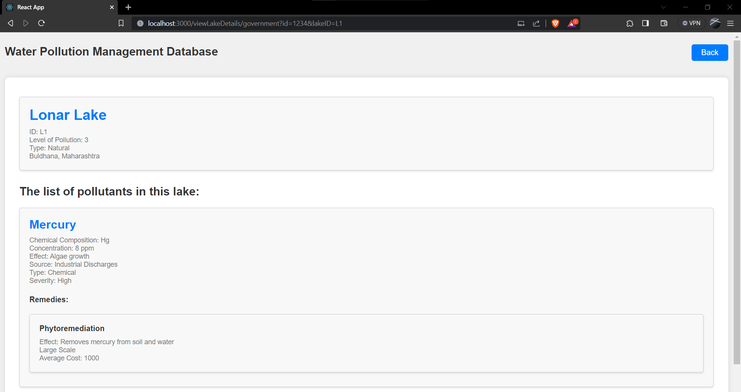

3) Finding the source of pollution

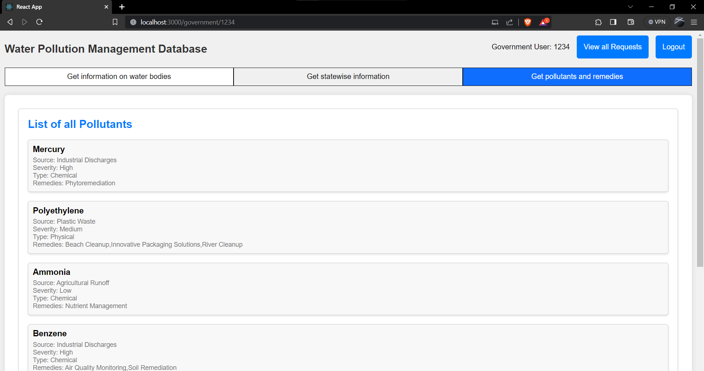

4) Giving remedies for a type of pollutant

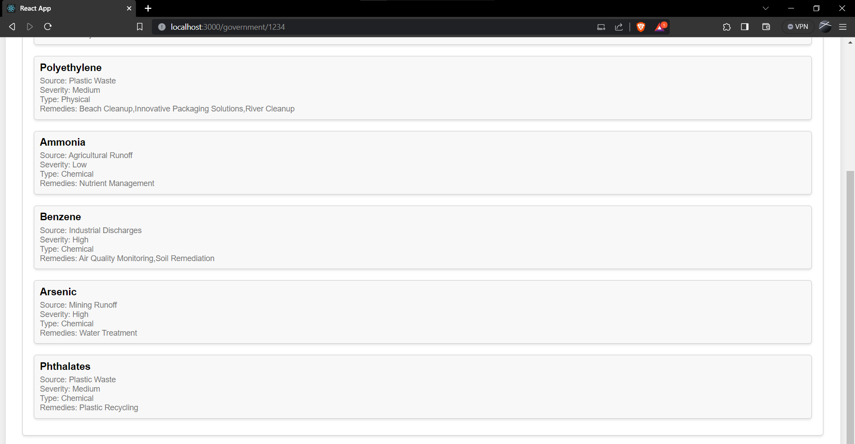

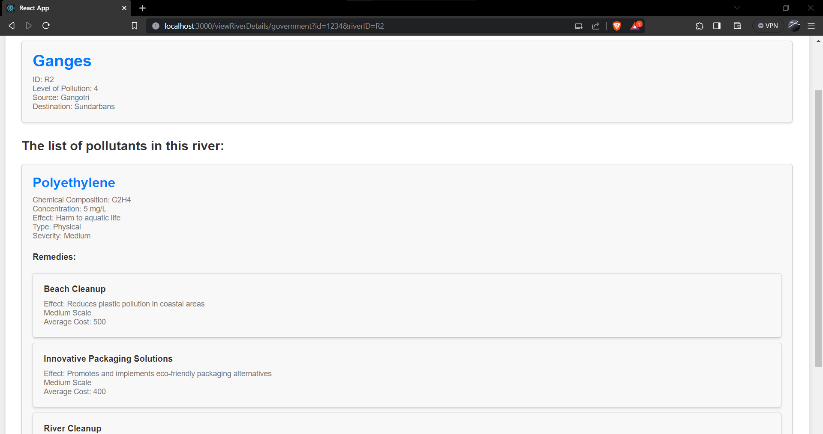

5) Raising public request regarding a specific water body

Adding Request:

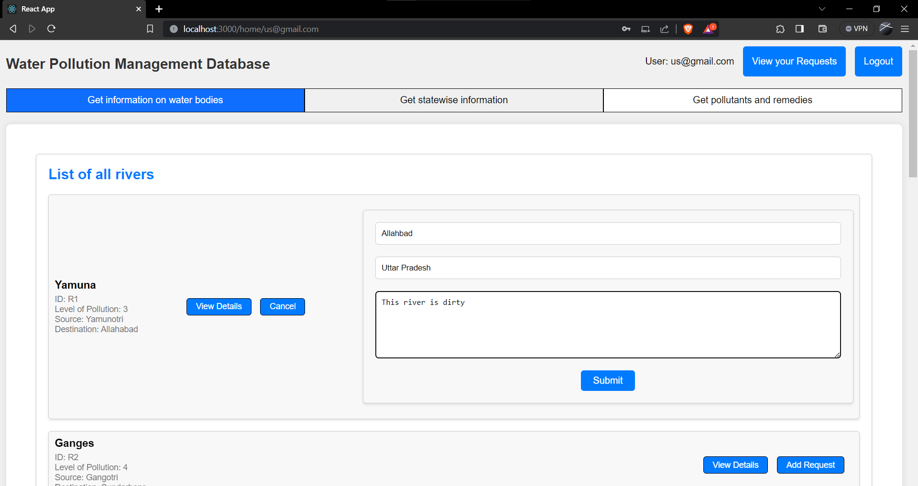

Viewing your requests as a user:

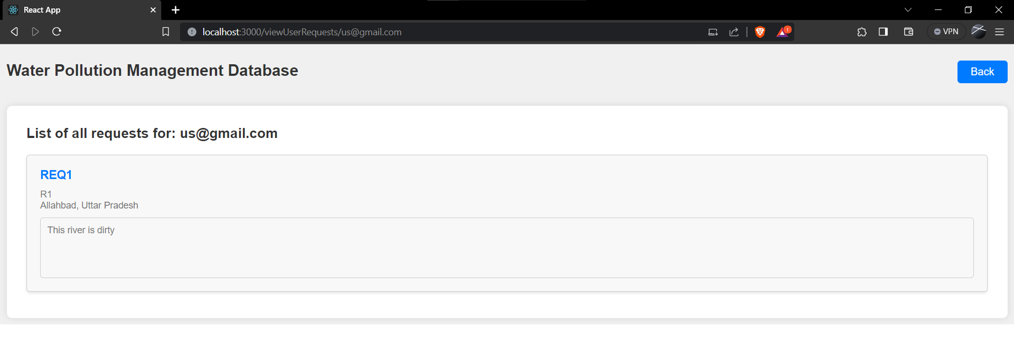

Viewing all requests as a government user:

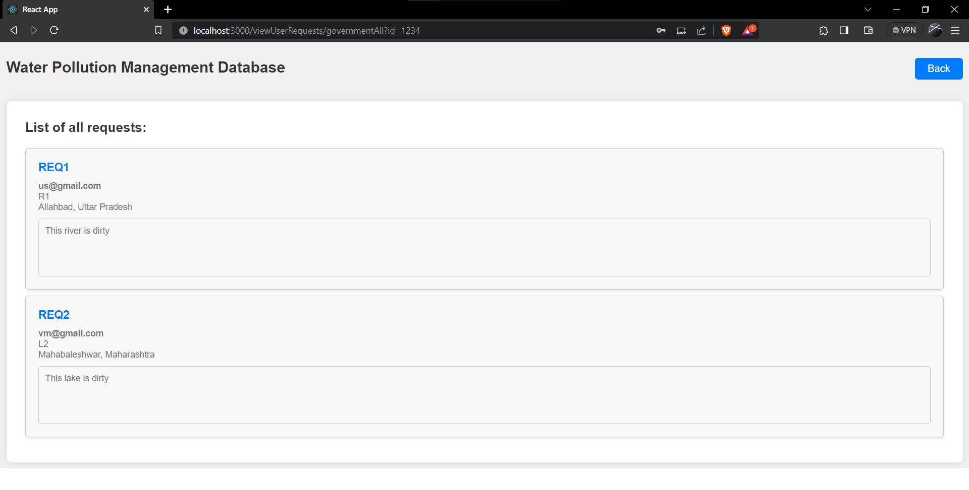

6) Viewing state wise information

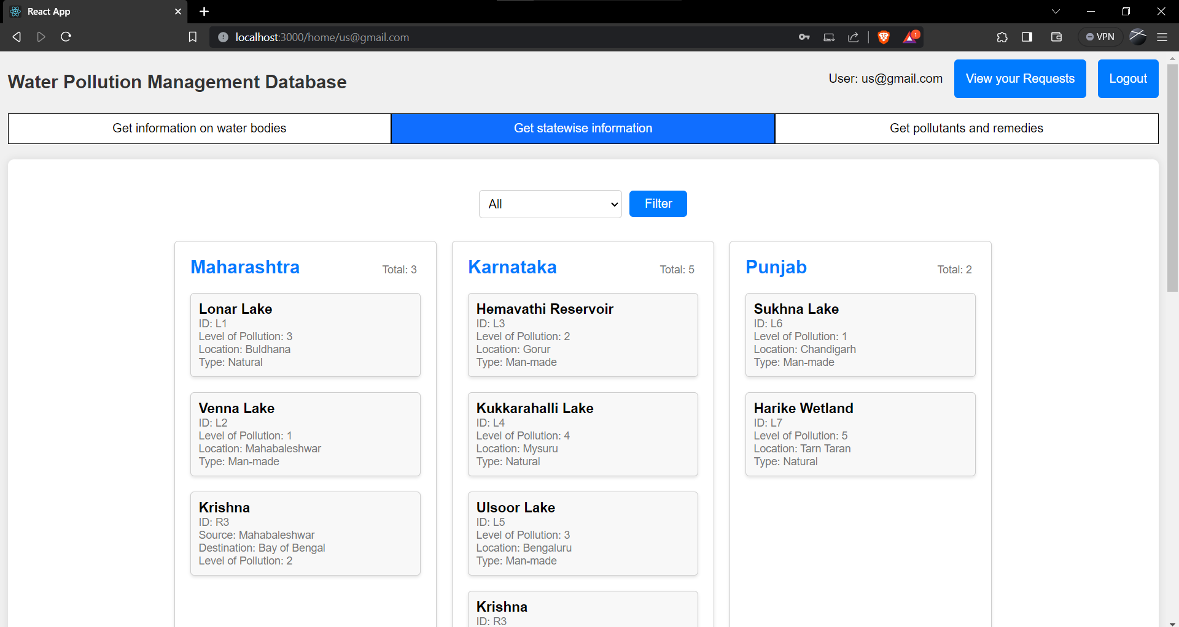

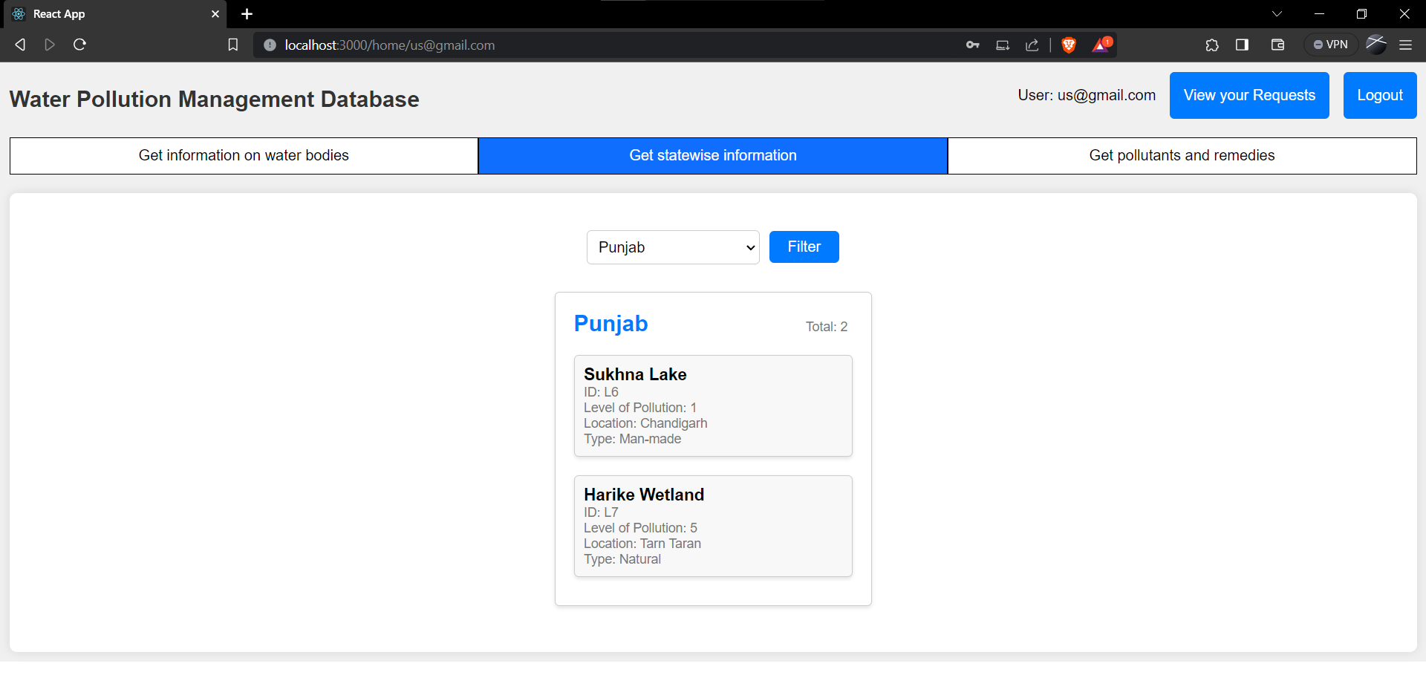

* **Procedures with Nested and Join queries, Functions with Aggregate queries and Triggers :**

1. **Procedures, Nested queries and Join queries**:

USE miniProject;

DELIMITER //

CREATE PROCEDURE GetLakeDetails(IN id VARCHAR(10))

BEGIN

WITH temp AS (

SELECT

L.lake_id AS lake_id,

L.name AS lake_name,

L.level_of_pollution,

L.location,

L.type,

L.state_name,

LP.pollutant_id,

LP.concentration,

LP.effect,

P.name AS pollutant_name,

P.chemical_composition,

P.source,

P.type AS pollutant_type,

P.severity

FROM

(SELECT *

FROM lakes

WHERE lake_id = id) AS L

JOIN lake_pollutants AS LP ON L.lake_id = LP.lake_id

JOIN pollutants AS P ON LP.pollutant_id = P.pollutant_id

)

SELECT

temp.*,

R.remedy_id,

R.name AS remedy_name,

R.effect AS remedy_effect,

R.scale AS remedy_scale,

R.avg_price AS remedy_avg_price

FROM temp

JOIN remedies AS R ON temp.pollutant_id = R.pollutant_id;

END //

DELIMITER ;

DELIMITER //

CREATE PROCEDURE GetRiverDetails(IN id VARCHAR(10))

BEGIN

WITH temp AS (

SELECT

RI.river_id AS river_id,

RI.name AS river_name,

RI.level_of_pollution,

RI.source AS source,

RI.destination AS destination,

RP.pollutant_id,

RP.concentration,

RP.effect,

P.name AS pollutant_name,

P.chemical_composition,

P.source AS pollutant_source,

P.type AS pollutant_type,

P.severity

FROM

(SELECT *

FROM rivers

WHERE river_id = id) AS RI

JOIN river_pollutants AS RP ON RI.river_id = RP.river_id

JOIN pollutants AS P ON RP.pollutant_id = P.pollutant_id

)

SELECT

temp.*,

R.remedy_id,

R.name AS remedy_name,

R.effect AS remedy_effect,

R.scale AS remedy_scale,

R.avg_price AS remedy_avg_price

FROM temp

JOIN remedies AS R ON temp.pollutant_id = R.pollutant_id;

END //

DELIMITER ;

DELIMITER //

CREATE PROCEDURE InsertUserDetails(IN user_email VARCHAR(50))

BEGIN

SET @create_user_query = CONCAT("CREATE USER ", CONCAT_WS('@', QUOTE(user_email), 'localhost'), ";");

PREPARE create_user_stmt FROM @create_user_query;

EXECUTE create_user_stmt;

DEALLOCATE PREPARE create_user_stmt;

SET @grant_query = CONCAT("GRANT 'users'@'localhost' TO ", CONCAT_WS('@', QUOTE(user_email), 'localhost'), ";");

PREPARE grant_stmt FROM @grant_query;

EXECUTE grant_stmt;

DEALLOCATE PREPARE grant_stmt;

END //

DELIMITER ;

DELIMITER //

CREATE PROCEDURE InsertGovernmentUserDetails(IN user_email VARCHAR(50))

BEGIN

SET @create_user_query = CONCAT("CREATE USER ", CONCAT_WS('@', QUOTE(user_email), 'localhost'), ";");

PREPARE create_user_stmt FROM @create_user_query;

EXECUTE create_user_stmt;

DEALLOCATE PREPARE create_user_stmt;

SET @grant_query = CONCAT("GRANT 'governmentUsers'@'localhost' TO ", CONCAT_WS('@', QUOTE(user_email), 'localhost'), ";");

PREPARE grant_stmt FROM @grant_query;

EXECUTE grant_stmt;

DEALLOCATE PREPARE grant_stmt;

END //

DELIMITER ;

DELIMITER //

CREATE PROCEDURE InsertAdminDetails(IN user_email VARCHAR(50))

BEGIN

SET @create_user_query = CONCAT("CREATE USER ", CONCAT_WS('@', QUOTE(user_email), 'localhost'), ";");

PREPARE create_user_stmt FROM @create_user_query;

EXECUTE create_user_stmt;

DEALLOCATE PREPARE create_user_stmt;

SET @grant_query = CONCAT("GRANT 'admins'@'localhost' TO ", CONCAT_WS('@', QUOTE(user_email), 'localhost'), ";");

PREPARE grant_stmt FROM @grant_query;

EXECUTE grant_stmt;

DEALLOCATE PREPARE grant_stmt;

END //

DELIMITER ;

1. **Functions, Aggregate queries :**

USE miniProject;

DELIMITER //

CREATE FUNCTION getTotalBodiesInState(input_state VARCHAR(30))

RETURNS INT

DETERMINISTIC

BEGIN

DECLARE number_of_rivers INT;

DECLARE number_of_lakes INT;

SELECT COUNT(*)

INTO number_of_rivers

FROM (

SELECT state_name, river_id

FROM rivers_in_state

WHERE state_name = input_state

) AS num_rivers

GROUP BY state_name;

SELECT COUNT(*)

INTO number_of_lakes

FROM (

SELECT state_name, lake_id

FROM lakes

WHERE state_name = input_state

) AS num_lakes

GROUP BY state_name;

IF number_of_lakes IS NULL AND number_of_rivers IS NULL THEN

RETURN 0;

ELSEIF number_of_lakes IS NULL THEN

RETURN number_of_rivers;

ELSEIF number_of_rivers IS NULL THEN

RETURN number_of_lakes;

ELSE

RETURN number_of_rivers + number_of_lakes;

END IF;

END //

DELIMITER ;

1. **Trigger queries :**

USE miniProject;

DELIMITER //

CREATE TRIGGER InsertLake

BEFORE INSERT ON lakes

FOR EACH ROW

BEGIN

DECLARE number_of_rows INT;

SELECT COUNT(*) INTO number_of_rows FROM lakes;

SET NEW.lake_id = CONCAT("L", number_of_rows + 1);

END //

DELIMITER ;

DELIMITER //

CREATE TRIGGER InsertRiver

BEFORE INSERT ON rivers

FOR EACH ROW

BEGIN

DECLARE number_of_rows INT;

SELECT COUNT(*) INTO number_of_rows FROM rivers;

SET NEW.river_id = CONCAT("R", number_of_rows + 1);

END //

DELIMITER ;

DELIMITER //

CREATE TRIGGER InsertRequest

BEFORE INSERT ON requests

FOR EACH ROW

BEGIN

DECLARE number_of_rows INT;

SELECT COUNT(*) INTO number_of_rows FROM requests;

SET NEW.request_id = CONCAT("REQ", number_of_rows + 1);

END //

DELIMITER ;

* **Code snippets for invoking the Procedures/Functions/Trigger**

**1) Procedures:**

database.query(query, [...values, request.body.governmentID], (error, result) => {

if(error) {

console.log(error)

return response.json(error)

}

var userQuery

if(request.body.governmentID == null) {

userQuery = "**CALL InsertUserDetails(?);**"

} else {

userQuery = "**CALL InsertGovernmentUserDetails(?);**"

}

database.query(userQuery, request.body.email, (error, userResult) => {

if(error) {

console.log(error)

return response.json(error)

}

return response.json(result)

})

})

app.get("/viewLakeDetails/:lakeID", (request, response) => {

const query = "**CALL GetLakeDetails(?);**"

database.query(query, request.params.lakeID, (error, result) => {

if(error) {

console.log(error)

return response.json(error)

}

const data = result[0]

if(data.length === 0) {

return response.json([])

}

const lakeInfo = {

lake_id: data[0].lake_id,

lake_name: data[0].lake_name,

level_of_pollution: data[0].level_of_pollution,

location: data[0].location,

type: data[0].type,

state_name: data[0].state_name

}

const pollutants = {}

for(var i in data) {

if(!pollutants[data[i]["pollutant_id"]]) {

pollutants[data[i]["pollutant_id"]] = {

pollutant_id: data[i]["pollutant_id"],

pollutant_name: data[i]["pollutant_name"],

concentration: data[i]["concentration"],

effect: data[i]["effect"],

chemical_composition: data[i]["chemical_composition"],

source: data[i]["source"],

pollutant_type: data[i]["pollutant_type"],

severity: data[i]["severity"],

remedies: {}

}

}

if(!pollutants[data[i]["pollutant_id"]]["remedies"]["remedy_id"]) {

pollutants[data[i]["pollutant_id"]]["remedies"][data[i]["remedy_id"]] = {

remedy_id: data[i]["remedy_id"],

remedy_name: data[i]["remedy_name"],

remedy_scale: data[i]["remedy_scale"],

remedy_effect: data[i]["remedy_effect"],

avg_price : data[i]["remedy_avg_price"]

}

}

}

return response.json([

lakeInfo,

pollutants

])

})

})

app.get("/viewRiverDetails/:riverID", (request, response) => {

const query = "**CALL GetRiverDetails(?);**"

database.query(query, request.params.riverID, (error, result) => {

if(error) {

console.log(error)

return response.json(error)

}

const data = result[0]

if(data.length === 0) {

return response.json([])

}

const lakeInfo = {

river_id: data[0].river_id,

river_name: data[0].river_name,

level_of_pollution: data[0].level_of_pollution,

source: data[0].source,

destination: data[0].destination

}

const pollutants = {}

for(var i in data) {

if(!pollutants[data[i]["pollutant_id"]]) {

pollutants[data[i]["pollutant_id"]] = {

pollutant_id: data[i]["pollutant_id"],

pollutant_name: data[i]["pollutant_name"],

concentration: data[i]["concentration"],

effect: data[i]["effect"],

chemical_composition: data[i]["chemical_composition"],

pollutant_source: data[i]["pollutant_source"],

pollutant_type: data[i]["pollutant_type"],

severity: data[i]["severity"],

remedies: {}

}

}

if(!pollutants[data[i]["pollutant_id"]]["remedies"]["remedy_id"]) {

pollutants[data[i]["pollutant_id"]]["remedies"][data[i]["remedy_id"]] = {

remedy_id: data[i]["remedy_id"],

remedy_name: data[i]["remedy_name"],

remedy_scale: data[i]["remedy_scale"],

remedy_effect: data[i]["remedy_effect"],

avg_price : data[i]["remedy_avg_price"]

}

}

}

return response.json([

lakeInfo,

pollutants

])

})

})

**2) Functions**

app.get("/getTotalBodiesInState", (request, response) => {

const query = "SELECT name, **getTotalBodiesInState(name)** AS total_count from states;"

database.query(query, (error, result) => {

if(error) {

console.log(error)

return response.json(error)

}

const counts = {}

for(var i in result) {

counts[result[i]["name"]] = result[i]["total_count"]

}

return response.json(counts)

})

})

**3) Triggers**

app.post("/insertLake", (request, response) => {

const query = "INSERT INTO lakes VALUES ('', ?, ?, ?, ?, ?);"

const values = [

request.body.name,

request.body.level,

request.body.location,

request.body.type,

request.body.state

]

database.query(query, [...values], (error, result) => {

if(error) {

console.log(error)

return response.json(error)

}

return response.json(result)

})

})

app.post("/insertRiver", (request, response) => {

const query = "INSERT INTO rivers VALUES ('', ?, ?, ?, ?);"

const values = [

request.body.name,

request.body.level,

request.body.source,

request.body.destination

]

database.query(query, [...values], (error, result) => {

if(error) {

console.log(error)

return response.json(error)

}

return response.json(result)

})

})

app.post("/newRequest", (request, response) => {

var query = ""

if(request.body.body_id[0] === "R") {

query = "INSERT INTO requests (`request_id`, `user_email`, `river_id`, `city`, `state_name`, `content`) VALUES ('', ?, ?, ?, ?, ?);"

} else {

query = "INSERT INTO requests (`request_id`, `user_email`, `lake_id`, `city`, `state_name`, `content`) VALUES ('', ?, ?, ?, ?, ?);"

}

const values = [

request.body.user_email,

request.body.body_id,

request.body.city,

request.body.state,

request.body.content

]

database.query(query, [...values], (error, result) => {

if(error) {

console.log(error)

return response.json(error)

}

return response.json(result)

})

})

**The triggers are called before inserting into the lakes, rivers and requests tables as shown above.**