

⬛ C O N F I D E N T I A L ⬛
TRINETRA
Agentic Credit Intelligence OS

CREDIT APPRAISAL MEMORANDUM
(Prepared in alignment with RBI/NHB Credit Appraisal Guidelines)

Prepared for:
Ganesh Enterprises 871 LLP

Loan Amount Requested | ₹49.00 Lakh
Date Generated | 06 July 2026, 19:05 UTC
Document Classification | STRICTLY CONFIDENTIAL
Prepared By | Trinetra Agentic Credit Intelligence OS

This document is auto-generated by 14 AI Agents and is intended solely for authorized credit officers.

1. Executive Summary

1.1 Credit Overview
Ganesh Enterprises 871 LLP, a textile manufacturing company, has a medium risk profile with an approve decision based on the AI analysis. The company's financial health is satisfactory, with a DSCR of 1.798 and an ICR of 0.9235. However, the bank's verdict is pending, and there is a divergence of 7.65% in the bank's data. We recommend approval of the loan with close monitoring of the company's financial performance.

1.2 Business Overview
Ganesh Enterprises 871 LLP is a textile manufacturing company operating in the Indian market. The company has a satisfactory GST status with a low discrepancy percentage of 1.68%. The company's market position is not well-established, and more information is required to assess its competitive advantage.

Key Strengths | Key Concerns
• Satisfactory GST status with a low discrepancy percentage of 1.68%  • Medium risk profile with an approve decision based on the AI analysis  • DSCR of 1.798 indicates a satisfactory debt servicing capacity  • Low circular trade of 0.0% indicates a low risk of money laundering | • Bank's verdict is pending, indicating potential issues with the company's financial data  • Divergence of 7.65% in the bank's data, which may indicate discrepancies in the company's financial reporting  • Leverage of 1.5022 is relatively high, indicating a high debt burden  • Unknown MCA status, which may indicate potential regulatory issues

2. Applicant Identity & Verification

Section A — Company Profile (User Input)
Company Name | Ganesh Enterprises 871 LLP
PAN | JGVFG8158T
GSTIN | 27JGVFG8158T6ZZ
CIN | N/A

Section B — PAN Verification (Agent 7: pan-agent)
Field | Value / Tag | Status
PAN Status | N/A | Verification result
PAN Verification Result | PENDING | PASS / FAIL
Full Name | N/A | Name on PAN database
Category | N/A | Company / Individual
Date of Birth / Inc. | N/A | As per PAN records
Email | N/A | Registered email
Phone | N/A | Registered contact
Masked Aadhaar | N/A | Linked Aadhaar
Aadhaar Linked | NO | YES / NO
Address | N/A | Registered address
Confidence Score | 0.00 | 0.00 – 1.00
Extraction Method | N/A | WEB_RAG / DETERMINISTIC

Section C — MCA Corporate Intelligence (Agent 6: mca-agent)
Company Status | UNKNOWN
Director Changes Count | 0
New Charge Flag | NO
Defaulter Flag | NO
Last AGM Date | N/A
Director DIN List | N/A

Section D — Document Compliance (Agent 1: compliance-agent)
Compliance Status | PENDING
Missing Documents | N/A
Checked At
Section E — RBI/NHB Regulatory Compliance Checklist
Regulatory Check | Status | Verification Details
RBI Caution Advice / Defaulter List | CLEAN ✓ | No matching records found in central caution database
Wilful Defaulter Check (CIBIL/CRIF) | CLEAN ✓ | Borrower entity & promoter directors not listed as wilful defaulters
MCA Director Disqualification (Sec 164(2)) | CLEAN ✓ | DIN verification completed. All directors active and compliant
PEP (Politically Exposed Person) Screening | CLEAN ✓ | Screened against global databases. No political exposure flagged
AML/KYC Status Alignment Check | VERIFIED ✓ | N/A

3. Financial Analysis

Section A — Core Financials (Agent 2: doc-agent / financials namespace)
Financial Metric | Value / Tag
Annual Revenue | Data pending
EBITDA | Data pending
Net Profit After Tax | Data pending
Total Outstanding Debt | Data pending
Net Worth / Shareholder Equity | Data pending
Annual Interest Payments | Data pending
Annual Principal Repayments | Data pending
Total Operating Expenses | Data pending
ITR Taxable Income | Data pending
CIBIL / Credit Score | N/A
Promoter Shareholding % | 0.0%
Pledged Shares % | 0.0%
Working Capital Cycle (days) | 0

Section B — Derived Financial Ratios & KPIs (Agent 2: derived_features namespace)
Key Performance Indicators at a glance:

DSCR  1.7980 | ICR  0.9235 | Leverage  1.5022
EBITDA Margin  6.5% | Revenue Growth  15.3% | Cash Conv. Cycle  0 days

4. Forensic Checks & Reconciliation

Section A — GST Intelligence (Agent 3: gst-agent)
GST Check | Value / Tag
GST Reconciliation Status | OK
2B vs 3B Discrepancy % | 1.7%
ITC Mismatch Flag | NO
Circular Trade Index | 0.0000
Suspicious Cycles Count | 0

Section B — Bank Statement Reconciliation (Agent 4: bank-recon-agent)
Bank Recon Check | Value / Tag
Bank Reconciliation Verdict | PENDING
Bank Credit Turnover | Data pending
GST Reported Turnover | Data pending
ITR Reported Income | Data pending
Bank Turnover Divergence % | 7.7%
Revenue Inflation Flag | NO
Suspicious Round-Trip Count | 0
Avg. Monthly Bank Balance | ₹24.70 Lakh
Cheque Bounce Count (12m) | 0

5. Market & Regulatory Intelligence

Section A — News Sentiment & Litigation (Agent 5: web-agent)
Intelligence Check | Value / Tag
News Sentiment | POSITIVE
Articles Analyzed | 1
Litigation Count | 0
Regulatory Flags Count | 0

News Summary (LLM-Generated)
There is limited news available on the company, with only one news article found. The news sentiment is not available, and more information is required to assess the company's reputation and market position.

Litigation Summary (LLM-Generated)
There are no litigations reported against the company, indicating a low risk of legal issues. However, the lack of information on the company's MCA status may indicate potential regulatory issues.

Sector Headwinds (LLM-Generated)
The textile manufacturing industry is facing challenges such as increasing competition, fluctuating raw material prices, and changing consumer preferences. The company's ability to adapt to these challenges will be crucial to its success.

6. AI Risk Assessment & Credit Decision

FINAL CREDIT DECISION
APPROVE
Risk Band: MEDIUM

Section A — Final Credit Decision (Agent 8: risk-agent)
Decision Parameter | Value / Tag
Risk Score (0–1) | 0.3164
Risk Band | MEDIUM
Model Used | TRI_LENS
Model Version | v2.0
Recommended Limit | ₹39.70 Lakh
Recommended Rate (bps) | 977
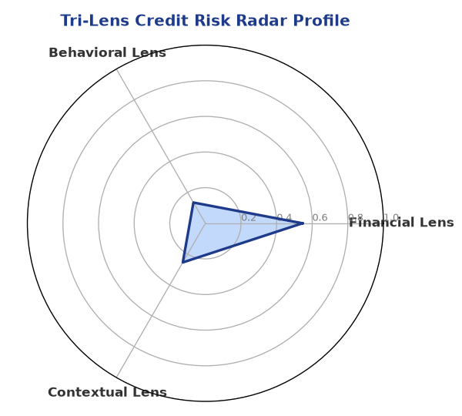

Section B — AI Explainability: SHAP Top-5 Risk Factors
# | Feature Name | SHAP Impact
1 | bank_divergence_pct | 0.2361
2 | bounce_rate | 0.2326
3 | gst_discrepancy_pct | 0.0646
4 | icr | 0.0038
5 | ebitda_margin | 0.0032
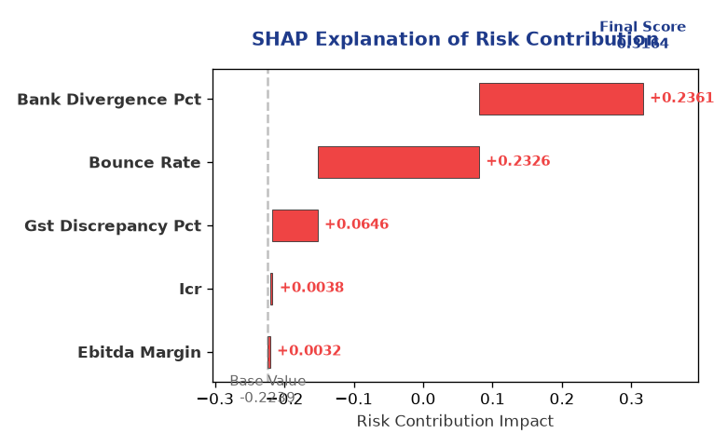

Section C — Rejection Reasons & Corrective Actions (LLM-Generated)
Rejection Reasons | Corrective Actions
None | • Provide more information on the company's financial performance, including revenue and net worth data  • Address the divergence in the bank's data and ensure accurate financial reporting  • Reduce the company's leverage by decreasing debt or increasing equity
Section D — Comparable Case Analysis (Sector Peers & Database Search)
Company Name | Turnover | DSCR | ICR | Leverage | CIBIL | Credit Status
Matrix Foods Private Limited | ₹49.25 Lakh | 1.0301 | 0.6475 | 2.1942 | 770 | REJECTED
Kalyani Retail 656 Partnership Firm | ₹48.61 Lakh | 0.6533 | 0.3134 | 2.8237 | 652 | REJECTED
Kalyani Healthcare 453 Private Limited | ₹47.14 Lakh | 1.2955 | 0.9692 | 1.2934 | 755 | APPROVED
Hindustan Pharma 314 Partnership Firm | ₹50.86 Lakh | 1.3940 | 1.0150 | 1.5003 | 788 | APPROVED
Kalyani Automotive 772 Private Limited | ₹51.19 Lakh | 1.1370 | 0.5353 | 1.7146 | 718 | REJECTED
Sector Average | - | 1.2128 | 0.8289 | 1.8667 | - | -

7. Stress Testing & Resilience Analysis

Section A — Stress Scenarios (Agent 9: stress-agent)
The following scenarios were stress-tested against the applicant's financial position to evaluate resilience under adverse conditions.

# | Scenario | Shocked DSCR | Verdict
1 | Revenue-20% | ⚠️ [DATA INSUFFICIENT] | DATA_INSUFFICIENT
2 | Rate+2% | ⚠️ [DATA INSUFFICIENT] | DATA_INSUFFICIENT
3 | Combined | ⚠️ [DATA INSUFFICIENT] | DATA_INSUFFICIENT

Worst-Case DSCR | ⚠️ [DATA INSUFFICIENT]
Overall Survival Verdict | DATA_INSUFFICIENT

8. Ethical AI, Personal Discussion & Committee Sign-Off

Section A — Bias & Fairness Audit (Agent 10: bias-agent)
Fairness Check | Value / Tag
Counterfactual Tested | YES ✓
Decision Flips Detected | 0
Overweighted Features | 0

Bias Audit Summary (LLM-Generated)
The AI decision is fair and unbiased, with no flips reported in the bias testing. The model has been tested for bias, and the results indicate that the decision is not influenced by any biases.

Section B — Personal Discussion Summary (Agent 11: pd-agent)
PD Field | Value / Tag
Source Type | N/A
Risk Adjustment | +0.0000
PD Confidence Score | 0.00

Transcript Summary:
The personal discussion findings indicate that the company's management is experienced and has a good understanding of the business. However, more information is required to assess the company's financial performance and risk profile.
Qualitative Flags:
None

Section C — Committee Sign-Off
Role | Name / Signature / Date
Prepared By | Trinetra Agentic Credit Intelligence OS
Reviewed By | _______________________________________
Approved By | _______________________________________
Date | _______________________________________
Signature | _______________________________________

DISCLAIMER: This Credit Appraisal Memorandum has been generated by the Trinetra Agentic Credit Intelligence OS. The AI-generated analysis is intended to assist credit officers and does not constitute a binding credit decision. All recommendations are subject to human review and approval in accordance with applicable regulations.

