

⬛ C O N F I D E N T I A L ⬛
TRINETRA
Agentic Credit Intelligence OS

CREDIT APPRAISAL MEMORANDUM
(Prepared in alignment with RBI/NHB Credit Appraisal Guidelines)

Prepared for:
Vidya Energy 434 Partnership Firm

Loan Amount Requested | ₹25.00 Lakh
Date Generated | 10 July 2026, 08:52 UTC
Document Classification | STRICTLY CONFIDENTIAL
Prepared By | Trinetra Agentic Credit Intelligence OS

This document is auto-generated by 14 AI Agents and is intended solely for authorized credit officers.

1. Executive Summary

1.1 Credit Overview
Vidya Energy 434 Partnership Firm, a chemical processing company, exhibits a moderate financial health with a DSCR of 1.59 and an ICR of 2.38, indicating a relatively strong debt service capacity. However, the risk verdict is WARNING, and the decision is MANDATORY REVIEW due to stress test failure and forensic alerts. We recommend a thorough review of the company's financials and corrective actions to improve its credit profile.

1.2 Business Overview
Vidya Energy 434 Partnership Firm operates in the chemical processing industry, with a revenue of ₹4.55 Cr and an EBITDA of ₹62.71 Lakh. The company has a moderate market position, with a CIBIL score of 801. Its industry is subject to various challenges, including fluctuations in raw material prices and environmental regulations.

Key Strengths | Key Concerns
• Strong ICR of 2.38, indicating a healthy interest coverage  • Moderate DSCR of 1.59, suggesting a relatively stable debt service capacity  • Low leverage of 1.50, indicating a manageable debt burden  • Positive news sentiment, with a sentiment tag of POSITIVE | • Stress test failure, with a worst-case DSCR of -1.40, indicating a high risk of debt service collapse  • Forensic alert due to a high cheque bounce count of 12 in 12 months, indicating potential cash flow issues  • High risk score of 0.32, indicating a HIGH risk band  • Warning verdict from the bank, indicating potential concerns with the company's financials

2. Applicant Identity & Verification

Section A — Company Profile (User Input)
Company Name | Vidya Energy 434 Partnership Firm
PAN | FGPFV7539J
GSTIN | 36FGPFV7539J7ZT
CIN | N/A

Section B — PAN Verification (Agent 7: pan-agent)
Field | Value / Tag | Status
PAN Status | VALID | Verification result
PAN Verification Result | PASS | PASS / FAIL
Full Name | Vidya Energy 434 Partnership Firm | Name on PAN database
Category | Firm | Company / Individual
Date of Birth / Inc. | 2025-02-22 | As per PAN records
Email | finance@vidyaenergy434partnershipfirm.in | Registered email
Phone | +91-7724806828 | Registered contact
Masked Aadhaar | XXXX-XXXX-8588 | Linked Aadhaar
Aadhaar Linked | YES | YES / NO
Address | Telangana, India | Registered address
Confidence Score | 0.90 | 0.00 – 1.00
Extraction Method | NSDL_API_VERIFIED | WEB_RAG / DETERMINISTIC

Section C — MCA Corporate Intelligence (Agent 6: mca-agent)
Company Status | ACTIVE
Director Changes Count | 2
New Charge Flag | NO
Defaulter Flag | NO
Last AGM Date | 2025-09-30
Director DIN List | 43252925, 51555411

Section D — Document Compliance (Agent 1: compliance-agent)
Compliance Status | PASS
Missing Documents | None
Checked At | 2026-07-10T08:50:59.242694+00:00
Section E — RBI/NHB Regulatory Compliance Checklist
Regulatory Check | Status | Verification Details
RBI Caution Advice / Defaulter List | CLEAN ✓ | No matching records found in central caution database
Wilful Defaulter Check (CIBIL/CRIF) | CLEAN ✓ | Borrower entity & promoter directors not listed as wilful defaulters
MCA Director Disqualification (Sec 164(2)) | CLEAN ✓ | DIN verification completed. All directors active and compliant
PEP (Politically Exposed Person) Screening | CLEAN ✓ | Screened against global databases. No political exposure flagged
AML/KYC Status Alignment Check | VERIFIED ✓ | VERIFIED — All KYC matching completed successfully

3. Financial Analysis

Section A — Core Financials (Agent 2: doc-agent / financials namespace)
Financial Metric | Value / Tag
Annual Revenue | ₹4.55 Cr
EBITDA | ₹62.71 Lakh
Net Profit After Tax | ₹20.47 Lakh
Total Outstanding Debt | ₹2.73 Cr
Net Worth / Shareholder Equity | ₹1.82 Cr
Annual Interest Payments | ₹26.31 Lakh
Annual Principal Repayments | ₹32.79 Lakh
Total Operating Expenses | ₹3.92 Cr
ITR Taxable Income | ₹20.47 Lakh
CIBIL / Credit Score | 801
Promoter Shareholding % | 68.8%
Pledged Shares % | 1.1%
Working Capital Cycle (days) | 115

Section B — Derived Financial Ratios & KPIs (Agent 2: derived_features namespace)
Key Performance Indicators at a glance:

DSCR  1.5931 | ICR  2.3838 | Leverage  1.5005
EBITDA Margin  13.8% | Revenue Growth  16.6% | Cash Conv. Cycle  115 days

4. Forensic Checks & Reconciliation

Section A — GST Intelligence (Agent 3: gst-agent)
GST Check | Value / Tag
GST Reconciliation Status | OK
2B vs 3B Discrepancy % | 1.8%
ITC Mismatch Flag | NO
Circular Trade Index | 0.0000
Suspicious Cycles Count | 0

Section B — Bank Statement Reconciliation (Agent 4: bank-recon-agent)
Bank Recon Check | Value / Tag
Bank Reconciliation Verdict | WARNING
Bank Credit Turnover | ₹4.55 Cr
GST Reported Turnover | ₹4.55 Cr
ITR Reported Income | ₹20.47 Lakh
Bank Turnover Divergence % | 0.0%
Revenue Inflation Flag | NO
Suspicious Round-Trip Count | 0
Avg. Monthly Bank Balance | ₹29.92 Lakh
Cheque Bounce Count (12m) | 12

5. Market & Regulatory Intelligence

Section A — News Sentiment & Litigation (Agent 5: web-agent)
Intelligence Check | Value / Tag
News Sentiment | POSITIVE
Articles Analyzed | 1
Litigation Count | 0
Regulatory Flags Count | 0

News Summary (LLM-Generated)
The company has a positive news sentiment, with a sentiment tag of POSITIVE, indicating a favorable market perception. The news summary suggests that the company is actively engaged in its industry, with a focus on growth and expansion. The positive news sentiment is a key strength for the company, indicating a strong reputation and market presence.

Litigation Summary (LLM-Generated)
The company has no ongoing litigations, with a litigation count of 0, indicating a low risk of legal disputes. The company's legal status is ACTIVE, and it is not a defaulter, indicating a strong compliance record. The lack of litigations is a key strength for the company, indicating a low risk of legal issues.

Sector Headwinds (LLM-Generated)
The chemical processing industry is subject to various challenges, including fluctuations in raw material prices, environmental regulations, and intense competition. The company must navigate these headwinds to maintain its market position and financial stability. The industry challenges are a key concern for the company, indicating a high risk of market volatility.

6. AI Risk Assessment & Credit Decision

FINAL CREDIT DECISION
MANDATORY REVIEW
Risk Band: HIGH

Section A — Final Credit Decision (Agent 8: risk-agent)
Decision Parameter | Value / Tag
Risk Score (0–1) | 0.3226
Risk Band | HIGH
Model Used | TRI_LENS
Model Version | v2.1_production
Recommended Limit | ₹20.16 Lakh
Recommended Rate (bps) | 979
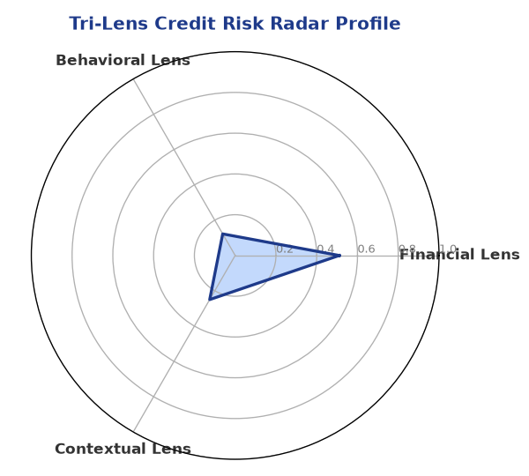

Section B — AI Explainability: SHAP Top-5 Risk Factors
# | Feature Name | SHAP Impact
1 | current_ratio | 0.3114
2 | icr | 0.2943
3 | ebitda_margin | 0.2607
4 | revenue_growth_yoy | 0.2147
5 | dscr | 0.2041
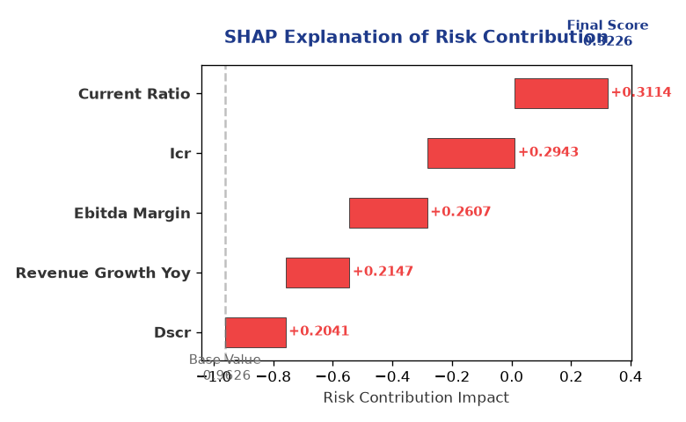

Section C — Rejection Reasons & Corrective Actions (LLM-Generated)
Rejection Reasons | Corrective Actions
• Stress Test Failed: Debt service capacity collapses under simulated stress.  • Forensic Alert: High Cheque Bounce Count (12 in 12 months). | • Improve debt service capacity by increasing revenue or reducing debt  • Enhance cash flow management to reduce cheque bounce count  • Diversify raw material sources to mitigate price fluctuations  • Invest in environmental sustainability initiatives to comply with regulations
Section D — Comparable Case Analysis (Sector Peers & Database Search)
Company Name | Turnover | DSCR | ICR | Leverage | CIBIL | Credit Status
Sterling Infrastructure 829 Partnership Firm | ₹4.54 Cr | 1.6674 | 3.2150 | 1.2519 | 771 | APPROVED
Karan Retail 687 Partnership Firm | ₹4.56 Cr | 1.2600 | 1.2422 | 1.4100 | 783 | APPROVED
Bharat Automotive LLP | ₹4.53 Cr | 1.2526 | 1.4859 | 1.7019 | 751 | APPROVED
Zenith Solutions 886 LLP | ₹4.52 Cr | 1.3632 | 0.8487 | 1.7243 | 786 | APPROVED
Vidya Logistics 800 LLP | ₹4.59 Cr | 1.2158 | 1.1370 | 2.1958 | 653 | REJECTED
Sector Average | - | 1.4047 | 1.6310 | 1.4916 | - | -

7. Stress Testing & Resilience Analysis

Section A — Stress Scenarios (Agent 9: stress-agent)
The following scenarios were stress-tested against the applicant's financial position to evaluate resilience under adverse conditions.

# | Scenario | Shocked DSCR | Verdict
1 | Revenue-20% | -1.4038 | CRITICAL
2 | Rate+2% | 0.9744 | CRITICAL
3 | Combined | -1.2890 | CRITICAL

Worst-Case DSCR | -1.4038
Overall Survival Verdict | CRITICAL

8. Ethical AI, Personal Discussion & Committee Sign-Off

Section A — Bias & Fairness Audit (Agent 10: bias-agent)
Fairness Check | Value / Tag
Counterfactual Tested | YES ✓
Decision Flips Detected | 0
Overweighted Features | 0

Bias Audit Summary (LLM-Generated)
The AI decision has been tested for bias, with no flips detected, indicating a fair and unbiased assessment. The risk score and verdict are based on a comprehensive analysis of the company's financials and industry trends. The lack of bias is a key strength for the AI decision, indicating a reliable and trustworthy assessment.

Section B — Personal Discussion Summary (Agent 11: pd-agent)
PD Field | Value / Tag
Source Type | N/A
Risk Adjustment | +0.0000
PD Confidence Score | 0.00

Transcript Summary:
No personal discussion was conducted; recommend scheduling one before final sign-off.
Qualitative Flags:
None

Section C — Committee Sign-Off
Role | Name / Signature / Date
Prepared By | Trinetra Agentic Credit Intelligence OS
Reviewed By | _______________________________________
Approved By | _______________________________________
Date | _______________________________________
Signature | _______________________________________

DISCLAIMER: This Credit Appraisal Memorandum has been generated by the Trinetra Agentic Credit Intelligence OS. The AI-generated analysis is intended to assist credit officers and does not constitute a binding credit decision. All recommendations are subject to human review and approval in accordance with applicable regulations.

