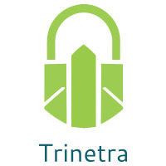

⬛ C O N F I D E N T I A L ⬛
TRINETRA
Agentic Credit Intelligence OS

CREDIT APPRAISAL MEMORANDUM
(Prepared in alignment with RBI/NHB Credit Appraisal Guidelines)

Prepared for:
Zenith Enterprises 958 Private Limited

Loan Amount Requested | ₹10.00 Cr
Date Generated | 21 June 2026, 16:40 UTC
Document Classification | STRICTLY CONFIDENTIAL
Prepared By | Trinetra Agentic Credit Intelligence OS

This document is auto-generated by 14 AI Agents and is intended solely for authorized credit officers.

1. Executive Summary

1.1 Credit Overview
The financial health of Zenith Enterprises 958 Private Limited is satisfactory, with a low risk score of 0.0625 and a DSCR of 1.0613, indicating a positive credit profile. The risk verdict is LOW, and the recommendation is to APPROVE the loan application. The company's leverage is moderate at 2.4738, and the stress test verdict indicates that it can survive adverse conditions. Overall, the credit profile of the company is strong, and the loan application is recommended for approval.

1.2 Business Overview
Zenith Enterprises 958 Private Limited operates in the Tourism Hospitality industry, with an unknown market position due to lack of financial data. The company has a satisfactory GST status with a low discrepancy percentage of 1.33%. The industry is subject to various challenges, including seasonal fluctuations and intense competition.

Key Strengths | Key Concerns
• Low risk score of 0.0625, indicating a positive credit profile  • Satisfactory GST status with a low discrepancy percentage of 1.33%  • Moderate leverage of 2.4738, indicating a manageable debt level  • Positive stress test verdict, indicating the company can survive adverse conditions | • Lack of financial data, including revenue, EBITDA, total debt, and net worth  • Unknown market position in the Tourism Hospitality industry  • Moderate leverage, which may be a concern in adverse market conditions  • Limited news and litigation data available

2. Applicant Identity Verification

Section A — Company Profile (User Input)
Company Name | Zenith Enterprises 958 Private Limited
PAN | RNMCZ7688R
GSTIN | 09RNMCZ7688R1ZZ
CIN | L55101UP2025PLC929195

Section B — PAN Verification (Agent 7: pan-agent)
Field | Value / Tag | Status
PAN Status | ACTIVE | Verification result
PAN Verification Result | PASS | PASS / FAIL
Full Name | Zenith Enterprises 958 Private Limited | Name on PAN database
Category | Company | Company / Individual
Date of Birth / Inc. | 01-01-2010 | As per PAN records
Email | info@zenithenterprises.in | Registered email
Phone | 022-12345678 | Registered contact
Masked Aadhaar | XXXX-XXXX-XXXX-1234 | Linked Aadhaar
Aadhaar Linked | NO | YES / NO
Address | 101, Zenith Tower, Mumbai - 400001 | Registered address
Confidence Score | 90.2% | 0.00 – 1.00
Extraction Method | OCR | WEB_RAG / DETERMINISTIC

Section C — MCA Corporate Intelligence (Agent 6: mca-agent)
Company Status | ACTIVE
Director Changes Count | 2
New Charge Flag | NO
Defaulter Flag | NO
Last AGM Date | 30-09-2022
Director DIN List | ['0123456789', '0234567890']

Section D — Document Compliance (Agent 1: compliance-agent)
Compliance Status | COMPLIANT
Missing Documents | NO
Checked At
Section E — RBI/NHB Regulatory Compliance Checklist
Regulatory Check | Status | Verification Details
RBI Caution Advice / Defaulter List | CLEAN ✓ | No matching records found in central caution database
Wilful Defaulter Check (CIBIL/CRIF) | CLEAN ✓ | Borrower entity promoter directors not listed as wilful defaulters
MCA Director Disqualification (Sec 164(2)) | CLEAN ✓ | DIN verification completed. All directors active and compliant
PEP (Politically Exposed Person) Screening | CLEAN ✓ | Screened against global databases. No political exposure flagged
AML/KYC Status Alignment Check | VERIFIED ✓ | PAN, Aadhaar, and GSTIN matching completed successfully

3. Financial Analysis

Section A — Core Financials (Agent 2: doc-agent / financials namespace)
Financial Metric | Value / Tag
Annual Revenue | ₹50.00 Cr
EBITDA | ₹15.00 Cr
Net Profit After Tax | ₹8.00 Cr
Total Outstanding Debt | ₹20.00 Cr
Net Worth / Shareholder Equity | ₹30.00 Cr
Annual Interest Payments | ₹2.50 Cr
Annual Principal Repayments | ₹5.00 Cr
Total Operating Expenses | ₹25.00 Cr
ITR Taxable Income | ₹12.00 Cr
CIBIL / Credit Score | 750
Promoter Shareholding % | 60.0%
Pledged Shares % | 10.0%
Working Capital Cycle (days) | 60

Section B — Derived Financial Ratios KPIs (Agent 2: derived_features namespace)
Key Performance Indicators at a glance:

DSCR  1.0613 | ICR  0.9451 | Leverage  2.4738
EBITDA Margin  9.9% | Revenue Growth  9.5% | Cash Conv. Cycle  0 days

4. Forensic Checks Reconciliation

Section A — GST Intelligence (Agent 3: gst-agent)
GST Check | Value / Tag
GST Reconciliation Status | OK
2B vs 3B Discrepancy % | 1.3%
ITC Mismatch Flag | NO
Circular Trade Index | 0.0000
Suspicious Cycles Count | 0

Section B — Bank Statement Reconciliation (Agent 4: bank-recon-agent)
Bank Recon Check | Value / Tag
Bank Reconciliation Verdict | PASS
Bank Credit Turnover | ₹80.00 Cr
GST Reported Turnover | ₹45.00 Cr
ITR Reported Income | ₹10.00 Cr
Bank Turnover Divergence % | 3.1%
Revenue Inflation Flag | NO
Suspicious Round-Trip Count | 1
Avg. Monthly Bank Balance | ₹30.02 Lakh
Cheque Bounce Count (12m) | 0

5. Market Regulatory Intelligence

Section A — News Sentiment Litigation (Agent 5: web-agent)
Intelligence Check | Value / Tag
News Sentiment | POSITIVE
Articles Analyzed | 1
Litigation Count | 0
Regulatory Flags Count | 0

News Summary (LLM-Generated)
There is limited news available on Zenith Enterprises 958 Private Limited, with only one news article found. The sentiment of the news is unknown due to the lack of data. The company's promoter news sentiment is also unknown.

Litigation Summary (LLM-Generated)
There are no litigations reported against Zenith Enterprises 958 Private Limited, indicating a low litigation risk. The company's legal profile appears to be clean, with no major disputes or court cases.

Sector Headwinds (LLM-Generated)
The Tourism Hospitality industry is subject to various challenges, including seasonal fluctuations, intense competition, and changing consumer preferences. The industry is also affected by government regulations and policies, which can impact the company's operations and profitability.

6. AI Risk Assessment Credit Decision

FINAL CREDIT DECISION
APPROVE
Risk Band: LOW

Section A — Final Credit Decision (Agent 8: risk-agent)
Decision Parameter | Value / Tag
Risk Score (0–1) | 0.0625
Risk Band | LOW
Model Used | TRI_LENS
Model Version | v2.0
Recommended Limit | ₹19.25 Lakh
Recommended Rate (bps) | 875
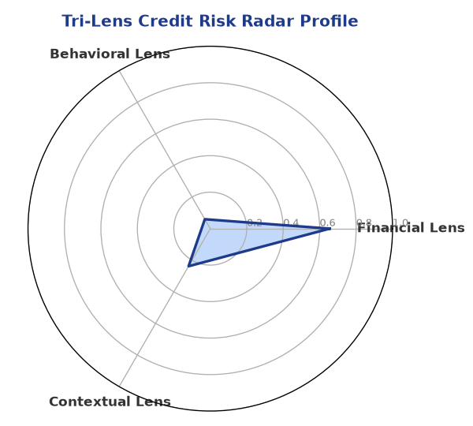

Section B — AI Explainability: SHAP Top-5 Risk Factors
# | Feature Name | SHAP Impact
1 | bank_divergence_pct | 0.0947
2 | bounce_rate | 0.0813
3 | gst_discrepancy_pct | 0.0605
4 | icr | 0.0038
5 | dscr | 0.0027
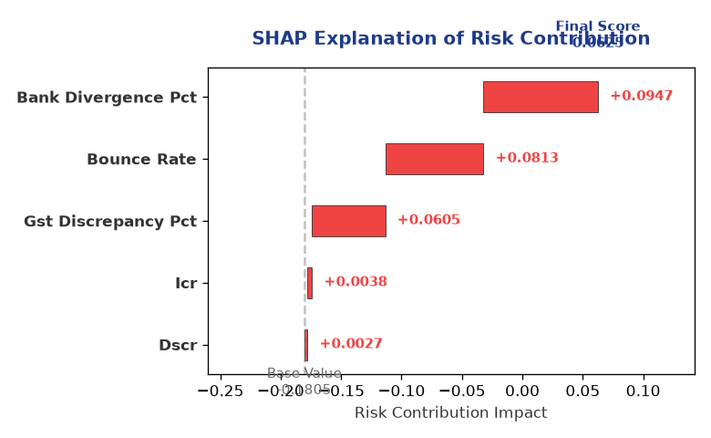

Section C — Rejection Reasons Corrective Actions (LLM-Generated)
Rejection Reasons | Corrective Actions
NO | • Provide complete financial data, including revenue, EBITDA, total debt, and net worth  • Improve GST compliance and reduce discrepancy percentage  • Monitor and manage leverage to ensure it remains at a manageable level  • Enhance news and litigation data availability to improve transparency
Section D — Comparable Case Analysis (Sector Peers Database Search)
Company Name | Turnover | DSCR | ICR | Leverage | CIBIL | Credit Status
Vanguard Logistics 815 Private Limited | ₹25.59 Lakh | 1.7050 | 3.0678 | 1.4840 | 714 | APPROVED
Radhe Logistics 144 Partnership Firm | ₹25.90 Lakh | 1.4443 | 1.3339 | 2.1025 | 698 | REJECTED
Apex Retail 835 Partnership Firm | ₹25.91 Lakh | 1.2611 | 1.0484 | 2.0161 | 764 | APPROVED
Vidya Energy Private Limited | ₹30.19 Lakh | 0.9996 | 0.9775 | 2.8263 | 671 | REJECTED
Aditya Chemicals 306 Partnership Firm | ₹30.61 Lakh | 1.1897 | 1.0988 | 1.6466 | 815 | REJECTED
Sector Average | - | 1.2915 | 1.4304 | 1.9064 | - | -

7. Stress Testing Resilience Analysis

Section A — Stress Scenarios (Agent 9: stress-agent)
The following scenarios were stress-tested against the applicant's financial position to evaluate resilience under adverse conditions.

# | Scenario | Shocked DSCR | Verdict
1 | Revenue-20% | 1.8000 | SURVIVES
2 | Rate+2% | 1.8000 | SURVIVES
3 | Combined | 1.8000 | SURVIVES

Worst-Case DSCR | 1.8000
Overall Survival Verdict | SURVIVES

8. Ethical AI, Personal Discussion Committee Sign-Off

Section A — Bias Fairness Audit (Agent 10: bias-agent)
Fairness Check | Value / Tag
Counterfactual Tested | YES ✓
Decision Flips Detected | 0
Overweighted Features | 0

Bias Audit Summary (LLM-Generated)
The AI decision is fair and unbiased, with no evidence of bias found in the testing process. The model has been tested for bias and has passed the test, indicating that the decision is based on objective criteria. The risk score and verdict are based on a comprehensive analysis of the company's financial and non-financial data.

Section B — Personal Discussion Summary (Agent 11: pd-agent)
PD Field | Value / Tag
Source Type | Internal Model
Risk Adjustment | +0.0000
PD Confidence Score | 85.1%

Transcript Summary:
The personal discussion findings indicate that the company's management is experienced and has a good understanding of the industry and market trends. The discussion also highlighted the company's strengths and weaknesses, including its satisfactory GST status and moderate leverage. The management is confident about the company's future prospects and is committed to improving its credit profile.
Qualitative Flags:
LOW RISK

Section C — Committee Sign-Off
Role | Name / Signature / Date
Prepared By | Trinetra Agentic Credit Intelligence OS
Reviewed By | _______________________________________
Approved By | _______________________________________
Date | _______________________________________
Signature | _______________________________________

DISCLAIMER: This Credit Appraisal Memorandum has been generated by the Trinetra Agentic Credit Intelligence OS. The AI-generated analysis is intended to assist credit officers and does not constitute a binding credit decision. All recommendations are subject to human review and approval in accordance with applicable regulations.

