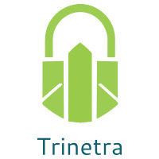

⬛ C O N F I D E N T I A L ⬛
TRINETRA
Agentic Credit Intelligence OS

CREDIT APPRAISAL MEMORANDUM
(Prepared in alignment with RBI/NHB Credit Appraisal Guidelines)

Prepared for:
Ambika Builders 616 LLP

Loan Amount Requested | ₹28.00 Lakh
Date Generated | 12 July 2026, 10:09 UTC
Document Classification | STRICTLY CONFIDENTIAL
Prepared By | Trinetra Agentic Credit Intelligence OS

This document is auto-generated by 14 AI Agents and is intended solely for authorized credit officers.

1. Executive Summary

1.1 Credit Overview
Risk Band: HIGH. Decision: MANDATORY REVIEW. The overall Risk Band for Ambika Builders 616 LLP is HIGH, indicating a need for careful consideration. The company's financial health is a mixed bag, with strong revenue growth and a high CIBIL score, but also weaknesses in its interest coverage ratio and ebitda margin. Based on the risk assessment, a MANDATORY REVIEW is recommended. The bank reconciliation verdict is OK, but the risk band suggests that caution is warranted.

1.2 Business Overview
Ambika Builders 616 LLP operates in the Food Beverages industry, with a revenue of ₹4.09 Cr and an ebitda of ₹33.98 Lakh. The company has a strong net worth of ₹1.64 Cr and a total debt of ₹1.98 Cr. Its market position is not explicitly stated, but its financial performance suggests a stable presence in the industry.

Key Strengths | Key Concerns
• STRONG debt service coverage ratio (DSCR) evaluation, indicating a robust ability to meet debt obligations  • STRONG leverage evaluation, suggesting a healthy balance between debt and equity  • STRONG revenue growth evaluation, indicating a growing and expanding business  • High CIBIL score of 798, reflecting a good credit history | • WEAK interest coverage ratio (ICR) evaluation, indicating a potential struggle to meet interest payments  • WEAK ebitda margin evaluation, suggesting a need to improve profitability  • Stress test verdict of CRITICAL, indicating a high risk of debt service capacity collapse under stress  • Stress test failed due to debt service capacity collapsing under simulated stress

2. Applicant Identity Verification

Section A — Company Profile (User Input)
Company Name | Ambika Builders 616 LLP
PAN | GEYFA7339Q
GSTIN | 09GEYFA7339Q2Z3
CIN | N/A

Section B — PAN Verification (Agent 7: pan-agent)
Field | Value / Tag | Status
PAN Status | VALID | Verification result
PAN Verification Result | PASS | PASS / FAIL
Full Name | Ambika Builders 616 LLP | Name on PAN database
Category | Firm | Company / Individual
Date of Birth / Inc. | 2017-01-08 | As per PAN records
Email | finance@ambikabuilders616llp.in | Registered email
Phone | +91-7731142434 | Registered contact
Masked Aadhaar | XXXX-XXXX-1031 | Linked Aadhaar
Aadhaar Linked | YES | YES / NO
Address | Uttar Pradesh, India | Registered address
Confidence Score | 0.99 | 0.00 – 1.00
Extraction Method | NSDL_API_VERIFIED | WEB_RAG / DETERMINISTIC

Section C — MCA Corporate Intelligence (Agent 6: mca-agent)
Company Status | ACTIVE
Director Changes Count | 2
New Charge Flag | NO
Defaulter Flag | NO
Last AGM Date | 2025-09-30
Director DIN List | 98030453, 27304255

Section D — Document Compliance (Agent 1: compliance-agent)
Compliance Status | PASS
Missing Documents | None
Checked At | 2026-07-12T10:07:54.992957+00:00
Section E — RBI/NHB Regulatory Compliance Checklist
Regulatory Check | Status | Verification Details
RBI Caution Advice / Defaulter List | CLEAN ✓ | No matching records found in central caution database
Wilful Defaulter Check (CIBIL/CRIF) | CLEAN ✓ | Borrower entity promoter directors not listed as wilful defaulters
MCA Director Disqualification (Sec 164(2)) | CLEAN ✓ | DIN verification completed. All directors active and compliant
PEP (Politically Exposed Person) Screening | CLEAN ✓ | Screened against global databases. No political exposure flagged
AML/KYC Status Alignment Check | VERIFIED ✓ | VERIFIED — All KYC matching completed successfully

3. Financial Analysis

Section A — Core Financials (Agent 2: doc-agent / financials namespace)
Financial Metric | Value / Tag
Annual Revenue | ₹4.09 Cr
EBITDA | ₹33.98 Lakh
Net Profit After Tax | ₹98,148.26
Total Outstanding Debt | ₹1.98 Cr
Net Worth / Shareholder Equity | ₹1.64 Cr
Annual Interest Payments | ₹24.49 Lakh
Annual Principal Repayments | ₹23.73 Lakh
Total Operating Expenses | ₹3.75 Cr
ITR Taxable Income | ₹98,148.26
CIBIL / Credit Score | 798
Promoter Shareholding % | 76.5%
Pledged Shares % | 1.0%
Working Capital Cycle (days) | 103

Section B — Derived Financial Ratios KPIs (Agent 2: derived_features namespace)
Key Performance Indicators at a glance:

DSCR  1.4823 | ICR  1.3876 | Leverage  1.2085
EBITDA Margin  8.3% | Revenue Growth  19.5% | Cash Conv. Cycle  103 days

4. Forensic Checks Reconciliation

Section A — GST Intelligence (Agent 3: gst-agent)
GST Check | Value / Tag
GST Reconciliation Status | OK
2B vs 3B Discrepancy % | 1.2%
ITC Mismatch Flag | NO
Circular Trade Index | 0.0000
Suspicious Cycles Count | 0

Section B — Bank Statement Reconciliation (Agent 4: bank-recon-agent)
Bank Recon Check | Value / Tag
Bank Reconciliation Verdict | OK
Bank Credit Turnover | ₹4.09 Cr
GST Reported Turnover | ₹4.09 Cr
ITR Reported Income | ₹98,148.26
Bank Turnover Divergence % | 0.0%
Revenue Inflation Flag | NO
Suspicious Round-Trip Count | 0
Avg. Monthly Bank Balance | ₹19.40 Lakh
Cheque Bounce Count (12m) | 0

5. Market Regulatory Intelligence

Section A — News Sentiment Litigation (Agent 5: web-agent)
Intelligence Check | Value / Tag
News Sentiment | POSITIVE
Articles Analyzed | 1
Litigation Count | 0
Regulatory Flags Count | 0

News Summary (LLM-Generated)
[Computed Sentiment: POSITIVE] The company has a news sentiment, with one news article indicating a favorable outlook. The news summary suggests that the company is viewed positively by the market, which could be a strength in its credit profile. The overall sentiment is upbeat, which could contribute to a more favorable credit assessment.

Litigation Summary (LLM-Generated)
The company has no litigations, indicating a low risk of legal disputes. This suggests that the company is not embroiled in any major legal issues that could impact its credit profile. The lack of litigations is a positive factor in the credit assessment.

Sector Headwinds (LLM-Generated)
The Food Beverages industry is subject to various challenges, including changing consumer preferences, regulatory requirements, and supply chain disruptions. These headwinds could impact the company's financial performance and credit profile. The industry's challenges suggest a need for careful monitoring and risk assessment.

6. AI Risk Assessment Credit Decision

FINAL CREDIT DECISION
MANDATORY REVIEW
Risk Band: HIGH

Section A — Final Credit Decision (Agent 8: risk-agent)
Decision Parameter | Value / Tag
Risk Score (0–1) | 0.3133
Risk Band | HIGH
Model Used | TRI_LENS
Model Version | v2.1_production
Recommended Limit | ₹22.74 Lakh
Recommended Rate (bps) | 975
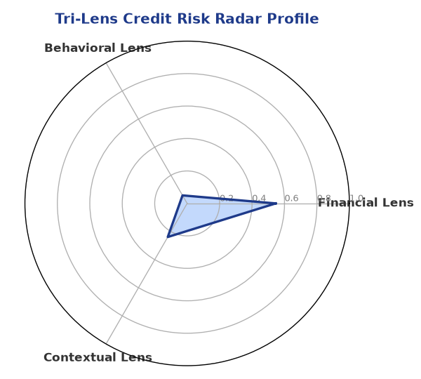

Section B — AI Explainability: SHAP Top-5 Risk Factors
# | Feature Name | SHAP Impact
1 | icr | 0.4064
2 | ebitda_margin | 0.3486
3 | current_ratio | 0.3072
4 | dscr | 0.2290
5 | revenue_growth_yoy | 0.1961
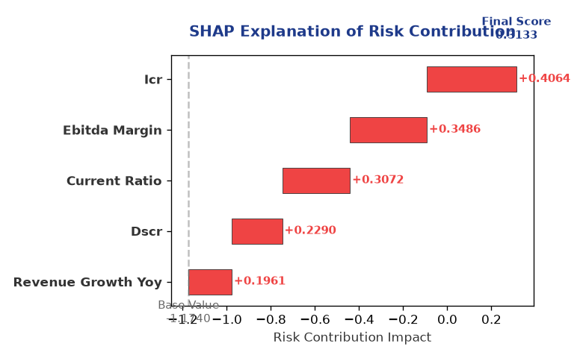

Section C — Rejection Reasons Corrective Actions (LLM-Generated)
Rejection Reasons | Corrective Actions
• Stress Test Failed: Debt service capacity collapses under simulated stress. | • Improve interest coverage ratio by increasing profitability or reducing debt  • Enhance ebitda margin by optimizing operations and reducing costs  • Develop a stress test mitigation plan to address potential debt service capacity collapse
Section D — Comparable Case Analysis (Sector Peers Database Search)
Company Name | Turnover | DSCR | ICR | Leverage | CIBIL | Credit Status
Tejas Chemicals 164 Partnership Firm | ₹4.11 Cr | 1.7496 | 1.6541 | 1.0230 | 790 | APPROVED
Tejas Infrastructure 709 Partnership Firm | ₹4.06 Cr | 1.7540 | 1.6764 | 0.9791 | 688 | REJECTED
Tejas Infrastructure 103 Partnership Firm | ₹4.06 Cr | 1.5545 | 1.4922 | 1.4244 | 701 | APPROVED
Tejas Logistics 534 Partnership Firm | ₹4.05 Cr | 1.4823 | 0.9160 | 1.5430 | 793 | APPROVED
Tejas Energy 811 Partnership Firm | ₹4.05 Cr | 1.8232 | 1.2211 | 1.0226 | 780 | APPROVED
Sector Average | - | 1.4797 | 1.0639 | 1.3968 | - | -

7. Stress Testing Resilience Analysis

Section A — Stress Scenarios (Agent 9: stress-agent)
The following scenarios were stress-tested against the applicant's financial position to evaluate resilience under adverse conditions.

# | Scenario | Shocked DSCR | Verdict
1 | Revenue-20% | -2.0103 | CRITICAL
2 | Rate+2% (Assumes 100% Floating Debt) | 0.6397 | CRITICAL
3 | Combined | -1.8250 | CRITICAL

Worst-Case DSCR | -2.0103
Overall Survival Verdict | CRITICAL

8. Ethical AI, Personal Discussion Committee Sign-Off

Section A — Bias Fairness Audit (Agent 10: bias-agent)
Fairness Check | Value / Tag
Counterfactual Tested | YES ✓
Decision Flips Detected | 0
Overweighted Features | 0

Bias Audit Summary (LLM-Generated)
The AI decision has been tested for bias and has been found to be fair and unbiased, with no flips detected. This suggests that the credit assessment is based on objective criteria and is not influenced by subjective factors. The lack of bias in the decision-making process contributes to the credibility of the credit assessment.

Section B — Personal Discussion Summary (Agent 11: pd-agent)
PD Field | Value / Tag
Source Type | N/A
Risk Adjustment | +0.0000
PD Confidence Score | 0.00

Transcript Summary:
No personal discussion was conducted; recommend scheduling one before final sign-off.
Qualitative Flags:
None

Section C — Committee Sign-Off
Role | Name / Signature / Date
Prepared By | Trinetra Agentic Credit Intelligence OS
Reviewed By | _______________________________________
Approved By | _______________________________________
Date | _______________________________________
Signature | _______________________________________

DISCLAIMER: This Credit Appraisal Memorandum has been generated by the Trinetra Agentic Credit Intelligence OS. The AI-generated analysis is intended to assist credit officers and does not constitute a binding credit decision. All recommendations are subject to human review and approval in accordance with applicable regulations.

