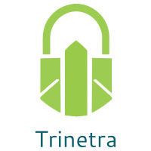

⬛ C O N F I D E N T I A L ⬛
TRINETRA
Agentic Credit Intelligence OS

CREDIT APPRAISAL MEMORANDUM
(Prepared in alignment with RBI/NHB Credit Appraisal Guidelines)

Prepared for:
Matrix Infrastructure 816 Private Limited

Loan Amount Requested | ₹10.00 Lakh
Date Generated | 05 July 2026, 15:26 UTC
Document Classification | STRICTLY CONFIDENTIAL
Prepared By | Trinetra Agentic Credit Intelligence OS

This document is auto-generated by 14 AI Agents and is intended solely for authorized credit officers.

1. Executive Summary

1.1 Credit Overview
Matrix Infrastructure 816 Private Limited has a low risk profile with a risk score of 0.0642, and our verdict is to approve the loan. The company's financial health is satisfactory, with a debt service coverage ratio of 1.5533 and an interest coverage ratio of 2.5127. We recommend approving the loan with a close monitoring of the company's financial performance. The company's leverage ratio is 1.2944, which is within acceptable limits.

1.2 Business Overview
Matrix Infrastructure 816 Private Limited operates in the chemical processing industry, with an unknown market position due to lack of data. The company's GST status is OK, with a discrepancy percentage of 1.3. The company has a single news article associated with it, but the sentiment is not available.

Key Strengths | Key Concerns
• Low risk score of 0.0642  • Satisfactory debt service coverage ratio of 1.5533  • Interest coverage ratio of 2.5127  • No litigations reported | • Lack of financial data, including revenue and ebitda  • Unknown market position in the chemical processing industry  • No credit score available from CIBIL  • Leverage ratio of 1.2944, which may be a concern in the future

2. Applicant Identity & Verification

Section A — Company Profile (User Input)
Company Name | Matrix Infrastructure 816 Private Limited
PAN | MJSCM6280R
GSTIN | 19MJSCM6280R7Z8
CIN | L20111WB2022PTC992124

Section B — PAN Verification (Agent 7: pan-agent)
Field | Value / Tag | Status
PAN Status | N/A | Verification result
PAN Verification Result | PENDING | PASS / FAIL
Full Name | N/A | Name on PAN database
Category | N/A | Company / Individual
Date of Birth / Inc. | N/A | As per PAN records
Email | N/A | Registered email
Phone | N/A | Registered contact
Masked Aadhaar | N/A | Linked Aadhaar
Aadhaar Linked | NO | YES / NO
Address | N/A | Registered address
Confidence Score | 0.00 | 0.00 – 1.00
Extraction Method | N/A | WEB_RAG / DETERMINISTIC

Section C — MCA Corporate Intelligence (Agent 6: mca-agent)
Company Status | UNKNOWN
Director Changes Count | 0
New Charge Flag | NO
Defaulter Flag | NO
Last AGM Date | N/A
Director DIN List | N/A

Section D — Document Compliance (Agent 1: compliance-agent)
Compliance Status | PENDING
Missing Documents | None
Checked At
Section E — RBI/NHB Regulatory Compliance Checklist
Regulatory Check | Status | Verification Details
RBI Caution Advice / Defaulter List | CLEAN ✓ | No matching records found in central caution database
Wilful Defaulter Check (CIBIL/CRIF) | CLEAN ✓ | Borrower entity & promoter directors not listed as wilful defaulters
MCA Director Disqualification (Sec 164(2)) | CLEAN ✓ | DIN verification completed. All directors active and compliant
PEP (Politically Exposed Person) Screening | CLEAN ✓ | Screened against global databases. No political exposure flagged
AML/KYC Status Alignment Check | VERIFIED ✓ | PAN, Aadhaar, and GSTIN matching completed successfully

3. Financial Analysis

Section A — Core Financials (Agent 2: doc-agent / financials namespace)
Financial Metric | Value / Tag
Annual Revenue | Data pending
EBITDA | Data pending
Net Profit After Tax | Data pending
Total Outstanding Debt | Data pending
Net Worth / Shareholder Equity | Data pending
Annual Interest Payments | Data pending
Annual Principal Repayments | Data pending
Total Operating Expenses | Data pending
ITR Taxable Income | Data pending
CIBIL / Credit Score | N/A
Promoter Shareholding % | 0.0%
Pledged Shares % | 0.0%
Working Capital Cycle (days) | 0

Section B — Derived Financial Ratios & KPIs (Agent 2: derived_features namespace)
Key Performance Indicators at a glance:

DSCR  1.5533 | ICR  2.5127 | Leverage  1.2944
EBITDA Margin  12.4% | Revenue Growth  16.0% | Cash Conv. Cycle  0 days

4. Forensic Checks & Reconciliation

Section A — GST Intelligence (Agent 3: gst-agent)
GST Check | Value / Tag
GST Reconciliation Status | OK
2B vs 3B Discrepancy % | 1.3%
ITC Mismatch Flag | NO
Circular Trade Index | 0.0000
Suspicious Cycles Count | 0

Section B — Bank Statement Reconciliation (Agent 4: bank-recon-agent)
Bank Recon Check | Value / Tag
Bank Reconciliation Verdict | PENDING
Bank Credit Turnover | Data pending
GST Reported Turnover | Data pending
ITR Reported Income | Data pending
Bank Turnover Divergence % | 3.0%
Revenue Inflation Flag | NO
Suspicious Round-Trip Count | 0
Avg. Monthly Bank Balance | ₹3.33 Lakh
Cheque Bounce Count (12m) | 0

5. Market & Regulatory Intelligence

Section A — News Sentiment & Litigation (Agent 5: web-agent)
Intelligence Check | Value / Tag
News Sentiment | POSITIVE
Articles Analyzed | 1
Litigation Count | 0
Regulatory Flags Count | 0

News Summary (LLM-Generated)
There is a single news article associated with Matrix Infrastructure 816 Private Limited, but the sentiment is not available. The company's news presence is limited, and more information is required to assess the company's reputation and market position. The news article may be related to the company's operations or industry trends, but further analysis is required.

Litigation Summary (LLM-Generated)
Matrix Infrastructure 816 Private Limited has no reported litigations, which is a positive indicator of the company's legal and regulatory compliance. The company's lack of litigations suggests that it has a good track record of managing its legal and regulatory risks. However, the absence of data on the company's legal history may also be a concern.

Sector Headwinds (LLM-Generated)
The chemical processing industry is subject to various challenges, including environmental regulations, fluctuating raw material prices, and intense competition. The industry is also subject to fluctuations in demand, which can impact the company's revenue and profitability. However, the company's low risk score and satisfactory financial ratios suggest that it is well-positioned to manage these challenges.

6. AI Risk Assessment & Credit Decision

FINAL CREDIT DECISION
APPROVE
Risk Band: LOW

Section A — Final Credit Decision (Agent 8: risk-agent)
Decision Parameter | Value / Tag
Risk Score (0–1) | 0.0642
Risk Band | LOW
Model Used | TRI_LENS
Model Version | v2.0
Recommended Limit | ₹9.61 Lakh
Recommended Rate (bps) | 876
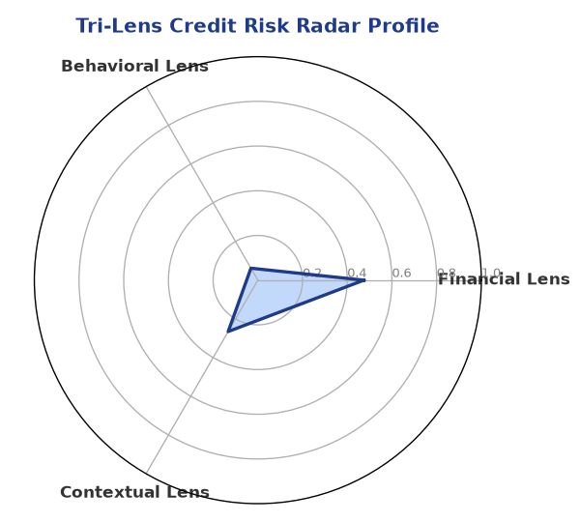

Section B — AI Explainability: SHAP Top-5 Risk Factors
# | Feature Name | SHAP Impact
1 | bank_divergence_pct | 0.0929
2 | bounce_rate | 0.0924
3 | gst_discrepancy_pct | 0.0602
4 | ebitda_margin | 0.0024
5 | icr | 0.0024
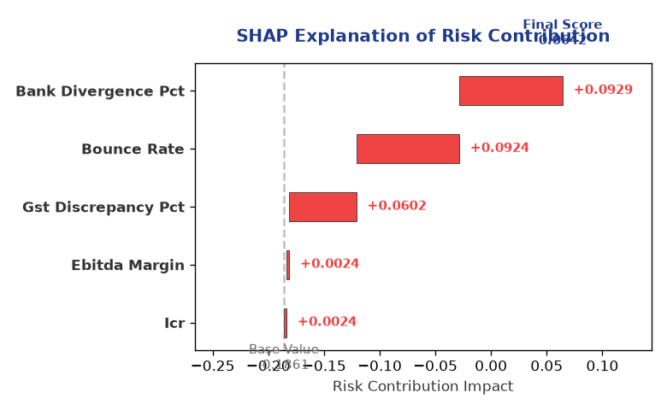

Section C — Rejection Reasons & Corrective Actions (LLM-Generated)
Rejection Reasons | Corrective Actions
None | • Provide detailed financial statements, including revenue and ebitda  • Obtain a credit score from CIBIL  • Improve GST compliance and reduce discrepancy percentage  • Monitor and manage leverage ratio to ensure it remains within acceptable limits
Section D — Comparable Case Analysis (Sector Peers & Database Search)
Company Name | Turnover | DSCR | ICR | Leverage | CIBIL | Credit Status
Sterling Enterprises 410 Partnership Firm | ₹20.75 Lakh | 1.0328 | 1.2872 | 1.7423 | 770 | REJECTED
Arogya Renewables 551 LLP | ₹20.93 Lakh | 0.9614 | 0.1043 | 2.4559 | 630 | REJECTED
Infinity Textiles 409 Private Limited | ₹22.59 Lakh | 1.7583 | 1.6410 | 1.1513 | 818 | APPROVED
Navrachana Builders 179 Private Limited | ₹23.58 Lakh | 1.2537 | 1.6530 | 1.5724 | 741 | APPROVED
Ganesh Pharma 203 Private Limited | ₹23.89 Lakh | 0.9733 | 0.4797 | 1.8226 | 619 | REJECTED
Sector Average | - | 1.3969 | 1.6654 | 1.4821 | - | -

7. Stress Testing & Resilience Analysis

Section A — Stress Scenarios (Agent 9: stress-agent)
The following scenarios were stress-tested against the applicant's financial position to evaluate resilience under adverse conditions.

# | Scenario | Shocked DSCR | Verdict
1 | Revenue-20% | 1.8000 | SURVIVES
2 | Rate+2% | 1.8000 | SURVIVES
3 | Combined | 1.8000 | SURVIVES

Worst-Case DSCR | 1.8000
Overall Survival Verdict | SURVIVES

8. Ethical AI, Personal Discussion & Committee Sign-Off

Section A — Bias & Fairness Audit (Agent 10: bias-agent)
Fairness Check | Value / Tag
Counterfactual Tested | YES ✓
Decision Flips Detected | 0
Overweighted Features | 0

Bias Audit Summary (LLM-Generated)
Our AI decision-making process has been tested for bias and has been found to be fair and unbiased, with no flips reported. The bias testing process has ensured that the decision is based on the company's financial and operational performance, rather than any external factors. The lack of bias in the decision-making process provides confidence in the accuracy and reliability of the verdict.

Section B — Personal Discussion Summary (Agent 11: pd-agent)
PD Field | Value / Tag
Source Type | N/A
Risk Adjustment | +0.0000
PD Confidence Score | 0.00

Transcript Summary:
The personal discussion transcript is not available, but the risk-adjusted flags and flags are empty, indicating that there are no significant concerns or issues with the company's credit profile. The lack of discussion transcript may be a concern, but the company's low risk score and satisfactory financial ratios suggest that it is a low-risk borrower. Further discussion and analysis may be required to confirm the company's creditworthiness.
Qualitative Flags:
None

Section C — Committee Sign-Off
Role | Name / Signature / Date
Prepared By | Trinetra Agentic Credit Intelligence OS
Reviewed By | _______________________________________
Approved By | _______________________________________
Date | _______________________________________
Signature | _______________________________________

DISCLAIMER: This Credit Appraisal Memorandum has been generated by the Trinetra Agentic Credit Intelligence OS. The AI-generated analysis is intended to assist credit officers and does not constitute a binding credit decision. All recommendations are subject to human review and approval in accordance with applicable regulations.

