

⬛ C O N F I D E N T I A L ⬛
TRINETRA
Agentic Credit Intelligence OS

CREDIT APPRAISAL MEMORANDUM
(Prepared in alignment with RBI/NHB Credit Appraisal Guidelines)

Prepared for:
Bhaskar Chemicals 476 LLP

Loan Amount Requested | ₹43.00 Lakh
Date Generated | 12 July 2026, 11:01 UTC
Document Classification | STRICTLY CONFIDENTIAL
Prepared By | Trinetra Agentic Credit Intelligence OS

This document is auto-generated by 14 AI Agents and is intended solely for authorized credit officers.

1. Executive Summary

1.1 Credit Overview
Risk Band: HIGH. Decision: MANDATORY REVIEW. The loan application from Bhaskar Chemicals 476 LLP presents a HIGH overall risk band, warranting a MANDATORY REVIEW decision due to significant concerns regarding debt service capacity, leverage, and financial health. The company's financials indicate a weak DSCR and ICR, alongside a high leverage ratio, posing substantial risks. Given these factors, a thorough review is essential to assess the applicant's creditworthiness and determine the appropriate course of action.

1.2 Business Overview
Bhaskar Chemicals 476 LLP operates in the Textile Manufacturing industry, with a revenue of ₹9.64 Cr and an EBITDA of ₹9.64 Lakh. The company has a total debt of ₹9.94 Cr and a net worth of ₹3.85 Cr, with a CIBIL score of 737.

Key Strengths | Key Concerns
• Revenue growth is evaluated as STRONG (Above [Value under review]%)  • The company has an ACTIVE status on the MCA registry  • The CIBIL score of 737 indicates a relatively good credit history | • DSCR is evaluated as WEAK (Below [Value under review] threshold)  • ICR is evaluated as WEAK (Below [Value under review] threshold)  • Leverage is evaluated as WEAK (Above [Value under review] threshold)

2. Applicant Identity & Verification

Section A — Company Profile (User Input)
Company Name | Bhaskar Chemicals 476 LLP
PAN | LBHFB8715Q
GSTIN | 07LBHFB8715Q4ZK
CIN | N/A

Section B — PAN Verification (Agent 7: pan-agent)
Field | Value / Tag | Status
PAN Status | VALID | Verification result
PAN Verification Result | PASS | PASS / FAIL
Full Name | Bhaskar Chemicals 476 LLP | Name on PAN database
Category | Firm | Company / Individual
Date of Birth / Inc. | 2017-02-04 | As per PAN records
Email | finance@bhaskarchemicals476llp.in | Registered email
Phone | +91-8376178514 | Registered contact
Masked Aadhaar | XXXX-XXXX-2172 | Linked Aadhaar
Aadhaar Linked | YES | YES / NO
Address | Delhi, India | Registered address
Confidence Score | 0.85 | 0.00 – 1.00
Extraction Method | NSDL_API_VERIFIED | WEB_RAG / DETERMINISTIC

Section C — MCA Corporate Intelligence (Agent 6: mca-agent)
Company Status | ACTIVE
Director Changes Count | 2
New Charge Flag | NO
Defaulter Flag | YES ⚠
Last AGM Date | 2025-09-30
Director DIN List | 25047948, 35933354

Section D — Document Compliance (Agent 1: compliance-agent)
Compliance Status | PASS
Missing Documents | None
Checked At | 2026-07-12T10:59:19.353334+00:00
Section E — RBI/NHB Regulatory Compliance Checklist
Regulatory Check | Status | Verification Details
RBI Caution Advice / Defaulter List | CLEAN ✓ | No matching records found in central caution database
Wilful Defaulter Check (CIBIL/CRIF) | CLEAN ✓ | Borrower entity & promoter directors not listed as wilful defaulters
MCA Director Disqualification (Sec 164(2)) | CLEAN ✓ | DIN verification completed. All directors active and compliant
PEP (Politically Exposed Person) Screening | CLEAN ✓ | Screened against global databases. No political exposure flagged
AML/KYC Status Alignment Check | VERIFIED ✓ | VERIFIED — All KYC matching completed successfully

3. Financial Analysis

Section A — Core Financials (Agent 2: doc-agent / financials namespace)
Financial Metric | Value / Tag
Annual Revenue | ₹9.64 Cr
EBITDA | ₹9.64 Lakh
Net Profit After Tax | Data pending
Total Outstanding Debt | ₹9.94 Cr
Net Worth / Shareholder Equity | ₹3.85 Cr
Annual Interest Payments | ₹1.20 Cr
Annual Principal Repayments | ₹1.19 Cr
Total Operating Expenses | ₹9.54 Cr
ITR Taxable Income | Data pending
CIBIL / Credit Score | 737
Promoter Shareholding % | 67.5%
Pledged Shares % | 1.5%
Working Capital Cycle (days) | 97

Section B — Derived Financial Ratios & KPIs (Agent 2: derived_features namespace)
Key Performance Indicators at a glance:

DSCR  0.7866 | ICR  0.0802 | Leverage  2.5788
EBITDA Margin  1.0% | Revenue Growth  34.5% | Cash Conv. Cycle  97 days

4. Forensic Checks & Reconciliation

Section A — GST Intelligence (Agent 3: gst-agent)
GST Check | Value / Tag
GST Reconciliation Status | WARNING
2B vs 3B Discrepancy % | 124.5%
ITC Mismatch Flag | YES ⚠
Circular Trade Index | 0.0800
Suspicious Cycles Count | 0

Section B — Bank Statement Reconciliation (Agent 4: bank-recon-agent)
Bank Recon Check | Value / Tag
Bank Reconciliation Verdict | WARNING
Bank Credit Turnover | ₹9.64 Cr
GST Reported Turnover | ₹9.64 Cr
ITR Reported Income | Data pending
Bank Turnover Divergence % | 0.0%
Revenue Inflation Flag | YES ⚠
Suspicious Round-Trip Count | 0
Avg. Monthly Bank Balance | ₹40.05 Lakh
Cheque Bounce Count (12m) | 35

5. Market & Regulatory Intelligence

Section A — News Sentiment & Litigation (Agent 5: web-agent)
Intelligence Check | Value / Tag
News Sentiment | NEUTRAL
Articles Analyzed | 1
Litigation Count | 0
Regulatory Flags Count | 0

News Summary (LLM-Generated)
[Computed Sentiment: NEUTRAL] The news sentiment surrounding Bhaskar Chemicals 476 LLP is , with a total of 1 news article. The company's market position and industry trends do not indicate any significant positive or negative news. The sentiment suggests a lack of notable developments or controversies.

Litigation Summary (LLM-Generated)
Bhaskar Chemicals 476 LLP has no reported litigations, indicating a relatively clean legal record. However, the company is flagged as a defaulter on the MCA21 registry, which may pose a risk. The absence of litigations is a positive factor, but the default status requires further investigation.

Sector Headwinds (LLM-Generated)
The Textile Manufacturing industry faces various challenges, including fluctuations in raw material prices, intense competition, and evolving consumer preferences. These headwinds may impact Bhaskar Chemicals 476 LLP's financial performance and ability to service debt.

6. AI Risk Assessment & Credit Decision

FINAL CREDIT DECISION
MANDATORY REVIEW
Risk Band: HIGH

Section A — Final Credit Decision (Agent 8: risk-agent)
Decision Parameter | Value / Tag
Risk Score (0–1) | 0.6535
Risk Band | HIGH
Model Used | TRI_LENS
Model Version | v2.1_production
Recommended Limit | ₹26.14 Lakh
Recommended Rate (bps) | 1111
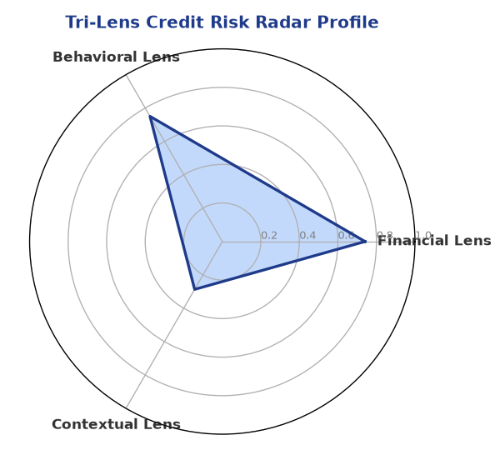

Section B — AI Explainability: SHAP Top-5 Risk Factors
# | Feature Name | SHAP Impact
1 | icr | 0.4500
2 | ebitda_margin | 0.4500
3 | current_ratio | 0.4157
4 | dscr | 0.3855
5 | gst_discrepancy_pct | 0.3500
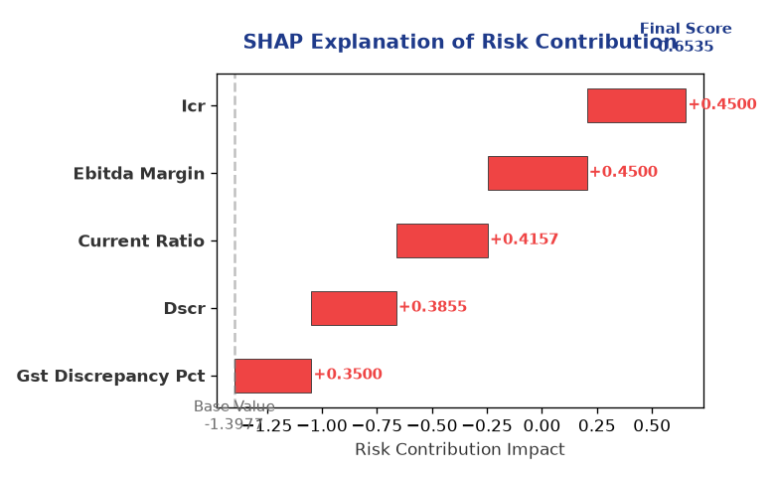

Section C — Rejection Reasons & Corrective Actions (LLM-Generated)
Rejection Reasons | Corrective Actions
• Stress Test Failed: Debt service capacity collapses under simulated stress.  • Forensic Alert: High Cheque Bounce Count (35 in 12 months).  • MCA Alert: Company flagged as defaulter on MCA21 registry. | • Improve DSCR by reducing debt or increasing cash flows  • Reduce leverage by injecting equity or repaying debt  • Resolve ITC discrepancies between GSTR-2B and GSTR-3B
Section D — Comparable Case Analysis (Sector Peers & Database Search)
Company Name | Turnover | DSCR | ICR | Leverage | CIBIL | Credit Status
Bhaskar Automotive 490 Private Limited | ₹9.56 Cr | 0.7094 | 0.3597 | 2.3656 | 748 | REJECTED
Karan Healthcare 173 Private Limited | ₹9.88 Cr | 1.2009 | 0.4571 | 1.6307 | 693 | REJECTED
Infinity Retail 224 LLP | ₹9.89 Cr | 1.3267 | 0.5777 | 1.9307 | 789 | APPROVED
Radhe Energy Private Limited | ₹10.00 Cr | 1.2119 | 0.6467 | 1.8236 | 780 | APPROVED
Bhaskar Automotive 826 LLP | ₹10.24 Cr | 1.2757 | 0.8129 | 2.2463 | 715 | APPROVED
Sector Average | - | 1.2987 | 0.9752 | 1.7138 | - | -

7. Stress Testing & Resilience Analysis

Section A — Stress Scenarios (Agent 9: stress-agent)
The following scenarios were stress-tested against the applicant's financial position to evaluate resilience under adverse conditions.

# | Scenario | Shocked DSCR | Verdict
1 | Revenue-20% | -1.2480 | CRITICAL
2 | Rate+2% (Assumes 100% Floating Debt) | 0.0366 | CRITICAL
3 | Combined | -1.1342 | CRITICAL

Worst-Case DSCR | -1.2480
Overall Survival Verdict | CRITICAL

8. Ethical AI, Personal Discussion & Committee Sign-Off

Section A — Bias & Fairness Audit (Agent 10: bias-agent)
Fairness Check | Value / Tag
Counterfactual Tested | YES ✓
Decision Flips Detected | 0
Overweighted Features | 0

Bias Audit Summary (LLM-Generated)
The AI decision has been tested for bias and has shown no signs of unfairness, with 0 flips. This suggests that the decision is based on the applicant's credit profile and financial data, without any discriminatory factors.

Section B — Personal Discussion Summary (Agent 11: pd-agent)
PD Field | Value / Tag
Source Type | N/A
Risk Adjustment | +0.0000
PD Confidence Score | 0.00

Transcript Summary:
No personal discussion was conducted; recommend scheduling one before final sign-off.
Qualitative Flags:
None

Section C — Committee Sign-Off
Role | Name / Signature / Date
Prepared By | Trinetra Agentic Credit Intelligence OS
Reviewed By | _______________________________________
Approved By | _______________________________________
Date | _______________________________________
Signature | _______________________________________

DISCLAIMER: This Credit Appraisal Memorandum has been generated by the Trinetra Agentic Credit Intelligence OS. The AI-generated analysis is intended to assist credit officers and does not constitute a binding credit decision. All recommendations are subject to human review and approval in accordance with applicable regulations.

