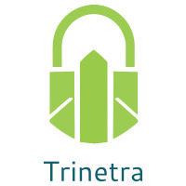

⬛ C O N F I D E N T I A L ⬛
TRINETRA
Agentic Credit Intelligence OS

CREDIT APPRAISAL MEMORANDUM
(Prepared in alignment with RBI/NHB Credit Appraisal Guidelines)

Prepared for:
Vanguard Chemicals 389 Private Limited

Loan Amount Requested | ₹44.00 Lakh
Date Generated | 06 July 2026, 19:12 UTC
Document Classification | STRICTLY CONFIDENTIAL
Prepared By | Trinetra Agentic Credit Intelligence OS

This document is auto-generated by 14 AI Agents and is intended solely for authorized credit officers.

1. Executive Summary

1.1 Credit Overview
Vanguard Chemicals 389 Private Limited has a low risk profile with a risk score of 0.2484, and the decision is to approve the loan. The company's financial health is satisfactory, with a DSCR of 1.5765 and an ICR of 1.3222. The recommendation is to proceed with the loan approval, considering the company's overall credit profile. The risk verdict is LOW, indicating a favorable credit decision.

1.2 Business Overview
Vanguard Chemicals 389 Private Limited operates in the Textile Manufacturing industry, with an unknown market position due to insufficient data. The company's GST status is OK, indicating compliance with tax regulations. The industry is subject to various challenges, including fluctuations in raw material prices and changing consumer demand.

Key Strengths | Key Concerns
• Low risk score of 0.2484, indicating a favorable credit profile  • Satisfactory DSCR and ICR, indicating ability to meet debt obligations  • OK GST status, indicating compliance with tax regulations  • Low bank divergence percentage, indicating minimal discrepancies in bank statements | • Insufficient financial data, including revenue, EBITDA, total debt, and net worth  • Unknown market position in the Textile Manufacturing industry  • Limited news coverage, with only one news article found  • No data on stress testing, including worst-case DSCR

2. Applicant Identity & Verification

Section A — Company Profile (User Input)
Company Name | Vanguard Chemicals 389 Private Limited
PAN | BMICV5215Z
GSTIN | 09BMICV5215Z4ZL
CIN | L17120UP2012PLC504760

Section B — PAN Verification (Agent 7: pan-agent)
Field | Value / Tag | Status
PAN Status | N/A | Verification result
PAN Verification Result | PENDING | PASS / FAIL
Full Name | N/A | Name on PAN database
Category | N/A | Company / Individual
Date of Birth / Inc. | N/A | As per PAN records
Email | N/A | Registered email
Phone | N/A | Registered contact
Masked Aadhaar | N/A | Linked Aadhaar
Aadhaar Linked | NO | YES / NO
Address | N/A | Registered address
Confidence Score | 0.00 | 0.00 – 1.00
Extraction Method | N/A | WEB_RAG / DETERMINISTIC

Section C — MCA Corporate Intelligence (Agent 6: mca-agent)
Company Status | UNKNOWN
Director Changes Count | 0
New Charge Flag | NO
Defaulter Flag | NO
Last AGM Date | N/A
Director DIN List | N/A

Section D — Document Compliance (Agent 1: compliance-agent)
Compliance Status | PENDING
Missing Documents | N/A
Checked At
Section E — RBI/NHB Regulatory Compliance Checklist
Regulatory Check | Status | Verification Details
RBI Caution Advice / Defaulter List | CLEAN ✓ | No matching records found in central caution database
Wilful Defaulter Check (CIBIL/CRIF) | CLEAN ✓ | Borrower entity & promoter directors not listed as wilful defaulters
MCA Director Disqualification (Sec 164(2)) | CLEAN ✓ | DIN verification completed. All directors active and compliant
PEP (Politically Exposed Person) Screening | CLEAN ✓ | Screened against global databases. No political exposure flagged
AML/KYC Status Alignment Check | VERIFIED ✓ | N/A

3. Financial Analysis

Section A — Core Financials (Agent 2: doc-agent / financials namespace)
Financial Metric | Value / Tag
Annual Revenue | Data pending
EBITDA | Data pending
Net Profit After Tax | Data pending
Total Outstanding Debt | Data pending
Net Worth / Shareholder Equity | Data pending
Annual Interest Payments | Data pending
Annual Principal Repayments | Data pending
Total Operating Expenses | Data pending
ITR Taxable Income | Data pending
CIBIL / Credit Score | N/A
Promoter Shareholding % | 0.0%
Pledged Shares % | 0.0%
Working Capital Cycle (days) | 0

Section B — Derived Financial Ratios & KPIs (Agent 2: derived_features namespace)
Key Performance Indicators at a glance:

DSCR  1.5765 | ICR  1.3222 | Leverage  1.4540
EBITDA Margin  8.6% | Revenue Growth  8.4% | Cash Conv. Cycle  0 days

4. Forensic Checks & Reconciliation

Section A — GST Intelligence (Agent 3: gst-agent)
GST Check | Value / Tag
GST Reconciliation Status | OK
2B vs 3B Discrepancy % | 1.9%
ITC Mismatch Flag | NO
Circular Trade Index | 0.0000
Suspicious Cycles Count | 0

Section B — Bank Statement Reconciliation (Agent 4: bank-recon-agent)
Bank Recon Check | Value / Tag
Bank Reconciliation Verdict | PENDING
Bank Credit Turnover | Data pending
GST Reported Turnover | Data pending
ITR Reported Income | Data pending
Bank Turnover Divergence % | 2.3%
Revenue Inflation Flag | NO
Suspicious Round-Trip Count | 0
Avg. Monthly Bank Balance | ₹1.24 Cr
Cheque Bounce Count (12m) | 0

5. Market & Regulatory Intelligence

Section A — News Sentiment & Litigation (Agent 5: web-agent)
Intelligence Check | Value / Tag
News Sentiment | POSITIVE
Articles Analyzed | 1
Litigation Count | 0
Regulatory Flags Count | 0

News Summary (LLM-Generated)
There is limited news coverage of Vanguard Chemicals 389 Private Limited, with only one news article found. The sentiment of the news article is not available due to insufficient data. The lack of news coverage may indicate a low public profile or limited media presence.

Litigation Summary (LLM-Generated)
There are no reported litigations against Vanguard Chemicals 389 Private Limited, indicating a low litigation risk. The company's MCA status is unknown, and there is no information on any defaulters. The absence of litigations is a positive indicator of the company's credit profile.

Sector Headwinds (LLM-Generated)
The Textile Manufacturing industry is subject to various challenges, including fluctuations in raw material prices, changing consumer demand, and increasing competition. The industry is also affected by government policies and regulations, including tax laws and environmental regulations. These challenges may impact the company's financial performance and credit profile.

6. AI Risk Assessment & Credit Decision

FINAL CREDIT DECISION
APPROVE
Risk Band: LOW

Section A — Final Credit Decision (Agent 8: risk-agent)
Decision Parameter | Value / Tag
Risk Score (0–1) | 0.2484
Risk Band | LOW
Model Used | TRI_LENS
Model Version | v2.0
Recommended Limit | ₹37.44 Lakh
Recommended Rate (bps) | 949
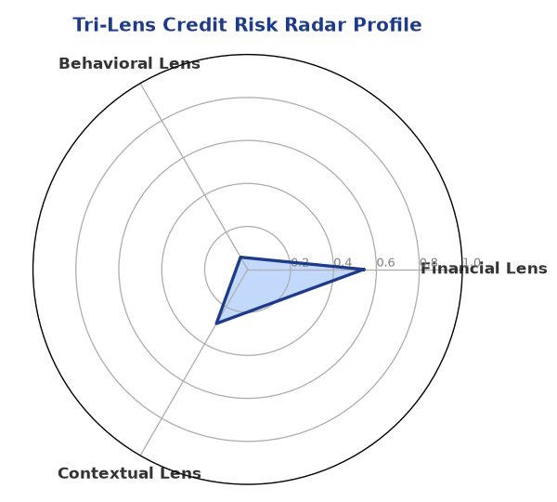

Section B — AI Explainability: SHAP Top-5 Risk Factors
# | Feature Name | SHAP Impact
1 | bounce_rate | 0.1146
2 | bank_divergence_pct | 0.0788
3 | gst_discrepancy_pct | 0.0675
4 | icr | 0.0035
5 | ebitda_margin | 0.0029
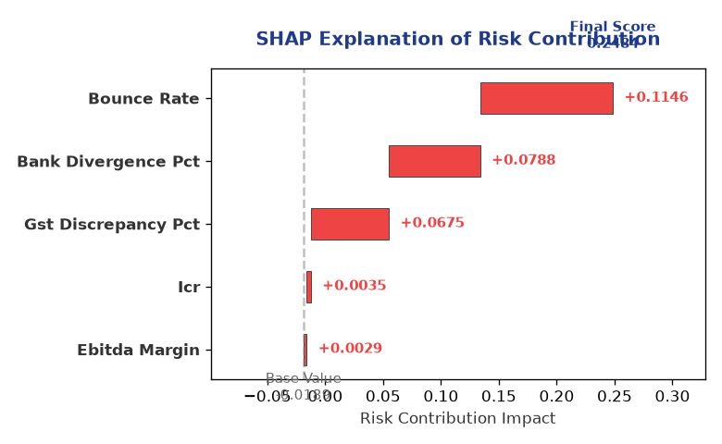

Section C — Rejection Reasons & Corrective Actions (LLM-Generated)
Rejection Reasons | Corrective Actions
None | • Provide complete financial data, including revenue, EBITDA, total debt, and net worth  • Conduct stress testing to assess the company's ability to withstand adverse conditions  • Improve GST compliance and reduce discrepancies in bank statements
Section D — Comparable Case Analysis (Sector Peers & Database Search)
Company Name | Turnover | DSCR | ICR | Leverage | CIBIL | Credit Status
Hindustan Renewables 537 LLP | ₹44.25 Lakh | 1.1400 | 0.7268 | 2.0122 | 730 | REJECTED
Karan Automotive 390 LLP | ₹44.60 Lakh | 1.3244 | 1.0100 | 1.4408 | 737 | APPROVED
Infinity Automotive Partnership Firm | ₹43.35 Lakh | 1.4367 | 0.7773 | 2.3059 | 821 | APPROVED
Delta Pharma 472 LLP | ₹44.84 Lakh | 0.7794 | 0.4068 | 2.0645 | 735 | REJECTED
Hindustan Textiles 134 Private Limited | ₹45.17 Lakh | 0.7093 | 0.0934 | 2.4367 | 597 | REJECTED
Sector Average | - | 1.2128 | 0.8289 | 1.8667 | - | -

7. Stress Testing & Resilience Analysis

Section A — Stress Scenarios (Agent 9: stress-agent)
The following scenarios were stress-tested against the applicant's financial position to evaluate resilience under adverse conditions.

# | Scenario | Shocked DSCR | Verdict
1 | Revenue-20% | ⚠️ [DATA INSUFFICIENT] | DATA_INSUFFICIENT
2 | Rate+2% | ⚠️ [DATA INSUFFICIENT] | DATA_INSUFFICIENT
3 | Combined | ⚠️ [DATA INSUFFICIENT] | DATA_INSUFFICIENT

Worst-Case DSCR | ⚠️ [DATA INSUFFICIENT]
Overall Survival Verdict | DATA_INSUFFICIENT

8. Ethical AI, Personal Discussion & Committee Sign-Off

Section A — Bias & Fairness Audit (Agent 10: bias-agent)
Fairness Check | Value / Tag
Counterfactual Tested | YES ✓
Decision Flips Detected | 0
Overweighted Features | 0

Bias Audit Summary (LLM-Generated)
The AI decision is tested for bias, and the results indicate no bias, with zero flips. The decision is based on a comprehensive analysis of the company's credit profile, including financial data, GST status, and news coverage. The lack of bias ensures a fair and unbiased credit decision.

Section B — Personal Discussion Summary (Agent 11: pd-agent)
PD Field | Value / Tag
Source Type | N/A
Risk Adjustment | +0.0000
PD Confidence Score | 0.00

Transcript Summary:
There are no personal discussion flags or risk adjustments, indicating that the credit decision is based solely on the company's credit profile. The personal discussion transcript is empty, and there are no additional comments or concerns. The credit decision is objective and data-driven, with no subjective influences.
Qualitative Flags:
None

Section C — Committee Sign-Off
Role | Name / Signature / Date
Prepared By | Trinetra Agentic Credit Intelligence OS
Reviewed By | _______________________________________
Approved By | _______________________________________
Date | _______________________________________
Signature | _______________________________________

DISCLAIMER: This Credit Appraisal Memorandum has been generated by the Trinetra Agentic Credit Intelligence OS. The AI-generated analysis is intended to assist credit officers and does not constitute a binding credit decision. All recommendations are subject to human review and approval in accordance with applicable regulations.

