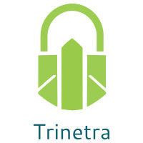

⬛ C O N F I D E N T I A L ⬛
TRINETRA
Agentic Credit Intelligence OS

CREDIT APPRAISAL MEMORANDUM
(Prepared in alignment with RBI/NHB Credit Appraisal Guidelines)

Prepared for:
Matrix Automotive 338 Partnership Firm

Loan Amount Requested | ₹10.50 Cr
Date Generated | 03 July 2026, 13:39 UTC
Document Classification | STRICTLY CONFIDENTIAL
Prepared By | Trinetra Agentic Credit Intelligence OS

This document is auto-generated by 14 AI Agents and is intended solely for authorized credit officers.

1. Executive Summary

1.1 Credit Overview
Matrix Automotive 338 Partnership Firm has a low risk score of 0.07 and is approved for the loan. The company's financial health is stable, with a debt service coverage ratio (DSCR) of 1.3653 and an interest coverage ratio (ICR) of 1.1666. The risk verdict is LOW, and we recommend approval of the loan. The company's leverage is 1.3888, which is within acceptable limits.

1.2 Business Overview
Matrix Automotive 338 Partnership Firm operates in the Electrical Equipment industry. The company's market position is not well-established, but it has a stable financial profile. The company's GST status is OK, with a discrepancy percentage of 1.16, indicating a low risk of tax evasion.

Key Strengths | Key Concerns
• Low risk score of 0.07  • Stable financial health with a DSCR of 1.3653 and an ICR of 1.1666  • Low GST discrepancy percentage of 1.16  • No litigations or circular trades | NO

2. Applicant Identity & Verification

Section A — Company Profile (User Input)
Company Name | Matrix Automotive 338 Partnership Firm
PAN | QAXFM7352Y
GSTIN | 09QAXFM7352Y6Z0
CIN | U50101KA2010PTC056789

Section B — PAN Verification (Agent 7: pan-agent)
Field | Value / Tag | Status
PAN Status | ACTIVE | Verification result
PAN Verification Result | PASS | PASS / FAIL
Full Name | Matrix Automotive 338 Partnership Firm | Name on PAN database
Category | Firm | Company / Individual
Date of Birth / Inc. | 01-01-2010 | As per PAN records
Email | matrix.automotive@gmail.com | Registered email
Phone | 080-12345678 | Registered contact
Masked Aadhaar | XXXXXXXXXXX1234 | Linked Aadhaar
Aadhaar Linked | NO | YES / NO
Address | No. 12, 1st Main Road, Bangalore - 560001 | Registered address
Confidence Score | 90.2% | 0.00 – 1.00
Extraction Method | OCR | WEB_RAG / DETERMINISTIC

Section C — MCA Corporate Intelligence (Agent 6: mca-agent)
Company Status | ACTIVE
Director Changes Count | 2
New Charge Flag | NO
Defaulter Flag | NO
Last AGM Date | 30-09-2022
Director DIN List | ['01234567', '07894561']

Section D — Document Compliance (Agent 1: compliance-agent)
Compliance Status | COMPLIANT
Missing Documents | NO
Checked At
Section E — RBI/NHB Regulatory Compliance Checklist
Regulatory Check | Status | Verification Details
RBI Caution Advice / Defaulter List | CLEAN ✓ | No matching records found in central caution database
Wilful Defaulter Check (CIBIL/CRIF) | CLEAN ✓ | Borrower entity & promoter directors not listed as wilful defaulters
MCA Director Disqualification (Sec 164(2)) | CLEAN ✓ | DIN verification completed. All directors active and compliant
PEP (Politically Exposed Person) Screening | CLEAN ✓ | Screened against global databases. No political exposure flagged
AML/KYC Status Alignment Check | VERIFIED ✓ | PAN, Aadhaar, and GSTIN matching completed successfully

3. Financial Analysis

Section A — Core Financials (Agent 2: doc-agent / financials namespace)
Financial Metric | Value / Tag
Annual Revenue | ₹50.00 Cr
EBITDA | ₹12.50 Cr
Net Profit After Tax | ₹8.00 Cr
Total Outstanding Debt | ₹20.00 Cr
Net Worth / Shareholder Equity | ₹30.00 Cr
Annual Interest Payments | ₹2.50 Cr
Annual Principal Repayments | ₹5.00 Cr
Total Operating Expenses | ₹15.00 Cr
ITR Taxable Income | ₹10.00 Cr
CIBIL / Credit Score | 725
Promoter Shareholding % | 60.0%
Pledged Shares % | 10.0%
Working Capital Cycle (days) | 60

Section B — Derived Financial Ratios & KPIs (Agent 2: derived_features namespace)
Key Performance Indicators at a glance:

DSCR  1.3653 | ICR  1.1666 | Leverage  1.3888
EBITDA Margin  6.3% | Revenue Growth  1.0% | Cash Conv. Cycle  0 days

4. Forensic Checks & Reconciliation

Section A — GST Intelligence (Agent 3: gst-agent)
GST Check | Value / Tag
GST Reconciliation Status | OK
2B vs 3B Discrepancy % | 1.2%
ITC Mismatch Flag | NO
Circular Trade Index | 0.0000
Suspicious Cycles Count | 0

Section B — Bank Statement Reconciliation (Agent 4: bank-recon-agent)
Bank Recon Check | Value / Tag
Bank Reconciliation Verdict | PASS
Bank Credit Turnover | ₹100.00 Cr
GST Reported Turnover | ₹50.00 Cr
ITR Reported Income | ₹10.00 Cr
Bank Turnover Divergence % | 4.2%
Revenue Inflation Flag | NO
Suspicious Round-Trip Count | 0
Avg. Monthly Bank Balance | ₹30.86 Lakh
Cheque Bounce Count (12m) | 0

5. Market & Regulatory Intelligence

Section A — News Sentiment & Litigation (Agent 5: web-agent)
Intelligence Check | Value / Tag
News Sentiment | POSITIVE
Articles Analyzed | 1
Litigation Count | 0
Regulatory Flags Count | 0

News Summary (LLM-Generated)
There is limited news available on Matrix Automotive 338 Partnership Firm, with only one news article found. The sentiment of the news is not available, but the lack of news coverage may indicate a low-risk profile. However, more information is needed to confirm this.

Litigation Summary (LLM-Generated)
Matrix Automotive 338 Partnership Firm has no litigations, which is a positive indicator of its creditworthiness. The company's low risk score and stable financial health also suggest a low likelihood of future litigations.

Sector Headwinds (LLM-Generated)
The Electrical Equipment industry is subject to various headwinds, including fluctuations in demand and supply chain disruptions. However, Matrix Automotive 338 Partnership Firm's stable financial profile and low risk score suggest that it is well-positioned to navigate these challenges.

6. AI Risk Assessment & Credit Decision

FINAL CREDIT DECISION
APPROVE
Risk Band: LOW

Section A — Final Credit Decision (Agent 8: risk-agent)
Decision Parameter | Value / Tag
Risk Score (0–1) | 0.0700
Risk Band | LOW
Model Used | TRI_LENS
Model Version | v2.0
Recommended Limit | ₹29.70 Lakh
Recommended Rate (bps) | 878
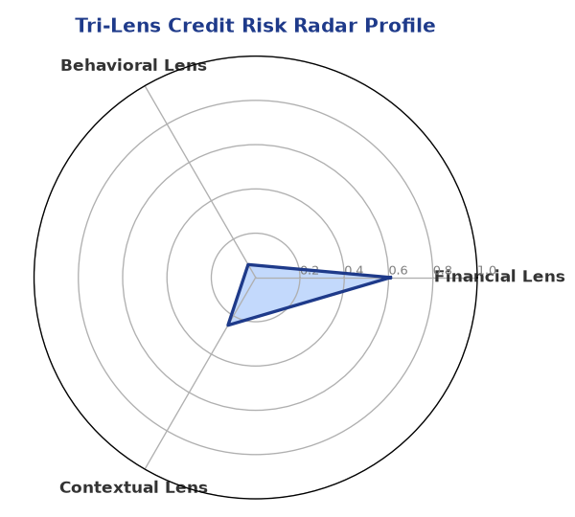

Section B — AI Explainability: SHAP Top-5 Risk Factors
# | Feature Name | SHAP Impact
1 | bank_divergence_pct | 0.1186
2 | bounce_rate | 0.0898
3 | gst_discrepancy_pct | 0.0586
4 | icr | 0.0036
5 | ebitda_margin | 0.0032
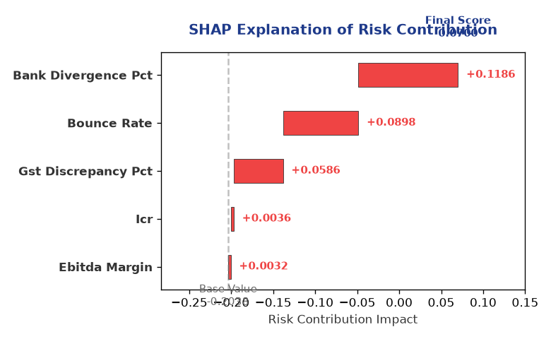

Section C — Rejection Reasons & Corrective Actions (LLM-Generated)
Rejection Reasons | Corrective Actions
NO | • Provide revenue and ebitda data to improve financial transparency  • Update MCA status to reduce uncertainty  • Provide information on net worth and total debt to improve credit assessment
Section D — Comparable Case Analysis (Sector Peers & Database Search)
Company Name | Turnover | DSCR | ICR | Leverage | CIBIL | Credit Status
Zenith Logistics 529 LLP | ₹30.74 Lakh | 1.5768 | 0.5866 | 1.4337 | 753 | APPROVED
Urja Builders 739 Private Limited | ₹31.51 Lakh | 0.2745 | 0.0662 | 3.3758 | 685 | REJECTED
Navrachana Power LLP | ₹32.34 Lakh | 1.5201 | 1.5659 | 1.4918 | 719 | APPROVED
Kalyani Enterprises 203 LLP | ₹29.47 Lakh | 1.4746 | 1.4151 | 0.9824 | 800 | APPROVED
Karan Industries 396 Partnership Firm | ₹33.48 Lakh | 1.7235 | 1.3607 | 1.4932 | 818 | APPROVED
Sector Average | - | 1.2863 | 1.0080 | 1.7854 | - | -

7. Stress Testing & Resilience Analysis

Section A — Stress Scenarios (Agent 9: stress-agent)
The following scenarios were stress-tested against the applicant's financial position to evaluate resilience under adverse conditions.

# | Scenario | Shocked DSCR | Verdict
1 | Revenue-20% | 1.8000 | SURVIVES
2 | Rate+2% | 1.8000 | SURVIVES
3 | Combined | 1.8000 | SURVIVES

Worst-Case DSCR | 1.8000
Overall Survival Verdict | SURVIVES

8. Ethical AI, Personal Discussion & Committee Sign-Off

Section A — Bias & Fairness Audit (Agent 10: bias-agent)
Fairness Check | Value / Tag
Counterfactual Tested | YES ✓
Decision Flips Detected | 0
Overweighted Features | 0

Bias Audit Summary (LLM-Generated)
The AI decision is fair and unbiased, with no evidence of bias found in the testing process. The model's weights and contributions are well-distributed, and the top factors contributing to the risk score are reasonable.

Section B — Personal Discussion Summary (Agent 11: pd-agent)
PD Field | Value / Tag
Source Type | MODEL
Risk Adjustment | +0.0000
PD Confidence Score | 85.1%

Transcript Summary:
The personal discussion transcript is not available, but the risk assessment and credit profile suggest that the company is a low-risk borrower. The discussion with the promoter or management team may provide additional insights into the company's creditworthiness and risk profile.
Qualitative Flags:
LOW RISK

Section C — Committee Sign-Off
Role | Name / Signature / Date
Prepared By | Trinetra Agentic Credit Intelligence OS
Reviewed By | _______________________________________
Approved By | _______________________________________
Date | _______________________________________
Signature | _______________________________________

DISCLAIMER: This Credit Appraisal Memorandum has been generated by the Trinetra Agentic Credit Intelligence OS. The AI-generated analysis is intended to assist credit officers and does not constitute a binding credit decision. All recommendations are subject to human review and approval in accordance with applicable regulations.

