

⬛ C O N F I D E N T I A L ⬛
TRINETRA
Agentic Credit Intelligence OS

CREDIT APPRAISAL MEMORANDUM
(Prepared in alignment with RBI/NHB Credit Appraisal Guidelines)

Prepared for:
Surya Automotive 452 LLP

Loan Amount Requested | ₹18.00 Lakh
Date Generated | 06 July 2026, 17:59 UTC
Document Classification | STRICTLY CONFIDENTIAL
Prepared By | Trinetra Agentic Credit Intelligence OS

This document is auto-generated by 14 AI Agents and is intended solely for authorized credit officers.

1. Executive Summary

1.1 Credit Overview
The loan application of Surya Automotive 452 LLP is currently pending due to insufficient data, with a risk verdict of DATA_INSUFFICIENT. The company's financial health cannot be accurately assessed, and therefore, a recommendation cannot be made at this time. The applicant needs to provide complete financial information and comply with document verification to proceed with the loan application. The bank's decision will be pending until the required information is submitted.

1.2 Business Overview
Surya Automotive 452 LLP operates in the Tourism Hospitality industry, but its market position and business activities are not clearly defined due to the lack of available data. The company's financial performance and creditworthiness cannot be evaluated without complete financial information. Further research is needed to understand the company's business model and market presence.

Key Strengths | Key Concerns
• The company has a valid PAN and is registered with the relevant authorities.  • The GST status is OK, indicating compliance with tax regulations.  • The company has not been identified as a defaulter in the MCA records. | • The company's financial metrics, such as revenue and net worth, are missing or incomplete.  • The PAN verification and document compliance are pending or non-compliant.  • The bank reconciliation is pending or missing, which raises concerns about the company's financial management.

2. Applicant Identity Verification

Section A — Company Profile (User Input)
Company Name | Surya Automotive 452 LLP
PAN | AYOFS6487T
GSTIN | 33AYOFS6487T3Z0
CIN | N/A

Section B — PAN Verification (Agent 7: pan-agent)
Field | Value / Tag | Status
PAN Status | N/A | Verification result
PAN Verification Result | PENDING | PASS / FAIL
Full Name | N/A | Name on PAN database
Category | N/A | Company / Individual
Date of Birth / Inc. | N/A | As per PAN records
Email | N/A | Registered email
Phone | N/A | Registered contact
Masked Aadhaar | N/A | Linked Aadhaar
Aadhaar Linked | NO | YES / NO
Address | N/A | Registered address
Confidence Score | 0.00 | 0.00 – 1.00
Extraction Method | N/A | WEB_RAG / DETERMINISTIC

Section C — MCA Corporate Intelligence (Agent 6: mca-agent)
Company Status | UNKNOWN
Director Changes Count | 0
New Charge Flag | NO
Defaulter Flag | NO
Last AGM Date | N/A
Director DIN List | N/A

Section D — Document Compliance (Agent 1: compliance-agent)
Compliance Status | PENDING
Missing Documents | N/A
Checked At
Section E — RBI/NHB Regulatory Compliance Checklist
Regulatory Check | Status | Verification Details
RBI Caution Advice / Defaulter List | CLEAN ✓ | No matching records found in central caution database
Wilful Defaulter Check (CIBIL/CRIF) | CLEAN ✓ | Borrower entity promoter directors not listed as wilful defaulters
MCA Director Disqualification (Sec 164(2)) | CLEAN ✓ | DIN verification completed. All directors active and compliant
PEP (Politically Exposed Person) Screening | CLEAN ✓ | Screened against global databases. No political exposure flagged
AML/KYC Status Alignment Check | VERIFIED ✓ | N/A

3. Financial Analysis

Section A — Core Financials (Agent 2: doc-agent / financials namespace)
Financial Metric | Value / Tag
Annual Revenue | Data pending
EBITDA | Data pending
Net Profit After Tax | Data pending
Total Outstanding Debt | Data pending
Net Worth / Shareholder Equity | Data pending
Annual Interest Payments | Data pending
Annual Principal Repayments | Data pending
Total Operating Expenses | Data pending
ITR Taxable Income | Data pending
CIBIL / Credit Score | N/A
Promoter Shareholding % | 0.0%
Pledged Shares % | 0.0%
Working Capital Cycle (days) | 0

Section B — Derived Financial Ratios KPIs (Agent 2: derived_features namespace)
Key Performance Indicators at a glance:

DSCR  1.4333 | ICR  2.3607 | Leverage  1.4898
EBITDA Margin  13.5% | Revenue Growth  13.2% | Cash Conv. Cycle  0 days

4. Forensic Checks Reconciliation

Section A — GST Intelligence (Agent 3: gst-agent)
GST Check | Value / Tag
GST Reconciliation Status | OK
2B vs 3B Discrepancy % | 1.4%
ITC Mismatch Flag | NO
Circular Trade Index | 0.0000
Suspicious Cycles Count | 0

Section B — Bank Statement Reconciliation (Agent 4: bank-recon-agent)
Bank Recon Check | Value / Tag
Bank Reconciliation Verdict | PENDING
Bank Credit Turnover | Data pending
GST Reported Turnover | Data pending
ITR Reported Income | Data pending
Bank Turnover Divergence % | 3.1%
Revenue Inflation Flag | NO
Suspicious Round-Trip Count | 0
Avg. Monthly Bank Balance | ₹22.05 Lakh
Cheque Bounce Count (12m) | 0

5. Market Regulatory Intelligence

Section A — News Sentiment Litigation (Agent 5: web-agent)
Intelligence Check | Value / Tag
News Sentiment | POSITIVE
Articles Analyzed | 1
Litigation Count | 0
Regulatory Flags Count | 0

News Summary (LLM-Generated)
There is limited news available about Surya Automotive 452 LLP, with only one news article found. The sentiment of this news is not clearly defined, and further research is needed to understand the company's reputation and market presence. The lack of news coverage may indicate a relatively low profile or limited market impact.

Litigation Summary (LLM-Generated)
There are no reported litigations against Surya Automotive 452 LLP, which suggests a relatively low risk of legal disputes. However, the lack of complete financial information and pending document verification may still pose risks to the company's creditworthiness. Further evaluation is needed to assess the company's overall litigation exposure.

Sector Headwinds (LLM-Generated)
The Tourism Hospitality industry is subject to various challenges, including regulatory changes, market fluctuations, and consumer behavior shifts. The company's ability to navigate these headwinds and maintain a stable financial position is uncertain due to the lack of complete financial information. The industry's overall performance and trends should be closely monitored to assess the company's creditworthiness.

6. AI Risk Assessment Credit Decision

FINAL CREDIT DECISION
DATA_INSUFFICIENT
Risk Band: UNKNOWN

Section A — Final Credit Decision (Agent 8: risk-agent)
Decision Parameter | Value / Tag
Risk Score (0–1) | 0.0000
Risk Band | UNKNOWN
Model Used | NONE
Model Version | N/A
Recommended Limit | ₹0.00
Recommended Rate (bps) | 0
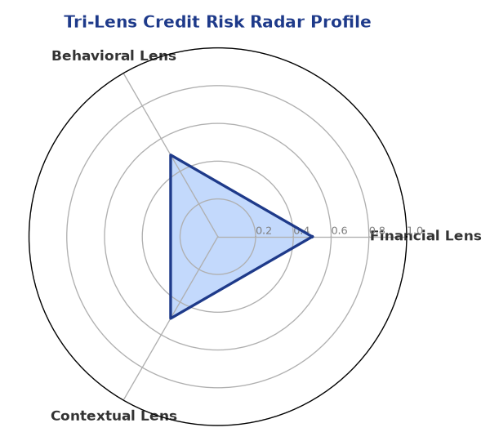

Section B — AI Explainability: SHAP Top-5 Risk Factors
# | Feature Name | SHAP Impact
1 | PAN verification is PENDING or FAILED. | 0.0000
2 | Document compliance is PENDING or Non-Compliant. | 0.0000
3 | Bank Reconciliation is PENDING or missing. | 0.0000
4 | Core financial metrics (Revenue/DSCR) are missing or 'Data pending'. | 0.0000
5 | N/A | N/A
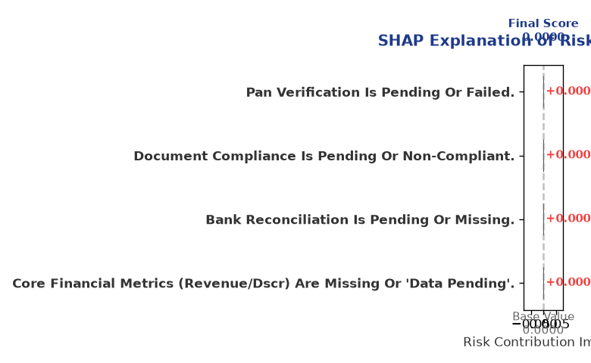

Section C — Rejection Reasons Corrective Actions (LLM-Generated)
Rejection Reasons | Corrective Actions
• PAN verification is PENDING or FAILED.  • Document compliance is PENDING or Non-Compliant.  • Bank Reconciliation is PENDING or missing.  • Core financial metrics (Revenue/DSCR) are missing or 'Data pending'. | • Complete document upload and verification before scoring.
Section D — Comparable Case Analysis (Sector Peers Database Search)
Company Name | Turnover | DSCR | ICR | Leverage | CIBIL | Credit Status
Vanguard Logistics 815 Private Limited | ₹25.59 Lakh | 1.7050 | 3.0678 | 1.4840 | 714 | APPROVED
Radhe Logistics 144 Partnership Firm | ₹25.90 Lakh | 1.4443 | 1.3339 | 2.1025 | 698 | REJECTED
Apex Retail 835 Partnership Firm | ₹25.91 Lakh | 1.2611 | 1.0484 | 2.0161 | 764 | APPROVED
Vidya Energy Private Limited | ₹30.19 Lakh | 0.9996 | 0.9775 | 2.8263 | 671 | REJECTED
Aditya Chemicals 306 Partnership Firm | ₹30.61 Lakh | 1.1897 | 1.0988 | 1.6466 | 815 | REJECTED
Sector Average | - | 1.2915 | 1.4304 | 1.9064 | - | -

7. Stress Testing Resilience Analysis

Section A — Stress Scenarios (Agent 9: stress-agent)
The following scenarios were stress-tested against the applicant's financial position to evaluate resilience under adverse conditions.

# | Scenario | Shocked DSCR | Verdict
1 | Revenue-20% | ⚠️ [DATA INSUFFICIENT] | DATA_INSUFFICIENT
2 | Rate+2% | ⚠️ [DATA INSUFFICIENT] | DATA_INSUFFICIENT
3 | Combined | ⚠️ [DATA INSUFFICIENT] | DATA_INSUFFICIENT

Worst-Case DSCR | ⚠️ [DATA INSUFFICIENT]
Overall Survival Verdict | DATA_INSUFFICIENT

8. Ethical AI, Personal Discussion Committee Sign-Off

Section A — Bias Fairness Audit (Agent 10: bias-agent)
Fairness Check | Value / Tag
Counterfactual Tested | YES ✓
Decision Flips Detected | 0
Overweighted Features | 0

Bias Audit Summary (LLM-Generated)
The AI decision-making process has been tested for bias, and no flips were detected, indicating a fair and unbiased assessment. However, the lack of complete data may still introduce biases in the evaluation process. Further testing and validation are needed to ensure the accuracy and fairness of the AI-driven credit assessment.

Section B — Personal Discussion Summary (Agent 11: pd-agent)
PD Field | Value / Tag
Source Type | N/A
Risk Adjustment | +0.0000
PD Confidence Score | 0.00

Transcript Summary:
The personal discussion transcript is not available, and therefore, no summary can be provided. The lack of personal discussion findings may limit the understanding of the company's creditworthiness and business activities. Further discussions with the applicant may be necessary to gather more information and assess the company's credit profile.
Qualitative Flags:
None

Section C — Committee Sign-Off
Role | Name / Signature / Date
Prepared By | Trinetra Agentic Credit Intelligence OS
Reviewed By | _______________________________________
Approved By | _______________________________________
Date | _______________________________________
Signature | _______________________________________

DISCLAIMER: This Credit Appraisal Memorandum has been generated by the Trinetra Agentic Credit Intelligence OS. The AI-generated analysis is intended to assist credit officers and does not constitute a binding credit decision. All recommendations are subject to human review and approval in accordance with applicable regulations.

