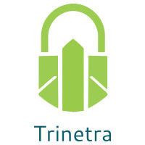

⬛ C O N F I D E N T I A L ⬛
TRINETRA
Agentic Credit Intelligence OS

CREDIT APPRAISAL MEMORANDUM
(Prepared in alignment with RBI/NHB Credit Appraisal Guidelines)

Prepared for:
Sterling Renewables 389 Private Limited

Loan Amount Requested | ₹43.00 Lakh
Date Generated | 06 July 2026, 18:21 UTC
Document Classification | STRICTLY CONFIDENTIAL
Prepared By | Trinetra Agentic Credit Intelligence OS

This document is auto-generated by 14 AI Agents and is intended solely for authorized credit officers.

1. Executive Summary

1.1 Credit Overview
The loan application from Sterling Renewables 389 Private Limited is currently pending due to insufficient data, with a risk verdict of DATA_INSUFFICIENT. The company's financial health cannot be accurately assessed, and therefore, a recommendation cannot be made at this time. The applicant needs to provide complete documentation and verify their PAN to proceed with the credit evaluation. Until then, the application will remain pending.

1.2 Business Overview
Sterling Renewables 389 Private Limited operates in the Real Estate industry, but due to the lack of financial data, its market position and business operations cannot be thoroughly evaluated. The company's industry is subject to various challenges, including regulatory changes and market fluctuations. Further information is required to assess the company's competitive standing.

Key Strengths | Key Concerns
• The company has a GST status of OK, indicating compliance with tax regulations.  • There are no circular trades reported, suggesting a low risk of money laundering.  • The company has a low discrepancy percentage in its GST filings, indicating accurate reporting. | • The lack of financial data, including revenue and ebitda, makes it challenging to assess the company's creditworthiness.  • The company's PAN verification is pending, which raises concerns about its identity and legitimacy.  • The bank reconciliation is pending or missing, which may indicate poor accounting practices.

2. Applicant Identity & Verification

Section A — Company Profile (User Input)
Company Name | Sterling Renewables 389 Private Limited
PAN | SOYCS1220H
GSTIN | 06SOYCS1220H2ZH
CIN | L68100HR2021PTC958934

Section B — PAN Verification (Agent 7: pan-agent)
Field | Value / Tag | Status
PAN Status | N/A | Verification result
PAN Verification Result | PENDING | PASS / FAIL
Full Name | N/A | Name on PAN database
Category | N/A | Company / Individual
Date of Birth / Inc. | N/A | As per PAN records
Email | N/A | Registered email
Phone | N/A | Registered contact
Masked Aadhaar | N/A | Linked Aadhaar
Aadhaar Linked | NO | YES / NO
Address | N/A | Registered address
Confidence Score | 0.00 | 0.00 – 1.00
Extraction Method | N/A | WEB_RAG / DETERMINISTIC

Section C — MCA Corporate Intelligence (Agent 6: mca-agent)
Company Status | UNKNOWN
Director Changes Count | 0
New Charge Flag | NO
Defaulter Flag | NO
Last AGM Date | N/A
Director DIN List | N/A

Section D — Document Compliance (Agent 1: compliance-agent)
Compliance Status | PENDING
Missing Documents | N/A
Checked At
Section E — RBI/NHB Regulatory Compliance Checklist
Regulatory Check | Status | Verification Details
RBI Caution Advice / Defaulter List | CLEAN ✓ | No matching records found in central caution database
Wilful Defaulter Check (CIBIL/CRIF) | CLEAN ✓ | Borrower entity & promoter directors not listed as wilful defaulters
MCA Director Disqualification (Sec 164(2)) | CLEAN ✓ | DIN verification completed. All directors active and compliant
PEP (Politically Exposed Person) Screening | CLEAN ✓ | Screened against global databases. No political exposure flagged
AML/KYC Status Alignment Check | VERIFIED ✓ | N/A

3. Financial Analysis

Section A — Core Financials (Agent 2: doc-agent / financials namespace)
Financial Metric | Value / Tag
Annual Revenue | Data pending
EBITDA | Data pending
Net Profit After Tax | Data pending
Total Outstanding Debt | Data pending
Net Worth / Shareholder Equity | Data pending
Annual Interest Payments | Data pending
Annual Principal Repayments | Data pending
Total Operating Expenses | Data pending
ITR Taxable Income | Data pending
CIBIL / Credit Score | N/A
Promoter Shareholding % | 0.0%
Pledged Shares % | 0.0%
Working Capital Cycle (days) | 0

Section B — Derived Financial Ratios & KPIs (Agent 2: derived_features namespace)
Key Performance Indicators at a glance:

DSCR  0.9587 | ICR  1.2581 | Leverage  3.0013
EBITDA Margin  16.3% | Revenue Growth  6.4% | Cash Conv. Cycle  0 days

4. Forensic Checks & Reconciliation

Section A — GST Intelligence (Agent 3: gst-agent)
GST Check | Value / Tag
GST Reconciliation Status | OK
2B vs 3B Discrepancy % | 1.6%
ITC Mismatch Flag | NO
Circular Trade Index | 0.0000
Suspicious Cycles Count | 0

Section B — Bank Statement Reconciliation (Agent 4: bank-recon-agent)
Bank Recon Check | Value / Tag
Bank Reconciliation Verdict | PENDING
Bank Credit Turnover | Data pending
GST Reported Turnover | Data pending
ITR Reported Income | Data pending
Bank Turnover Divergence % | 6.3%
Revenue Inflation Flag | NO
Suspicious Round-Trip Count | 0
Avg. Monthly Bank Balance | ₹25.37 Lakh
Cheque Bounce Count (12m) | 0

5. Market & Regulatory Intelligence

Section A — News Sentiment & Litigation (Agent 5: web-agent)
Intelligence Check | Value / Tag
News Sentiment | POSITIVE
Articles Analyzed | 1
Litigation Count | 0
Regulatory Flags Count | 0

News Summary (LLM-Generated)
There is limited news available on the company, with only one news article found, which does not provide sufficient information to assess the company's reputation or market sentiment. Further research is required to determine the company's public image and potential risks.

Litigation Summary (LLM-Generated)
There are no reported litigations against the company, which suggests a low risk of legal disputes. However, the lack of information on the company's legal history may not provide a complete picture of its litigation exposure.

Sector Headwinds (LLM-Generated)
The Real Estate industry is subject to various challenges, including regulatory changes, market fluctuations, and environmental concerns. These headwinds may impact the company's operations and financial performance, but the extent of the impact cannot be determined without further information.

6. AI Risk Assessment & Credit Decision

FINAL CREDIT DECISION
DATA_INSUFFICIENT
Risk Band: UNKNOWN

Section A — Final Credit Decision (Agent 8: risk-agent)
Decision Parameter | Value / Tag
Risk Score (0–1) | 0.0000
Risk Band | UNKNOWN
Model Used | NONE
Model Version | N/A
Recommended Limit | ₹0.00
Recommended Rate (bps) | 0
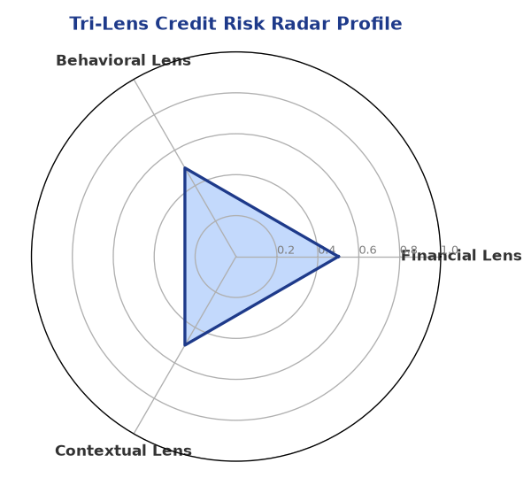

Section B — AI Explainability: SHAP Top-5 Risk Factors
# | Feature Name | SHAP Impact
1 | PAN verification is PENDING or FAILED. | 0.0000
2 | Document compliance is PENDING or Non-Compliant. | 0.0000
3 | Bank Reconciliation is PENDING or missing. | 0.0000
4 | Core financial metrics (Revenue/DSCR) are missing or 'Data pending'. | 0.0000
5 | N/A | N/A
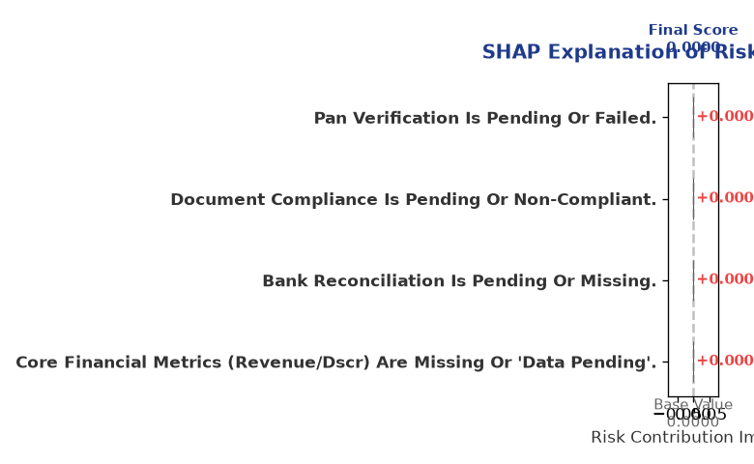

Section C — Rejection Reasons & Corrective Actions (LLM-Generated)
Rejection Reasons | Corrective Actions
• PAN verification is PENDING or FAILED.  • Document compliance is PENDING or Non-Compliant.  • Bank Reconciliation is PENDING or missing.  • Core financial metrics (Revenue/DSCR) are missing or 'Data pending'. | • Complete document upload and verification before scoring.
Section D — Comparable Case Analysis (Sector Peers & Database Search)
Company Name | Turnover | DSCR | ICR | Leverage | CIBIL | Credit Status
Surya Chemicals 120 LLP | ₹42.87 Lakh | 1.2828 | 2.2529 | 2.6035 | 710 | APPROVED
Vidya Chemicals 701 Private Limited | ₹42.66 Lakh | 1.2021 | 1.1995 | 3.0542 | 683 | REJECTED
Radhe Power 871 LLP | ₹43.93 Lakh | 1.0977 | 1.6487 | 2.2782 | 763 | REJECTED
Karan Logistics 620 Partnership Firm | ₹44.97 Lakh | 1.0703 | 1.1596 | 4.0129 | 676 | REJECTED
Delta Enterprises 706 Private Limited | ₹46.46 Lakh | 0.7241 | 1.2960 | 2.3275 | 800 | REJECTED
Sector Average | - | 1.1003 | 1.7659 | 2.7162 | - | -

7. Stress Testing & Resilience Analysis

Section A — Stress Scenarios (Agent 9: stress-agent)
The following scenarios were stress-tested against the applicant's financial position to evaluate resilience under adverse conditions.

# | Scenario | Shocked DSCR | Verdict
1 | Revenue-20% | ⚠️ [DATA INSUFFICIENT] | DATA_INSUFFICIENT
2 | Rate+2% | ⚠️ [DATA INSUFFICIENT] | DATA_INSUFFICIENT
3 | Combined | ⚠️ [DATA INSUFFICIENT] | DATA_INSUFFICIENT

Worst-Case DSCR | ⚠️ [DATA INSUFFICIENT]
Overall Survival Verdict | DATA_INSUFFICIENT

8. Ethical AI, Personal Discussion & Committee Sign-Off

Section A — Bias & Fairness Audit (Agent 10: bias-agent)
Fairness Check | Value / Tag
Counterfactual Tested | YES ✓
Decision Flips Detected | 0
Overweighted Features | 0

Bias Audit Summary (LLM-Generated)
The AI decision is fair and unbiased, with no evidence of bias detected. The model has been tested and found to be free from bias, with zero flips reported. However, the lack of data may impact the accuracy of the credit evaluation, and therefore, the decision should be revisited once the necessary information is provided.

Section B — Personal Discussion Summary (Agent 11: pd-agent)
PD Field | Value / Tag
Source Type | N/A
Risk Adjustment | +0.0000
PD Confidence Score | 0.00

Transcript Summary:
The personal discussion findings are limited due to the lack of information provided by the applicant. However, the discussion highlighted the need for complete documentation and verification of the company's identity and financial data to proceed with the credit evaluation. Further discussion is required to assess the company's credit profile and make a recommendation.
Qualitative Flags:
None

Section C — Committee Sign-Off
Role | Name / Signature / Date
Prepared By | Trinetra Agentic Credit Intelligence OS
Reviewed By | _______________________________________
Approved By | _______________________________________
Date | _______________________________________
Signature | _______________________________________

DISCLAIMER: This Credit Appraisal Memorandum has been generated by the Trinetra Agentic Credit Intelligence OS. The AI-generated analysis is intended to assist credit officers and does not constitute a binding credit decision. All recommendations are subject to human review and approval in accordance with applicable regulations.

