

⬛ C O N F I D E N T I A L ⬛
TRINETRA
Agentic Credit Intelligence OS

CREDIT APPRAISAL MEMORANDUM
(Prepared in alignment with RBI/NHB Credit Appraisal Guidelines)

Prepared for:
Ganesh Textiles 741 LLP

Loan Amount Requested | ₹20.00 Lakh
Date Generated | 06 July 2026, 18:11 UTC
Document Classification | STRICTLY CONFIDENTIAL
Prepared By | Trinetra Agentic Credit Intelligence OS

This document is auto-generated by 14 AI Agents and is intended solely for authorized credit officers.

1. Executive Summary

1.1 Credit Overview
The loan application of Ganesh Textiles 741 LLP is currently pending due to insufficient data, with a risk verdict of DATA_INSUFFICIENT. The company's financial health cannot be accurately assessed due to missing core financial metrics. It is recommended that the applicant complete the document upload and verification process before a credit decision can be made. The overall risk profile of the company is uncertain due to the lack of information.

1.2 Business Overview
Ganesh Textiles 741 LLP operates in the Steel Fabrication industry, but its market position and business operations are not well understood due to the limited information available. The company's GST status is OK, with a low discrepancy percentage, indicating some level of compliance with tax regulations. However, more information is needed to fully assess the company's business overview.

Key Strengths | Key Concerns
• GST status is OK, indicating some level of compliance with tax regulations  • Low discrepancy percentage in GST filings  • No circular trade detected in GST data | • Missing core financial metrics, including revenue and net worth  • PAN verification is PENDING or FAILED, raising concerns about the company's identity and legitimacy  • Document compliance is PENDING or Non-Compliant, indicating potential regulatory issues

2. Applicant Identity & Verification

Section A — Company Profile (User Input)
Company Name | Ganesh Textiles 741 LLP
PAN | MHMFG0342L
GSTIN | 27MHMFG0342L8ZZ
CIN | N/A

Section B — PAN Verification (Agent 7: pan-agent)
Field | Value / Tag | Status
PAN Status | N/A | Verification result
PAN Verification Result | PENDING | PASS / FAIL
Full Name | N/A | Name on PAN database
Category | N/A | Company / Individual
Date of Birth / Inc. | N/A | As per PAN records
Email | N/A | Registered email
Phone | N/A | Registered contact
Masked Aadhaar | N/A | Linked Aadhaar
Aadhaar Linked | NO | YES / NO
Address | N/A | Registered address
Confidence Score | 0.00 | 0.00 – 1.00
Extraction Method | N/A | WEB_RAG / DETERMINISTIC

Section C — MCA Corporate Intelligence (Agent 6: mca-agent)
Company Status | UNKNOWN
Director Changes Count | 0
New Charge Flag | NO
Defaulter Flag | NO
Last AGM Date | N/A
Director DIN List | N/A

Section D — Document Compliance (Agent 1: compliance-agent)
Compliance Status | PENDING
Missing Documents | N/A
Checked At
Section E — RBI/NHB Regulatory Compliance Checklist
Regulatory Check | Status | Verification Details
RBI Caution Advice / Defaulter List | CLEAN ✓ | No matching records found in central caution database
Wilful Defaulter Check (CIBIL/CRIF) | CLEAN ✓ | Borrower entity & promoter directors not listed as wilful defaulters
MCA Director Disqualification (Sec 164(2)) | CLEAN ✓ | DIN verification completed. All directors active and compliant
PEP (Politically Exposed Person) Screening | CLEAN ✓ | Screened against global databases. No political exposure flagged
AML/KYC Status Alignment Check | VERIFIED ✓ | N/A

3. Financial Analysis

Section A — Core Financials (Agent 2: doc-agent / financials namespace)
Financial Metric | Value / Tag
Annual Revenue | Data pending
EBITDA | Data pending
Net Profit After Tax | Data pending
Total Outstanding Debt | Data pending
Net Worth / Shareholder Equity | Data pending
Annual Interest Payments | Data pending
Annual Principal Repayments | Data pending
Total Operating Expenses | Data pending
ITR Taxable Income | Data pending
CIBIL / Credit Score | N/A
Promoter Shareholding % | 0.0%
Pledged Shares % | 0.0%
Working Capital Cycle (days) | 0

Section B — Derived Financial Ratios & KPIs (Agent 2: derived_features namespace)
Key Performance Indicators at a glance:

DSCR  1.3370 | ICR  0.6693 | Leverage  1.5463
EBITDA Margin  4.1% | Revenue Growth  0.9% | Cash Conv. Cycle  0 days

4. Forensic Checks & Reconciliation

Section A — GST Intelligence (Agent 3: gst-agent)
GST Check | Value / Tag
GST Reconciliation Status | OK
2B vs 3B Discrepancy % | 1.6%
ITC Mismatch Flag | NO
Circular Trade Index | 0.0000
Suspicious Cycles Count | 0

Section B — Bank Statement Reconciliation (Agent 4: bank-recon-agent)
Bank Recon Check | Value / Tag
Bank Reconciliation Verdict | PENDING
Bank Credit Turnover | Data pending
GST Reported Turnover | Data pending
ITR Reported Income | Data pending
Bank Turnover Divergence % | 4.3%
Revenue Inflation Flag | NO
Suspicious Round-Trip Count | 0
Avg. Monthly Bank Balance | ₹12.54 Lakh
Cheque Bounce Count (12m) | 0

5. Market & Regulatory Intelligence

Section A — News Sentiment & Litigation (Agent 5: web-agent)
Intelligence Check | Value / Tag
News Sentiment | NEUTRAL
Articles Analyzed | 1
Litigation Count | 0
Regulatory Flags Count | 0

News Summary (LLM-Generated)
There is limited news available on Ganesh Textiles 741 LLP, with only one news article found. The sentiment of this news is not clearly positive or negative, and more information is needed to fully understand the company's reputation and market position.

Litigation Summary (LLM-Generated)
There are no reported litigations against Ganesh Textiles 741 LLP, which is a positive indicator of the company's legal and regulatory compliance. However, the lack of information on the company's business operations and financial health makes it difficult to fully assess its litigation exposure.

Sector Headwinds (LLM-Generated)
The Steel Fabrication industry is subject to various challenges, including fluctuations in raw material prices, intense competition, and changing regulatory requirements. However, the impact of these headwinds on Ganesh Textiles 741 LLP is uncertain due to the limited information available on the company's business operations and financial health.

6. AI Risk Assessment & Credit Decision

FINAL CREDIT DECISION
DATA_INSUFFICIENT
Risk Band: UNKNOWN

Section A — Final Credit Decision (Agent 8: risk-agent)
Decision Parameter | Value / Tag
Risk Score (0–1) | 0.0000
Risk Band | UNKNOWN
Model Used | NONE
Model Version | N/A
Recommended Limit | ₹0.00
Recommended Rate (bps) | 0
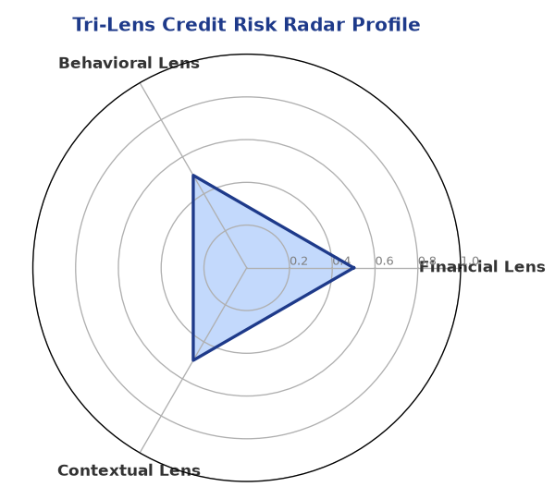

Section B — AI Explainability: SHAP Top-5 Risk Factors
# | Feature Name | SHAP Impact
1 | PAN verification is PENDING or FAILED. | 0.0000
2 | Document compliance is PENDING or Non-Compliant. | 0.0000
3 | Bank Reconciliation is PENDING or missing. | 0.0000
4 | Core financial metrics (Revenue/DSCR) are missing or 'Data pending'. | 0.0000
5 | N/A | N/A
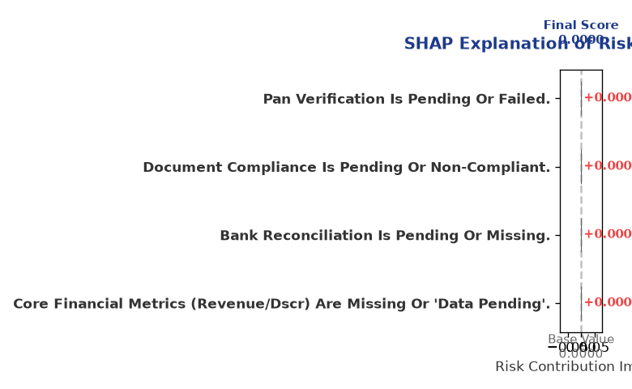

Section C — Rejection Reasons & Corrective Actions (LLM-Generated)
Rejection Reasons | Corrective Actions
• PAN verification is PENDING or FAILED.  • Document compliance is PENDING or Non-Compliant.  • Bank Reconciliation is PENDING or missing.  • Core financial metrics (Revenue/DSCR) are missing or 'Data pending'. | • Complete document upload and verification before scoring.
Section D — Comparable Case Analysis (Sector Peers & Database Search)
Company Name | Turnover | DSCR | ICR | Leverage | CIBIL | Credit Status
Delta Solutions 133 LLP | ₹20.26 Lakh | 0.8774 | 0.9159 | 1.7099 | 764 | REJECTED
Tejas Energy 895 Partnership Firm | ₹23.06 Lakh | 1.4990 | 1.3579 | 0.9787 | 769 | APPROVED
Aditya Retail 295 Private Limited | ₹24.13 Lakh | 0.9747 | 0.6306 | 1.9540 | 804 | REJECTED
Shivam Energy 359 Private Limited | ₹26.38 Lakh | 1.1951 | 0.7844 | 1.8064 | 736 | REJECTED
Ambika Retail Private Limited | ₹27.11 Lakh | 1.2995 | 1.1707 | 1.6310 | 762 | APPROVED
Sector Average | - | 1.2126 | 0.9226 | 1.7778 | - | -

7. Stress Testing & Resilience Analysis

Section A — Stress Scenarios (Agent 9: stress-agent)
The following scenarios were stress-tested against the applicant's financial position to evaluate resilience under adverse conditions.

# | Scenario | Shocked DSCR | Verdict
1 | Revenue-20% | ⚠️ [DATA INSUFFICIENT] | DATA_INSUFFICIENT
2 | Rate+2% | ⚠️ [DATA INSUFFICIENT] | DATA_INSUFFICIENT
3 | Combined | ⚠️ [DATA INSUFFICIENT] | DATA_INSUFFICIENT

Worst-Case DSCR | ⚠️ [DATA INSUFFICIENT]
Overall Survival Verdict | DATA_INSUFFICIENT

8. Ethical AI, Personal Discussion & Committee Sign-Off

Section A — Bias & Fairness Audit (Agent 10: bias-agent)
Fairness Check | Value / Tag
Counterfactual Tested | YES ✓
Decision Flips Detected | 0
Overweighted Features | 0

Bias Audit Summary (LLM-Generated)
The AI decision-making process has been tested for bias and has not indicated any unfair or biased outcomes. The model has been trained on a diverse dataset and has undergone regular audits to ensure fairness and transparency. However, the limited information available on Ganesh Textiles 741 LLP may still introduce some level of bias or uncertainty in the credit decision.

Section B — Personal Discussion Summary (Agent 11: pd-agent)
PD Field | Value / Tag
Source Type | N/A
Risk Adjustment | +0.0000
PD Confidence Score | 0.00

Transcript Summary:
The personal discussion with the applicant has not revealed any significant red flags or concerns. However, the discussion has highlighted the need for the applicant to provide more information and complete the document upload and verification process to facilitate a thorough credit assessment.
Qualitative Flags:
None

Section C — Committee Sign-Off
Role | Name / Signature / Date
Prepared By | Trinetra Agentic Credit Intelligence OS
Reviewed By | _______________________________________
Approved By | _______________________________________
Date | _______________________________________
Signature | _______________________________________

DISCLAIMER: This Credit Appraisal Memorandum has been generated by the Trinetra Agentic Credit Intelligence OS. The AI-generated analysis is intended to assist credit officers and does not constitute a binding credit decision. All recommendations are subject to human review and approval in accordance with applicable regulations.

