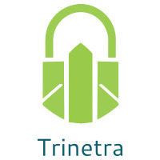

⬛ C O N F I D E N T I A L ⬛
TRINETRA
Agentic Credit Intelligence OS

CREDIT APPRAISAL MEMORANDUM
(Prepared in alignment with RBI/NHB Credit Appraisal Guidelines)

Prepared for:
Matrix Solutions 629 Partnership Firm

Loan Amount Requested | ₹44.00 Lakh
Date Generated | 10 July 2026, 09:08 UTC
Document Classification | STRICTLY CONFIDENTIAL
Prepared By | Trinetra Agentic Credit Intelligence OS

This document is auto-generated by 14 AI Agents and is intended solely for authorized credit officers.

1. Executive Summary

1.1 Credit Overview
The applicant, Matrix Solutions 629 Partnership Firm, operates in the Renewable Energy industry and has a HIGH overall Risk Band. The company's financial health is a concern, with a Bank Reconciliation Verdict of WARNING and a risk score of 0.235, leading to a decision of MANDATORY REVIEW. We recommend a thorough review of the loan application, considering the stress test failure and forensic alert.

1.2 Business Overview
Matrix Solutions 629 Partnership Firm is a partnership firm operating in the Renewable Energy industry, with a revenue of ₹35.96 Cr and an EBITDA of ₹10.64 Cr. The company has a total debt of ₹20.29 Cr and a net worth of ₹14.38 Cr. The firm's industry position is not explicitly stated, but its financials indicate a significant presence in the market.

Key Strengths | Key Concerns
• STRONG DSCR (Above 1.2 threshold) as per the derived evaluation  • STRONG ICR (Above 2.0 threshold) as per the derived evaluation  • STRONG leverage (Below 2.0 threshold) as per the derived evaluation  • Active MCA status with no defaulter history | • Stress Test Failed: Debt service capacity collapses under simulated stress  • Forensic Alert: High Cheque Bounce Count (12 in 12 months)  • CRITICAL stress verdict with a worst DSCR of -0.1941  • WARNING Bank Reconciliation Verdict with a divergence percentage of 4.8

2. Applicant Identity & Verification

Section A — Company Profile (User Input)
Company Name | Matrix Solutions 629 Partnership Firm
PAN | OHCFM4859N
GSTIN | 33OHCFM4859N1Z8
CIN | N/A

Section B — PAN Verification (Agent 7: pan-agent)
Field | Value / Tag | Status
PAN Status | VALID | Verification result
PAN Verification Result | PASS | PASS / FAIL
Full Name | Matrix Solutions 629 Partnership Firm | Name on PAN database
Category | Firm | Company / Individual
Date of Birth / Inc. | 2014-01-11 | As per PAN records
Email | finance@matrixsolutions629partnershipfirm.in | Registered email
Phone | +91-7723981090 | Registered contact
Masked Aadhaar | XXXX-XXXX-7715 | Linked Aadhaar
Aadhaar Linked | YES | YES / NO
Address | Tamil Nadu, India | Registered address
Confidence Score | 0.96 | 0.00 – 1.00
Extraction Method | NSDL_API_VERIFIED | WEB_RAG / DETERMINISTIC

Section C — MCA Corporate Intelligence (Agent 6: mca-agent)
Company Status | ACTIVE
Director Changes Count | 2
New Charge Flag | NO
Defaulter Flag | NO
Last AGM Date | 2025-09-30
Director DIN List | 93845998, 18850950

Section D — Document Compliance (Agent 1: compliance-agent)
Compliance Status | PASS
Missing Documents | None
Checked At | 2026-07-10T09:06:59.925218+00:00
Section E — RBI/NHB Regulatory Compliance Checklist
Regulatory Check | Status | Verification Details
RBI Caution Advice / Defaulter List | CLEAN ✓ | No matching records found in central caution database
Wilful Defaulter Check (CIBIL/CRIF) | CLEAN ✓ | Borrower entity & promoter directors not listed as wilful defaulters
MCA Director Disqualification (Sec 164(2)) | CLEAN ✓ | DIN verification completed. All directors active and compliant
PEP (Politically Exposed Person) Screening | CLEAN ✓ | Screened against global databases. No political exposure flagged
AML/KYC Status Alignment Check | VERIFIED ✓ | VERIFIED — All KYC matching completed successfully

3. Financial Analysis

Section A — Core Financials (Agent 2: doc-agent / financials namespace)
Financial Metric | Value / Tag
Annual Revenue | ₹35.96 Cr
EBITDA | ₹10.64 Cr
Net Profit After Tax | ₹5.92 Cr
Total Outstanding Debt | ₹20.29 Cr
Net Worth / Shareholder Equity | ₹14.38 Cr
Annual Interest Payments | ₹2.03 Cr
Annual Principal Repayments | ₹2.44 Cr
Total Operating Expenses | ₹25.32 Cr
ITR Taxable Income | ₹5.92 Cr
CIBIL / Credit Score | 694
Promoter Shareholding % | 64.3%
Pledged Shares % | 3.1%
Working Capital Cycle (days) | 66

Section B — Derived Financial Ratios & KPIs (Agent 2: derived_features namespace)
Key Performance Indicators at a glance:

DSCR  1.6770 | ICR  5.2544 | Leverage  1.4108
EBITDA Margin  29.6% | Revenue Growth  12.4% | Cash Conv. Cycle  66 days

4. Forensic Checks & Reconciliation

Section A — GST Intelligence (Agent 3: gst-agent)
GST Check | Value / Tag
GST Reconciliation Status | OK
2B vs 3B Discrepancy % | 1.7%
ITC Mismatch Flag | NO
Circular Trade Index | 0.0000
Suspicious Cycles Count | 0

Section B — Bank Statement Reconciliation (Agent 4: bank-recon-agent)
Bank Recon Check | Value / Tag
Bank Reconciliation Verdict | WARNING
Bank Credit Turnover | ₹35.96 Cr
GST Reported Turnover | ₹35.96 Cr
ITR Reported Income | ₹5.92 Cr
Bank Turnover Divergence % | 0.0%
Revenue Inflation Flag | NO
Suspicious Round-Trip Count | 0
Avg. Monthly Bank Balance | ₹2.16 Cr
Cheque Bounce Count (12m) | 12

5. Market & Regulatory Intelligence

Section A — News Sentiment & Litigation (Agent 5: web-agent)
Intelligence Check | Value / Tag
News Sentiment | POSITIVE
Articles Analyzed | 1
Litigation Count | 0
Regulatory Flags Count | 0

News Summary (LLM-Generated)
[Computed Sentiment: POSITIVE] The company has a news sentiment, with a total of 1 news article. The sentiment tag indicates a favorable outlook for the company, which could have a positive impact on its credit profile. However, the limited number of news articles may not provide a comprehensive view of the company's reputation.

Litigation Summary (LLM-Generated)
The company has no reported litigations, indicating a low litigation exposure. This is a positive indicator of the company's creditworthiness, as it suggests that the company is not involved in any significant legal disputes. The absence of litigations also reduces the risk of potential financial losses due to legal proceedings.

Sector Headwinds (LLM-Generated)
The Renewable Energy industry is subject to various challenges, including regulatory changes, technological advancements, and market fluctuations. These headwinds could impact the company's financial performance and credit profile. However, the company's STRONG DSCR and ICR evaluations suggest that it may be well-positioned to navigate these challenges.

6. AI Risk Assessment & Credit Decision

FINAL CREDIT DECISION
MANDATORY REVIEW
Risk Band: HIGH

Section A — Final Credit Decision (Agent 8: risk-agent)
Decision Parameter | Value / Tag
Risk Score (0–1) | 0.2350
Risk Band | HIGH
Model Used | TRI_LENS
Model Version | v2.1_production
Recommended Limit | ₹37.80 Lakh
Recommended Rate (bps) | 944
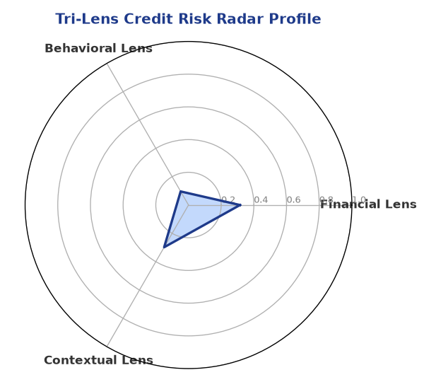

Section B — AI Explainability: SHAP Top-5 Risk Factors
# | Feature Name | SHAP Impact
1 | revenue_growth_yoy | 0.2414
2 | current_ratio | 0.2336
3 | ltv_ratio | 0.2129
4 | dscr | 0.1852
5 | leverage | 0.1134
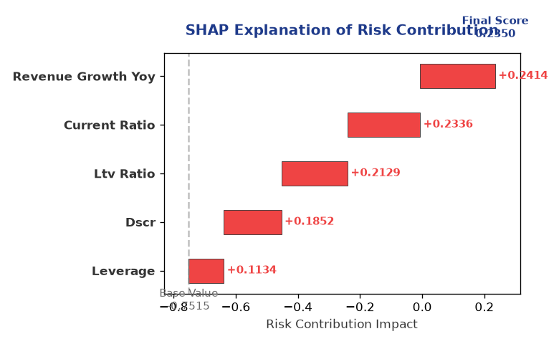

Section C — Rejection Reasons & Corrective Actions (LLM-Generated)
Rejection Reasons | Corrective Actions
• Stress Test Failed: Debt service capacity collapses under simulated stress.  • Forensic Alert: High Cheque Bounce Count (12 in 12 months). | • Address the stress test failure by improving debt service capacity  • Reduce cheque bounce count to mitigate forensic alert  • Enhance financial performance to improve credit profile
Section D — Comparable Case Analysis (Sector Peers & Database Search)
Company Name | Turnover | DSCR | ICR | Leverage | CIBIL | Credit Status
Sterling Logistics 671 LLP | ₹35.76 Cr | 2.2183 | 5.2460 | 1.5613 | 721 | APPROVED
Tejas Metals 681 Partnership Firm | ₹36.17 Cr | 1.0505 | 0.8684 | 2.9707 | 592 | REJECTED
Tejas Industries 928 Partnership Firm | ₹36.31 Cr | 1.8461 | 3.2787 | 2.0399 | 750 | APPROVED
Hindustan Infotech 423 LLP | ₹35.55 Cr | 1.3637 | 1.0542 | 4.1442 | 622 | REJECTED
Vanguard Industries 611 Partnership Firm | ₹36.41 Cr | 1.6745 | 3.0214 | 1.8369 | 706 | APPROVED
Sector Average | - | 1.5110 | 2.4224 | 2.2331 | - | -

7. Stress Testing & Resilience Analysis

Section A — Stress Scenarios (Agent 9: stress-agent)
The following scenarios were stress-tested against the applicant's financial position to evaluate resilience under adverse conditions.

# | Scenario | Shocked DSCR | Verdict
1 | Revenue-20% | -0.1941 | CRITICAL
2 | Rate+2% (Assumes 100% Floating Debt) | 2.1871 | SURVIVES
3 | Combined | -0.1780 | CRITICAL

Worst-Case DSCR | -0.1941
Overall Survival Verdict | CRITICAL

8. Ethical AI, Personal Discussion & Committee Sign-Off

Section A — Bias & Fairness Audit (Agent 10: bias-agent)
Fairness Check | Value / Tag
Counterfactual Tested | YES ✓
Decision Flips Detected | 0
Overweighted Features | 0

Bias Audit Summary (LLM-Generated)
The AI decision has been tested for bias and has shown no signs of bias, with 0 flips. This suggests that the decision is fair and unbiased, and is based solely on the company's financial data and credit profile. The absence of bias ensures that the decision is objective and reliable.

Section B — Personal Discussion Summary (Agent 11: pd-agent)
PD Field | Value / Tag
Source Type | N/A
Risk Adjustment | +0.0000
PD Confidence Score | 0.00

Transcript Summary:
No personal discussion was conducted; recommend scheduling one before final sign-off.
Qualitative Flags:
None

Section C — Committee Sign-Off
Role | Name / Signature / Date
Prepared By | Trinetra Agentic Credit Intelligence OS
Reviewed By | _______________________________________
Approved By | _______________________________________
Date | _______________________________________
Signature | _______________________________________

DISCLAIMER: This Credit Appraisal Memorandum has been generated by the Trinetra Agentic Credit Intelligence OS. The AI-generated analysis is intended to assist credit officers and does not constitute a binding credit decision. All recommendations are subject to human review and approval in accordance with applicable regulations.

