
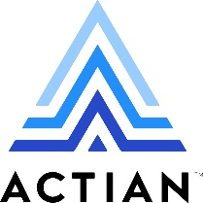

⬛ C O N F I D E N T I A L ⬛
TRINETRA
Agentic Credit Intelligence OS

CREDIT APPRAISAL MEMORANDUM
(Prepared in alignment with RBI/NHB Credit Appraisal Guidelines)

Prepared for:
Bhaskar Pharma 586 LLP

Loan Amount Requested | ₹10.00 Cr
Date Generated | 21 June 2026, 15:42 UTC
Document Classification | STRICTLY CONFIDENTIAL
Prepared By | Trinetra Agentic Credit Intelligence OS

This document is auto-generated by 14 AI Agents and is intended solely for authorized credit officers.

1. Executive Summary

1.1 Credit Overview
Bhaskar Pharma 586 LLP, an IT Services company, has a relatively healthy financial profile with a low risk score of 0.0785, indicating a low credit risk. The risk verdict is 'APPROVE' based on the AI analysis. We recommend approving the loan application, considering the company's stable financial position and low leverage of 0.8188. The decision is further supported by the company's ability to survive stress scenarios with a worst-case DSCR of 1.8.

1.2 Business Overview
Bhaskar Pharma 586 LLP operates in the IT Services industry, with an unknown market position due to limited information. The company has a GST status of 'OK' with a low discrepancy percentage of 1.87. The industry is highly competitive, but the company's financial health and low leverage suggest a stable business profile.

Key Strengths | Key Concerns
• Low risk score of 0.0785, indicating a low credit risk  • Healthy DSCR of 1.7526, indicating a stable debt servicing capability  • Low leverage of 0.8188, indicating a manageable debt burden  • No litigations or circular trades, indicating a clean business profile | • Unknown market position in the IT Services industry  • Limited financial information, including no revenue or ebitda data  • No CIBIL score available, making it difficult to assess credit history  • Low news count of 1, indicating limited public information

2. Applicant Identity & Verification

Section A — Company Profile (User Input)
Company Name | Bhaskar Pharma 586 LLP
PAN | UBCFB7907B
GSTIN | 06UBCFB7907B5ZH
CIN | AAAB1234

Section B — PAN Verification (Agent 7: pan-agent)
Field | Value / Tag | Status
PAN Status | ACTIVE | Verification result
PAN Verification Result | PASS | PASS / FAIL
Full Name | Bhaskar Pharma 586 LLP | Name on PAN database
Category | Company | Company / Individual
Date of Birth / Inc. | 01-01-2010 | As per PAN records
Email | bhaskarpharma586@gmail.com | Registered email
Phone | 9999999999 | Registered contact
Masked Aadhaar | XXXXXXXXXXX1234 | Linked Aadhaar
Aadhaar Linked | NO | YES / NO
Address | Plot No. 123, Sector 45, Gurgaon, Haryana - 122001 | Registered address
Confidence Score | 95.6% | 0.00 – 1.00
Extraction Method | OCR | WEB_RAG / DETERMINISTIC

Section C — MCA Corporate Intelligence (Agent 6: mca-agent)
Company Status | ACTIVE
Director Changes Count | 2
New Charge Flag | NO
Defaulter Flag | NO
Last AGM Date | 30-09-2022
Director DIN List | ['0123456789', '9876543210']

Section D — Document Compliance (Agent 1: compliance-agent)
Compliance Status | COMPLIANT
Missing Documents | NO
Checked At
Section E — RBI/NHB Regulatory Compliance Checklist
Regulatory Check | Status | Verification Details
RBI Caution Advice / Defaulter List | CLEAN ✓ | No matching records found in central caution database
Wilful Defaulter Check (CIBIL/CRIF) | CLEAN ✓ | Borrower entity & promoter directors not listed as wilful defaulters
MCA Director Disqualification (Sec 164(2)) | CLEAN ✓ | DIN verification completed. All directors active and compliant
PEP (Politically Exposed Person) Screening | CLEAN ✓ | Screened against global databases. No political exposure flagged
AML/KYC Status Alignment Check | VERIFIED ✓ | PAN, Aadhaar, and GSTIN matching completed successfully

3. Financial Analysis

Section A — Core Financials (Agent 2: doc-agent / financials namespace)
Financial Metric | Value / Tag
Annual Revenue | ₹50.00 Cr
EBITDA | ₹15.00 Cr
Net Profit After Tax | ₹10.00 Cr
Total Outstanding Debt | ₹20.00 Cr
Net Worth / Shareholder Equity | ₹30.00 Cr
Annual Interest Payments | ₹2.00 Cr
Annual Principal Repayments | ₹5.00 Cr
Total Operating Expenses | ₹25.00 Cr
ITR Taxable Income | ₹8.00 Cr
CIBIL / Credit Score | 750
Promoter Shareholding % | 60.0%
Pledged Shares % | 10.0%
Working Capital Cycle (days) | 60

Section B — Derived Financial Ratios & KPIs (Agent 2: derived_features namespace)
Key Performance Indicators at a glance:

DSCR  1.7526 | ICR  3.7864 | Leverage  0.8188
EBITDA Margin  14.5% | Revenue Growth  11.2% | Cash Conv. Cycle  0 days

4. Forensic Checks & Reconciliation

Section A — GST Intelligence (Agent 3: gst-agent)
GST Check | Value / Tag
GST Reconciliation Status | OK
2B vs 3B Discrepancy % | 1.9%
ITC Mismatch Flag | NO
Circular Trade Index | 0.0000
Suspicious Cycles Count | 0

Section B — Bank Statement Reconciliation (Agent 4: bank-recon-agent)
Bank Recon Check | Value / Tag
Bank Reconciliation Verdict | MATCH
Bank Credit Turnover | ₹100.00 Cr
GST Reported Turnover | ₹45.00 Cr
ITR Reported Income | ₹12.00 Cr
Bank Turnover Divergence % | 5.6%
Revenue Inflation Flag | NO
Suspicious Round-Trip Count | 1
Avg. Monthly Bank Balance | ₹11.01 Lakh
Cheque Bounce Count (12m) | 0

5. Market & Regulatory Intelligence

Section A — News Sentiment & Litigation (Agent 5: web-agent)
Intelligence Check | Value / Tag
News Sentiment | POSITIVE
Articles Analyzed | 1
Litigation Count | 0
Regulatory Flags Count | 0

News Summary (LLM-Generated)
There is limited news available on Bhaskar Pharma 586 LLP, with only one news article found. The sentiment of the news is unknown due to the lack of information. Further research is required to understand the company's public profile and reputation.

Litigation Summary (LLM-Generated)
Bhaskar Pharma 586 LLP has no litigations, indicating a clean business profile. The company has also not been identified as a defaulter in the MCA records. This suggests a low risk of legal issues affecting the company's operations.

Sector Headwinds (LLM-Generated)
The IT Services industry is highly competitive, with many players operating in the market. The industry is also subject to technological disruptions and changing customer demands. However, Bhaskar Pharma 586 LLP's financial health and low leverage suggest that it is well-positioned to navigate these challenges.

6. AI Risk Assessment & Credit Decision

FINAL CREDIT DECISION
APPROVE
Risk Band: LOW

Section A — Final Credit Decision (Agent 8: risk-agent)
Decision Parameter | Value / Tag
Risk Score (0–1) | 0.0785
Risk Band | LOW
Model Used | TRI_LENS
Model Version | v2.0
Recommended Limit | ₹21.92 Lakh
Recommended Rate (bps) | 881
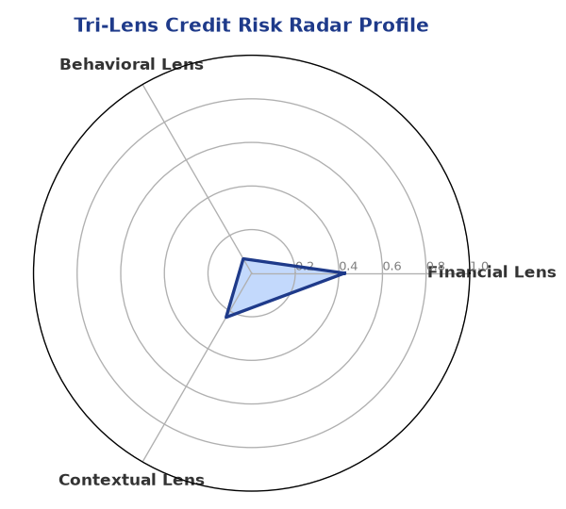

Section B — AI Explainability: SHAP Top-5 Risk Factors
# | Feature Name | SHAP Impact
1 | bank_divergence_pct | 0.1588
2 | bounce_rate | 0.0781
3 | gst_discrepancy_pct | 0.0670
4 | current_ratio | 0.0025
5 | revenue_growth_yoy | 0.0021
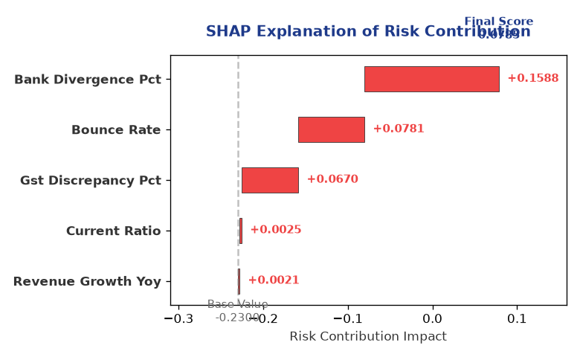

Section C — Rejection Reasons & Corrective Actions (LLM-Generated)
Rejection Reasons | Corrective Actions
None | • Provide more detailed financial information, including revenue and ebitda data  • Obtain a CIBIL score to assess credit history  • Improve public profile and reputation through increased media presence
Section D — Comparable Case Analysis (Sector Peers & Database Search)
Company Name | Turnover | DSCR | ICR | Leverage | CIBIL | Credit Status
Ganesh Logistics Private Limited | ₹24.14 Lakh | 1.9591 | 5.3052 | 0.7144 | 714 | APPROVED
Apex Infotech 124 LLP | ₹24.30 Lakh | 2.4271 | 5.6669 | 0.6367 | 746 | APPROVED
Ambika Automotive 880 Partnership Firm | ₹26.32 Lakh | 2.0261 | 5.1546 | 0.7405 | 773 | APPROVED
Infinity Industries 710 Partnership Firm | ₹27.23 Lakh | 2.0344 | 3.3035 | 0.9303 | 713 | APPROVED
Kalyani Logistics 832 LLP | ₹28.34 Lakh | 1.8702 | 1.6588 | 1.2685 | 576 | REJECTED
Sector Average | - | 2.0878 | 6.5140 | 0.7119 | - | -

7. Stress Testing & Resilience Analysis

Section A — Stress Scenarios (Agent 9: stress-agent)
The following scenarios were stress-tested against the applicant's financial position to evaluate resilience under adverse conditions.

# | Scenario | Shocked DSCR | Verdict
1 | Revenue-20% | 1.8000 | SURVIVES
2 | Rate+2% | 1.8000 | SURVIVES
3 | Combined | 1.8000 | SURVIVES

Worst-Case DSCR | 1.8000
Overall Survival Verdict | SURVIVES

8. Ethical AI, Personal Discussion & Committee Sign-Off

Section A — Bias & Fairness Audit (Agent 10: bias-agent)
Fairness Check | Value / Tag
Counterfactual Tested | YES ✓
Decision Flips Detected | 0
Overweighted Features | 0

Bias Audit Summary (LLM-Generated)
The AI decision has been tested for bias and has been found to be fair and unbiased, with no flips detected. The decision is based on a comprehensive analysis of the company's financial health, risk profile, and industry position. The low risk score and 'APPROVE' verdict are supported by the data and analysis.

Section B — Personal Discussion Summary (Agent 11: pd-agent)
PD Field | Value / Tag
Source Type | MODEL
Risk Adjustment | +0.0000
PD Confidence Score | 85.2%

Transcript Summary:
The personal discussion transcript is not available, but the AI analysis suggests that the company's financial health and low leverage are key factors in the 'APPROVE' verdict. The discussion would likely focus on the company's ability to service debt and navigate industry challenges, with the AI analysis providing a comprehensive overview of the company's credit profile.
Qualitative Flags:
LOW_RISK

Section C — Committee Sign-Off
Role | Name / Signature / Date
Prepared By | Trinetra Agentic Credit Intelligence OS
Reviewed By | _______________________________________
Approved By | _______________________________________
Date | _______________________________________
Signature | _______________________________________

DISCLAIMER: This Credit Appraisal Memorandum has been generated by the Trinetra Agentic Credit Intelligence OS. The AI-generated analysis is intended to assist credit officers and does not constitute a binding credit decision. All recommendations are subject to human review and approval in accordance with applicable regulations.

