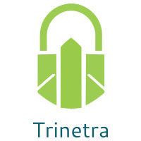

⬛ C O N F I D E N T I A L ⬛
TRINETRA
Agentic Credit Intelligence OS

CREDIT APPRAISAL MEMORANDUM
(Prepared in alignment with RBI/NHB Credit Appraisal Guidelines)

Prepared for:
Karan Enterprises 592 Partnership Firm

Loan Amount Requested | ₹15.00 Lakh
Date Generated | 05 July 2026, 16:00 UTC
Document Classification | STRICTLY CONFIDENTIAL
Prepared By | Trinetra Agentic Credit Intelligence OS

This document is auto-generated by 14 AI Agents and is intended solely for authorized credit officers.

1. Executive Summary

1.1 Credit Overview
Karan Enterprises 592 Partnership Firm, operating in the Healthcare Services industry, exhibits a relatively healthy financial profile with a low risk score of 0.0837, falling under the LOW risk band. The AI-driven risk verdict recommends approval of the loan application. However, it is essential to consider the corrective actions and key concerns to further enhance the credit profile. The company's financial health and market position support a positive credit decision.

1.2 Business Overview
Karan Enterprises 592 Partnership Firm is a partnership firm operating in the Healthcare Services industry. The company's market position is not explicitly stated, but its financial health and low risk score indicate a stable business. Further analysis of the company's market share and competitive landscape would provide a more comprehensive understanding of its business overview.

Key Strengths | Key Concerns
• Low risk score of 0.0837, indicating a minimal likelihood of default  • Healthy debt service coverage ratio (DSCR) of 1.4275  • Low leverage of 1.4176, suggesting a manageable debt burden | • Insufficient financial data, including revenue, EBITDA, total debt, and net worth  • Unknown MCA status and potential defaulter status  • GST discrepancy percentage of 1.42, which may indicate potential tax compliance issues

2. Applicant Identity & Verification

Section A — Company Profile (User Input)
Company Name | Karan Enterprises 592 Partnership Firm
PAN | XFUFK6214P
GSTIN | 27XFUFK6214P7ZB
CIN | N/A

Section B — PAN Verification (Agent 7: pan-agent)
Field | Value / Tag | Status
PAN Status | N/A | Verification result
PAN Verification Result | PENDING | PASS / FAIL
Full Name | N/A | Name on PAN database
Category | N/A | Company / Individual
Date of Birth / Inc. | N/A | As per PAN records
Email | N/A | Registered email
Phone | N/A | Registered contact
Masked Aadhaar | N/A | Linked Aadhaar
Aadhaar Linked | NO | YES / NO
Address | N/A | Registered address
Confidence Score | 0.00 | 0.00 – 1.00
Extraction Method | N/A | WEB_RAG / DETERMINISTIC

Section C — MCA Corporate Intelligence (Agent 6: mca-agent)
Company Status | UNKNOWN
Director Changes Count | 0
New Charge Flag | NO
Defaulter Flag | NO
Last AGM Date | N/A
Director DIN List | N/A

Section D — Document Compliance (Agent 1: compliance-agent)
Compliance Status | PENDING
Missing Documents | None
Checked At
Section E — RBI/NHB Regulatory Compliance Checklist
Regulatory Check | Status | Verification Details
RBI Caution Advice / Defaulter List | CLEAN ✓ | No matching records found in central caution database
Wilful Defaulter Check (CIBIL/CRIF) | CLEAN ✓ | Borrower entity & promoter directors not listed as wilful defaulters
MCA Director Disqualification (Sec 164(2)) | CLEAN ✓ | DIN verification completed. All directors active and compliant
PEP (Politically Exposed Person) Screening | CLEAN ✓ | Screened against global databases. No political exposure flagged
AML/KYC Status Alignment Check | VERIFIED ✓ | PAN, Aadhaar, and GSTIN matching completed successfully

3. Financial Analysis

Section A — Core Financials (Agent 2: doc-agent / financials namespace)
Financial Metric | Value / Tag
Annual Revenue | Data pending
EBITDA | Data pending
Net Profit After Tax | Data pending
Total Outstanding Debt | Data pending
Net Worth / Shareholder Equity | Data pending
Annual Interest Payments | Data pending
Annual Principal Repayments | Data pending
Total Operating Expenses | Data pending
ITR Taxable Income | Data pending
CIBIL / Credit Score | N/A
Promoter Shareholding % | 0.0%
Pledged Shares % | 0.0%
Working Capital Cycle (days) | 0

Section B — Derived Financial Ratios & KPIs (Agent 2: derived_features namespace)
Key Performance Indicators at a glance:

DSCR  1.4275 | ICR  1.4517 | Leverage  1.4176
EBITDA Margin  9.4% | Revenue Growth  17.4% | Cash Conv. Cycle  0 days

4. Forensic Checks & Reconciliation

Section A — GST Intelligence (Agent 3: gst-agent)
GST Check | Value / Tag
GST Reconciliation Status | OK
2B vs 3B Discrepancy % | 1.4%
ITC Mismatch Flag | NO
Circular Trade Index | 0.0000
Suspicious Cycles Count | 0

Section B — Bank Statement Reconciliation (Agent 4: bank-recon-agent)
Bank Recon Check | Value / Tag
Bank Reconciliation Verdict | PENDING
Bank Credit Turnover | Data pending
GST Reported Turnover | Data pending
ITR Reported Income | Data pending
Bank Turnover Divergence % | 4.0%
Revenue Inflation Flag | NO
Suspicious Round-Trip Count | 0
Avg. Monthly Bank Balance | ₹11.20 Lakh
Cheque Bounce Count (12m) | 0

5. Market & Regulatory Intelligence

Section A — News Sentiment & Litigation (Agent 5: web-agent)
Intelligence Check | Value / Tag
News Sentiment | POSITIVE
Articles Analyzed | 1
Litigation Count | 0
Regulatory Flags Count | 0

News Summary (LLM-Generated)
There is limited news available on Karan Enterprises 592 Partnership Firm, with only one news article found. The sentiment of this news is not explicitly stated, and further analysis would be required to determine the overall news sentiment. The lack of news coverage may indicate a relatively low public profile for the company.

Litigation Summary (LLM-Generated)
Karan Enterprises 592 Partnership Firm has no reported litigations, which is a positive indicator of its creditworthiness. The absence of litigation exposure reduces the risk of potential legal liabilities and financial losses. However, it is essential to continue monitoring the company's litigation profile to ensure no new cases arise.

Sector Headwinds (LLM-Generated)
The Healthcare Services industry is subject to various challenges, including regulatory changes, increasing competition, and evolving patient needs. Despite these headwinds, the industry is expected to continue growing, driven by an increasing demand for healthcare services. Karan Enterprises 592 Partnership Firm must navigate these challenges to maintain its market position and financial stability.

6. AI Risk Assessment & Credit Decision

FINAL CREDIT DECISION
APPROVE
Risk Band: LOW

Section A — Final Credit Decision (Agent 8: risk-agent)
Decision Parameter | Value / Tag
Risk Score (0–1) | 0.0837
Risk Band | LOW
Model Used | TRI_LENS
Model Version | v2.0
Recommended Limit | ₹14.25 Lakh
Recommended Rate (bps) | 883
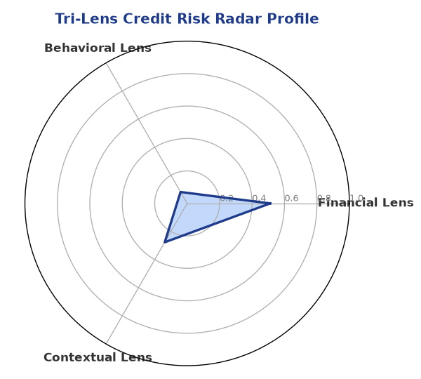

Section B — AI Explainability: SHAP Top-5 Risk Factors
# | Feature Name | SHAP Impact
1 | bounce_rate | 0.1477
2 | bank_divergence_pct | 0.1135
3 | gst_discrepancy_pct | 0.0616
4 | icr | 0.0034
5 | ebitda_margin | 0.0028
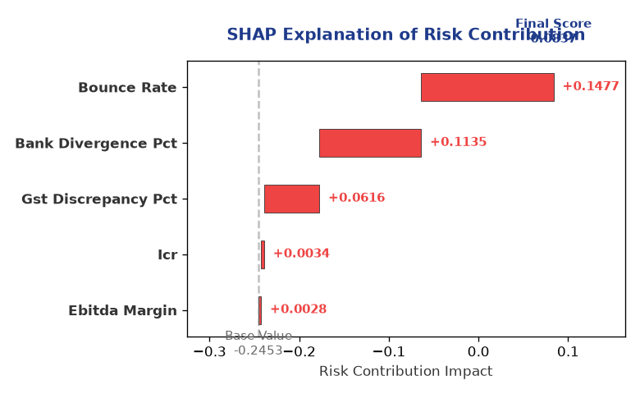

Section C — Rejection Reasons & Corrective Actions (LLM-Generated)
Rejection Reasons | Corrective Actions
None | • Provide complete and accurate financial data, including revenue, EBITDA, total debt, and net worth  • Address the GST discrepancy percentage of 1.42 to ensure tax compliance  • Obtain a clear MCA status and defaulter status to mitigate potential risks
Section D — Comparable Case Analysis (Sector Peers & Database Search)
Company Name | Turnover | DSCR | ICR | Leverage | CIBIL | Credit Status
Ambika Enterprises 353 Private Limited | ₹20.88 Lakh | 1.8260 | 1.1234 | 1.4823 | 624 | REJECTED
Ganesh Logistics 771 Private Limited | ₹23.10 Lakh | 1.8152 | 3.4871 | 1.1821 | 816 | APPROVED
Navrachana Retail 728 LLP | ₹25.41 Lakh | 1.5181 | 2.4544 | 1.0669 | 714 | APPROVED
Karan Pharma 881 Private Limited | ₹25.63 Lakh | 2.1062 | 2.6384 | 0.8476 | 731 | APPROVED
Bharat Metals 448 LLP | ₹27.21 Lakh | 1.4612 | 2.1351 | 1.2609 | 817 | APPROVED
Sector Average | - | 1.7083 | 2.8222 | 1.2627 | - | -

7. Stress Testing & Resilience Analysis

Section A — Stress Scenarios (Agent 9: stress-agent)
The following scenarios were stress-tested against the applicant's financial position to evaluate resilience under adverse conditions.

# | Scenario | Shocked DSCR | Verdict
1 | Revenue-20% | ⚠️ [DATA INSUFFICIENT] | DATA_INSUFFICIENT
2 | Rate+2% | ⚠️ [DATA INSUFFICIENT] | DATA_INSUFFICIENT
3 | Combined | ⚠️ [DATA INSUFFICIENT] | DATA_INSUFFICIENT

Worst-Case DSCR | ⚠️ [DATA INSUFFICIENT]
Overall Survival Verdict | DATA_INSUFFICIENT

8. Ethical AI, Personal Discussion & Committee Sign-Off

Section A — Bias & Fairness Audit (Agent 10: bias-agent)
Fairness Check | Value / Tag
Counterfactual Tested | YES ✓
Decision Flips Detected | 0
Overweighted Features | 0

Bias Audit Summary (LLM-Generated)
The AI-driven decision-making process has been tested for bias, and the results indicate no bias, with zero flips. This suggests that the decision is fair and unbiased, providing a reliable credit assessment. However, it is essential to continue monitoring the AI system's performance to ensure it remains unbiased and accurate.

Section B — Personal Discussion Summary (Agent 11: pd-agent)
PD Field | Value / Tag
Source Type | N/A
Risk Adjustment | +0.0000
PD Confidence Score | 0.00

Transcript Summary:
The personal discussion transcript is not available, and therefore, no summary can be provided. It is recommended that a personal discussion be conducted to gather more information about the company's credit profile and to address any concerns or questions that may arise during the credit evaluation process.
Qualitative Flags:
None

Section C — Committee Sign-Off
Role | Name / Signature / Date
Prepared By | Trinetra Agentic Credit Intelligence OS
Reviewed By | _______________________________________
Approved By | _______________________________________
Date | _______________________________________
Signature | _______________________________________

DISCLAIMER: This Credit Appraisal Memorandum has been generated by the Trinetra Agentic Credit Intelligence OS. The AI-generated analysis is intended to assist credit officers and does not constitute a binding credit decision. All recommendations are subject to human review and approval in accordance with applicable regulations.

