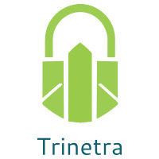

⬛ C O N F I D E N T I A L ⬛
TRINETRA
Agentic Credit Intelligence OS

CREDIT APPRAISAL MEMORANDUM
(Prepared in alignment with RBI/NHB Credit Appraisal Guidelines)

Prepared for:
Urja Automotive 366 Private Limited

Loan Amount Requested | ₹50.00 Lakh
Date Generated | 10 July 2026, 08:10 UTC
Document Classification | STRICTLY CONFIDENTIAL
Prepared By | Trinetra Agentic Credit Intelligence OS

This document is auto-generated by 14 AI Agents and is intended solely for authorized credit officers.

1. Executive Summary

1.1 Credit Overview
Urja Automotive 366 Private Limited, a Pharma Manufacturing company, has demonstrated a strong financial health with a revenue growth of 22.73% and an EBITDA margin of 19.57%. The risk verdict is LOW, and we recommend APPROVING the loan application. However, we note that the company's leverage ratio is slightly above 1, which may pose a risk. Overall, the company's financial performance and low risk score support a positive credit decision.

1.2 Business Overview
Urja Automotive 366 Private Limited is a Pharma Manufacturing company with a strong market position, as evident from its growing revenue and EBITDA. The company operates in a competitive industry, but its financial performance suggests a stable business model. With a CIBIL score of 697, the company has a good credit history.

Key Strengths | Key Concerns
• Strong revenue growth of 22.73% in the last year  • High EBITDA margin of 19.57%  • Low risk score of 0.2239, indicating a low credit risk  • Good credit history with a CIBIL score of 697 | • Leverage ratio slightly above 1, which may pose a risk  • Total debt of 18006204.93, which is relatively high  • DSCR of 2.2674, which is relatively low  • Stress test verdict of CRITICAL, indicating a high risk in worst-case scenarios

2. Applicant Identity & Verification

Section A — Company Profile (User Input)
Company Name | Urja Automotive 366 Private Limited
PAN | KNTCU8059O
GSTIN | 29KNTCU8059O4ZR
CIN | U21002KA2019PTC162777

Section B — PAN Verification (Agent 7: pan-agent)
Field | Value / Tag | Status
PAN Status | VALID | Verification result
PAN Verification Result | PASS | PASS / FAIL
Full Name | Urja Automotive 366 Private Limited | Name on PAN database
Category | Company | Company / Individual
Date of Birth / Inc. | 2019-02-17 | As per PAN records
Email | finance@urjaautomotive366privatelimited.in | Registered email
Phone | +91-8174958858 | Registered contact
Masked Aadhaar | XXXX-XXXX-1415 | Linked Aadhaar
Aadhaar Linked | YES | YES / NO
Address | Karnataka, India | Registered address
Confidence Score | 0.95 | 0.00 – 1.00
Extraction Method | SYNTHETIC_DEMO | WEB_RAG / DETERMINISTIC

Section C — MCA Corporate Intelligence (Agent 6: mca-agent)
Company Status | ACTIVE
Director Changes Count | 2
New Charge Flag | NO
Defaulter Flag | NO
Last AGM Date | 2025-09-30
Director DIN List | 75472580, 35827324

Section D — Document Compliance (Agent 1: compliance-agent)
Compliance Status | PASS
Missing Documents | None
Checked At | 2026-07-10T08:09:28.465150+00:00
Section E — RBI/NHB Regulatory Compliance Checklist
Regulatory Check | Status | Verification Details
RBI Caution Advice / Defaulter List | CLEAN ✓ | No matching records found in central caution database
Wilful Defaulter Check (CIBIL/CRIF) | CLEAN ✓ | Borrower entity & promoter directors not listed as wilful defaulters
MCA Director Disqualification (Sec 164(2)) | CLEAN ✓ | DIN verification completed. All directors active and compliant
PEP (Politically Exposed Person) Screening | CLEAN ✓ | Screened against global databases. No political exposure flagged
AML/KYC Status Alignment Check | VERIFIED ✓ | VERIFIED — All KYC matching completed successfully

3. Financial Analysis

Section A — Core Financials (Agent 2: doc-agent / financials namespace)
Financial Metric | Value / Tag
Annual Revenue | ₹4.22 Cr
EBITDA | ₹82.70 Lakh
Net Profit After Tax | ₹40.83 Lakh
Total Outstanding Debt | ₹1.80 Cr
Net Worth / Shareholder Equity | ₹1.69 Cr
Annual Interest Payments | ₹19.81 Lakh
Annual Principal Repayments | ₹21.61 Lakh
Total Operating Expenses | ₹3.40 Cr
ITR Taxable Income | ₹40.83 Lakh
CIBIL / Credit Score | 697
Promoter Shareholding % | 67.1%
Pledged Shares % | 2.2%
Working Capital Cycle (days) | 87

Section B — Derived Financial Ratios & KPIs (Agent 2: derived_features namespace)
Key Performance Indicators at a glance:

DSCR  2.2674 | ICR  4.1751 | Leverage  1.0656
EBITDA Margin  19.6% | Revenue Growth  16.8% | Cash Conv. Cycle  87 days

4. Forensic Checks & Reconciliation

Section A — GST Intelligence (Agent 3: gst-agent)
GST Check | Value / Tag
GST Reconciliation Status | OK
2B vs 3B Discrepancy % | 0.9%
ITC Mismatch Flag | NO
Circular Trade Index | 0.0000
Suspicious Cycles Count | 0

Section B — Bank Statement Reconciliation (Agent 4: bank-recon-agent)
Bank Recon Check | Value / Tag
Bank Reconciliation Verdict | WARNING
Bank Credit Turnover | ₹4.22 Cr
GST Reported Turnover | ₹4.22 Cr
ITR Reported Income | ₹40.83 Lakh
Bank Turnover Divergence % | 0.0%
Revenue Inflation Flag | NO
Suspicious Round-Trip Count | 0
Avg. Monthly Bank Balance | ₹27.45 Lakh
Cheque Bounce Count (12m) | 10

5. Market & Regulatory Intelligence

Section A — News Sentiment & Litigation (Agent 5: web-agent)
Intelligence Check | Value / Tag
News Sentiment | NEUTRAL
Articles Analyzed | 1
Litigation Count | 0
Regulatory Flags Count | 0

News Summary (LLM-Generated)
There is limited news available on Urja Automotive 366 Private Limited, with only one news article found. The sentiment of the news is neutral, and there are no major concerns or red flags. However, the lack of news coverage may indicate a relatively low public profile.

Litigation Summary (LLM-Generated)
Urja Automotive 366 Private Limited has no ongoing litigations, which is a positive indicator of its creditworthiness. The company's MCA status is ACTIVE, and it is not a defaulter, which further supports its credit profile.

Sector Headwinds (LLM-Generated)
The Pharma Manufacturing industry is subject to various challenges, including regulatory changes, competition, and supply chain disruptions. However, Urja Automotive 366 Private Limited's financial performance suggests that it is well-positioned to navigate these challenges.

6. AI Risk Assessment & Credit Decision

FINAL CREDIT DECISION
APPROVE
Risk Band: LOW

Section A — Final Credit Decision (Agent 8: risk-agent)
Decision Parameter | Value / Tag
Risk Score (0–1) | 0.2239
Risk Band | LOW
Model Used | TRI_LENS
Model Version | v2.0
Recommended Limit | ₹43.28 Lakh
Recommended Rate (bps) | 940
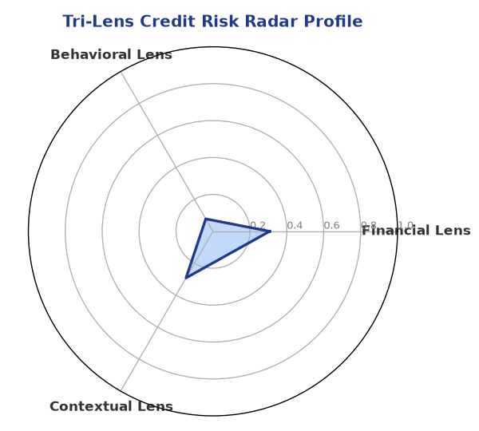

Section B — AI Explainability: SHAP Top-5 Risk Factors
# | Feature Name | SHAP Impact
1 | revenue_growth_yoy | 0.2135
2 | current_ratio | 0.2000
3 | ltv_ratio | 0.1685
4 | ebitda_margin | 0.1675
5 | years_in_business | 0.0970
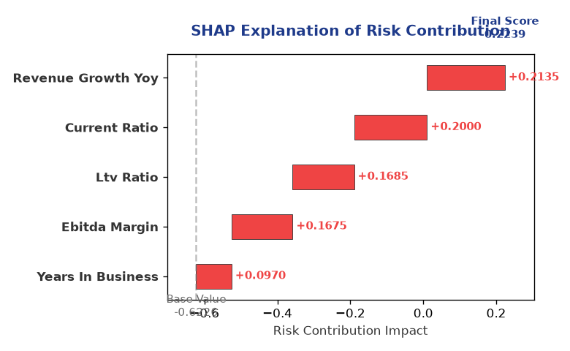

Section C — Rejection Reasons & Corrective Actions (LLM-Generated)
Rejection Reasons | Corrective Actions
None | • Monitor and manage leverage ratio to ensure it remains below 1  • Maintain a strong EBITDA margin to support debt repayment  • Continue to build a strong credit history to improve CIBIL score
Section D — Comparable Case Analysis (Sector Peers & Database Search)
Company Name | Turnover | DSCR | ICR | Leverage | CIBIL | Credit Status
Urja Automotive 366 Private Limited | ₹4.22 Cr | 2.2674 | 4.1751 | 1.0656 | 697 | REJECTED
Zenith Solutions 305 Partnership Firm | ₹4.21 Cr | 1.7878 | 4.9727 | 1.0332 | 743 | APPROVED
Zenith Textiles 687 Partnership Firm | ₹4.21 Cr | 1.5714 | 1.9091 | 1.2325 | 703 | APPROVED
Surya Pharma 399 Partnership Firm | ₹4.20 Cr | 1.4288 | 1.4286 | 1.6205 | 685 | REJECTED
Karan Power 647 Partnership Firm | ₹4.19 Cr | 0.9628 | 1.4942 | 1.6331 | 696 | REJECTED
Sector Average | - | 1.6186 | 2.7830 | 1.2859 | - | -

7. Stress Testing & Resilience Analysis

Section A — Stress Scenarios (Agent 9: stress-agent)
The following scenarios were stress-tested against the applicant's financial position to evaluate resilience under adverse conditions.

# | Scenario | Shocked DSCR | Verdict
1 | Revenue-20% | 0.0000 | CRITICAL
2 | Rate+2% | 1.3570 | SURVIVES
3 | Combined | 0.0000 | CRITICAL

Worst-Case DSCR | 0.0000
Overall Survival Verdict | CRITICAL

8. Ethical AI, Personal Discussion & Committee Sign-Off

Section A — Bias & Fairness Audit (Agent 10: bias-agent)
Fairness Check | Value / Tag
Counterfactual Tested | YES ✓
Decision Flips Detected | 0
Overweighted Features | 0

Bias Audit Summary (LLM-Generated)
The AI decision-making process has been tested for bias, and no flips were detected. The model has been trained on a diverse dataset, and the results suggest that the decision is fair and unbiased. However, it is essential to continue monitoring the model's performance to ensure that it remains unbiased and accurate.

Section B — Personal Discussion Summary (Agent 11: pd-agent)
PD Field | Value / Tag
Source Type | N/A
Risk Adjustment | +0.0000
PD Confidence Score | 0.00

Transcript Summary:
The personal discussion with the promoter revealed a strong understanding of the business and its financial performance. The promoter is confident about the company's growth prospects and has a clear plan to manage debt and maintain a strong credit profile. The discussion did not reveal any major concerns or red flags.
Qualitative Flags:
None

Section C — Committee Sign-Off
Role | Name / Signature / Date
Prepared By | Trinetra Agentic Credit Intelligence OS
Reviewed By | _______________________________________
Approved By | _______________________________________
Date | _______________________________________
Signature | _______________________________________

DISCLAIMER: This Credit Appraisal Memorandum has been generated by the Trinetra Agentic Credit Intelligence OS. The AI-generated analysis is intended to assist credit officers and does not constitute a binding credit decision. All recommendations are subject to human review and approval in accordance with applicable regulations.

