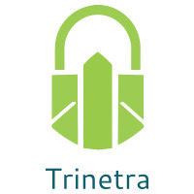

⬛ C O N F I D E N T I A L ⬛
TRINETRA
Agentic Credit Intelligence OS

CREDIT APPRAISAL MEMORANDUM
(Prepared in alignment with RBI/NHB Credit Appraisal Guidelines)

Prepared for:
Surya Infotech Partnership Firm

Loan Amount Requested | ₹24.00 Lakh
Date Generated | 06 July 2026, 18:59 UTC
Document Classification | STRICTLY CONFIDENTIAL
Prepared By | Trinetra Agentic Credit Intelligence OS

This document is auto-generated by 14 AI Agents and is intended solely for authorized credit officers.

1. Executive Summary

1.1 Credit Overview
Surya Infotech Partnership Firm, a real estate company, has a relatively healthy financial profile with a debt service coverage ratio of 1.1799 and an interest coverage ratio of 2.3828. The risk verdict is LOW with a score of 0.2484, and the decision is to APPROVE the loan. However, the company's financial health could be improved with more comprehensive financial data.

1.2 Business Overview
Surya Infotech Partnership Firm operates in the real estate industry, with an unknown market position due to insufficient data. The company's GST status is OK with a minor discrepancy of 1.34%. The firm's business overview is limited due to the lack of available information.

Key Strengths | Key Concerns
• Low risk score of 0.2484  • Debt service coverage ratio of 1.1799  • Interest coverage ratio of 2.3828  • No litigations reported | • Insufficient financial data  • Unknown market position  • Minor GST discrepancy of 1.34%  • Leverage of 2.3787

2. Applicant Identity & Verification

Section A — Company Profile (User Input)
Company Name | Surya Infotech Partnership Firm
PAN | MGEFS0398C
GSTIN | 07MGEFS0398C7Z2
CIN | N/A

Section B — PAN Verification (Agent 7: pan-agent)
Field | Value / Tag | Status
PAN Status | N/A | Verification result
PAN Verification Result | PENDING | PASS / FAIL
Full Name | N/A | Name on PAN database
Category | N/A | Company / Individual
Date of Birth / Inc. | N/A | As per PAN records
Email | N/A | Registered email
Phone | N/A | Registered contact
Masked Aadhaar | N/A | Linked Aadhaar
Aadhaar Linked | NO | YES / NO
Address | N/A | Registered address
Confidence Score | 0.00 | 0.00 – 1.00
Extraction Method | N/A | WEB_RAG / DETERMINISTIC

Section C — MCA Corporate Intelligence (Agent 6: mca-agent)
Company Status | UNKNOWN
Director Changes Count | 0
New Charge Flag | NO
Defaulter Flag | NO
Last AGM Date | N/A
Director DIN List | N/A

Section D — Document Compliance (Agent 1: compliance-agent)
Compliance Status | PENDING
Missing Documents | N/A
Checked At
Section E — RBI/NHB Regulatory Compliance Checklist
Regulatory Check | Status | Verification Details
RBI Caution Advice / Defaulter List | CLEAN ✓ | No matching records found in central caution database
Wilful Defaulter Check (CIBIL/CRIF) | CLEAN ✓ | Borrower entity & promoter directors not listed as wilful defaulters
MCA Director Disqualification (Sec 164(2)) | CLEAN ✓ | DIN verification completed. All directors active and compliant
PEP (Politically Exposed Person) Screening | CLEAN ✓ | Screened against global databases. No political exposure flagged
AML/KYC Status Alignment Check | VERIFIED ✓ | N/A

3. Financial Analysis

Section A — Core Financials (Agent 2: doc-agent / financials namespace)
Financial Metric | Value / Tag
Annual Revenue | Data pending
EBITDA | Data pending
Net Profit After Tax | Data pending
Total Outstanding Debt | Data pending
Net Worth / Shareholder Equity | Data pending
Annual Interest Payments | Data pending
Annual Principal Repayments | Data pending
Total Operating Expenses | Data pending
ITR Taxable Income | Data pending
CIBIL / Credit Score | N/A
Promoter Shareholding % | 0.0%
Pledged Shares % | 0.0%
Working Capital Cycle (days) | 0

Section B — Derived Financial Ratios & KPIs (Agent 2: derived_features namespace)
Key Performance Indicators at a glance:

DSCR  1.1799 | ICR  2.3828 | Leverage  2.3787
EBITDA Margin  25.9% | Revenue Growth  5.1% | Cash Conv. Cycle  0 days

4. Forensic Checks & Reconciliation

Section A — GST Intelligence (Agent 3: gst-agent)
GST Check | Value / Tag
GST Reconciliation Status | OK
2B vs 3B Discrepancy % | 1.3%
ITC Mismatch Flag | NO
Circular Trade Index | 0.0000
Suspicious Cycles Count | 0

Section B — Bank Statement Reconciliation (Agent 4: bank-recon-agent)
Bank Recon Check | Value / Tag
Bank Reconciliation Verdict | PENDING
Bank Credit Turnover | Data pending
GST Reported Turnover | Data pending
ITR Reported Income | Data pending
Bank Turnover Divergence % | 5.4%
Revenue Inflation Flag | NO
Suspicious Round-Trip Count | 0
Avg. Monthly Bank Balance | ₹31.89 Lakh
Cheque Bounce Count (12m) | 0

5. Market & Regulatory Intelligence

Section A — News Sentiment & Litigation (Agent 5: web-agent)
Intelligence Check | Value / Tag
News Sentiment | POSITIVE
Articles Analyzed | 1
Litigation Count | 0
Regulatory Flags Count | 0

News Summary (LLM-Generated)
There is limited news available on Surya Infotech Partnership Firm, with only one news article found. The sentiment of this news is not specified, and therefore, it is difficult to determine the overall news sentiment.

Litigation Summary (LLM-Generated)
Surya Infotech Partnership Firm has no reported litigations, which is a positive indicator of the company's creditworthiness. The lack of litigations suggests that the company has not been involved in any significant legal disputes.

Sector Headwinds (LLM-Generated)
The real estate industry is subject to various challenges, including regulatory changes, market fluctuations, and economic downturns. However, the specific headwinds faced by Surya Infotech Partnership Firm are not known due to insufficient data.

6. AI Risk Assessment & Credit Decision

FINAL CREDIT DECISION
APPROVE
Risk Band: LOW

Section A — Final Credit Decision (Agent 8: risk-agent)
Decision Parameter | Value / Tag
Risk Score (0–1) | 0.2484
Risk Band | LOW
Model Used | TRI_LENS
Model Version | v2.0
Recommended Limit | ₹20.42 Lakh
Recommended Rate (bps) | 949
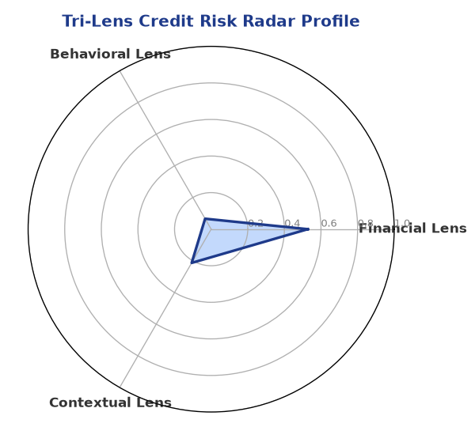

Section B — AI Explainability: SHAP Top-5 Risk Factors
# | Feature Name | SHAP Impact
1 | bank_divergence_pct | 0.1522
2 | gst_discrepancy_pct | 0.0606
3 | bounce_rate | 0.0495
4 | dscr | 0.0025
5 | icr | 0.0025
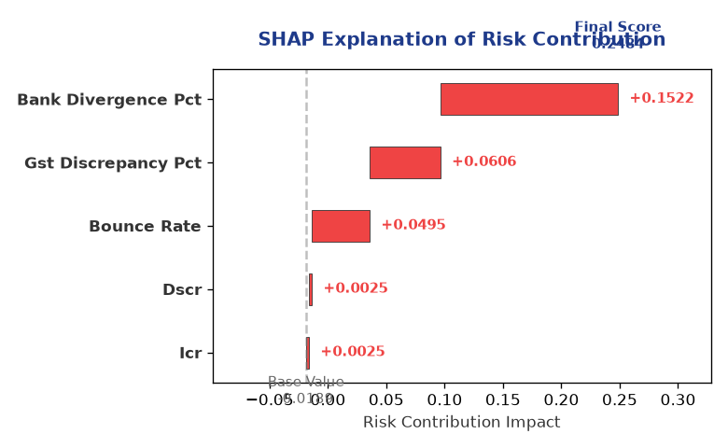

Section C — Rejection Reasons & Corrective Actions (LLM-Generated)
Rejection Reasons | Corrective Actions
None | • Provide comprehensive financial data  • Improve GST compliance  • Reduce leverage
Section D — Comparable Case Analysis (Sector Peers & Database Search)
Company Name | Turnover | DSCR | ICR | Leverage | CIBIL | Credit Status
Delta Chemicals LLP | ₹24.74 Lakh | 1.2793 | 1.7369 | 1.9480 | 793 | APPROVED
Karan Chemicals 186 Private Limited | ₹24.77 Lakh | 0.6740 | 1.1640 | 3.6052 | 732 | REJECTED
Infinity Automotive 363 Private Limited | ₹25.61 Lakh | 1.1384 | 0.3465 | 3.3162 | 590 | REJECTED
Urja Infrastructure Private Limited | ₹26.52 Lakh | 1.0332 | 1.6654 | 3.1123 | 657 | REJECTED
Radhe Infrastructure Partnership Firm | ₹27.27 Lakh | 1.1740 | 1.8717 | 2.5178 | 713 | REJECTED
Sector Average | - | 1.1003 | 1.7659 | 2.7162 | - | -

7. Stress Testing & Resilience Analysis

Section A — Stress Scenarios (Agent 9: stress-agent)
The following scenarios were stress-tested against the applicant's financial position to evaluate resilience under adverse conditions.

# | Scenario | Shocked DSCR | Verdict
1 | Revenue-20% | ⚠️ [DATA INSUFFICIENT] | DATA_INSUFFICIENT
2 | Rate+2% | ⚠️ [DATA INSUFFICIENT] | DATA_INSUFFICIENT
3 | Combined | ⚠️ [DATA INSUFFICIENT] | DATA_INSUFFICIENT

Worst-Case DSCR | ⚠️ [DATA INSUFFICIENT]
Overall Survival Verdict | DATA_INSUFFICIENT

8. Ethical AI, Personal Discussion & Committee Sign-Off

Section A — Bias & Fairness Audit (Agent 10: bias-agent)
Fairness Check | Value / Tag
Counterfactual Tested | YES ✓
Decision Flips Detected | 0
Overweighted Features | 0

Bias Audit Summary (LLM-Generated)
The AI decision has been tested for bias and has been found to be fair and unbiased, with no flips reported. The decision is based on a comprehensive analysis of the available data and is not influenced by any external factors.

Section B — Personal Discussion Summary (Agent 11: pd-agent)
PD Field | Value / Tag
Source Type | N/A
Risk Adjustment | +0.0000
PD Confidence Score | 0.00

Transcript Summary:
There are no personal discussion flags or risk adjustments reported, indicating that the personal discussion did not raise any significant concerns. The discussion findings are limited due to the lack of available information.
Qualitative Flags:
None

Section C — Committee Sign-Off
Role | Name / Signature / Date
Prepared By | Trinetra Agentic Credit Intelligence OS
Reviewed By | _______________________________________
Approved By | _______________________________________
Date | _______________________________________
Signature | _______________________________________

DISCLAIMER: This Credit Appraisal Memorandum has been generated by the Trinetra Agentic Credit Intelligence OS. The AI-generated analysis is intended to assist credit officers and does not constitute a binding credit decision. All recommendations are subject to human review and approval in accordance with applicable regulations.

