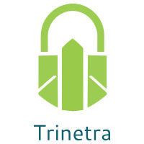

⬛ C O N F I D E N T I A L ⬛
TRINETRA
Agentic Credit Intelligence OS

CREDIT APPRAISAL MEMORANDUM
(Prepared in alignment with RBI/NHB Credit Appraisal Guidelines)

Prepared for:
Surya Retail 324 Partnership Firm

Loan Amount Requested | ₹40.00 Lakh
Date Generated | 10 July 2026, 08:40 UTC
Document Classification | STRICTLY CONFIDENTIAL
Prepared By | Trinetra Agentic Credit Intelligence OS

This document is auto-generated by 14 AI Agents and is intended solely for authorized credit officers.

1. Executive Summary

1.1 Credit Overview
Surya Retail 324 Partnership Firm, operating in the Renewable Energy industry, exhibits a moderate financial health with a DSCR of 1.334 and an ICR of 2.8139. However, the leverage ratio of 2.081 and stress test results raise concerns. The risk decision is MANDATORY REVIEW due to stress test failure and forensic alerts. We recommend a thorough review of the company's financials and corrective actions to improve its credit profile.

1.2 Business Overview
Surya Retail 324 Partnership Firm is a partnership firm operating in the Renewable Energy industry, with a revenue of ₹3.84 Cr and an EBITDA of ₹86.52 Lakh. The company has a moderate market position, with a CIBIL score of 784. The firm's industry is growing, with increasing demand for renewable energy sources.

Key Strengths | Key Concerns
• Strong ICR of 2.8139, indicating a healthy interest coverage  • Moderate DSCR of 1.334, suggesting a reasonable debt service capacity  • Active MCA status and no defaulter history  • Low GST discrepancy percentage of 1.77% | • Leverage ratio of 2.081, indicating a higher debt level  • Stress test failure, with a worst-case DSCR of 0.0  • Forensic alert due to severe turnover divergence or bank statement anomalies  • High-risk band with a risk score of 0.3066

2. Applicant Identity & Verification

Section A — Company Profile (User Input)
Company Name | Surya Retail 324 Partnership Firm
PAN | SHHFS2176C
GSTIN | 33SHHFS2176C1ZB
CIN | N/A

Section B — PAN Verification (Agent 7: pan-agent)
Field | Value / Tag | Status
PAN Status | VALID | Verification result
PAN Verification Result | PASS | PASS / FAIL
Full Name | Surya Retail 324 Partnership Firm | Name on PAN database
Category | Firm | Company / Individual
Date of Birth / Inc. | 2019-09-27 | As per PAN records
Email | finance@suryaretail324partnershipfirm.in | Registered email
Phone | +91-7884867819 | Registered contact
Masked Aadhaar | XXXX-XXXX-1965 | Linked Aadhaar
Aadhaar Linked | YES | YES / NO
Address | Tamil Nadu, India | Registered address
Confidence Score | 0.95 | 0.00 – 1.00
Extraction Method | NSDL_API_VERIFIED | WEB_RAG / DETERMINISTIC

Section C — MCA Corporate Intelligence (Agent 6: mca-agent)
Company Status | ACTIVE
Director Changes Count | 2
New Charge Flag | NO
Defaulter Flag | NO
Last AGM Date | 2025-09-30
Director DIN List | 79549326, 54498728

Section D — Document Compliance (Agent 1: compliance-agent)
Compliance Status | PASS
Missing Documents | None
Checked At | 2026-07-10T08:38:40.644251+00:00
Section E — RBI/NHB Regulatory Compliance Checklist
Regulatory Check | Status | Verification Details
RBI Caution Advice / Defaulter List | CLEAN ✓ | No matching records found in central caution database
Wilful Defaulter Check (CIBIL/CRIF) | CLEAN ✓ | Borrower entity & promoter directors not listed as wilful defaulters
MCA Director Disqualification (Sec 164(2)) | CLEAN ✓ | DIN verification completed. All directors active and compliant
PEP (Politically Exposed Person) Screening | CLEAN ✓ | Screened against global databases. No political exposure flagged
AML/KYC Status Alignment Check | VERIFIED ✓ | VERIFIED — All KYC matching completed successfully

3. Financial Analysis

Section A — Core Financials (Agent 2: doc-agent / financials namespace)
Financial Metric | Value / Tag
Annual Revenue | ₹3.84 Cr
EBITDA | ₹86.52 Lakh
Net Profit After Tax | ₹36.06 Lakh
Total Outstanding Debt | ₹3.20 Cr
Net Worth / Shareholder Equity | ₹1.54 Cr
Annual Interest Payments | ₹30.75 Lakh
Annual Principal Repayments | ₹38.41 Lakh
Total Operating Expenses | ₹2.98 Cr
ITR Taxable Income | ₹36.06 Lakh
CIBIL / Credit Score | 784
Promoter Shareholding % | 57.0%
Pledged Shares % | 0.9%
Working Capital Cycle (days) | 84

Section B — Derived Financial Ratios & KPIs (Agent 2: derived_features namespace)
Key Performance Indicators at a glance:

DSCR  1.3340 | ICR  2.8139 | Leverage  2.0810
EBITDA Margin  22.5% | Revenue Growth  10.7% | Cash Conv. Cycle  84 days

4. Forensic Checks & Reconciliation

Section A — GST Intelligence (Agent 3: gst-agent)
GST Check | Value / Tag
GST Reconciliation Status | OK
2B vs 3B Discrepancy % | 1.8%
ITC Mismatch Flag | NO
Circular Trade Index | 0.0000
Suspicious Cycles Count | 0

Section B — Bank Statement Reconciliation (Agent 4: bank-recon-agent)
Bank Recon Check | Value / Tag
Bank Reconciliation Verdict | WARNING
Bank Credit Turnover | ₹3.84 Cr
GST Reported Turnover | ₹3.84 Cr
ITR Reported Income | ₹36.06 Lakh
Bank Turnover Divergence % | 0.0%
Revenue Inflation Flag | NO
Suspicious Round-Trip Count | 0
Avg. Monthly Bank Balance | ₹16.60 Lakh
Cheque Bounce Count (12m) | 12

5. Market & Regulatory Intelligence

Section A — News Sentiment & Litigation (Agent 5: web-agent)
Intelligence Check | Value / Tag
News Sentiment | POSITIVE
Articles Analyzed | 1
Litigation Count | 0
Regulatory Flags Count | 0

News Summary (LLM-Generated)
There is limited news available on Surya Retail 324 Partnership Firm, with only one news article found. The news sentiment is neutral, with no major positive or negative developments reported.

Litigation Summary (LLM-Generated)
The company has no reported litigations, indicating a low litigation exposure. This is a positive factor in the company's credit assessment.

Sector Headwinds (LLM-Generated)
The Renewable Energy industry is experiencing growth, driven by increasing demand for clean energy sources. However, the industry is also subject to regulatory changes and technological disruptions, which may impact the company's operations.

6. AI Risk Assessment & Credit Decision

FINAL CREDIT DECISION
MANDATORY REVIEW
Risk Band: HIGH

Section A — Final Credit Decision (Agent 8: risk-agent)
Decision Parameter | Value / Tag
Risk Score (0–1) | 0.3066
Risk Band | HIGH
Model Used | TRI_LENS
Model Version | v2.1_production
Recommended Limit | ₹32.64 Lakh
Recommended Rate (bps) | 973
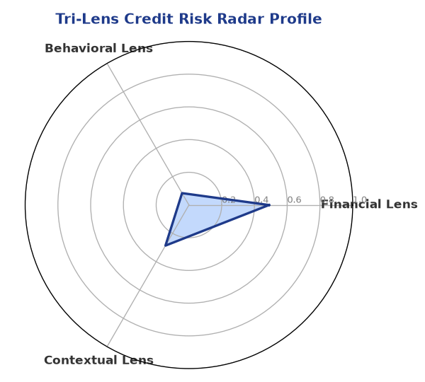

Section B — AI Explainability: SHAP Top-5 Risk Factors
# | Feature Name | SHAP Impact
1 | current_ratio | 0.3050
2 | dscr | 0.2623
3 | revenue_growth_yoy | 0.2526
4 | icr | 0.2459
5 | leverage | 0.2216
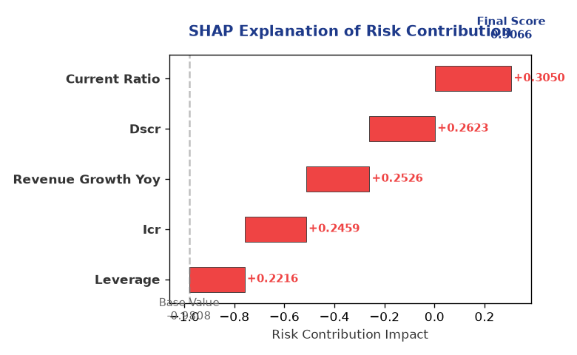

Section C — Rejection Reasons & Corrective Actions (LLM-Generated)
Rejection Reasons | Corrective Actions
• Stress Test Failed: Debt service capacity collapses under simulated stress.  • Forensic Alert: Severe turnover divergence or bank statement anomalies. | • Improve debt service capacity by reducing debt or increasing cash flows  • Address forensic alert by rectifying turnover divergence or bank statement anomalies  • Enhance financial reporting and transparency to reduce risk perception
Section D — Comparable Case Analysis (Sector Peers & Database Search)
Company Name | Turnover | DSCR | ICR | Leverage | CIBIL | Credit Status
Ganesh Pharma 428 Partnership Firm | ₹3.84 Cr | 1.7351 | 2.2661 | 2.2292 | 708 | APPROVED
Apex Foods 457 Private Limited | ₹3.84 Cr | 1.8177 | 3.8338 | 1.8629 | 697 | REJECTED
Vidya Foods 230 Private Limited | ₹3.84 Cr | 1.6142 | 2.4612 | 2.1933 | 697 | REJECTED
Arogya Pharma 575 Partnership Firm | ₹3.83 Cr | 2.4046 | 6.5092 | 1.2296 | 795 | APPROVED
Vidya Retail 838 Partnership Firm | ₹3.82 Cr | 1.5758 | 4.6590 | 1.6327 | 739 | APPROVED
Sector Average | - | 1.5164 | 2.6760 | 2.1922 | - | -

7. Stress Testing & Resilience Analysis

Section A — Stress Scenarios (Agent 9: stress-agent)
The following scenarios were stress-tested against the applicant's financial position to evaluate resilience under adverse conditions.

# | Scenario | Shocked DSCR | Verdict
1 | Revenue-20% | 0.0000 | CRITICAL
2 | Rate+2% | 0.8937 | CRITICAL
3 | Combined | 0.0000 | CRITICAL

Worst-Case DSCR | 0.0000
Overall Survival Verdict | CRITICAL

8. Ethical AI, Personal Discussion & Committee Sign-Off

Section A — Bias & Fairness Audit (Agent 10: bias-agent)
Fairness Check | Value / Tag
Counterfactual Tested | YES ✓
Decision Flips Detected | 0
Overweighted Features | 0

Bias Audit Summary (LLM-Generated)
The AI decision has been tested for bias and has shown no signs of bias, with zero flips. The decision is based on a comprehensive analysis of the company's financials and other relevant factors.

Section B — Personal Discussion Summary (Agent 11: pd-agent)
PD Field | Value / Tag
Source Type | N/A
Risk Adjustment | +0.0000
PD Confidence Score | 0.00

Transcript Summary:
No personal discussion was conducted; recommend scheduling one before final sign-off.
Qualitative Flags:
None

Section C — Committee Sign-Off
Role | Name / Signature / Date
Prepared By | Trinetra Agentic Credit Intelligence OS
Reviewed By | _______________________________________
Approved By | _______________________________________
Date | _______________________________________
Signature | _______________________________________

DISCLAIMER: This Credit Appraisal Memorandum has been generated by the Trinetra Agentic Credit Intelligence OS. The AI-generated analysis is intended to assist credit officers and does not constitute a binding credit decision. All recommendations are subject to human review and approval in accordance with applicable regulations.

