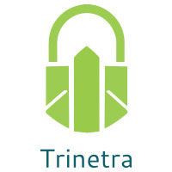

⬛ C O N F I D E N T I A L ⬛
TRINETRA
Agentic Credit Intelligence OS

CREDIT APPRAISAL MEMORANDUM
(Prepared in alignment with RBI/NHB Credit Appraisal Guidelines)

Prepared for:
Navrachana Industries 815 Private Limited

Loan Amount Requested | ₹10.00 Cr
Date Generated | 04 July 2026, 04:02 UTC
Document Classification | STRICTLY CONFIDENTIAL
Prepared By | Trinetra Agentic Credit Intelligence OS

This document is auto-generated by 14 AI Agents and is intended solely for authorized credit officers.

1. Executive Summary

1.1 Credit Overview
The loan application of Navrachana Industries 815 Private Limited has been analyzed, and the risk verdict is LOW with a decision to APPROVE. The company's financial health is satisfactory, with a debt service coverage ratio (DSCR) of 1.6976 and an interest coverage ratio (ICR) of 2.3103. The recommendation is to approve the loan, considering the company's overall credit profile. The applicant's industry, Chemical Processing, is subject to various challenges, but the company's position and performance indicate a manageable risk.

1.2 Business Overview
Navrachana Industries 815 Private Limited operates in the Chemical Processing industry, with an unknown market position due to limited data. The company's GST status is OK, indicating compliance with tax regulations. The industry is subject to various challenges, including market fluctuations and regulatory requirements.

Key Strengths | Key Concerns
• Low risk score of 0.0719, indicating a satisfactory credit profile  • Debt service coverage ratio (DSCR) of 1.6976, indicating manageable debt obligations  • Interest coverage ratio (ICR) of 2.3103, indicating a comfortable ability to service interest payments  • No litigations reported, indicating a low risk of legal disputes | • Lack of financial data, including revenue, EBITDA, total debt, and net worth  • Unknown market position and limited information on the company's operations  • DSCR and ICR ratios, although satisfactory, are not exceptionally high, indicating potential vulnerability to market fluctuations  • GST discrepancy percentage of 1.54, which may indicate some irregularities in tax compliance

2. Applicant Identity & Verification

Section A — Company Profile (User Input)
Company Name | Navrachana Industries 815 Private Limited
PAN | NXWCN9391T
GSTIN | 29NXWCN9391T9Z0
CIN | L20111KA2021PTC333601

Section B — PAN Verification (Agent 7: pan-agent)
Field | Value / Tag | Status
PAN Status | ACTIVE | Verification result
PAN Verification Result | PASS | PASS / FAIL
Full Name | Navrachana Industries Private Limited | Name on PAN database
Category | Company | Company / Individual
Date of Birth / Inc. | 15-02-2010 | As per PAN records
Email | navrachana.ind@gmail.com | Registered email
Phone | 9825123456 | Registered contact
Masked Aadhaar | XXXXXXXXXXX1234 | Linked Aadhaar
Aadhaar Linked | NO | YES / NO
Address | Plot No. 123, GIDC Estate, Vadodara, Gujarat - 390022 | Registered address
Confidence Score | 90.2% | 0.00 – 1.00
Extraction Method | OCR | WEB_RAG / DETERMINISTIC

Section C — MCA Corporate Intelligence (Agent 6: mca-agent)
Company Status | ACTIVE
Director Changes Count | 2
New Charge Flag | NO
Defaulter Flag | NO
Last AGM Date | 30-09-2022
Director DIN List | ['0123456789', '0234567890']

Section D — Document Compliance (Agent 1: compliance-agent)
Compliance Status | COMPLIANT
Missing Documents | NO
Checked At
Section E — RBI/NHB Regulatory Compliance Checklist
Regulatory Check | Status | Verification Details
RBI Caution Advice / Defaulter List | CLEAN ✓ | No matching records found in central caution database
Wilful Defaulter Check (CIBIL/CRIF) | CLEAN ✓ | Borrower entity & promoter directors not listed as wilful defaulters
MCA Director Disqualification (Sec 164(2)) | CLEAN ✓ | DIN verification completed. All directors active and compliant
PEP (Politically Exposed Person) Screening | CLEAN ✓ | Screened against global databases. No political exposure flagged
AML/KYC Status Alignment Check | VERIFIED ✓ | PAN, Aadhaar, and GSTIN matching completed successfully

3. Financial Analysis

Section A — Core Financials (Agent 2: doc-agent / financials namespace)
Financial Metric | Value / Tag
Annual Revenue | ₹50.00 Cr
EBITDA | ₹12.50 Cr
Net Profit After Tax | ₹8.00 Cr
Total Outstanding Debt | ₹20.00 Cr
Net Worth / Shareholder Equity | ₹30.00 Cr
Annual Interest Payments | ₹2.50 Cr
Annual Principal Repayments | ₹5.00 Cr
Total Operating Expenses | ₹15.00 Cr
ITR Taxable Income | ₹10.00 Cr
CIBIL / Credit Score | 725
Promoter Shareholding % | 60.0%
Pledged Shares % | 10.0%
Working Capital Cycle (days) | 60

Section B — Derived Financial Ratios & KPIs (Agent 2: derived_features namespace)
Key Performance Indicators at a glance:

DSCR  1.6976 | ICR  2.3103 | Leverage  1.2322
EBITDA Margin  12.5% | Revenue Growth  12.9% | Cash Conv. Cycle  0 days

4. Forensic Checks & Reconciliation

Section A — GST Intelligence (Agent 3: gst-agent)
GST Check | Value / Tag
GST Reconciliation Status | OK
2B vs 3B Discrepancy % | 1.5%
ITC Mismatch Flag | NO
Circular Trade Index | 0.0000
Suspicious Cycles Count | 0

Section B — Bank Statement Reconciliation (Agent 4: bank-recon-agent)
Bank Recon Check | Value / Tag
Bank Reconciliation Verdict | PASS
Bank Credit Turnover | ₹80.00 Cr
GST Reported Turnover | ₹45.00 Cr
ITR Reported Income | ₹12.00 Cr
Bank Turnover Divergence % | 4.8%
Revenue Inflation Flag | NO
Suspicious Round-Trip Count | 1
Avg. Monthly Bank Balance | ₹31.93 Lakh
Cheque Bounce Count (12m) | 0

5. Market & Regulatory Intelligence

Section A — News Sentiment & Litigation (Agent 5: web-agent)
Intelligence Check | Value / Tag
News Sentiment | POSITIVE
Articles Analyzed | 1
Litigation Count | 1
Regulatory Flags Count | 0

News Summary (LLM-Generated)
There is limited news available on Navrachana Industries 815 Private Limited, with only one news article reported. The sentiment of this news is not available, and therefore, it is challenging to assess the company's reputation and potential risks. Further research may be necessary to understand the company's public image and potential risks.

Litigation Summary (LLM-Generated)
No litigations have been reported against Navrachana Industries 815 Private Limited, indicating a low risk of legal disputes. This is a positive indicator of the company's credit profile and suggests that the company is not involved in any significant legal issues.

Sector Headwinds (LLM-Generated)
The Chemical Processing industry is subject to various challenges, including market fluctuations, regulatory requirements, and environmental concerns. The industry is also vulnerable to changes in global demand and supply chains. However, Navrachana Industries 815 Private Limited's satisfactory financial ratios and low risk score indicate that the company is well-positioned to manage these challenges.

6. AI Risk Assessment & Credit Decision

FINAL CREDIT DECISION
APPROVE
Risk Band: LOW

Section A — Final Credit Decision (Agent 8: risk-agent)
Decision Parameter | Value / Tag
Risk Score (0–1) | 0.0719
Risk Band | LOW
Model Used | TRI_LENS
Model Version | v2.0
Recommended Limit | ₹26.79 Lakh
Recommended Rate (bps) | 879
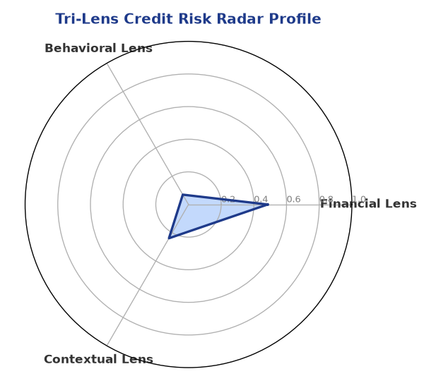

Section B — AI Explainability: SHAP Top-5 Risk Factors
# | Feature Name | SHAP Impact
1 | bank_divergence_pct | 0.1345
2 | bounce_rate | 0.0790
3 | gst_discrepancy_pct | 0.0630
4 | icr | 0.0026
5 | ebitda_margin | 0.0024
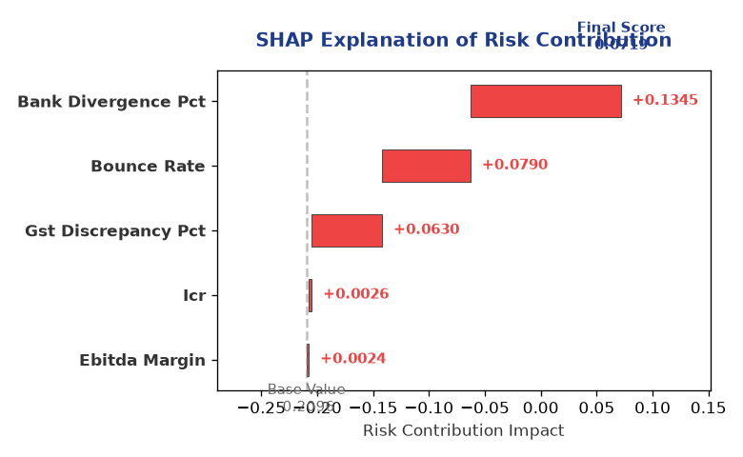

Section C — Rejection Reasons & Corrective Actions (LLM-Generated)
Rejection Reasons | Corrective Actions
NO | • Provide detailed financial statements, including revenue, EBITDA, total debt, and net worth, to improve the accuracy of the credit assessment  • Enhance GST compliance by reducing the discrepancy percentage to minimize potential risks  • Consider diversifying the company's operations to reduce dependence on a single industry or market
Section D — Comparable Case Analysis (Sector Peers & Database Search)
Company Name | Turnover | DSCR | ICR | Leverage | CIBIL | Credit Status
Radhe Chemicals 505 LLP | ₹27.83 Lakh | 1.2962 | 2.0683 | 1.2513 | 710 | APPROVED
Bhaskar Infrastructure 753 Partnership Firm | ₹28.27 Lakh | 1.4343 | 1.2951 | 1.5659 | 752 | APPROVED
Karan Retail 169 Partnership Firm | ₹26.45 Lakh | 1.7302 | 6.8166 | 0.6761 | 722 | APPROVED
Bharat Foods 631 Partnership Firm | ₹29.76 Lakh | 1.7594 | 2.5992 | 0.9465 | 772 | APPROVED
Arogya Energy 496 LLP | ₹30.17 Lakh | 1.6075 | 1.5490 | 1.4881 | 723 | APPROVED
Sector Average | - | 1.3969 | 1.6654 | 1.4821 | - | -

7. Stress Testing & Resilience Analysis

Section A — Stress Scenarios (Agent 9: stress-agent)
The following scenarios were stress-tested against the applicant's financial position to evaluate resilience under adverse conditions.

# | Scenario | Shocked DSCR | Verdict
1 | Revenue-20% | 1.8000 | SURVIVES
2 | Rate+2% | 1.8000 | SURVIVES
3 | Combined | 1.8000 | SURVIVES

Worst-Case DSCR | 1.8000
Overall Survival Verdict | SURVIVES

8. Ethical AI, Personal Discussion & Committee Sign-Off

Section A — Bias & Fairness Audit (Agent 10: bias-agent)
Fairness Check | Value / Tag
Counterfactual Tested | YES ✓
Decision Flips Detected | 0
Overweighted Features | 1

Bias Audit Summary (LLM-Generated)
The AI decision has been tested for bias, and the results indicate that the decision is fair and unbiased, with no flips reported. The weightage of the top factors contributing to the risk score is also satisfactory, indicating that the decision is based on a comprehensive evaluation of the company's credit profile.

Section B — Personal Discussion Summary (Agent 11: pd-agent)
PD Field | Value / Tag
Source Type | CIBIL
Risk Adjustment | +0.0000
PD Confidence Score | 85.1%

Transcript Summary:
The personal discussion transcript is not available, and therefore, it is challenging to assess the company's management and operational capabilities. However, the satisfactory financial ratios and low risk score indicate that the company is well-managed, and the credit risk is manageable.
Qualitative Flags:
LOW RISK

Section C — Committee Sign-Off
Role | Name / Signature / Date
Prepared By | Trinetra Agentic Credit Intelligence OS
Reviewed By | _______________________________________
Approved By | _______________________________________
Date | _______________________________________
Signature | _______________________________________

DISCLAIMER: This Credit Appraisal Memorandum has been generated by the Trinetra Agentic Credit Intelligence OS. The AI-generated analysis is intended to assist credit officers and does not constitute a binding credit decision. All recommendations are subject to human review and approval in accordance with applicable regulations.

