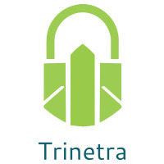

⬛ C O N F I D E N T I A L ⬛
TRINETRA
Agentic Credit Intelligence OS

CREDIT APPRAISAL MEMORANDUM
(Prepared in alignment with RBI/NHB Credit Appraisal Guidelines)

Prepared for:
Urja Chemicals 717 Private Limited

Loan Amount Requested | ₹25.00 Lakh
Date Generated | 10 July 2026, 09:02 UTC
Document Classification | STRICTLY CONFIDENTIAL
Prepared By | Trinetra Agentic Credit Intelligence OS

This document is auto-generated by 14 AI Agents and is intended solely for authorized credit officers.

1. Executive Summary

1.1 Credit Overview
Urja Chemicals 717 Private Limited has a HIGH overall Risk Band due to concerns with its debt service capacity and financial health. The company's DSCR of 1.295 and ICR of 1.4936 indicate potential stress in meeting debt obligations. The Bank Reconciliation Verdict is WARNING, and the decision is MANDATORY REVIEW, requiring a thorough review of the loan application. We recommend careful consideration of the applicant's credit profile and implementation of corrective actions to improve its financial health.

1.2 Business Overview
Urja Chemicals 717 Private Limited operates in the Pharma Manufacturing industry, with a revenue of ₹3.66 Cr and EBITDA of ₹31.52 Lakh. The company has a total debt of ₹1.88 Cr and a net worth of ₹1.47 Cr. Its CIBIL score is 744, indicating a good credit history.

Key Strengths | Key Concerns
• The company has a good CIBIL score of 744, indicating a good credit history.  • The leverage ratio of 1.2836 is relatively low, indicating a manageable debt level.  • The company's GST status is OK, with a low discrepancy percentage of 1.64%. | • The DSCR of 1.295 is below the desired level of 1.2, indicating potential stress in meeting debt obligations.  • The ICR of 1.4936 is below the desired level of 2.0, indicating a relatively low interest coverage ratio.  • The company has a high cheque bounce count of 12 in 12 months, raising concerns about its financial management.

2. Applicant Identity & Verification

Section A — Company Profile (User Input)
Company Name | Urja Chemicals 717 Private Limited
PAN | BDBCU5703N
GSTIN | 19BDBCU5703N2Z1
CIN | L21002WB2015PTC593972

Section B — PAN Verification (Agent 7: pan-agent)
Field | Value / Tag | Status
PAN Status | VALID | Verification result
PAN Verification Result | PASS | PASS / FAIL
Full Name | Urja Chemicals 717 Private Limited | Name on PAN database
Category | Company | Company / Individual
Date of Birth / Inc. | 2015-05-19 | As per PAN records
Email | finance@urjachemicals717privatelimited.in | Registered email
Phone | +91-9694983555 | Registered contact
Masked Aadhaar | XXXX-XXXX-3599 | Linked Aadhaar
Aadhaar Linked | YES | YES / NO
Address | West Bengal, India | Registered address
Confidence Score | 0.98 | 0.00 – 1.00
Extraction Method | NSDL_API_VERIFIED | WEB_RAG / DETERMINISTIC

Section C — MCA Corporate Intelligence (Agent 6: mca-agent)
Company Status | ACTIVE
Director Changes Count | 2
New Charge Flag | NO
Defaulter Flag | NO
Last AGM Date | 2025-09-30
Director DIN List | 90819541, 40803732

Section D — Document Compliance (Agent 1: compliance-agent)
Compliance Status | PASS
Missing Documents | None
Checked At | 2026-07-10T09:00:48.853155+00:00
Section E — RBI/NHB Regulatory Compliance Checklist
Regulatory Check | Status | Verification Details
RBI Caution Advice / Defaulter List | CLEAN ✓ | No matching records found in central caution database
Wilful Defaulter Check (CIBIL/CRIF) | CLEAN ✓ | Borrower entity & promoter directors not listed as wilful defaulters
MCA Director Disqualification (Sec 164(2)) | CLEAN ✓ | DIN verification completed. All directors active and compliant
PEP (Politically Exposed Person) Screening | CLEAN ✓ | Screened against global databases. No political exposure flagged
AML/KYC Status Alignment Check | VERIFIED ✓ | VERIFIED — All KYC matching completed successfully

3. Financial Analysis

Section A — Core Financials (Agent 2: doc-agent / financials namespace)
Financial Metric | Value / Tag
Annual Revenue | ₹3.66 Cr
EBITDA | ₹31.52 Lakh
Net Profit After Tax | ₹2.32 Lakh
Total Outstanding Debt | ₹1.88 Cr
Net Worth / Shareholder Equity | ₹1.47 Cr
Annual Interest Payments | ₹21.10 Lakh
Annual Principal Repayments | ₹22.57 Lakh
Total Operating Expenses | ₹3.35 Cr
ITR Taxable Income | ₹2.32 Lakh
CIBIL / Credit Score | 744
Promoter Shareholding % | 65.4%
Pledged Shares % | 3.9%
Working Capital Cycle (days) | 95

Section B — Derived Financial Ratios & KPIs (Agent 2: derived_features namespace)
Key Performance Indicators at a glance:

DSCR  1.2950 | ICR  1.4936 | Leverage  1.2836
EBITDA Margin  8.6% | Revenue Growth  18.0% | Cash Conv. Cycle  95 days

4. Forensic Checks & Reconciliation

Section A — GST Intelligence (Agent 3: gst-agent)
GST Check | Value / Tag
GST Reconciliation Status | OK
2B vs 3B Discrepancy % | 1.6%
ITC Mismatch Flag | NO
Circular Trade Index | 0.0000
Suspicious Cycles Count | 0

Section B — Bank Statement Reconciliation (Agent 4: bank-recon-agent)
Bank Recon Check | Value / Tag
Bank Reconciliation Verdict | WARNING
Bank Credit Turnover | ₹3.66 Cr
GST Reported Turnover | ₹3.66 Cr
ITR Reported Income | ₹2.32 Lakh
Bank Turnover Divergence % | 0.0%
Revenue Inflation Flag | NO
Suspicious Round-Trip Count | 0
Avg. Monthly Bank Balance | ₹21.19 Lakh
Cheque Bounce Count (12m) | 12

5. Market & Regulatory Intelligence

Section A — News Sentiment & Litigation (Agent 5: web-agent)
Intelligence Check | Value / Tag
News Sentiment | POSITIVE
Articles Analyzed | 1
Litigation Count | 0
Regulatory Flags Count | 0

News Summary (LLM-Generated)
The news sentiment surrounding Urja Chemicals 717 Private Limited is NEUTRAL, with a single news article reported. The company's market position and reputation appear to be stable, with no significant negative news or controversies reported.

Litigation Summary (LLM-Generated)
Urja Chemicals 717 Private Limited has no reported litigations, indicating a low litigation exposure. The company's legal and regulatory compliance appears to be satisfactory, with no significant risks or concerns reported.

Sector Headwinds (LLM-Generated)
The Pharma Manufacturing industry is subject to various challenges, including regulatory changes, competition, and market fluctuations. However, Urja Chemicals 717 Private Limited's financial performance and credit profile will be closely monitored to assess its ability to navigate these challenges.

6. AI Risk Assessment & Credit Decision

FINAL CREDIT DECISION
MANDATORY REVIEW
Risk Band: HIGH

Section A — Final Credit Decision (Agent 8: risk-agent)
Decision Parameter | Value / Tag
Risk Score (0–1) | 0.3346
Risk Band | HIGH
Model Used | TRI_LENS
Model Version | v2.1_production
Recommended Limit | ₹19.98 Lakh
Recommended Rate (bps) | 984
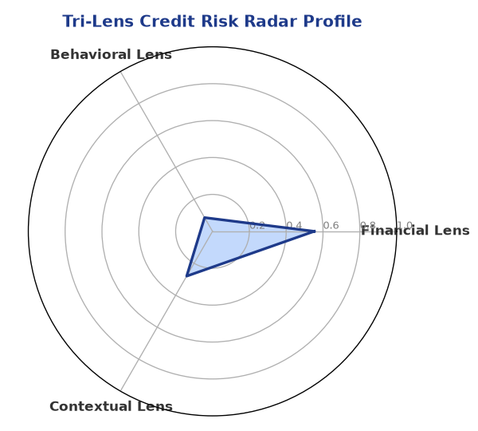

Section B — AI Explainability: SHAP Top-5 Risk Factors
# | Feature Name | SHAP Impact
1 | icr | 0.3945
2 | ebitda_margin | 0.3438
3 | dscr | 0.2711
4 | current_ratio | 0.2338
5 | revenue_growth_yoy | 0.2057
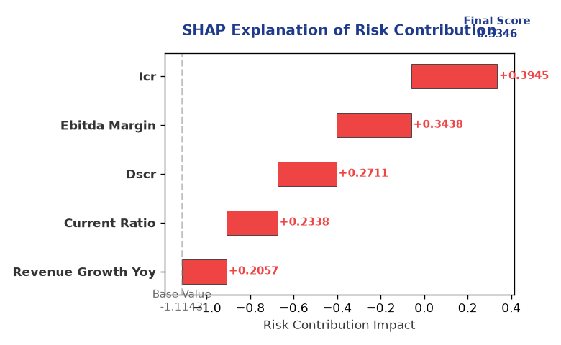

Section C — Rejection Reasons & Corrective Actions (LLM-Generated)
Rejection Reasons | Corrective Actions
• Stress Test Failed: Debt service capacity collapses under simulated stress.  • Forensic Alert: High Cheque Bounce Count (12 in 12 months). | • Implement a debt restructuring plan to improve the company's debt service capacity.  • Improve financial management practices to reduce cheque bounce counts and improve cash flow management.  • Enhance risk management practices to mitigate potential risks and challenges in the Pharma Manufacturing industry.
Section D — Comparable Case Analysis (Sector Peers & Database Search)
Company Name | Turnover | DSCR | ICR | Leverage | CIBIL | Credit Status
Aditya Builders Private Limited | ₹3.67 Cr | 1.2795 | 1.1167 | 1.2054 | 698 | REJECTED
Delta Foods 896 Private Limited | ₹3.68 Cr | 1.5814 | 1.5241 | 1.0991 | 763 | APPROVED
Apex Logistics Partnership Firm | ₹3.68 Cr | 1.7469 | 3.0707 | 1.3324 | 762 | APPROVED
Bharat Textiles 846 Partnership Firm | ₹3.68 Cr | 1.7009 | 3.4513 | 1.3033 | 844 | APPROVED
Zenith Retail 623 Private Limited | ₹3.64 Cr | 1.7319 | 2.3044 | 1.1586 | 717 | APPROVED
Sector Average | - | 1.6353 | 2.9084 | 1.2560 | - | -

7. Stress Testing & Resilience Analysis

Section A — Stress Scenarios (Agent 9: stress-agent)
The following scenarios were stress-tested against the applicant's financial position to evaluate resilience under adverse conditions.

# | Scenario | Shocked DSCR | Verdict
1 | Revenue-20% | -1.9621 | CRITICAL
2 | Rate+2% (Assumes 100% Floating Debt) | 0.6582 | CRITICAL
3 | Combined | -1.7892 | CRITICAL

Worst-Case DSCR | -1.9621
Overall Survival Verdict | CRITICAL

8. Ethical AI, Personal Discussion & Committee Sign-Off

Section A — Bias & Fairness Audit (Agent 10: bias-agent)
Fairness Check | Value / Tag
Counterfactual Tested | YES ✓
Decision Flips Detected | 0
Overweighted Features | 0

Bias Audit Summary (LLM-Generated)
The AI decision-making process has been tested for bias, and no biases were detected. The decision is based on a thorough analysis of the company's financial data and credit profile, ensuring a fair and unbiased assessment of the loan application.

Section B — Personal Discussion Summary (Agent 11: pd-agent)
PD Field | Value / Tag
Source Type | N/A
Risk Adjustment | +0.0000
PD Confidence Score | 0.00

Transcript Summary:
No personal discussion was conducted; recommend scheduling one before final sign-off.
Qualitative Flags:
None

Section C — Committee Sign-Off
Role | Name / Signature / Date
Prepared By | Trinetra Agentic Credit Intelligence OS
Reviewed By | _______________________________________
Approved By | _______________________________________
Date | _______________________________________
Signature | _______________________________________

DISCLAIMER: This Credit Appraisal Memorandum has been generated by the Trinetra Agentic Credit Intelligence OS. The AI-generated analysis is intended to assist credit officers and does not constitute a binding credit decision. All recommendations are subject to human review and approval in accordance with applicable regulations.

