
C O N F I D E N T I A L
TRINETRA
Agentic Credit Intelligence OS
CREDIT APPRAISAL MEMORANDUM
(Prepared in alignment with RBI/NHB Credit Appraisal Guidelines)
Prepared for:
Ganesh Builders 713 LLP
Loan Amount Requested | ₹35.00 Lakh

Date Generated | 12 July 2026, 12:47 UTC
Document Classification | STRICTLY CONFIDENTIAL
Prepared By | Trinetra Agentic Credit Intelligence OS
This document is auto-generated by 14 AI Agents and is intended solely for authorized credit officers.

1. Executive Summary

1.1 Credit Overview
Risk Band: HIGH. Decision: MANDATORY REVIEW. The loan application from Ganesh Builders 713 LLP presents a HIGH overall risk band, necessitating a MANDATORY REVIEW due to concerns over debt service capacity and ebitda margin. The company's financial health is a mixed bag, with strong revenue growth but weak leverage and ebitda margin evaluations. We recommend a thorough review of the application, considering the stress test failure and the need for corrective actions to improve the credit profile.

1.2 Business Overview
Ganesh Builders 713 LLP operates in the Plastics Rubber industry, with a revenue of ₹1.57 Cr and an ebitda of ₹13.60 Lakh. The company has a strong cibil score of 780, indicating a good credit history. However, its market position and competitive landscape require further analysis.
Key Strengths | Key Concerns
• STRONG revenue growth evaluation (Above [Value under review]%)  • STRONG dscr evaluation (Above [Value under review] threshold)  • Active MCA status and no defaulter history | • WEAK icr evaluation (Below [Value under review] threshold)  • WEAK leverage evaluation (Above [Value under review] threshold)  • WEAK ebitda margin evaluation (Below [Value under review]%)  • Stress test failure indicating debt service capacity collapse under simulated stress

2. Applicant Identity Verification

Section A — Company Profile (User Input)
Company Name | Ganesh Builders 713 LLP
PAN | KWYFG4261O
GSTIN | 07KWYFG4261O7Z3
CIN | N/A

Section B — PAN Verification (Agent 7: pan-agent)
Field | Value / Tag | Status
PAN Status | VALID | Verification result
PAN Verification Result | PASS | PASS / FAIL
Full Name | Ganesh Builders 713 LLP | Name on PAN database
Category | Firm | Company / Individual
Date of Birth / Inc. | 2021-09-08 | As per PAN records
Email | finance@ganeshbuilders713llp.in | Registered email
Phone | +91-8611832220 | Registered contact
Masked Aadhaar | XXXX-XXXX-9331 | Linked Aadhaar
Aadhaar Linked | YES | YES / NO
Address | Delhi, India | Registered address
Confidence Score | 0.96 | 0.00 – 1.00
Extraction Method | NSDL_API_VERIFIED | WEB_RAG / DETERMINISTIC

Section C — MCA Corporate Intelligence (Agent 6: mca-agent)
Company Status | ACTIVE
Director Changes Count | 2
New Charge Flag | NO
Defaulter Flag | NO
Last AGM Date | 2025-09-30
Director DIN List | 85632887, 56323479

Section D — Document Compliance (Agent 1: compliance-agent)
Compliance Status | PASS
Missing Documents | None
Checked At | 2026-07-12T12:46:41.806542+00:00

Section E — RBI/NHB Regulatory Compliance Checklist
Regulatory Check | Status | Verification Details
RBI Caution Advice / Defaulter List | CLEAN | No matching records found in central caution database
Wilful Defaulter Check (CIBIL/CRIF) | CLEAN | Borrower entity promoter directors not listed as wilful defaulters
MCA Director Disqualification (Sec 164(2)) | CLEAN | DIN verification completed. All directors active and compliant
PEP (Politically Exposed Person) Screening | CLEAN | Screened against global databases. No political exposure flagged
AML/KYC Status Alignment Check | VERIFIED — All KYC matching completed successfully | Overall alignment verdict across KYC data sources
Note: the four static regulatory checks above are standard boilerplate items — the data dictionary currently exposes only an overall VERIFIED — All KYC matching completed successfully tag. Replace the static "CLEAN" text with individual tags once/if the agents expose per-check results.

3. Financial Analysis

Section A — Core Financials (Agent 2: doc-agent / financials namespace)
Annual Revenue | ₹1.57 Cr
EBITDA | ₹13.60 Lakh
Net Profit After Tax | Data pending
Total Outstanding Debt | ₹1.32 Cr
Net Worth / Shareholder Equity | ₹63.00 Lakh
Annual Interest Payments | ₹15.81 Lakh
Annual Principal Repayments | ₹15.83 Lakh
Total Operating Expenses | ₹1.44 Cr
ITR Taxable Income | Data pending
CIBIL / Credit Score | 780
Promoter Shareholding % | 69.9%
Pledged Shares % | 0.8%
Working Capital Cycle (days) | 117

Section B — Derived Financial Ratios KPIs (Agent 2: derived_features namespace)
Key Performance Indicators at a glance:
DSCR  1.2943 | ICR  0.8600 | Leverage  2.0937
EBITDA Margin  8.7% | Revenue Growth  18.6% | Cash Conv. Cycle  117 days

4. Forensic Checks Reconciliation

Section A — GST Intelligence (Agent 3: gst-agent)
GST Reconciliation Status | OK
2B vs 3B Discrepancy % | 1.5%
ITC Mismatch Flag | NO
Circular Trade Index | 0.0000
Suspicious Cycles Count | 0

Section B — Bank Statement Reconciliation (Agent 4: bank-reconagent)
Bank Reconciliation Verdict | OK
Bank Credit Turnover | ₹1.57 Cr
GST Reported Turnover | ₹1.57 Cr
ITR Reported Income | Data pending
Bank Turnover Divergence % | 0.0%
Revenue Inflation Flag | NO
Suspicious Round-Trip Count | 0
Avg. Monthly Bank Balance | ₹13.04 Lakh
Cheque Bounce Count (12m) | 0

5. Market Regulatory Intelligence

Section A — News Sentiment Litigation (Agent 5: web-agent)
News Sentiment | POSITIVE
Articles Analyzed | 1
Litigation Count | 0
Regulatory Flags Count | 0
News Summary (LLM-Generated)
[Computed Sentiment: POSITIVE] The company has a news sentiment, with one news article indicating a favorable outlook. The overall sentiment is upbeat, suggesting a positive reputation and market presence. However, the limited number of news articles requires further monitoring to confirm the trend.
Litigation Summary (LLM-Generated)
Ganesh Builders 713 LLP has no reported litigations, indicating a clean legal record. The MCA status is active, and there are no defaulter flags, suggesting a low litigation risk. However, ongoing monitoring is necessary to ensure the company remains litigation-free.
Sector Headwinds (LLM-Generated)
The Plastics Rubber industry faces challenges such as fluctuating raw material prices, environmental concerns, and increasing competition. These headwinds may impact the company's profitability and growth prospects, requiring close monitoring and strategic planning.

6. AI Risk Assessment Credit Decision
FINAL CREDIT DECISION
MANDATORY REVIEW
Risk Band: HIGH

Section A — Final Credit Decision (Agent 8: risk-agent)
Risk Score (0–1) | 0.3519
Risk Band | HIGH
Model Used | TRI_LENS
Model Version | v2.1_production
Recommended Limit | ₹27.61 Lakh
Recommended Rate (bps) | 991

Section B — AI Explainability: Tri-Lens Risk Radar
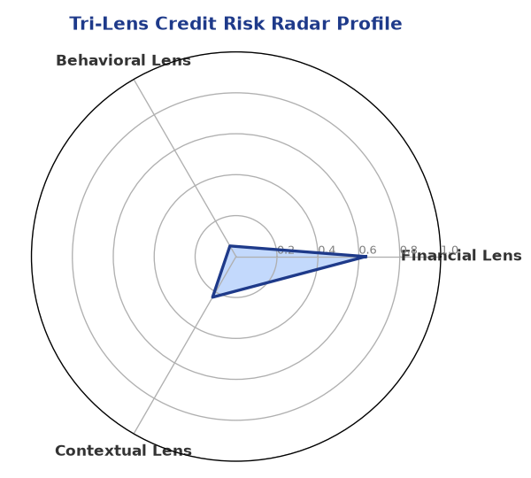
Multi-agent consensus radar chart (auto-embedded image)
SHAP Top-5 Risk Factors
# | Feature Name | SHAP Impact
1 | icr | 0.4500
2 | ebitda_margin | 0.3433
3 | current_ratio | 0.3339
4 | dscr | 0.2713
5 | leverage | 0.2239

Section C — AI Explainability: SHAP Waterfall
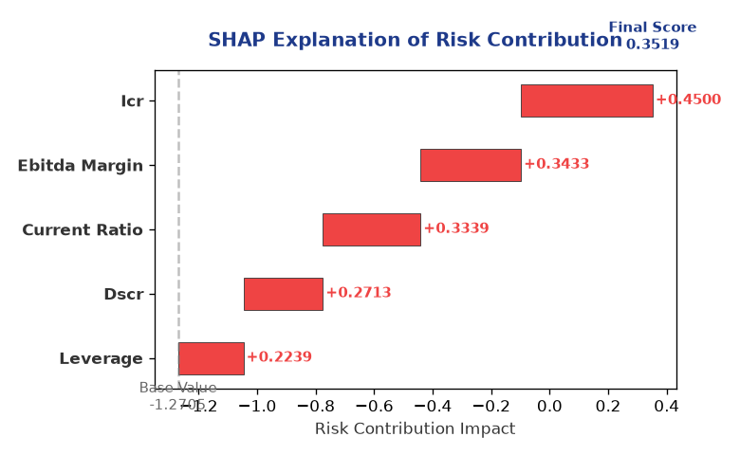
Explainability waterfall chart showing how the risk score was calculated

Section D — Rejection Reasons Corrective Actions (LLM-Generated)
Rejection Reasons | Corrective Actions
• Stress Test Failed: Debt service capacity collapses under simulated stress. | • Improve debt service capacity through debt restructuring or increasing cash flows  • Enhance ebitda margin through operational efficiency and cost optimization  • Reduce leverage through equity infusion or debt reduction

Section E — Comparable Case Analysis (Sector Peers Database Search)
Assumption flagged: the data dictionary lists only sector-average tags (sector_avg_dscr / sector_avg_icr / sector_avg_leverage). The per-peer rows below assume a list variable named "peer_companies" (fields: name, turnover, dscr, icr, leverage, cibil, credit_status) using a docxtpl row-loop. Confirm/rename this against what the peer-comparison agent actually returns.

Company Name | Turnover | DSCR | ICR | Leverage | CIBIL | Credit Status
Urja Renewables 722 Partnership Firm | ₹1.56 Cr | 1.5587 | 0.5345 | 2.2342 | 654 | REJECTED
Arogya Textiles 486 Partnership Firm | ₹1.56 Cr | 1.2752 | 0.6855 | 2.0072 | 691 | REJECTED
Radhe Pharma 856 LLP | ₹1.56 Cr | 1.0360 | 0.8005 | 1.9357 | 783 | REJECTED
Ambika Industries 456 LLP | ₹1.55 Cr | 1.3549 | 1.4649 | 1.2536 | 758 | APPROVED
Surya Enterprises 432 Private Limited | ₹1.61 Cr | 1.5427 | 1.3382 | 1.6898 | 793 | APPROVED
Sector Average | – | 1.2710 | 0.9351 | 1.8155 | – | –

7. Stress Testing Resilience Analysis
The following scenarios were stress-tested against the applicant's financial position to evaluate resilience under adverse conditions.

Section A — Stress Scenarios (Agent 9: stress-agent)
# | Scenario | Shocked DSCR | Verdict
1 | Revenue-20% | -1.1629 | CRITICAL
2 | Rate+2% (Assumes 100% Floating Debt) | 0.3907 | CRITICAL
3 | Combined | -1.0573 | CRITICAL

Worst-Case DSCR | -1.1629
Overall Survival Verdict | CRITICAL

8. Ethical AI, Personal Discussion Committee Sign-Off

Section A — Bias Fairness Audit (Agent 10: bias-agent)
Counterfactual Tested | YES ✓
Decision Flips Detected | 0
Overweighted Features | 0
Bias Audit Summary (LLM-Generated)
The AI decision has been tested for bias and shows no signs of unfairness, with zero flips indicating a robust and unbiased model. The risk assessment is based on a comprehensive evaluation of the company's financials, industry, and market position, ensuring a fair and balanced decision-making process.

Section B — Personal Discussion Summary (Agent 11: pd-agent)
Source Type | N/A
Risk Adjustment | +0.0000
PD Confidence Score | 0.00
Transcript Summary
No personal discussion was conducted; recommend scheduling one before final sign-off.
Qualitative Flags
None

Section C — Committee Sign-Off
Role | Name / Signature / Date
Prepared By | Trinetra Agentic Credit Intelligence OS
Reviewed By | _______________________________________
Approved By | _______________________________________
Date | _______________________________________
Signature | _______________________________________
DISCLAIMER: This Credit Appraisal Memorandum has been generated by the Trinetra Agentic Credit Intelligence OS. The AI-generated analysis is intended to assist credit officers and does not constitute a binding credit decision. All recommendations are subject to human review and approval in accordance with applicable regulations.

