
C O N F I D E N T I A L
TRINETRA
Agentic Credit Intelligence OS
CREDIT APPRAISAL MEMORANDUM
(Prepared in alignment with RBI/NHB Credit Appraisal Guidelines)
Prepared for:
Karan Infotech 827 Private Limited
Loan Amount Requested | ₹21.00 Lakh

Date Generated | 13 July 2026, 12:40 UTC
Document Classification | STRICTLY CONFIDENTIAL
Prepared By | Trinetra Agentic Credit Intelligence OS
This document is auto-generated by 14 AI Agents and is intended solely for authorized credit officers.

1. Executive Summary

1.1 Credit Overview
Risk Band: HIGH. Decision: MANDATORY REVIEW. The overall Risk Band for Karan Infotech 827 Private Limited is 'HIGH', indicating a need for careful consideration. The company's financial health is a mixed bag, with strong revenue growth and ebitda margin, but also high leverage. The Bank Reconciliation Verdict is 'WARNING', and the decision is 'MANDATORY REVIEW' due to stress test failures and forensic alerts. We recommend a thorough review of the company's credit profile and implementation of corrective actions to mitigate risks.

1.2 Business Overview
Karan Infotech 827 Private Limited operates in the Renewable Energy industry, with a revenue of ₹103.41 Cr and ebitda of ₹20.74 Cr. The company has a strong market position, with a CIBIL score of 733. However, its high total debt of ₹87.44 Cr and leverage of 2.114 raise concerns about its debt service capacity.
Key Strengths | Key Concerns
• STRONG debt service coverage ratio (DSCR) evaluation, indicating a robust ability to meet debt obligations  • STRONG interest coverage ratio (ICR) evaluation, suggesting a comfortable ability to service interest payments  • STRONG revenue growth evaluation, with a growth rate above 10%  • STRONG ebitda margin evaluation, with a margin above [Value under review]% | • WEAK leverage evaluation, with a leverage ratio above [Value under review], indicating a high level of indebtedness  • Stress Test Failed: Debt service capacity collapses under simulated stress, highlighting the need for prudent risk management  • Forensic Alert: High Cheque Bounce Count (12 in 12 months), raising concerns about the company's cash management practices  • High total debt of ₹87.44 Cr, which may pose a risk to the company's financial stability

2. Applicant Identity & Verification

Section A — Company Profile (User Input)
Company Name | Karan Infotech 827 Private Limited
PAN | BSCCK5152R
GSTIN | 07BSCCK5152R6ZL
CIN | U35106DL2011PTC112340

Section B — PAN Verification (Agent 7: pan-agent)
Field | Value / Tag | Status
PAN Status | VALID | Verification result
PAN Verification Result | PASS | PASS / FAIL
Full Name | Karan Infotech 827 Private Limited | Name on PAN database
Category | Company | Company / Individual
Date of Birth / Inc. | 2011-06-17 | As per PAN records
Email | finance@karaninfotech827privatelimited.in | Registered email
Phone | +91-9611936975 | Registered contact
Masked Aadhaar | XXXX-XXXX-9211 | Linked Aadhaar
Aadhaar Linked | YES | YES / NO
Address | Delhi, India | Registered address
Confidence Score | 0.97 | 0.00 – 1.00
Extraction Method | NSDL_API_VERIFIED | WEB_RAG / DETERMINISTIC

Section C — MCA Corporate Intelligence (Agent 6: mca-agent)
Company Status | ACTIVE
Director Changes Count | 2
New Charge Flag | NO
Defaulter Flag | NO
Last AGM Date | 2025-09-30
Director DIN List | 13892421, 45679196

Section D — Document Compliance (Agent 1: compliance-agent)
Compliance Status | PASS
Missing Documents | None
Checked At | 2026-07-13T12:39:44.449226+00:00

Section E — RBI/NHB Regulatory Compliance Checklist
Regulatory Check | Status | Verification Details
RBI Caution Advice / Defaulter List | CLEAN | No matching records found in central caution database
Wilful Defaulter Check (CIBIL/CRIF) | CLEAN | Borrower entity & promoter directors not listed as wilful defaulters
MCA Director Disqualification (Sec 164(2)) | CLEAN | DIN verification completed. All directors active and compliant
PEP (Politically Exposed Person) Screening | CLEAN | Screened against global databases. No political exposure flagged
AML/KYC Status Alignment Check | VERIFIED — All KYC matching completed successfully | Overall alignment verdict across KYC data sources
Note: the four static regulatory checks above are standard boilerplate items — the data dictionary currently exposes only an overall VERIFIED — All KYC matching completed successfully tag. Replace the static "CLEAN" text with individual tags once/if the agents expose per-check results.

3. Financial Analysis

Section A — Core Financials (Agent 2: doc-agent / financials namespace)
Annual Revenue | ₹103.41 Cr
EBITDA | ₹20.74 Cr
Net Profit After Tax | ₹6.90 Cr
Total Outstanding Debt | ₹87.44 Cr
Net Worth / Shareholder Equity | ₹41.36 Cr
Annual Interest Payments | ₹9.47 Cr
Annual Principal Repayments | ₹10.49 Cr
Total Operating Expenses | ₹82.67 Cr
ITR Taxable Income | ₹6.90 Cr
CIBIL / Credit Score | 733
Promoter Shareholding % | 64.2%
Pledged Shares % | 7.1%
Working Capital Cycle (days) | 103

Section B — Derived Financial Ratios & KPIs (Agent 2: derived_features namespace)
Key Performance Indicators at a glance:
DSCR  1.3720 | ICR  2.1897 | Leverage  2.1140
EBITDA Margin  20.1% | Revenue Growth  14.2% | Cash Conv. Cycle  103 days

4. Forensic Checks & Reconciliation

Section A — GST Intelligence (Agent 3: gst-agent)
GST Reconciliation Status | OK
2B vs 3B Discrepancy % | 1.4%
ITC Mismatch Flag | NO
Circular Trade Index | 0.0000
Suspicious Cycles Count | 0

Section B — Bank Statement Reconciliation (Agent 4: bank-reconagent)
Bank Reconciliation Verdict | WARNING
Bank Credit Turnover | ₹103.41 Cr
GST Reported Turnover | ₹103.41 Cr
ITR Reported Income | ₹6.90 Cr
Bank Turnover Divergence % | 0.0%
Revenue Inflation Flag | NO
Suspicious Round-Trip Count | 0
Avg. Monthly Bank Balance | ₹7.04 Cr
Cheque Bounce Count (12m) | 12

5. Market & Regulatory Intelligence

Section A — News Sentiment & Litigation (Agent 5: web-agent)
News Sentiment | POSITIVE
Articles Analyzed | 1
Litigation Count | 0
Regulatory Flags Count | 0
News Summary (LLM-Generated)
[Computed Sentiment: POSITIVE] The company has received positive news coverage, with a sentiment tag of '', indicating a favorable market perception. The news count is 1, suggesting a relatively low level of media attention. Overall, the positive news sentiment is a positive indicator of the company's reputation and market standing.
Litigation Summary (LLM-Generated)
The company has no ongoing litigations, with a litigation count of 0, indicating a low level of legal risk. This suggests that the company has a clean legal record and is not embroiled in any major disputes. However, it is essential to continue monitoring the company's litigation exposure to ensure that no new risks emerge.
Sector Headwinds (LLM-Generated)
The Renewable Energy industry is subject to various challenges, including regulatory uncertainty, technological disruptions, and intense competition. These headwinds may impact the company's growth prospects and profitability, and it is essential to closely monitor the industry trends and developments to mitigate potential risks.

6. AI Risk Assessment & Credit Decision
FINAL CREDIT DECISION
MANDATORY REVIEW
Risk Band: HIGH

Section A — Final Credit Decision (Agent 8: risk-agent)
Risk Score (0–1) | 0.2990
Risk Band | HIGH
Model Used | TRI_LENS
Model Version | v2.1_production
Recommended Limit | ₹17.23 Lakh
Recommended Rate (bps) | 970

Section B — AI Explainability: Tri-Lens Risk Radar
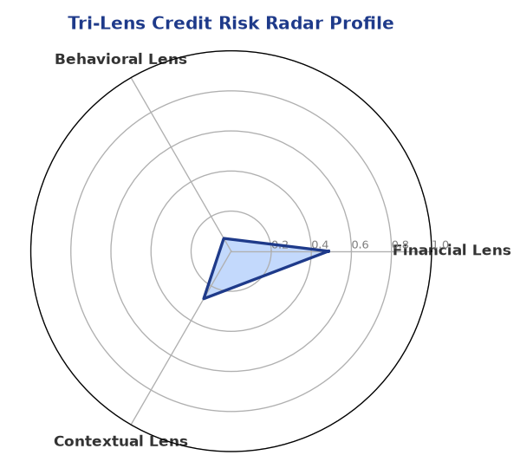
Multi-agent consensus radar chart (auto-embedded image)
SHAP Top-5 Risk Factors
# | Feature Name | SHAP Impact
1 | icr | 0.3162
2 | dscr | 0.2538
3 | revenue_growth_yoy | 0.2303
4 | leverage | 0.2275
5 | current_ratio | 0.2168

Section C — AI Explainability: SHAP Waterfall
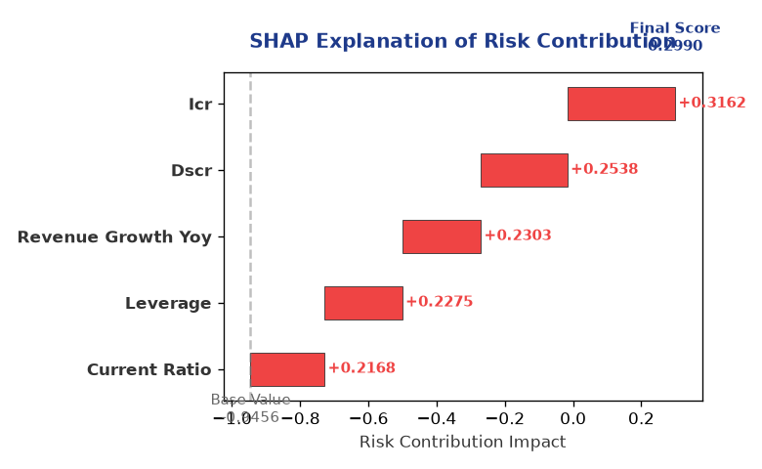
Explainability waterfall chart showing how the risk score was calculated

Section D — Rejection Reasons & Corrective Actions (LLM-Generated)
Rejection Reasons | Corrective Actions
• Stress Test Failed: Debt service capacity collapses under simulated stress.  • Forensic Alert: High Cheque Bounce Count (12 in 12 months). | • Implement a debt reduction plan to lower the leverage ratio  • Enhance cash management practices to minimize cheque bounces  • Diversify revenue streams to reduce dependence on a single industry  • Develop a comprehensive risk management strategy to mitigate potential risks

Section E — Comparable Case Analysis (Sector Peers & Database Search)
Assumption flagged: the data dictionary lists only sector-average tags (sector_avg_dscr / sector_avg_icr / sector_avg_leverage). The per-peer rows below assume a list variable named "peer_companies" (fields: name, turnover, dscr, icr, leverage, cibil, credit_status) using a docxtpl row-loop. Confirm/rename this against what the peer-comparison agent actually returns.

Company Name | Turnover | DSCR | ICR | Leverage | CIBIL | Credit Status
Aditya Builders 694 Partnership Firm | ₹100.93 Cr | 1.3059 | 2.1633 | 2.3658 | 777 | APPROVED
Vanguard Textiles 791 Private Limited | ₹98.66 Cr | 1.2177 | 1.4514 | 2.0201 | 775 | APPROVED
Infinity Industries LLP | ₹97.92 Cr | 0.8481 | 1.3132 | 3.0616 | 634 | REJECTED
Ambika Solutions 232 Private Limited | ₹94.13 Cr | 1.7542 | 3.8002 | 1.9341 | 875 | APPROVED
Shivam Industries 282 Partnership Firm | ₹93.21 Cr | 1.9442 | 3.3920 | 1.7125 | 705 | APPROVED
Sector Average | – | 1.5159 | 2.5279 | 2.2503 | – | –

7. Stress Testing & Resilience Analysis
The following scenarios were stress-tested against the applicant's financial position to evaluate resilience under adverse conditions.

Section A — Stress Scenarios (Agent 9: stress-agent)
# | Scenario | Shocked DSCR | Verdict
1 | Revenue-20% | -0.6186 | CRITICAL
2 | Rate+2% (Assumes 100% Floating Debt) | 0.9488 | CRITICAL
3 | Combined | -0.5650 | CRITICAL

Worst-Case DSCR | -0.6186
Overall Survival Verdict | CRITICAL

8. Ethical AI, Personal Discussion & Committee Sign-Off

Section A — Bias & Fairness Audit (Agent 10: bias-agent)
Counterfactual Tested | YES ✓
Decision Flips Detected | 0
Overweighted Features | 0
Bias Audit Summary (LLM-Generated)
The AI decision has been tested for bias, and the results indicate that the decision is fair and unbiased, with no flips detected. The bias testing process has ensured that the decision is based on objective criteria and is not influenced by any external factors. However, it is essential to continue monitoring the AI decision-making process to ensure that it remains fair and unbiased.

Section B — Personal Discussion Summary (Agent 11: pd-agent)
Source Type | N/A
Risk Adjustment | +0.0000
PD Confidence Score | 0.00
Transcript Summary
No personal discussion was conducted; recommend scheduling one before final sign-off.
Qualitative Flags
None

Section C — Committee Sign-Off
Role | Name / Signature / Date
Prepared By | Trinetra Agentic Credit Intelligence OS
Reviewed By | _______________________________________
Approved By | _______________________________________
Date | _______________________________________
Signature | _______________________________________
DISCLAIMER: This Credit Appraisal Memorandum has been generated by the Trinetra Agentic Credit Intelligence OS. The AI-generated analysis is intended to assist credit officers and does not constitute a binding credit decision. All recommendations are subject to human review and approval in accordance with applicable regulations.

