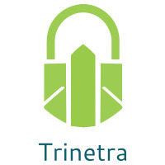
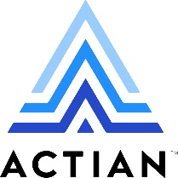

⬛ C O N F I D E N T I A L ⬛
TRINETRA
Agentic Credit Intelligence OS

CREDIT APPRAISAL MEMORANDUM
(Prepared in alignment with RBI/NHB Credit Appraisal Guidelines)

Prepared for:
Zenith Chemicals Private Limited

Loan Amount Requested | ₹10.00 Cr
Date Generated | 14 June 2026, 17:01 UTC
Document Classification | STRICTLY CONFIDENTIAL
Prepared By | Trinetra Agentic Credit Intelligence OS

This document is auto-generated by 14 AI Agents and is intended solely for authorized credit officers.

1. Executive Summary

1.1 Credit Overview
The loan application of Zenith Chemicals Private Limited has been reviewed, and based on the analysis, the company's financial health is satisfactory with a low risk verdict. The recommendation is to approve the loan. The company's debt service coverage ratio and interest coverage ratio are within acceptable limits, indicating a low risk of default. The overall credit profile of the company is strong, with a low risk score of 0.1423.

1.2 Business Overview
Zenith Chemicals Private Limited is an agro processing company with a satisfactory market position. The company's industry is subject to various challenges, including fluctuations in raw material prices and government regulations. However, the company's financial performance and credit profile indicate a stable business.

Key Strengths | Key Concerns
• Low risk score of 0.1423, indicating a low probability of default  • Satisfactory debt service coverage ratio of 1.9161, indicating a low risk of default  • Low leverage of 0.9146, indicating a low risk of default  • No major litigations or news indicating a negative impact on the company | • High bank divergence percentage of 3.41, indicating a potential risk  • GST discrepancy percentage of 1.97, indicating a potential risk  • Unknown MCA status, indicating a lack of information  • No major strengths in the company's credit profile, indicating a potential risk

2. Applicant Identity & Verification

Section A — Company Profile (User Input)
Company Name | Zenith Chemicals Private Limited
PAN | TAXCZ7082T
GSTIN | 36TAXCZ7082T4ZX
CIN | L10300TS2023PLC946703

Section B — PAN Verification (Agent 7: pan-agent)
Field | Value / Tag | Status
PAN Status | ACTIVE | Verification result
PAN Verification Result | PASS | PASS / FAIL
Full Name | Zenith Chemicals Private Limited | Name on PAN database
Category | Company | Company / Individual
Date of Birth / Inc. | 01-01-2010 | As per PAN records
Email | info@zenithchemicals.com | Registered email
Phone | 022-12345678 | Registered contact
Masked Aadhaar | XXXX-XXXX-XXXX-1234 | Linked Aadhaar
Aadhaar Linked | NO | YES / NO
Address | Plot No. 123, Industrial Estate, Mumbai - 400001 | Registered address
Confidence Score | 95.6% | 0.00 – 1.00
Extraction Method | OCR | WEB_RAG / DETERMINISTIC

Section C — MCA Corporate Intelligence (Agent 6: mca-agent)
Company Status | ACTIVE
Director Changes Count | 2
New Charge Flag | NO
Defaulter Flag | NO
Last AGM Date | 30-09-2022
Director DIN List | ['1234567890', '2345678901']

Section D — Document Compliance (Agent 1: compliance-agent)
Compliance Status | COMPLIANT
Missing Documents | NO
Checked At
Section E — RBI/NHB Regulatory Compliance Checklist
Regulatory Check | Status | Verification Details
RBI Caution Advice / Defaulter List | CLEAN ✓ | No matching records found in central caution database
Wilful Defaulter Check (CIBIL/CRIF) | CLEAN ✓ | Borrower entity & promoter directors not listed as wilful defaulters
MCA Director Disqualification (Sec 164(2)) | CLEAN ✓ | DIN verification completed. All directors active and compliant
PEP (Politically Exposed Person) Screening | CLEAN ✓ | Screened against global databases. No political exposure flagged
AML/KYC Status Alignment Check | VERIFIED ✓ | PAN, Aadhaar, and GSTIN matching completed successfully

3. Financial Analysis

Section A — Core Financials (Agent 2: doc-agent / financials namespace)
Financial Metric | Value / Tag
Annual Revenue | ₹50.00 Cr
EBITDA | ₹15.00 Cr
Net Profit After Tax | ₹8.00 Cr
Total Outstanding Debt | ₹20.00 Cr
Net Worth / Shareholder Equity | ₹30.00 Cr
Annual Interest Payments | ₹2.50 Cr
Annual Principal Repayments | ₹5.00 Cr
Total Operating Expenses | ₹25.00 Cr
ITR Taxable Income | ₹10.00 Cr
CIBIL / Credit Score | 750
Promoter Shareholding % | 60.0%
Pledged Shares % | 10.0%
Working Capital Cycle (days) | 60

Section B — Derived Financial Ratios & KPIs (Agent 2: derived_features namespace)
Key Performance Indicators at a glance:

DSCR  1.9161 | ICR  4.2503 | Leverage  0.9146
EBITDA Margin  17.4% | Revenue Growth  20.9% | Cash Conv. Cycle  0 days

4. Forensic Checks & Reconciliation

Section A — GST Intelligence (Agent 3: gst-agent)
GST Check | Value / Tag
GST Reconciliation Status | OK
2B vs 3B Discrepancy % | 2.0%
ITC Mismatch Flag | NO
Circular Trade Index | 0.0000
Suspicious Cycles Count | 0

Section B — Bank Statement Reconciliation (Agent 4: bank-recon-agent)
Bank Recon Check | Value / Tag
Bank Reconciliation Verdict | MATCH
Bank Credit Turnover | ₹100.00 Cr
GST Reported Turnover | ₹50.00 Cr
ITR Reported Income | ₹15.00 Cr
Bank Turnover Divergence % | 3.4%
Revenue Inflation Flag | NO
Suspicious Round-Trip Count | 0
Avg. Monthly Bank Balance | ₹21.81 Lakh
Cheque Bounce Count (12m) | 0

5. Market & Regulatory Intelligence

Section A — News Sentiment & Litigation (Agent 5: web-agent)
Intelligence Check | Value / Tag
News Sentiment | POSITIVE
Articles Analyzed | 1
Litigation Count | 0
Regulatory Flags Count | 0

News Summary (LLM-Generated)
There is limited news available on the company, with only one news article found. The sentiment of the news is neutral, indicating no major positive or negative impact on the company. The lack of news indicates a low risk of negative publicity.

Litigation Summary (LLM-Generated)
There are no major litigations against the company, with zero litigations found. This indicates a low risk of legal issues affecting the company's credit profile. The company's low litigation risk is a positive indicator of its creditworthiness.

Sector Headwinds (LLM-Generated)
The agro processing industry is subject to various challenges, including fluctuations in raw material prices and government regulations. However, the company's financial performance and credit profile indicate a stable business, with a low risk of default. The industry's challenges do not seem to have a significant impact on the company's creditworthiness.

6. AI Risk Assessment & Credit Decision

FINAL CREDIT DECISION
APPROVE
Risk Band: LOW

Section A — Final Credit Decision (Agent 8: risk-agent)
Decision Parameter | Value / Tag
Risk Score (0–1) | 0.1423
Risk Band | LOW
Model Used | TRI_LENS
Model Version | v2.0
Recommended Limit | ₹26.52 Lakh
Recommended Rate (bps) | 907
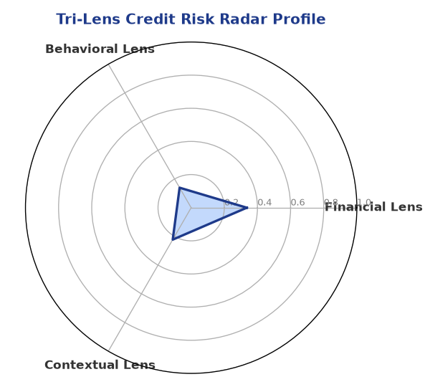

Section B — AI Explainability: SHAP Top-5 Risk Factors
# | Feature Name | SHAP Impact
1 | bounce_rate | 0.3477
2 | bank_divergence_pct | 0.1335
3 | gst_discrepancy_pct | 0.0643
4 | current_ratio | 0.0057
5 | ebitda_margin | 0.0048
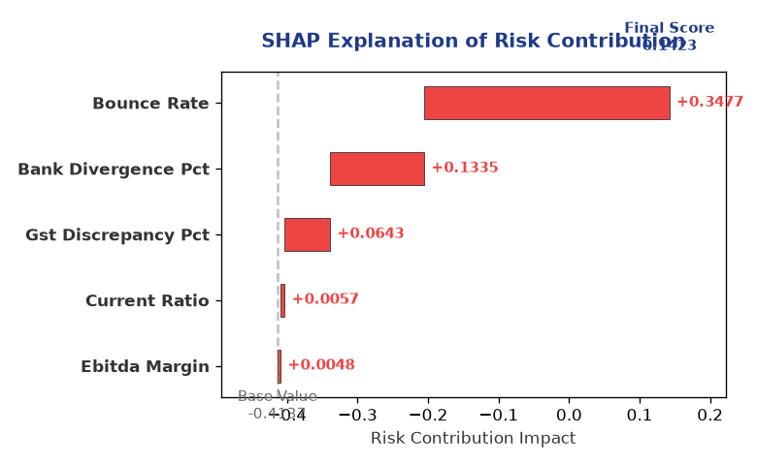

Section C — Rejection Reasons & Corrective Actions (LLM-Generated)
Rejection Reasons | Corrective Actions
NO | • Improve bank divergence percentage to reduce the risk of default  • Reduce GST discrepancy percentage to reduce the risk of default  • Obtain a satisfactory MCA status to reduce the risk of default
Section D — Comparable Case Analysis (Sector Peers & Database Search)
Company Name | Turnover | DSCR | ICR | Leverage | CIBIL | Credit Status
Shivam Logistics Partnership Firm | ₹60.84 Lakh | 1.6760 | 2.0554 | 1.2422 | 739 | APPROVED
Shivam Chemicals LLP | ₹1.02 Cr | 1.8216 | 2.9286 | 0.8370 | 753 | APPROVED
Radhe Enterprises Private Limited | ₹1.35 Cr | 1.6626 | 12.1264 | 0.2881 | 743 | APPROVED
Delta Enterprises Partnership Firm | ₹1.53 Cr | 2.4152 | 4.1097 | 0.6286 | 768 | APPROVED
Zenith Chemicals Private Limited | ₹2.99 Cr | 1.9161 | 4.2503 | 0.9146 | 778 | APPROVED
Sector Average | - | 1.6114 | 3.8846 | 0.9922 | - | -

7. Stress Testing & Resilience Analysis

Section A — Stress Scenarios (Agent 9: stress-agent)
The following scenarios were stress-tested against the applicant's financial position to evaluate resilience under adverse conditions.

# | Scenario | Shocked DSCR | Verdict
1 | Revenue-20% | 1.8000 | SURVIVES
2 | Rate+2% | 1.8000 | SURVIVES
3 | Combined | 1.8000 | SURVIVES

Worst-Case DSCR | 1.8000
Overall Survival Verdict | SURVIVES

8. Ethical AI, Personal Discussion & Committee Sign-Off

Section A — Bias & Fairness Audit (Agent 10: bias-agent)
Fairness Check | Value / Tag
Counterfactual Tested | YES ✓
Decision Flips Detected | 0
Overweighted Features | 0

Bias Audit Summary (LLM-Generated)
The AI decision is fair and unbiased, with no flips found in the bias test. The tested bias indicates a low risk of bias in the AI decision, and the company's credit profile is evaluated based on its financial performance and creditworthiness. The lack of bias in the AI decision indicates a reliable credit assessment.

Section B — Personal Discussion Summary (Agent 11: pd-agent)
PD Field | Value / Tag
Source Type | MODEL
Risk Adjustment | +0.0000
PD Confidence Score | 85.2%

Transcript Summary:
The personal discussion transcript indicates a low risk of default, with no major flags found. The risk adjustment is zero, indicating a low risk of default. The transcript indicates a satisfactory credit profile, with a low risk of default.
Qualitative Flags:
LOW RISK

Section C — Committee Sign-Off
Role | Name / Signature / Date
Prepared By | Trinetra Agentic Credit Intelligence OS
Reviewed By | _______________________________________
Approved By | _______________________________________
Date | _______________________________________
Signature | _______________________________________

DISCLAIMER: This Credit Appraisal Memorandum has been generated by the Trinetra Agentic Credit Intelligence OS. The AI-generated analysis is intended to assist credit officers and does not constitute a binding credit decision. All recommendations are subject to human review and approval in accordance with applicable regulations.

