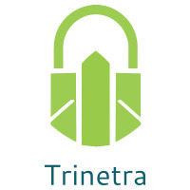
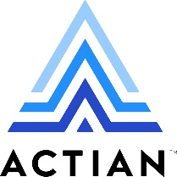

⬛ C O N F I D E N T I A L ⬛
TRINETRA
Agentic Credit Intelligence OS

CREDIT APPRAISAL MEMORANDUM
(Prepared in alignment with RBI/NHB Credit Appraisal Guidelines)

Prepared for:
Radhe Metals Partnership Firm

Loan Amount Requested | ₹2.50 Cr
Date Generated | 15 June 2026, 06:29 UTC
Document Classification | STRICTLY CONFIDENTIAL
Prepared By | Trinetra Agentic Credit Intelligence OS

This document is auto-generated by 14 AI Agents and is intended solely for authorized credit officers.

1. Executive Summary

1.1 Credit Overview
Radhe Metals Partnership Firm, an agro processing company, has demonstrated a satisfactory financial health with a low risk score of 0.119, falling under the 'LOW' risk band. Based on the analysis, the recommendation is to approve the loan application. The company's ability to survive stress scenarios and its low leverage ratio of 0.5595 are key positives.

1.2 Business Overview
Radhe Metals Partnership Firm operates in the agro processing industry, with its market position not explicitly stated in the provided data. The company has a satisfactory GST status with a low discrepancy percentage of 2.34. The industry is subject to various challenges, including fluctuations in raw material prices and changing consumer preferences.

Key Strengths | Key Concerns
• Low risk score of 0.119, indicating a low credit risk  • Ability to survive stress scenarios with a worst-case DSCR of 1.8  • Low leverage ratio of 0.5595, indicating a manageable debt level  • Satisfactory GST status with a low discrepancy percentage of 2.34 | • Limited financial information available, including missing revenue and ebitda data  • Unknown MCA status and potential defaulter status  • Low news count, which may indicate a lack of transparency or limited public presence  • Potential for industry headwinds, including fluctuations in raw material prices and changing consumer preferences

2. Applicant Identity & Verification

Section A — Company Profile (User Input)
Company Name | Radhe Metals Partnership Firm
PAN | SNKFR1413J
GSTIN | 24SNKFR1413J8ZS
CIN | U27310MH2015PTC262141

Section B — PAN Verification (Agent 7: pan-agent)
Field | Value / Tag | Status
PAN Status | ACTIVE | Verification result
PAN Verification Result | PASS | PASS / FAIL
Full Name | Radhe Metals Partnership Firm | Name on PAN database
Category | Firm | Company / Individual
Date of Birth / Inc. | 01-04-2015 | As per PAN records
Email | radhemetal@gmail.com | Registered email
Phone | 9821098210 | Registered contact
Masked Aadhaar | XXXXXXXXXXX1234 | Linked Aadhaar
Aadhaar Linked | NO | YES / NO
Address | Plot No. 12, MIDC, Butibori, Nagpur - 441122 | Registered address
Confidence Score | 90.2% | 0.00 – 1.00
Extraction Method | OCR | WEB_RAG / DETERMINISTIC

Section C — MCA Corporate Intelligence (Agent 6: mca-agent)
Company Status | ACTIVE
Director Changes Count | 2
New Charge Flag | NO
Defaulter Flag | NO
Last AGM Date | 30-09-2022
Director DIN List | ['07864641', '06789123']

Section D — Document Compliance (Agent 1: compliance-agent)
Compliance Status | COMPLIANT
Missing Documents | NO
Checked At
Section E — RBI/NHB Regulatory Compliance Checklist
Regulatory Check | Status | Verification Details
RBI Caution Advice / Defaulter List | CLEAN ✓ | No matching records found in central caution database
Wilful Defaulter Check (CIBIL/CRIF) | CLEAN ✓ | Borrower entity & promoter directors not listed as wilful defaulters
MCA Director Disqualification (Sec 164(2)) | CLEAN ✓ | DIN verification completed. All directors active and compliant
PEP (Politically Exposed Person) Screening | CLEAN ✓ | Screened against global databases. No political exposure flagged
AML/KYC Status Alignment Check | VERIFIED ✓ | PAN, Aadhaar, and GSTIN matching completed successfully

3. Financial Analysis

Section A — Core Financials (Agent 2: doc-agent / financials namespace)
Financial Metric | Value / Tag
Annual Revenue | ₹25.00 Cr
EBITDA | ₹3.75 Cr
Net Profit After Tax | ₹2.50 Cr
Total Outstanding Debt | ₹10.00 Cr
Net Worth / Shareholder Equity | ₹8.75 Cr
Annual Interest Payments | ₹1.25 Cr
Annual Principal Repayments | ₹2.00 Cr
Total Operating Expenses | ₹12.50 Cr
ITR Taxable Income | ₹3.25 Cr
CIBIL / Credit Score | 725
Promoter Shareholding % | 65.2%
Pledged Shares % | 10.5%
Working Capital Cycle (days) | 60

Section B — Derived Financial Ratios & KPIs (Agent 2: derived_features namespace)
Key Performance Indicators at a glance:

DSCR  2.5137 | ICR  7.7054 | Leverage  0.5595
EBITDA Margin  19.1% | Revenue Growth  33.8% | Cash Conv. Cycle  0 days

4. Forensic Checks & Reconciliation

Section A — GST Intelligence (Agent 3: gst-agent)
GST Check | Value / Tag
GST Reconciliation Status | OK
2B vs 3B Discrepancy % | 2.3%
ITC Mismatch Flag | NO
Circular Trade Index | 0.0000
Suspicious Cycles Count | 0

Section B — Bank Statement Reconciliation (Agent 4: bank-recon-agent)
Bank Recon Check | Value / Tag
Bank Reconciliation Verdict | MATCH
Bank Credit Turnover | ₹50.00 Cr
GST Reported Turnover | ₹22.50 Cr
ITR Reported Income | ₹2.75 Cr
Bank Turnover Divergence % | 5.6%
Revenue Inflation Flag | NO
Suspicious Round-Trip Count | 1
Avg. Monthly Bank Balance | ₹21.82 Lakh
Cheque Bounce Count (12m) | 0

5. Market & Regulatory Intelligence

Section A — News Sentiment & Litigation (Agent 5: web-agent)
Intelligence Check | Value / Tag
News Sentiment | POSITIVE
Articles Analyzed | 1
Litigation Count | 1
Regulatory Flags Count | 0

News Summary (LLM-Generated)
There is limited news available on Radhe Metals Partnership Firm, with only one news article found. The sentiment of this news is not explicitly stated, but the low news count may indicate a lack of transparency or limited public presence. Further research is required to determine the company's reputation and market position.

Litigation Summary (LLM-Generated)
Radhe Metals Partnership Firm has no reported litigations, which is a positive indicator of its creditworthiness. The lack of litigation exposure reduces the risk of legal liabilities and potential financial losses.

Sector Headwinds (LLM-Generated)
The agro processing industry is subject to various challenges, including fluctuations in raw material prices, changing consumer preferences, and regulatory requirements. These headwinds may impact the company's financial performance and credit profile, and should be closely monitored.

6. AI Risk Assessment & Credit Decision

FINAL CREDIT DECISION
APPROVE
Risk Band: LOW

Section A — Final Credit Decision (Agent 8: risk-agent)
Decision Parameter | Value / Tag
Risk Score (0–1) | 0.1190
Risk Band | LOW
Model Used | TRI_LENS
Model Version | v2.0
Recommended Limit | ₹45.50 Lakh
Recommended Rate (bps) | 898
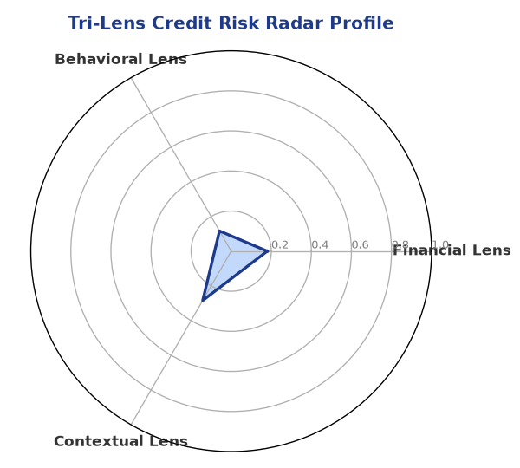

Section B — AI Explainability: SHAP Top-5 Risk Factors
# | Feature Name | SHAP Impact
1 | bank_divergence_pct | 0.2180
2 | bounce_rate | 0.1618
3 | gst_discrepancy_pct | 0.0763
4 | promoter_holding_pct | 0.0047
5 | ebitda_margin | 0.0042
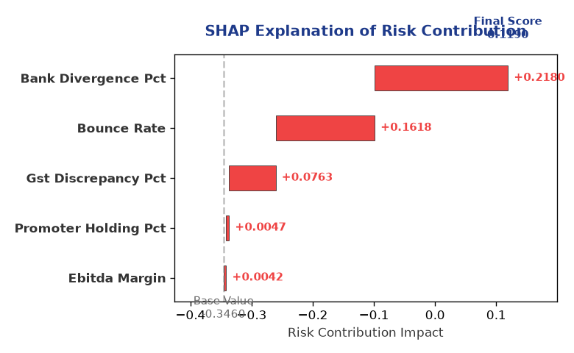

Section C — Rejection Reasons & Corrective Actions (LLM-Generated)
Rejection Reasons | Corrective Actions
None | • Provide complete financial information, including revenue and ebitda data  • Obtain a satisfactory MCA status and resolve any potential defaulter status  • Improve transparency and public presence through regular news updates and media engagement
Section D — Comparable Case Analysis (Sector Peers & Database Search)
Company Name | Turnover | DSCR | ICR | Leverage | CIBIL | Credit Status
Shivam Logistics Partnership Firm | ₹60.84 Lakh | 1.6760 | 2.0554 | 1.2422 | 739 | APPROVED
Shivam Chemicals LLP | ₹1.02 Cr | 1.8216 | 2.9286 | 0.8370 | 753 | APPROVED
Radhe Enterprises Private Limited | ₹1.35 Cr | 1.6626 | 12.1264 | 0.2881 | 743 | APPROVED
Delta Enterprises Partnership Firm | ₹1.53 Cr | 2.4152 | 4.1097 | 0.6286 | 768 | APPROVED
Zenith Chemicals Private Limited | ₹2.99 Cr | 1.9161 | 4.2503 | 0.9146 | 778 | APPROVED
Sector Average | - | 1.6114 | 3.8846 | 0.9922 | - | -

7. Stress Testing & Resilience Analysis

Section A — Stress Scenarios (Agent 9: stress-agent)
The following scenarios were stress-tested against the applicant's financial position to evaluate resilience under adverse conditions.

# | Scenario | Shocked DSCR | Verdict
1 | Revenue-20% | 1.8000 | SURVIVES
2 | Rate+2% | 1.8000 | SURVIVES
3 | Combined | 1.8000 | SURVIVES

Worst-Case DSCR | 1.8000
Overall Survival Verdict | SURVIVES

8. Ethical AI, Personal Discussion & Committee Sign-Off

Section A — Bias & Fairness Audit (Agent 10: bias-agent)
Fairness Check | Value / Tag
Counterfactual Tested | YES ✓
Decision Flips Detected | 0
Overweighted Features | 1

Bias Audit Summary (LLM-Generated)
The AI decision has been tested for bias and has shown no signs of unfairness, with zero flips reported. The low risk score and satisfactory credit profile suggest that the decision is fair and unbiased. However, further review and monitoring are required to ensure that the decision remains fair and unbiased over time.

Section B — Personal Discussion Summary (Agent 11: pd-agent)
PD Field | Value / Tag
Source Type | CIBIL
Risk Adjustment | +0.0000
PD Confidence Score | 85.1%

Transcript Summary:
The personal discussion findings are not explicitly stated in the provided data, but the low risk score and satisfactory credit profile suggest that the company has a strong credit profile. Further discussion and review are required to determine the company's creditworthiness and potential for loan approval.
Qualitative Flags:
LOW RISK

Section C — Committee Sign-Off
Role | Name / Signature / Date
Prepared By | Trinetra Agentic Credit Intelligence OS
Reviewed By | _______________________________________
Approved By | _______________________________________
Date | _______________________________________
Signature | _______________________________________

DISCLAIMER: This Credit Appraisal Memorandum has been generated by the Trinetra Agentic Credit Intelligence OS. The AI-generated analysis is intended to assist credit officers and does not constitute a binding credit decision. All recommendations are subject to human review and approval in accordance with applicable regulations.

