
C O N F I D E N T I A L
TRINETRA
Agentic Credit Intelligence OS
CREDIT APPRAISAL MEMORANDUM
(Prepared in alignment with RBI/NHB Credit Appraisal Guidelines)
Prepared for:
Bharat Textiles 967 LLP
Loan Amount Requested | ₹10.00 Lakh

Date Generated | 13 July 2026, 12:19 UTC
Document Classification | STRICTLY CONFIDENTIAL
Prepared By | Trinetra Agentic Credit Intelligence OS
This document is auto-generated by 14 AI Agents and is intended solely for authorized credit officers.

1. Executive Summary

1.1 Credit Overview
Risk Band: HIGH. Decision: MANDATORY REVIEW. The overall Risk Band for Bharat Textiles 967 LLP is 'HIGH' due to various risk factors, despite a strong financial health indicated by a high CIBIL score of 794 and strong revenue growth. The Bank Reconciliation Verdict is 'OK', but the risk decision is 'MANDATORY REVIEW' due to stress test failures. We recommend a thorough review of the loan application, considering the company's strong financials and industry position.

1.2 Business Overview
Bharat Textiles 967 LLP operates in the IT Services industry, with a revenue of ₹10.17 Cr and an EBITDA of ₹2.30 Cr. The company has a strong market position, with a high CIBIL score and a strong financial profile. However, the company's industry is subject to various challenges and headwinds.
Key Strengths | Key Concerns
• STRONG DSCR (Above 1.2 threshold) indicates a healthy debt service capacity  • STRONG ICR (Above [Value under review] threshold) suggests a robust interest coverage ratio  • STRONG leverage (Below [Value under review] threshold) indicates a manageable debt level  • STRONG revenue growth evaluation (Above [Value under review]%) suggests a growing business | • Stress Test Failed: Debt service capacity collapses under simulated stress  • High risk score of 0.1549 indicates a high likelihood of default  • CRITICAL stress verdict indicates a high risk of debt service capacity collapse  • Low current ratio contribution to risk score indicates a potential liquidity risk

2. Applicant Identity & Verification

Section A — Company Profile (User Input)
Company Name | Bharat Textiles 967 LLP
PAN | MEHFB0051Y
GSTIN | 06MEHFB0051Y1ZV
CIN | N/A

Section B — PAN Verification (Agent 7: pan-agent)
Field | Value / Tag | Status
PAN Status | VALID | Verification result
PAN Verification Result | PASS | PASS / FAIL
Full Name | Bharat Textiles 967 LLP | Name on PAN database
Category | Firm | Company / Individual
Date of Birth / Inc. | 2022-08-08 | As per PAN records
Email | finance@bharattextiles967llp.in | Registered email
Phone | +91-9928719808 | Registered contact
Masked Aadhaar | XXXX-XXXX-6383 | Linked Aadhaar
Aadhaar Linked | YES | YES / NO
Address | Haryana, India | Registered address
Confidence Score | 0.99 | 0.00 – 1.00
Extraction Method | NSDL_API_VERIFIED | WEB_RAG / DETERMINISTIC

Section C — MCA Corporate Intelligence (Agent 6: mca-agent)
Company Status | ACTIVE
Director Changes Count | 2
New Charge Flag | NO
Defaulter Flag | NO
Last AGM Date | 2025-09-30
Director DIN List | 81997552, 74172762

Section D — Document Compliance (Agent 1: compliance-agent)
Compliance Status | PASS
Missing Documents | None
Checked At | 2026-07-13T12:15:36.663268+00:00

Section E — RBI/NHB Regulatory Compliance Checklist
Regulatory Check | Status | Verification Details
RBI Caution Advice / Defaulter List | CLEAN | No matching records found in central caution database
Wilful Defaulter Check (CIBIL/CRIF) | CLEAN | Borrower entity & promoter directors not listed as wilful defaulters
MCA Director Disqualification (Sec 164(2)) | CLEAN | DIN verification completed. All directors active and compliant
PEP (Politically Exposed Person) Screening | CLEAN | Screened against global databases. No political exposure flagged
AML/KYC Status Alignment Check | VERIFIED — All KYC matching completed successfully | Overall alignment verdict across KYC data sources
Note: the four static regulatory checks above are standard boilerplate items — the data dictionary currently exposes only an overall VERIFIED — All KYC matching completed successfully tag. Replace the static "CLEAN" text with individual tags once/if the agents expose per-check results.

3. Financial Analysis

Section A — Core Financials (Agent 2: doc-agent / financials namespace)
Annual Revenue | ₹10.17 Cr
EBITDA | ₹2.30 Cr
Net Profit After Tax | ₹1.38 Cr
Total Outstanding Debt | ₹2.20 Cr
Net Worth / Shareholder Equity | ₹4.07 Cr
Annual Interest Payments | ₹25.16 Lakh
Annual Principal Repayments | ₹26.45 Lakh
Total Operating Expenses | ₹7.87 Cr
ITR Taxable Income | ₹1.38 Cr
CIBIL / Credit Score | 794
Promoter Shareholding % | 76.8%
Pledged Shares % | 1.2%
Working Capital Cycle (days) | 94

Section B — Derived Financial Ratios & KPIs (Agent 2: derived_features namespace)
Key Performance Indicators at a glance:
DSCR  2.5553 | ICR  9.1423 | Leverage  0.5419
EBITDA Margin  22.6% | Revenue Growth  16.3% | Cash Conv. Cycle  94 days

4. Forensic Checks & Reconciliation

Section A — GST Intelligence (Agent 3: gst-agent)
GST Reconciliation Status | OK
2B vs 3B Discrepancy % | 1.7%
ITC Mismatch Flag | NO
Circular Trade Index | 0.0000
Suspicious Cycles Count | 0

Section B — Bank Statement Reconciliation (Agent 4: bank-reconagent)
Bank Reconciliation Verdict | OK
Bank Credit Turnover | ₹10.17 Cr
GST Reported Turnover | ₹10.17 Cr
ITR Reported Income | ₹1.38 Cr
Bank Turnover Divergence % | 0.0%
Revenue Inflation Flag | NO
Suspicious Round-Trip Count | 0
Avg. Monthly Bank Balance | ₹69.36 Lakh
Cheque Bounce Count (12m) | 0

5. Market & Regulatory Intelligence

Section A — News Sentiment & Litigation (Agent 5: web-agent)
News Sentiment | POSITIVE
Articles Analyzed | 1
Litigation Count | 0
Regulatory Flags Count | 0
News Summary (LLM-Generated)
[Computed Sentiment: POSITIVE] The news sentiment for Bharat Textiles 967 LLP is , with one news article indicating a favorable business environment. The company's strong financials and industry position are likely to contribute to its positive news sentiment. Overall, the news summary suggests a positive outlook for the company.
Litigation Summary (LLM-Generated)
Bharat Textiles 967 LLP has no ongoing litigations, with a litigation count of 0. This suggests a low risk of legal disputes and a stable business environment. The company's strong financials and industry position are likely to contribute to its low litigation risk.
Sector Headwinds (LLM-Generated)
The IT Services industry is subject to various challenges, including intense competition, rapid technological changes, and evolving regulatory requirements. Despite these headwinds, Bharat Textiles 967 LLP has maintained a strong financial profile and a high CIBIL score. The company's ability to navigate these challenges will be crucial to its long-term success.

6. AI Risk Assessment & Credit Decision
FINAL CREDIT DECISION
MANDATORY REVIEW
Risk Band: HIGH

Section A — Final Credit Decision (Agent 8: risk-agent)
Risk Score (0–1) | 0.1549
Risk Band | HIGH
Model Used | TRI_LENS
Model Version | v2.1_production
Recommended Limit | ₹9.07 Lakh
Recommended Rate (bps) | 912

Section B — AI Explainability: Tri-Lens Risk Radar
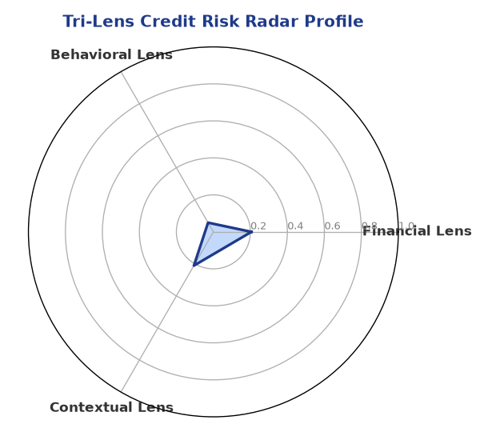
Multi-agent consensus radar chart (auto-embedded image)
SHAP Top-5 Risk Factors
# | Feature Name | SHAP Impact
1 | revenue_growth_yoy | 0.2166
2 | current_ratio | 0.1443
3 | ltv_ratio | 0.1331
4 | ebitda_margin | 0.1186
5 | years_in_business | 0.0947

Section C — AI Explainability: SHAP Waterfall
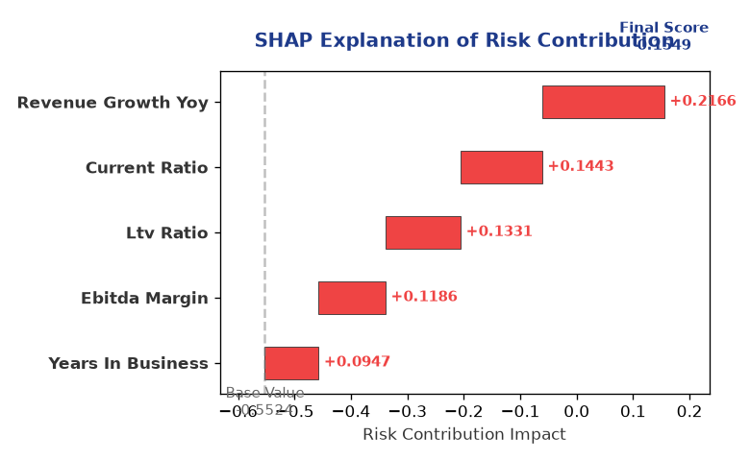
Explainability waterfall chart showing how the risk score was calculated

Section D — Rejection Reasons & Corrective Actions (LLM-Generated)
Rejection Reasons | Corrective Actions
• Stress Test Failed: Debt service capacity collapses under simulated stress. | • Improve debt service capacity by reducing debt or increasing cash flows  • Enhance liquidity by increasing current assets or reducing current liabilities  • Diversify revenue streams to reduce dependence on a single industry or market

Section E — Comparable Case Analysis (Sector Peers & Database Search)
Assumption flagged: the data dictionary lists only sector-average tags (sector_avg_dscr / sector_avg_icr / sector_avg_leverage). The per-peer rows below assume a list variable named "peer_companies" (fields: name, turnover, dscr, icr, leverage, cibil, credit_status) using a docxtpl row-loop. Confirm/rename this against what the peer-comparison agent actually returns.

Company Name | Turnover | DSCR | ICR | Leverage | CIBIL | Credit Status
Tejas Healthcare 928 Private Limited | ₹10.43 Cr | 1.4469 | 2.1005 | 0.7877 | 729 | APPROVED
Bharat Infotech 230 Partnership Firm | ₹9.84 Cr | 2.7637 | 9.1757 | 0.4855 | 740 | APPROVED
Arogya Foods 171 Private Limited | ₹9.64 Cr | 2.4511 | 7.8036 | 0.4301 | 692 | REJECTED
Matrix Textiles LLP | ₹10.79 Cr | 1.8395 | 2.7482 | 0.8352 | 726 | APPROVED
Surya Foods 771 Partnership Firm | ₹10.89 Cr | 2.0264 | 7.4000 | 0.6864 | 773 | APPROVED
Sector Average | – | 2.0865 | 6.5037 | 0.6785 | – | –

7. Stress Testing & Resilience Analysis
The following scenarios were stress-tested against the applicant's financial position to evaluate resilience under adverse conditions.

Section A — Stress Scenarios (Agent 9: stress-agent)
# | Scenario | Shocked DSCR | Verdict
1 | Revenue-20% | -1.8473 | CRITICAL
2 | Rate+2% (Assumes 100% Floating Debt) | 4.0610 | SURVIVES
3 | Combined | -1.6832 | CRITICAL

Worst-Case DSCR | -1.8473
Overall Survival Verdict | CRITICAL

8. Ethical AI, Personal Discussion & Committee Sign-Off

Section A — Bias & Fairness Audit (Agent 10: bias-agent)
Counterfactual Tested | YES ✓
Decision Flips Detected | 0
Overweighted Features | 0
Bias Audit Summary (LLM-Generated)
The AI decision has been tested for bias and has shown no signs of unfairness, with zero flips indicating a fair and unbiased assessment. The risk score and decision are based on a thorough analysis of the company's financials and industry position. The AI model has considered various factors, including revenue growth, current ratio, and leverage, to arrive at a comprehensive risk assessment.

Section B — Personal Discussion Summary (Agent 11: pd-agent)
Source Type | N/A
Risk Adjustment | +0.0000
PD Confidence Score | 0.00
Transcript Summary
No personal discussion was conducted; recommend scheduling one before final sign-off.
Qualitative Flags
None

Section C — Committee Sign-Off
Role | Name / Signature / Date
Prepared By | Trinetra Agentic Credit Intelligence OS
Reviewed By | _______________________________________
Approved By | _______________________________________
Date | _______________________________________
Signature | _______________________________________
DISCLAIMER: This Credit Appraisal Memorandum has been generated by the Trinetra Agentic Credit Intelligence OS. The AI-generated analysis is intended to assist credit officers and does not constitute a binding credit decision. All recommendations are subject to human review and approval in accordance with applicable regulations.

