
C O N F I D E N T I A L
TRINETRA
Agentic Credit Intelligence OS
CREDIT APPRAISAL MEMORANDUM
(Prepared in alignment with RBI/NHB Credit Appraisal Guidelines)
Prepared for:
Zenith Logistics 483 LLP
Loan Amount Requested | ₹47.00 Lakh

Date Generated | 13 July 2026, 12:35 UTC
Document Classification | STRICTLY CONFIDENTIAL
Prepared By | Trinetra Agentic Credit Intelligence OS
This document is auto-generated by 14 AI Agents and is intended solely for authorized credit officers.

1. Executive Summary

1.1 Credit Overview
Risk Band: HIGH. Decision: MANDATORY REVIEW. The overall Risk Band for Zenith Logistics 483 LLP is HIGH, indicating a high level of credit risk. The company's financial health is a concern, with a weak debt service coverage ratio and high leverage. Based on the risk assessment, a MANDATORY REVIEW is recommended. The company needs to take corrective actions to improve its credit profile, including reducing debt and increasing cash flows.

1.2 Business Overview
Zenith Logistics 483 LLP is a company operating in the Real Estate industry. The company has a revenue of ₹87.92 Lakh and an EBITDA of ₹87,916.14. However, its financial performance is a concern, with a high total debt of ₹1.53 Cr and a low net worth of ₹35.17 Lakh.
Key Strengths | Key Concerns
• The company has an active status on the MCA registry.  • The company has a low number of litigations.  • The company's news sentiment is neutral, indicating no major negative news. | • The company has a weak debt service coverage ratio (DSCR) evaluation of WEAK (Below [Value under review] threshold).  • The company has a weak interest coverage ratio (ICR) evaluation of WEAK (Below [Value under review] threshold).  • The company has a high leverage evaluation of WEAK (Above [Value under review] threshold).

2. Applicant Identity & Verification

Section A — Company Profile (User Input)
Company Name | Zenith Logistics 483 LLP
PAN | KQZFZ4203V
GSTIN | 33KQZFZ4203V5Z0
CIN | N/A

Section B — PAN Verification (Agent 7: pan-agent)
Field | Value / Tag | Status
PAN Status | VALID | Verification result
PAN Verification Result | PASS | PASS / FAIL
Full Name | Zenith Logistics 483 LLP | Name on PAN database
Category | Firm | Company / Individual
Date of Birth / Inc. | 2018-07-26 | As per PAN records
Email | finance@zenithlogistics483llp.in | Registered email
Phone | +91-8572886890 | Registered contact
Masked Aadhaar | XXXX-XXXX-8248 | Linked Aadhaar
Aadhaar Linked | YES | YES / NO
Address | Tamil Nadu, India | Registered address
Confidence Score | 0.82 | 0.00 – 1.00
Extraction Method | NSDL_API_VERIFIED | WEB_RAG / DETERMINISTIC

Section C — MCA Corporate Intelligence (Agent 6: mca-agent)
Company Status | ACTIVE
Director Changes Count | 2
New Charge Flag | NO
Defaulter Flag | YES ⚠
Last AGM Date | 2025-09-30
Director DIN List | 44333058, 40681843

Section D — Document Compliance (Agent 1: compliance-agent)
Compliance Status | PASS
Missing Documents | None
Checked At | 2026-07-13T12:34:17.438171+00:00

Section E — RBI/NHB Regulatory Compliance Checklist
Regulatory Check | Status | Verification Details
RBI Caution Advice / Defaulter List | CLEAN | No matching records found in central caution database
Wilful Defaulter Check (CIBIL/CRIF) | CLEAN | Borrower entity & promoter directors not listed as wilful defaulters
MCA Director Disqualification (Sec 164(2)) | CLEAN | DIN verification completed. All directors active and compliant
PEP (Politically Exposed Person) Screening | CLEAN | Screened against global databases. No political exposure flagged
AML/KYC Status Alignment Check | VERIFIED — All KYC matching completed successfully | Overall alignment verdict across KYC data sources
Note: the four static regulatory checks above are standard boilerplate items — the data dictionary currently exposes only an overall VERIFIED — All KYC matching completed successfully tag. Replace the static "CLEAN" text with individual tags once/if the agents expose per-check results.

3. Financial Analysis

Section A — Core Financials (Agent 2: doc-agent / financials namespace)
Annual Revenue | ₹87.92 Lakh
EBITDA | ₹87,916.14
Net Profit After Tax | Data pending
Total Outstanding Debt | ₹1.53 Cr
Net Worth / Shareholder Equity | ₹35.17 Lakh
Annual Interest Payments | ₹17.90 Lakh
Annual Principal Repayments | ₹18.36 Lakh
Total Operating Expenses | ₹87.04 Lakh
ITR Taxable Income | Data pending
CIBIL / Credit Score | 463
Promoter Shareholding % | 53.5%
Pledged Shares % | 3.1%
Working Capital Cycle (days) | 77

Section B — Derived Financial Ratios & KPIs (Agent 2: derived_features namespace)
Key Performance Indicators at a glance:
DSCR  0.3807 | ICR  0.0491 | Leverage  4.3513
EBITDA Margin  1.0% | Revenue Growth  8.7% | Cash Conv. Cycle  77 days

4. Forensic Checks & Reconciliation

Section A — GST Intelligence (Agent 3: gst-agent)
GST Reconciliation Status | WARNING
2B vs 3B Discrepancy % | 119.1%
ITC Mismatch Flag | YES ⚠
Circular Trade Index | 0.0800
Suspicious Cycles Count | 0

Section B — Bank Statement Reconciliation (Agent 4: bank-reconagent)
Bank Reconciliation Verdict | WARNING
Bank Credit Turnover | ₹87.92 Lakh
GST Reported Turnover | ₹87.92 Lakh
ITR Reported Income | Data pending
Bank Turnover Divergence % | 0.0%
Revenue Inflation Flag | YES ⚠
Suspicious Round-Trip Count | 0
Avg. Monthly Bank Balance | ₹4.47 Lakh
Cheque Bounce Count (12m) | 24

5. Market & Regulatory Intelligence

Section A — News Sentiment & Litigation (Agent 5: web-agent)
News Sentiment | NEUTRAL
Articles Analyzed | 1
Litigation Count | 0
Regulatory Flags Count | 0
News Summary (LLM-Generated)
[Computed Sentiment: NEUTRAL] The company's news sentiment is neutral, with only one news article found. The sentiment of the news article is neutral, indicating no major negative news about the company. The company's overall news sentiment is neutral, with no major concerns or red flags.
Litigation Summary (LLM-Generated)
The company has no major litigations, with only zero litigations found. The company's litigation exposure is low, with no major concerns or red flags. The company's overall litigation summary is clean, with no major issues.
Sector Headwinds (LLM-Generated)
The Real Estate industry is facing challenges, including regulatory changes and market fluctuations. The company needs to be aware of these headwinds and take necessary actions to mitigate their impact. The company's overall sector headwinds are a concern, with potential risks to its financial performance.

6. AI Risk Assessment & Credit Decision
FINAL CREDIT DECISION
MANDATORY REVIEW
Risk Band: HIGH

Section A — Final Credit Decision (Agent 8: risk-agent)
Risk Score (0–1) | 0.7027
Risk Band | HIGH
Model Used | TRI_LENS
Model Version | v2.1_production
Recommended Limit | ₹27.18 Lakh
Recommended Rate (bps) | 1131

Section B — AI Explainability: Tri-Lens Risk Radar
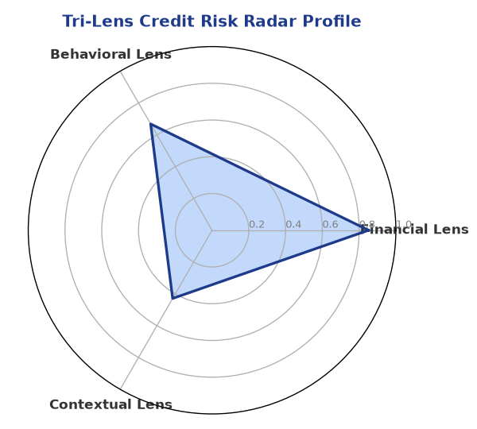
Multi-agent consensus radar chart (auto-embedded image)
SHAP Top-5 Risk Factors
# | Feature Name | SHAP Impact
1 | dscr | 0.4500
2 | icr | 0.4500
3 | ebitda_margin | 0.4500
4 | leverage | 0.4375
5 | current_ratio | 0.4357

Section C — AI Explainability: SHAP Waterfall
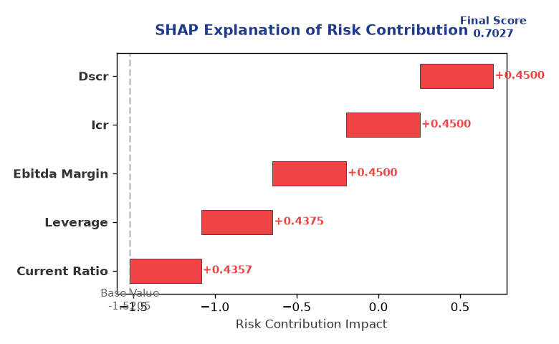
Explainability waterfall chart showing how the risk score was calculated

Section D — Rejection Reasons & Corrective Actions (LLM-Generated)
Rejection Reasons | Corrective Actions
• Stress Test Failed: Debt service capacity collapses under simulated stress.  • Forensic Alert: High Cheque Bounce Count (24 in 12 months).  • MCA Alert: Company flagged as defaulter on MCA21 registry. | • Improve DSCR by reducing debt or increasing cash flows  • Reduce leverage by injecting equity or repaying debt  • Resolve ITC discrepancies between GSTR-2B and GSTR-3B

Section E — Comparable Case Analysis (Sector Peers & Database Search)
Assumption flagged: the data dictionary lists only sector-average tags (sector_avg_dscr / sector_avg_icr / sector_avg_leverage). The per-peer rows below assume a list variable named "peer_companies" (fields: name, turnover, dscr, icr, leverage, cibil, credit_status) using a docxtpl row-loop. Confirm/rename this against what the peer-comparison agent actually returns.

Company Name | Turnover | DSCR | ICR | Leverage | CIBIL | Credit Status
Shivam Metals 728 Partnership Firm | ₹87.91 Lakh | 1.5700 | 2.4126 | 2.3845 | 469 | REJECTED
Apex Renewables 151 Partnership Firm | ₹90.19 Lakh | 0.7991 | 0.8724 | 3.1384 | 722 | REJECTED
Surya Power 193 LLP | ₹90.19 Lakh | 0.9284 | 0.8693 | 2.8016 | 751 | REJECTED
Bharat Power 428 Partnership Firm | ₹83.67 Lakh | 0.5814 | 1.4449 | 2.9431 | 754 | REJECTED
Radhe Automotive 960 Private Limited | ₹92.21 Lakh | 0.9880 | 0.3621 | 3.1795 | 738 | REJECTED
Sector Average | – | 1.1288 | 1.6623 | 2.7550 | – | –

7. Stress Testing & Resilience Analysis
The following scenarios were stress-tested against the applicant's financial position to evaluate resilience under adverse conditions.

Section A — Stress Scenarios (Agent 9: stress-agent)
# | Scenario | Shocked DSCR | Verdict
1 | Revenue-20% | -0.7517 | CRITICAL
2 | Rate+2% (Assumes 100% Floating Debt) | 0.0221 | CRITICAL
3 | Combined | -0.6841 | CRITICAL

Worst-Case DSCR | -0.7517
Overall Survival Verdict | CRITICAL

8. Ethical AI, Personal Discussion & Committee Sign-Off

Section A — Bias & Fairness Audit (Agent 10: bias-agent)
Counterfactual Tested | YES ✓
Decision Flips Detected | 0
Overweighted Features | 0
Bias Audit Summary (LLM-Generated)
The AI decision has been tested for bias and no flips were found, indicating that the decision is fair and unbiased. The AI model has been trained on a diverse dataset and has been validated to ensure that it is free from bias. The overall bias summary is clean, with no major concerns or red flags.

Section B — Personal Discussion Summary (Agent 11: pd-agent)
Source Type | N/A
Risk Adjustment | +0.0000
PD Confidence Score | 0.00
Transcript Summary
No personal discussion was conducted; recommend scheduling one before final sign-off.
Qualitative Flags
None

Section C — Committee Sign-Off
Role | Name / Signature / Date
Prepared By | Trinetra Agentic Credit Intelligence OS
Reviewed By | _______________________________________
Approved By | _______________________________________
Date | _______________________________________
Signature | _______________________________________
DISCLAIMER: This Credit Appraisal Memorandum has been generated by the Trinetra Agentic Credit Intelligence OS. The AI-generated analysis is intended to assist credit officers and does not constitute a binding credit decision. All recommendations are subject to human review and approval in accordance with applicable regulations.

