Synopsis of Hospital Management System

|  |  |
| --- | --- |
| **Page No.** | **Topic Title** |
| 1 | Title of the project |
| **3** | Introduction of the Project |
| **4** | Abstract of the Project |
| **5** | Objective of the Project |
| **6** | Scope of the Project |
| **7** | Reports of the project |
| **7** | Modules of the Project |
| **8** | Input data and validation of the project |
| **9** | Features of the project |
| **10** | Software Requirement Specification |
| **11** | Identification of need |
| **12** | Feasibility Study |
| **13** | System design of the project |
| **14** | User Interface Design |
| **15** | Preliminary Product Descriptions |
| **17** | Project Category |
| **18** | Implementation Methodology |
| **19** | Tools and Platform – Software Requirements |
| **19** | Tools and Platform – Hardware Requirements |
| **20** | System Analysis |
| **22** | Data Dictionary |
| **23** | Conclusion of the Project |
| **24** | Future scope of the Project |
| **25** | Limitations of the Project |
| **26** | Bibliography and references |

# Introduction of the Project Hospital Management System:

The "Hospital Management System" has been developed to override the problems prevailing in the practicing manual system. This software is supported to eliminate and in some cases reduce the hardships faced by this existing system. Moreover this system is designed for the particular need of the company to carry out operations in a smooth and effective manner.

The application is reduced as much as possible to avoid errors while entering the data. It also provides error message while entering invalid data. No formal knowledge is needed for the user to use this system. Thus by this all it proves it is user-friendly. Hospital Management System , as described above, can lead to error free, secure, reliable and fast management system. It can assist the user to concentrate on their other activities rather to concentrate on the record keeping. Thus it will help organization in better utilization of resources.

Every organization, whether big or small, has challenges to overcome and managing the informations of Doctors, Hospital, Employee, Medicine, Test. Every Hospital Management System has different Hospital needs, therefore we design exclusive employee management systems that are adapted to your managerial requirements. This is designed to assist in strategic planning, and will help you ensure that your organization is equipped with the right level of information and details for your future goals. Also, for those busy executive who are always on the go, our systems come with remote access features, which will allow you to manage your workforce anytime, at all times. These systems will ultimately allow you to better manage resources.

# Abstract of the Project Hospital Management System:

The purpose of Hospital Management System is to automate the existing manual system by the help of computerized equipments and full-fledged computer software, fulfilling their requirements, so that their valuable data/information can be stored for a longer period with easy accessing and manipulation of the same. The required software and hardware are easily available and easy to work with.

Hospital Management System, as described above, can lead to error free, secure, reliable and fast management system. It can assist the user to concentrate on their other activities rather to concentrate on the record keeping. Thus it will help organization in better utilization of resources. The organization can maintain computerized records without redundant entries. That means that one need not be distracted by information that is not relevant, while being able to reach the information.

The aim is to automate its existing manual system by the help of computerized equipments and full-fledged computer software, fulfilling their requirements, so that their valuable data/information can be stored for a longer period with easy accessing and manipulation of the same. Basically the project describes how to manage for good performance and better services for the clients.

# Objective of Project on Hospital Management System:

The main objective of the Project on Hospital Management System is to manage the details of Hospital, Doctors, Patient, Employee, Test. It manages all the information about Hospital, Medicine, Test, Hospital. The project is totally built at administrative end and thus only the administrator is guaranteed the access. The purpose of the project is to build an application program to reduce the manual work for managing the Hospital, Doctors, Medicine, Patient. It tracks all the details about the Patient, Employee, Test.

## Functionalities provided by Hospital Management System are as follows:

* Provides the searching facilities based on various factors. Such as Hospital, Patient, Employee, Test
* Hospital Management System also manage the Medicine details online for Employee details, Test details, Hospital.
* It tracks all the information of Doctors, Medicine, Employee etc
* Manage the information of Doctors
* Shows the information and description of the Hospital, Patient
* To increase efficiency of managing the Hospital, Doctors
* It deals with monitoring the information and transactions of Employee.
* Manage the information of Hospital
* Editing, adding and updating of Records is improved which results in proper resource management of Hospital data.
* Manage the information of Employee
* Integration of all records of Test.

# Scope of the project Hospital Management System

It may help collecting perfect management in details. In a very short time, the collection will be obvious, simple and sensible. It will help a person to know the management of passed year perfectly and vividly. It also helps in current all works relative to Hospital Management System. It will be also reduced the cost of collecting the management & collection procedure will go on smoothly.

Our project aims at Business process automation, i.e. we have tried to computerize various processes of Hospital Management System.

* + In computer system the person has to fill the various forms & number of copies of the forms can be easily generated at a time.
  + In computer system, it is not necessary to create the manifest but we can directly print it, which saves our time.
  + To assist the staff in capturing the effort spent on their respective working areas.
  + To utilize resources in an efficient manner by increasing their productivity through automation.
  + The system generates types of information that can be used for various purposes.
  + It satisfy the user requirement
  + Be easy to understand by the user and operator
  + Be easy to operate
  + Have a good user interface
  + Be expandable
  + Delivered on schedule within the budget.

# Reports of Hospital Management System:

* It generates the report on Hospital, Doctors, Medicine
* Provide filter reports on Patient, Employee, Test
* You can easily export PDF for the Hospital, Medicine, Employee
* Application also provides excel export for Doctors, Patient, Test
* You can also export the report into csv format for Hospital, Doctors, Test

# Modules of Hospital Management System:

* Hospital Management Module: Used for managing the Hospital details.
* Test Module : Used for managing the details of Test
* Medicine Module : Used for managing the details of Medicine
* Doctors Management Module: Used for managing the information and details of

the Doctors.

* Patient Module : Used for managing the Patient details
* Employee Module : Used for managing the Employee information
* Login Module: Used for managing the login details
* Users Module : Used for managing the users of the system

# Input Data and Validation of Project on Hospital Management System

* All the fields such as Hospital, Patient, Test are validated and does not take invalid values
* Each form for Hospital, Doctors, Medicine can not accept blank value fields
* Avoiding errors in data
* Controlling amount of input
* Integration of all the modules/forms in the system.
* Preparation of the test cases.
* Preparation of the possible test data with all the validation checks.
* Actual testing done manually.
* Recording of all the reproduced errors.
* Modifications done for the errors found during testing.
* Prepared the test result scripts after rectification of the errors.
* Functionality of the entire module/forms.
* Validations for user input.
* Checking of the Coding standards to be maintained during coding.
* Testing the module with all the possible test data.
* Testing of the functionality involving all type of calculations etc.
* Commenting standard in the source files.

**The software quality plan we will use the following SQA Strategy:**

* In the first step, we will select the test factors and rank them. The selected test

factors such as reliability, maintainability, portability or etc, will be placed in the matrix according to their ranks.

* The second step is for identifying the phases of the development process. The

phase should be recorded in the matrix.

* The third step is that identifying the business risks of the software deliverables. The risks will be ranked into three ranks such as high, medium and low.

# Features of the project Hospital Management System:

* Product and Component based
* Creating & Changing Issues at ease
* Query Issue List to any depth
* Reporting & Charting in more comprehensive way
* User Accounts to control the access and maintain security
* Simple Status & Resolutions
* Multi-level Priorities & Severities.
* Targets & Milestones for guiding the programmers
* Attachments & Additional Comments for more information
* Robust database back-end
* Various level of reports available with a lot of filter criteria’s
* It contain better storage capacity.
* Accuracy in work.
* Easy & fast retrieval of information.
* Well designed reports.
* Decrease the load of the person involve in existing manual system.
* Access of any information individually.
* Work becomes very speedy.
* Easy to update information

# Software Requirement Specification

The Software Requirements Specification is produced at the culmination of the analysis task. The function and performance allocated to software as part of system engineering are refined by establishing a complete information description, a detailed functional and behavioral description, an indication of performance requirements and design constraints, appropriate validation criteria, and other data pertinent to requirements.

## The proposed system has the following requirements:

* System needs store information about new entry of Hospital.
* System needs to help the internal staff to keep information of Doctors and find

them as per various queries.

* System need to maintain quantity record.
* System need to keep the record of Patient.
* System need to update and delete the record.
* System also needs a search area.
* It also needs a security system to prevent data.

# Identification of need:

The old manual system was suffering from a series of drawbacks. Since whole of the system was to be maintained with hands the process of keeping, maintaining and retrieving the information was very tedious and lengthy. The records were never used to be in a systematic order. there used to be lots of difficulties in associating any particular transaction with a particular context. If any information was to be found it was required to go through the different registers, documents there would never exist anything like report generation. There would always be unnecessary consumption of time while entering records and retrieving records. One more problem was that it was very difficult to find errors while entering the records. Once the records were entered it was very difficult to update these records.

The reason behind it is that there is lot of information to be maintained and have to be kept in mind while running the business .For this reason we have provided features Present system is partially automated (computerized), actually existing system is quite laborious as one has to enter same information at three different places.

## Following points should be well considered:

* Documents and reports that must be provided by the new system: there can also be few reports, which can help management in decision-making and cost controlling, but since these reports do not get required attention, such kind of reports and information were also identified and given required attention.
* Details of the information needed for each document and report.
* The required frequency and distribution for each document.
* Probable sources of information for each document and report.
* With the implementation of computerized system, the task of keeping records in an organized manner will be solved. The greatest of all is the retrieval of

information, which will be at the click of the mouse. So the proposed system helps in saving the time in different operations and making information flow easy giving valuable reports.

# Feasibility Study:

After doing the project Hospital Management System, study and analyzing all the existing or required functionalities of the system, the next task is to do the feasibility study for the project. All projects are feasible - given unlimited resources and infinite time.

Feasibility study includes consideration of all the possible ways to provide a solution to the given problem. The proposed solution should satisfy all the user requirements and should be flexible enough so that future changes can be easily done based on the future upcoming requirements.

## Economical Feasibility

This is a very important aspect to be considered while developing a project. We decided the technology based on minimum possible cost factor.

* + All hardware and software cost has to be borne by the organization.
  + Overall we have estimated that the benefits the organization is going to receive from the proposed system will surely overcome the initial costs and the later on running cost for system.

## Technical Feasibility

This included the study of function, performance and constraints that may affect the ability to achieve an acceptable system. For this feasibility study, we studied complete functionality to be provided in the system, as described in the System Requirement Specification (SRS), and checked if everything was possible using different type of frontend and backend plaformst.

## Operational Feasibility

No doubt the proposed system is fully GUI based that is very user friendly and all inputs to be taken all self-explanatory even to a layman. Besides, a proper training has been conducted to let know the essence of the system to the users so that they feel comfortable with new system. As far our study is concerned the clients are comfortable and happy as the system has cut down their loads and doing.

# System Design of Hospital Management System

In this phase, a logical system is built which fulfils the given requirements. Design phase of software development deals with transforming the clients’s requirements into a logically working system. Normally, design is performed in the following in the following two steps:

## Primary Design Phase:

In this phase, the system is designed at block level. The blocks are created on the basis of analysis done in the problem identification phase. Different blocks are created for different functions emphasis is put on minimising the information flow between blocks. Thus, all activities which require more interaction are kept

in one block.

## Secondary Design Phase:

In the secondary phase the detailed design of every block is performed.

## The general tasks involved in the design process are the following:

1. Design various blocks for overall system processes.
2. Design smaller, compact and workable modules in each block.
3. Design various database structures.
4. Specify details of programs to achieve desired functionality.
5. Design the form of inputs, and outputs of the system.
6. Perform documentation of the design.
7. System reviews.

# User Interface Design

User Interface Design is concerned with the dialogue between a user and the computer. It is concerned with everything from starting the system or logging into the system to the eventually presentation of desired inputs and outputs. The overall flow of screens and messages is called a dialogue.

## The following steps are various guidelines for User Interface Design:

1. The system user should always be aware of what to do next.
2. The screen should be formatted so that various types of information, instructions and messages always appear in the same general display area.
3. Message, instructions or information should be displayed long enough to allow the system user to read them.
4. Use display attributes sparingly.
5. Default values for fields and answers to be entered by the user should be specified.
6. A user should not be allowed to proceed without correcting an error.
7. The system user should never get an operating system message or fatal error.

# Preliminary Product Description:

The first step in the system development life cycle is the preliminary investigation to determine the feasibility of the system. The purpose of the preliminary investigation is to evaluate project requests. It is not a design study nor does it include the collection of details to describe the business system in all respect. Rather, it is the collecting of information that helps committee members to evaluate the merits of the project request and make an informed judgment about the feasibility of the proposed project.

## Analysts working on the preliminary investigation should accomplish the following objectives:

* Clarify and understand the project request
* Determine the size of the project.
* Assess costs and benefits of alternative approaches.
* Determine the technical and operational feasibility of alternative approaches.
* Report the findings to management, with recommendations outlining the acceptance or rejection of the proposal.

## Benefit to Organization

The organization will obviously be able to gain benefits such as savings in operating cost, reduction in paperwork, better utilization of human resources and more presentable image increasing goodwill.

## The Initial Cost

The initial cost of setting up the system will include the cost of hardware software (OS, add-on software, utilities) & labour (setup & maintenance). The same has to bear by the organization.

## Running Cost

Besides, the initial cost the long term cost will include the running cost for the system including the AMC, stationary charges, cost for human resources, cost for update/renewal of various related software.

## Need for Training

The users along with the administrator need to be trained at the time of implementation of the system for smooth running of the system. The client will provide the training site.

We talked to the management people who were managing a the financial issues of the center, the staff who were keeping the records in lots of registers and the reporting manager regarding their existing system, their requirements and their expectations from the new proposed system. Then, we did the system study of the entire system based on their requirements and the additional features they wanted to incorporate in this system.

Reliable, accurate and secure data was also considered to be a complex task without this proposed system. Because there was no such record for keeping track of all the activities, which was done by the Hospital Management System on the daily basis.

The new system proposed and then developed by me will ease the task of the organization in consideration. It will be helpful in generating the required reports by the staff, which will help them to track their progress and services.

Thus, it will ease the task of Management to a great extent as all the major activities to be performed, are computerized through this system.

# Project Category

Relational Database Management System (RDBMS) : This is an RDBMS based project which is currently using MySQL for all the transaction statements. MySQL is an opensource RDBMS System.

## Brief Introduction about RDBSM :

A relational database management system (RDBMS) is a database management system (DBMS) that is based on the relational model as invented by E. F. Codd, of IBM's San Jose Research Laboratory. Many popular databases currently in use are based on the relational database model.

RDBMSs have become a predominant choice for the storage of information in new databases used for financial records, manufacturing and logistical information, personnel data, and much more since the 1980s. Relational databases have often replaced legacy hierarchical databases and network databases because they are easier to understand and use. However, relational databases have been challenged by object databases, which were introduced in an attempt to address the object-relational impedance mismatch in relational database, and XML databases.

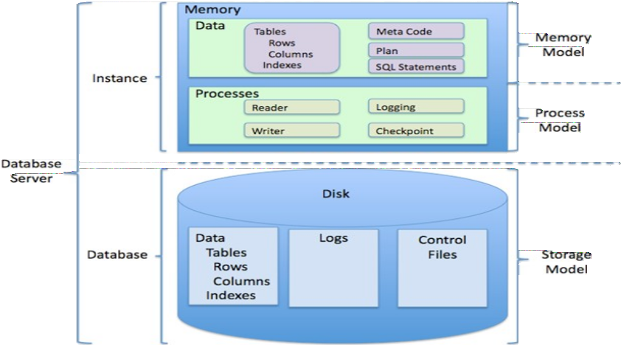

# Implementation Methodology:

Model View Controller or MVC as it is popularly called, is a software design pattern for developing web applications. A Model View Controller pattern is made up of the following three parts:

* **Model** - The lowest level of the pattern which is responsible for maintaining data.
* **View** - This is responsible for displaying all or a portion of the data to the user.
* **Controller** - Software Code that controls the interactions between the Model and View.

MVC is popular as it isolates the application logic from the user interface layer and supports separation of concerns. Here the Controller receives all requests for the application and then works with the Model to prepare any data needed by the View. The View then uses the data prepared by the Controller to generate a final presentable response. The MVC abstraction can be graphically represented as follows.

## MVC (Model View Controller Flow) Diagram

**DATA FLOW DIAGRAMS**

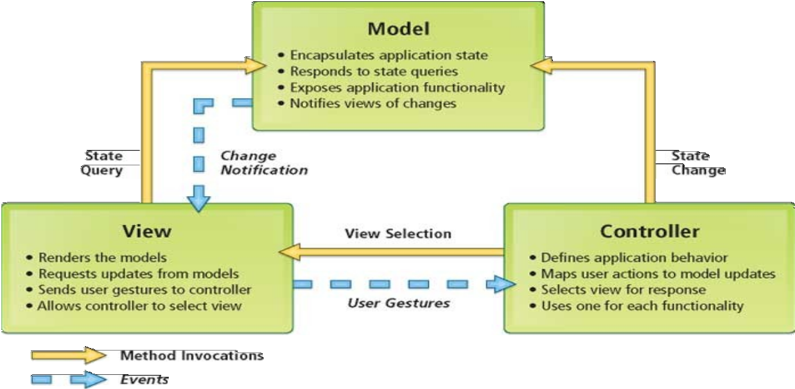

**Tools/Platform,**

**Requirement**

**Hardware and Software**

**specifications:**

**Software**

**Requirements:**

## Name of component Specification

**Operating System** Windows 98, Windows XP, Windows7,

Linux

**Language** Java 2 Runtime Environment

**Database** MySQL Server

**Browser** Any of Mozilla, Opera, Chrome etc

**Web Server** Tomcat 7

**Software Development Kit** Java JDK 1.7 or Above

**Scripting Language Enable** JSP (Java Server Pages)

**Database JDBC Driver** MySQL Jconnector

## Hardware Requirements:

**Name of component Specification**

**Processor** Pentium III 630MHz

**RAM** 128 MB

**Hard disk** 20 GB

**Monitor** 15” color monitor

**Keyboard** 122 keys

## System Analysis:

System analysis is a process of gathering and interpreting facts, diagnosing problems and the information about the Hospital Management System to recommend improvements on the system. It is a problem solving activity that requires intensive communication between the system users and system developers. System analysis or study is an important phase of any system development process. The system is studied to the minutest detail and analyzed. The system analyst plays the role of the interrogator and dwells deep into the working of the present system. The system is viewed as a whole and the input to the system are identified. The outputs from the organizations are traced to the various processes. System analysis is concerned with becoming aware of the problem, identifying the relevant and decisional variables, analyzing and synthesizing the various factors and determining an optimal or at least a satisfactory solution or program of action. A detailed study of the process must be made by various techniques like interviews, questionnaires etc. The data collected by these sources must be scrutinized to arrive to a conclusion. The conclusion is an understanding of how the system functions. This system is called the existing system. Now the existing system is subjected to close study and problem areas are identified. The designer now functions as a problem solver and tries to sort out the difficulties that the enterprise faces. The solutions are given as proposals. The proposal is then weighed with the existing system analytically and the best one is selected. The proposal is presented to the user for an endorsement by the user. The proposal is reviewed on user request and suitable changes are made. This is loop that ends as soon as the user is satisfied with proposal. Preliminary study is the process of gathering and interpreting facts, using the information for further studies on the system. Preliminary study is problem solving activity that requires intensive communication between the system users and system developers. It does various feasibility studies. In these studies a rough figure of the system activities can be obtained, from which the decision about the strategies to be followed for effective system study and analysis can be taken.

## Existing System of Hospital Management System:

In the existing system the exams are done only manually but in proposed system we have to computerize the exams using this application.

* Lack of security of data.
* More man power.
* Time consuming.
* Consumes large volume of pare work.
* Needs manual calculations.
* No direct role for the higher officials

## Proposed System of Hospital Management System:

The aim of proposed system is to develop a system of improved facilities. The proposed system can overcome all the limitations of the existing system. The system provides proper security and reduces the manual work.

* Security of data.
* Ensure data accuracy’s.
* Proper control of the higher officials.
* Minimize manual data entry.
* Minimum time needed for the various processing.
* Greater efficiency.
* Better service.
* User friendliness and interactive.
* Minimum time required.

## Data Dictionary:

This is normally represented as the data about data. It is also termed as metadata some times which gives the data about the data stored in the database. It defines each data term encountered during the analysis and design of a new system. Data elements can describe files or the processes.

Following are some major symbols used in the data dictionary

• = equivalent to

• + and

* + [] either/ or
  + () Optional entry

## Following are some rules, which defines the construction of data dictionary entries:

1. Words should be defined to understand for what they need and not the variable need by which they may be described in the program .
2. Each word must be unique. We cannot have two definition of the same client.
3. Aliases or synonyms are allowed when two or more enters shows the same meaning. For example a vendor number may also be called as customer number.
4. A self-defining word should not be decomposed. It means that the reduction of any information in to subpart should be done only if it is really required that is it is not easy to understand directly.

Data dictionary includes information such as the number of records in file, the frequency a process will run, security factor like pass word which user must enter to get excess to the information.

## Conclusion of the Project Hospital Management System:

Our project is only a humble venture to satisfy the needs to manage their project work. Several user friendly coding have also adopted. This package shall prove to be a powerful package in satisfying all the requirements of the school. The objective of software planning is to provide a frame work that enables the manger to make reasonable estimates made within a limited time frame at the beginning of the software project and should be updated regularly as the project progresses.

## At the end it is concluded that we have made effort on following points…

* A description of the background and context of the project and its relation to work already done in the area.
* Made statement of the aims and objectives of the project.
* The description of Purpose, Scope, and applicability.
* We define the problem on which we are working in the project.
* We describe the requirement Specifications of the system and the actions that can be done on these things.
* We understand the problem domain and produce a model of the system, which describes operations that can be performed on the system.
* We included features and operations in detail, including screen layouts.
* We designed user interface and security issues related to system.
* Finally the system is implemented and tested according to test cases.

# Future Scope of the Project:

In a nutshell, it can be summarized that the future scope of the project circles around maintaining information regarding:

* We can add printer in future.
* We can give more advance software for Hospital Management System including more facilities
* We will host the platform on online servers to make it accessible worldwide
* Integrate multiple load balancers to distribute the loads of the system
* Create the master and slave database structure to reduce the overload of the database queries
* Implement the backup mechanism for taking backup of codebase and database on regular basis on different servers

The above mentioned points are the enhancements which can be done to increase the applicability and usage of this project. Here we can maintain the records of Hospital and Doctors. Also, as it can be seen that now-a-days the players are versatile,

i.e. so there is a scope for introducing a method to maintain the Hospital Management System. Enhancements can be done to maintain all the Hospital, Doctors, Patient, Employee, Test.

We have left all the options open so that if there is any other future requirement in the system by the user for the enhancement of the system then it is possible to implement them.In the last we would like to thanks all the persons involved in the development of the system directly or indirectly. We hope that the project will serve its purpose for which it is develop there by underlining success of process.

# Limitation of Project on Hospital Management System

Although I have put my best efforts to make the software flexible, easy to operate but limitations cannot be ruled out even by me. Though the software presents a broad range of options to its users some intricate options could not be covered into it; partly because of logistic and partly due to lack of sophistication. Paucity of time was also major constraint, thus it was not possible to make the software foolproof and dynamic. Lack of time also compelled me to ignore some part such as storing old result of the candidate etc.

Considerable efforts have made the software easy to operate even for the people not related to the field of computers but it is acknowledged that a layman may find it a bit problematic at the first instance. The user is provided help at each step for his convenience in working with the software.

## List of limitations which is available in the Hospital Management System:

* Excel export has not been developed for Hospital, Doctors due to some criticality.
* The transactions are executed in off-line mode, hence on-line data for Patient, Employee capture and modification is not possible.
* Off-line reports of Hospital, Test, Patient cannot be generated due to batch mode execution.

## References and Bibliography:

* Google for problem solving
* <http://www.javaworld.com/javaworld/jw-01-1998/jw-01-Credentialreview.html>
* Database Programming with JDBC and Java by O'Reilly
* Head First Java 2nd Edition
* <http://www.jdbc-tutorial.com/>
* Java and Software Design Concepts by Apress
* https://[www.tutorialspoint.com/java/](http://www.tutorialspoint.com/java/)
* <http://www.javatpoint.com/java-tutorial>
* https://docs.oracle.com/javase/tutorial/
* <http://www.wampserver.com/en/>
* <http://www.JSP.net/>
* <http://www.tutorialspoint.com/mysql/>
* httpd.apache.org/docs/2.0/misc/tutorials.html