**Database Assignment 1**

**Note : Use Emp, dept and salgrade table**

**1. To list all records with sal > 2000 and comm>200**

**2. To list all record with job=’Clerk’ or sal>2000**

**3. To list all the record with sal=1250 or 1100 or 2850**

**4. To list all employees with sal>1250 and <2850**

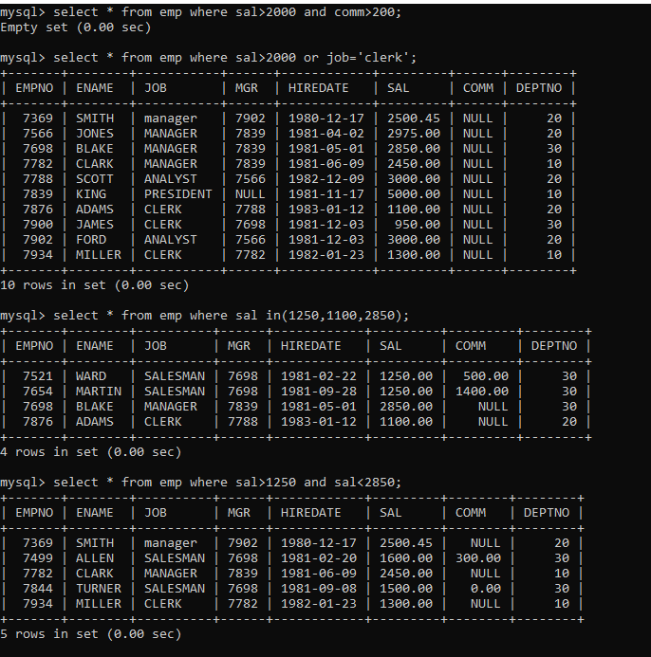

**5. To list all employees with name ends with AS**



**6. To list all employees with job starts with C and ends with K**

**7. To list all employees with job contains L at third position and**

**M at third last position**

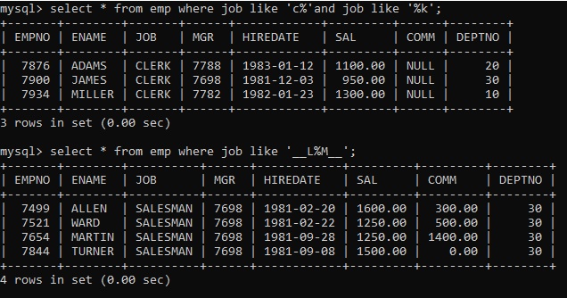

**8. To list all the record with sal not equal to 1250 or 1100 or 2850**

**9. To list all employees with salnot >1250 and <2850**

**10. To list all employees with job starts with C , E at 3rd position and ends with K**

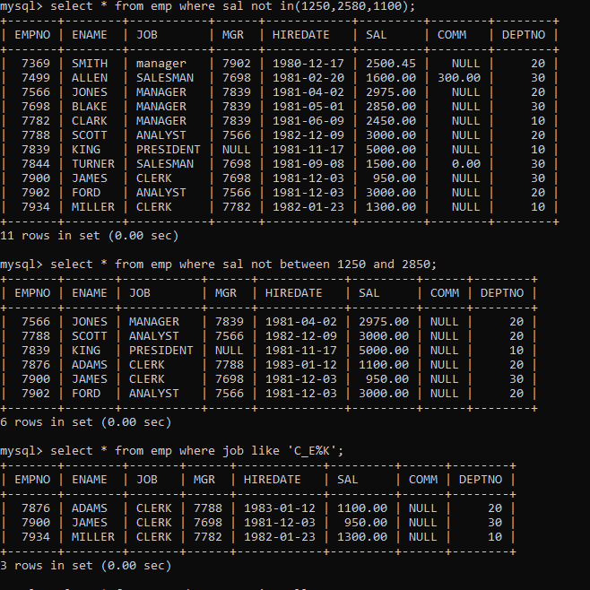

**11. To list all rows with comm is null**

**12. To list all employees with sal is null and name starts with ‘S’**

**13. To list all employees with job contains 5 characters**

**14. To list all employees with name contain ‘A’ at 1 position and job**

**Contains 5 characters**

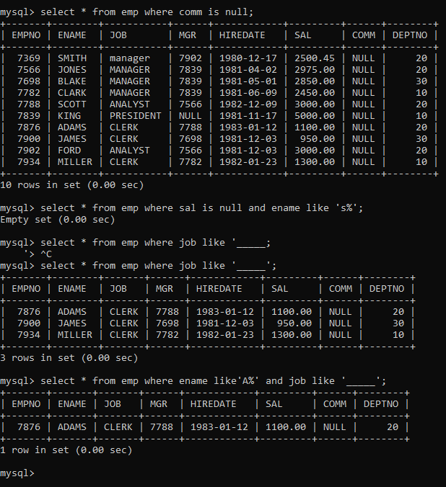

**Q2. Solve the following**

**1. Retrieve the details (Name, Salary and dept no) of the emp who are working in**

**department code 20, 30 and 40.**

**2. Display the total salary of all employees . Total salary will be calculated as**

**sal+comm+sal*0.10.**

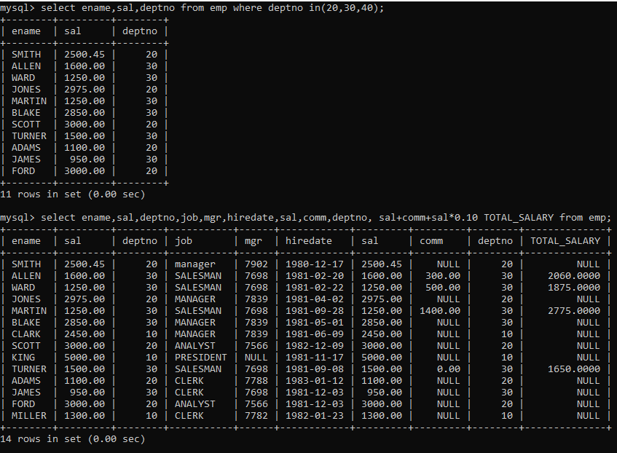

**3. List the Name and job of the emp who have joined before 1 jan 1986 and whose**

**salary range is between 1200and 2500. Display the columns with user defined Column**

**headers.**

**4. List the empno, name, and department number of the emp works under manager**

**with id 7698**

**5. List the name, job, and salary of the emp who are working in departments 10 and**

**30.**

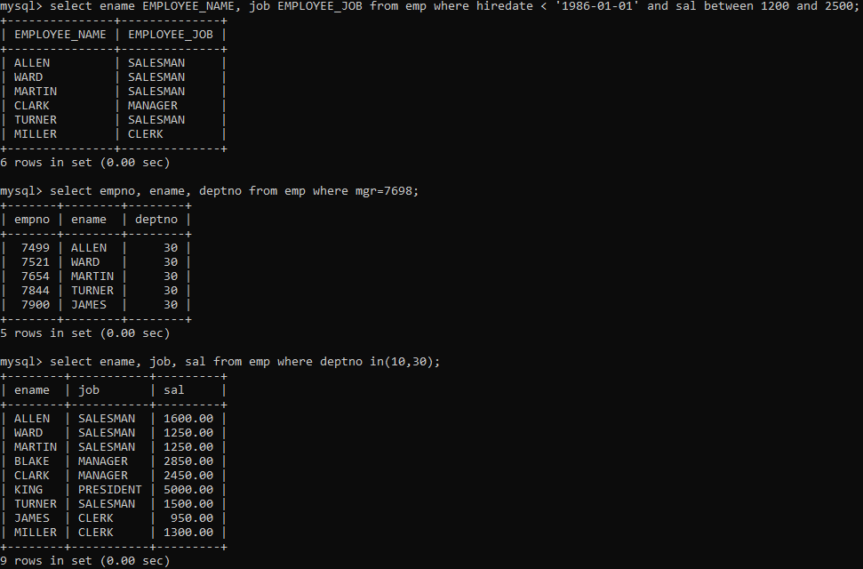

**6. Display name concatenated with dept code separated by comma and space. Name**

**the column as ‘Emp info’.**

**7. Display the emp details who do not have manager.**

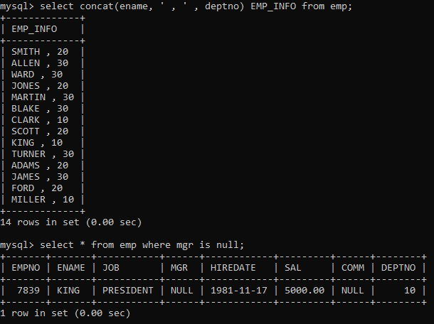

**8. Write a query which will display name, department no and date of joining of all**

**employee who were joined January 1, 1981 and March 31, 1983. Sort it based on date of**

**joining (ascending).**

**9. Display the employee details where the job contains word ‘AGE’ anywhere in the Job.**

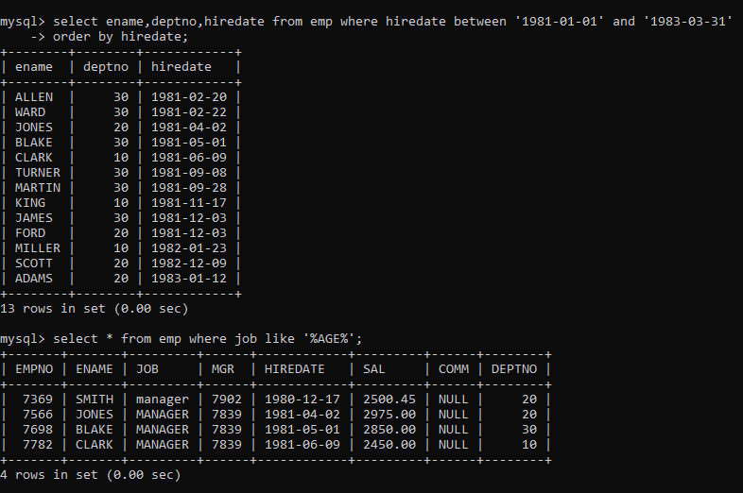

**11. List the details of the employee , whose names start with ‘A’ and end with ‘S’ or**

**whose names contains N as the second or third character, and ending with either ‘N’ or ‘S’.**

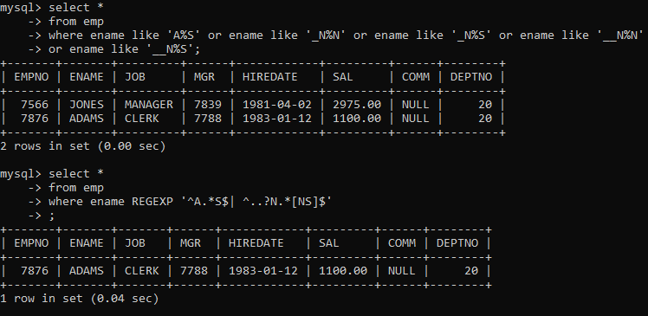

**12. List the names of the emp having ‘_’ character in their name.**



**Single Row functions**

**1. To list all employees and their email, to generate email use 2 to 5 characters from ename**

**Concat it with 2 to 4 characters in job and then concat it with ‘@mycompany.com’**

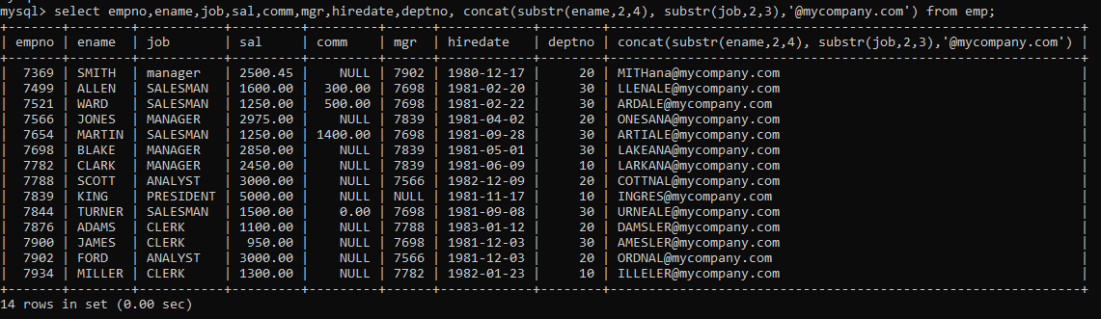

**2. List all employees who joined in September.**

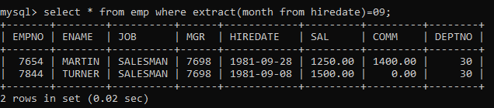

**3. List the empno, name, and department number of the emp who have experience of 18 or**

**more years and sort them based on their experience.**

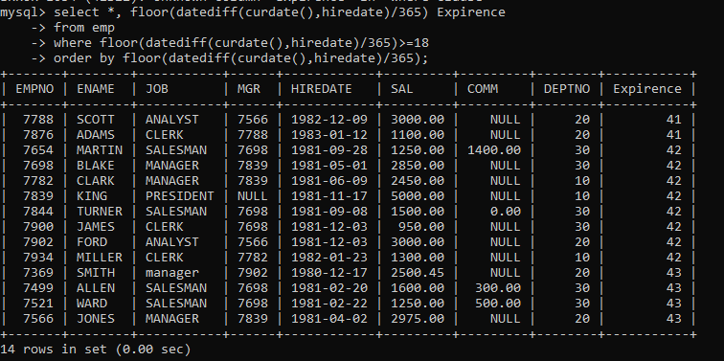

**4. Display the employee details who joined on 3rd of any month or any year.**

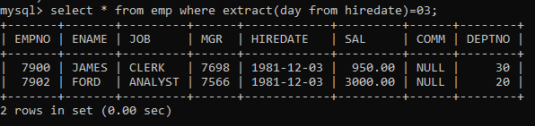

**5. display all employees who joined between years 1981 to 1983.**

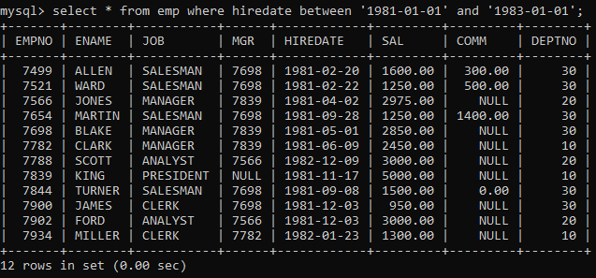

**Group functions**

**6. Display the Highest, Lowest, Total & Average salary of all employee. Label the columns**

**Maximum, Minimum, Total and Average respectively for each Department. Also round the**

**result to the nearest whole number.**

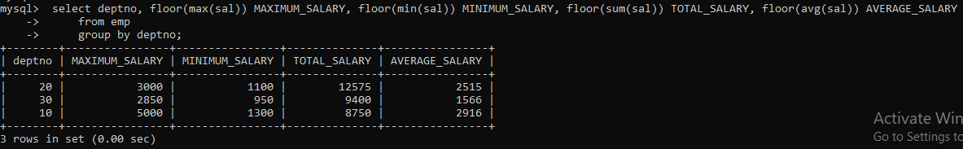

**7. Display Department no and number of managers working in that department. Label the**

**column as ‘Total Number of Managers’ for each department.**

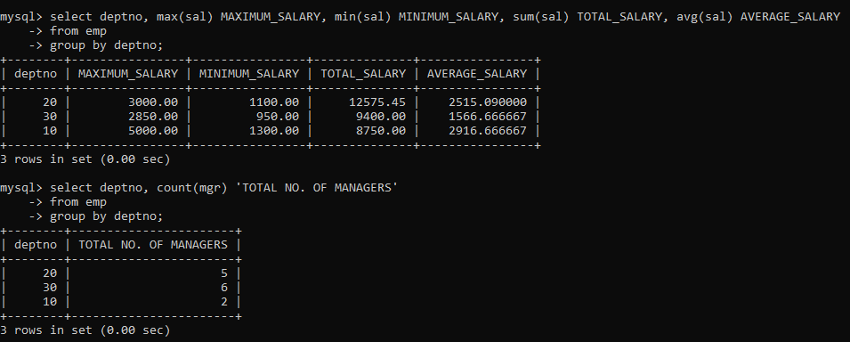

**8. Get the Department number, and sum of Salary of all non managers where the sum is**

**greater than 20000.**