HCLTech Career Shaper Programme
III Year Industry Project Report
RAG-Based Document Q&A System
Project No. 72 | Domain: LLM / Python | Academic Year 2025-26
Field | Details
Learner Name | Utkarsh Sharna
Roll Number | 2300321540201
College / Campus | ABES Engineering College
Mentor Name | Divya Verma
Submission Date | 18 October 2026
Tech Stack | Python, LangChain, ChromaDB, HuggingFace Transformers, OpenAI API / Ollama, Streamlit

Abstract
Large Language Models answer fluently, but they can state wrong facts with confidence and they do not know the private or recent documents of an organisation. Retrieval-Augmented Generation (RAG) solves this by first searching the documents for relevant passages and then asking the model to answer only from those passages. This project builds a working RAG-based Document Q&A System for PDF, Word and text documents using Python, LangChain, ChromaDB, HuggingFace sentence embeddings and Streamlit.
The system loads documents, splits them into overlapping chunks, converts each chunk into a vector, stores the vectors in a vector database, and at question time retrieves the top-K most similar chunks. The answer is shown together with the source chunks and a disclaimer, and the system refuses to answer when the best retrieved chunk is not similar enough to the question. A sample corpus of 8 documents (33 chunks) on the Indian Constitution, government schemes and a technical manual was created for testing. On 33 test questions the default configuration (MiniLM embeddings, ChromaDB, extractive answers) reached Hit@1 of 97.0%, Hit@3 of 100%, MRR of 0.985 and answer keyword accuracy of 87.9%, refused 100% of 5 out-of-scope questions, and took 67.9 ms on average per question. An offline TF-IDF baseline reached Hit@1 of 100% and answer keyword accuracy of 90.9% on the same small test set. An exploratory data analysis of the 5,000-row provided dataset is also included.
Keywords: RAG, LLM, vector database, embeddings, LangChain, ChromaDB, question answering, hallucination.

1. Introduction

1.1 Background
Organisations keep important knowledge in PDF manuals, Word policies and government circulars. Employees and citizens lose time searching these files by keyword. A general chatbot cannot help because it has not seen these documents, and when it does not know, it may invent an answer (called hallucination). RAG, introduced by Lewis et al. (2020), combines a retriever with a generator so that the answer is grounded in real text that can be checked.

1.2 Problem Statement (5W1H)
Question | Answer
Who | Students, employees and citizens who must find exact answers in long documents such as the Constitution, scheme guidelines and technical manuals.
What | Keyword search is slow and incomplete, and general chatbots hallucinate and cannot read private documents.
When / where | Whenever a quick, reliable answer is needed from an enterprise or government document, for example while checking scheme eligibility or an article number.
Why | Wrong answers on rules, amounts or deadlines can cause real loss, so answers must be traceable to the source.
How | Build a RAG pipeline that retrieves relevant chunks, answers only from them, shows the source chunk, and refuses when nothing relevant is found.

1.3 Objectives
- Build a working prototype that answers questions from uploaded PDF, Word and text documents.
- Use a vector database and embeddings to retrieve the most relevant chunks for every question.
- Always display the source chunk and a disclaimer beside the answer to reduce the risk of hallucination.
- Measure the system with retrieval and answer metrics (Hit@K, MRR, answer accuracy, refusal rate, latency).
- Analyse the provided dataset.csv with at least three visualisations and document the findings.

1.4 Scope
The system answers factual and procedural questions from text-based documents. Scanned images need OCR first and are outside the scope. Tables inside PDFs are read as plain text. The system is a learning prototype and is not designed for legal or medical decisions.

2. Background and Related Work

2.1 Retrieval-Augmented Generation
A RAG system has two parts. The retriever finds passages related to the question. The generator (an LLM) writes the answer using those passages as context. Because the passages come from the user's own documents, the answer can be verified, and the knowledge can be updated just by adding new documents, without retraining the model.

2.2 Embeddings and vector search
An embedding model converts text into a list of numbers (a vector) so that texts with similar meaning are close to each other. Sentence-BERT (Reimers and Gurevych, 2019) made this practical for sentences and paragraphs. Similarity is usually measured with cosine similarity, which is also the retrieval_score used in the provided dataset. A vector database such as ChromaDB stores the vectors and quickly returns the nearest ones for a query.

2.3 Chunking
Documents are too long to pass to a model in one piece, so they are cut into chunks. Small chunks are precise but may lose context; large chunks keep context but add noise. A small overlap between neighbouring chunks avoids cutting an answer in half. This project uses 500 characters with an 80 character overlap through the LangChain RecursiveCharacterTextSplitter.

2.4 Comparison with other approaches
Approach | Strength | Weakness
Keyword search | Simple, fast, exact words | Misses synonyms, returns whole documents
Plain LLM chatbot | Fluent answers | Does not know private documents, can hallucinate
Fine-tuned LLM | Learns domain style | Costly, hard to update, still no source shown
RAG (this project) | Grounded, updatable, shows source | Depends on retrieval quality and chunking

3. System Design

3.1 Architecture
The system works in two phases. In the offline phase, documents are loaded, chunked, embedded and stored. In the online phase, the question is embedded, the top-K chunks are searched, and the answer is generated from those chunks and shown with its sources.
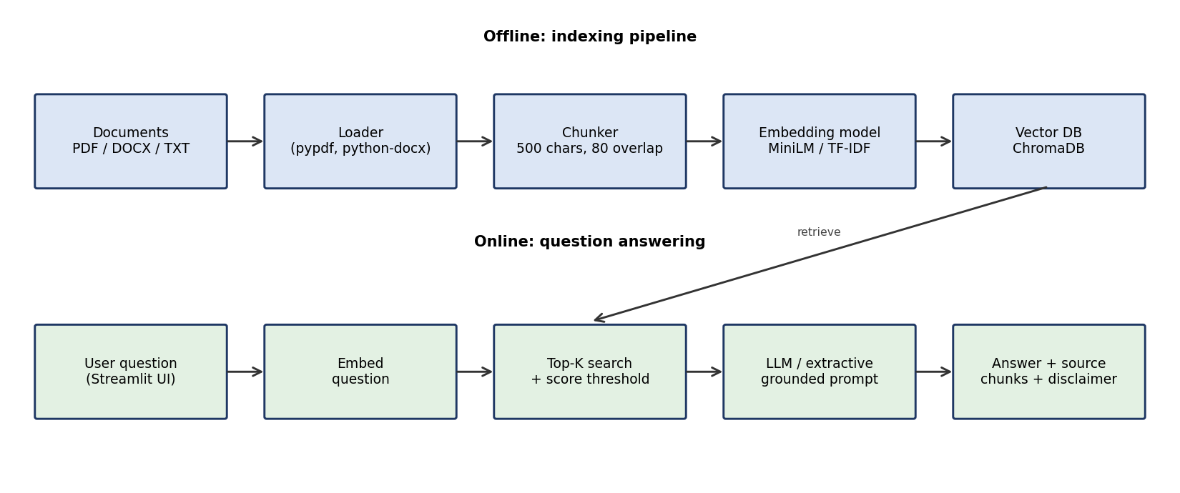
Figure 1: System block diagram (indexing and question-answering pipelines)

3.2 Data Flow Diagram - Level 0
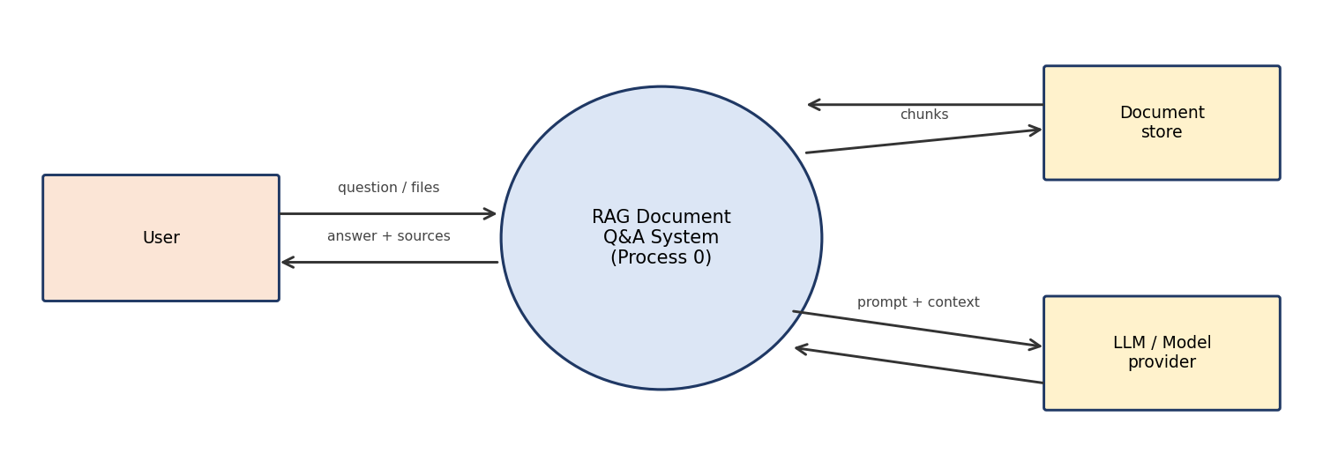
Figure 2: DFD Level 0 - external entities and the single system process

3.3 Module description
Module (file) | Responsibility
rag/loader.py | Reads .pdf (pypdf), .docx (python-docx), .txt and .md files and assigns a doc_id.
rag/chunker.py | Splits text into overlapping chunks and gives each a unique chunk_id and word_count.
rag/embeddings.py | HuggingFace all-MiniLM-L6-v2 embeddings, with a TF-IDF fallback that works fully offline.
rag/vectorstore.py | ChromaDB persistent store with cosine distance, with an in-memory numpy fallback.
rag/llm.py | Grounded prompt for OpenAI or Ollama through LangChain, and an extractive (no-LLM) fallback.
rag/pipeline.py | Connects all steps, applies the minimum-score refusal rule, and measures latency.
app.py | Streamlit UI with question box, answer, source chunks, scores and the disclaimer.
evaluate.py / eda.py | Evaluation metrics and exploratory data analysis with figures.

3.4 Technology stack
Layer | Technology
Frontend / UI | Streamlit
Backend / logic | Python 3, LangChain text splitters and chat model wrappers
Vector database | ChromaDB (cosine similarity)
AI / ML framework | HuggingFace sentence-transformers, OpenAI API or Ollama (open-source LLM)
Visualisation | Matplotlib, Seaborn

4. Dataset and Exploratory Data Analysis

4.1 Dataset description
The provided dataset.csv had 500 rows and 7 columns. Using the dataset generation prompt, 4,500 more rows were generated with the same columns and the same value ranges to reach 5,000 rows. Columns: doc_id (50 documents), doc_type (5 file formats), chunk_id (unique), word_count (50 to 500), retrieval_score (0.50 to 1.00), query_type (5 types) and answer_quality_score (0.60 to 1.00). The full description of every column is given in data_dictionary.csv. The additional rows are synthetic and were produced to match the distributions of the original rows.

4.2 Cleaning and validation
Checks were done for missing values (0 found), duplicate rows (0), duplicate chunk_id (0) and out-of-range values (0). No rows had to be removed, so 5,000 rows remain. Two helper columns were added: quality_band (low below 0.70, medium 0.70 to 0.85, high above 0.85) and retrieval_band (weak below 0.60, good 0.60 to 0.80, strong above 0.80). The cleaned file is saved as dataset_clean.csv.
Column | Mean | Std | Min | Max
word_count | 275.304 | 130.598 | 50 | 500
retrieval_score | 0.748 | 0.143 | 0.5 | 1
answer_quality_score | 0.803 | 0.116 | 0.6 | 1
Table 1: Summary statistics of numeric columns

4.3 Visualisations and findings
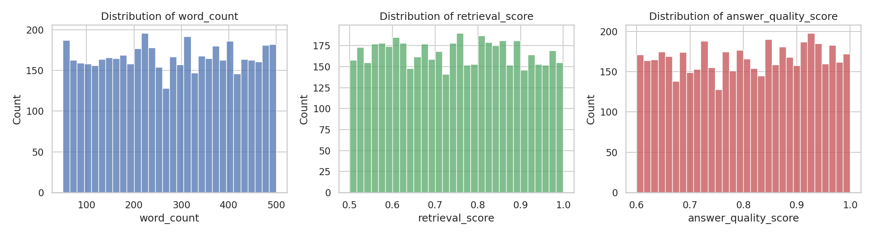
Figure 3: Distribution of word_count, retrieval_score and answer_quality_score
All three numeric columns are spread almost evenly across their ranges. The mean retrieval score is 0.748 and the mean answer quality is 0.803. About 20.3% of the chunks have a retrieval score below 0.60, which can be treated as weak retrieval.
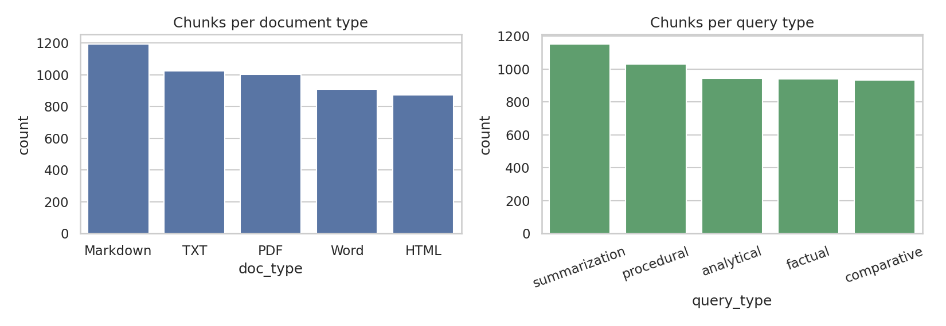
Figure 4: Number of chunks per document type and per query type
The five document types and five query types are well balanced, so no group dominates the analysis. Markdown and summarization are the largest groups, but the difference from the others is small.
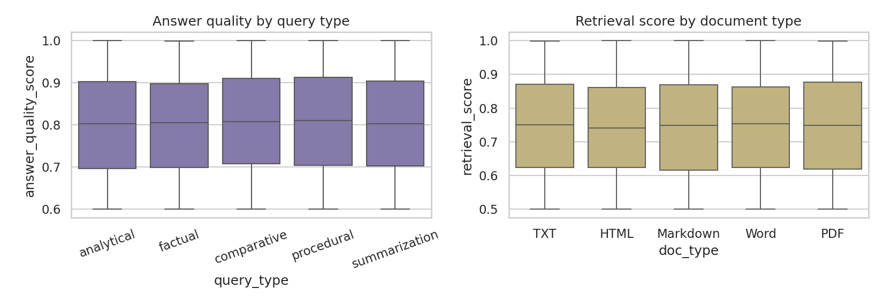
Figure 5: Answer quality by query type and retrieval score by document type
The boxplots look almost the same for every group. This means that, in this dataset, the query type does not change the answer quality and the file format does not change the retrieval score.
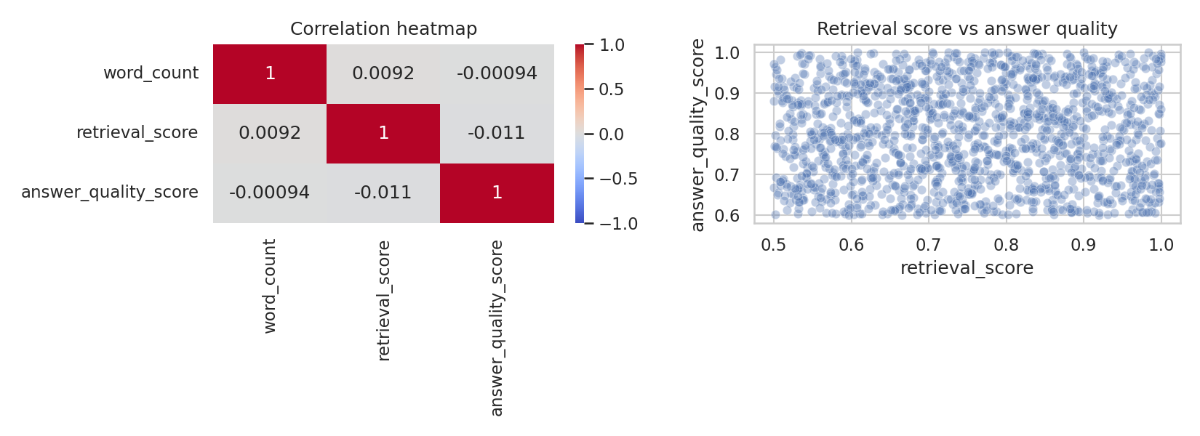
Figure 6: Correlation heatmap and retrieval score versus answer quality
The correlations between the three numeric columns are close to zero (retrieval vs quality: -0.011). In a real RAG system, we would expect better retrieval to give better answers. The absence of this relationship shows that the extra rows are synthetic and independent, so the dataset is useful for practising EDA and building dashboards, but it cannot be used to claim real-world relationships.
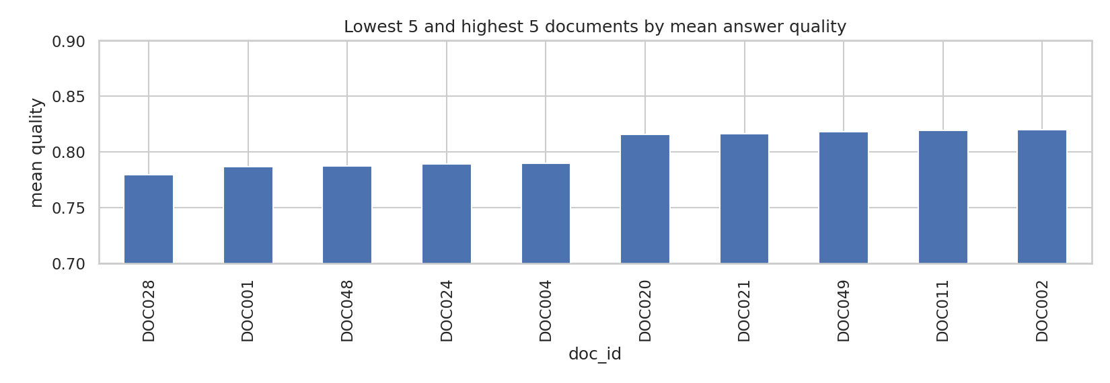
Figure 7: Documents with lowest and highest mean answer quality
Answer quality is split as 39.1% high, 36.0% medium and 24.8% low. Differences between documents are small and are expected to be random variation rather than a real document effect.

5. Implementation

5.1 Ingestion
Files are read from the data/corpus folder or uploaded in the Streamlit sidebar. The document ID is taken from the file name (for example DOC004). Each document is cut into chunks of about 500 characters with 80 characters overlap. Every chunk keeps its doc_id, chunk_id, file name and word count so that it can be shown as a source later. The sample corpus has 8 documents and 33 chunks (31 with the simple fallback splitter used offline).

5.2 Embedding and storage
With the default setting, chunks are converted to 384-dimension vectors by the all-MiniLM-L6-v2 model and stored in a persistent ChromaDB collection that uses cosine similarity. If these packages are not installed, the system automatically falls back to TF-IDF vectors and an in-memory store, so that the whole pipeline can still run offline.

5.3 Retrieval and answer generation
The question is embedded with the same model and the top-K chunks (default K = 3) are returned with their similarity score. If the best score is below the threshold MIN_SCORE, the system replies that it could not find the answer in the documents. Otherwise the chunks are given to the LLM with a strict prompt: answer only from the context, and say so if the answer is not there. Three answer modes are available: OpenAI (through LangChain), Ollama with an open-source model, and an extractive mode that selects the most similar sentences without any LLM.

5.4 User interface
The Streamlit app has a clean card-based interface. A header banner shows the active embedding model, vector store and answer mode, and four summary cards show the number of documents, chunks indexed, chunks per answer and average chunk size. The user can click an example question or type their own and press Ask. The answer is shown in a card with a confidence badge (strong match, moderate match or no confident answer), the response time and the best matching document. Below the answer, every source chunk is shown as a separate card with its document ID, chunk ID, file name, a similarity bar and score, and the words of the question highlighted in the text. When no chunk is similar enough, the card says that the answer was not found and the closest passages are shown as hints only. A second tab, Knowledge base, lists all indexed documents with their chunk and word counts and allows a preview of each document. The sidebar lets the user upload their own PDF, DOCX, TXT or MD files, change the Top-K value and see recent questions. A disclaimer is displayed at the bottom of every page.

5.5 How to run
- pip install -r requirements.txt
- streamlit run app.py (default: HuggingFace embeddings, ChromaDB, extractive answers)
- set LLM_BACKEND=openai and OPENAI_API_KEY to use GPT, or LLM_BACKEND=ollama for a local model
- python evaluate.py and python eda.py to reproduce the results in this report

6. Testing and Results

6.1 Test set and metrics
A test set of 33 in-scope questions was written from the corpus (each has one expected document and one expected keyword), plus 5 out-of-scope questions that the documents cannot answer (for example a cricket question). Hit@K checks whether the expected document appears in the top K chunks, MRR is the mean of 1 divided by the rank of the first correct document, answer keyword accuracy checks whether the expected keyword appears in the answer, and refusal rate is the share of out-of-scope questions for which the system correctly says it has no answer.

6.2 Results
Metric | TF-IDF + numpy + extractive (offline baseline) | MiniLM + ChromaDB + extractive (default)
Documents / chunks | 8 / 31 | 8 / 33
Hit@1 | 100.0% | 97.0%
Hit@3 | 100.0% | 100.0%
MRR | 1.0 | 0.985
Answer keyword accuracy | 90.9% | 87.9%
Out-of-scope refusal rate | 100.0% | 100.0%
Average latency (retrieval + extraction) | 2.29 ms | 67.91 ms
95th percentile latency | 2.66 ms | 79.0 ms
Table 2: Evaluation results on the same 33 in-scope and 5 out-of-scope questions. Both columns are measured. The right column is the default configuration of the system. An LLM answer mode (OpenAI or Ollama) was not evaluated.

6.3 Discussion
Both configurations retrieved the correct document within the top three chunks for every question (Hit@3 of 100%). With HuggingFace MiniLM embeddings the correct document was ranked first for 32 of 33 questions (Hit@1 of 97.0%, MRR of 0.985). For the question about approaching the Supreme Court directly, the top chunk came from the neighbouring document on Directive Principles and the correct document was ranked second. The TF-IDF baseline scored slightly higher (Hit@1 of 100%, answer accuracy of 90.9% against 87.9%). This should not be read as TF-IDF being better. The corpus is small (8 documents), the questions were written by the project author using words that appear in the documents, which favours word overlap, and the answer-selection rules were tuned on this same test set. A larger corpus with questions written in different words is where semantic embeddings are expected to help, but this was not tested here. The answer keyword accuracy of 87.9% is lower than the retrieval accuracy because the extractive mode copies only three sentences, and sometimes the sentence with the exact value is not among them (for example for the questions on who is not eligible for PM-KISAN and which committee recommended the Fundamental Duties). An LLM that reads the three chunks is expected to improve this, but it was not measured in this report. All five out-of-scope questions were refused by both configurations, so the minimum score threshold (0.30 for MiniLM) works as a basic protection against made-up answers. The average response time of 67.9 ms is higher than TF-IDF because the question has to be encoded by the neural model, but it is still fast enough for interactive use.

6.4 Limitations
- The test set is small and was written by the same person who built the system, so the results are optimistic.
- The sample corpus consists of short simplified summaries written for demonstration. They are not the official texts and may be out of date.
- The additional 4,500 dataset rows are synthetic, so no real-world conclusions can be drawn from them.
- The refusal threshold was set by hand and has to be tuned again when the embedding model changes.
- Scanned PDFs, tables and images are not supported.

7. Challenges Faced and How They Were Resolved
Challenge | Resolution
LangChain, ChromaDB and HuggingFace could not be installed in the build environment (no internet). | Each component has an optional import with a fallback (TF-IDF vectors, numpy store, extractive answers), so the full pipeline is testable offline. The LangChain / Chroma / HuggingFace path was later run and checked on the learner's machine (Section 6).
First extractive answerer reached only 63.6% keyword accuracy because it picked sentences by simple word overlap and often returned heading lines. | Sentences are now ranked by TF-IDF cosine similarity with the question and short heading lines are ignored. Accuracy rose to 75.8%, and to 90.9% after further changes (embedding-based sentence ranking, a boost for sentences with the right kind of number for how much / how many / when questions, and returning three sentences instead of two). These changes were tuned on the same 33-question test set (offline TF-IDF baseline; the MiniLM configuration gave 87.9%), so these figures are optimistic.
Questions outside the documents still return the "closest" chunk, which could produce a wrong answer. | A minimum similarity threshold was added. The system refuses when the best chunk is below the threshold.
Provided dataset has no real relationship between columns. | This was stated openly in the EDA, and the dataset is used for analysis practice, while system quality is measured separately with evaluate.py.

8. Ethical Considerations
- Hallucination: the model can still make mistakes. The source chunk is always shown next to the answer so that the user can verify it.
- No legal or medical advice: answers about the Constitution, schemes or health cover must be checked by a qualified person or the official source before action is taken. The corpus documents contain this disclaimer.
- Privacy: no personal data is stored. Uploaded files stay in a temporary folder during the session. If OpenAI is used, the retrieved text is sent to an external service, so confidential documents should be used only with a local model such as Ollama. The DPDP Act 2023 should be followed where personal data is involved.
- Data licence: the sample corpus was written by the author as summaries of publicly available government information. Real deployments must check the licence of every document.
- Disclosure of AI assistance: AI tools were used to help write the code, the sample corpus and the report draft. This should be listed in the Appendix of the final submission.

9. Future Work
- Test with real PDFs and a larger corpus (the 50 public-domain documents planned in the dataset prompt).
- Add a re-ranker and hybrid search (keyword + vector) to improve retrieval on questions that use different words.
- Use an LLM-as-a-judge or RAGAS-style metrics for faithfulness and answer relevance.
- Add OCR for scanned documents and support for tables.
- Add chat history so that follow-up questions can be understood.

10. Conclusion
This project delivered a working RAG-based Document Q&A System with ingestion of PDF, Word and text files, vector retrieval, grounded answers, visible source chunks, a refusal rule for out-of-scope questions and a Streamlit interface. The system was evaluated on a small test set, and the dataset provided with the project was cleaned and analysed with five visualisations. The main learning is that retrieval quality, chunking and honest evaluation matter more than the choice of LLM, and that showing the source is the simplest and most effective control against hallucination.

References
[1] Lewis, P. et al. (2020). Retrieval-Augmented Generation for Knowledge-Intensive NLP Tasks. Advances in Neural Information Processing Systems (NeurIPS) 33.
[2] Reimers, N. and Gurevych, I. (2019). Sentence-BERT: Sentence Embeddings using Siamese BERT-Networks. Proceedings of EMNLP-IJCNLP 2019.
[3] LangChain documentation - https://python.langchain.com (text splitters, chat models).
[4] ChromaDB documentation - https://docs.trychroma.com.
[5] Streamlit documentation - https://docs.streamlit.io.
[6] Mentor to validate and add further links (as per Project Brief).

Appendix A: Ethical Compliance Declaration
I confirm that (to be ticked and signed by the learner):
☐ All dataset usage complies with the source licence.
☐ No personally identifiable information (PII) is stored without consent.
☐ AI tools used for code/writing are disclosed in this Appendix.
☐ This project complies with the DPDP Act 2023 where applicable.

AI tools used: Claude (Anthropic) was used to help write the project code, the sample corpus summaries, the dataset extension script and the draft of this report. All outputs were reviewed by the learner.
Learner Signature: _________________________ Date: ________________

