**Project Report**

**Stopwatch Application**

Utkarsh Jaiswal  
utkarshj19@gmail.com

I would like to express my heartfelt gratitude to everyone who contributed to the successful completion of the Stopwatch Application project.

Firstly, I thank my mentors and guides for their invaluable support, guidance, and constructive feedback throughout the development process. Their expertise and encouragement have been instrumental in shaping this project.

I am deeply grateful to my peers and colleagues for their collaboration and insightful suggestions, which enhanced the project’s quality and functionality.

A special thanks to my family and friends for their unwavering support and understanding during this journey. Their motivation has been a driving force behind the completion of this project.

Lastly, I extend my gratitude to the online developer community and open-source contributors for providing resources and knowledge that greatly facilitated the development of the Stopwatch Application.

**1. Aim**To develop a lightweight and user-friendly stopwatch application for Android that offers precise time tracking and simple controls.  
**2. Objective**

* **Primary Objective:** To create a fully functional stopwatch app that tracks time with start, pause, and reset functionalities.
* **Secondary Objectives:**
* To provide an intuitive and clean user interface.
* To ensure compatibility with most Android devices.
* To minimize resource usage for smooth app performance.

**3. Requirements of Your Project**

**Hardware Requirements:**

• Android Device (Min Specifications: 2GB RAM, 16GB storage, Android 5.0 or higher).

• Development Machine: Minimum i3 processor, 4GB RAM, 128GB HDD/SSD.

**Software Requirements:**

Android Studio: Integrated Development Environment (IDE) for building and debugging the app.

Languages: Java for app development.

* **Testing Tools:** Android Emulator and Physical Android Devices for real-world testing.

**4. Flow Diagram of Your Project**

**User Opens Stopwatch Application**  
    |  
**Main Screen with Timer Display**  
    |  
**Press Start → Timer Begins Counting**  
    |  
**Press Pause → Timer Pauses Counting**  
    |  
**Press Reset → Timer Resets to 00:00:00**  
    |  
**User Closes the Application**

1. **User Opens Stopwatch Application:** Displays a clean interface with a timer and three buttons (Start, Pause, Reset).
2. **Main Screen:** Provides a clear view of the elapsed time with bold digits and accessible controls.
3. **Press Start:** The timer begins incrementing every second and displays the time in HH:MM:SS format.
4. **Press Pause:** The timer stops incrementing while maintaining the current value on the display.
5. **Press Reset:** The timer resets to "00:00:00," preparing for a new session.
6. **User Closes the Application:** The app exits, stopping all timer activity.

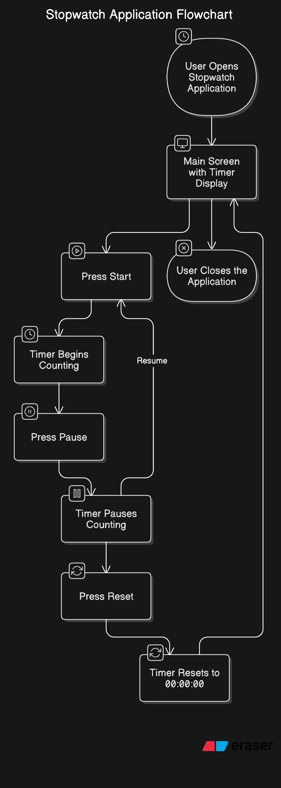

**5. Project Description**

The Stopwatch Application is a simple yet effective time-tracking tool designed for Android users. Key features include:

* **Time Tracking:** Allows users to start, pause, and reset the timer.
* **Precise Display:** Displays elapsed time in hours, minutes, and seconds.
* **User-Friendly Design:** Provides a minimalistic interface for ease of use.
* **Responsive Performance:** Optimized to function smoothly on various Android devices.

**6. Screenshots of Project**

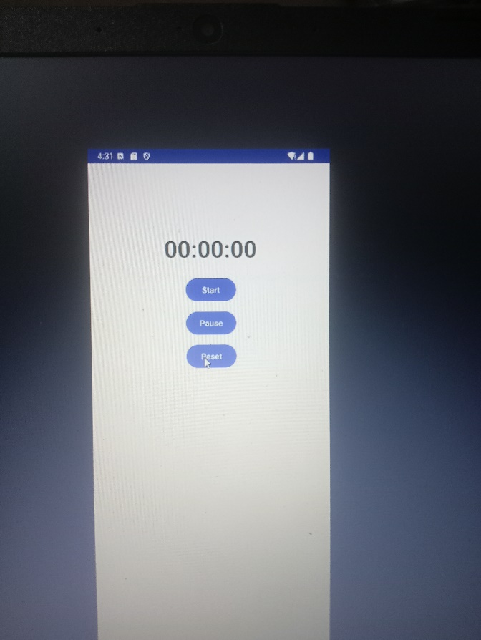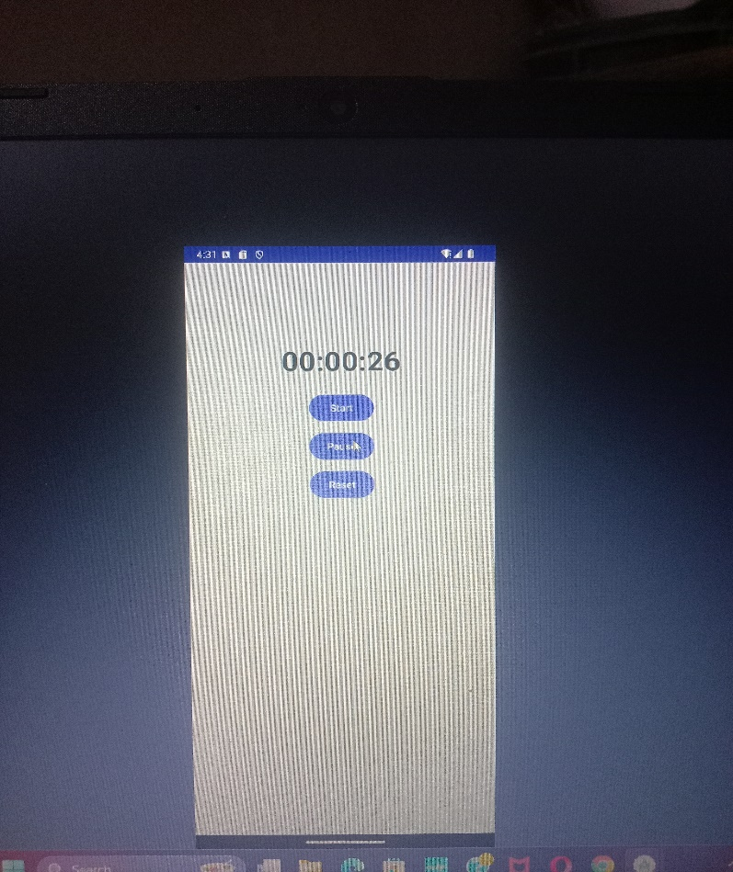

* Timer Screen: Displays the timer with Start, Pause, and Reset buttons.

**7. Advantages and Limitations of Your Project**

**Advantages:**

* Simple and intuitive user interface.
* Accurate time tracking with minimal resource usage.
* Lightweight and compatible with most Android devices.

**Limitations:**

* No support for background execution in the current version.
* Limited to manual time tracking without lap functionality.

**8. Implementation Areas of Your Project**

**Primary Areas:**

Personal productivity, fitness tracking, and time management.

**Future Scope:**

• Adding lap functionality for advanced users.

• Allowing the timer to run in the background.

• Expanding compatibility to wearable devices.

**9. Conclusion**

The Stopwatch Application project demonstrates a straightforward yet highly functional tool for time management. Its simple interface, precise tracking, and responsive performance make it an essential app for users requiring reliable timing. Future updates aim to enhance its utility with additional features like lap tracking and background functionality.

**10. Bibliography**

**Android Development Resources:**

* + Official Documentation: <https://developer.android.com>
  + Android Studio Tutorials: <https://developer.android.com/studio/intro>