PROJECT REPORT

ON

**StayHome.com**

**Affiliated**

**J.C BOSE University, YMCA, Faridabad**

Session (2020-2024)

**Submitted By: -Utkarsh Kumar  
20/CSE54**

**20012004054**

**Under the Guidance of**

Ms. Shilpi Ms. Shilpi

**(Project guide) (Head of Department)**

**DEPARTMENT OF COMPUTER SCIENCE AND ENGINEERING**

**B.S.Anangpuria Institute of Technology & Management**

**Alampur, Faridabad**

|  |  |
| --- | --- |
|  | **INDEX** |
| **S NO.** | **CONTENT** |
| **1.** | **Acknowledgement** |
| 2 | **Abstract** |
| **3.** | **INTRODUCTION** |
| 4. | **Project Overview** |
| **5.** | **Motivation** |
| **6.** | **Keywords** |
| **7.** | **PROBLEM DEFINITION** |
| **8.** | **PROPOSED METHODOLOGY** |
| **9.** | **Hardware and Software Specifications** |
| **10.** | **RESULTS / OUTPUTS/ SCREEN SHOT** |
| **11.** | **Conclusions** |
| **12.** | **Future Scope and reference** |

**Acknowledgement**

I am highly indebted to B.S. Anangpuria Institute of Technology and Management for their guidance and constant supervision as well as for providing necessary information regarding the project & also for their support in completing the project.

I would like to express my gratitude towards my parents & faculty member of B.S.A.I.T.M for their kind cooperation and encouragement which help me in completion of this project.

I would like to express my special gratitude and thanks to our project guide Ms. Shilpi for giving me such attention and time during the all-time of Project.

Finally, while we acknowledge the contribution of all, we claim total responsibility for whatever shortcomings the project may have or contain.

**Abstract**

Immerse yourself in a world of seamless travel and accommodation at StayHome.com, where cutting-edge technology meets exceptional user experience. Powered by the MERN stack—MongoDB, Express.js, React, and Node.js—our platform redefines the art of staycation planning.

Discover a diverse array of accommodations with our dynamic listings, offering instant booking confirmations powered by real-time functionality. Let our smart algorithms, backed by MongoDB, curate personalized recommendations tailored to your preferences, ensuring each stay is uniquely yours.

Experience the advantage of a responsive design, courtesy of React, ensuring a consistent and enjoyable browsing experience across all devices. Rest easy knowing that your transactions are secure, thanks to Node.js, providing encrypted protection for your peace of mind.

**INTRODUCTION**

Welcome to StayHome.com, the epitome of modern staycation planning where innovation and comfort converge seamlessly. At StayHome.com, we've crafted a unique online sanctuary powered by the cutting-edge MERN stack—MongoDB, Express.js, React, and Node.js. Our platform is more than just a website; it's a dynamic portal designed to elevate your staycation experience, ensuring each getaway is a personalized and memorable adventure.

In this digital oasis, explore a curated selection of accommodations ranging from cozy retreats to luxurious escapes. With real-time booking capabilities, powered by our MERN stack architecture, securing your dream stay is not just quick—it's instantaneous.

Our commitment to personalization is fueled by smart algorithms driven by MongoDB's robust data management. These algorithms tailor recommendations based on your preferences and past stays, ensuring that each suggestion aligns with your unique travel style.

StayHome.com is more than just a website; it's an immersive experience. The responsiveness of our platform, thanks to React, ensures a seamless user journey across all devices—be it a desktop, tablet, or smartphone. And with Node.js at the helm, rest assured that your transactions are fortified with secure, encrypted protection.

**Project Overview/Specifications: -**

I. Introduction:

StayHome.com is a revolutionary online platform designed to streamline the staycation planning process, offering users a personalized and seamless experience.

II. Technology Stack:

* MongoDB: Database management for efficient storage and retrieval of accommodation data.

Dynamic and flexible schema design.

* Express.js: Backend server framework for handling HTTP requests and managing data flow.
* React: Frontend library for building dynamic and interactive user interfaces.

Node.js: Server-side JavaScript runtime for executing server-side scripts.

**Motivation**

At the heart of StayHome.com lies a deep motivation to transform staycations into personalized, unforgettable experiences. We recognize that each traveler is unique, and our platform is driven by the commitment to tailor every stay to individual preferences. The seamless planning process is a key focus, inspired by the belief that the journey of arranging a staycation should be as enjoyable as the stay itself.

StayHome.com embraces cutting-edge technology, leveraging the MERN stack, to serve as a catalyst for enhanced user comfort. Our motivation is rooted in the idea that technology should elevate the overall staycation experience, offering speed, responsiveness, and security. We aspire to empower travellers with a platform that not only simplifies the booking process but also enhances the joy of discovery, making every moment spent away from home truly special.

Diversity in accommodations is a guiding principle, reflecting our motivation to cater to a wide range of tastes and needs. StayHome.com is not merely a website; it's a passion project dedicated to creating moments that linger in memories and providing a space where every traveler finds their perfect home away from home. Welcome to StayHome.com, where motivation meets hospitality, and your ideal staycation awaits.

**Problem Definition**

The conventional approach to staycation planning faces significant hurdles that StayHome.com aims to overcome. Firstly, there's a glaring lack of personalization in existing platforms, offering a generic experience that fails to cater to the diverse preferences of individual travelers. StayHome.com tackles this challenge head-on by incorporating smart algorithms, driven by MongoDB's robust data management, to provide personalized recommendations based on users' unique tastes and past stays.

Secondly, the cumbersome and time-consuming nature of the booking process has long been a pain point for travelers. StayHome.com seeks to streamline this experience by implementing real-time booking functionalities through the MERN stack. This not only ensures instant confirmations but also facilitates dynamic listings, allowing users to secure their ideal stay with unparalleled ease and efficiency.

Lastly, the limited range of accommodation options on traditional platforms restricts user choices. StayHome.com disrupts this norm by presenting a comprehensive selection, from cozy apartments to luxurious villas. The platform embraces the diversity of travel preferences, providing a wide array of options for users seeking unique and tailored staycation experiences.

**Proposed Methodology**

1)User-Centric Design and Research:

* Initiate the development process with a thorough understanding of user needs through surveys, interviews, and usability testing.
* Identify pain points in traditional staycation planning to inform the design of an intuitive and user-friendly interface.

2) MERN Stack Implementation:

* Harness the power of the MERN stack—MongoDB, Express.js, React, and Node.js—to build a robust and scalable platform.
* Utilize MongoDB for dynamic listings, Express.js for server-side operations, React for an interactive frontend, and Node.js for real-time processing and secure transactions.

3) Smart Algorithm Integration:

* Implement smart algorithms leveraging MongoDB's capabilities to analyze user preferences and past stays.
* Generate personalized recommendations, transforming the staycation planning process into a curated and tailored experience for each user.

**Hardware Specification: -**

* Processor=Intel Core i5
* Operating system=WINDOWS 10
* Memory= Minimum 4GB RAM
* Hard Disc space= Minimum 4GB

**Software Specification: -**

1. Programming Language:

JavaScript is the primary language for developing StayHome.com. Its versatility and compatibility with both frontend and backend development make it an ideal choice.

* Backend Development Framework:

Node.js and Express.js form the core of StayHome.com's backend. Node.js enables server-side JavaScript execution, while Express.js simplifies routing and middleware handling, ensuring a robust and efficient backend structure.

* Database Management System:

MongoDB is selected as the NoSQL database for its flexibility in handling dynamic data, making it well-suited for the diverse accommodation listings and user data on StayHome.com.

* Frontend Development Framework:

React.js is employed to create a dynamic and responsive user interface. Its component-based architecture facilitates the development of interactive features, enhancing the overall user experience on StayHome.com

**RESULTS / OUTPUTS/SCREENSHOT**

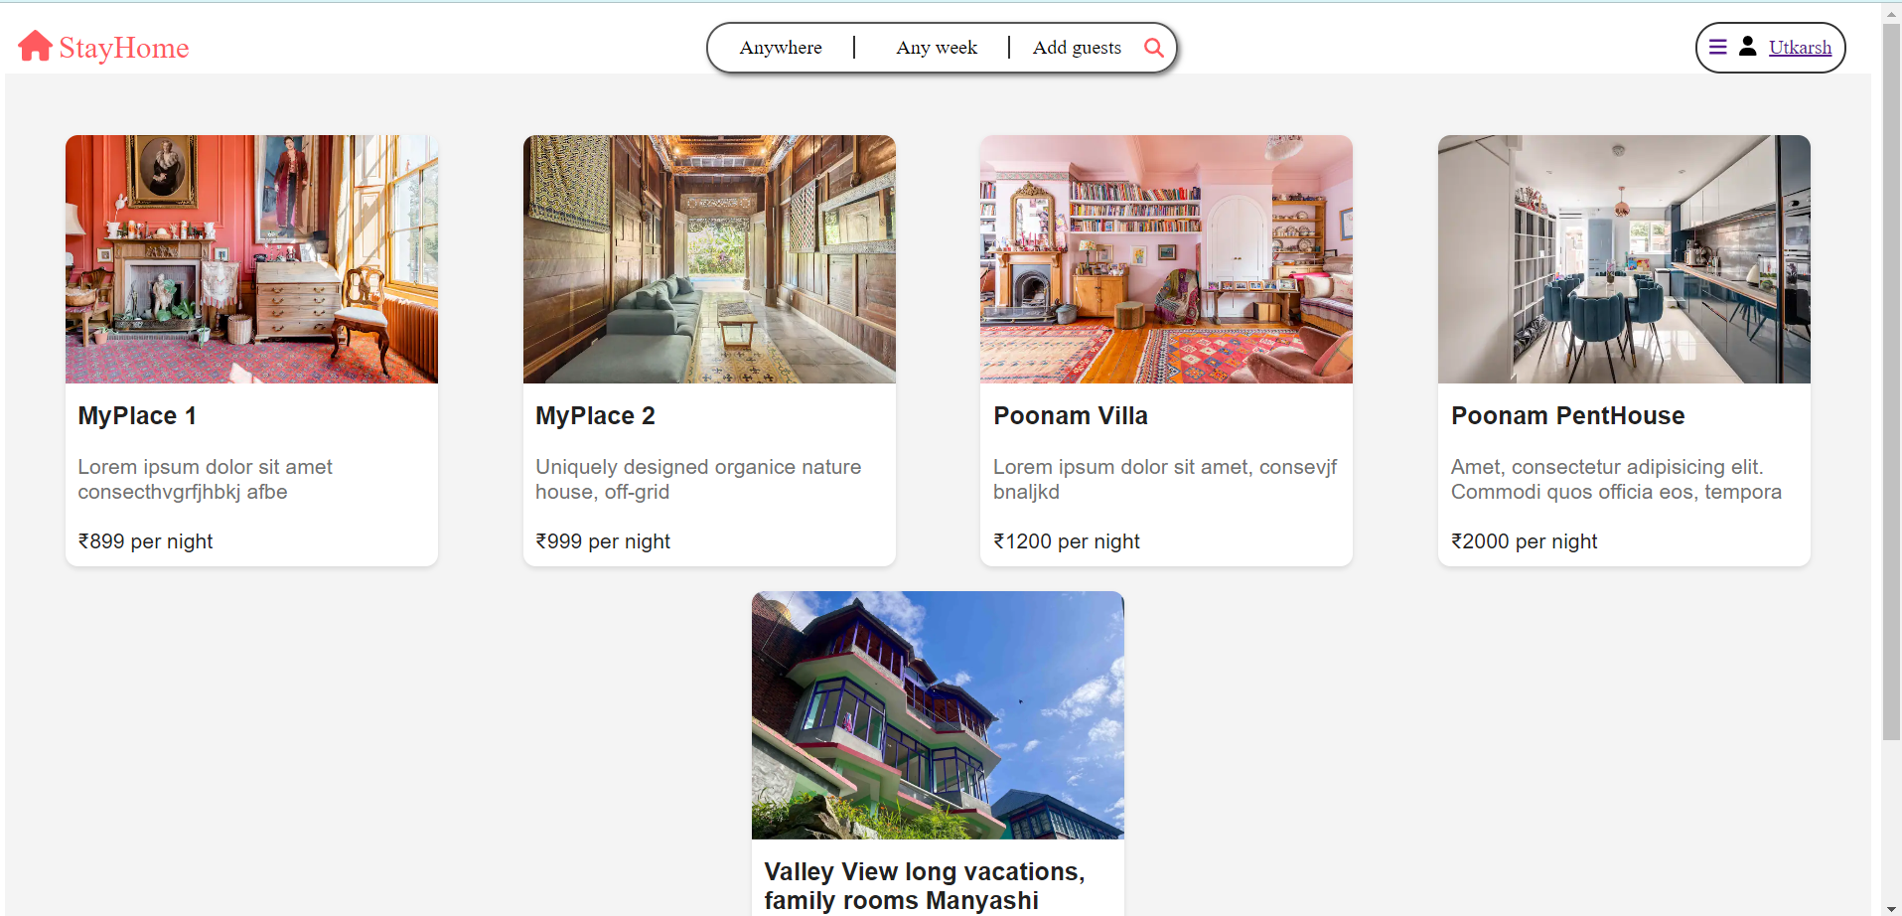

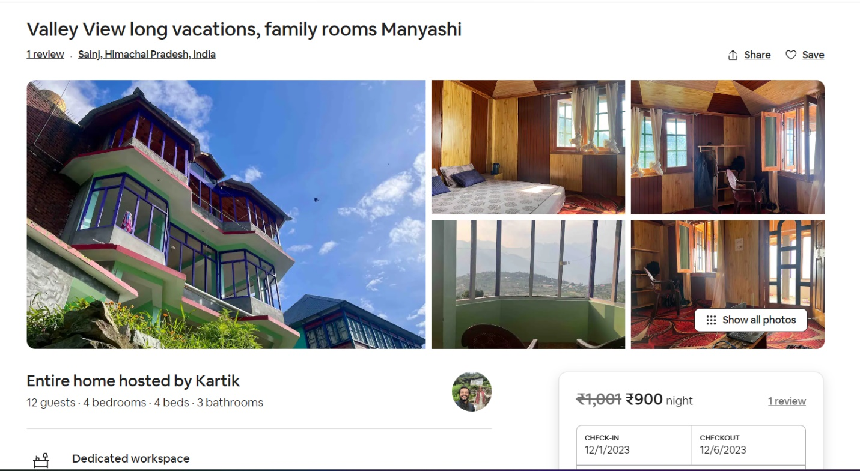

**CONCLUSION**

Conclusion: StayHome.com - Redefining Staycations with Innovation and User-Centric Design

In conclusion, StayHome.com emerges as a dynamic and user-centric platform poised to redefine the landscape of staycation planning. The software and hardware specifications outlined, coupled with a meticulous methodology, reflect our commitment to creating an unparalleled user experience.

From the adoption of the MERN stack to the integration of smart algorithms, StayHome.com combines cutting-edge technology to address the pain points of traditional staycation planning. The platform's user-centric design, facilitated by continuous iteration and feedback, ensures that every interaction is intuitive and tailored to individual preferences.

The hardware specifications underscore our dedication to reliability and scalability, utilizing cloud-based hosting, robust server infrastructure, and secure networking measures. On the software front, the choice of technologies such as MongoDB, Node.js, and React positions StayHome.com as a responsive, secure, and feature-rich solution.

**Future scope**

1. Enhanced Personalization:

StayHome.com will invest in advanced machine learning algorithms to further personalize recommendations. By analyzing user behavior and preferences, the platform aims to offer tailored suggestions that go beyond accommodations to include curated experiences, making each stay truly unique.

2. Augmented Reality (AR) Integration:

The future of staycations on StayHome.com includes immersive AR experiences. Users will have the ability to virtually explore accommodations, amenities, and local attractions before making a reservation, providing a more informed and engaging decision-making process.

3. Global Expansion:

StayHome.com is poised for global expansion, introducing a diverse range of accommodations from various regions. Collaborations with international partners and the inclusion of multilingual support will make StayHome.com a go-to platform for travelers worldwide.

4. Blockchain for Security and Transparency:

Implementation of blockchain technology will fortify security measures on StayHome.com. Smart contracts and decentralized ledgers will enhance data integrity, ensuring secure transactions and fostering a transparent ecosystem for users and accommodation providers.

5. Sustainability Initiatives:

StayHome.com is committed to integrating sustainability into its future endeavors. Collaborations with eco-friendly accommodations, carbon footprint tracking, and initiatives to promote responsible travel will be at the forefront of StayHome.com's commitment to environmental consciousness.

**References: -**

<https://www.google.com>

<https://www.w3schools.com/>

<https://www.mongodb.com/docs/>

<https://legacy.reactjs.org/docs/getting-started.html>

<https://devdocs.io/express/>