Dependancy Management using Gradle

- Add a gradle dependency and its related repository url.
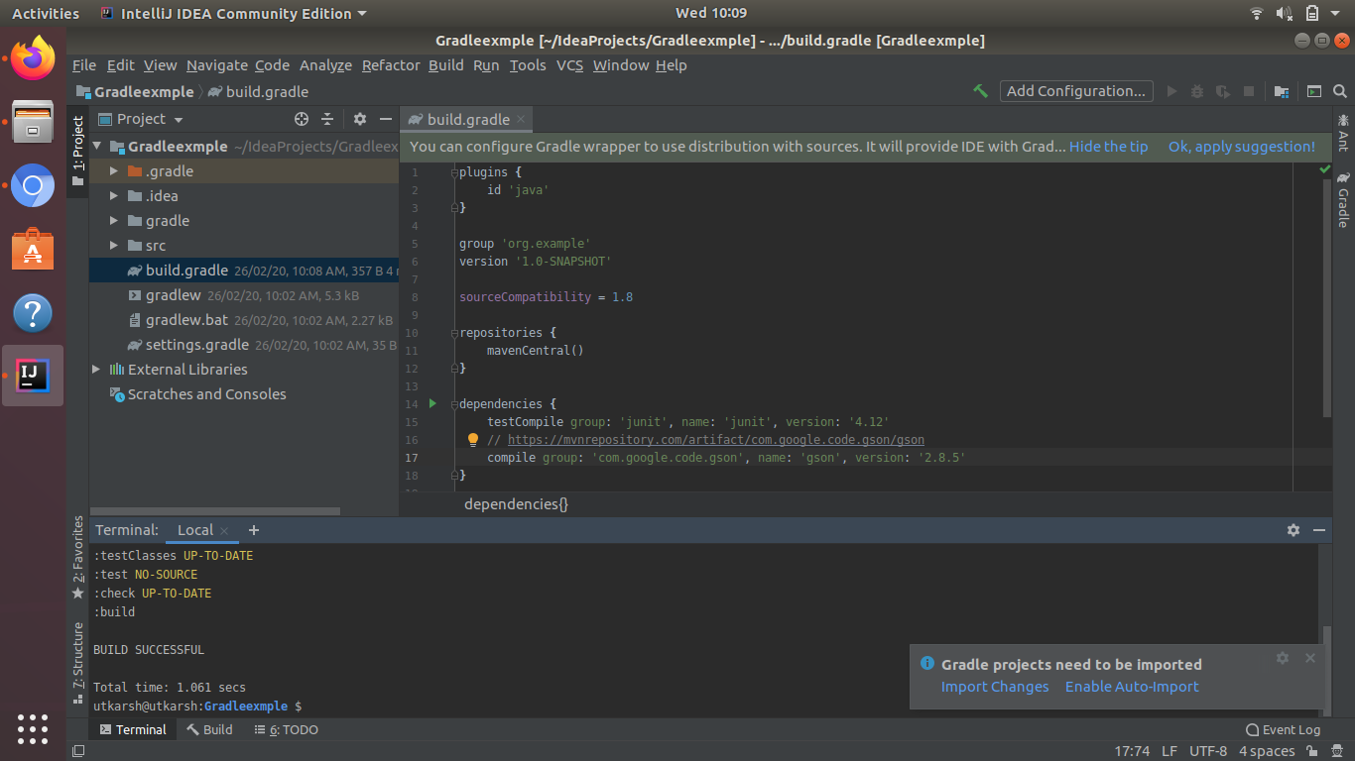
- Using java plugin, make changes in the manifest to make the jar executable. Using java -jar JAR_NAME, the output should be printed as "Hello World"
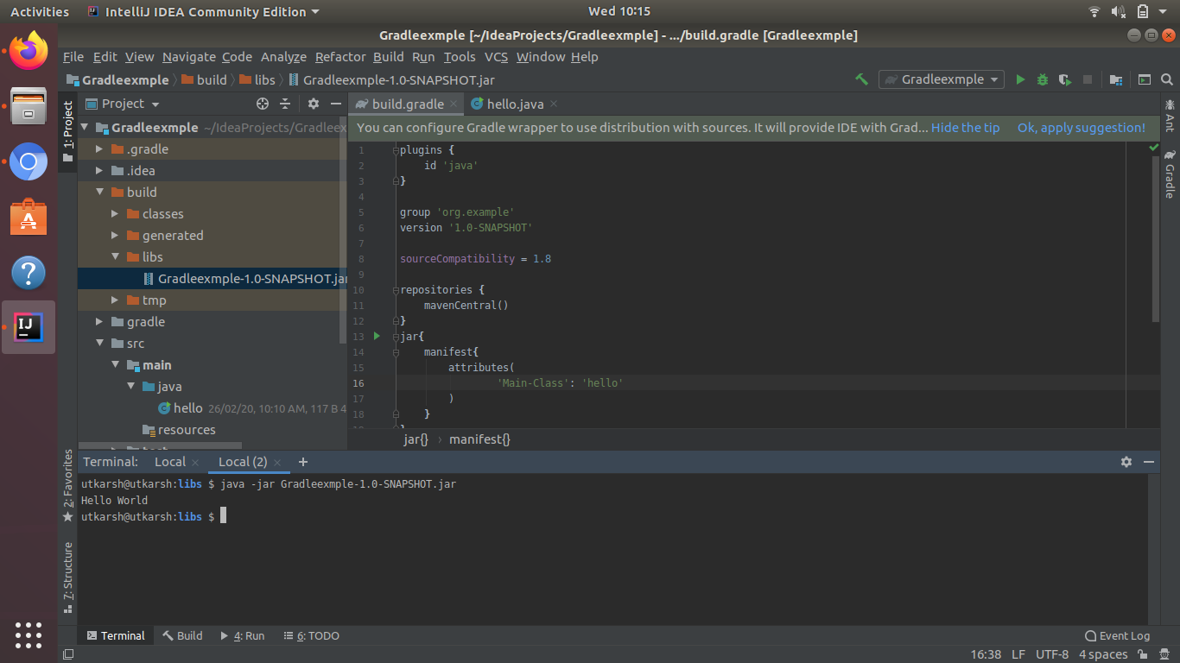

- Differentiate between the different dependency scopes: compile, runtime, testCompile, testRuntime using different dependencies being defined in your build.gradle.
Compile is the group of dependencies you need to build your application while testCompile -is a group of dependencies that you need only for testing. "compile" is for dependencies for your "main" code, "testCompile" for your test classes
runtime :This scope indicates that the dependency is not required for compilation, but is for execution. testRuntime is a group of dependencies that you need only for running the tests.

- Create a custom plugin which contains a custom task which prints the current date-time. Using that plugin in your project, execute that task after the jar task executes.
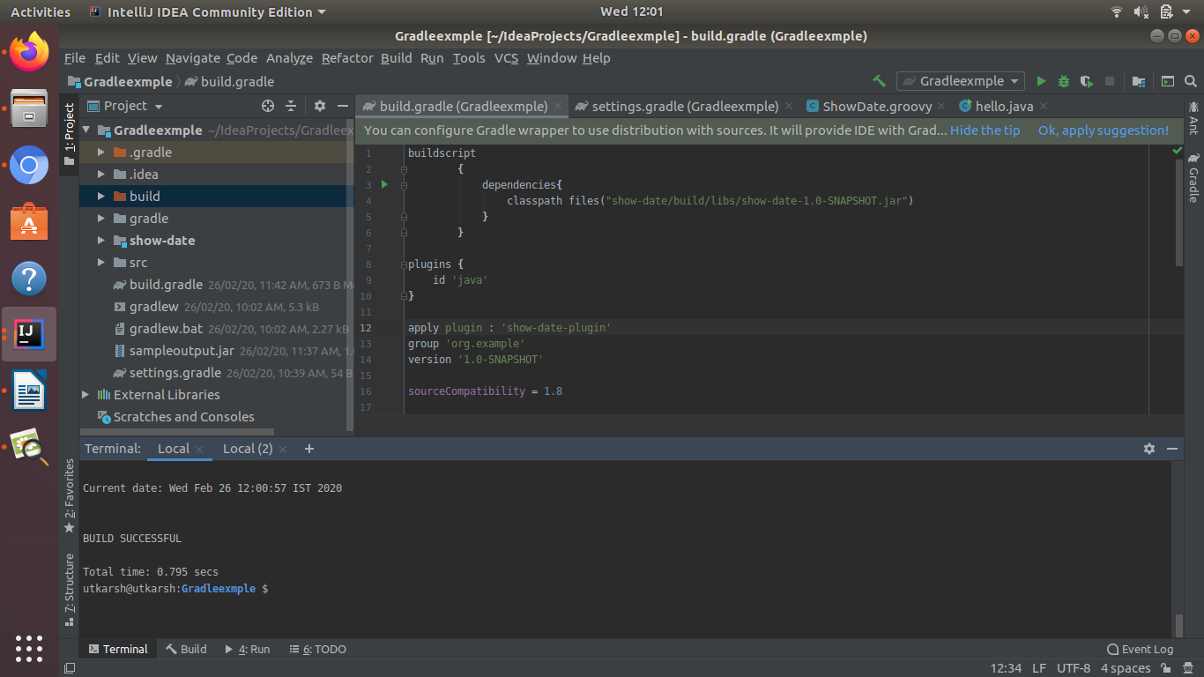
- Instead of using default source set, use src/main/javaCode1, src/main/javaCode2 to be taken as code source. Make sure that the JAR created contains files from both the directories and not from src/main/java.
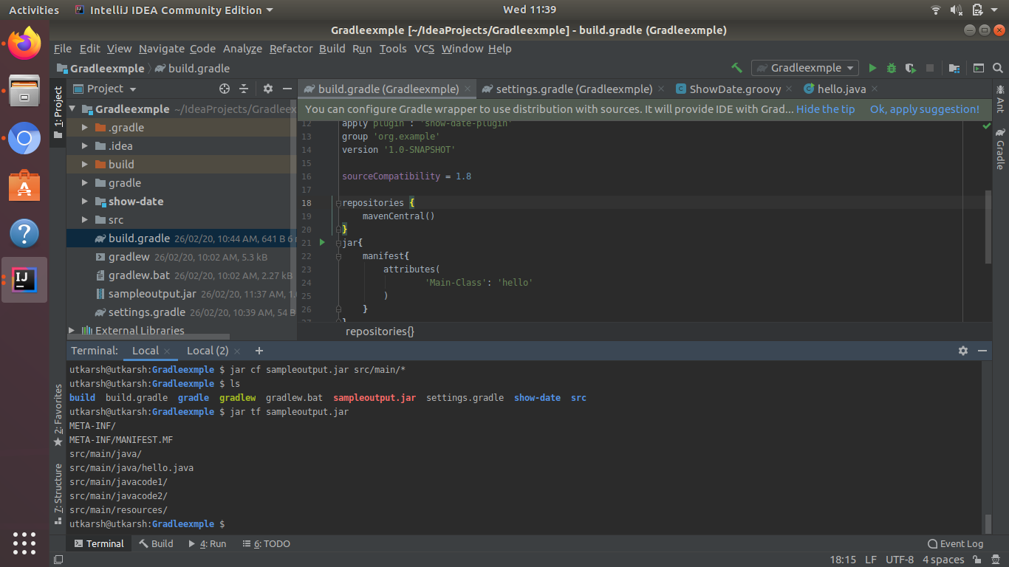
- Override the Gradle Wrapper task to install a different version of gradle. Make sure that the task written in Q4 also executes with it.
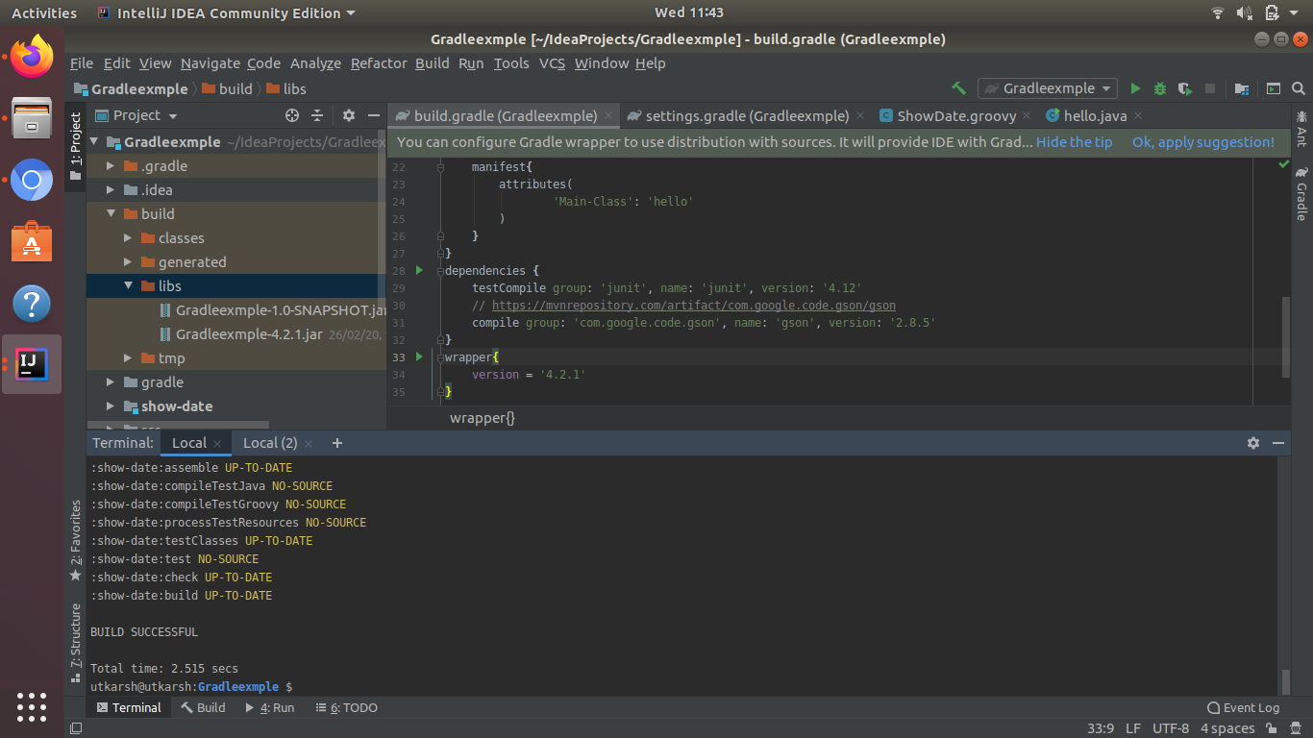
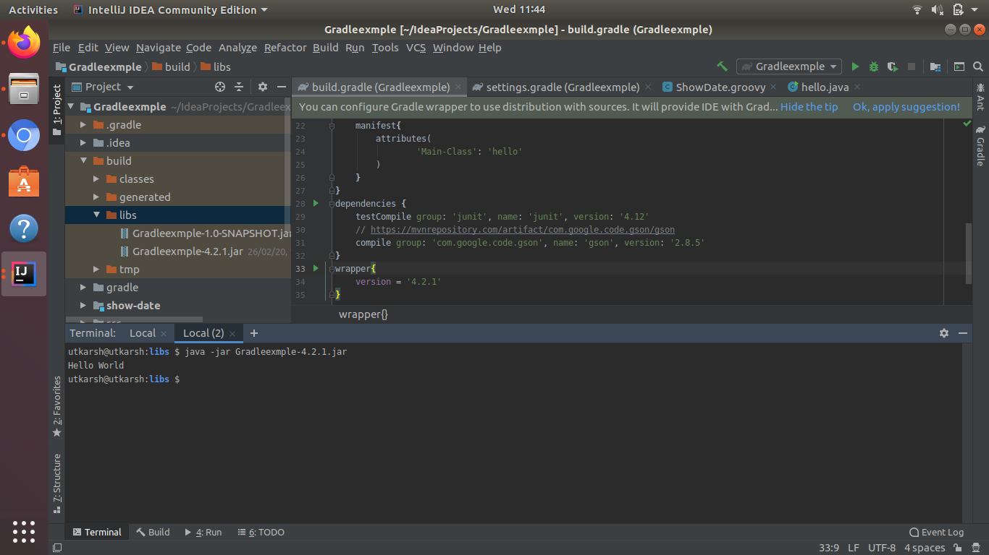
- Run the gradle profile command and attach the resulting files.
