A Project Report

On

**Developing an E-Commerce Website with Various Functionalities**

BY

| Utkarsh Verma | 2018AAPS0383H |
| --- | --- |
| Nikhil Kumar Singh | 2018AAPS0497H |
| Adarsh Shrivastava | 2018A3PS0537H |
| Kartik Kanotra | 2018A3PS0649H |

Under the supervision of

Dr. Subhrakant Panda

**SUBMITTED AS AN EVALUATION COMPONENT OF**

**THE COURSE OBJECT ORIENTED PROGRAMMING CSF213**

**BIRLA INSTITUTE OF TECHNOLOGY AND SCIENCE PILANI HYDERABAD CAMPUS**

**(April,2021)**

**Acknowledgements**

**We would like to thank Dr. Subhrakant Panda for giving us the chance to work on this project as part of our CS F213: Object Oriented Programming course and for his constant support. The project was a Interesting and a wonderful learning experience for us.**

**Languages and Framework**

**Front End**

**1) HTML**

Hyper Text Markup Language is the abbreviation for Hyper Text Markup Language. It's a collection of software solutions. Both humans and computers can find the language simple to read and understand. It is both coherent and adaptable.

**2) CSS**

Cascading Style Sheets (CSS) is a term for defining the appearance of a text written in a markup language like HTML. Along with HTML and JavaScript, CSS is a key component of the World Wide Web**.**

**3) JAVASCRIPT**

JavaScript, also known as JS, is a programming language that follows the ECMAScript standard. JavaScript is a multi-paradigm, high-level programming language that is often compiled just-in-time. Curly-bracket notation, dynamic typing, prototype-based object orientation, and first-class functions are all features of this language.

**Backend**

**Django Web Framework**

Django is an open source framework that uses the model-template-views architectural pattern and is well-known for its ease of use, scalability, and stability. Furthermore, since Django is a platform, it comes with built-in features that help users create and manage websites quickly. Django also offers a hassle-free experience in creating websites because it is built on Python, which is a really user-friendly language.

**Database**

**MySQL**

MySQL is an open access relational database management framework that is pronounced "My S-Q-L" or "My Sequel." It is built on the structure query language (SQL), which is used to add, delete, and change data in databases.

1. **LOGIN / SIGN UP PAGE**

A total of four interfaces were created for the Login and Sign up page.

- For Customer:

**Login Page:**

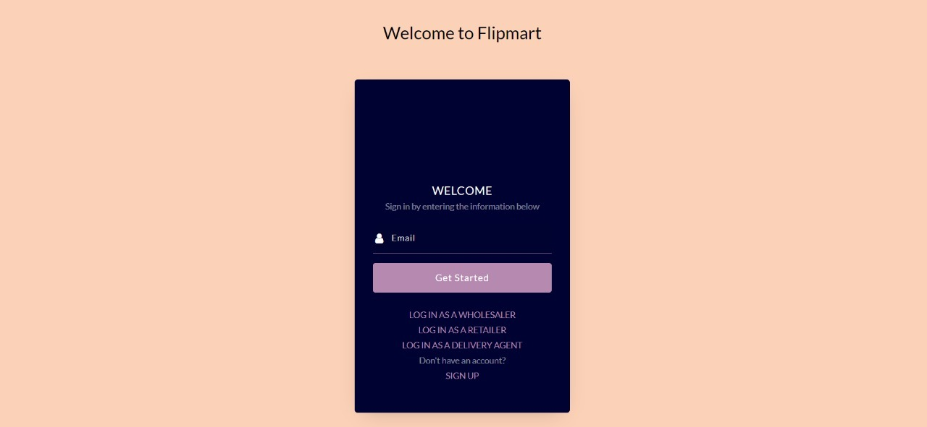

**SignUp Page:**

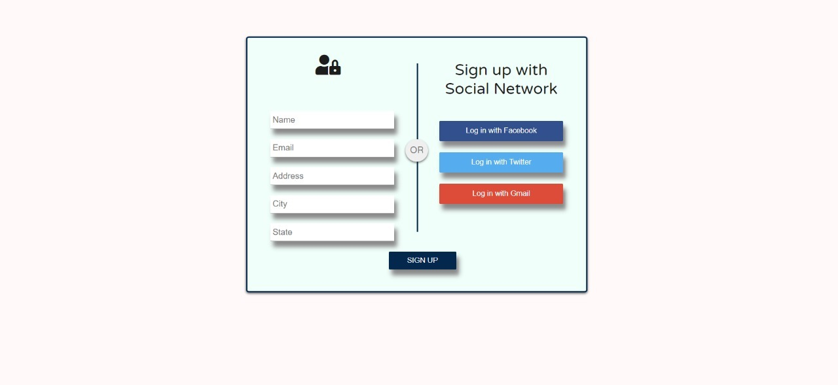

- For Retailer , For Wholesaler

**Login Page:**

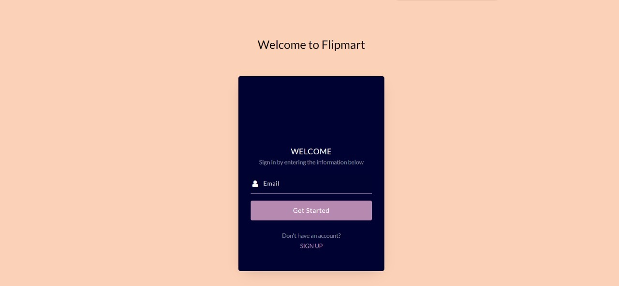

**SignUp Page:**

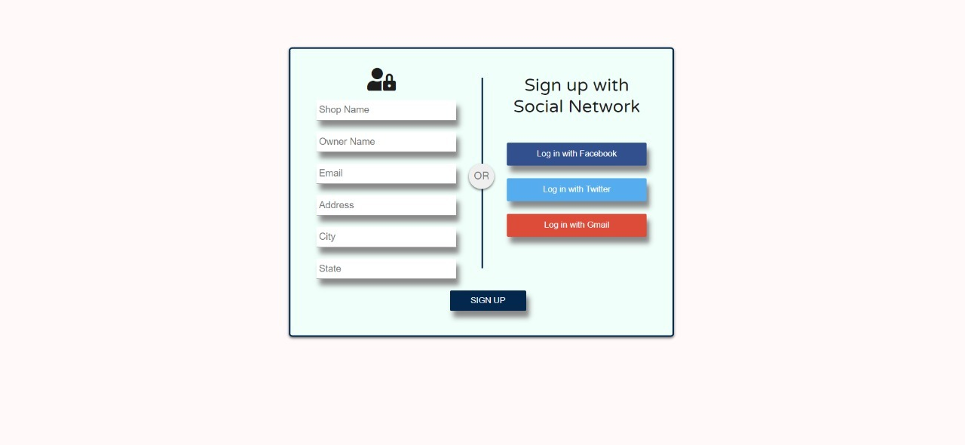

For Delivery person:

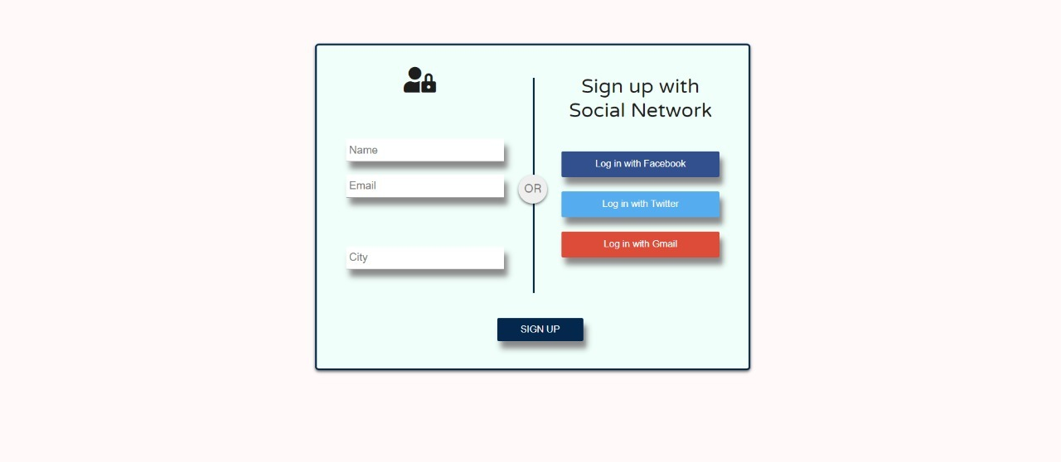

**2) OTP GENERATION PAGE:**

The OTP generation page is common for all the three i.e Customer , Owner and Delivery Executive.

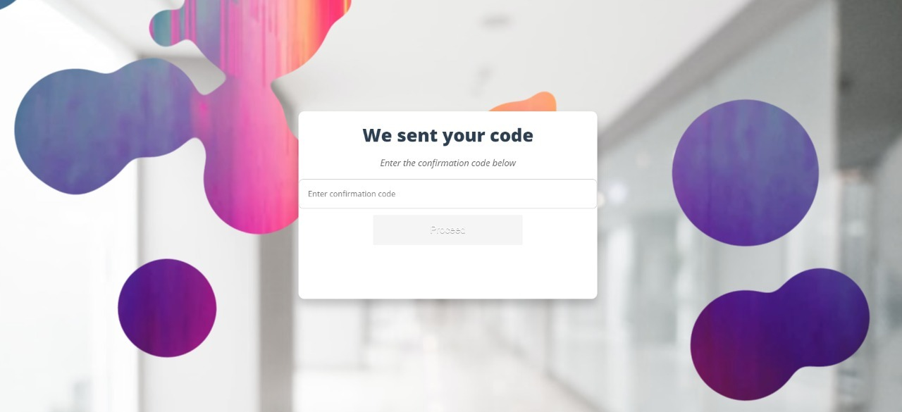

**3) USER DASHBOARD**

This is the user dashboard. Customer has the option to choose between different stores as per convenience and based upon services available.

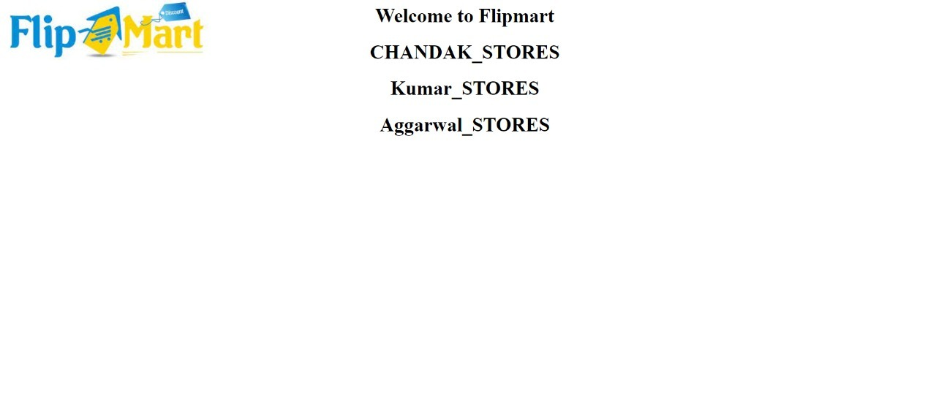

Upon selecting the desired Supermarket , the customer is directed to the main interface of the shop chosen which displays all the commodities available for purchase with price of each product displayed. The user then selects the desired products along with the quantities required.

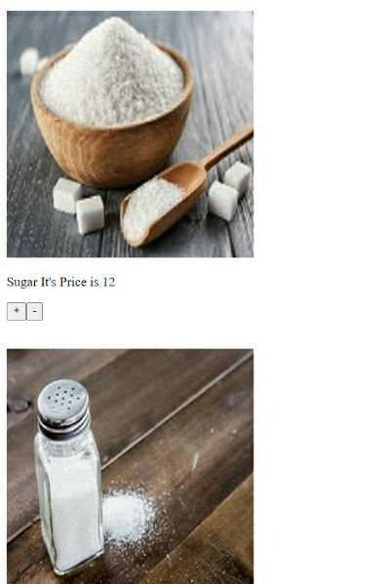

When the required products along with quantities are added to the cart , the user selects next and is directed to a new page which displays all the stock in user’s cart for confirmation along with the total cost.

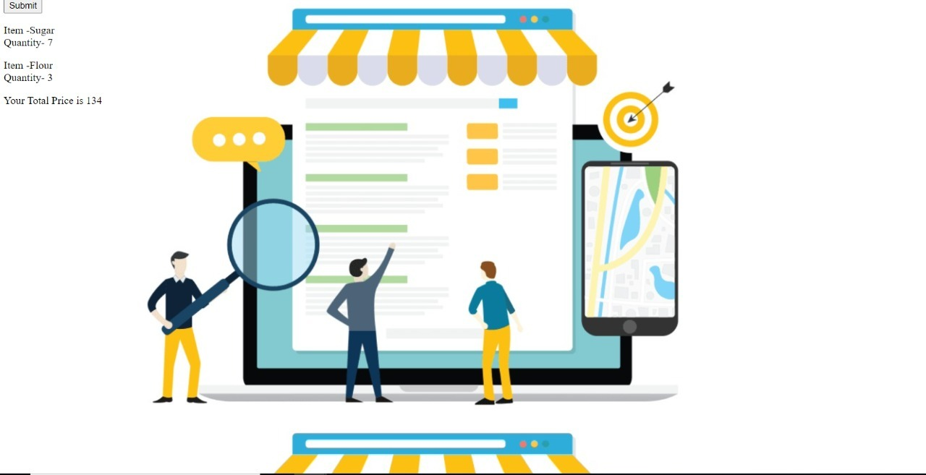

**FEEDBACK:**

After the user is done with the purchase , the next button directs the customer to the feedback page which asks the user to rate the services of the website, review the supermarket and recommend the services .

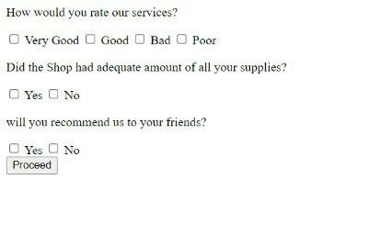

**FOR RETAILER:**

**Setting Up A New Shop:**

For setting up a new shop , firstly the owner has to sign up and create an account with his name , address , email and name of the Supermarket



Upon Setting up the supermarket in the website the retailer chooses to buy his products from any one of the given wholesalers.

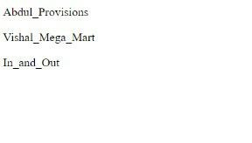

After this the retailer proceeds the same way as the customer to buy product from the wholesaler.

**LOGGING IN :**

If the retailer’s account is already set up he can directly login in to his shop and is directed to the dashboard.

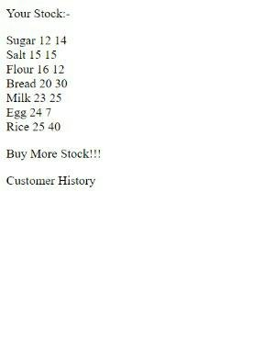

If the retailer desires to add more stock , the Buy More Stock!! Button leads to the page where the retailer can buy more product after choosing the wholesaler , which is the same procedure as setting up the shop.

**FOR WHOLESALER:**

**Setting Up A New Shop:**

For setting up a new shop , firstly the owner has to sign up and create an account with his name , address , email and name of the Wholesale market.



After setting up the account , the wholesaler can add products to his market in the wholesaler’s dashboard.

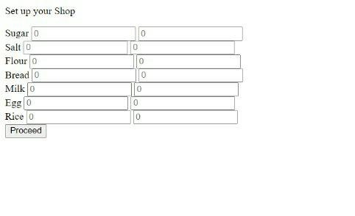

**LOGGING IN :**

If the wholesaler has already set up his account , he can then log in to update the quantity of his products to satisfy demand.

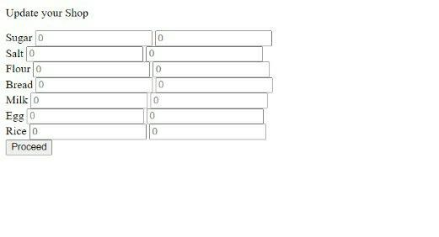

**Problems Faced**

1. Learning how to use a project-to-database connection to extract and apply data to the database.
2. Either Group members or their family members were suffering from covid.
3. Working in the middle of the challenges we've been dealing with in these trying days, when we've been under a lot of pressure and exhaustion.
4. Some errors were very difficult to figure out.

**Solution**

1.Learning concepts beforehand through youtube or some other platform.

2. Continuous discussion on platforms like google meet.

3. Workload was managed equally.

4. Used Github for collaboration.

**References**

<https://bootsnipp.com/tags/login>

<https://github.com/topics/ecommerce-website>

<https://www.youtube.com/watch?v=PkZNo7MFNFg&ab_channel=freeCodeCamp.org>

<https://www.youtube.com/watch?v=F5mRW0jo-U4&ab_channel=freeCodeCamp.org>