**Online Food Delivery Industry**

One of the fast growing industry at the rate of 16.2%. This industry has became the need of our daily life. Double-Income-No-Kids families, increasing number of people with smartphone & access to internet, working women are some of the major factors that are leading this growth of the online food-delivery industry in India.

**Key players** in this industry: Zomato, Swiggy, Foodpanda, Fassos.

**A] Demand drivers:**

**Aa] Population:** statistics says that over the population of 1.2billion, 50% of it falls under 18-40yrs. The college students and working professional are the key drivers for ordering online food delivery. These are the age group of population who gives less significance to cooking and shift towards online food delivery.

**Ab] Propitious income:** Youth of India are employed in sectors like IT, private that have upped their standard of living and fattened their wallets. Higher disposable income is also key driving factor for this industry.

**Ac] Trying new dishes:** Wish to try out new recipe, social status competitiveness adds up to demand for this industry.

**Ad] Cost competitiveness:** Online offersand affordable price options with good quality of food makes good hole on consumer’s pocket.

**Ae] Lifestyle:** Now with double-income families, Indian families are witnessing drastic change in routine, lifestyle as well as their food habits. Due to time crunches, there is demand of quick response. Around 92% of nuclear families in India would choose to order quick food delivery rather than to invest time in cooking.

**Af] Working women:** career demands and increasing work load does not leave any space, time and energy that women will cook full blown meals at home. Giving their time for productive efforts, they tend to spend less time in cooking and choosing online food delivery option.

**B] Typical customers & their drivers:**

**Ba] Working professionals:**

**i)** Unavailability of time, no-cooking abilities, surrounding environment comprises these people to go for food delivery option.

**ii)** Desire to earn more and becoming the superioropts for lot of Career demands, thus cooking becomes an inferior task.

**iii)** As, the spending power of this generation got stronger the urge to satisfy social needs became easier. Food is now is ordered not just for eating but also for showing the world.

**Bb] Meals on wheels:**

**i)** Nuclear families contribute to 92%, thus their elderly are at home alone. Due to their work-life, it is not possible to take care of them or cook for them.

**ii)** Meals on wheels is an initiative for the senior citizens, as they can’t go for groceries shopping and prepare nutritious meals for themselves this initiative will provide fastest home food delivery all you have to do is order.

**Bc] College students:**

**i)** Students residing in hostels and just came out for their houses are in special need for this food delivery industry. Hostel food is struggling; it is no taste-less nutrition food. The quality and affordable price offered by this industry is far better.

**ii)** It is said that “Teenage makes the trend” **-**studying no time for cooking; no gas for cooking; birthday give us a party; farewell order online; hangout, let’s have a pizza; night-out, trip or tour pack some fast food and beverages. These are some driving factors for online food delivery industry.

**C] Buyer’s characteristics and its effect:**

**Ca] Cultural:**

**i) Culture-** demand for food delivery depends on the person’s wants n behaviour considering individuals routine diet, nutrition value, taste, appearance of food the demand varies.

**ii) Subculture-**Meat or non-veg food items will not be able to earn a revenue in Gujarat, same like in Maharashtra *Pithla-Bhakari* is demanding dish whereas in some areas it is unknown.

**iii) Social class-**Higher the income higher will be the spending power, it is likely to be a key for healthy food choices, and more people will order food delivery.

**Cb] Social:**

**i) Reference groups:** It may influence in 3 ways- Informative, Comparative & Normative. Consumers are more motivated using reference groups.

**ii) Family:** Quality of food, Nutritional value, offers, and fast delivery stimulates customers to order food delivery at their home. Around 82% of orders for food delivery comes from home.

**iii) Role and status:** Status comes with more responsibility and less time. Time constraint and spending power stimulates consumer to fulfil their desires.

**Cc] Personal:**

**i) Age:** Age group between 18-40yrs are the key drivers for online food delivery order. Approximately 80% of food delivery orders comes from this age group.

**ii) Occupation:** Low-income population are the key drivers for this industry. They comprises around 41% of orders.

**iii) Lifestyle:** Working coupleshave time constraints they prefer to order healthy and nutritious food rather than to prepare it in the home. Customers like to explore food of different variety and taste.

**iv) Personality:** Customers with explorative and adventurous nature remains loyal to this industry as they order for happiness rather than need.

**Cd) Psychological:**

**i) Motivation:** Customers are highly motivated by their social-esteem and self-esteem.

**ii) Perception:** Being Tech-savvy customers, they are glued to their mobiles and ordering from their mobile saves time, offers applied saves money & energy to prepare food

**iii) Learning beliefs & attitudes:** Rate of food deliveries differ accordingly depending on prices, food safety, taste & quality of food. If one of these parameter changes the attitude of customer changes.

**D] Mean-end chain model**

**Attributes Psychological & Functional consequences Values**

Nourishment

Hygiene

Fresh Vegetables and Raw materials

Quality

Healthy

Freshly prepared

Wholesomeness

New Experience

Variety

Trying new things

Hunger Kill

Time for other things

Quick response

Time saved

Quick delivery

Good storage

Aspect and packaging

Satisfaction

Relationship building

Food safety

Trust factor

Taste

Money saved, money earned

Customization

Discounts

Value for money

Prices and offers

Affordability

**E] Examples of Print Ad:**

**1)Realtions: by Zomato-**

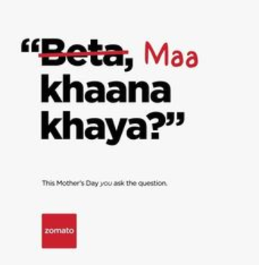

From “Beta khaana khaya? to Maa khaana khaya?” relationships turned around. Due to Quality & Trust on this industry, sons and daughters away from their parents can take care and fulfil their responsibilities.

**2) Voice of Hunger: by Swiggy-**

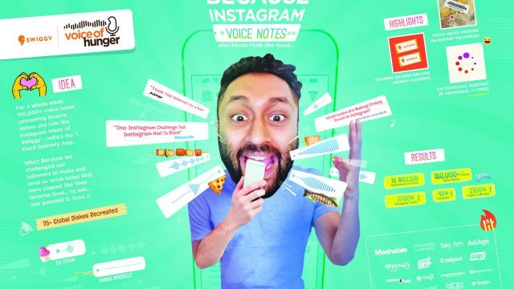

This is more of the marketing strategy, here in this Ad Swiggy is asking their customers to post an review, feedback, idea, response, comments on your Instagram, Whatsapp, Facebook any social media and let others know your experience.

The satisfaction you experienced tell about it to others. It may be a voice note, photograph, video, live streaming.

**3) Choose your own food: by Swiggy-**

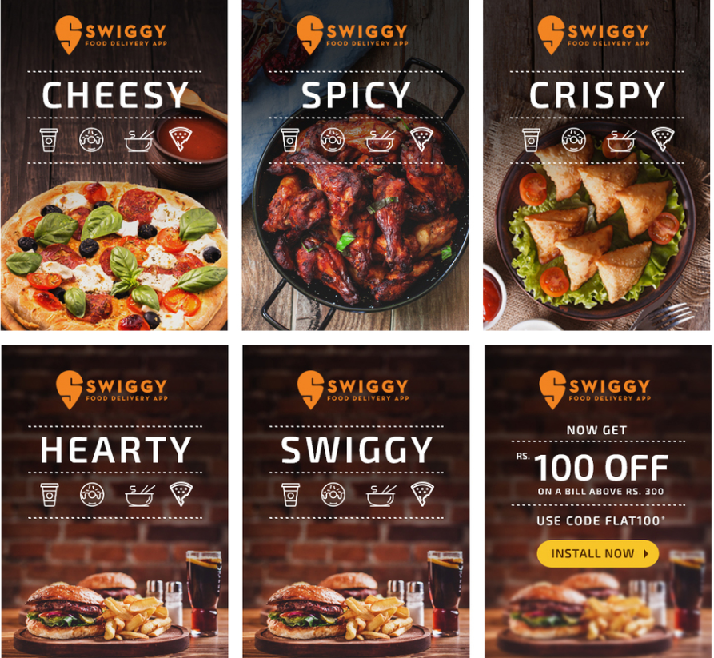

Customers can choose any variety of food, whatever customers need this industry will fulfil their hunger that too at affordable prices and good taste.

Word of mouth plays a key factor here, one person experience the dish and promotes to other this sense of satisfaction or competence can be easily fulfill. Self and social esteem both are guaranteed satisfied.

**4) you can earn too: by Zomato-**

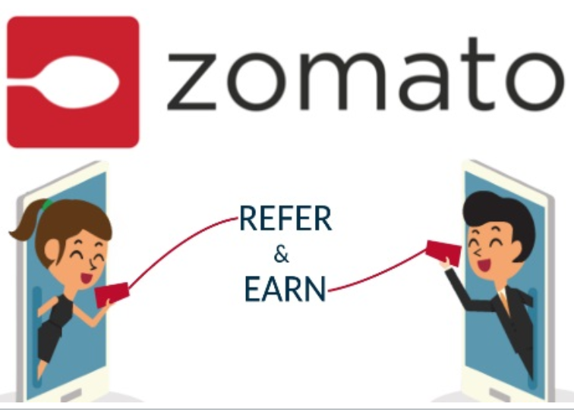

The discounts and offers can save your money, but don’t you just enjoy ask your friends, colleagues and family to enjoy with you. You are getting paid for that. They offer coupons, codes to the customers, all customers have to do it refer it to your acquaintances.